

Student name: Eileen Margia Cooper
Student ID: 2416088
Module name: Introduction to Physiology
Module code: BMHP5023
Lecturer name: G1 & G2 : Shaila Hussain
Assessment: Component 1: written Assignment Case Study Report

Table of Contents

- Introduction : Definition of diabetes mellitus
- Type 1 Diabetes
- Type 2 Diabetes
- Risk factors associated with diabetes
- Endocrine System related to diabetes
- Overview of cellular metabolism
- Case study cellular metabolism and lifestyles changes
- Recording and tracking blood sugar levels for type 2 diabetes
- Significant failure to track and recording blood sugar levels
- Recommendations and evidence base diabetes foot clinical practices
- Conclusion
- References

1. Introduction

Definition of Diabetes Mellitus

Diabetes mellitus is a metabolic disorder that influences how the body control carbohydrates, fats and proteins. It’s described as high blood sugar levels where the pancreas cannot produce enough insulin causes insulin deficiency. When blood sugar is too low hyperglycaemia can increase glucose auto-antioxidant ,protein glycation and stimulate the poliyol pathway. (Laraeni and Danuyanti, 2021).

Diabetes is divided into two categories : Type 1 diabetes and type 2 diabetes .

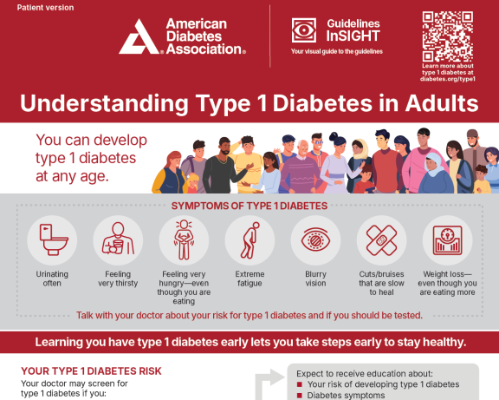
Type 1 Diabetes Mellitus: Is the most prevalent chronic diseases in children and adolescent, (Martens, 2021). It’s an autoimmune disorder where the body attacks and destroys the insulin-producing beta cells in the pancreas, causing blood glucose levels to increase due to insulin deficiency. Insulin is a hormone that allowed glucose to enter body cells to produce energy, maintaining body functions. Individuals with type 1 diabetes needs insulin to regulate their glucose levels. (NHS,2025).

(American Diabetes Association,2025).

Types 2 Diabetes Mellitus: Is a common form of diabetes, caused mainly by lifestyle factors such as poor diet, physical inactivity, obesity and genetic tendency. In this condition the body doesn’t produce enough insulin or the insulin it produce is not used effectively, known as (insulin resistance ) that leads to high blood sugar levels, (NHS, 2025).The pancreases are responsible for making insulin beta cells, can become damaged due to weakened immune system, and causes inflammation that harm beta cells. This damage reduces insulin production and high risk of developing type 1 diabetes, that affect children and adolescents, due to insufficient insulin. (NHS,2025).

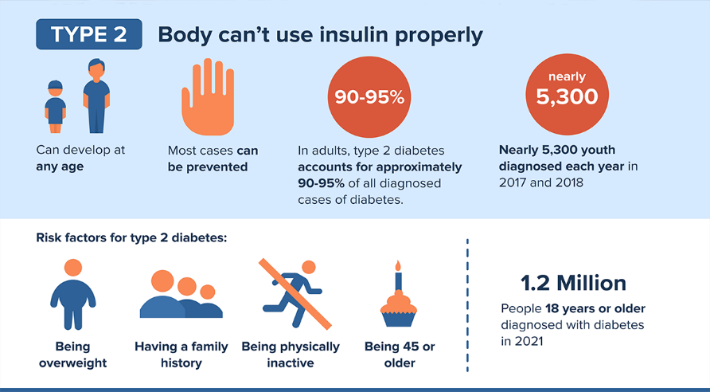(CDC,2025)

Risk factors associated with Diabetes : individuals with diabetes are at risk of health complications such as
- Genetic : having a parent with type 2 diabetes
- Lack of physical activity less than 3 times per week
- Overweight and obesity are major issue for diabetes
- Ages between 45 and older
- Smoking can increase risk of type 2 diabetes and causes other health complications.
- Nerve damage such as nerve pain,
- Hearth attacks with or without system
- Ethic background e.g. African -Caribbeans (CDC,2025)
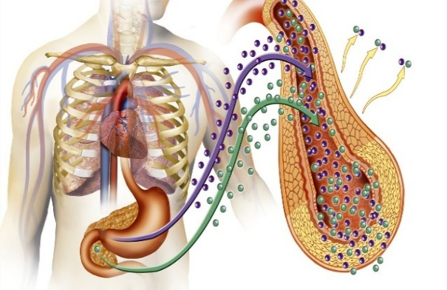
Overview of the Endocrine System: The endocrine system is important within diabetes mellitus, collaborating with the nervous and immune systems to maintain the body balanced and regulate bodily functions. Hormones are release into the bloodstream, entering multiple tissues and regulate cells activity, to maintain homeostasis, e.g. blood pressure and body temperature.(Knight,2021).These processes regulate different bodily functions, e.g. metabolism, growth, and reproduction that produces hormones controlling blood sugar, levels, regulating internal body clock and maintain stress responses,(Cappola, 2023). Adjusting hormones levels, the body ensures that cells function properly to maintain energy production. When the pancreas doesn’t produce enough insulin, cells cannot used glucose for energy and causes the body to break down fat and produces ketones, the build-up of ketones within the body makes the blood acidic, that causes major health issues and life-threatening condition that needs urgent treatment.(Endocrine Society, 2022).
Endocrine system (Endocrine Society, 2022).
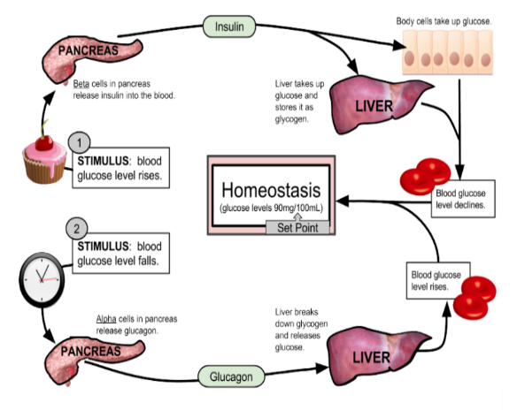
Blood Sugar Regulation: Blood sugar levels are maintained safe and effectively though the endocrine system, and pancreas, that work together to maintain safe blood sugar levels. (Bondy,2020) Carbohydrates broken down into glucose and provide energy for the body. Glucose enters the bloodstream and causes blood sugar levels to increase too high. The pancreas release insulin in the body to regulate blood sugar levels and prevent it from getting too high. Beta cells release insulin, that enables glucose to enter cells Insulin helps glucose to transfer from the bloodstream into the body cells to produce energy and stored excess glucose that is used as glycogen in the liver and muscles. This process helps maintain a stable blood sugar levels, ensuring the body energy needs are met. (Bondy and Prasad, 2020).

Homeostasis and cellular Function

(Vanniasinkam,2023)

Cellular Metabolism : cellular metabolic a biochemical reaction that occur within the cells to enables them to maintain cellular functions to live, grow and transfer nutrients into energy. The energy production basal needed for basic body functions are affected by various factors e.g. sex, race, activity level, diet, ages and environment, (Nava,2022).

According to Kaur (2015) there are two types of metabolic reactions, e.g. Anabolism-the process of building larger molecules from smaller molecules that required energy to provide complex molecules. Catabolism- the process of breaking down larger molecules into smaller molecules releasing energy. These metabolic reactions combine to support life and cellular function.

Metabolic Pathway: metabolic pathway is important in organisms that produces energy and maintain body movement, occurs within organisms, enabling them to grow in different sizes, maintain cellular functions, these structures respond to environment changes. Metabolic pathways breakdown molecules, provide energy production, growth, and repair providing energy molecules, Biosynthesis produced new molecules e.g. proteins and lipids, (Gupta, 2025).

Degradation: helps to break down molecules, e.g. carbohydrates and fats within the body. Regulation: control metabolic flux and responding to process includes cellular building blocks e.g. lipids, amino acids, carbohydrates, nucleotides and enzymes. metabolic pathways are important for life that led to diseases disorder. The nutrients intake is the main cellular metabolic reactions, e.g. lipid metabolism an important within the body to provide energy nutrients that cells used to fuel and support cells functions and membranes (Gupta, 2025).

Efficiency of cellular metabolism : Cellular metabolism is affected by lifestyle choices e.g. obesity, diet, exercise, sleep and medication When cells are damage metabolic dysfunction can occur, leading to reducing energy and increasing the risk of types 2 diabetes, insulin resistance and metabolic syndrome (Newsholme, 2019).

Case study : Cellular Metabolic and lifestyles changes :
Introduction
This case study looks at how the role of a healthcare professional support individuals living with diabetes. It outlines main duties including tracking health indicators, aiding daily activities, encouraging healthier habits and delivering person-centred and care planning.
As a healthcare practitioner working in a local GP surgery, I have seen a growing number of patients being diagnosed with type 2 diabetes. Many of them have a limited understanding of their condition and find it difficult to take part in their own care plans.
Mrs, S is a 50-year-old secretary who live alone and was diagnosed with types 2 diabetes, after a routine health check. she is overweight, feels fatigue and low energy levels and is not clear on how diabetes impacts her body or how to manage her blood glucose levels safely. During her first appointment several health checks were performed, blood glucose, BP, weight, and a foot exam that revealed Mrs, S lacked knowledge how insulin resistance leads to high blood glucose levels. The education session explained how lifestyles such as diet, physical inactivity and excess weight ,smoking, alcohol consumption and inaccurate sleep contribute to diabetes control. Mrs, S lifestyles show several factors that affect her cellular metabolism and physical health. Mrs S daily activity is limited because of her job that including siting for too long.
Physical inactivity - reduces muscles efficiency and slow down cellular metabolic disorders e.g. obesity and type 2 diabetes. Mrs smith social interaction is very small as she spends most of her time working, leaving her feeling isolated, and lonely that have an impact on her health and well-being.
Limited interaction - with other individuals can increase stress hormones and elevates cortisol levels that is harmful for Mrs Smith health and interferes with her metabolic balance.
Alcohol consumption - has taken a toll on her health excessive alcohol intake can damage organs e.g. liver and kidney function and causes metabolic reactions that affect Mrs Smith’s body to process nutrients and remove toxins, causes low energy levels and fatigue that prevent her body to remove toxins.
Smoking - Mrs S is also a heavy smoker she smokes an average of 20 cigarettes and a daily basis; smoking reduces oxygen from reaches the cells that slow down respiration and energy production that are important for cellular metabolic.
Accurate sleep- Mrs S, have five hours sleep per night ,due to her busy lifestyle not having enough sleep disrupts hormonal regulation and reduce insulin sensitivity and slowing metabolic processes. Mrs S lifestyle has an impact and her cellular metabolism, having regularly physical activity e.g. walking , swimming gardening, reduced alcohol intake and smoking, maintain regular sleep, and social interaction can provide healthy metabolic function, improve health outcomes and her well-being.( Koning,2023).

4. Recording and tracking blood sugar levels for type 2 diabetes
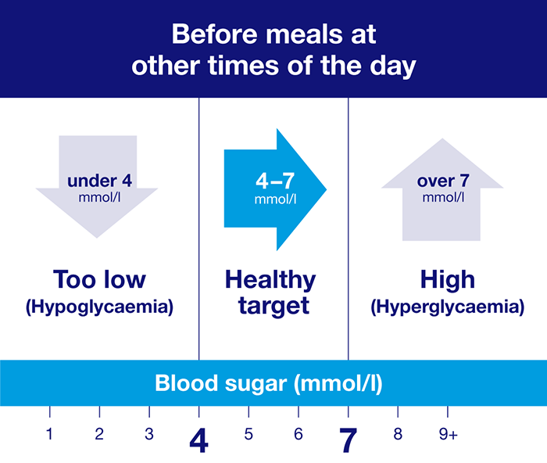
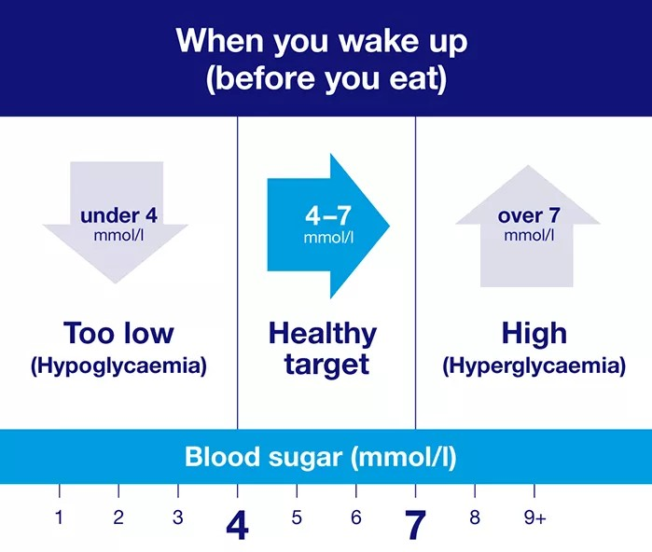
Tracking and recording blood sugar levels are important to help individuals with type 2 diabetes make informed lifestyle choices about food, physical activities, stress management enabling them to adjust their habits, and fine out if treatment is working. ( Diabetes UK,2025) Regular monitoring keeps glucose levels in check, enabling individuals prevent early signs of hyperglycaemia high blood sugar or hypoglycaemia low blood sugar preventing complications, (Diabetes UK, 2025.)
(Diabetes UK, 2025).
Tracking and recording blood sugar levels provides healthcare professionals with accurate records and adjust treatment .Type2 diabetes medication e.g. metformin, sulfonylureas and GLP-1 insulin dosing relies on accurate monitoring to work effectively helping individuals stay healthy and avoid diabetes complications e.g. sight loss and feet amputation, recording improve communication with healthcare professionals to ensure decisions are up to date on reliable (Diabetes UK, 2025).

Significant risk failure to track and recording blood glucose levels
The danger of not tracking and recording blood glucose levels increase the risks of diabetes coma and major health issues from high or low blood glucose levels, changes may result in insulin and medication dosing. Not recording blood glucose levels can lead to errors in medication doses delayed in interventions and poor care co-ordination, that will increase complications e.g. kidney damage, nerve damage, loss of visions cardiovascular disease, neuropathy ,retinopathy. Not recording blood glucose levels reduces continuity care and put patients’ safety at risk. (American Diabetes Association, 2024).

5. Recommendations and Evidence base Diabetes foot clinical Practices
According to the (IDF), 366 million people worldwide had diabetes mellitus in 2011 and predicted an increase of 552 million by 2030. (Jiang, 2022).
Diabetic foot is the most common conditions of diabetes that is a major concern for diabetic specialists and surgeons, affecting 6% of individuals with ulcers, infections and damage of the foot tissues. The foots is a vulnerable part for individuals with diabetes prone to trauma and needing carful protection. Clinical practice guideline( CPGs) for diabetes foot can help healthcare professionals improve care planning in line with various organisations recommendations (IDF,2017).
Managing diabetic foot need clinical care support and lifestyle changes , structured diabetes foot self-care education is important to help individuals understand their condition and get involved in their care plan maintain health outcomes and well-being. self- management education can lead to better long- term blood sugar control . healthcare professionals can encourage regular glucose monitoring, review medication, and personalised care plans to adjust treatment for individuals. (Jiang, 2023).
According to NICE guideline,(2015) healthcare setting, should provide a care plan for individuals with diabetic foot issues who required hospital admission. The individual with diabetic foot ulcerations should get yearly checks for nerve damage and arterial diseases symptoms, an Individual with a higher risk required screened every 3-6 months the risk levels of the individual with foot problem can changes and needed continuous monitoring. Prevention and treatment can reduce economic cost of diabetic foot diseases, lowering risks of foot ulcers, infections, amputations and hospital admissions. (NICE,2015).

Conclusion

Summary: Diabetes mellitus is a metabolic disorder due to increase high blood glucose levels; the body doesn’t produce enough insulin hormone or cannot use it properly. Risk factors for complication include genetics, long – term diabetes and inadequate blood glucose control. A negative attitude, lack of knowledge and poor treatment about diabetes management can interrupt disease control. Diabetes management aims to delay disease progressions and complications, improving blood sugar levels, reducing cardiovascular risk and preventing diabetic complications, e.g. organ damage and microvascular issues. Blood glucose level needs to be monitor decline control can lead to serious issues e.g. cognitive impairment and weakened immunity.

References
American Diabetes Association Professional Practice Committee, (2023). 6. Glycaemic goals and hypoglycaemia: standards of care in diabetes—(2024). Diabetes care, 47(Suppl 1), p.S111. (Accessed: 15th November 2025)

Apergi, K., Dimosthenopoulos, C. and Papanasa, N., (2025). The role of nutrients and diet characteristics in the management of diabetic foot ulcers: a systematic review. The international journal of lower extremity wounds, 24(3), pp.525-541.(Accessed: 15th November 2025)
Alexiadou, K., Doupis, J. Management of Diabetic Foot Ulcers. (2022) Diabetes Ther 3, 4 https://doi.org/10.1007/s13300-012-0004 (Accessed:15th November 2025)
Bondy, S.C., Wu, M. and Prasad, K.N., (2020). Alternatives to insulin for the regulation of blood sugar levels in type 2 diabetes. International journal of molecular sciences, 21(21), p.8302. (Accessed: 16th November 2025)
Ceriello, A. and Colagiuri, S., (2008). International Diabetes Federation guideline for management of postmeal glucose: a review of recommendations. Diabetic Medicine, 25(10), pp.1151-1156. (Accessed: 20th November 2025)
Cappola, A.R., Auchus, R.J., El-Hajj Fuleihan, G., Handelsman, D.J., Kalyani, R.R., McClung, M., Stuenkel, C.A., Thorner, M.O. and Verbalis, J.G., (2023). Hormones and aging: an endocrine society scientific statement. The Journal of Clinical Endocrinology & Metabolism, 108(8), pp.1835-1874.(Accessed: 28 November 2025)
Christiaens, A., Boureau, A.S., Guyomarch, B., de Decker, L., Boland, B., Hadjadj, S. and Cariou, B., (2025). Diabetes overtreatment and hypoglycaemia in older patients with type 2 diabetes on insulin therapy: insights from the HYPOAGE cohort study. Diabetes Care, 48(1), pp.61-66. Accessed : (21st November 2025)
DeFronzo, R.A., Ferrannini, E., Groop, L., Henry, R.R., Herman, W.H., Holst, J.J., Hu, F.B., Kahn, C.R., Raz, I., Shulman, G.I. and Simonson, D.C.,( 2015). Type 2 diabetes mellitus. Nature reviews Disease primers, 1(1), pp.1-22. Accessed: 23rd November 2025)

Fu, Z., R. Gilbert, E. and Liu, D., (2013). Regulation of insulin synthesis and secretion and pancreatic Beta-cell dysfunction in diabetes. Current diabetes reviews, 9(1), pp.25-53.
Gupta, S., Bhatnagar, R.K., Gupta, D., K, M.K. and Chopra, A., (2025). The evolution of N, N-dimethyltryptamine: from metabolic pathways to brain connectivity. Psychopharmacology, pp.1-23. Accessed : (15 November 2025)
Gooday, C., Berrington, R. and is Principal, C.G., (2015). New NICE guidance on the diabetic foot. Diabetes Prim Care, 17, pp.278-284. (Accessed :15 Nov 2025)
Ibrahim, A., (2017). IDF Clinical Practice Recommendation on the Diabetic Foot: A guide for healthcare professionals. Diabetes research and clinical practice, 127, pp.285-287.
(Accessed : 23rd November 2025)

Guest, J.F., Fuller, G.W. and Vowden, P., (2018). Diabetic foot ulcer management in clinical practice in the UK: costs and outcomes. International wound journal, 15(1), pp.43-52.

Jiang, M., Gan, F., Gan, M., Deng, H., Chen, X., Yuan, X., Huang, D., Liu, S., Qin, B., Wei, Y. and Su, S., (2022). Predicting the risk of diabetic foot ulcers from diabetics with dysmetabolism: a retrospective clinical trial. Frontiers in Endocrinology, 13, p.929864.
(Accessed: 20th November 2025)

Jiang, P., Li, Q., Luo, Y., Luo, F., Che, Q., Lu, Z., Yang, S., Yang, Y., Chen, X. and Cai, Y., (2023). Status and progress in research on dressing management for diabetic foot ulcer. Frontiers in Endocrinology, 14, p.1221705. (Accessed :15 November 2025)

Jakubowski, H.V., Agnew, H., Jardine, B. and Sauro, H.M., (2024). Use of interactive mathematical simulations in fundamentals of biochemistry, a Libre Text online educational resource, to promote understanding of dynamic reactions. Biochemistry and Molecular Biology Education, 52(4), pp.426-435. (01st November 2025)
Koning, C., Pelletier, M. and Spooner, J., (2023). The national health service England diabetes prevention program—A narrative review. Journal of Diabetology, 14(4), pp.198-206. (01st November 2025)
Koju, N. and Sheng, R., (2025). Anabolism and Catabolism of Coenzyme II. In Biology of Nicotinamide Coenzymes: From Basic Science to Clinical Applications (pp. 119-133). Singapore: Springer Nature Singapore. (12 November 2025)
Knight, J., (2021). Endocrine system 1: overview of the endocrine system and hormones. Nursing Times, 117(5), pp.38-42. (Accessed: 28 November 2025)

Kaur, J., Debnath, J.(2015). Autophagy at the crossroads of catabolism and anabolism. Nat Rev Mol Cell Biol 16, 461–472 https:// doi.org/10.1038/nrm4024 (Accessed 11 November 2025)

Laraeni, Y., Danuyanti, I.G.A.N., Resnhaleksmana, E., Pauzi, I., Mataram, I.K.A. and Agustini, N.P., (2021). High antioxidant level in cajanus Sajan reduces blood glucose level and improves blood lipid profile of rats as diabetes mellitus models. International Journal of Health Sciences, 5(1), pp.29-37. (Accessed: 28th November 2025)
Lal, A. and Vanniasinkam, T.,( 2023). Special Series: Scientific Literacy.
Accessed:02nd December 2025

Lalani, B., Shim, J., Vadini, V., Valdez, Y., Zade, D. and Mathioudakis, N., (2025). Consumer-oriented review of digital diabetes prevention programs: insights from the CDC s diabetes prevention recognition program. Frontiers in Clinical Diabetes and Healthcare, 6, p.1562108. (Acessed:19th November 2025)

Martens, P., Gysemans, C., & Mathieu, C. (2021). 100 YEARS OF INSULIN: Arresting or curing type 1 diabetes: an elusive goal but closing the gap. Journal of Endocrinology, 249(2), T1-T11. Retrieved (Nov 28, 2025), from https://doi.org/10.1530/JOE-20-0552
Marshall, S.M. (2021) Celebrating 100 years of insulin. Diabetologia 64, 944–946 https://doi.org/10.1007/s00125-021-05417-3
Metallo, C.M. and Vander Heiden, M.G., (2013). Understanding metabolic regulation and its influence on cell physiology. Molecular cell, 49(3), pp.388-398.
( Accessed : 19th November 2025)

McCall, A.L., Lieb, D.C., Gianchandani, R., MacMaster, H., Maynard, G.A., Murad, M.H., Seaquist, E., Wolfsdorf, J.I., Wright, R.F. and Wiercioch, W., (2023). Management of individuals with diabetes at high risk for hypoglycaemia: an endocrine society clinical practice guideline. The Journal of Clinical Endocrinology & Metabolism, 108(3), pp.529-562. (Accessed: 23 November 2025)

Mansoori, A., Nosrati, M., Dorchin, M., Mohammadyari, F., Derakhshan‐Nezhad, E., Ferns, G., Esmaily, H. and Ghayour‐Mobarhan, M., (2025). A novel index for diagnosis of type 2 diabetes mellitus: Cholesterol, High density lipoprotein, and Glucose (CHG) index. Journal of Diabetes Investigation, 16(2), pp.309-314. (Accessed: 12 November 2025)
Newsholme, P., Keane, K.N., Carlessi, R. and Cruzat, V., (2019). Oxidative stress pathways in pancreatic β-cells and insulin-sensitive cells and tissues: importance to cell metabolism, function, and dysfunction. American Journal of Physiology-Cell Physiology, 317(3), pp.C420-C433 .(Accessed : 20 Nov 2025)
Peel, E., Douglas, M. and Lawton, J., (2007.) Self-monitoring of blood glucose in type 2 diabetes: longitudinal qualitative study of patients' perspectives. Bmj, 335(7618), p.493.
Santos-Pardo, I., Andersson Franko, M., Lagerqvist, B., Ritsinger, V., Eliasson, B., Witt, N., Norhammar, A. and Nyström, T., (2024). Glycaemic control and coronary stent failure in patients with type 2 diabetes mellitus. Journal of the American College of Cardiology, 84(3), pp.260-272. (Accessed :19 Nov 2025)
Valabhji, J., Gorton, T., Barron, E., Safazadeh, S., Earnshaw, F., Helm, C., Virr, M., Kernan, J., Crowe, S., Aveyard, P. and Wilding, J., (2024). Early findings from the NHS Type 2 Diabetes Path to Remission Programme: a prospective evaluation of real-world implementation. The Lancet Diabetes & Endocrinology, 12(9), pp.653-663
(Accessed: 21st Nov 2025)
Victor. D Torres Roldan, Meritxell Urtecho, Tarek Nayfeh, Mohammed Firwana, Kalpana Muthusamy, Bashar Hasan, Rami Abd-Rabu, Andrea Maraboto, Amjad Qoubaitary, Larry Prokop, David C Lieb, Anthony L McCall, Zhen Wang, Mohammad Hassan Murad, (2023). A Systematic Review Supporting the Endocrine Society Guidelines: Management of Diabetes and High Risk of Hypoglycaemia, The Journal of Clinical Endocrinology & Metabolism, Volume 108, Issue 3, Pages 592–603, https://doi.org/10.1210/clinem/dgac601
Accessed: (20th Nov 2025)
Walshe, K., (2002). The rise of regulation in the NHS. Bmj, 324(7343), pp.967-970. Acessed:20 Nov 2025

Xiong, Y., Knoedler, S., Alfertshofer, M., Kim, B.S., Jiang, D., Liu, G., Rinkevich, Y. and Mi, B., (2025). Mechanisms and therapeutic opportunities in metabolic aberrations of diabetic wounds: a narrative review. Cell Death & Disease, 16(1), p.341.Acessed: (28th Nov 2025)

