Enterprise and Entrepreneurship

BMSP5006

Assignment 1 – Essay

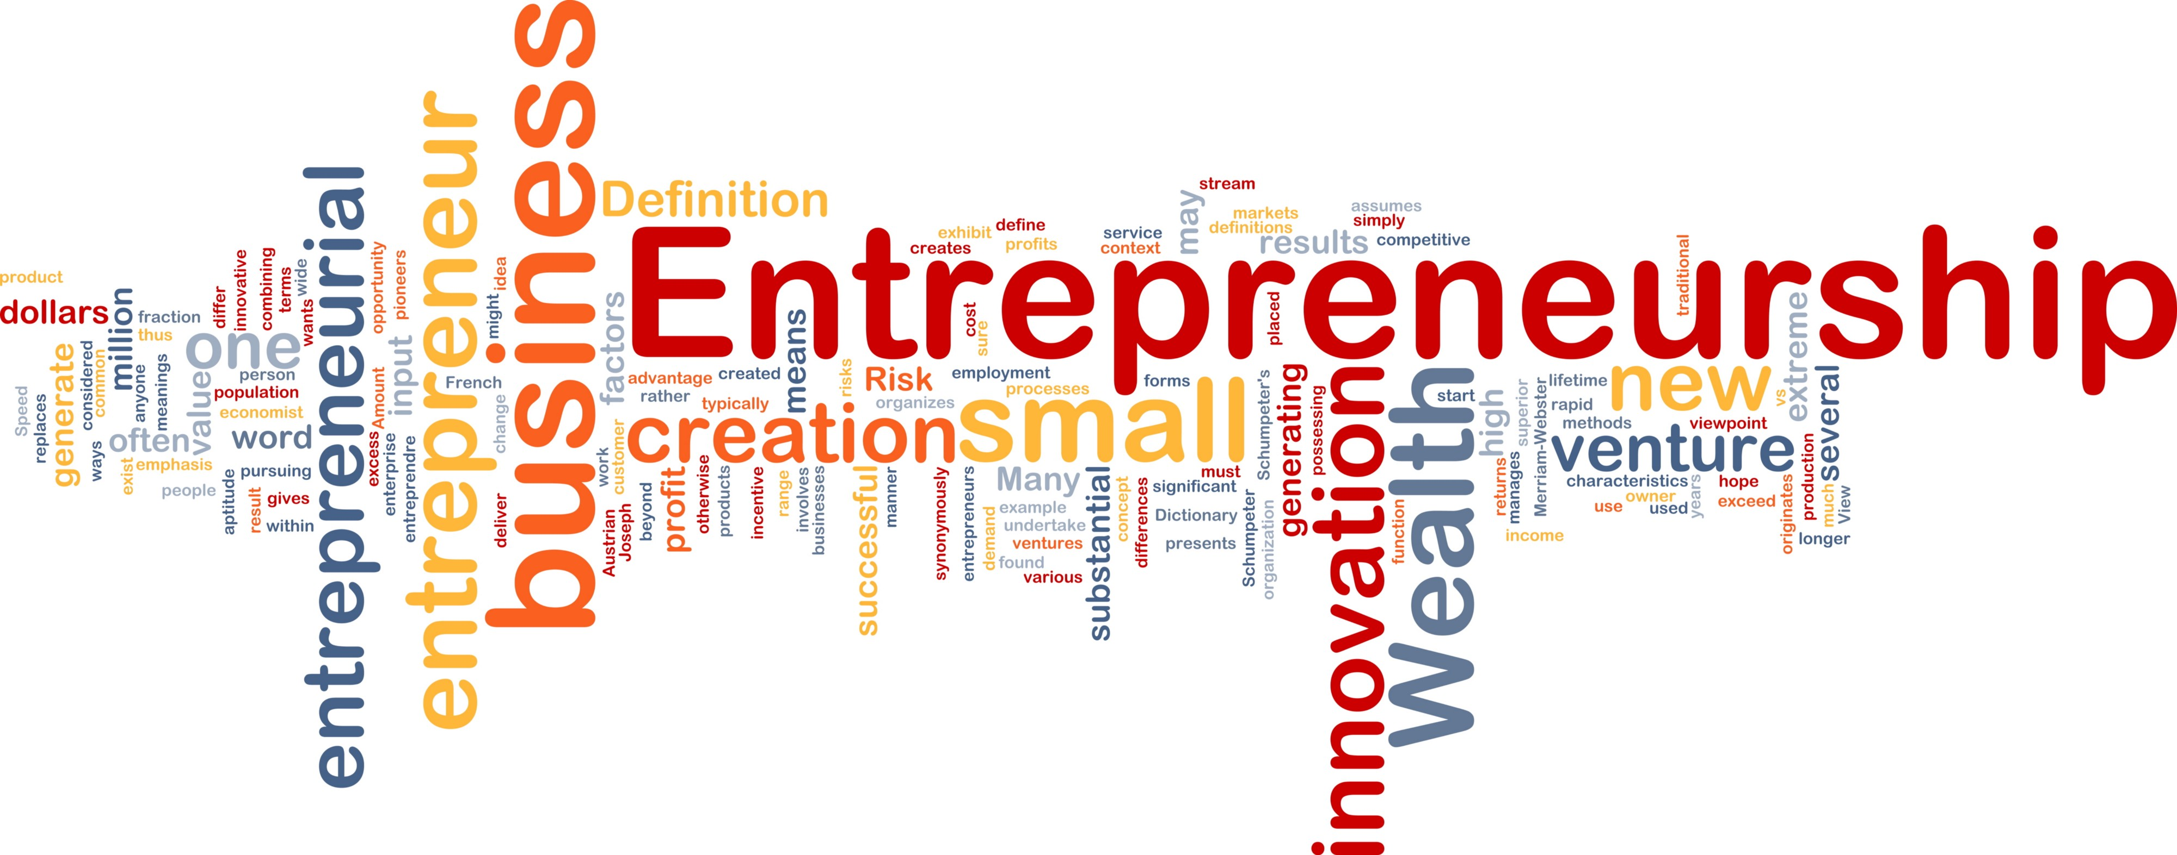
Hannah Kilburn

1805552

Tutor – Jessica Shore

Introduction
For this assignment a local or regional entrepreneur must be chosen and information on what motivates them should be found out through published interviews, news articles and factual information. The person that has a big welsh company and has also expended to other parts of the UK with this business is John Burns who owns the Burns nutritional pet food. Motivation is a key element that will be highlighted and reasons behind why John Burns started up his business will be outlined, and these reasons will be explained through published interviews and information that is set up on his own business website. John Burns has kept his business quite local but also sells his products to other parts of the country and UK on his website, which allows him to gain more customers as well as having his own café and shop which is based in Kidwelly.

What is entrepreneurship?
Being innovative | Creative | Passionate
Motivated | Confident | Determined
Optimistic | Takes risks | Persuasive
According to google the definition if an entrepreneur is “the activity of setting up a business or businesses, taking on financial risks in the hope of profit.” (GoogleDictionary, 2020) Entrepreneurs can be seen to set up a business for either profit, status or even just to feel the power or starting up a new venture and if they feel they are successful, they can build up a whole range of different businesses. A new modern definition of entrepreneurship is “about transforming the world by solving big problems. Like initiating social change, creating an innovative product or presenting a new life-changing solution.” (Oberlo, 2020) There are some key characteristics of an entrepreneur which can make them seem to stand out from others that may not have the entrepreneurial mind set, some of these include -
Entrepreneurs are people that feel they can take risks and they can also accept failure if one idea doesn’t work out but be able to also deal with the hard work, time and money it may take if they manage a successful business or businesses. Entrepreneurs are made to see rewards rather than risks which is why they can be so successful. (Patel, 2017)
Types of entrepreneur
There are different types of entrepreneurs which look at running their business differently to others and they want different things out of their own company. One type of entrepreneurship includes social entrepreneurship. “A social entrepreneur is a person who pursues novel applications that have the potential to solve community-based problems.” This definition relates to how a someone will want to change their business to be more social and work around the social issues and problems of how society is working today. (Hayes, 2019)
An ecopreneur is someone that thinks about the environment and makes sure their business idea thinks about being environmentally friendly and only benefiting the surroundings and to make it sustainable for future generations. Ecopreneurs want to do better for the world and make sure they have a small carbon footprint in whatever business they plan to set up. These entrepreneurs believe they are multi-tasking by helping the environment and also running a very successful sustainable business. (Steeple, 2013)
A traditional entrepreneur is someone who is more likely to want to run a business for power, profit and status rather than focussing on other elements such as the environment and social issues. An entrepreneur is someone that strives for success and wants to make a big profit from either selling their products or services to other people. This type of entrepreneur is related to passion and wanting to use their drive to be successful and have the confidence to jump into starting a new business that could easily go wrong. (Torre, 2015)

Why are entrepreneurs important?
Entrepreneurs are known as national assets to the world as they are providing for the economy and growing new fresh ideas for people, entrepreneurs are creative and challenge global issues that may be around, they are able to challenge the way the world works and change the way certain things work. Entrepreneurs create economic growth as mew products or services are being created for the public to use and this can further stimulate different business sectors to increase the economic development. Entrepreneurs are adding to the national wage and developing new technology which is bringing in a higher amount of profit which is helping the general economy and therefore new markets can be created and established. They are also creating social change which is a big factor in todays world as they create new and unique products or services which introduce an improved quality of life for some and an improved morale. (Seth, 2019)

John Burns – Pet food entrepreneur

As a local entrepreneur, John burns has excelled in what he does for his business and has provided for many people as his business has grown to become more regional as a result of great entrepreneurial skills. John Burns story started in 1993 where the vet set up his new business venture where he realised he needed to make a change in pets that need more nutritional food to keep them healthy, he specifically made it for cats, dogs and rabbits as those are some of the most popular pets in this area. Some of his food is specially made for animals with specific needs such as pets with allergies and intolerances. As the business has grown John burns has set up a Burns pet rescue scheme and has also set up his own charity which is the Burns Pet Nutrition Foundation and as the type of entrepreneur John Burns is, his main focus is not to gain a huge profit for himself, but to help others that may be in need and to help animals which is his main goal when beginning his own company. (Burns, 2020)

John Burns created pet food that he thought had the right ingredients and enough nutrition for the animal that could have specific dietary needs. As he was always working with animals he began to see that the pets coming in had the same issues such as itchy skin and poor digestion, so he believed that it was the food that created these issues, therefore he came up with a new product for animals which he felt would benefit them in the long run, his home-cooked own food would benefit the animals digestive system and the pets health in general. His food would also lead to the owners not having to attend the vets and spend out huge amounts on specific medicine when their pet has any certain allergies or intolerances. (Pearce, Petbusinessworld.co.uk, 2018)
John Burns wants to make sure that everything in his product is as nutritional and healthy as possible for any animal. This is why he has created 10 different varieties for every pet need, these include types such as sensitive pet food, weight control and free from food to ensure that every pet is catered for. The benefits to using his food include that they use ethically sourced produce to establish a higher quality food for the pets and some of the eggs and seasonal vegetables come from their own working farm which is cost effective for the company as a whole, the meat that they use is also usually sourced from Wales and the rice is typically brown organic rice. John burns is not entirely motivated by money as he chooses to help others and feel he has achieved a great amount by making pets and owners happy, but by helping and setting up charities to help the less fortune pets that are around, he gives out free nutritional information to people if they need it which is a great perk to purchasing his pet food brand. Today the company has got around 140 people employed in the three shops that are located in the UK, there is also a set team of nutritional advisors which help the company massively. (TheNewsFront, 2019)

What motivates John Burns
John burns has been motivated through his line of work through creating and developing a new product to benefit pets and also their owners by establishing a new form of healthy eating which will further lead to less trips to the vet. In the beginning, he got a few people which said he didn’t really have the chance to create such a successful new product, determination was key at this stage because if he had listened to the manufacturers that turned him down, he wouldn’t be as successful as he is today. John burns has given his own advice to new start up company’s that he believes will help people in the future. He says to start slow and make sure that the overheads are kept low, it is also easier to start the business locally and spend time working on the company before becoming regional, this form of working locally is always far less expensive and cost effective that sharing your idea to too many people. John Burns is motivated everyday to come to work knowing he built his own company from almost nothing but a box of food in the boot of his car, he isn’t just motivated through money, he has set out to help others and make life easier for people and to keep pets on a healthy diet which has also lead on to him starting up charities and motivating his own staff with different perks and benefits for them to feel motivated when attending work. (Burns J. , 2020)
Burns has two charities that he has put forward to the charity of the year award, which is another highlighting factor which would motivate anyone to work hard at what they do and create new ideas and elements that makes new customers want to try his products. The money that he owns goes to all his well paid staff and work on the charities that he has started up to help others that are in need. Burns is currently helping by sending his pet food to over 40 different rescue centres over the UK and also helping with any financial needs that those centres may need to care for and look after the animals in their care. (Pearce, 2020)
John Burns has also worked hard at making sure that his staff are motivated as well by giving them perks of working on the job. Some of the benefits that they can achieve include
- Owning a company car after 2 years of working with Burns
- 10% annual pension contribution
- A sickness bonus in the month of January
- Great opportunities to travel the UK and sometimes internationally to different events in the year
- On-site kennels to bring your dog to work if needed
- And 28 days of annual leave
These benefits are there to motivate the staff and to possibly create new ideas for the company. (BurnsPetFood, 2020)
John Burns – Sustainable future
As a now growing business it is important that the company stays sustainable and helping to reduce the carbon footprint. Burns makes sure that they are able to recycle as much as possible and over time aim to recycle a tonne of cardboard and plastic and they have been able to purchase their own compactor which helps them to recycle the plastic and cardboard in their warehouses. As a big way to help reduce their carbon footprint and help the environment, they have made all their packaging 100% recyclable, so customers are able to help as well. When thinking sustainably, it is key to ensure that it is benefitting future generations, Burns pet food uses their own produce as much as they can where possible which is reducing costs for them but also reducing things such as pollution so they don’t have to use different methods of transport to make the food in the warehouses. The shops have sheep wool insulation, solar panels to heat the water systems and a specific toilet flush which is water saving so nothing is wasted unnecessarily, this is a great way forward for the company and they have shown many ways of being a sustainable company. The staff that work at Burns are encouraged to car share when coming to work to avoid any unnecessary pollution from travelling to work and once the staff members are eligible for a company car, it will more than likely be a hybrid car to help with fuel emissions. (McGuire, 2020)
Conclusion
Overall, becoming an entrepreneur takes determination and a gap in the market to start off in the right direction to become successful. There are different highlighted factors that are shown when becoming an entrepreneur, some of these factors include being generally motivated, having good communication skill and being able to lead other people. John Burns has shown the certain characteristics when becoming an entrepreneur as he has shown how he is motivated and how determination got him to where he is today, he believes in helping others and ensuring that other people and pets have a better quality of life when choosing his products. Also, he makes sure that sustainability is key as tries to benefit the environment and the future generation as well. Burns has been very successful in starting up his own business and providing a product that he feels helps other people and encourages pets to eat healthier and better if they have certain allergies or intolerances, he has the key characteristics of an entrepreneur and used them to his advantage.

References
Burns. (2020, February). Retrieved from Burns.co.uk: https://burnspet.co.uk/our-story-2/
Burns, J. (2020, February ). Retrieved from Burnspet.co.uk: https://burnspet.co.uk/blog/john-shares-career-highlights-predictions-for-future-of-pet-food/
BurnsPetFood. (2020, February). Retrieved from Burnspet.co.uk: https://burnspet.co.uk/working-for-burns/
GoogleDictionary. (2020, February). Retrieved from Google.com: https://www.google.com/search?safe=active&source=hp&ei=qP9gXquUH821sAf6tJHIDw&q=what+is+entrepreneurship&oq=what+is+entre&gs_l=psy-ab.1.0.0i131i70i249j0l9.1393.3731..6058...0.0..0.97.887.14......0....1..gws-wiz.....6..0i362i308i154i357j0i131.fDzD6s8DvEY&s
Hayes, A. (2019, August). Retrieved from Investopedia.com: https://www.investopedia.com/terms/s/social-entrepreneur.asp
McGuire, L. (2020, January). Retrieved from Realbusiness.co.uk: https://realbusiness.co.uk/sustainable-business/
Oberlo. (2020, January). Retrieved from Oberlo.co.uk: https://www.oberlo.co.uk/blog/what-is-entrepreneurship
Patel, S. (2017, September). Retrieved from Inc.com: https://www.inc.com/sujan-patel/10-essential-characteristics-of-highly-successful-.html
Pearce, S. (2018, Sewptember). Retrieved from Petbusinessworld.co.uk: https://www.petbusinessworld.co.uk/news/feed/industry-profile--burns-pet-nutrition
Pearce, S. (2020, January). Retrieved from Petbusinessworld.co.uk: https://www.petbusinessworld.co.uk/news/feed/burns-reveals-its-two-charities-for-2020
Seth. (2019, July). Retrieved from Investopedia.com: https://www.investopedia.com/articles/personal-finance/101414/why-entrepreneurs-are-important-economy.asp
Steeple, D. (2013, August). Retrieved from Medium.com: https://medium.com/@alliancedstudio/what-is-an-ecopreneur-cecf6431536
TheNewsFront. (2019, September). Retrieved from Thenewsfront.com: https://thenewsfront.com/burns-pet-nutrition-offers-natural-pet-food-to-manage-common-health-problems-in-cats-dogs-and-rabbits/
Torre, J. (2015, April). Retrieved from Entrepreneur.com: https://www.entrepreneur.com/article/245628

