about us
Welcome to our Hotel Trinity 4* We are pleasured to inform that now we have also a restaurant and you can enjoy your stay in our hotel and having lunch here with beautiful view to south Wales coast. This hotel was built for our customers, and we are more likely to do everything that you can feel during your stay like a home. This building was built 100 years ago but we are involving new ideas very day and, we are keeping a bit of our history here to our lovely customers. We are ready to serve every single customer with pleasure and if you have any allergy, please feel free to let us know and we will take care of you and your family. We have and take away delivery for people who just want to join our food from their home. You easily can find us on Uber Eat and Just Eat. And do not forget about safety our delivery is keeping a distance and we are leaving food in front of your door so like that we keep you safe. We are more welcome for everyone. We are happy that you choose us.

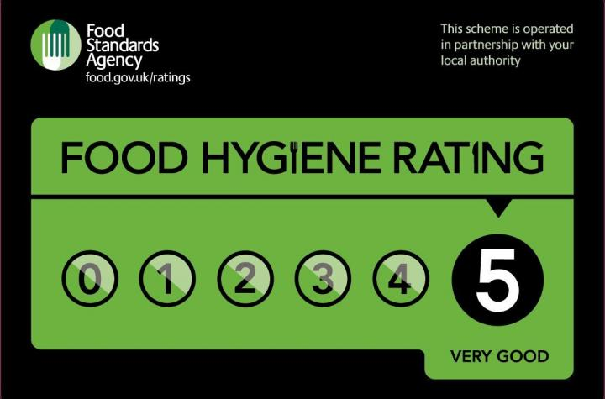

Hotel trinity 4* SWANSEA, south wales

Morris Walk
Swansea,Sa32hp
07766554433
www.trinityhotel.com
working time Daily 12PM-23pm

 |   Appetizers  Brusshetta All italiana  (Grilled bread, tomatoes, basil, garlic&extra virgin olive oil) -10  Baked Artichoke Hearts  (artichoke hearts in garlic butter with mozzarella)- 11.50  SALAD  Cezar salad  (iceberg , tomato cherry, parmegano,grilled chicken , cezar dressing ) -15  Mushrooms Salad  (cheese, mushrooms, chicken file onion, Maio) -13 |  |  |  |  | sef specials
Grilled Steak prepared in vine with rice or chips 25

Cripsy duck in port cherry sauce 30

Grilled salmon prepared in white wine served with broccoli 27

Tenderloin of beef wellington with spinach 17

Deserts

Ice cream assorted flavors 10

Waffle with any chosen topic 14

Cheesecake classic 8

 |  |  | Steak prepared on grill and preparation must be requested before, also you can choose with what you like to be served. And is perfectly combined with Sauvignon blank wine. | Roasted turnips, parsnips, rutabaga and carrots with cornmeal, johnnycake wrapped duck confit, Bok choy. Perfectly combined with Merlot red wine
 |  |  | Grilled salmon prepared on grill after with broccoli and olive oil, basil, and white wine cooked in oven. Completed with Chardonnay. | Foie gras, spinach, duxelles. Added with red wine.
 |  |  | For dessert s and ice cream please feel free to ask any of our waiter about flavors and what kind of topic you can serve your dessert. | Also, for any allergy enquiries please also inform our staff. And we will take care of rest.  Please avoid anu cash payments due pandemic we must keep everyone safe do card payment is available only. Thank you

