LEADERSHIP AND MANAGEMENT THEORY AND PRACTICE LCBB6003
Assignment 1
Valentin Daniel Susanu 2019937

Table of Contents
Introduction 3
Brief information about the chosen organisation 3
Reviewing different leadership and management theories and models 4
Application of these theories and models and analysis of their impact on Cafepod 6
Analysing my experience of leadership 7
Conclusion 10
References 11
Appendix 1: Leadership development plan 13

Introduction
In the contemporary era of business, leadership and people management is an important aspect so that the management of the organisation can be able to influence the performance of the employees in a manner that can lead the company to achieve its organisational goals. Leadership is considered to be an essential factor which helps to collect human endeavour from identifying and establishing goals to achieve a common objective (Keohane, 2010). In this study, the discussion is based on different aspects of leadership including theories and styles along with the leadership that is used in Cafepod. In addition to that, the discussion also includes my own experience in the area of leadership while being engaged in an internship programme within the mentioned company. In the final part, an action plan is developed to enhance the leadership skill that can help the individual to excel in the future career as a leader in a proper manner.

Brief information about the chosen organisation
Cafepod Coffee Co. is considered as one of the small and medium-sized business organisations in the UK. This organisation is operating under the cafe and restaurant industry of the UK which is mainly concerned with providing high-quality coffee to consumers so that the consumer can gain a great experience. The vision of this particular industry is altering the quality and standard of coffee so that the overall experience of the consumers can be improved in this particular area (Cafepod, 2023). In addition to that, the mentioned company is also concerned with the maintenance of the quality along with the taste in their products. The company is being focused on the process of blending and roasting coffee in a proper manner.
The product range of the company includes different products such as craft coffee of different flavours. Apart from that, different types of coffee are seen within the product range of the company such as Daily Grind, Brunch Blend, Supercharged Espresso in which the consumers can choose their preferred types of coffee for their everyday use (Cafepod, 2023). In addition to that, different flavours of coffee that are being provided by the company to their consumers are mentioned as caramel, vanilla, chocolate, hazelnut, black velvet and so on. The revenue of the mentioned company in the current time is mentioned as 7.1 Million Dollars so that the company can be able to maintain their sustainability in the market (Gov, 2023). In this organisation, I have got the chance to work as an intern in which I have been exposed to different leaders of the company. In this scenario, I have observed different styles of leadership for managing these people within the organisation.

Reviewing different leadership and management theories and models
It is essential to evaluate the leadership contexts of an organisation under relevant theoretical concepts to provide a comprehensive and insightful outcome. For that reason, different classical and modern leadership theories and models can be incorporated into this study. The first and most important theory is the classical Trait theory of leadership that describes leaders cannot be made, rather leaders are born and specific qualities or interpersonal traits distinguish their leaders from nonleaders (Uslu, 2019).
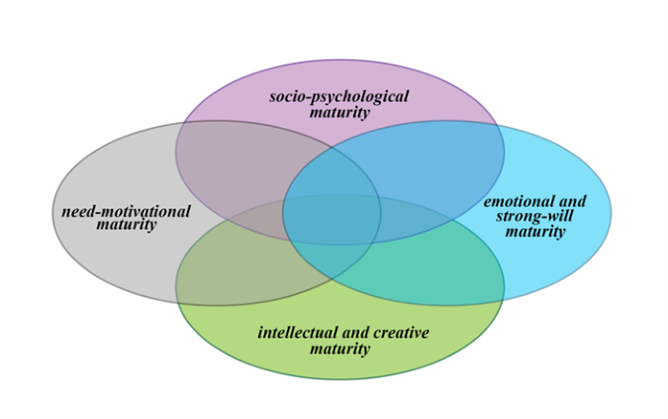
Figure 1: Fundamental traits of leaders
(Source: Karabuschenko and Petrovskaya, 2020)
Accordingly, leaders are born with specific traits of leading and influencing others. Therefore, it is essential for a leader to have certain leadership qualities such as critical thinking, effective decision-making, insightful vision, influencing others, attractive characteristics, and effective communication skills and others (Uslu, 2019). However, it has also been argued that certain skills might be developed by an individual over time through real-life experiences and active practice of leadership skills.
In this regard, the modern form of traits theory might be mentioned which is known as Greatman's theory of leadership (Uslu, 2019). Additionally, situational leadership theory is another effective concept that facilitates the behavioural attributes of a leader in which leaders generally adapt different leadership styles based on each unique situation or task requirement to meet the requirements of the business goals of the teams. Based on different situations leaders adopt specific styles of people management to influence and motivate the team members such as delegating, supporting, coaching and directing (Vilela et al., 2020). Different behaviours of situational leaders either fall under the supportive or directive approach of leading teams which is required to be followed in different consequences.
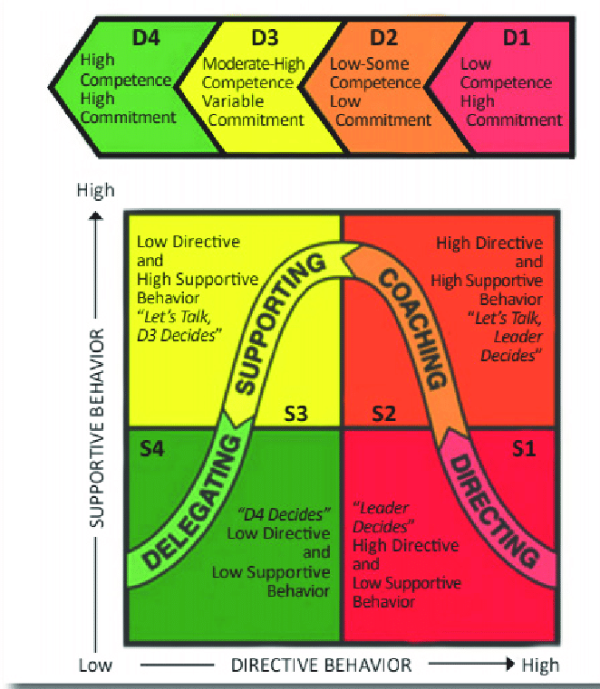
Figure 2: Different leadership approaches in situational leadership
(Source: Vilela et al., 2020)
Apart from that, the transformational leadership model is considered to be the most effective and has a strong foundation for different leadership practices. For instance, transformational leadership is more likely to motivate the employees and either internal stakeholders with an intention to transform the organisational elements in a favourable manner that can support organisation requirements in terms of performance and productivity. As per the views of Asbari (2020), transformational leadership positively incorporates innovation as well as individual member learning along with encouraging team building and providing continuous motivation to develop a productive work atmosphere.

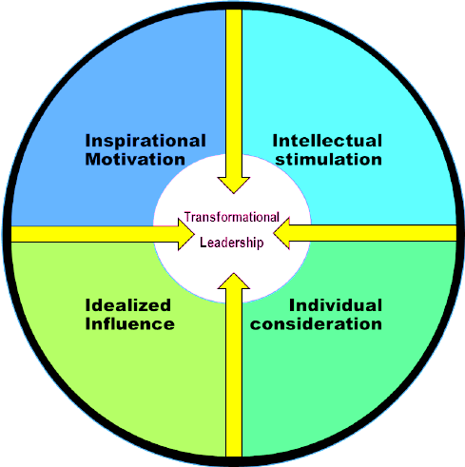
Figure 3: The transformational leadership model
(Source: Susilo, 2018)

Application of these theories and models and analysis of their impact on CafePod
With the reviewing of leadership and management theories and models, it only creates and builds importance if it is applied in an effective manner in the organisation. However, the application of the theories can differ from each other and similarly can create different sorts of impacts from each other. The theories that will be applied in Cafepod are trait theory, situational theory and transformational theory.
Application of Trait theory and its impact
The theory can be effectively devoted to the leaders in the Cafepod by provoking and conducting personality tests. Personality Tests can assist the organisation in assessing the type and nature of personality an individual holds and accordingly function in future times. The theory can be applied with parallel sorts of questionnaires to accumulate insight into contemporary capacities with respect to specific traits that are considered consequential for leadership (Technofunc, 2022). The consequence of the application would be highly favourable and positive as it would help the company elect and appoint appropriate leaders based on the traits they possess.
Application of Situational theory and its impact
As the situational theory is well comprehended and repeatedly utilised for training leaders within an organisation, the application would be based upon a particular circumstance or situation. In the Cafepod, the theory can be used by the leaders by furnishing them with adequate training and coaching determining the situation and type of training required (Technofunc, 2022). The impact of training the leaders would result in the satisfactory function of leadership being performed by leaders and handling the situation.
Application of Transformational theory and its impact
As said by Hein (2013), transformational leadership theory is believed to be the only kind of management but it has an elevated possibility to delegate the workforce to do more for the business unit. The leaders at the Cafepod can utilise and apply the theory by propelling the team out of their consolation zone. That signifies that the leaders in the Cafepod can propel the members and employees to work in the area beyond their expertise and comfort. This can result in the building and development of new skills within them and can lead to the success of the organisation as a whole. By encouraging employees and coworkers to step out of their comfort zones can make them experience reinvigorated and unexplored things as well which can create a significant impact on them by producing inner motivation.

Analysing my experience of leadership
I have conducted a group project to understand the different aspects of leadership in Cafepod to identify the role and responsibilities of a leader to motivate and guide their teammates to enhance their productivity and develop a culture of positive and friendly working environment for helping the organisation to achieve their desired objectives. This leadership experience has taught me many valuable capabilities that help me to enhance my own leadership style and improve my employability opportunity in future. My overall experience is high-yielding and fruitful. I have obtained a lot of new things that assist me in getting in-depth knowledge about different skills and capabilities which are essential for becoming a good leader. I was a little confused and nervous in my initial days as I experienced several difficulties in understanding the best leadership style for enhancing the performance of an organisation and motivating team members to increase their engagement in the workplace. My co-workers have assisted me a lot in overcoming this bad phase and provided appropriate guidance to improve my research skills. It has aided in identifying the best qualities of a leader and recognises the capabilities which helped to enhance organisational performance.
I have understood that a transformational leadership style is the most suitable approach for motivating employees and developing a culture of innovation, creativity and employee engagement in the workplace (Virgiawan et al., 2021). I have identified that transformational leaders are risk-takers and always try to motivate their team members to enhance their participation in the workplace. It can help leaders to incorporate unique ideas into their decision-making process and solve critical issues in an easier manner. I have identified some qualities that I have which help me to become a transformational leader in future. I have a good team working ability that assists me in maintaining a clear line of communication among my teammates and can explain their roles and responsibilities in a well-organised manner. Additionally, I have a good creativity ability that helps me to take risks and chalk out new and unique ideas for enhancing the business performance of my future workplace. Moreover, during this leadership assignment, I have understood the importance of emotional intelligence in leadership quality for identifying the physical and mental issues of teammates and incorporating effective approaches to overcoming them in order to boost their morale and confidence. On the other hand, I have identified some difficulties in time management, communication and critical thinking which I need to develop with a proper leadership development plan.
Action plan
Objectives | Task | Resources | Time frame
To improve my time management skill | At the beginning of the task, I will develop a priority task list. Using this I will be able to prioritise the task that I need to do first as it would need urgent attention.  Along with this, I will take online courses and give tests about what I learned to assess how much I have improved.  Moreover, I will also watch videos and read books on how to improve time management. | Internet connection, digital device, tasks, online courses and books. | 6-9 months
To improve my communication skill | To improve my communication skills I will look at how the leader within the organisation is communicating with its employees. Along with this, I will focus on listening to other experts and reading books about effective ways of communicating.  Moreover, I will practice communication by communicating with my friends and colleagues about office work or others. | Job, internet connection, books, leaders and experts. | 3-9 months
To improve my critical thinking skill | To improve my critical thinking skills I will participate in a team-building exercise where I will practice active listening.  Alongside this, I will develop my technical skills through online courses using which I will be able to identify the problems more easily.  Moreover, I will learn about self-awareness with this I will be able to evaluate the existing evidence that has been provided and critically solve it.  I will also read books and watch the leaders within the workplace to learn how they critically think in a situation and try to implement them myself. | Work, internet, team building exercises, online courses and leaders. | 9-12 months
Table 1: Action plan
(Source: Created by the learner)

Conclusion
From the above study, it can be concluded that Cafepod is one of the companies that is based in the UK. For the analysis of different leadership and management theories Trait theory of leadership, situational leadership theory and Greatman's theory of leadership are considered. Following these theories, the leadership can build and develop new skills which overall leads to the success of the individual as well as the organisation. Reflecting on the experiences that I had as an intern at Cafepod, I have been able to find that I am good at decision-making and problem-solving. However, I have also identified my weaknesses are time management, critical thinking and communication skills.

References
Asbari, M., 2020. Is transformational leadership suitable for future organizational needs?. International Journal of Social, Policy and Law, 1(1), pp.51-55.
Cafepod.com, 2023, ALL PRODUCTS [online], Available at: https://www.cafepod.com/collections/all (Accessed on: 23 August, 2023)
Cafepod.com, 2023, HELPING PEOPLE MAKE GREAT COFFEE AT HOME [online], Available at: https://www.cafepod.com/pages/our-story (Accessed on: 23 August, 2023)
Gov.uk, 2023, CAFEPOD LIMITED overview - Companies House [online], Available at: https://find-and-update.company-information.service.gov.uk/company/07562551 (Accessed on: 23 August, 2023)
Hein, R. 2013. How to Apply Transformational Leadership at Your Company? Available at: <https://www.cio.com/article/288976/careers-staffing-how-to-apply-transformational-leadership-at-your-company.html> [Accessed on August 25 2023]
Karabuschenko, N.B. and Petrovskaya, M.V., 2020, February. Psychological Characteristics of Leadership as a Component of the Elitism of Personality. In 1st International Conference on Emerging Trends and Challenges in the Management Theory and Practice (ETCMTP 2019) (pp. 121-124). Atlantis Press.
Keohane, N.O., 2010. Thinking about leadership. Princeton University Press.
Susilo, D., 2018. Transformational leadership: a style of motivating employees. MEC-J (Management and Economics Journal), 2(2), pp.109-116.
Technofunc. 2022. Situational Leadership - Application. Available at: <https://www.technofunc.com/index.php/leadership-skills-2/leadership-theories/item/practical-application-of-situational-leadership-theory#:~:text=Practical%20Applications%20of%20the%20Situational,to%20solve%20common%20workplace%20conflicts.> [Accessed on August 25 2023]
Technofunc. 2022. Trait Theories - Application. Available at: <https://www.technofunc.com/index.php/leadership-skills-2/leadership-theories/item/practical-application-of-trait-theories-of-leadership#:~:text=Use%20personality%20tests%20and%20other,weaknesses%20with%20regard%20to%20leadership.> [Accessed on August 23 2023].
Uslu, O., 2019. A general overview to leadership theories from a critical perspective. Маркетинг і менеджмент інновацій, (1), pp.161-172.
Vilela, V.S., Santos, W. and de Mello Cordeiro, J.V.B., 2020. LEVELS OF CONSCIOUSNESS AND THEIR IMPACT ON THE EFFECTIVENESS OF DIFFERENT LEADERSHIP STYLES AND ORGANIZATIONAL ARRANGEMENTS ON INNOVATION PROCESSES. Caderno PAIC, 21(1), pp.189-220.
Virgiawan, A.R., Riyanto, S. and Endri, E., 2021. Organizational culture as a mediator motivation and transformational leadership on employee performance. Academic Journal of Interdisciplinary Studies, 10(3), pp.67-79.

Appendix 1: Leadership development plan
Objectives of leadership development | The development of the activities that are important for achieving the objectives | The place where I can develop my skill to reach the particular objective | Target date of achievement
To enhance my skill in the area of emotional intelligence | I will try to observe different physical and bodily characteristics of the people to identify the cue in their behaviour. In this manner, I can be able to understand different personal characteristics and requirements of them. Therefore this can help me to manage the employees according to their attitude and needs. | At the workplace and by consulting a psychologist and other behavioural experts. | 25.8.2023-22.2.2024
To enhance my level of patience | In order to achieve this particular objective, I will try to minimise my level of anxiety. Additionally, I also have the habit of being overwhelmed while facing any kind of new situation and any kind of negative situation. In this regard, I will try to face the situation in a calm way and will also try to devise the strategies to mitigate the problems in a proper manner. | This skill will be developed in my future workplace. In addition to that, in terms of minimising the anxiety level, I will consult a psychologist to learn the process of handling a stressful situation in an effective way. In this manner, I can be able to develop my patience level while managing the people of an organisation. | 30.8.2023-30.3.2024
To enhance my skill of maintaining and increasing the level of motivation with the employees | In this regard, I will try to learn different aspects of reward management and different factors of personality that are directly or indirectly associated with motivation for work within the employees of a company. In addition to that, I will also try to learn about several factors behind maintaining the level of motivation among the employees according to their requirements. On the other hand, I will also try to arrange rewards such as increased salaries, giving promotions, and providing paid holidays on the basis of the standard of performance of the employees in the organisation. This can be resulted in increased ability within me of keeping a high level of motivation within the employees. | In a learning session and in my future workplace. | 1.9.2023-1.12.2023

