Paintings by Constantin Guys
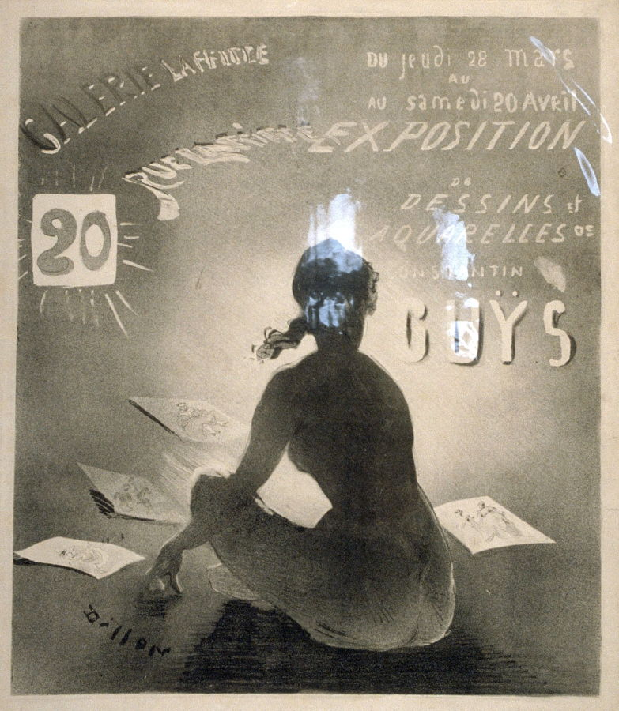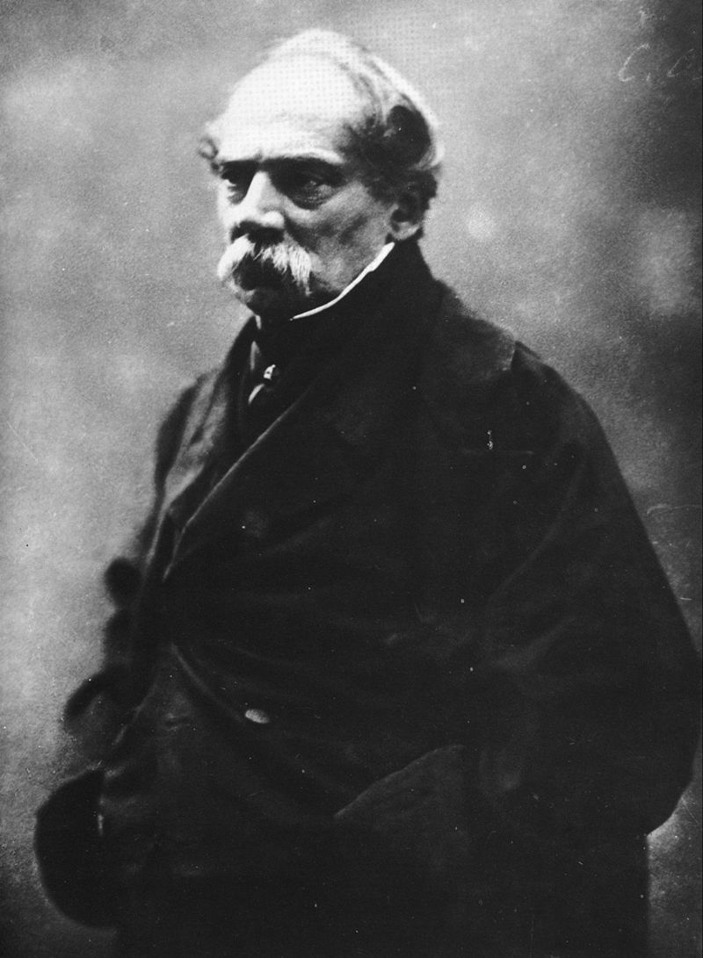
Poster for Exhibition of Drawings and Watercolours by Constantin Guys (1820–1910), c. 1985; Guys photographed by Félix Nadar

On Guys, see: Joanna Richardson, ‘The Painter of Modern Times: Constantin Guys,’ History Today (Vol. 24, No. 1, November 1974), pp. 789–793.

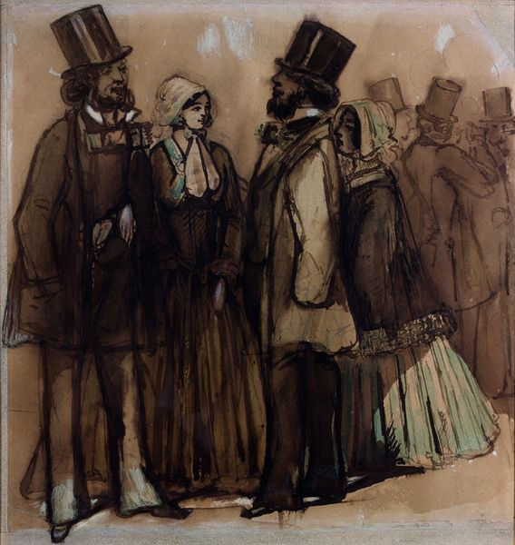Meeting on the Promenade, 1889

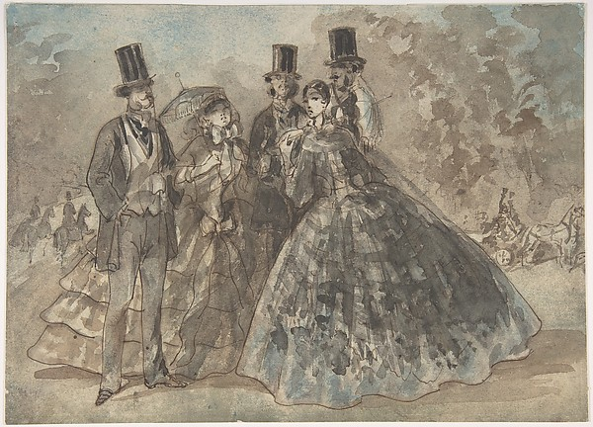
Meeting in the Park
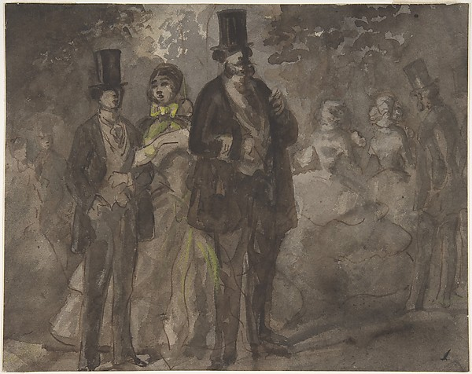
Walking in the Park
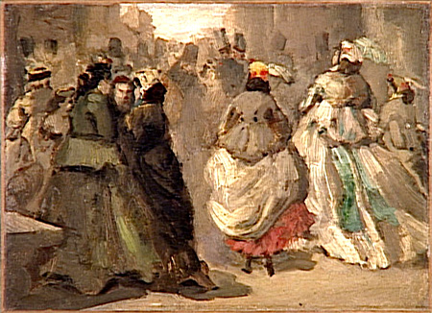
In the Street
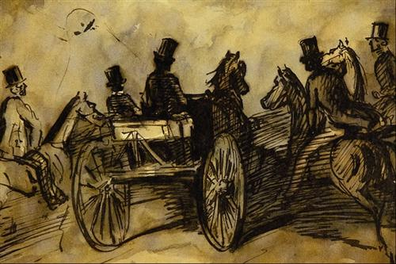
Carriage and Three Gentlemen on Horses
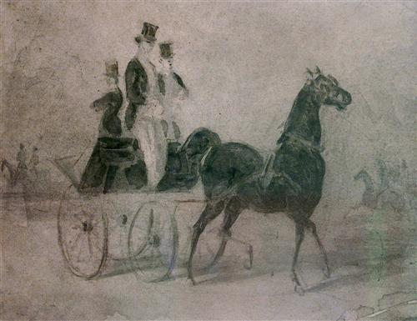
Dandies in the Park

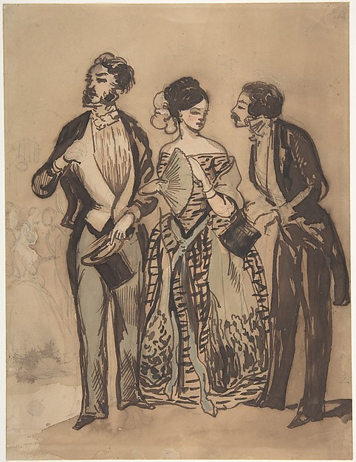
Two Gentlemen and a Lady
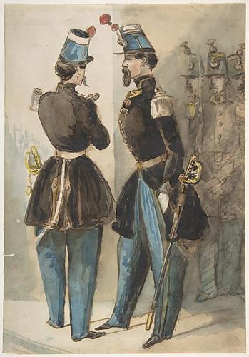
Officers of the Guard

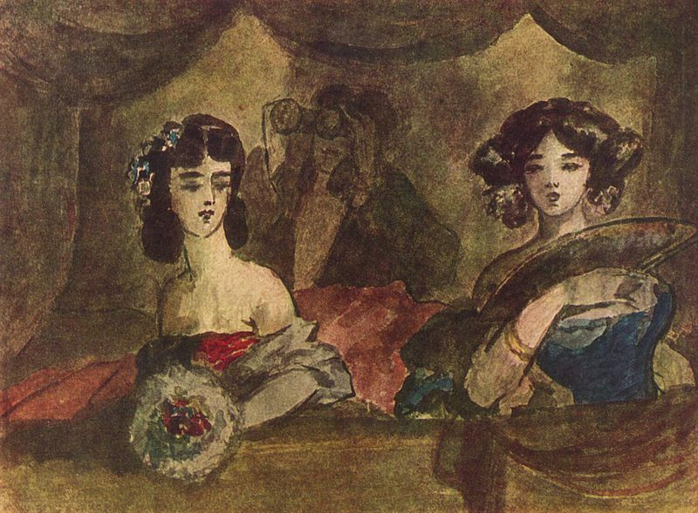The Loge [box] at the Opera

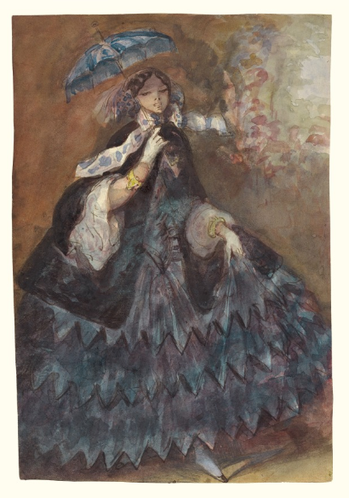
Woman with a Parasol, c.1860–1865
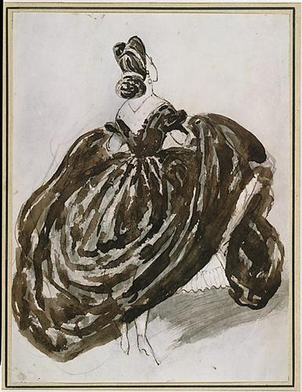
Parisienne Seen from the Back, 1855

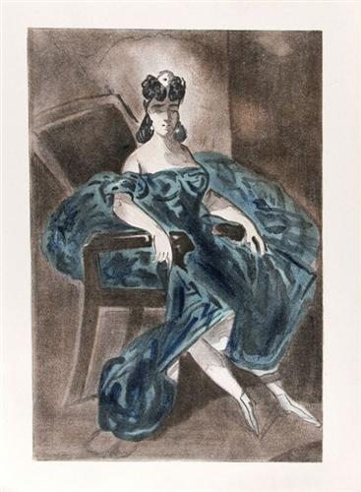
Portrait #2, 1865
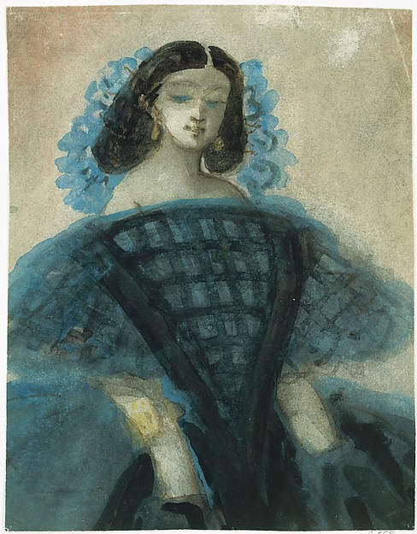
Young Woman in a Blue and Black Dress, c. 1863
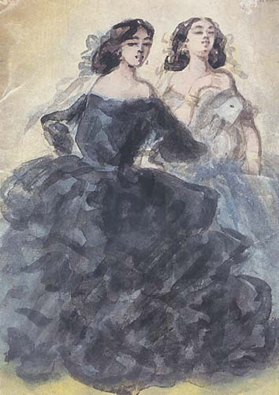
Demi-mondaines [demimondes], 1860

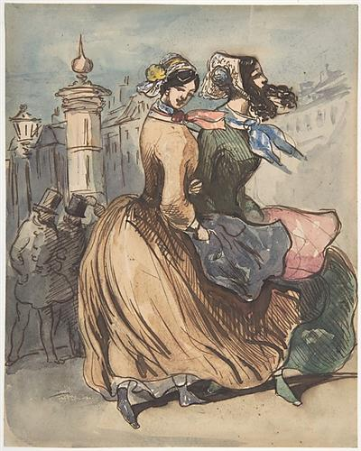
Two Grisettes
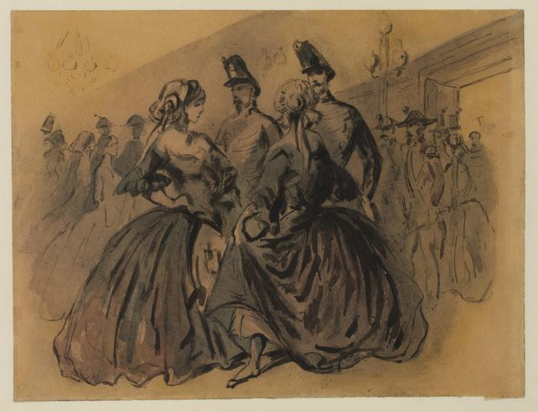
Two Grisettes with Two Soldiers, c. 1860
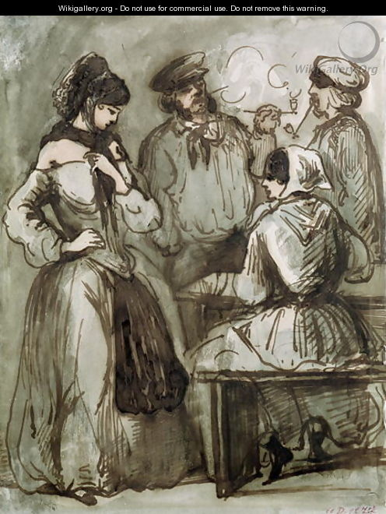
Grisettes and Workers

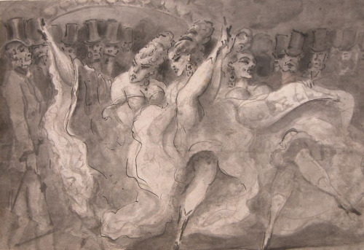
Cabaret Dancers
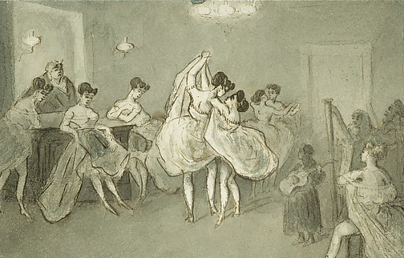
Women Dancing in a Brothel, c. 1865

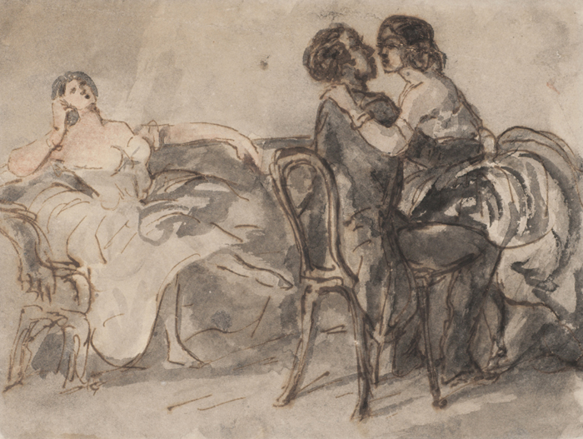
The House of Ill Repute, after 1860
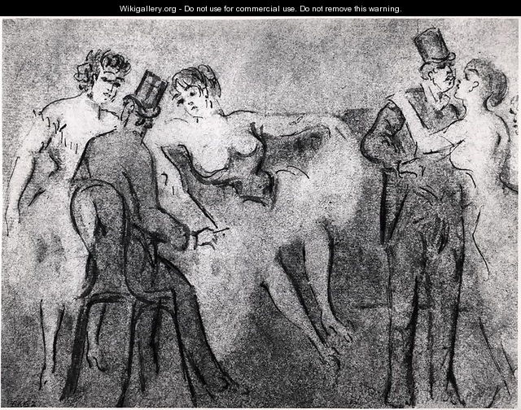
At the Brothel

Demi-monde refers to a group of people who live hedonistic lifestyles, usually in a flagrant and conspicuous manner. The term was commonly used in Europe from the late 19th to the early 20th century, and contemporary use has an anachronistic character. Its connotations of pleasure-seeking often contrasted with wealth and ruling class behavior. The term was often used as one of disapprobation, the behavior of a person in the demimonde being contrary to more traditional or bourgeois values. Such behaviors often included drinking or drug use, gambling, high spending (particularly in pursuit of fashion, as through clothing as well as servants and houses), and sexual promiscuity. The term demimondaine referred to a woman who embodied these qualities; later it became a euphemism for a courtesan or prostitute. The term 'demi-monde' is French for "half-world". It derives from a comedy by Alexandre Dumas fils published in 1855 called Le Demi-Monde.
The word grisette (sometimes spelled grizette) has referred to a French working-class woman from the late 17th century and remained in common use through the Belle Époque era

