

Environmental Protection and Sustainable
Manufacturing Systems

Investigative report

Lewis Murray

2015857

Abstract
The purpose of this report is to investigate the pre-heating methods used at Valero's Pembroke refinery on the crude distillation unit. The report will also analyse and report on methods used in order to reduce energy losses within the process before looking at improvements in which could be made in order to increase efficiency as well as energy recovery and how local and global regulations and standards can be met. Improvements could be made by installing a further two heat exchangers as this would assist with the reduction of greenhouse gasses by at least 80% by 2050. Finally, the report will also analyse how Pembroke refinery monitors and treats any wastewater through their wastewater treatment plant.
Table of Contents

Introduction 1
Pembroke refinery 1
Crude distillation unit 1
What is crude oil? 2
Fractional distillation 2
Aims and objectives 3
Pre-heating crude oil 4
Tube and shell heat exchangers 5
Fired heaters 5
Overhead product system 6
Improvements to the overhead product system 7
Disadvantages to the possible improvements on the overhead product system 8
Conclusion 9
Waste water treatment plant 10
Conclusion 11
References 12

Figure 1 - Pembroke refinery (Valero, 2021) 1
Figure 2 - Atomic structure of crude oil (Bitesize, 2021b) 2
Figure 3 - Basis of a crude distillation column (Stone, 2018) 3
Figure 4 - Crude distillation unit overview (Valero Intranet, 2021, Used with permission) 4
Figure 5 - Shell and tube heat exchanger (Industry Insights, 2021) 5
Figure 6 - Basics of a fired heater (Lenox, 2021) 5
Figure 7 - CDU overhead's system (Valero Intranet, 2021, Used with permission) 6
Figure 8 - Forced draft fin fan (Valero BOT, 2021) 6
Figure 9 - Possible improvements to the overhead system (Valero Intranet, 2021, Used with permission) 7

Introduction

Pembroke refinery
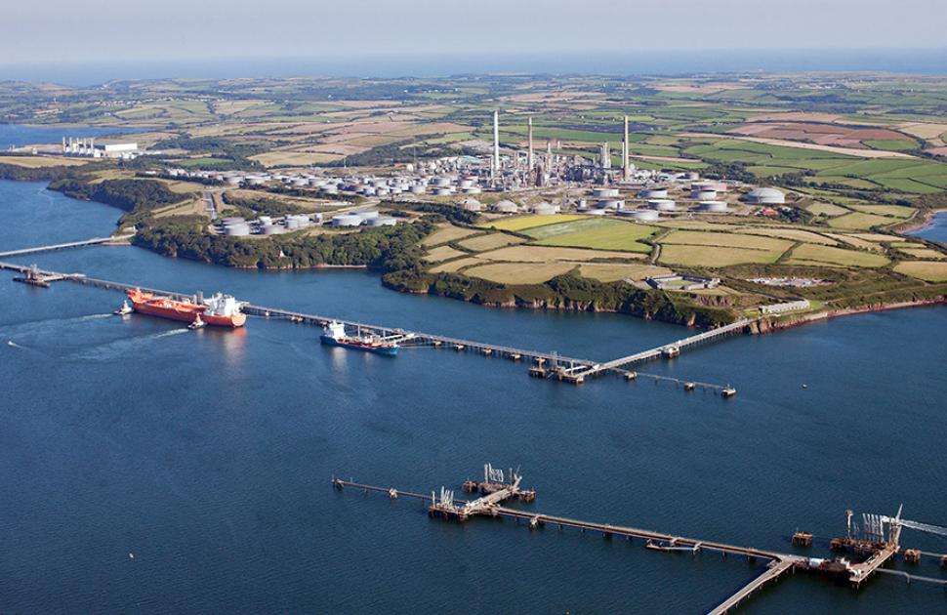
Pembroke refinery was opened in 1964 and is one of the largest, most complex petroleum refineries in Western Europe (Valero, 2021). The refinery is located on the Milford Haven Waterway and covers a 1,275 acre site. Valero bought Pembroke refinery in 2011 in order to enter the European refining market (Valero, 2021). Pembroke refinery has a total throughput capacity of 270,000 barrels per day with approximately 10.5 million barrels of storage and makes up for 15% of Welsh exports per year (Valero, 2020). Pembroke refinery refines mainly sweet crude oils producing gasoline, diesel, jet fuel, heating oil and low-sulfur fuel oil (Valero, 2021).

Figure 1 - Pembroke refinery (Valero, 2021)

Crude distillation unit
In order to refine crude oil at Pembroke refinery, fractional distillation is used. This method is used in order to split the crude oil into different components as the hydrocarbon mixtures all have different boiling points (Bitesize, 2021a). When using the fractional distillation method in order to split crude oil, it must be largely vaporised at a temperature of around 350ºC before reaching the fractional distillation column (Pearson Longman, 2008).

What is crude oil?
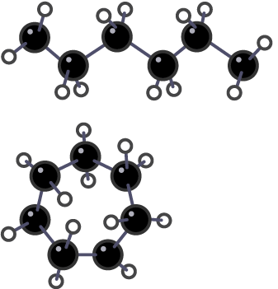
Crude oil is a non-renewable, naturally created, unrefined petroleum product made up of hydrocarbon deposits and other organic materials which we can refine in order to produce products such as gasoline and diesel (Chen, 2021). Crude oil is also known as petroleum, petroleum is made up of both unrefined crude oil as well as refined petroleum products (Howden, 2021). Crude oil is the remains of organisms that lived and died millions of years ago, mainly plankton which was then buried in mud. It is a complex mixture of hydrocarbons with the carbon atoms joined together in either chains or rings. Figure 2 shows the atomic structure of crude oil in either a chain or ring, carbon atoms are black and hydrogen atoms are white (Bitesize, 2021b).

Figure 2 - Atomic structure of crude oil (Bitesize, 2021b)

Fractional distillation
Fractional distillation makes uses of many trays stacked on top of each other within one column. From these trays, there are then side draws at which the product is taken from at the desired boiling point. Within a fractional distillation column, the hottest temperatures are found at the bottom and the coolest at the top, this is because the less dense components of crude oil are cooler and rise while the heavier, denser components are hotter and fall down the column (Stone, 2018).

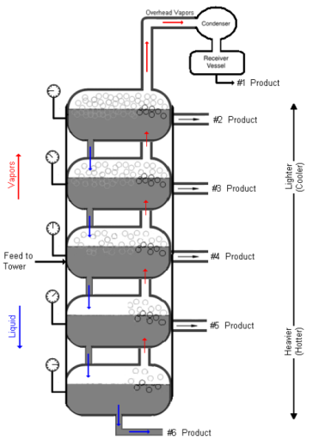
Figure 3 shows the basics of a fractional distillation column which is utilised on a crude unit. At Valero's Pembroke refinery, the crude column has the tag ID 1-C-1 and is made up of 47 horizontal trays. From the products which are separated out of crude oil, the bottom product is atmospheric residue. The next side draw within 1-C-1 is heavy diesel, followed by light diesel and then kerosene. The overhead product within column 1-C-1 is naphtha (Stone, 2018).
Figure 3 - Basis of a crude distillation column (Stone, 2018)

Aims and objectives
The aim of this paper is to explore the infrastructure of Pembroke refinery and the equipment used on site. Consideration will be given about the equipment and how energy can be saved. Subsequently, the treatment of waste water from the plant will be analysed.

The next chapter will explore the current techniques in which Pembroke refinery pre-heats the crude oil in order to perform fractional distillation including use of differing types of heat exchangers. Improvements will be recommended based on the conducted analysis of heat exchangers in order to improve the efficiency of the plant. Finally, a conclusion will be made about the current processes utilised and the potential new equipment made in recommendations.

Additionally, task 2 will look at the techniques used in order to treat the waste water produced by the plant so that it meets the standards set by National Resources Wales are withheld.

Pre-heating crude oil
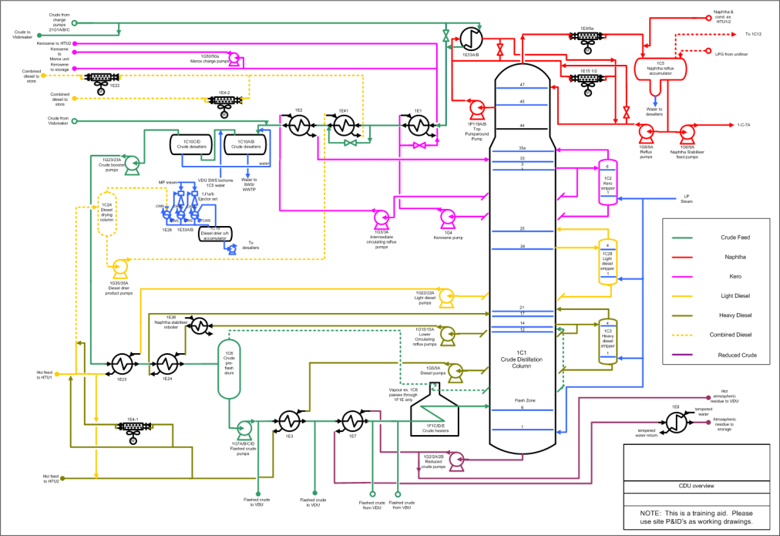
In order to pre-heat the crude oil to the required temperature of around 350ºC, several different methods are used including lagging, steam tracing, heat exchangers and fired heaters. All of these methods are utilised at the refinery in order to reduce energy losses within the process and improve energy conservation. Figure 4 shows an overview of the crude distillation unit with the pre-heat system shown in dark green. From this drawing, we can see how the pre-heat system ties in with the product draw off points through the use of heat exchangers in order to gain the heat needed for the process.
Figure 4 - Crude distillation unit overview (Valero Intranet, 2021, Used with permission)

Tube and shell heat exchangers
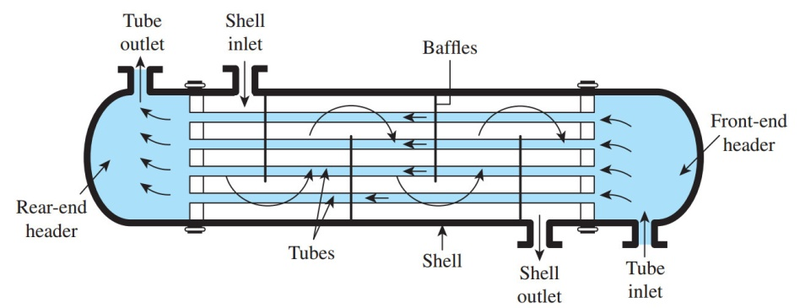
When crude oil arrives at the crude unit at Pembroke refinery, it flows through numerous shell and tube heat exchangers in order to obtain some preheat before flowing through the crude fired heater. The reason in which we preheat the crude oil before it reaches the fired heater is so that it does not shock the heater with cold crude. If this was to occur, it can lead to pipe failures. Once the crude oil has passed through all of these heat exchangers, it is at a temperature of between 110-150ºC. Figure 5 shows the basics of a shell and tube heat exchanger.
Figure 5 - Shell and tube heat exchanger (Industry Insights, 2021)

A heat exchanger is used in order to transfer heat from a finished product out of the distillation column to the crude oil entering the unit. The finished heated product will enter the shell side of the exchanger at the top and leave at the bottom whereas the crude oil will enter the tube side of the exchanger at the bottom and leave at the top in a vaporized liquid.

Fired heaters
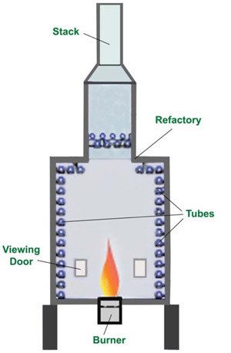
The crude distillation column at Pembroke refinery also makes use of three different fired heaters which are utilised in order to vaporise the majority of the crude oil before it enters the distillation column at a temperature of around 340ºC (Stone, 2018). Figure 6 shows the basics of a fired heater.
Figure 6 - Basics of a fired heater (Lenox, 2021)

Overhead product system
Figure 7 shows the current process equipment being used on the crude distillation unit at Pembroke refinery. The lines shown in red are the overhead product of naphtha which is produced during the distillation process. As the drawing shows, the overhead system is currently made up of one tube and shell heat exchanger as well as two sets of fin fans.
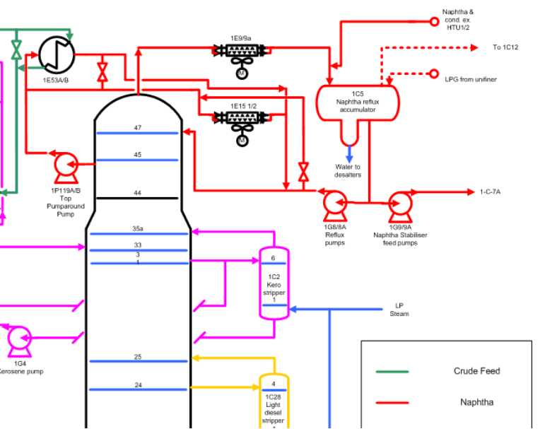
The heat exchanger currently installed into the process takes naphtha from tray 45 of the distillation column before being pumped into the shell side of a heat exchanger, exchanging its heat with crude oil from storage. This naphtha then returns back into the distillation column at tray 47 cooler and is used as a reflux within the process.
Figure 7 - CDU overhead's system (Valero Intranet, 2021, Used with permission)

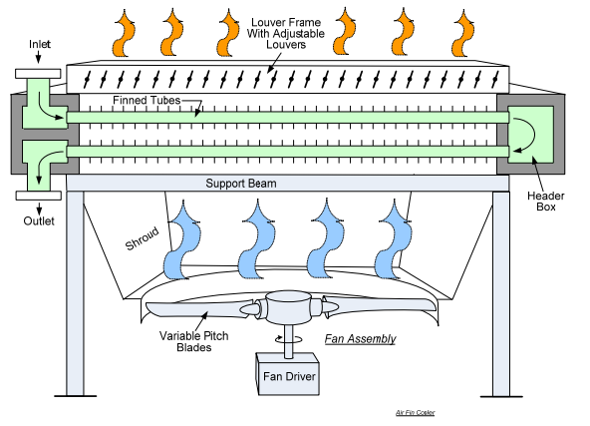
Naphtha taken from the top of the distillation column in a gaseous form is routed towards a bank of fin fans where it is then cooled into a liquid state. Figure 8 shows the basics of a forced draft fin fan heat exchanger.
Figure 8 - Forced draft fin fan (Valero BOT, 2021)

A forced draft fin fan makes use of air which is driven upwards passing through finned tubes in which the product is contained within. The louver position can be adjusted in order to regulate air flow passing through the tubes, when the louver is fully open, the more the product is being cooled (Valero BOT, 2021).
Although a forced draft fin fan is a very effective way of cooling a product, they are not an efficient way of running a process as the reject heat from the process is released directly to atmosphere and now recycled back into the process in any form (Solken, 2021).

Improvements to the overhead product system
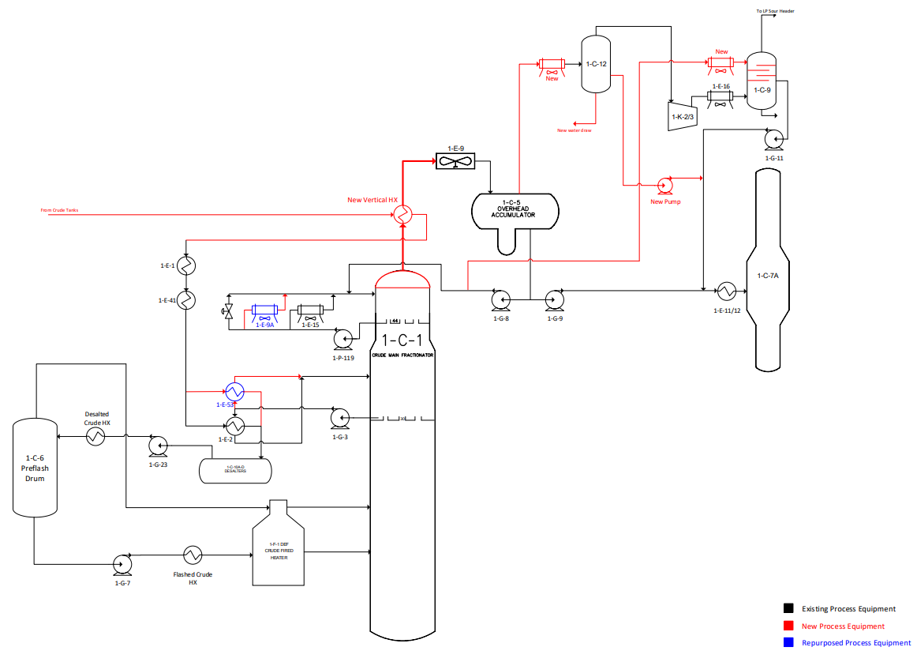
Figure 9 shows possible improvements which could be made to the overhead system on crude distillation unit at Pembroke refinery in order to improve its efficiency and sustainability.
Figure 9 - Possible improvements to the overhead system (Valero Intranet, 2021, Used with permission)

As the drawing shows, an additional shell and tube heat exchanger could be installed to the overhead product coming from the distillation column 1-C-1 in order to increase the temperature of the tankage crude oil before arriving at the current process equipment.
A second additional shell and tube heat exchanger could be installed alongside 1-E-2, namely 1-E-53 on figure 9. This additional heat exchanger would also help to increase efficiency throughout the crude distillation unit as well as improving throughput.
As a result of the two additional shell and tube heat exchangers shown in figure 9, the efficiency of the unit would be improved due to a number of reasons. The main improvement on the crude distillation unit would be the heat energy recovered and reinstated into the unit. Currently the overhead products are completely cooled by forced draft fin fans with all this heat being lost to atmosphere.
The shell and tube heat exchanger installed in figure 9 would transfer some of this heat into the crude oil from tankage increasing its temperature before arriving at the current process equipment. The overhead naphtha then which has already been partly cooled through this heat exchanger would then continue through the current process equipment. Due to the naphtha already been partly cooled by the heat exchanger, the forced draft fin fan could be run at a lower speed and as a result using less electricity improving the unit's efficiency (Smith, 2016).
Heat energy recovery within the overhead system would also be increased as the additional heat exchanger would be used to transfer heat from a process where it is not needed into a process where it is needed therefore reducing the energy input needed from other equipment to get the crude oil up to process temperature (IPIECA, 2014).
In 2012, it was reported that oil refineries emitted 16.3 million tonnes of CO₂, the third highest industry within the United Kingdom (WSP & DNV.GL, 2015). If Pembroke refinery was able to reduce the energy required to run process equipment at the desired temperature, this would help towards the government's goal of reducing greenhouse gas emissions by at least 80% by 2050 as set out in the Paris Agreement in 2015 (UKPIA, 2017). The Paris Agreement was signed by 196 countries worldwide in order to reduce emissions and keeping the global mean temperature rise to less than two degrees and if possible less than 1.5 degrees compared to pre-industrial levels (United Nations Climate Change, 2021).

Disadvantages to the possible improvements on the overhead product system
Heat exchangers like any other process equipment require regular maintenance in order to operate at their optimum efficiency. The most common type of problem which occurs within a shell and tube heat exchanger is fouling, this is when foreign particles gather within the exchanger's surfaces inhibiting heat transfer and restricting fluid flow (IPIECA, 2014).
If the heat exchanger was to become fouled, depending on the severity of the fouling, the maintenance can be carried out either online or offline.
If the blockage within the tube side of the exchanger is not to severe, the exchanger can be taken out of the process and simply flushed with a specialised cleaning agent in order to remove any foreign particles.
If this method does not clear the blockage on the exchanger, the maintenance required comes at a much higher cost as not only does it need to be taken out of the process, the tube side and shell side also need to be removed from one another so that each tube can be cleaned and inspected individually (IPIECA, 2014).

Conclusion
Valero is an oil refinery based on the Milford Haven Waterway in South West Wales opened in 1964. This report looks into ways in which the refinery could improve the overhead product system on the crude distillation unit in order to reduce energy losses as well as maximising profits by installing an additional two shell and tube heat exchangers. By adding these two shell and tube heat exchangers, this would help Pembroke refinery to meet the government's goal of reducing greenhouse gas emissions by at least 80% by 2050.

Waste water treatment plant
Pembroke refinery produces approximately three million gallons of contaminated water every day which needs to be treated so that its quality meets the standards set by National Resources Wales in order for it to be discharged into the Milford Haven waterway via the T head (Lloyd, 2021).
In order to achieve these standards, a biological activated waste water treatment plant is located at the refinery and is designed to anticipate the following flows and composition:

Flow | 568 m³/hr
Suspended solids | 200 ppm
Oil | 300 ppm
Biological oxygen demand | 150 ppm
Total dissolved solids | 6000 ppm

The standards as set out by National Resources Wales for water released back into the Haven waterway are as follows:

Flow | 25,000 m³/day
Temperature | 35 ºC
Suspended solids | 85 ppm
pH | 6 - 9
COD | 270 ppm
Sulphides | 1 ppm
Ammonia | 20 ppm
Phenols | 3 ppm
Cyanide | 250 ug/l
Copper (Cu) | 80 ug/l
Nickel (Ni) | 85 ug/l
Zinc (Zn) | 560 ug/l
Oil | 17 ppm

There are five sources in which the waste water treatment plant receives contaminated water from on the refinery, these are:
- Ballast water - Water which is discharged from tankers at the jetty to act as a counter weight.
- Process water - Water used within refinery process which could be contaminated with oils, phenols, ammonia and sulphides.
- Surface water - Mostly rainwater that has collected in the refinery storm water drains.
- Product tankage - Water which has been drawn off product tanks.
- Sanitary system - Waste from the toilet facilities at the refinery.
The waste water treatment plant is supplied water from an equalisation basin to ensure that feed to the plant is consistent before then being split into two main different process, the primary process is located at the API separates where heavy solids and oil are separated from the main influent. The water then flows into two dissolved air flotation (DAF) units which further remove oil and suspended solids. The second process at the waste water treatment plant is the biological system which further refines the influent in order to meet the above standards as set by National Resources Wales (National Resources Wales, 2016).
In order to ensure the standards set by National Resources Wales are continuously met, a plant operator takes numerous samples at different locations throughout the process in order to analyse the running condition of the plant and adjust process conditions if needed. The waste water process equipment is designed so that if the water is found not to meet the above standards as set by National Resources Wales, it can easily be diverted back to the starting point of the plant in order to undergo the process again to ensure cleanliness and quality.

Conclusion
The waste water treatment plant at Pembroke refinery is responsible for treating all contaminated refinery water so that it meets the standards as set by National Resources Wales in order for it to be pumped back into the Haven waterway.

References
Bitesize (2021a) Available at: https://www.bbc.co.uk/bitesize/guides/zshvw6f/revision/3%20(Accessed: 9th January 2021).

Bitesize (2021b) Available at: https://www.bbc.co.uk/bitesize/guides/zshvw6f/revision/1 (Accessed: 25th March 2021).

Chen (2020) Available at: https://www.investopedia.com/terms/c/crude-oil.asp (Accessed: 25th March 2021).

Howden (2021) Available at: https://www.howden.com/en-gb/articles/pcog/where-does-crude-oil-come-from (Accessed: 25th March 2021).

Industry Insights (2021) Available at: https://www.thomasnet.com/articles/process-equipment/shell-and-tube-heat-exchangers/ (Accessed: 1st April 2021).

IPIECA (2014) Available at: https://www.ipieca.org/resources/energy-efficiency-solutions/efficient-use-of-heat/heat-exchangers/#:~:text=Heat%20exchangers%20can%20improve%20a,it%20can%20be%20usefully%20used.&text=This%20reduces%20the%20energy%20input,incoming%20fluid%20to%20working%20temperature (Accessed: 3rd April 2021).

Lenox (2021) Available at: https://www.lenoxinst.com/Hydrocarbon-Processing.html (Accessed: 1st April 2021).

Lloyd, K. (2021) 'Plant Operator - Waste Water Treatment Plant'
National Resources Wales (2016) Available at: https://naturalresources.wales/media/682707/v005-valero-cogen-permit-final.pdf (Accessed: 6th April 2021).

Pearson Longman (2008) Available at: http://www.pearsonlongman.com/technicalenglish/pdf/level2/level2_Unit8.pdf (Accessed: 9th January 2021).
Smith (2016) Available at: https://www.sciencedirect.com/topics/engineering/variable-speed-drives (Accessed: 3rd April 2021).

Solken (2021) Available at: http://www.wermac.org/equipment/air-cooled_heatexchanger.html (Accessed: 2nd April 2021).

Stone, K. (2018) 'Crude Distillation Unit, Plant and Process Knowledge'.

UKPIA (2017) Available at: https://assets.publishing.service.gov.uk/government/uploads/system/uploads/attachment_data/file/652109/oil-refining-decarbonisation-action-plan.pdf (Accessed: 5th April 2021).

United Nations Climate Change (2021) Available at: https://unfccc.int/process-and-meetings/the-paris-agreement/the-paris-agreement (Accessed: 5th April 2021).

Valero (2020) Available at: https://www.valero.com/sites/default/files/valero-documents/Pembroke%20Refinery%20Fact%20Sheet%20MAR2020.pdf (Accessed: 20th January 2021).

Valero (2021) Available at: https://www.valero.com/about/locations/pembroke-refinery (Accessed: 20th January 2021).

Valero BOT (2021) 'Heat Exchangers' VOL: 03 Process Fundamentals, Version 7.0
WSP & DNV.GL (2015) Available at: https://assets.publishing.service.gov.uk/government/uploads/system/uploads/attachment_data/file/416671/Oil_Refining_Report.pdf (Accessed: 5th April 2021).

