Maze Game

|M5X01043|INDIE GAME DEVELOPMENT|13/12/2017| |CREATED USING UNITY 2017.2.0f3 PESONAL (64bit)|
  - Iestyn Williams |P147615|

Table of Contents
INTRODUCTION 2
DESIGN 2
Description of the game 2
Rules of the game 2
How to play the game 2
Player-centric challenges 2
Termination conditions for progressing to the next level 2
IMPLEMENTATION 3
Scripts Implemented 3
Bits 3
Enemy 3
GameEvents 3
HealthPack 3
Moving Obstacle 3
Player 3
Portal 3
QFPCMazeGame 4
UIControl 4
Screenshots of completed game 5
EVALUATION 9
Errors and challenges encountered 9
Evaluation of the completed game 10
Future versions 10
REFERENCES 10

INTRODUCTION
This report contains the three sections; Design, Implementation and Evaluation.
The design section gives a description of the game created, how to play the game, in-game challenges and how the player wins the game. Implementation is the area of the report that lists and describes the scripts that have been implemented into the game to make it all work. Evaluation is the part where we evaluate the created game, the problems that were faced during implementation and what could be implemented in the future.

DESIGN

Description of the game
The game created is a simple maze game with a few features to challenge the player. The maze is generated randomly, and the size of the maze increases each time the player completes a level. Here is the maze generator asset used to help the creation of the maze [1]. Each level contains Bits, health packs, obstacles and a Portal. To complete the game the player must complete all the levels which can vary from one level to infinity.

Rules of the game

How to play the game
Moving the character is controlled by the ‘W’, ‘A’, ‘S’ and ‘D’ keys, forward, left, backward and right respectively. To complete a maze the player must collect all items which are called Bits to unlock the portal to exit the current maze and to move on to the next maze (level). The end goal of the game is to unlock the final maze’s portal and go through, where a menu will display a congratulations screen.

Player-centric challenges
The challenges that have been designed and implemented in this early version of the game are vertical moving cubes used as obstacles that damage the player when they collide with each other. Another challenge the player has is the player’s health doesn’t regenerate over time or gets reset to full when getting to a new level. To help the survivability of the player health packs are dotted around each level to keep the player alive. They are a small square and has a positive sign.

Termination conditions for progressing to the next level
The goal of the maze is to simply to complete all levels of the maze without dying. To unlock each level’s portal the player must collect a collectable called Bits. They are small and spherical in shape and are green/yellow colour. The number of Bits is the width of the maze times the height of the maze. For example, a 10 by 10 maze will have 100 Bits to collect to unlock the portal.

IMPLEMENTATION

Scripts implemented
Bits
This script is a component for the Bit game object and created for when the player collides into a Bit. It sends an integer to the UIControl’s OnPlayerBitScoreChanged method, where it increases the number of a variable which then gets displayed at the top right corner.
Enemy
This script is a component of the obstacle wall and created for when the vertical obstacle wall collides with the player. It has two messengers, both sends a different damage integer to the player script where it gets used in player’s HurtPlayer method. [2]

Modified original script
Now does constant damage to the player.
GameEvents
This script is used by many of the other scrips. Created so parameter values from one script can be can be passed to another. [2]

Modified original script
Now passes single Boolean unity events.
HealthPack
This script is identical to the enemy script but heals the player when a player and a health pack collides. The script has one messenger that sends a healing integer to the player script. It’s a component of the health pack prefab.
Moving Obstacle
This script is a component of the obstacle wall and its only purpose is to move the obstacle up and down.
Player
This script uses the health script to control the player’s health. [2]

Modified original script
Now has a heal method for the health pack prefab.

Portal
This script is a component of the QFinishFX prefab used to find if the player collides with the portal. It has two messengers both send an integer value, one gets sent to QMazeGame’s currentLevelIncrease method where it is used to generate a new level. The second messenger does something identical to the Bits messenger but increases the count of level in UIControl instead of increasing the Bit count.
QFPCMazeGame
This script is a component of the QMazeGame and is created to generate new random mazes with varied sizes and adding prefabs like Bits and wall obstacles to the maze.

Modified original script
Added three more prefab slots; obstacle, health pack and Bits. Three UnityEvents all of which send a message to UIControl. Two integer values for finding the total amount of an item and a Boolean variable to find if the player has completed the game, five new methods, three private methods to spawn and position the new prefabs added and two public methods that are listeners one that increases a variable used to generate a new maze and the other is created to enable the teleporter when all the Bits are collected. Modified existing methods an example is the position player method where the player now spawns somewhere random on the maze and rather than (0,0,0). [3]
UIControl: This script is a component of the UIControl game object. It’s created to keep the HUD constantly up to date. It deals with the health bar, level score, Bits score and more.

Modified original script
Four new public methods, two of which are listeners that get the max level possible and the max amount of Bits collectable, one identical to OnPlayerLevelScoreChanged except for Bits and another identical method to DoGameOver but is a listener instead of a void method. A single private method has also been coded and is a messenger to QFPCMazeGame where it sends a Boolean parameter to enable the portal if all the Bits have been collected. [2]

Screenshots of completed game

Bit
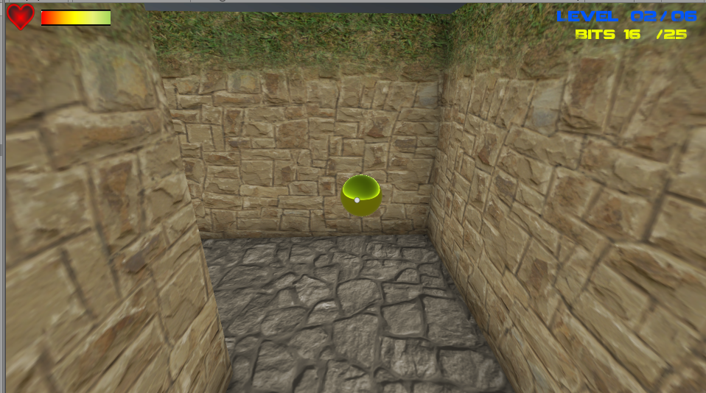

Health pack
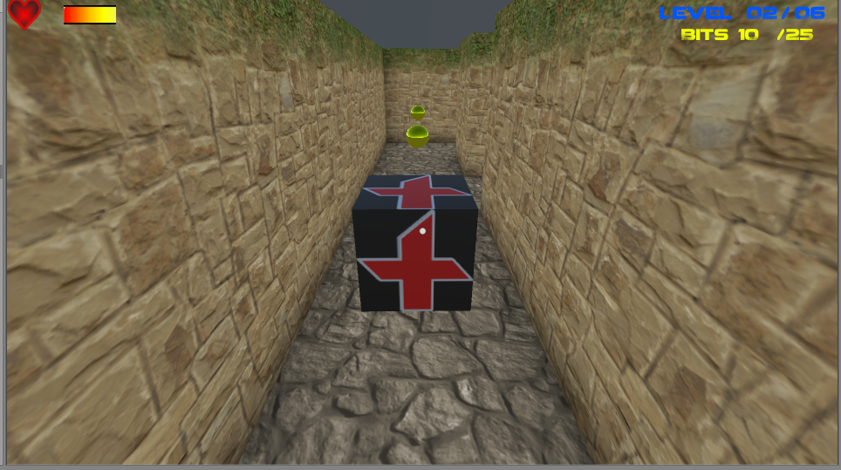

Wall obstacle
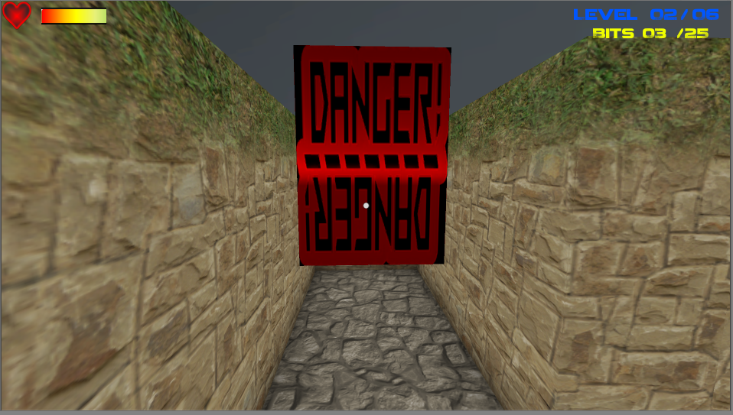

Portal
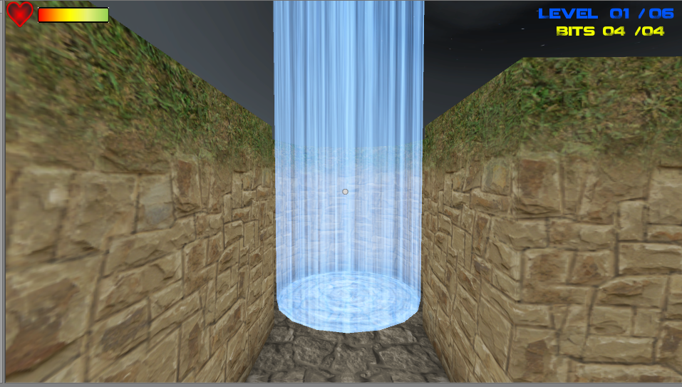

Game Over
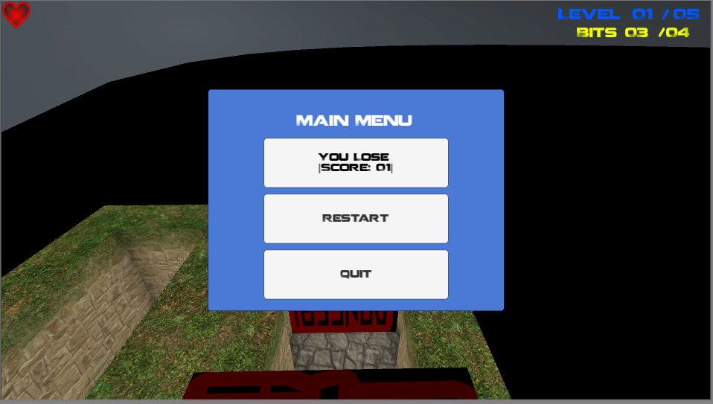

Winner
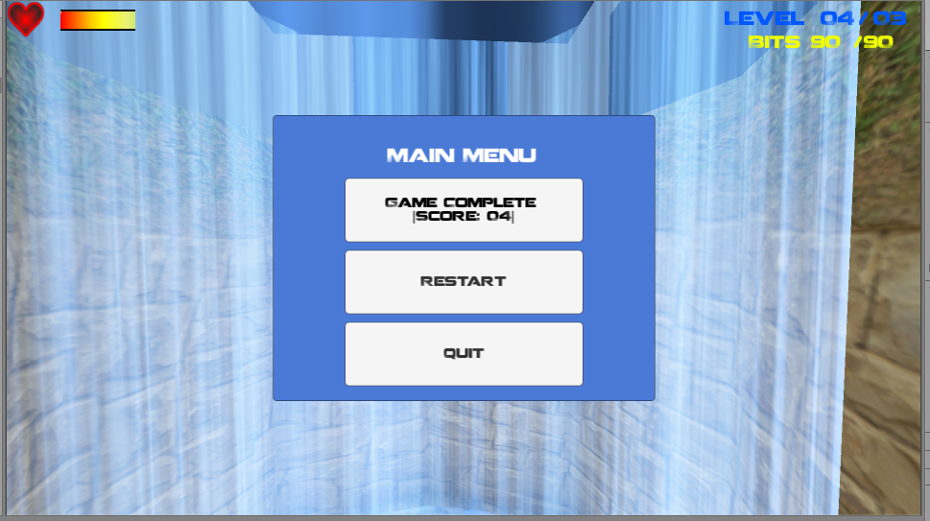

EVALUATION

Errors and challenges encountered
The first problem was when the QFPCMazeGame generated a maze, it would sometimes position the player in the walls of the maze pieces and would therefore the player would fall through the map. This problem was resolved through two ways, the first was using a function from the QMazeEngine class called PointInMaze [4] which checked if a random position created from a range of two numbers was a position that wasn’t obstructed by a wall, but the implementation didn’t really work because the player would sometimes still spawn in a wall. The second and gameplay reducing way this problem was resolved was by removing a few special pieces from the QMazeEngine. This is a short-term fix for 2 problems, this problem and a smaller problem of not being able to get all the Bits on the map because some of the maze pieces wouldn’t allow the player to get the Bits. (e.g. A Bit spawns in a wall where it would usually spawn a floor)
A second problem that wasn’t resolved was a creation of an AI character. The first implementation of the AI was to bake the area where the navigation agents could find their way around, but because Unity’s ordinary baking doesn’t work at runtime and the maze needs to be dynamically generated the maze couldn’t be baked. After some research there were new scripts in the 2017 version of Unity created by Unity where baking at runtime could be possible [5] [6]. Sadly, since the scripts were found at a late stage of implementation in the project, the AI was canned due to time constraints and a simple moving obstacle was created to add a challenge to the player rather than either a broken AI or nothing.
The final problem encountered was when the player collected the final Bit, the portal wouldn’t activate. After plenty of testing and failures a test was conducted to find the name of the portal game object that was being set active/inactive. The game object was the prefab of the portal and not the portal instantiated from the QFPCMazeGame script. After resolving that problem another problem was found. A messenger was set up to send a message every time a Bit was collected but for some reason the listener received messages before the messenger sent anything. This meant that the portal would never open because the listener never got sent a message of true instead of false. This problem was resolved by calling the messenger in the update function instead of when a Bit was collected.

Evaluation of the completed game
The game has foundation level features that the player can have some enjoyment with. It has four interactable game objects (Bits, health packs, obstacles and a portal) and has a random maze generator.
At the beginning the maze game was meant to be pitch black where the player had a torchlight to help them navigate around the maze, but couldn’t find a way to make the maze dark without putting a roof on the maze which led to not being able to see the sky dome. The materials created for the health pack, obstacles and Bits were made for a dark dank environment but are still usable in the final setting of the maze.
The gameplay is lacking. The collecting of all the Bits is an effective way to make the player explore the maze and gives them another goal to head for but gets very tedious, quickly. The end screen is also a little disappointing for the time spent collecting Bits and walking through portals.

Future versions
For future versions to make the game harder to complete multiple AIs would wonder the maze and try to hunt the player down before they can get to the next level.
Using all the maze Pieces would bring more gameplay to the game.
An invisible ceiling to stop the player getting on top of the map using the wall obstacles or creating invisible walls for the outside of the maze so the player couldn’t leave the game world and fall out the map.
A second game mode where the player must do five levels as quick as possible. The time will be stored in a local leader board.
A future addition to the game would be a simple start menu with a mode choice of doing the timed run or a casual maze run where the player can input a number in a box and the player then completes the amount of levels inputted.

REFERENCES

[1] | S. Smurov, “QMaze,” 10 Oct 2017. [Online]. Available: https://assetstore.unity.com/packages/tools/modeling/qmaze-30600. [Accessed 28 November 2017].
[2] | K. Ademoye, “Lecture 4 Lab: Unity Events,” [Online]. Available: http://moodle.uwtsd.ac.uk/mod/lesson/view.php?id=79291. [Accessed 6 December 2017].
[3] | K. Ademoye. [Online]. Available: http://moodle.uwtsd.ac.uk/mod/lesson/view.php?id=76878. [Accessed 3 December 2017].
[4] | K. Ademoye, “Assignment Tips,” 5 December 2017. [Online]. Available: http://moodle.uwtsd.ac.uk/mod/page/view.php?id=86028. [Accessed 5 December 2017].
[5] | Unity, “Baking NavMesh at Runtime,” [Online]. Available: https://unity3d.com/learn/tutorials/topics/navigation/baking-navmesh-runtime. [Accessed 10 December 2017].
[6] | Unity, “Asset Download for runtime baking,” [Online]. Available: https://oc.unity3d.com/index.php/s/PZNxx9NysMrZvli. [Accessed 10 December 2017].

