University of Wales Trinity Saint David

Programme: BSc Health and Social Care

Module Code: BMHP5014

Module Title: Changemakers: Creativity and Value Creation

Assignment Title: Component 2: Written Assignment, Poster and Pitch

Innovation Title: ScreenHer: A Culturally Sensitive Cervical Screening Campaign

Name: Portia Amankonah

Student Number: 2426673

ScreenHer Campaign
ScreenHer is a culturally sensitive cervical screening campaign designed to improve screening uptake among South Asian women in the UK. The campaign would not replace the NHS Cervical Screening Programme; instead, it would make the existing service easier to understand, trust and access. Its purpose is to address a preventable health inequality by combining community engagement, translated digital information and NHS-linked appointment signposting.
The need for ScreenHer is clear. NHS cervical screening is offered to women and people with a cervix aged 25 to 64, yet uptake remains below the expected standard. In England, cervical screening coverage was 68.8% in 2023–24, below the 80% acceptable performance threshold, with lower coverage among those aged 25 to 49 (NHS England Digital, 2024). This matters because cervical screening helps prevent cervical cancer by identifying abnormal cell changes early, before cancer develops (NHS, 2025). Therefore, low uptake is not only an individual health issue; it is a public health and equality issue.
The target group for ScreenHer is South Asian women aged 25–64, particularly those who may feel unsure, embarrassed, under-informed or mistrustful about cervical screening. This focus is justified because evidence suggests that women from Black, Asian and minority ethnic backgrounds are less likely to attend screening than White British women (UK Health Security Agency, 2024). Academic research also identifies barriers including fear, embarrassment, shame, language difficulties, low awareness, cultural stigma and concerns about confidentiality (Marlow, Waller and Wardle, 2015; Anderson de Cuevas et al., 2018; Bolarinwa and Holt, 2023). These barriers show that simply sending a standard invitation letter is not enough. If the message does not feel understandable, culturally sensitive or safe, some women may avoid screening even when they know it is important.
ScreenHer’s innovation is its hybrid model. It would combine NHS digital tools with community-based trust. The digital element would use QR codes on posters and leaflets in GP surgeries, pharmacies, Family Hubs, community centres, colleges, mosques, temples and women’s groups. These QR codes would link to short videos and translated information in English, Urdu, Punjabi, Bengali and Hindi. The content would explain what cervical screening is, why it matters, how to book, what happens at the appointment, how confidentiality is protected and how to request a female sample taker where available. This is important because the campaign does not only tell women to attend; it reduces uncertainty around the process (NHS England, 2025a).
The community element would use trained female community champions. These could include volunteers, link workers, health promotion staff or members of local voluntary organisations. Their role would be to start conversations, challenge myths, support women with booking routes and signpost them back to NHS services. This approach responds to evidence that screening barriers are not only medical, but also cultural, emotional, linguistic and practical (Anderson de Cuevas et al., 2018; Bolarinwa and Holt, 2023). Therefore, ScreenHer creates value by using trusted community voices, not only clinical authority.
Implementation would take place through a 12-month pilot within one Integrated Care System, targeting areas with large South Asian populations and lower cervical screening coverage. Phase one would involve co-design with South Asian women, GP practices, pharmacists, community leaders and local voluntary organisations. Phase two would produce translated materials, videos, posters and champion training. Phase three would launch the campaign in selected GP practices, pharmacies, Family Hubs and community spaces. Phase four would evaluate uptake, engagement and feedback before wider rollout. This reflects official guidance that local cervical screening initiatives should identify barriers, tailor access approaches and evaluate impact (NHS England, 2025a).
ScreenHer would integrate with existing NHS systems rather than creating a separate clinical pathway. Women would still receive official NHS invitations, book through GP practices or approved routes, and receive results through normal NHS systems. The campaign would simply make the pathway clearer and more accessible. This is realistic because NHS England has already been expanding digital screening invitations and reminders through the NHS App and text messaging (NHS England, 2024). ScreenHer could build on this by adding culturally tailored explanation and community support, while still following screening text message principles around consent, clarity and information governance (UK Health Security Agency, 2022).
The campaign would also need to meet legal and professional standards. Under the Equality Act 2010, services must avoid discrimination and make reasonable adjustments for protected characteristics such as race, religion and disability (Great Britain, 2010). This supports the use of culturally sensitive messaging, inclusive design and accessible formats. The Accessible Information Standard also requires health and adult social care services to identify, record, flag, share and meet people’s communication needs (NHS England, 2025b). Data protection is equally important. ScreenHer should not store clinical information or screening results. Any text updates should be opt-in, general and non-clinical, with personal data handled under UK GDPR and the Data Protection Act 2018 (Great Britain, 2018; Information Commissioner’s Office, no date).
However, there are limitations. A culturally targeted campaign could be criticised for stereotyping South Asian women or assuming all communities have the same needs. To reduce this risk, ScreenHer must be co-designed with women from different South Asian backgrounds, ages, faiths and languages. Another risk is digital exclusion. Some women may not use QR codes, smartphones or the NHS App. Therefore, the campaign must also include paper leaflets, face-to-face conversations, interpreters and direct GP support. Digital access should widen choice, not become another barrier. There is also a confidentiality risk if community champions are not trained properly. This would be managed through clear boundaries: champions would provide general information only and would not collect private medical details.
The value of ScreenHer is that it is preventative, realistic and cost-conscious. It uses existing NHS services, buildings and digital systems, so the main costs would be translation, design, training, community outreach and evaluation. Rather than creating a separate service, ScreenHer strengthens the pathway that already exists by making it more understandable, culturally responsive and accessible. More importantly, it supports the common good by reducing avoidable inequality and giving women information in a way that feels respectful rather than frightening.
Overall, ScreenHer is needed because cervical screening uptake is too low, and standard communication does not work equally well for every community. By combining NHS pathways with culturally sensitive education, trusted community voices and accessible technology, ScreenHer would make cervical screening more understandable, acceptable and reachable for South Asian women. Its success would be measured not only by higher uptake, but by improved confidence, trust and informed choice. ScreenHer demonstrates value creation by using existing NHS infrastructure in a more inclusive way, improving preventative access without creating a separate or costly service.

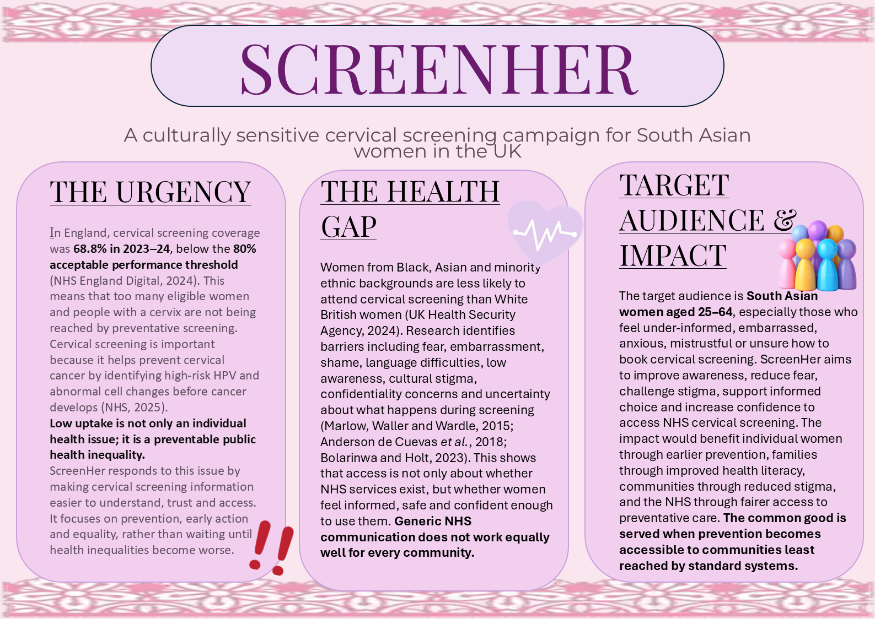

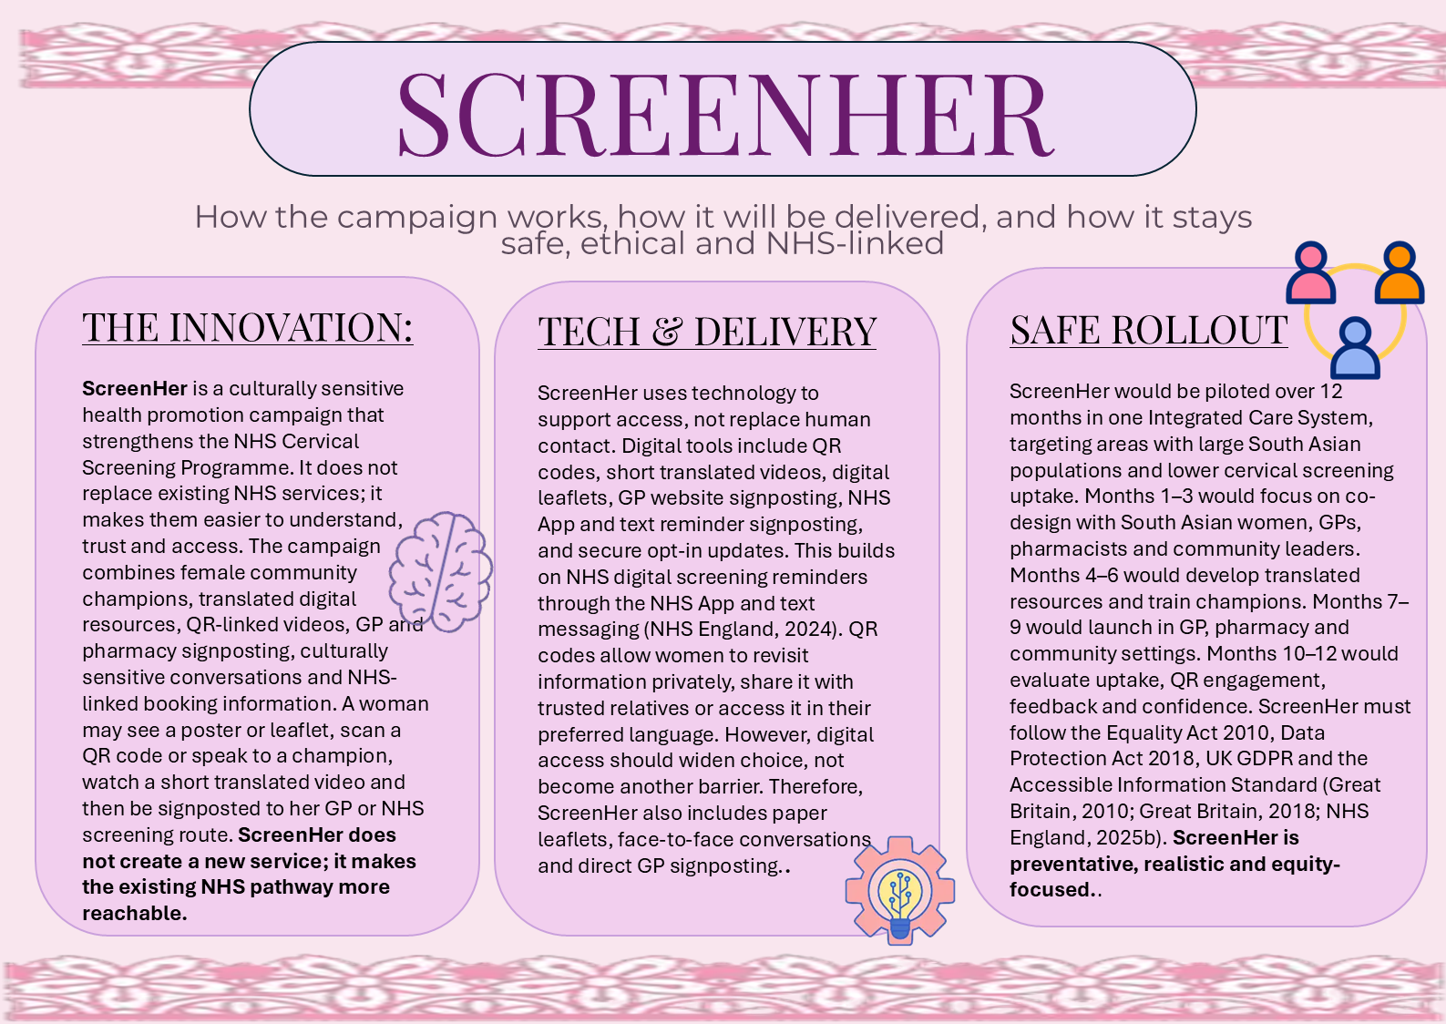

Reference List
Anderson de Cuevas, R.M. et al. (2018) ‘A systematic review of barriers and enablers to South Asian women’s attendance for asymptomatic screening of breast and cervical cancers in emigrant countries’, BMJ Open, 8(7), e020892. Available at: https://doi.org/10.1136/bmjopen-2017-020892.
Bolarinwa, O.A. and Holt, N. (2023) ‘Barriers to breast and cervical cancer screening uptake among Black, Asian, and Minority Ethnic women in the United Kingdom: evidence from a mixed-methods systematic review’, BMC Health Services Research, 23, article 390. Available at: https://doi.org/10.1186/s12913-023-09410-x.
Great Britain (2010) Equality Act 2010. London: The Stationery Office. Available at: https://www.legislation.gov.uk/ukpga/2010/15/contents
Great Britain (2018) Data Protection Act 2018. London: The Stationery Office. Available at: https://www.legislation.gov.uk/ukpga/2018/12/contents
Information Commissioner’s Office (no date) Consent. Available at: https://ico.org.uk/for-organisations/uk-gdpr-guidance-and-resources/lawful-basis/consent/
Marlow, L.A.V., Waller, J. and Wardle, J. (2015) ‘Barriers to cervical cancer screening among ethnic minority women: a qualitative study’, Journal of Family Planning and Reproductive Health Care, 41(4), pp. 248–254. Available at: Barriers to cervical cancer screening among ethnic minority women: a qualitative study | BMJ Sexual & Reproductive Health.
NHS (2025) Cervical screening. Available at: https://www.nhs.uk/tests-and-treatments/cervical-screening/
NHS England (2024) NHS “ping and book” screening to help save thousands of women’s lives. Available at: https://www.england.nhs.uk/2024/11/nhs-ping-and-book-screening-to-help-save-thousands-of-womens-lives/
NHS England (2025a) Cervical screening: ideas for improving access and uptake. Available at: https://www.gov.uk/guidance/cervical-screening-ideas-for-improving-access-and-uptake
NHS England (2025b) Accessible Information Standard – requirements (DAPB1605). Available at: https://www.england.nhs.uk/long-read/accessible-information-standard-requirements-dapb1605/
NHS England Digital (2024) Cervical Screening Programme, England – 2023–2024: Section 1, call and recall. Available at: https://digital.nhs.uk/data-and-information/publications/statistical/cervical-screening-annual/england-2023-24/section-1-call-and-recall
UK Health Security Agency (2022) Screening text message principles. Available at: https://www.gov.uk/government/publications/nhs-population-screening-effective-text-message-use/screening-text-message-principles
UK Health Security Agency (2024) Equality impact assessment: risk stratification in the NHS Cervical Screening Programme. Available at: https://www.gov.uk/government/publications/cervical-screening-risk-stratification-impact-assessments/equality-impact-assessment-risk-stratification-in-the-nhs-cervical-screening-programme
Vecteezy (no date) Diversity, equity and inclusion concept. DEIB. Colorful people figures on pink background [online image]. Available at: https://static.vecteezy.com/system/resources/previews/046/961/332/large_2x/diversity-equity-and-inclusion-concept-deib-colorful-people-figures-on-pink-background-photo.jpg.
Creazilla (no date) Double exclamation mark emoji clipart [online image]. Available at: https://cdn.creazilla.com/emojis/49139/double-exclamation-mark-emoji-clipart-sm.png
Creative Fabrica (2022) Paper Lace Border [online image]. Available at: https://www.creativefabrica.com/wp-content/uploads/2022/09/23/1663939257/Paper-Lace-Border
Pinterest (no date) Pink lace background image [online image]. Available at: https://i.pinimg.com/736x/50/71/59/5071596808126ae5cef251e63ff78493.jpg
Flaticon (no date) Teamwork animated icon [online image]. Available at: https://cdn-icons-gif.flaticon.com/14164/14164931.gif
Flaticon (no date) Technology icon [online image]. Available at: https://cdn-icons-png.flaticon.com/512/8710/8710552.png

