

Making better decisions for better outcomes within the Hywel Dda Health Board
Making the right decisions is critical in the Health Board to ensure we meet our organisational goals and our values of putting patients at the heart of what we do. Often decisions are made with a personal bias or from our own opinions, with little or no evidence to support decisions.
We need managers and all staff to think critically and use valid evidence to make better decisions. This is paper outlines the importance of how we as a department ensure we are using evidence-based practice and analytics within the NHS to make informed and justified decisions.

What is evidenced-based practice (AC 1.1)
According to Young (2022) evidence-based practice is making better decisions, informing action that has a desired impact. This approach to decision making uses a combination of critical thinking and using the best evidence from reliable sources to develop knowledge and understanding. Essentially evidence-based practice improves the effectiveness of making decisions through gathering, analysing and evaluating data, ensuring decisions are not based on any personal bias, experiences or word of mouth. These sources are not trustworthy and should not be used to make informed decisions. Moitra (2017) states that people professions need move away from fads and suppositions and use sufficient quality evidence, so decisions don’t deduce from incomplete patterns and be reliant on less creditable sources such as hearsay. Waite et al (2021) highlights the implications of ‘getting it wrong’ are huge when relaying on these opinions and using a single form of evidence is risky. Examples of applying evidence-based practice within Hywel Ddas recruitment process is conducting exit interviews with staff leaving, this would be used to make decisions on departments to see if there are any management or training issues. It is important we ensure when using the data that it is reliable by asking the right questions and that the way it is being asked is consistent. Similarly, surveys can be used for staff retention on existing employees to obtain feedback to analyse to see what could be improved on, alongside gathering information from other organisations. By gathering the best available evidence from multiple sources and critically appraising the trustworthiness will determine the probability of our decision to solve problems.

The importance of using accurate data in organisations (AC 1.2)
Data is a key component to the organisation for making informed strategic decisions, it helps us understand our customers and service. By understanding this it allows us to make better decisions to achieve our organisational goals and make any necessary adjustments to improve future outcomes. Hill and Houghton (2018) states no decision should rely on a ‘gut feeling’ or opinion and instead an auditable, wide-ranging approach of evidence gathering is needed. Mohdzaini (2022) outlines the importance of data analytics as it allows us to measure our workforce in areas such as performance, employee wellbeing and inclusion and diversity. Using data can help us look at the impact of any policies or procedures on the workforce's performance meaning we make more effective evidence-based decisions when addressing any problems and lead us to increased success. Using data is important for our culture as it is transparent and provides real time insights to where course correction may be needed Gleeson (2017). It is important to note when we are making decisions that our data is reliable and valid. Waite et al (2021) emphasises the need to ensure any sources being used are correctly measuring what is supposed to measured. And that data is gathered using consistent methods to ensure sound decisions are made. Alternatively, using out of date information is also unreliable as this would mean we are making decisions that would not benefit the organisation and ultimately wasting, time resources and money leading to our employees being less engaged and being further away from our organisational goals.

Quantitative and qualitative data (AC 1.3)
Quantitative and qualitive are the two forms of data that people professionals can analyse to get evidence of the organisations current state of play and identify any problems or issues. Mohdzaini (2022) describes qualitative data as qualities observed by someone and is subjective, it is practical for us to understand the ‘what, why and how’ in this type of data. Waite et all (2021) outlines it is non statistical and found in the meanings of words, focusing on groups of people. Qualitative data is sourced via interviews, we use this type of data from carrying out exit interviews, performance/appraisal reviews and recordings of any disciplinary or grievance investigations. This approach is helpful to understand how people feel as it captures their views and perceptions. We should not rely solely on qualitative data as it is drawn off one person's experience.
On the other hand, quantitative data is objective and is mostly expressed as numbers. Waite et al (2021) suggests this type of data is useful when we need to measure trends or patterns over time. Quantitative data is gathered by carrying out staff surveys or drawn off internal systems. Mohdzaini (2022) notes that quantitative data is used when reviewing the number of employees and averages ages. We can look at labour turnover and patterns, absence rates over a period and job satisfaction or engagement surveys to revise organisational policies, procedures or to help design wellbeing initiatives. It is important to note we need to use these types of data in conjunction with each other when making decisions to get the bigger picture. An example of this would be exit interviews, it would not be good practice to just go off this as everyone has different experiences, there may have been grievances. We would also need to consider the way the survey was delivered, and check was everybody asked the question in the same way and often people interpretate questions differently.

Agreed policies and procedures inform decisions (AC 1.6)
Policies and procedures provide a uniform framework for the organisation to make informed decisions by using set written guidelines for the organisation to comply with ensuring decisions are consistent across the board. Policies and procedures ensure transparency which helps builds trust between employees and managers, allowing staff to make informed decisions of their own behaviour at the workplace and understand what is expected of them, also ensuring equity. Policies and procedures help management teams make informed decisions confidently and hold people accountable by following the guidelines. George (2021) explains policies play a key role in supporting consistency and fairness as well as protecting the organisation against claims. Waite et al (2021) explains HR as the gate keepers of ethical practice by developing and communicating clear policies that ensure ethical practice and achieve fairness. An example of this would be in employee turnover, if a line manager needed to end employment for a staff member, our policy will guide and support both the manager and employee and we would need to ensure we adhere to its legal obligations – eliminating any bias in the decision-making process. We can then use this information to identify any patterns of leavers. This is the case with disciplines, grievances and sickness policies, staff can be off work and should not be subject to any unlawful discrimination. George (2021) identified policies may need to be changed if there are any changes in the micro and macro world such as employment law or processes within the organisation such as new strategies, internal changes or keeping updated with the latest effective people management. To conclude, policies and procedures can help measure outcomes and can help improve decision making.

How we create value for people, organisations, and wider stakeholders (AC 2.1)
Waite et all (2021) outlines there are many ways people professionals can help create value within the organisation throughout the employee's lifecycle from recruitment to performance management. Firstly, developing a robust onboarding process, Green (2017) describes this as the golden opportunity to engage with new employees and assimilate the employee to the organisational culture. This first contact is a major factor when staying in an organisation, therefore this a vital aspect. Learning and development is a key part of overall business strategy and as an organisation we need to adapt to changing external patterns therefore as people professionals it is essential our L&D initiatives are helping to support employees to be competent in their role and offer then continuous professional development opportunities. Hayden (2022) outlines the important role we have with management ensuring they are involved in L&D initiatives and ensuring they have the relevant support to enable them to support their wider team accessing relevant training. By supporting L&D this ensures our staff are sufficiently trained to their job role which leads to fewer mistakes being made and quicker diagnosis for patients. In addition to these examples people professionals can create value by identifying potential risk and patterns in the organisation and developing procedures to mitigate these, for example looking at patterns in absences to help reduce the cost of agency cover. Finally, we can ensure that we are operating in an ethical manner by developing policies promoting diversity and inclusion and procedure that reduce our impact on the environment. Ensuring employees feel valued, competent, and confident carrying out their role.

Customer-focused, and standards-driven in your own context (AC 2.2)
Our main priority is putting patients at the heart of what we do therefore it is vital to be patient focused and strive to provide them with the best possible care. Dodge (2012) found within the NHS that higher staff engagement levels have lower patient mortality rates, and that that patient satisfaction was significantly higher in trusts with higher levels of employee engagement. Dodge (2012) found the keys drivers were receiving job relevant training and structured appraisals, with good managerial support. To support our colleagues to provide the best care to our patients we need to ensure that we are keeping up to date with the latest field developments, so it is important for us to have a good relationship with management teams and our learning and development partners to provide relevant training and updates when needed. Gifford (2021) highlighted that employees who are managed well will be happier and be more fulfilled which will ultimately be more likely to drive productivity and provide a better service. We are currently implementing a new internal management training programme which will provide all managers sufficient tailored training to maintain fairness and inclusivity, and staff are being treated equally across the board receiving the same support. From a HR perspective we also need to ensure managers are following the NHS appraisal process, we will analyse this put pulling reports of staff retentions, leaving surveys and appraisal records.

Section 2
(AC 1.4) The below table shows the staffs age ranges of departments C & D as percentages, percentages are easier to interpret when analysing data as they can be compared quickly.
Department C |  | Department D
Aged 16-25 | 18.6% | Aged 16-25 | 0%
Aged 26-35 | 6.98% | Aged 26-35 | 2.22%
Aged 36-45 | 18.6% | Aged 36-45 | 4.44%
Aged 46-55 | 15.70% | Aged 46-55 | 10%
Aged56-65 | 29.65% | Aged 56-65 | 22.22%
Aged 66-75 | 9.88% | Aged66-75 | 61.1%
Aged 76-80 | 0.58% | Aged 75-80 | 0%

(AC 1.5)
Below is a practical working example of how a people practice team interprets and presents data in a diagrammatic format.
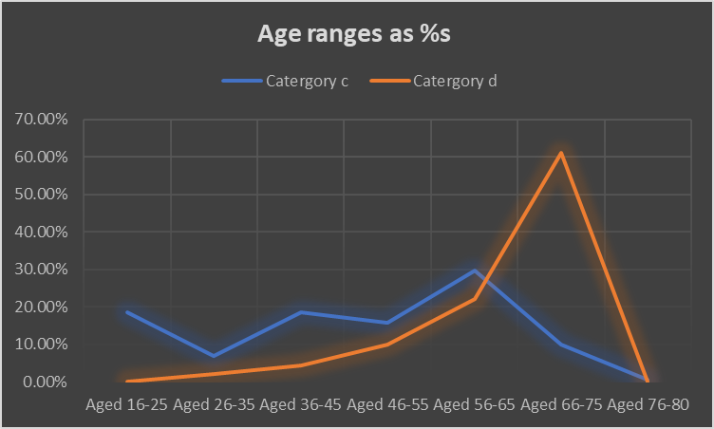
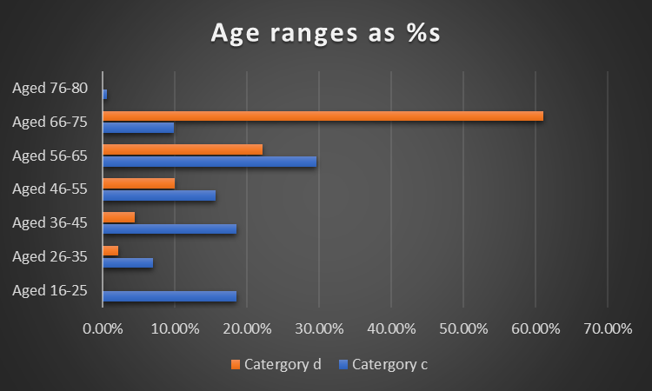

It is clear from the above graphs that department D has a more ageing workforce compared to Department C, particularly showing a higher percentage of staff in the age category 66-75, which is close to or even past retirement age. Therefore, there is a risk of most of the workforce leaving within the same time frame which will leave the organisation with a talent shortage. This will have a huge impact on the team's workload and from a HR perspective the time and cost of recruiting and training any new members of the team. A suggestion to department D would be to capture the employee's knowledge by creating procedures of their duties to pass on to future employees and to start upskilling the staff in the younger age ranges through shadowing and offering relevant training courses for them to move smoothly into new positions if they desire. This will also help retain staff as they can see potential development opportunities within the department and will be more motivated and want to stay to progress with the department/organisation. Older employees can often be stuck in their ways and not open to change which can have an impact on the organisations success if there are any changes to processes, structure, or direction, it is important to note this is not always the case and we would need to compare this to other data such as PADRs and monthly 121 reviews. By analysing the data, Department C clearly have a more diverse workforce however a large proportion are between 16-25 years old, although many people say it is preferable to have younger employees as they can bring fresh ideas to the table there are also some downs, such as lack of experience and direction. It would be a good idea to use mentoring to develop the staff’s knowledge and support them in their role, this will help with employee retention. In reflection, this is the information we have today however before we do move onto a decision making, it would be beneficial if we had some qualitative data from the staff working in both departments rather than moving on with what we have and make a bad decision.

References
- Admin_Jododds (2021) The Evidence White Paper. Available at: https://engageforsuccess.org/insights-data-surveys/the-evidence-white-paper/. (Accessed: February 1, 2023).

- Dodge, T. (2012) Employee Engagement Task Force “Nailing the evidence” workgroup, https://engageforsuccess.org/wp-content/uploads/2021/03/The-Evidence.pdf. M&S. Available at: https://engageforsuccess.org/wp-content/uploads/2021/03/The-Evidence.pdf (Accessed: January 19, 2023).

- Employee Engagement & Motivation | Factsheets (2021). Available at: https://www.cipd.co.uk/knowledge/fundamentals/relations/engagement/factsheet. (Accessed: February 1, 2023).

- Evidence-based practice for effective decision-making | Factsheets (2022). Available at: https://www.cipd.co.uk/knowledge/strategy/analytics/evidence-based-practice-factsheet. (Accessed: February 2, 2023).

- Getting started with people analytics: a practitioners’ guide (2018) https://www.cipd.co.uk/Images/peope-analytics-guide_tcm18-51569.pdf. CIPD. Available at: https://www.cipd.co.uk/Images/peope-analytics-guide_tcm18-51569.pdf (Accessed: January 20, 2023).

- Gleeson, B. (2017) The Benefits Of Leading Data-Driven Organizational Change. Available at: https://www.forbes.com/sites/brentgleeson/2017/09/28/the-benefits-of-leading-data-driven-organizational-change/?sh=29c471895e09 (Accessed: January 30, 2023).

- Healthcare hiring - getting new employees on board | In a Nutshell article (2017). Available at: https://www.cipd.co.uk/news-views/nutshell/issue-70/healthcare-hiring. (Accessed: February 2, 2023).

- HR Policies | Factsheets (2022). Available at: https://www.cipd.co.uk/knowledge/fundamentals/people/hr/policies-factsheet. (Accessed: February 5, 2023).

- Learning & Development Strategy and Policy | Factsheets (2022). Available at: https://www.cipd.co.uk/knowledge/strategy/development/factsheet?_gl=1*172ajef*_ga*ODE4NjM0LjE2NDMyOTI4MTU.*_ga_D9HN5GYHYY*MTY3NTY5OTQ5OS4yNC4xLjE2NzU3MDI1NzEuMjIuMC4w. (Accessed: January 30, 2023).

- Moitra, T. (2017) An Overview of Evidence Based Management in HR: Moving from Suppositions to Data. Available at: https://blog.sage.hr/overview-evidence-based-management-hr-moving-suppositions-data/. (Accessed: February 8, 2023).

- People Analytics | Factsheets (2022). Available at: https://www.cipd.co.uk/knowledge/strategy/analytics/factsheet. (Accessed: January 6, 2023).

- Waite, K. et al. (2021) People Practice: A Complete Guide. 1st edn. CIPD - Kogan Page.

