Creating and managing your electronic PTE file (OneDrive)
If you have problems with the steps outlined here, you’re welcome to contact Dave Stacey (david.stacey@uwtsd.ac.uk) outlining in as much detail as possible what stage you’ve got to, and what has gone wrong!
1. Creating your electronic PTE file
Log in to your OneDrive account.
You can do this by following the link in MyDay, or going direct to Office.com and clicking on the 'OneDrive' tile.
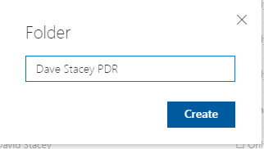
Create a new folder. 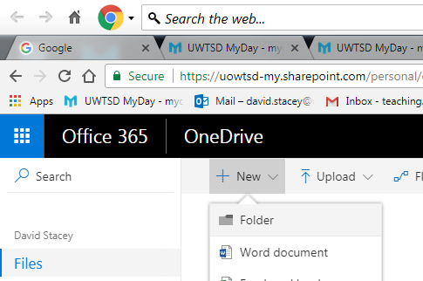
Name it in the format <yourname PTEfile> ( eg Dave Stacey PTEfile).

2. Downloading the templates
Log in to Moodle and click on Yr Athrofa tile.
Click onto PGCE 19/20, and scroll down to the PTE file. Click on the English or Cymraeg zip file to download the files to your computer.

3. Adding the files
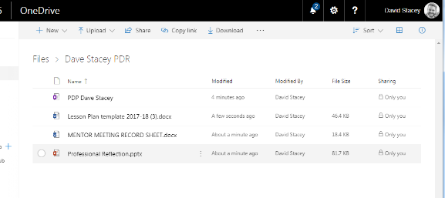
In OneDrive, open the folder you created in step 1. You can either drag-and-drop the files you downloaded in step 2, or you can click on Upload > Files and find and upload them one at a time.

4. Sharing your electronic PTE file

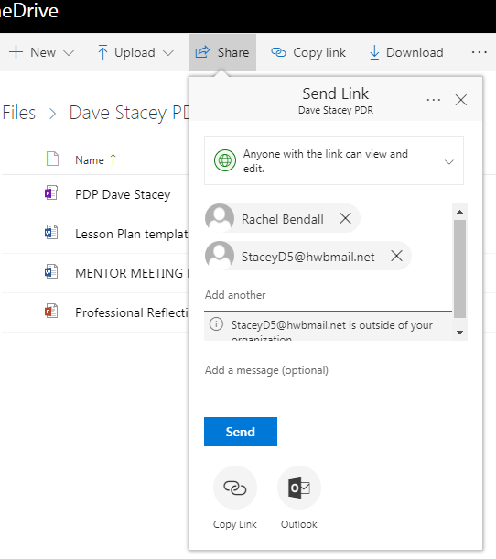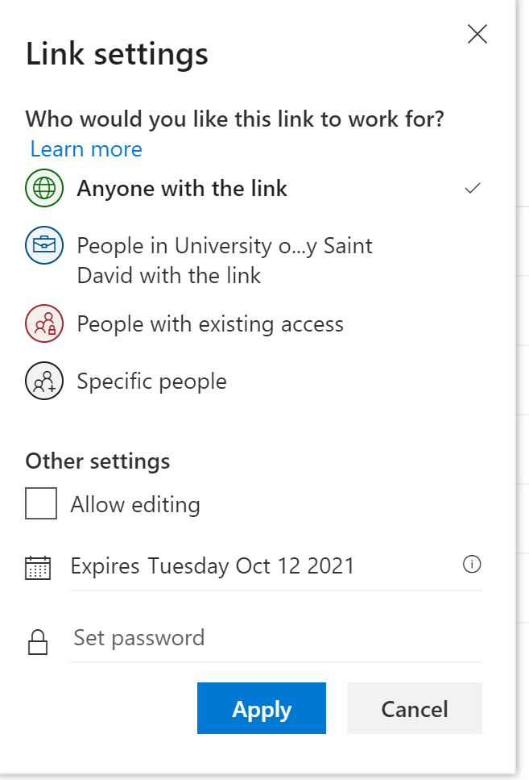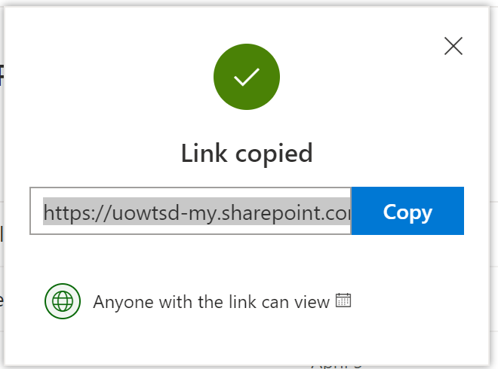
From OneDrive, click on 'share' at the top of the screen.
Click on ‘Anyone with the link can edit’. Click ‘Apply’.
Click on the ‘Copy link’ icon and copy the link that appears. You should then email this to the Class/Subject Mentor, Senior Mentor, Network Lead, University Tutor (Professional), and the Secondary Subject University Tutor. This will allow them to see the contents of your file as it develops.

5. Using your electronic PTE file
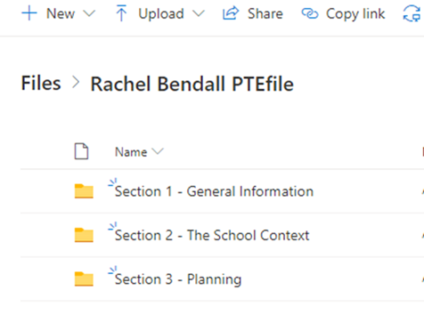
You should create a new folder within your electronic PTE file for your first teaching experience placement. In here you should store all the lesson plans and resources you create (see PTE Guidance Handbook, pg. 3-4 for the specific requirements).

Data security – Please note that this shared folder should NOT be used to store personal information about the students you teach. If you are given any documents from your school that contain this type of information, you should store it in a separate folder on your University OneDrive or on a school provided IT system. You should also ensure personal information about students is not stored on your personal devices, but accessed via secure online platforms such as your University Office 365 account. If you have any questions about this, check with your school mentor.
6. Syncing your electronic PTE file to your computer (optional)

If you are using your own computer, you can sync your University OneDrive to appear as a drive on your computer. Any files saved to your OneDrive will be copied to your computer, and anything you save in your OneDrive folder on your computer will be copied to your OneDrive when your computer is connected to the internet.
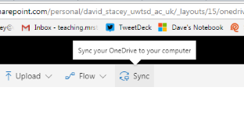
Click on the ‘Sync’ button from OneDrive and follow the steps that follow. Note the instructions will differ depending on which operating system you are using. University IT services may be able to help if you encounter problems with this.

