
BA (Hons) Leadership and Management Skills for the Workplace
LCLM5003 Project Management

Kazi Nelima Begum
Student ID:2330804


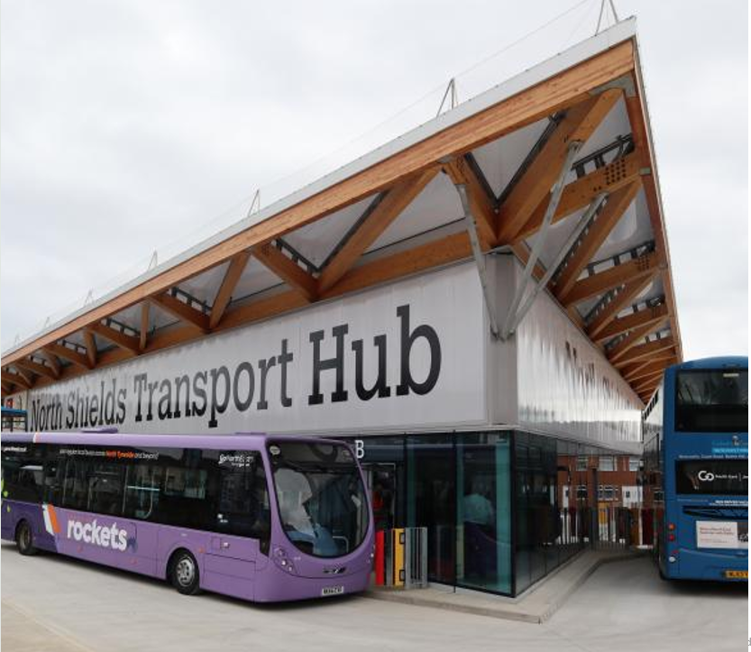
Key Stakeholders
Effective stakeholder management will be ensured through regular communication plans
- Department for Transport (funding & regulation) Local Authority & City Council (project sponsor)
- Transport operators
- Local businesses and community groups
- Contractors, engineers, and consultants
- Environmental agencies
- Passengers and the general public
Scope and Boundaries
Scope includes demolition of unsafe infrastructure, construction of a new hub, integration of rail, bus, and freight systems, and implementation of smart technologies. Out of scope includes city-wide transport upgrades, long-term operations, and unrelated policy reforms
Strategic Value of the Project
This project aligns with national and regional priorities, including the UK Net Zero Strategy. It aims to restore economic productivity by enhancing logistics and commuting efficiency, while also improving environmental performance through the introduction of greener infrastructure. In addition, it seeks to future-proof transport systems by integrating digital innovation. Ultimately, the redevelopment will transform the transport hub into a resilient, sustainable, and user-centred infrastructure asset, strengthening the city’s competitiveness and overall quality of life!
Redevelopment of the Central Transport Hub
High Level Risks & Trade Offs
Key Risks:
- Cost overruns due to inflation and supply chain disruption
- Delays from regulatory approvals and planning permissions
- Public dissatisfaction during prolonged construction
- Environmental compliance challenges
Trade-Offs:
- Balancing speed of delivery vs quality and sustainability
- Increase in technology integration
- Minimising disruption vs construction efficiency
Mitigation strategies include contingency budgeting, phased delivery, and robust monitoring of the project
AIMS and Objectives
The aim is to deliver a safe, modern, and integrated transport hub. Objectives include restoring full transport capacity, ensuring compliance with laws, integrating smart digital systems, reducing carbon emissions, and enhancing passenger experience.
This presents an opportunity to redesign a future ready transport hub that prioritises sustainability, digital innovation, and inclusive urban development. Without intervention, ongoing disruption could negatively impact regional economic growth and public confidence.
The previous transport hub was an outdated facility that no longer met modern accessibility and safety standards. However, its closure has caused severe disruption to commuter travel, supply chains, and local businesses, resulting in economic losses and public dissatisfaction.
Part B – Reflect critically on the feedback received from tutor and peers

The feedback received provided valuable insights into the strengths of the project proposal and highlighted areas that require further development. The feedback confirmed that the poster effectively communicated the need for redeveloping the Central Transport Hub and demonstrated a clear understanding of the project's purpose, stakeholders, risks, and strategic value.
One of the key strengths identified was the project's rationale and its clear link to sustainability, digital innovation, and long-term economic benefits. The feedback recognised that the poster successfully explained how the closure of the outdated transport hub has negatively affected commuters, supply chains, and local businesses, while also presenting the redevelopment as an opportunity to create a modern, inclusive, and environmentally sustainable transport network. The strategic value section was considered particularly effective because it linked the project to wider objectives, such as the UK Net Zero Strategy, improved logistics performance, and enhanced passenger experience. In addition, the identification of key stakeholders and major project risks demonstrated an understanding of the complexities involved in delivering large-scale infrastructure projects.
Despite these strengths, the feedback identified several areas for improvement. The most significant issue was that the project objectives were not sufficiently specific or measurable. While the aims were relevant, they lacked clear targets and timescales. As a result, the revised objectives should utilise SMART framework to ensure they are Specific, Measurable, Achievable, Relevant, and Time-bound.
Another area for improvement concerns the project scope and boundaries. Although the poster outlined what was included and excluded from the project, the feedback suggested that these definitions could be expanded to provide clearer project limits and deliverables. The final project management plan, there should be detailed scope statement, to improve clarity and reduce the risk of scope creep.
The feedback also highlighted the need for greater application of recognised project management tools and techniques. This is an important observation because effective project management requires more than identifying stakeholders and risks; it also involves structured analysis and control mechanisms. The final project plan will consider incorporating a stakeholder power-interest matrix, a detailed risk register, a risk heat map, and a governance framework. These tools will demonstrate a more professional and methodical approach to project planning and monitoring.
Finally, the feedback noted the absence of academic and professional references. To strengthen the credibility and academic rigour of the final submission.
In conclusion, the feedback was highly constructive and has helped identify practical ways to strengthen my final project management plan. By introducing SMART objectives, expanding the scope definition, applying project management tools, and incorporating appropriate references, The final report will provide a more detailed, evidence-based, and professionally structured project plan. This will improve both the quality of the project proposal and its alignment with recognised project management standards.

Contents

1.0 Introduction | P6
2.0 Project Scope | P6
3.0 Scope | P6
4.0 Work Breakdown Structure | P7
5.0 Quad Chart | P9
6.0 Gantt Chart | P9
7.0 Stakeholders involvement | P10
8.0 Allocation of resources | P13
9.0 Risk Analysis | P13
10.0 Conclusion | P15
11Refrences | P16

Table Content
Table 1 | P8
Table 2 | P9
Table 3 | P10
Table 4 | P12
Table 5 | P14

Part C: Project Management Plan
- Introduction
This Project Management Plan has been developed for the Redevelopment of the Central Transport Hub, a strategic infrastructure initiative aimed at replacing an outdated and unsafe transport facility with a modern, integrated, sustainable, and digitally enabled transport hub. The existing facility no longer complies with contemporary safety and accessibility standards, and its closure has caused disruption to commuters, local businesses, and wider supply chains. The plan adopts recognised project management methodologies and techniques. It addresses project scope, work structure, scheduling, stakeholder engagement, resource allocation, risk management, and performance controls necessary to ensure successful project delivery.
Project management is the application of knowledge, skills, tools, and techniques to project activities to meet project requirements Effective project management ensures that projects are delivered within agreed constraints of scope, time, cost, quality, and risk (Kerzner, 2022).

2.0 Project Description
The previous Central Transport Hub had become obsolete due to ageing infrastructure, poor accessibility arrangements, and increasing safety concerns. As a result, the facility was closed, leading to significant disruption across regional transport networks and negatively affecting economic activity.
The redevelopment project seeks to address these challenges by constructing a modern transport facility capable of integrating rail, bus, freight, and digital mobility services while supporting sustainability and future transport demands.
The project aims to deliver a modern and integrated transport hub capable of supporting rail, bus, and freight services while incorporating smart digital technologies and sustainability initiatives. This aligns with contemporary transport infrastructure strategies that emphasise economic growth, environmental responsibility, and user-centred design.
3.0 Scope
The project scope defines the boundaries of work required to deliver project objectives and prevents scope creep throughout implementation (Burke, 2018).
The project includes the delivery of key infrastructure works, beginning with the demolition of unsafe existing facilities, followed by site preparation and any necessary environmental remediation. This will lead to the construction of the new transport hub.
The scope also covers transport integration improvements, including upgrades to rail infrastructure, the development of bus interchange facilities, the provision of freight handling facilities, and the integration of multiple transport modes to enhance connectivity and operational efficiency.
Technology implementation forms another important part of the project. This includes the installation of smart ticketing systems, real-time passenger information systems, intelligent traffic management solutions, and CCTV and security monitoring systems to improve user experience, safety, and operational control.
In addition, the project incorporates several sustainability initiatives. These include the installation of renewable energy systems, the adoption of energy-efficient building designs, the provision of electric vehicle charging infrastructure, and the implementation of sustainable drainage systems to minimise environmental impact and support long-term sustainability objectives.
The project specifically excludes city-wide transport network upgrades, long-term operational management of the completed facilities, national transport policy reforms, and the construction or development of facilities that are unrelated to transport operations.
The scope is subject to several constraints, including budget limitations, regulatory compliance requirements, available construction timeframes, environmental protection regulations, and stakeholder expectations, all of which must be carefully managed throughout the project lifecycle.

4.0 Work Breakdown Structure (WBS)
The Work Breakdown Structure (WBS) is a hierarchical decomposition of project work into manageable work packages that support planning, scheduling, and resource allocation (PMI, 2021).
For the Redevelopment of the Central Transport Hub, the WBS breaks the project into seven major phases, each containing specific tasks necessary to complete the project successfully.

The below table shows the seven phases

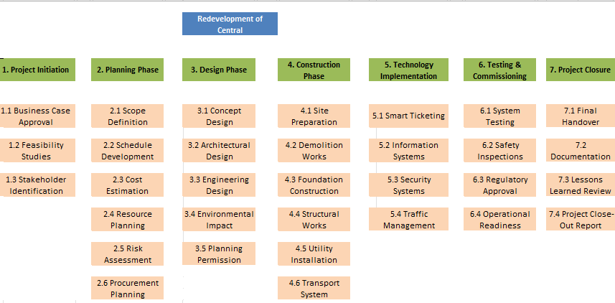
Table 1

The WBS phases help the project team clearly define the overall scope of the redevelopment project by breaking the work into smaller, manageable components. It enables project managers to organise complex activities into structured work packages, making planning and execution more efficient. The WBS also supports more accurate cost estimation and budgeting by identifying all required tasks and resources.
In addition, the structure facilitates effective scheduling and resource allocation, ensuring that project activities are coordinated and delivered in the correct sequence. By providing a detailed breakdown of work, the WBS allows project teams to monitor progress more effectively, identify risks and dependencies at an early stage, and implement appropriate mitigation measures. It also helps clarify roles and responsibilities by assigning specific work packages to project team members, contractors, and other stakeholders.

5.0 Quad Chart
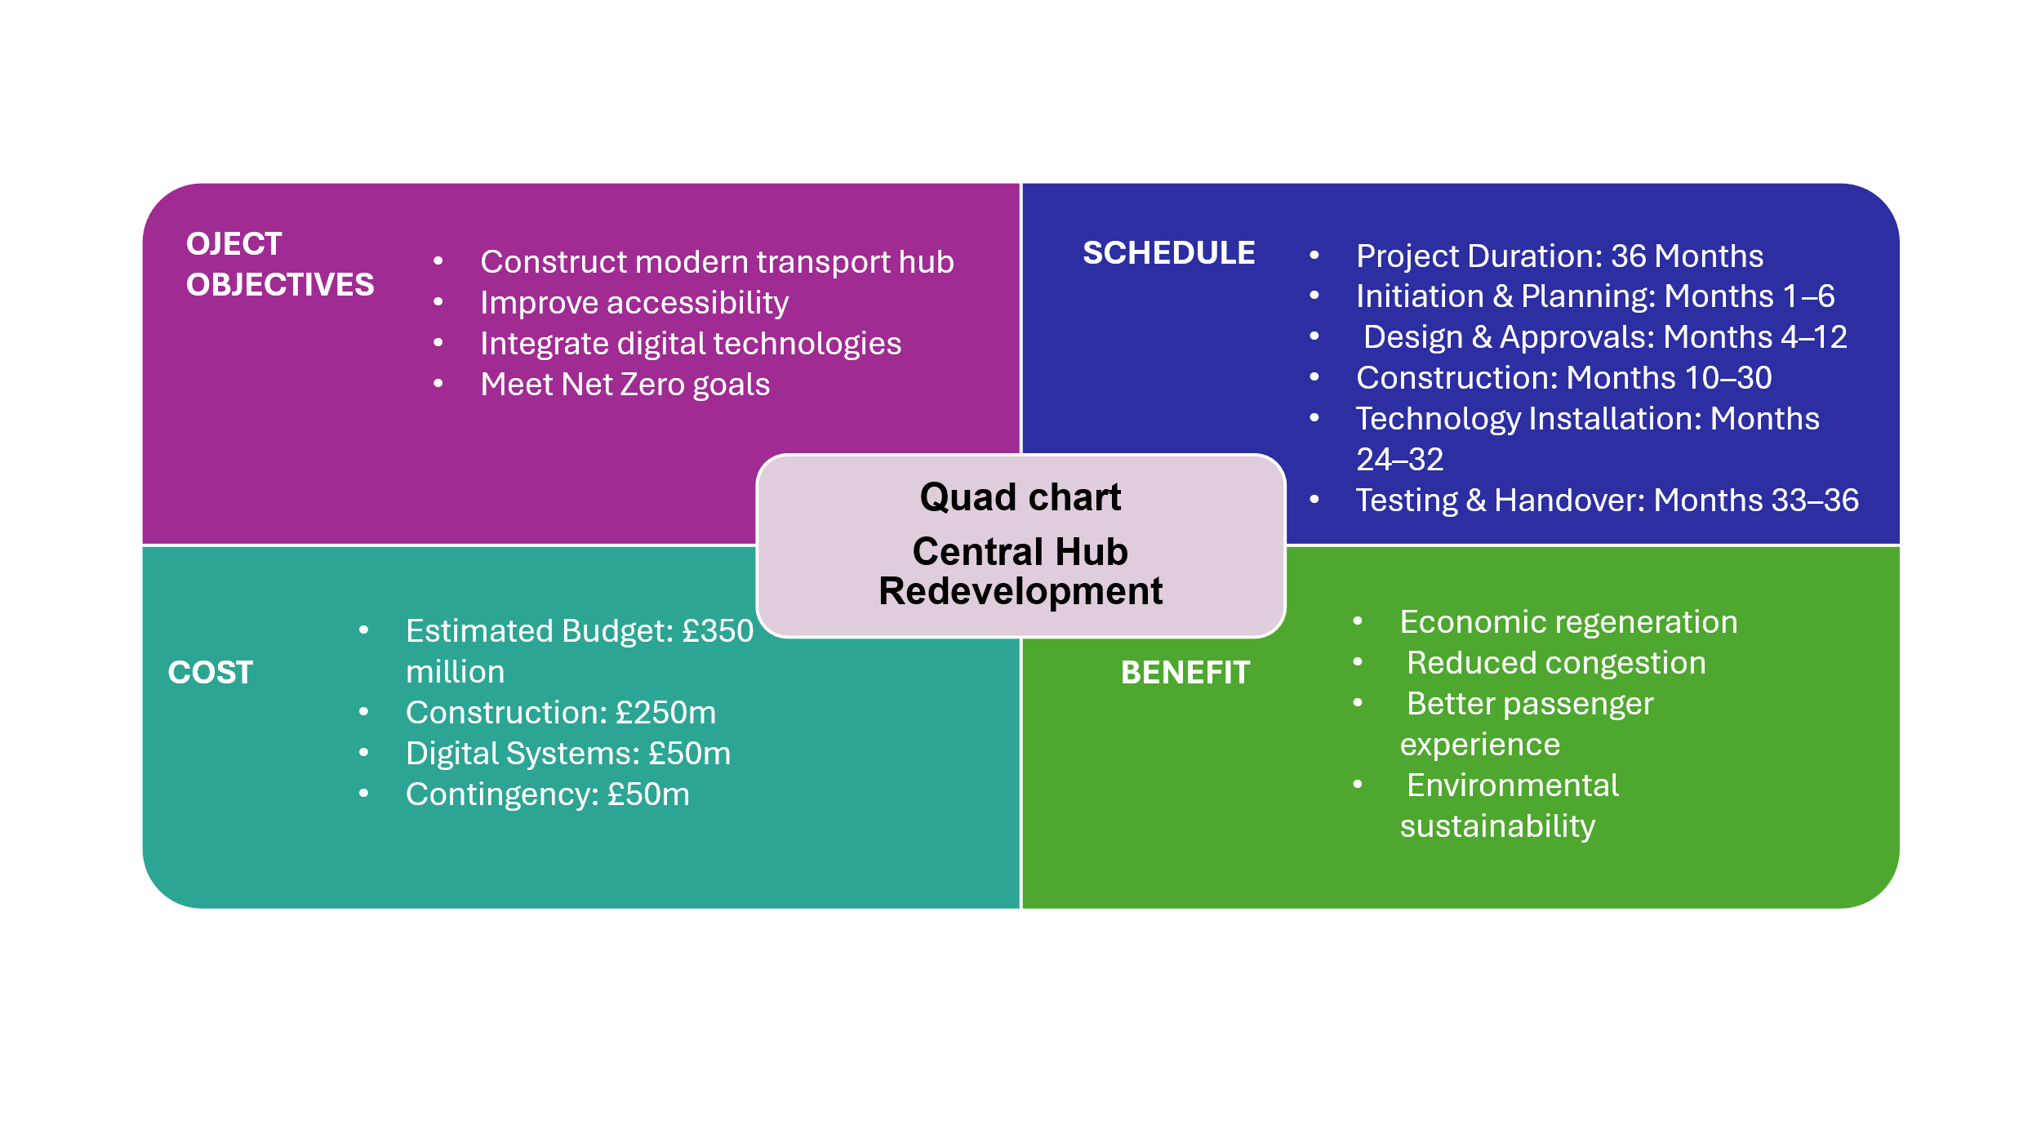
Quad Charts provide a concise visual summary of project objectives, costs, schedule, and expected benefits (Heldman, 2022). It is used to help us clarify exactly what our project is all about.
Below table shows the the Quad chart plan for the redevelopment

Table 2

The Quad Chart confirms that the project is aligned with stakeholder needs, sustainability objectives, and regional development priorities, while providing a concise summary of the key factors necessary for successful project delivery.

6.0 Gantt Chart
A Gantt Chart is a scheduling tool that visually represents project activities and timelines (PMI, 2021). It assists project managers in monitoring progress, identifying dependencies, and managing critical path activities (Kerzner, 2022).
The redevelopment project schedule spans approximately three years, beginning with planning and design activities before progressing through construction, technology installation, testing, and handover phases.
The following table Gantt chart illustrates the key project phases and milestones over a three-year delivery period.

Activity | Y1 Q1 | Y1 Q2 | Y1 Q3 | Y1 Q4 | Y2 Q1 | Y2 Q2 | Y2 Q3 | Y2 Q4 | Y3 Q1 | Y3 Q2 | Y3 Q3 | Y3 Q4
Project Initiation
Planning
Design Development
Approvals
Procurement
Site Preparation
Construction
Technology Installation
Testing & Commissioning
Handover & Closure
Table 3
Blue bars = Standard project activities
Red bars = Critical path activities

The project's critical path comprises approvals, procurement, construction, technology installation, testing and commissioning, and handover activities. These tasks require close monitoring because any delay may impact the planned completion date.

7.0 Stakeholder Involvement

Stakeholder management is one of the most significant success factors in large-scale infrastructure projects (Freeman, 1984;).
A stakeholder is any individual, group, or organisation that is affected by, impacted by, or has an interest in the outcome of a project or initiative. Stakeholders typically include those who are directly or indirectly affected by the project and therefore have a vested interest in its success.
The project's key stakeholders include:
- Department for Transport.
- Local Authority and City Council.
- Transport operators.
- Community groups.
- Environmental agencies.
- Contractors and consultants.
- Local businesses.
- Passengers and the general public

According to Bourne (2016), effective stakeholder engagement improves collaboration, reduces resistance to change, and enhances project outcomes. Regular communication plans, consultation workshops, steering group meetings, and public engagement activities will therefore be implemented throughout the project lifecycle

Involving and communicating with stakeholders is key to the project. This will involve preparing and presenting monthly executive reports to the Project Board, ensuring that strategic updates, key risks, and project performance information are communicated effectively. Weekly progress meetings with contractors will be coordinated and led by the construction manager, who will monitor progress, address operational issues, and ensure delivery milestones are achieved. Monthly steering meetings with the Local Authority will be managed by the Stakeholder Engagement Manager, who will maintain regulatory liaison and provide updates on project developments. The Communications Manager will be responsible for publishing monthly website updates to keep the public informed about project progress, milestones, and any upcoming activities. Quarterly public consultations with community groups will be organised and facilitated by the Community Liaison Officer, who will gather feedback, address concerns, and help maintain positive relationships with local stakeholders.

The below stakeholder analysis table was conducted using the principles of Mendelow's Power Interest Matrix to assess each stakeholder's level of interest, importance, and influence on project outcomes (Mendelow, 1991).

Risk | Probability | Impact | Rating
Department for Transport | Ensuring the project supports national transport policies, delivers value for money, and achieves intended outcomes. | Critical as a funding body and provider of strategic direction. | High
Local Authority and City Council | Improving local infrastructure, economic growth, accessibility, and community well-being. | Essential for planning approvals, policy alignment, and local governance. | High
Transport Operators | Maintaining efficient operations | Important for successful implementation and operation of transport services. | Medium–High
Community Groups | Minimising disruption, protecting local interests, and maximising community benefits. | Important for securing public support | Medium
Environmental Agencies | Ensuring compliance with environmental regulations, | Essential for obtaining environmental approvals | High
Contractors and Consultants | Delivering the project safely, on time, within budget. | Critical for project execution | High
Local Businesses | Maintaining customer access and reducing disruption, | Important for sustaining local economic activity and stakeholder support. | Medium
Passengers and the General Public | Access to reliable, safe, and efficient transport services with improved journey times and connectivity. | Primary beneficiaries of the project and key indicators of project success. | Low–Medium
Table 4

8.0 Allocation of resources
Resource allocation involves assigning human, financial, technological, and physical resources to project activities (Wysocki, 2020).
Resource allocation is a critical component of the project success, ensuring that sufficient personnel, financial resources, equipment, materials, and technology are available throughout the project lifecycle. The project will be supported by a dedicated management team, including the Project Manager for overall delivery, the Design Manager for design coordination, the Construction Manager for site execution, the Risk Manager for risk control, the Procurement Manager for contract and supplier management, the Environmental Manager for sustainability compliance, and the IT Systems Manager for digital infrastructure and technology integration. Financially, the project has an estimated budget of £350 million excluding contingency funding. Key equipment and material resources will include excavators, cranes, construction machinery, smart technology equipment, renewable energy systems, and essential building materials. To ensure efficient resource utilisation and minimise scheduling conflicts, labour demand forecasting will be undertaken, contractor workloads will be balanced across project phases, equipment utilisation rates will be closely monitored, and critical resources will be prioritised to maintain progress and prevent delays.
Risk is managed during resource allocation by identifying and monitoring potential issues that could affect the availability of labour, equipment, materials, and funding. Resource forecasting, workload balancing, and resource levelling are used to prevent shortages, over-allocation, and scheduling conflicts. Contingency budgets and alternative resource plans help mitigate unexpected disruptions, while critical resources are prioritised and regularly reviewed to ensure project objectives are achieved on time and within budget.

9.0 Risk Analysis
Risk management is the systematic process of identifying, assessing, responding to, and monitoring uncertainties that may affect project objectives (PMI, 2021).
The project faces several key risks, including:
- Cost overruns due to inflation
- Supply chain disruptions
- Regulatory approval delays
- Environmental compliance issues
- Public dissatisfaction during construction
According to Ward and Chapman (2008), early identification and proactive management of risks significantly increase the likelihood of project success
The below risk register table identifies potential threats to the project, assesses how likely they are to occur (Probability), the severity of their consequences (Impact), and assigns an overall Risk Rating

Risk | Probability | Impact | Rating
Cost Inflation | High | High | Extreme
Supply Chain Delays | High | High | Extreme
Planning Delays | Medium | High | High
Environmental Compliance Issues | Medium | High | High
Public Opposition | Medium | Medium | Medium
Technology Integration Failure | Low | High | Medium
Contractor Performance Issues | Medium | High | High
Table 5
The most critical risks are Cost Inflation and Supply Chain Delays, both rated Extreme because they are highly likely and could have a major impact on budget and schedule. The next priority risks are Planning Delays, Environmental Compliance Issues, and Contractor Performance Issues, all rated High. Public Opposition and Technology Integration Failure are currently considered Medium risks but still require ongoing monitoring throughout the project lifecycle.
Each significant risk will be assigned to an accountable manager who will review mitigation effectiveness monthly and report through the project governance structure
The project will however manage key risks through proactive planning, strong governance, and continuous monitoring. To address cost overruns, a contingency budget will be maintained, fixed-price contracts used where appropriate, and costs reviewed monthly. Planning delays will be mitigated through early engagement with regulators, a dedicated approvals team, and ongoing legal compliance monitoring.
To reduce supply chain risks, the project will utilise multiple suppliers, strategic stock management, and early procurement of long-lead items. Environmental risks will be controlled through environmental impact assessments, compliance audits, and sustainability monitoring. Stakeholder risks will be managed through transparent communication, community engagement programmes, and public consultation events. (RiskWatch, 2026; McKinsey & Company, 2019)
10. Conclusion
The Redevelopment of the Central Transport Hub represents a major strategic infrastructure project that will deliver significant economic, social, and environmental benefits for the region. Through the replacement of an outdated and unsafe facility, the project aims to restore transport capacity, improve connectivity, enhance passenger experience, and support long-term sustainable growth. The introduction of integrated transport services, smart technologies, and environmentally responsible infrastructure will contribute to improved operational efficiency while supporting wider Net Zero objectives.
This Project Management Plan has established a structured approach for delivering the project by defining clear objectives, scope boundaries, work packages, schedules, stakeholder responsibilities, resource requirements, and risk management procedures. The use of recognised project management practices, including the Work Breakdown Structure (WBS), Gantt scheduling, stakeholder engagement strategies, and risk controls, provides a robust framework for effective governance and decision-making throughout the project lifecycle.
Effective stakeholder engagement, careful resource allocation, and proactive risk management will be critical to the successful delivery of the project. By continuously monitoring performance against cost, time, quality, and sustainability targets, the project team will be able to respond efficiently to emerging challenges and maintain alignment with strategic objectives.
Ultimately, the successful completion of the Central Transport Hub redevelopment will create a modern, safe, accessible, and future-ready transport facility that meets current transport demands while supporting future growth and regional economic regeneration. Through strong leadership, effective planning, and continuous project control, the project is well positioned to achieve its intended outcomes and provide lasting value to passengers, businesses, stakeholders, and the wider community.

11.0 Reference
Mendelow, A.L. (1991) Stakeholder mapping. In: Proceedings of the 2nd International Conference on Information Systems. Cambridge, MA, pp. 10–24.
McKinsey & Company (2019) A practical approach to supply-chain risk management. Available at: https://www.mckinsey.com (Accessed: 18 July 2026)
RiskWatch (2026) Supply Chain Risk Management: The Complete Guide. Available at: https://www.riskwatch.com (Accessed: 16 July 2026)
PMI (2012) Contingency—Are You Covered? Project Management Institute. Available at: https://www.pmi.org (Accessed: 16 July 2026).
PMI (2014) A Model to Develop and Use Risk Contingency Reserve. Project Management Institute. Available at: https://www.pmi.org (Accessed: 18 July 2026
APM (2023) APM Body of Knowledge. 8th edn. Buckinghamshire: Association for Project Management.
Burke, R. (2018) Project Management: Planning and Control Techniques. 6th edn. Chichester: Wiley.
Heldman, K. (2022) Project Management JumpStart. 5th edn. Indianapolis: Wiley.
Kerzner, H. (2022) Project Management: A Systems Approach to Planning, Scheduling and Controlling. 13th edn. Hoboken: Wiley.
Lock, D. (2020) Project Management. 11th edn. London: Routledge.
Maylor, H. (2017) Project Management. 5th edn. Harlow: Pearson.
Meredith, J.R., Mantel, S.J. and Shafer, S.M. (2021) Project Management: A Managerial Approach. 10th edn. Hoboken: Wiley.
Morris, P.W.G. (2013) Reconstructing Project Management. Chichester: Wiley-Blackwell.
Office of Government Commerce (2017) Managing Successful Projects with PRINCE2. 6th edn. London: TSO.
Project Management Institute (PMI) (2021) A Guide to the Project Management Body of Knowledge (PMBOK Guide). 7th edn. Pennsylvania: PMI.
Wysocki, R.K. (2020) Effective Project Management: Traditional, Agile, Extreme. 8th edn. Indianapolis: Wiley.
Winch, G.M. (2024) Managing Construction Projects. 4th edn. Oxford: Wiley-Blackwell.
Ward, S. and Chapman, C. (2008) How to Manage Project Opportunity and Risk. 3rd edn. Chichester: Wiley.

