SAIMA RAHMAN
1922002
PROBLEM SOLVING AND DECISION MAKING
AKINSEYE ALUKO

REPORT

Table of contents

1)Introduction ………………………………………. 3
2)Problem of workplace………………………….4

3)Analyzing information ………………………….5
a. SWOT analysis……………………………….6
b. PESTEL Analysis …………………………….6
c. Fishbone analysis……………………………7

4)rang of alternative solutions…………………8
5)Evaluate the solution……………………………9
6)Implementing the solution………………….10
7)Communicate plan to stakeholders…….11
9)Review and monitoring ………………………12
10)Conclusion …………………………………………13
11)References …………………………………………14
12)Appendix ……………………………………………15

Introduction: problem solving is an analyzing process that used to find or identify the possible solution of the problems in any situation and decision making is also part of the problem solving. Decision making is defining the problem and judgement the choice and then take decision. Problem solving and decision making is an undertaken action of defining a problem, determining the cause of problem, whilst identifying, with in order of importance and selecting a substitute for a solution and administer the solution. (Engel,1997).
This is a very important factor for any workplace or organization. Success and friendly environment in workplace, cannot make automatically, so problem solving and decision-making help to develop this. It can help to develop and progress career opportunities. It is also show lots of skills such as critical thinking, creativity, determination. These skills always find correct and easy solution for any problem not only for employer also for employees.
This report is about some problem that employee faces in the workplace like communication problem, time management training and impact of these problem as well. There is also discuss about the possible solution and analyzing the problem and solution, using SWOT, PESTEL and fishbone concepts. In this report, there are discussion about evaluation of the solution and implemented the solution.

Problem in workplace: every workplace there is some problem that employee and employer face. In this workplace, (care home) employee and employer discuss about problems like communication problem. employees feel there is a communication gap between staff to staff or staff to client or staff to management. It will cause many problems to the workplace. Staff to staff communication problem is staff does not feel comfortable to share their thought or knowledge each other. Staff to client also has communication gap, its look like CARER wants to finish their job and go to next client so there is no relation make between staff and client. Another communication problem is with staff and management. They do not have comfortable and friendly relation because of communication gap. If staff faces any problem in workplace, they do not want to share with management and its causes more problem.
There is another problem come out which is training. Company give training who join new and does not give any more training. Care home there is lots of equipment needs to be moving and holding. Only one day training is not enough for everyone because it is difficult to remember all the instruction. Training also needs for medication to provide correct medication to correct person.
Time management is also creating problem in this workplace. Lots of staff wants to finish their call quickly and run for another call. That is why they could not pay attention to the clients and their personal need. In this report I will discuss about these problems and correct solution of this care home.

Analyzing information: These problems, as mentioned before like communication problem, training and time management issues are really having problem on this organization. Due to communication problem between staff to staff, cannot performed teamwork. In any teamwork staff needs to follow leader or share their option but because of communication gap they cannot give their best. That is why lots of staff does not work as a team they want to do their job individually.
Lack of knowledge and training not only company service user also faces problem. if CARER does not know proper use of the equipment, it will cause lots of incident and its already happened in the past. There is same problem happened in medication as well, which is dangerous for client life. For example, CARER give out of date medication to clients, or give extra dose of medication. This information I also find in the record book.
Lots of CARER has time management problem. they just run from one client to another client’s house. It is also created big problem like clients does not wants any CARER or they do not want to take any service from them. Because they feel neglect and upset. Some CARER does not think about clients feeling or give them parity. That is why company face some big trouble.
The consultant came up with all the problem and it is in the appendix.
- SWOT Analysis: this swot analysis of the communication and training.

1.strength- this gives company positive vibe. Career, management team must need effective communication among them, and this will best advantage for the company to grow and develop. As a result of good communication staff and management care about each other.

2. weakness- In this part company need more alert and careful. Lack of effective communication or communication gap and training company can damage reputation.

3. opportunities- opportunities could be beneficial for the company if given proper training and make a friendly working environment by effective communication among employee and employer.

4. Threat- It will cause company big trouble and loss if there is communication gap and not provide training. Then company not just lost reputation also faces financial problem.

B. Fishbone analysis: The fishbone will help to visually display the many potential causes for a specific problem or effect (Simon.N. D). in here I did fishbone analysis to understand the situation-
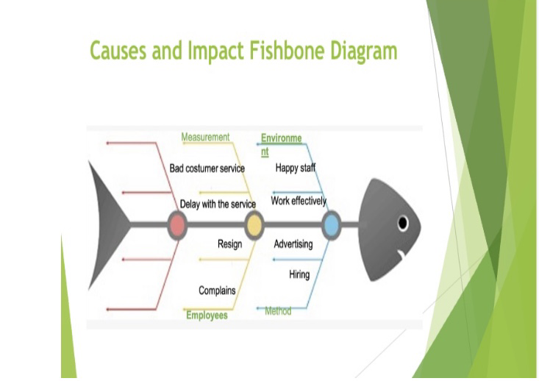
While analysis this situation, I understand that there is lots of changes needed to be done. So that the communication and other problems can be solve. Because of communication gap CARER to CARER and management does not respect each other and it is also affected on teamwork and service user. As a result, this workplace cannot create a friendly environment for employee and employer. So, the company face the bad review and bad clients’ services.

C) PESTEL Analysis: I also used PESTEL analysis along with my previous analysis, for discuss the external impacts of communication problem. the political factor did not affect our company, but it did affect economically. Socially it is also affected as we had good, recognized company so if something negative happen its affect socially as well such as website bad report. However, the technological does not affect our company but environmental impact surely affect in care home. The legal aspect has a great impact on the care home as if service user takes the company to court for safety and life-threatening accident.

RANGE OF ALTERNATIVE SOLUTION: For all these problems purpose, I may have come up with few solutions, which is providing training to everyone in every year, and it will be for all section of staff who involve in care home service. It must be equal rule for everyone. This training not only for equipment it must be for medication as well to make every CARER understand how important medication for clients is, also how dangerous is give wrong medication. Communication gap can be fill up by regular meeting to meet each other and share each other knowledge and experiences, management can give review to CARER for their work. There is some solution for time management like company needs to make strict rule for log in and log out while CARER go for calls to client’s house. They must stay with clients in this fixed time and chart with them to build a trust and good relation.

EVALITION OF THE SOLUTION: After brainstorming, I came up the evaluation that give training and regular meeting was the best solution for the company. I have made this conclusion as in my opinion if the company give proper training and set meeting, then company keep good reputation. Re- training CARER and management team as a result manager will be more flexible in which ways, they can understand CARER and client’s problem, also can find the perfect solution for any problem. same as regular meeting with CARER and management will create fr friendly workplace environment because both employee and employer can take part of share problem and suitable solution as well. I have created my evaluation
solution in chart to explain my opinion. Evaluation solution chart:
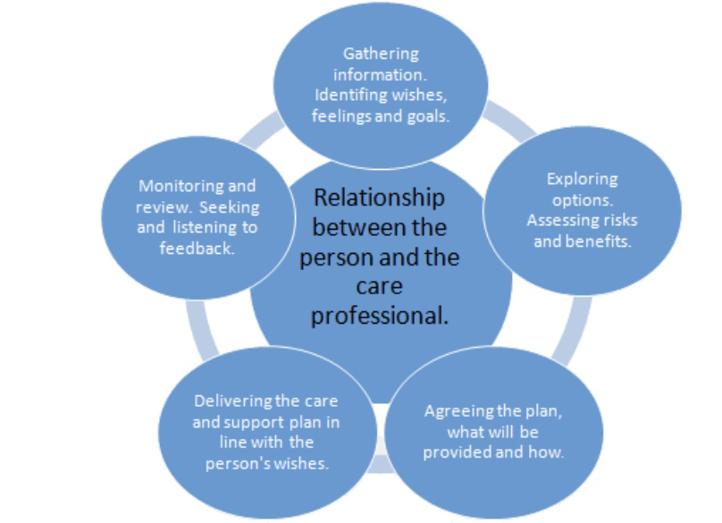
Implementing the solution: To execute this plan, I have to come up with ways of implementing it. To start with, I have designated a chart where I put my opinion like re- traning, communication effectively, time management rule. I also have decided, who would be accountable for who would be responsible to execute this feasible goal, also who and how updates be provided and how often will this happened.

Communication plan to stakeholders: in this situtation, it is vital to understand that carer, management and owner are my stakeholder then later my clients. I need to focuse on the internel stakeholder as it is my intution that is my problem. these is important, as if these are not best or well communicated with then it can affect our externel stakeholders. As a result I will must communicating with these via email and monthly staff meeting.

MONITORING AND REVIEW: Above all of them, it is vital that we implement a time fram by using a monthly strtegy review session. These dates will be set for whole year in advance. We will continue follow this rules to keep a record of our collecting by doing this- we will request feedback by monitoring, questioning and asking service user, carer, management who may be affected by my decisions.

CONCLUSION: In conclusion, re- traning, communication gap and time management are the issues in the workplace. Effective communication is very important for any organization to achieve goal.however, there is lots of skills for improve communication. In this company who has this problem can solve by regular meeting and there anyone share their feeling or experience or suggesion.re- traning also important for all the staff who involve in this company. So that all the staff can do their job profesionlly with out create any harzard. Time managemt problem also can solve by make stric rule that all the must need to follow. All these problem can be create big trouble for this company. So if everyone follow the rule then will be able to create safe aand fair enviroment for staff and service user. As a result we will able to fulfile our goal and make clients and carer happy. Last but not the least, these will make a better working environment, friendly and good qualification staff.

Reference:
- Engel, A (1997). Problems - Solving Strategies.
- Combes Taylor, j, Lashman, R (1994). Practical Problem- solving Skills in the Workplace American management association 1994.
- Johnson (2008). A PESTEL Analysis of the company Siemens.
- Stafford, K (2018). Work the problem: How Experts Tackle Workplace challenges.
- Bowen, P (2016). The Fishbone Diagram Handbook, publisher Emereo pty Limited, 2016.
- Sheila, P (2006) Group and team roles. Available from https://www.skillsyouneed.com (accessed date: March 20, 2021).

APPENDIX:

ROLE PLAY

Istvan: Good morning Saima
My name is ISTVAN, and I am the consultant today representing company problems and we will try to find the solution as well. Thank you so much for attendance today regarding to the consultation.
SAIMA: Good morning ISTVAN.
ISTVAN: SAIMA are you know why we are here for this meeting?
SAIMA: yes, I know. I have few complains about our company.
ISTVAN: correct. We heard about some complains about few things. That is why we arrange this meeting, so as a result we can mark the problems and find the solution as well.
Regarding this topic I asked you some questions. Before we started, I just let you know that all the information or data you will give we will remain these in private and confidential. Is it ok for you?
SAIMA: yes, that is fine for me and I would love to assist you.
ISTVAN: My first question is about communication problems. Can you explain me what is the communication problem in our company?
Saima: well, the communication problem in our company is staff to staff or staff to management or staff to client’s communication. Some staff when go to client house they just wanted to finish their duties or if they get time, they use mobile instead of talking to clients. That is why they fail to build trust relations between them. Sometimes CARER needs to work with team but there is a communication gap, so they do not want to work with team. There are some communication problems between management and staff as well. That is why if staff make any mistake or not sure what to do in some situation, they do not free to talk to management team.
Istvan: off course communication is very important for any organization. But do you think everyone needs to understand that and develop their communication skill?
Saima: There are many ways we can develop communication skills. It is not very useful for only company; it is also valuable for employee and employer as well. So, anyone who has communication problem it is better not to run from it, try to develop it.
Istvan: Istvan as you mention our company has ineffective communication problem with staff or client or management. What do you think that what will be reason behind this, and do you have any idea for this problem solution?
Saima: the reason of poor communication in our company could be anything like frustration, confusion, lack of motivation etc. in my thinking the solution for management and staff communication gap will be give staff review for their work. If their work is not like expected, still give them motivation, or encourage them. Sometimes arrange meeting so staff can meet each other and talk about some problem and solution with them. So, I think it will be a friendly environment for work.

Istvan: we give training everyone who join our company. Then why there is complain about it?
Saima: yes, our company give one day training who join the company but in the care home we need to use lots of equipment every day. it is difficult to memorize all the instruction. That is why some Carers face big problem and it is also harmful for clients as well. So, I think it will be very useful if our company arrange a free training day in every year for everybody.
Istvan: you mention about equipment training but there is also medication training. Do you think it is also important?
Saima: off course medication is very important. If someone ignore or do not give any importance to medicine, then it causes put clints life in danger. So, it is very necessary to explain every CARER how dangerous it could be if someone does not pay attention.
Istvan: there is some issue about time management. Can you please explain what is the time management issue in our company?
Saima: yes, I can explain about that. Some carers just wanted to run from one clint to another. So that they do not do their job properly. Even the client feels unhappy and unsatisfied. That is why some CARER does not want to do teamwork. They do not have patience to wait few minutes for other CARER.
Istvan: it is look like one of the big problems. What will be the better solution for that?
Saima: I am positive about that if management do not solve this problem everyone will be face lots of trouble. I personally think if company make any rule like that maximum and minimum time give to clint and informed that staff must stay in this time otherwise company charge for that. If they finished before their minimum time, they must spend time with clients.
Istvan: thank you Istvan for your cooperation. I believe I find all the information and manage to cover all the topics like training, time management and communication problem. I will mark all our answer and try to apply it. Do you think it will be helpful for our company?
Saima: Thank you Saima. Yes, I believe it will be very useful for our company and for clints and staff as well. I feel great to share my idea and information with you. In the future if you need any help, please let me, I will be happy to help you.
Istvan: I will let you know if we need more information. Now all the information and solution you give us, we will look of it and make a report about it and then we will apply the solution. Bye take care.

