ASSIGNMENT 1: HUMAN RESOURCE MANAGEMENT
Name: Simranjeet kour
Student I'd: 2215780
Program: MBA (Master of business administration)
Module code: LCMB7000
Word count: 2500

Contents
Executive summary 3
1.0 Introduction 4
2.0 The current state of the labour market in the UK 4
2.1 The progress of the UK labour market 4
2.2 Laws regarding labours in the UK 6
2.3 The recent state of the labour market 7
2.4 Obstacles faced by the labours due to external factors 8
3.0 The obstacles faced by human resource management due to COVID 9
3.1 Employee engagement 9
3.2 Employee retention 10
4.0 The current changes in the strategies of human resource management in the post-COVID situation 10
4.1 Personalisation of the employees 11
4.2 Focusing on employee well-being 11
4.3 Upskilling the employee base 12
4.4 Increasing flexibility in the workplace 12
5.0 The obstacles faced by human resource management due to Brexit 12
5.1 Effect of employee absence 12
5.2 Reviewing employment policies 13
5.3 Understanding the new immigration system 13
6.0 The current changes in the strategies of human resource management in the post-Brexit situation 14
6.1 Conducting an audit 14
6.2 Guiding the employees 14
7.0 Conclusion 14
8.0 References 16

Executive summary
Handling human resources properly is very much essential for organisations operating in any country to get maximum productivity from them. Multiple factors influencing the regulation of human capital have been properly discussed in the following report including COVID-19 pandemic and Brexit. The evolution of the labour market in the United Kingdom has briefly been analysed here, which has reflected the contemporary employment scenario in the country. The obstacles in terms of managing human resources have also been illustrated here alongside the implications of multiple employment laws to sustain the proper regulations.

1.0 Introduction
The emerging changes in the rapidly evolving Human Resource Management have been adopting significant strategic plans. The report offers a significant perspective on how human resource management strategies are evolving due to the unprecedented coronavirus virus pandemic. The external working environment of Human resource strategies in the emerging labour market of the United States interprets the need of understanding how human resource practices are changing post-Brexit and coronavirus. The report targets the current state of the UK's labour market.
The underlying legal legislation within the labour market of the UK majorly focuses on the various challenges and obstacles faced by the workforce in the market. The unprecedented and uncertain times of covid-19 pandemic leave the HRM practices of UK-based organisations vulnerable. The report came on strips of how the UK-based organisations are improving their HRM practices in order to address the significant challenge due to the uncertain times of the Coronavirus pandemic. Various strategic advancement has been adopted in UK-based organisations to help because and demonstrate a better strategy recruitment approach in HRM operations. A brief overview of the labour market of the UK and proper regulations of human capital has been clearly obtained from this work.

2.0 The current state of the labour market in the UK

2.1 The progress of the UK labour market
The labour market in the United Kingdom has gone through multiple layers of evolution over the years to reach its current state. The economic condition of the country has a direct influence in terms of controlling the labour market. Full employment became mainstream in the United Kingdom and other developed countries between 1950 and 1966 to fill out the gap of existing frictional and cyclical unemployment (Carnevale and Hatak, 2020). Frictional unemployment accounts for 3-4% of the entire workforce, which goes unused. This figure started changing over the years.
The number of existing employees increased by a large margin at the current size of the recruited labour market and is estimated at a figure of approximately 30 million by the end of August 2022 with a stunning increase of roughly 74000 from the last quarter. The current number of job vacancies in the United Kingdom is figured at 1.3 billion approximately, which is a decrease from the last quarter by a margin of approximately 20000 (Mahapatro, 2022). The constant changes in the employment rate and fancy creation are a result of multiple contemporary political and environmental scenarios such as Brexit and covid-19 pandemic respectively. The political environment has always influenced the labour market to reshape the productivity levels and economic growth of a country to a greater extent. Due to the covid-19 pandemic, job vacancies fell to an all-time low in June 2020.
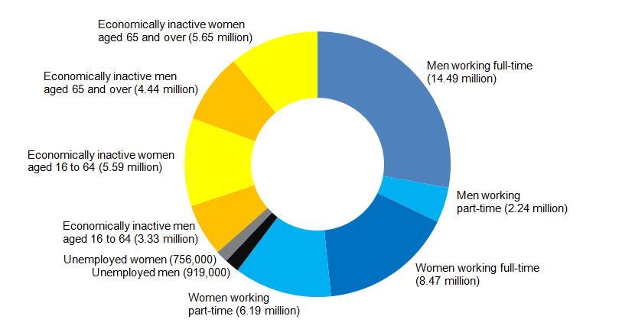
Figure 1: UK labour market
(Source: Mahapatro, 2022)

2.2 Laws regarding labours in the UK
Different laws and regulations are implemented in the labour market of the United Kingdom to regulate human capital properly by maintaining all the basic human rights.
National minimum wage act 1998: The organisations operating in the UK are liable to pay a minimum wage to the existing employees so that they can sustain basic life. The minimum average pay scale in the UK is £9.50 per hour for 23 years old and above from April 2022 (Mahapatro, 2022). It is also termed the National living wage, which is to be provided by the companies.
Equality act 2010: It is implied when recruiters hire new candidates for any job designation and any kind of discrimination between the candidates and the existing employees is completely to be diminished within the implication of this law (Minbaeva, 2018). The working environment should always be free from gender, race or disability to create proper harmony to maintain productivity levels in the workplace.
Health and safety at work act 1974: This law ensures the complete safety of the existing employees at the workplace and it also covers the medical aspects of the employees as well. Any form of workplace harassment is also mitigated in this law to keep the mental well-being of the employees intact alongside their physical well-being.
The existing legislation regarding employment in the labour market of the United Kingdom keeps human rights unaffected by providing them with proper pay, leaves, working hours, disciplinary procedures etc. (De Mauro et al., 2018). It is very evident that the established laws from the UK Government to sustain the human working capital properly regulate the labour market in the United Kingdom.

2.3 The recent state of the labour market
The Global management operation has been deteriorating due to the sudden advent of the coronavirus and make. The Global labour market has significant challenges due to the government-imposed social distancing measures and significant restrictions in order to contain the spread of the contagious virus (Gallardo-Gallardo et al., 2020). It has a significant impact on the labour market that leads the Global labour market to face tremendous challenges. This includes unemployment issues and degrading economic stability across the globe. The postcode management operation has involved the organisational bodies to impress and implement logical advancement and improved HRM practices. The current economic condition across the globe has been influencing the labour market while designing and implementing significant labour regulations, labour market programs and income protection policies. Social inclusion and personal fulfilment have been the most significant approach that interprets social identity to accomplish economic independence in the Global marketplace. The post-COVID Global marketplace has significantly witnessed a structural shift and transition that enabled the organisation to receive the world of economic interference (Singh and El-Kassar, 2019). The development and generation of paradigm shifts would be based on the accelerating technology evolution in management.
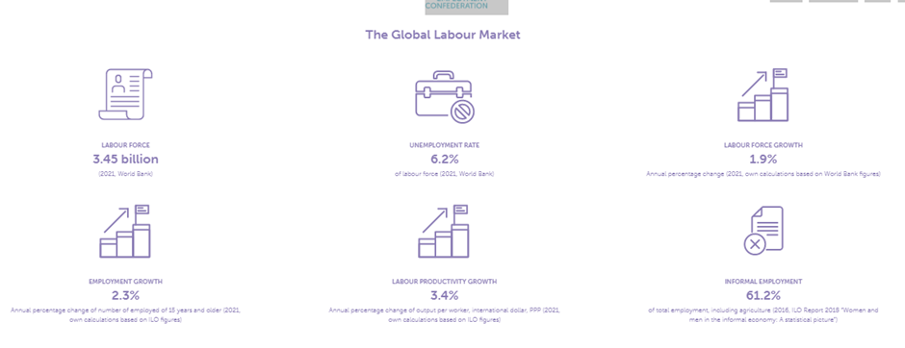
Figure 2: Current state of the UK in the labour market
(Source: Singh and El-Kassar)
According to the confederation of world employment, the 3.45 billion labour force has been investing in management strategies. The rate of unemployment suggests a 6.2% labour force according to the reports of the World Bank of 2021. 1.9% growth has been identified in the labour force according to the annual percentage change in 2021. Employment growth has been identified to be 2.3%, which also experiences 3.4% labour product activity improvement and growth in the business (Hamouche, 2020). 61.2% of informal employment has been observed in the marketplace which articulates how the economic and social viability is highly influenced by the current labelled market that is globally accepted.

2.4 Obstacles faced by the labours due to external factors
The advent of the coronavirus pandemic has hit the labour market globally and has experienced significant challenges in the whole operation. The uncertain and unprecedented outbreak of the COVID-19 pandemic caused the whole operation to reflect upon the economic stability in the UK market.
Unemployment: The advent of this Global pandemic situation has caused the UK market to witness a significant and great depression. This results in an accelerating unemployment rate across the UK market due to the imposed governmental restrictions and social distancing measures (Shore et al., 2018). Physical business operation has been inhibited due to the unprecedented and uncertain advent of the global pandemic. Unemployment in the UK rose by almost 400,000.
Job loss: The UK labour market has suffered from unemployment. Employment opportunities started to decrease due to these global uncertainties. It also resulted in job loss and huge employee layoffs due to this significant situation.
Brexit has been the most important aspect that purposely changed employment opportunities and management strategy to change.
Labour shortage: During the ongoing impact of Brexit on the management, strategies of the UK articulated how the labour shortage can be detrimental for a business to expand and grow. The EU workers are restricted to avail the opportunity of organisations (Sima et al., 2020). It has been the most significant issue and threat. It suggests outmigration approaches that significantly reduced the number of available workers in the UK market.

3.0 The obstacles faced by human resource management due to COVID
The Global pandemic has impacted the entire HRM practices in organisations. HRM is considered and recognised as the foundation, which is a part of organizational management strategy (Boon et al., 2019). It targets to improvise and monitor operational practices towards employee engagement, customer satisfaction and other significant approaches towards improving the operational practices.

3.1 Employee engagement
Employee engagement is another significant challenge that caused the HR managers due to the restriction of physical work practices. The new normal during this time would have been the most competitive challenge to retail and satisfy the workforce. The employee engagement program has been disrupted due to this unprecedented time (Carter et al., 2018). The government imposed restrictions on organisations enabling the HR practices to have significant and threatening implications on continuing effective interaction, open communication, training and development programs and employee retention.
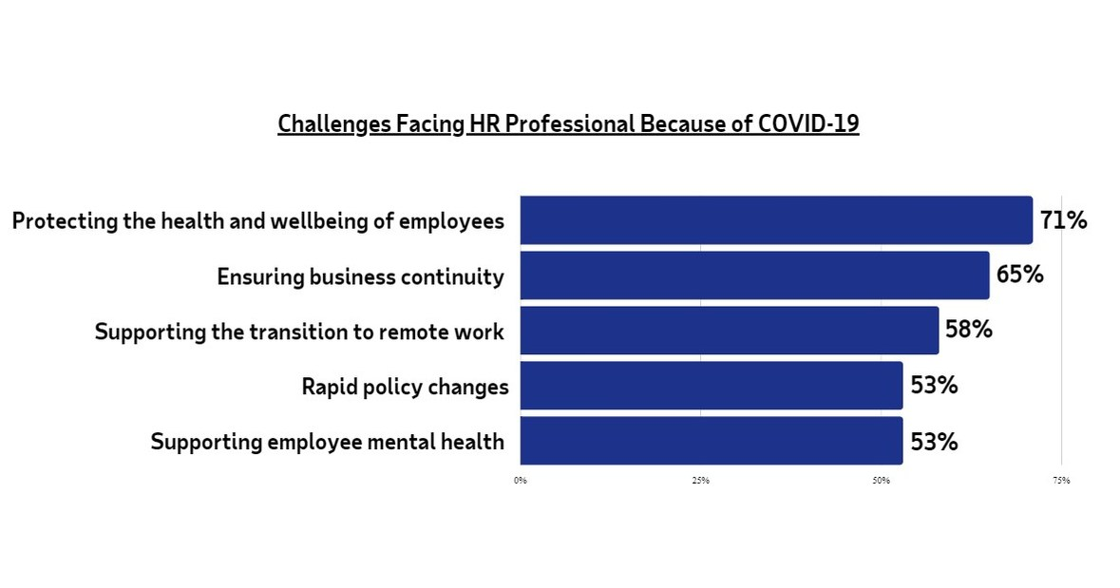
Figure 3: Challenges faced by HR professionals during the COVID outbreak
(Source: Carter et al., 2018)

3.2 Employee retention
Employee retention is another significant challenge that has been impacting the operational practices of the organisation. The dissatisfied workforce attempts to resort to other organisations to improve their working experience during this uncertain time (Mensah, 2019). The lack of health coverage from the organisations during this advert of the coronavirus pandemic made the operational workforce vulnerable.
Adopting remote working practices
Significant management challenges in adapting work-from-home practices are degrading the work culture. HRM practices faced tremendous challenges in managing the paradigm shift due to the emergence of various government-imposed restrictions in these uncertain times.

4.0 The current changes in the strategies of human resource management in the post-COVID situation
The human resource management of business organisations has faced major challenges due to the Covid-19 pandemic (Wikhamn, 2019). It is essential for the management to implement effective strategies to overcome the adverse consequences of the pandemic in an efficient manner.

4.1 Personalisation of the employees
It is essential for the human resource management of an organisation to provide the employees with an opportunity to share their unique perspectives in the workplace. The management is starting to provide personalised benefits to the employees in order to improve their productivity in a proper manner (Gonzalez and de Melo, 2018). The benefits are paired up with individualised online porters, which enable the employees to review the benefits and handle their own needs in the work environment. A wide array of options can be provided to employees in order to improve their performance in the workplace.

4.2 Focusing on employee well-being
The employees have faced anxiety and stress due to the sudden outbreak of the covid-19 pandemic. It is important for human resource management to focus on the mental well-being of their employees (Cooke, 2018). The different aspects of employee well-being including economic security and mental health should be provided to the workforce by the organisations operating in the UK market.
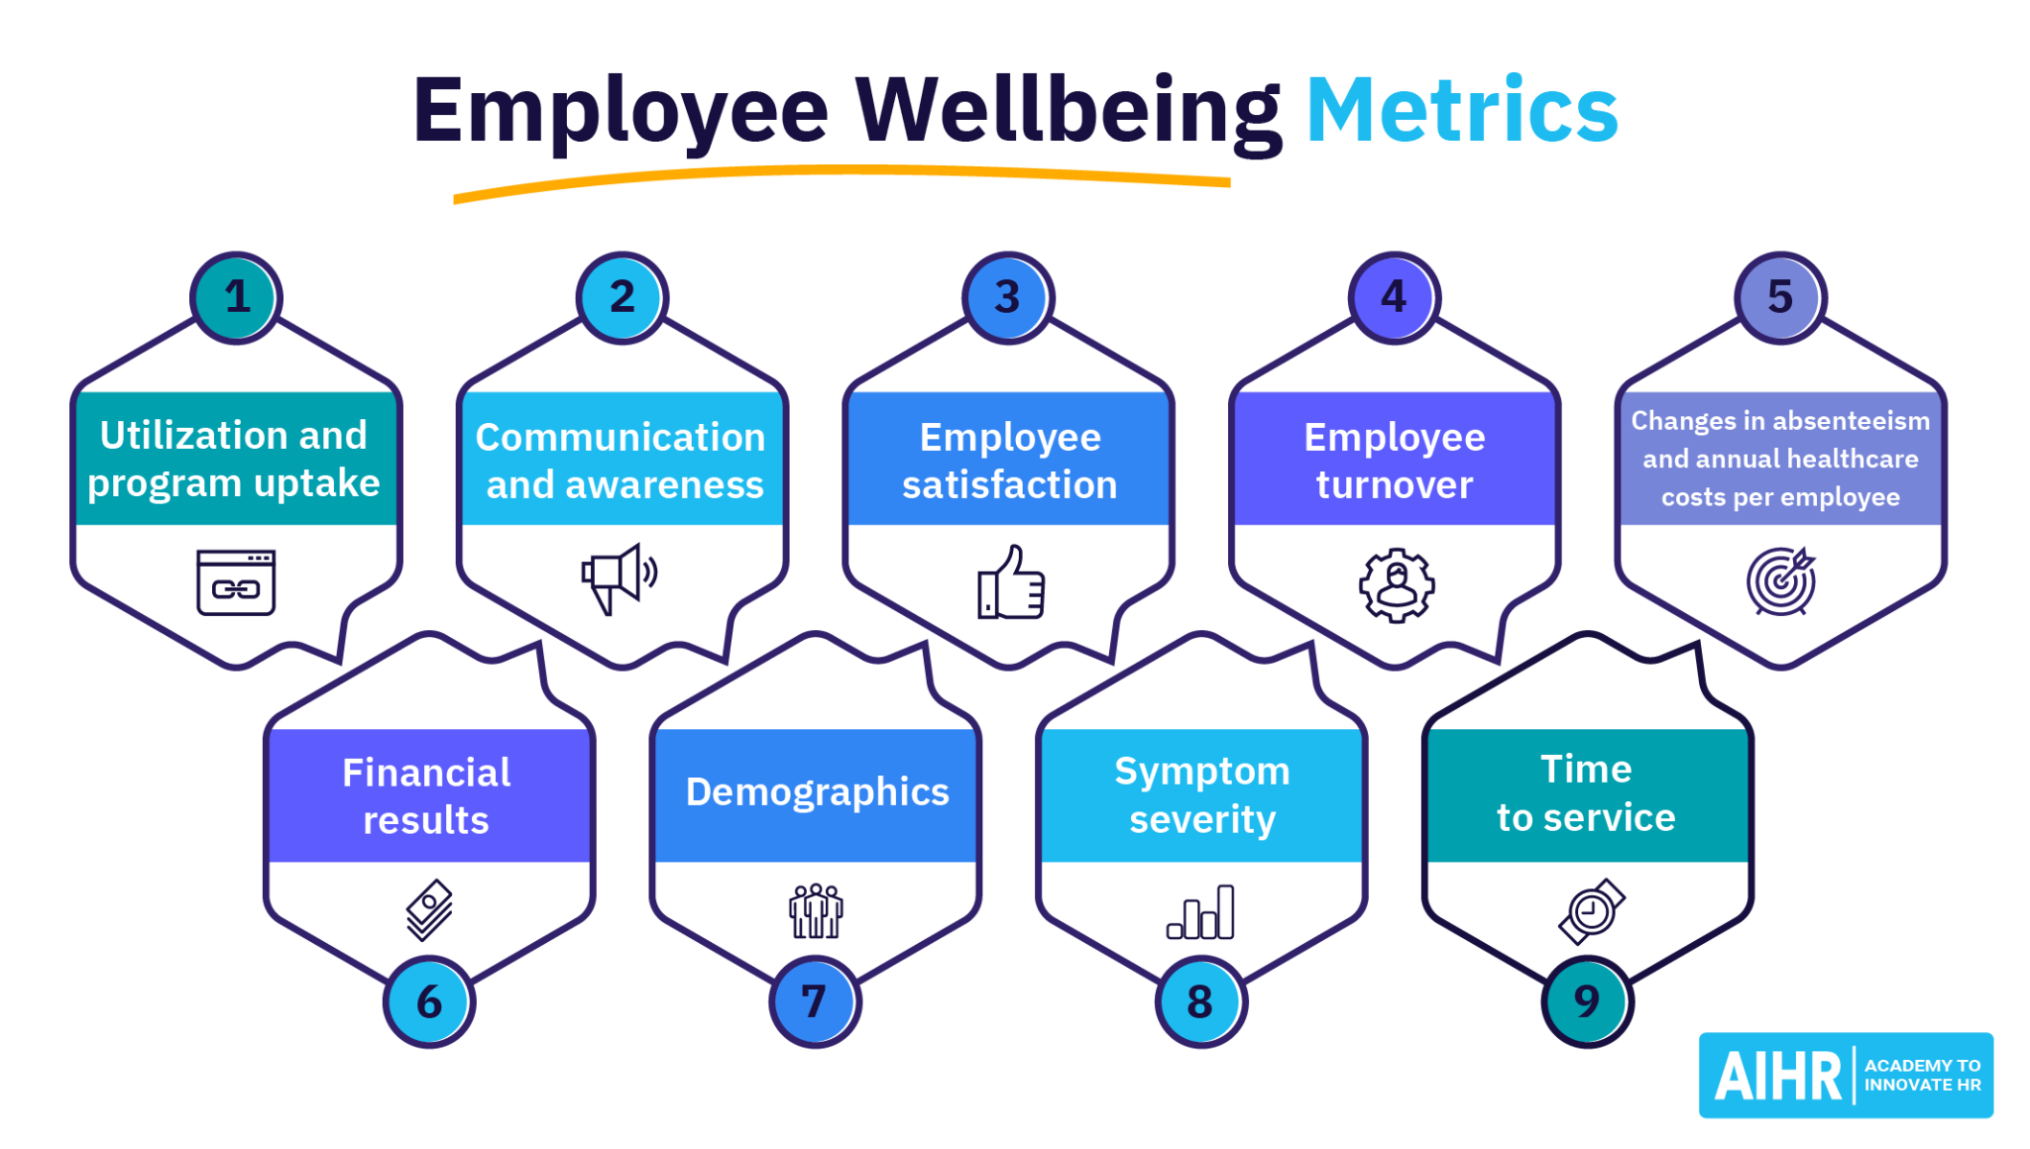
Figure 4: Employee well-being metrics
(Source: Cooke, 2018)

4.3 Upskilling the employee base
The personalization of the employee base can help human resource management to develop the scales of the employees in a proper manner. Up-skilling can effectively improve productivity, which can make the employees feel appreciated within the work environment (Minbaeva, 2018). It is important to provide employees with an opportunity to grow in the workplace, which can improve the overall business growth of any organisation.

4.4 Increasing flexibility in the workplace
During the Covid-19 pandemic, the landscape of the workplace has fluctuated to a great extent. The employees had to follow the pandemic protocols different from the standard office hours. The policies of the organisations operating in the UK have changed time and provided a proper flexible work environment for the employees (De Mauro et al., 2018). The flexibility has helped the employees to improve their performance in the workplace in a proper manner.

5.0 The obstacles faced by human resource management due to Brexit
Brexit has brought major challenges to the human resource management of the organisations operating in the UK market. It is essential for HR managers to analyse the obstacles to implementing effective strategies.

5.1 Effect of employee absence
Due to the political turbulence of Brexit, the UK labour market has faced significant consequences of employee absence. The ability of individual employees to obtain a stable status has become difficult due to the political instability in the UK (Boon et al., 2019). Therefore, the absence of employees has affected the business operations of the organisations to a great extent.

5.2 Reviewing employment policies
It is important for human resource management to review the employment policies and the immigration audit in a proper manner. The policies regarding inclusion and diversity need to be considered. Business organisations might face difficulties to recruit skilled employees without proper consideration of the various employment policies, which can be time-consuming.

Figure 5: Importance of HR policies
(Source: Boon et al., 2019)

5.3 Understanding the new immigration system
The UK immigration system needs to be analysed by human resource management in order to provide the employees with the necessary benefits. The recruitment process should be conducted according to the policies of the new UK immigration system (Singh and El-Kassar). It is important for human resource management to develop effective strategies which can overcome the adverse situation of Brexit in a proper manner.

6.0 The current changes in the strategies of human resource management in the post-Brexit situation
The effective strategies of Human Resource Management can help business organisations to overcome the negative consequences of the post-Brexit situation.

6.1 Conducting an audit
It is essential for human resource management to properly develop an audit for the workforce. This process can help the HR managers to make a proper assessment of the employees (Gonzalez and de Melo, 2018). The management along with the managers, which can improve the auditing process effectively, should consider tax implications for the individuals.

6.2 Guiding the employees
Human resource management needs to guide the employees in the advert situation to overcome the negative issues. Providing effective training and development programmes can help the employees to utilise the opportunities of upskilling themselves within the work environment. It is important to keep the training programs up to date with the latest regulations mandated by the government and advanced technology (Carnevale and Hatak, 2020). This way the organisations are able to improve the productivity of the employees in a proper manner to increase profitability.

7.0 Conclusion
The report will focus on the different aspects of the UK labour market and the significance of Human Resource Management. The human resource management of a business organisation handles the selection, recruitment, training and development of employees. The development of effective policies has been analysed in terms of external adverse situations faced by the organisation. In this report, the evolution of the UK labour market has been discussed along with the laws related to labour. The recent state of the labour market has been analysed in this report. Due to covid-19 pandemic and the political turbulence of Brexit the UK labour market has faced major challenges which have been discussed in this report. Due to both external issues, human resource management has faced major changes. It is essential for human resource management to adopt effective and improved strategies in order to overcome the post-COVID and post-Brexit situations.

8.0 References
Boon, C., Den Hartog, D.N. and Lepak, D.P., (2019). A systematic review of human resource management systems and their measurement. Journal of management, 45(6), pp.2498-2537.
Carnevale, J.B. and Hatak, I., (2020). Employee adjustment and well-being in the era of COVID-19: Implications for human resource management. Journal of business research, 116, pp.183-187.
Carter, W.R., Nesbit, P.L., Badham, R.J., Parker, S.K. and Sung, L.K., (2018). The effects of employee engagement and self-efficacy on job performance: a longitudinal field study. The international journal of human resource management, 29(17), pp.2483-2502.
Cooke, F.L., (2018). Concepts, contexts, and mindsets: Putting human resource management research in perspectives. Human Resource Management Journal, 28(1), pp.1-13.
De Mauro, A., Greco, M., Grimaldi, M. and Ritala, P., (2018). Human resources for Big Data professions: A systematic classification of job roles and required skill sets. Information Processing & Management, 54(5), pp.807-817.
Gallardo-Gallardo, E., Thunnissen, M. and Scullion, H., (2020). Talent management: context matters. The International Journal of Human Resource Management, 31(4), pp.457-473.
Gonzalez, R.V.D. and de Melo, T.M., (2018). The effects of organization context on knowledge exploration and exploitation. Journal of Business Research, 90, pp.215-225.
Hamouche, S., (2020). COVID-19 and employees’ mental health: stressors, moderators and agenda for organizational actions. Emerald Open Research, 2.
Mahapatro, B.B., (2022). Human resource management. PG Department of Business Management.
Mensah, J., (2019). Sustainable development: Meaning, history, principles, pillars, and implications for human action: Literature review. Cogent social sciences, 5(1), p.1653531.
Minbaeva, D.B., (2018). Building credible human capital analytics for organizational competitive advantage. Human Resource Management, 57(3), pp.701-713.
Shore, L.M., Cleveland, J.N. and Sanchez, D., (2018). Inclusive workplaces: A review and model. Human Resource Management Review, 28(2), pp.176-189.
Sima, V., Gheorghe, I.G., Subić, J. and Nancu, D., (2020). Influences of the industry 4.0 revolution on the human capital development and consumer behavior: A systematic review. Sustainability, 12(10), p.4035.
Singh, S.K. and El-Kassar, A.N., (2019). Role of big data analytics in developing sustainable capabilities. Journal of cleaner production, 213, pp.1264-1273.
Wikhamn, W., (2019). Innovation, sustainable HRM and customer satisfaction. International Journal of Hospitality Management, 76, pp.102-110.

