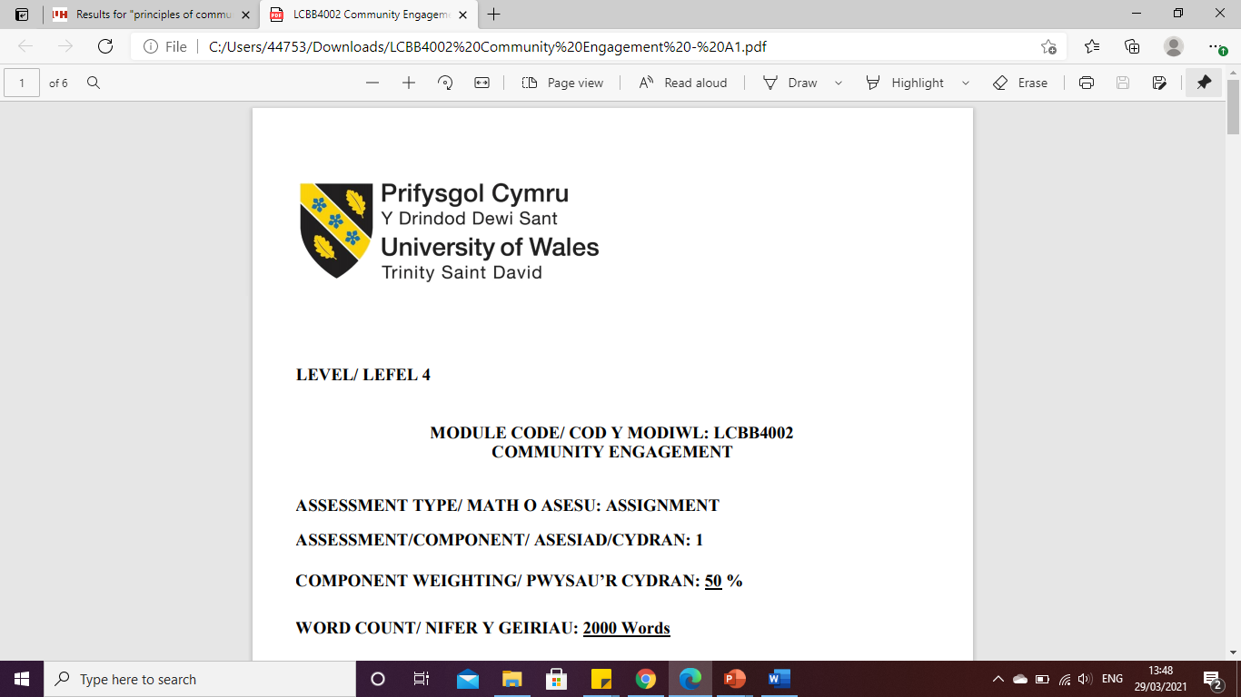

LEVEL 4

Analysis and Evaluation- ZARA
MODULE CODE: LCBB4004
Marketing Fundamentals

ASSESSMENT TYPE: ASSIGNMENT
ASSESSMENT/COMPONENT: 2
COMPONENT WEIGHTING: 70 %
WORD COUNT: 3494 Words
SUBMISSION DETAILS:
Name: Cosmin Adrian Mitu
Student Number: 2021613

Table of Contents
1. Introduction 3
2. Background context of the research 3
2.1. Background of the company 4
2.2. Mission 4
2.3. Vision 4
3. Rationale 4
4. Aim and objectives 5
5. Organizational background in marketing 5
5.1 Stages of marketing 5
5.2 Marketing environment and situational analysis 6
5.3 STP analysis 7
5.3.1. Segmentation 7
5.3.2 Targeting best customers 7
5.3.3 Position offering 7
6. Identification and analysis of issues 8
6.1. International production issues in Zara during pandemics 8
6.2. Lack of technical operators 8
6.3. Effective communication issues 9
6.4. Changed governmental policies 9
7. Analysis of the organization 10
7.1 Internal analysis 10
7.2 External analysis (Porter's five forces) 11
8. Theoretical approaches 13
8.1. Network theory 13
8.2. Maslow’s hierarchy of need theory 14
9. Recommendations 14
9.1. Implementation of KPI 14
9.2. Integration of digital transformations 14
10. Conclusion 15
References 16

1. Introduction
Marketing is observed as one of the most important factors within an organization as it helps in advertising the products and services of the company in such a Manner that a large value base of customers can get aware about the products and services. This helps in enhancing the growth rate and sales of the company. It has also been found that marketing depends on several factors such as segmentation of the organization. Zara has been observed as one of the most renowned organizations within the UK. In this regard, Zara has been chosen for this assessment for discussing its stages of marketing along with critically analysing the marketing mix of the company. The discussions are also going to be made on internal and external analysis of the organization to understand the impact of covid-19 on its performance as well as sales.

2. Background context of the research
Market research has demonstrated that covid-19 has negatively affected all organizations globally in terms of lowering down its growth rate. This has been found to be happening due to the pandemic situation created in covid-19. Zara is a Fashion retail company of the UK that produces stylish and modern costumes for men, women and children. Market research has demonstrated that the company had the maximum brand value in the year 2018 which was 18,424 billion US dollars and declined to 13,156 billion US dollars in the year 2021 due to pandemics disruption in bsuiness (Zara.com, 2021). However, it has been identified that Zara of the UK also suffered from several issues such as operational maintenance, customer’s delivery maintenance, shoring up cash and liquidity maintenance. This has been found to be negatively influencing the growth rate of the company in terms of lowering down its sales by 14%. In this regard, the managers of Zara have been found to be making home delivery protocols through delivering products and services to the customers at their residence along with keeping safe distance from the customers (Zara.com, 2021). All covid-19 rules and regulations were also observed to be maintained by the managers of Zara at the time of developing protocols for home delivery of their services. This has helped the company to tackle the issues that have happened due to covid-19 in terms of lack of growth and revenues.

2.1. Background of the company

Zara is observed as a multinational company of the UK, which is located in almost 190 countries all across the globe. It has been identified that low cost strategy is integrated within this company to create good quality products and long-term value (Zara.com, 2021).

2.2. Mission
Mission of the company is associated with adding vitality to the people’s lives by fulfilling everyday needs and requirements of customers and fulfil their demands faster than anyone else (Zara.com, 2021). The company aims to offer simplistic, concise and straightforward statement to provide distinguished products and improve the lifestyles of people.

2.3. Vision
Vision of the company is associated with providing enhanced quality products and services to the customers all across the globe in such a manner that it can fulfil their needs and requirements (statista.com, 2021).

3. Rationale
The research has demonstrated that several issues in terms of operational management, customer management, project management, innovation management and many more activities of the organization have negatively been affected during the era of covid-19 all across the globe. In this regard, the research has also illustrated that Zara has also suffered a loss of 14% lowering down to the sales rate of the company during the pandemic situation (Slack et al. 2016). This has been observed to be associated due to lack of operational management staff as well as lower technical operators. It has also been identified that a lack of technical operators were available to Zara during the situation as physical stores shutting down. In this regard, the managers of Zara decided to provide home delivery to their customers according to their needs and requirements along with maintaining all the protocols of covid-19. It has also been identified from the research that virtual operations of the organization started to be processed within the company that held the managers of company to maintain its sales and revenues even during the era of covid-19.

4. Aim and objectives
Aim
The aim of this assessment is observed to be associated with critically analysing the internal and external factors of Zara along with proper justification and evidence in relation to covid-19.
Objectives
- To understand internal and external factors of Zara that has impacted due to covid-19 situation
- To analyse the STP factors and marketing mix of the company
- Analyse issues during the era of pandemic within the Zara of the UK
- To demonstrate effective solutions based on issues

5. Organizational background in marketing

5.1 Stages of marketing
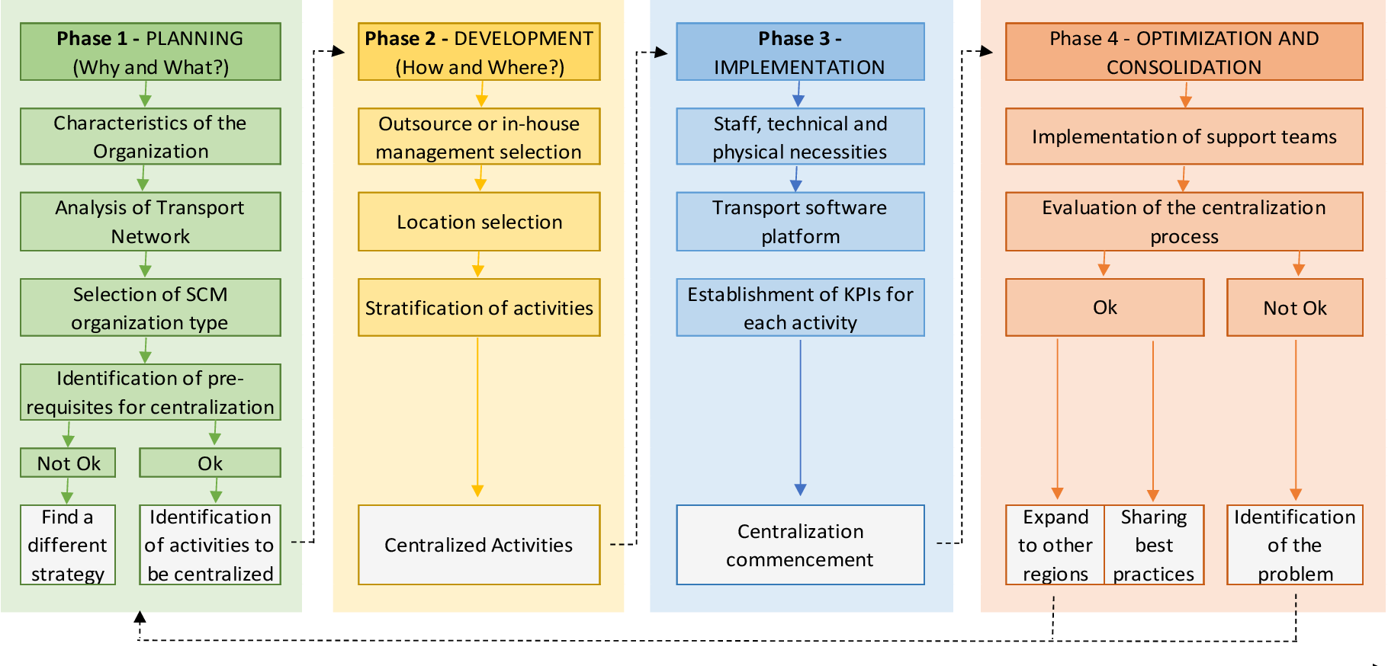
Figure 1: Stages of marketing
(Source: Zara.com, 2021)
It has been analysed from the market study that the respective company is having four stages involved with the marketing process that includes planning, development, implementation, optimization and consolidation. The research has also demonstrated that the company is having several substations within each of the main stages that includes a proper execution of the programming (Fernie and Sparks, 2018). In this regard, it has been identified that these stages help the managers of the company to enhance their value base of customers along with getting enhanced market growth. Planning stage of this company is associated with analyzing the transport network, needs of customers, identification of prerequisites for centralization, and implementation of effective strategy. The development stage of marketing is focused on selection of activities, location selecting for marketing, and outsource in-house management selection for centralized activities.
Stage 3 consists of transport software platform, staff, and technical and physical necessities analysis for centralized commencement. Lastly, the optimization and consolidation stage consists of implementation of support items, evaluation of centralized processes and evaluation of the whole process (Goworek et al. 2020). The marketing managers of Zara maintain these stages of marketing so that on time delivery of the products can be done.

5.2 Marketing environment and situational analysis
Marketing environment
It has been identified from the market study that the marketing environment of Zara depends on several factors: demographic factors, natural factors, economic factors, political factors, technology factors and cultural factors. In this regard, the managers of Zara have been found to be associated with providing first preferences to the demographic factors while doing any marketing for certain products and services (Papadopoulos et al. 2020). The demographic factors are observed to be associated with the human population in terms of location, size, age, gender, race, occupation and many more. In this regard, considerations of this factor have also helped the managers of Zara to cope up with the covid-19 changes.
The research has also demonstrated that economic factors of the organization are considered through focusing on the buying patterns of the customer according to their salary, policies and nature of economy within Zara (Zara.com, 2021). On the other hand, the technological environment has been implemented within the respective organization through considering the innovative techniques within the organization as per the requirement of customers in a certain place.

5.3 STP analysis
It has been observed from the research that STP is the process of marketing in targeting Zara through which segmentation of market, position offering, and targeting best customers are done.

5.3.1. Segmentation
Segmentation of the market in Zara is done through several factor focusing such as demongraohiocs, behavioural, psychographic, geographic, and behavioural. It has been observed that 2-55 years of people including all gender and low to high-income range are targeted by Zara (Zara.com, 2021). Zara is located in almost 190 countries all across the globe through which people of all ethnicities are considered. All skin type people who have a low to high lifestyle are considered. This has also helped the managers of this company to cope up with the challenges faced during pandemic situations.

5.3.2 Targeting best customers
This factor is implemented within Zara in such a manner that the particular region where the company is located of providing services contains high population growth according to their segmentation. In this regard, it has also made it easier for the managers of this company to cope up with the challenges faced during pandemic situations.

5.3.3 Position offering
Position offering of Zara will be done through analysing four P’s of marketing mix.

Product
It has been found that several products are provided to the customers who are targeted within Zara that consist of clothing, accessories, perfumes, beauty products, shoes, swimwears and many others. This targeting of the company has helped it to attain higher revenue in the market even during the era of pandemics (Zara.com, 2021).
Price
The research has illustrated that the price of products within the respective company is considered in such a manner that all income ranges of people from low to high can afford it effectively. However, the range of products starts from $2-$398 dollars (Zara.com, 2021).
Place
The study has demonstrated that almost 190 countries are observed to be covered by Zara in terms of providing products to the people of these countries. The managers of the company target China, Middle East, UK, USA, Australia, India, Netherlands and many more countries.
Promotion
The research has demonstrated that the company is observed to be including several factors of promotional activities that includes social media advertisement, campoagin, billboard advertisement, TVC in ABC and BBC, newspaper advertisement, banners advertisements, and many others. These promotional activities have been observed to be positively affecting to the growth of the organization in an advanced manner. This has also helped the managers of this company to cope up with the challenges faced during pandemic situations.

6. Identification and analysis of issues
  - International production issues in Zara during pandemics
International production of Zara is observed to be negatively impacted during the era of covid-19. This has been illustrated as the 27% manufacturer of products and services that are sold in Zara are not available during the era of Covid 19, which has created a gap within international production of the company (Statista, 2021). In this context, these issues have also been observed to be negatively affecting the international operation management of the respective company.
  - Lack of technical operators
It has been analysed from the market research that Zara was having low technical operators during the era of covid-19. This has been found to be associated due to shutting down of physical stores of Zara in all branches globally due to pandemic protocols maintenance. In this regard, this has negatively affected the technical management of the respective company in terms of lowering down the innovative management. This has further negatively impacted the sales rate of the products within the respective company. In this regard, the sales rate has been found to decrease by 14% during the era of pandemic.
  - Effective communication issues
According to the research, it has been identified that pandemic situations have created issues related to effective communication during the international operation management of the respective company. This has been illustrated as Zara of the UK is opting for making its company cloud based for online meetings instead of offline meetings with stakeholders, finance managers, production managers, and marketing managers. This has created a gap in communication in terms of dealing with organizational issues, risk management and many other factors that are related to internationalization.
  - Changed governmental policies
As per the view of Li et al. (2020), the covid situation has led the government of the UK towards changing policies, rules and regulations of internationalization and foreign trading. This has been illustrated as taxation policies, retailing in foreign markets policies, and trading policies, have changed during the era of covid situation. This has negatively affected the organizational growth and attention of high revenues as all these policies are mandatory for all retailing businesses in terms of opting for international retailing. These policy changes are also observed to have changed many organizational changes, which is creating obstacles for the managers of Zara in the UK.

7. Analysis of the organization

7.1 Internal analysis
Strength | Weakness
- High customer value base  - Good technological implementation  - Located in almost 190 countries of the world all across the globe  - High skilled management team | - Improper operational management  - Issues in supply chain management  - Dissatisfaction of employees  - Lack of resources
Threats | Opportunities
- Strong competitors  - Threat of competitors  - High risk of ethics  - Political uncertainties (Chofreh et al. 2020) | - Building on brand equity  - Stronger and focused portfolio of the company  - Association with governmental bodies  - Product localisation
Table 1: SWOT
(Source: Zara.com, 2021)
It has been identified from the market research that the company is having several strengths, weaknesses, opportunities and threats that have been discussed in the above table (ipl, 2021). The research has demonstrated that the company has several strengths such as a high customer value base. High customer value has been achieved through 255 physical stores in 190 countries of the globe along with having more than thousand online stores globally in different social media as well. It has also been identified from the research that the company is having a skilled management team that is capable of maintaining all required and essential activities of the organization effectively. However it has been identified that lack of resources are available within the organization during the era of covid-19 with discrete charges for this company in terms of slowing down its production.
Zara is a popular clothing brand that involves a great strength in handling internal factors like operation management. However, ZARA experiences weaknesses in maintaining the big data due to vast customer engagement. The biggest opportunities of Zara lies in its capitalizing fashion trends. Gradual growth of other fashion brands like Gucci, Prada, Chanel, H&M, etc. can be considered as its trend.
Furthermore, issues in supply chain management have also been identified within the respective company during the year of covid-19, as lack of staff is available during this situation. However, the opportunities that are associated with the respective company are observed as building on brand equity that will lead the company towards maintaining a good brand image and trust among customers that can affect positively on their sales rate (Student Share, 2021). It has also been identified that the company is having a strong and focused portfolio in all social media as well as online stores that grabs the attention of customers in a positive manner that has also been found to be positively affecting the growth rate of the organization. The researchers also demonstrated that several traits are also associated with the company such as strong competitors such as Burberry. Negative publicity is also observed to be the threats of the company during the era of covid-19.

7.2 External analysis (Porter's five forces)
Factors | Analysis | Likelihood
Industry rivalry | Burberry is one of the top competitors of Zara, which has been observed to achieve higher revenue of $66.832 billion, whereas the revenue of Zara was $76.324 billion (ipl. 2021). It can be visualized that P&G has not achieved the higher brand value of Zara but the customer value base of it is very high that can create a threat for Zara. | Moderate
Bargaining power of consumers | As per the comment of Varelas and Georgopoulos (2017), bargaining power of consumers is focused on analysing the satisfaction of customers in a company. The research says that 86% of customers in Zara are observed to be satisfied with the products and its quality and 65% of customers assume this brand authentic, as it is associated with adding value to the lives of people (Zara.com, 2020). Hence, the bargaining power of the consumer is moderate for this company. | Moderate
Threat of substitutes | This company has a high customer base along with having more than 149000 employees working in the company all over the globe. The brand value of the company is $42.9 billion. On the contrary, the brand value of other food manufacturing companies in the UK is less than 32 US dollars. In addition, after the integration of zero carb food products in this company, the revenue, customer value base and brand value of this company will be enhanced in a more enhanced manner because of attracting more customers (SR, 2021). | Low
Bargaining power of suppliers | As per the comment of Raj and Aithal (2018), bargaining power of suppliers is one of the essential factor analysis of a company. In this regard, it has been identified that the gaining power of suppliers for Zara is moderate as company success depends on the suppliers of the company. The suppliers of Zara are also satisfied with the behaviour of managers and the company along with having a good pay scale. | Moderate
Threat of new entrants | As per the view of Wee (2017), threat of new entrants is a very essential factor of competitive analysis for a company. This has been illustrated as it provides an overview of the power of new entrants in the market of Zara. Based on market research, it has been identified that 3.5 million people all over the globe are found to be using the products from Zara brand. In this regard, the threat of new entrants is low for this company. Moreover, after the enhancement of products of the respective company, more customers will be attracted to it and the customer value base will be increased more (Zara.com, 2020). | Low
Table 1: Porters’ five forces
(Source: Influenced by Zara.com)

8. Theoretical approaches

8.1. Network theory
Network theory is observed as a theory for analysing graphical representation of an organization that can display their symmetric relations or asymmetric relations of the organization (Salavatian et al. 2020). In this regard, it has been noticed through implementing network theory that Zara is having an advanced network all across the globe that has helped the company to get enhanced growth within the respective market of retailing. However, the covid situation has negatively affected the marketing network of the organization in terms of lowering down the sales rate that can be improved through proper maintenance of digital transformation within the organization.

8.2. Maslow’s hierarchy of need theory
The respective theory is identified as the motivational theory that is capable of motivating employees within an organization through fulfilling their self-actualization, esteem, physiological needs, safety needs, and belongings. In this regard, through the implementation of the respective theory it has been identified that the employees of Zara are provided with all the motivational factors that are needed to them in order to tackle the organizational situation as well as coping up with covid situation (Velmurugan and Sankar, 2017). This has been observed to be positively impacting to the sales rate of the company in an advanced manner to cope with the challenges that have occurred during pandemic situations.

9. Recommendations

9.1. Implementation of KPI
The research has demonstrated that KPI tool is a performance measurement tool that is capable of illustrating progress within an organization within the provided period. In this regard, this tool can be integrated by the managers of Zara in terms of analysing the performance in such a manner that it can be capable of providing effective recommendations for the improvement of the performance. Furthermore, it has also been found from the research that this tool is capable of highlighting the strengths and weaknesses in an organization along with demonstrating the pitfalls of it. In this context, it can also be effective for demonstrating the relevant factors that are required within the organization through which further enhancement can be done (Sharma et al. 2020)

9.2. Integration of digital transformations
It has been identified from the research that covid situation has made a trend of online purchasing in order to be safe and secure. In this regard, the managers of this organization should further analyze the requirements of the customers in such a manner digital transformations can be done in an advanced manner (Bertola and Teunissen, 2018). Digital transformation can be done in several ways such as several techniques for production of products can be adopted along with adaptation of AI for supply management systems. In this regard, technological development can be effective and beneficial enough for delivering products and services along with enhancing the supply chain management of the company.

10. Conclusion
Based on the discussions made in the section above, it can be concluded that Zara is a consumer goods company which is located in almost 190 countries all across the globe. However, it has been found that several issues in operation management, keeping employees and customers safe during the era of covid-19 have been identified which has led the company towards getting a decreased revenue and sales rate. In this regard, several recommendations have been provided within the respective assessment that can be effective for the mitigation of issues and management of all challenges caused due to pandemics.

References
Journals
Bertola, P. and Teunissen, J., 2018. Fashion 4.0. Innovating fashion industry through digital transformation. Research Journal of Textile and Apparel.
Chofreh, A.G., Goni, F.A., Klemeš, J.J., Moosavi, S.M.S., Davoudi, M. and Zeinalnezhad, M., 2020. Covid-19 shock: Development of strategic management framework for global energy. Renewable and Sustainable Energy Reviews, p.110643.
Fernie, J. and Sparks, L. eds., 2018. Logistics and retail management: emerging issues and new challenges in the retail supply chain. Kogan page publishers.
Glock, C.H., Grosse, E.H., Jaber, M.Y. and Smunt, T.L., 2019. Applications of learning curves in production and operations management: A systematic literature review. Computers & Industrial Engineering, 131, pp.422-441.
Goworek, H., Oxborrow, L., Claxton, S., McLaren, A., Cooper, T. and Hill, H., 2020. Managing sustainability in the fashion business: Challenges in product development for clothing longevity in the UK. Journal of Business Research, 117, pp.629-641.
Obanda, P., 2017. Public procurement process design and small and medium enterprises access to contracts in Uganda. International Journal of Supply and Operations Management, 4(3), pp.274-278.
Papadopoulos, T., Baltas, K.N. and Balta, M.E., 2020. The use of digital technologies by small and medium enterprises during COVID-19: Implications for theory and practice. International Journal of Information Management, 55, p.102192.
Salavatian, S., Hesampour, M. and Soltani, T., 2020. Analyzing Network of Media Organization, Audiences, and ICTs Based on Actor Network Theory: The Case of IRIB. In Contemporary Applications of Actor Network Theory (pp. 231-255). Palgrave Macmillan, Singapore.
Sharma, P., Leung, T.Y., Kingshott, R.P., Davcik, N.S. and Cardinali, S., 2020. Managing uncertainty during a global pandemic: An international business perspective. Journal of business research, 116, pp.188-192.
Slack, N. and Jones, A.B. (2018) Essentials of Operations Management (2nd edition), London, Pearson.
Velmurugan, T.A. and Sankar, J.G., 2017. A comparative study on motivation theory with Maslow’s hierarchy theory and two factor theory in organization. Indo-Iranian Journal of Scientific Research, 1(1), pp.204-208.
Websites
Ipl. (2021). Porter's Five Forces Analysis Of Zara. Available at https://www.ipl.org/essay/Porters-Five-Forces-Analysis-Of-Zara-PKZXCFHESJPR (Accessed 12 December 2021)
Ipl. (2021). SWOT analysis of Zara. Available at https://www.ipl.org/essay/Swot-Analysis-Of-Zara-FKYQVRHESCPR (Accessed 12 December 2021)
Satista. (2021). Net sales of the Inditex Group worldwide from 2013 to 2020, by format. Available at https://www.statista.com/statistics/456505/sales-inditex-group-worldwide-by-format/ (Accessed 12 December 2021)
SR. (2021). Sustainable Retailing Performance of Zara during COVID-19 Pandemic. Available at https://www.scirp.org/journal/paperinformation.aspx?paperid=108440 (Accessed 12 December 2021)
Statista. (2021). Zara's brand value worldwide from 2016 to 2021. Available at https://www.statista.com/statistics/980126/brand-value-of-zara-worldwide/ (Accessed 12 December 2021)
StudnetShare. (2021). Essays on swot analysis for zara brand. Available at https://studentshare.org/essays/swot-analysis-for-zara-brand (Accessed 12 December 2021)
Zara. (2021). About us. Available at https://www.zara.com/in/en/z-company-corp1391.html?v1=11112 (Accessed 12 December 2021)
Zara. (2021). Product. Available at https://www.zara.com/in/en/help/product-h9.html (Accessed 12 December 2021)

