Electro Hydraulics and Pneumatics
Assignment 1
Brodie Morris
M4X00385

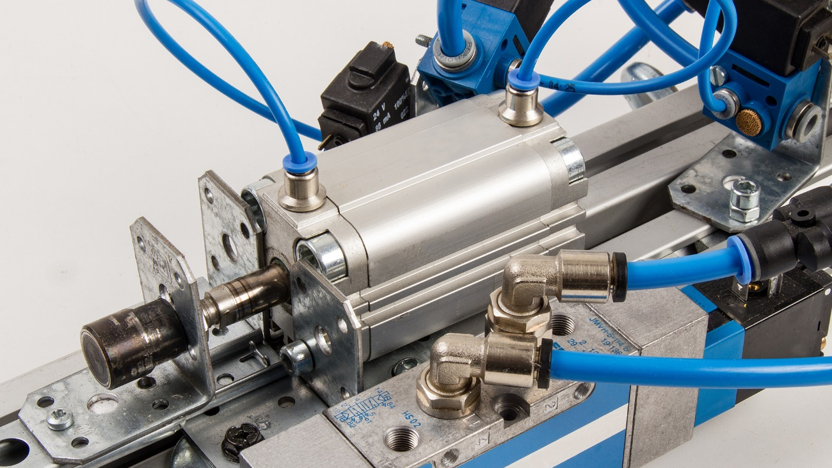
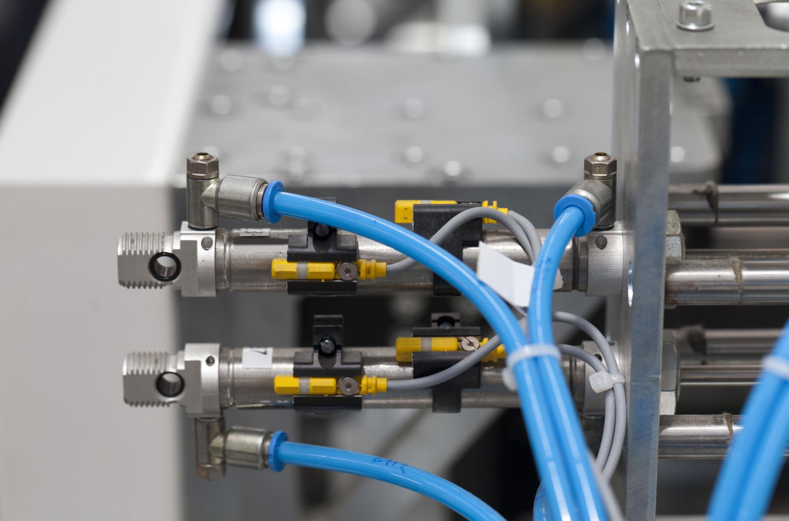
Table Of Contents

Introduction Page 3

Health and Safety Page 3

Pneumatic Circuit Page 3-4

Fault Finding Page 4

Pneumatic Circuit Rig Page 5

Costing Pneumatic Circuit Page 5

Electro Pneumatic Circuit Page 6

Fault Finding Page 6

Electro Pneumatic Circuit Rig Page 7

Costing Electro Pneumatic Circuit Page 7

References Page 8

Introduction
In this assignment we have been handed the task to produce a pneumatic circuit for a polymer processing plant. The process is that blister pack thermoplastic sheets are welded together by the use of a heating elements, one heating element will be fixed and the other will be fixed to double acting cylinders which will move to clamp the material for a time of 12 seconds. This process will also be protected by a guard which will be lowered prior to the heating element to ensure safety within the circuit. Finally, the whole process will return to its start position. There will be a pneumatic circuit and there will also be an electro pneumatic circuit just to show the difference between the two. The program that the circuit is going to be designed and simulated on is going to be OFT2. Both the pneumatic and electro pneumatic circuits are going to assembled onto a rig which will be shown below in their allocated tasks.
Health and Safety
With regards to health and safety within the pneumatic industry we abide to the regulation ‘pressure systems safety regulations 2000’ (PSSR). This regulation came into force on 21st February 2000. The aim of this regulation is to prevent any injuries while working with the hazard of stored energy which is known as the pressure, this also covers the components within the pressurized system and in them resulting in a failure. Regular health and safety should be provided when in the workplace regarding actions, appropriate PPE and emergency circumstances. For example, appropriate PPE to be worn would be protective glasses and work boots. When in the workplace do not point direct airlines at yourselves or others or even not to leave food or drink in the workplace near rigs. Finally, emergency stops should be installed to enable the shut off of any machinery in case of emergency.
Pneumatic Circuit
Firstly, I was given the task to create a pneumatic circuit for the scenario that I had which is explained above. Therefore, using the software OFT2 I was able to produce this circuit and watch it working making sure of the correct timings which had to be 12 seconds and making sure all the cylinders extended and retracted at the correct time. Below is a picture of my completed pneumatic circuit.
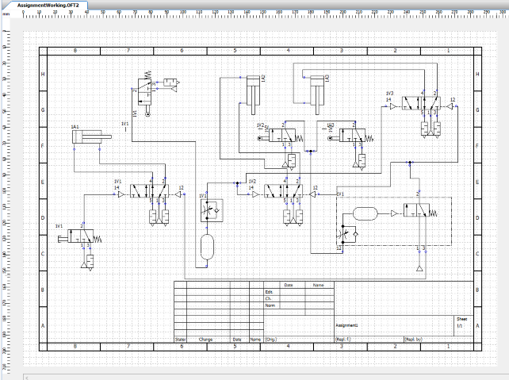
As you can see from the above picture this is my completed pneumatic circuit. Within this circuit we have various components which will be listed below in a parts list. However, for this circuit to work you activate the push button and then the first cylinder (which represents the clamp to clamp the product in place) extends allowing the other two cylinders to activate and extend to complete the process. This whole process is then on a timer which is 12 seconds long, therefore once the timer reaches 12 seconds the welding of the product is complete which allows the two cylinders to retract and then the guard cylinder to retract also allowing the whole process to be repeated again and again. I also provided all of my components with different names just to address them, this meant that I was able to give certain components instructions on when to operate for example when the first guard cylinder operated the directional control valve was linked to the cylinder so would not operate until the cylinder had finished its cycle.
Fault Finding
1 - On completion of my pneumatic circuit and during the testing period to enable everything was working correctly I noticed that during my cycle the guard cylinder was not returning to its normal position (retracted) it was continuing to stay in the extended position. On further investigation I noticed that I used a 2/2 pneumatic directional control valve rather than a 3/2 pneumatic directional control valve. Having the wrong control valve meant the guard cylinder would not return to its start position as there was a constant air supply to the cylinder after the cycle had ended which would constantly extend the cylinder.
2 – The second fault that I discovered on my circuit was that the cycle was not lasting a total of 12 seconds it was going way over that time and lasting 18 seconds. Therefore, to correct this I had to change the figure on the timer delay and then continue to test the length of the process until I got the correct time.
Pneumatic Circuit Rig
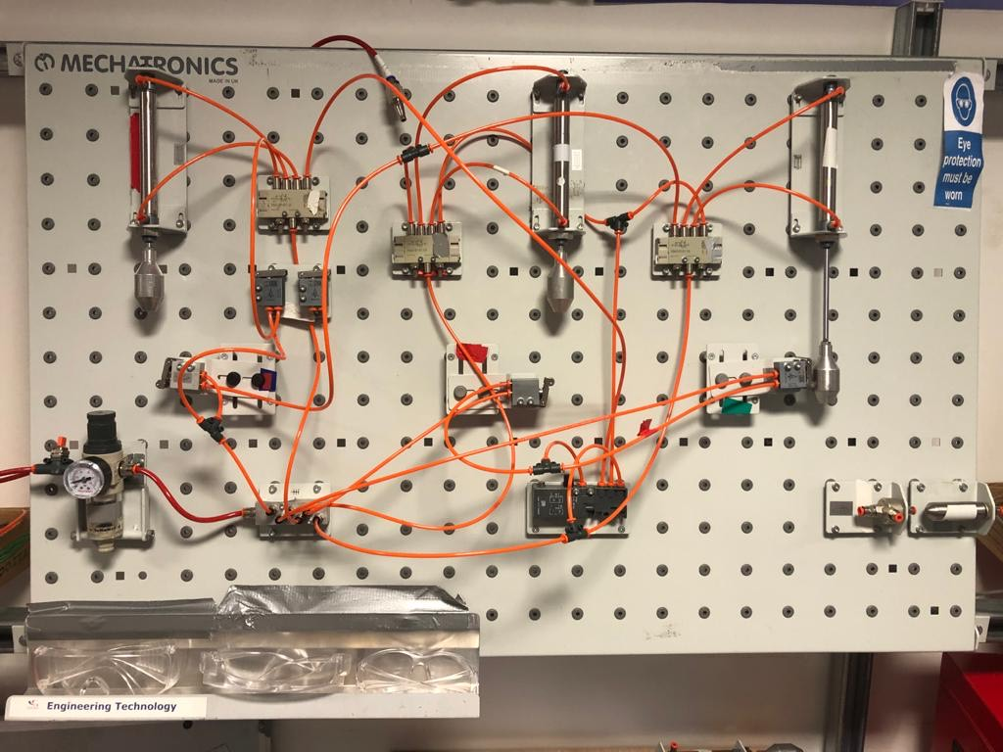
Above is the pneumatic circuit that I assembled onto one of the rigs. After completion I tested the rig to make sure everything worked as it should, and the time delay was set up correctly exactly like my design on OFT2.
Costing Pneumatic Circuit
Below is a breakdown of the individual prices for each component for the pneumatic circuit.
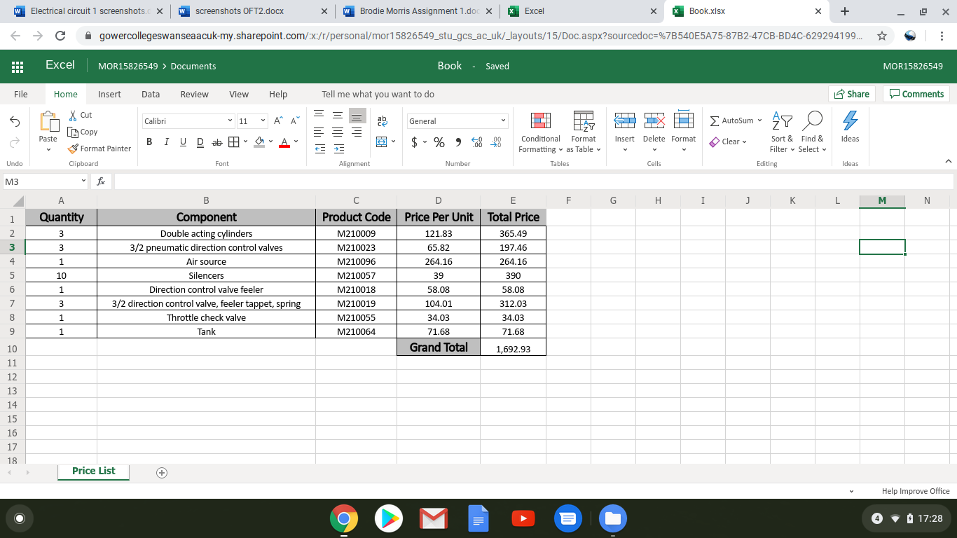

Electro Pneumatic Circuit
I have now created my pneumatic circuit into an electro pneumatic circuit. The reason behind this is that an electro pneumatic circuit is more likely to be used in a real-life circumstance, also I prefer this type of circuit as it has electrical components incorporated within it and I believe this is more reliable. The only downside to the electro pneumatic circuit is that it would cost more than a normal pneumatic circuit as it has the electrical components however, I believe this is totally worth every penny.
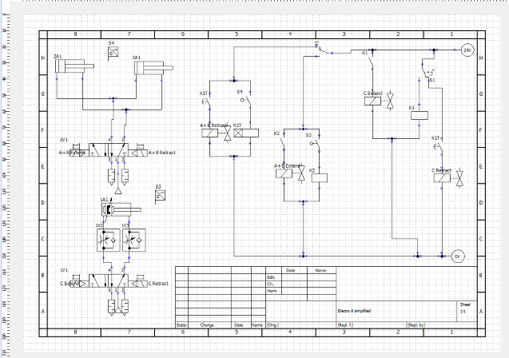
Fault Finding
1 – the only fault that I came across when designing the electro pneumatic circuit was when I built the circuit onto the rig. The guard was operating in the opposite direction for example when I pressed the button the cylinder would retract instead of extending however, this was an easy fix and was rectified.

Electro Pneumatic Circuit Rig
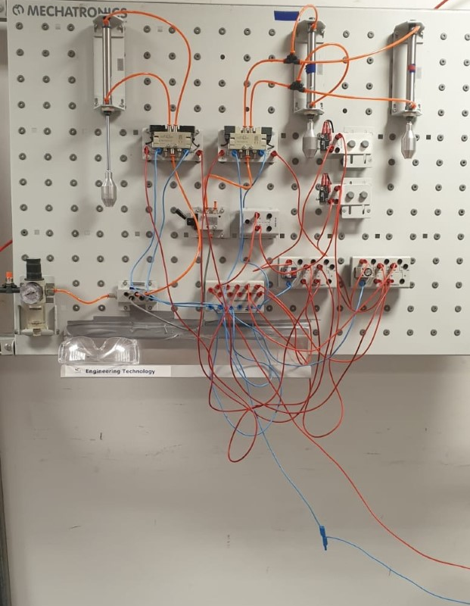
Above is the electro pneumatic that I assembled onto the rig which is fully working the same as the design that I created on OFT2.
Costing Electro Pneumatic Circuit
Below is a breakdown of the individual prices for each component for the electro pneumatic circuit.
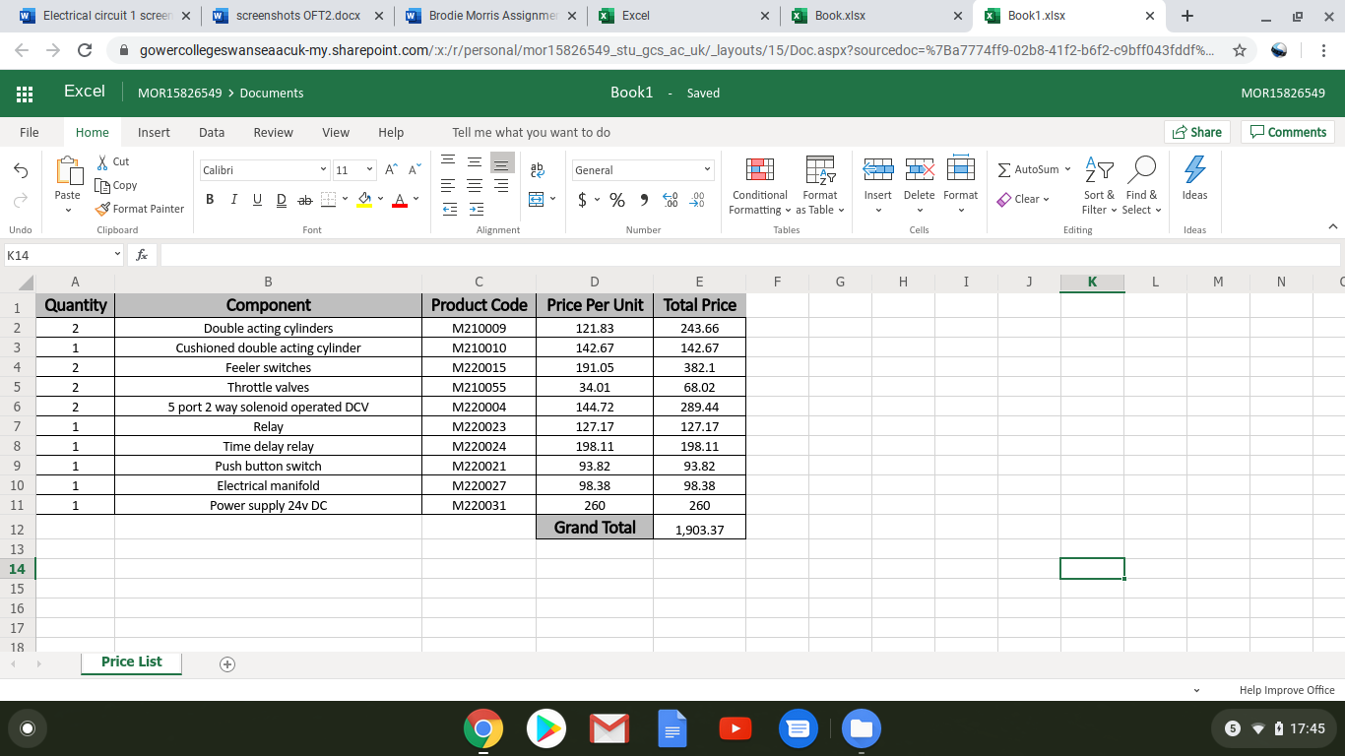

References
Rowse, T. (2019, 7 1). THE FUTURE OF PNEUMATICS. Retrieved from rowse.co.uk:
https://www.rowse.co.uk/blog/post/the-future-of-pneumatics

MCT. (2020, 2 3). Automation Maintenance Part 2 – Introduction to Electro-Pneumatics. Retrieved from participant.co.uk:
https://www.participant.co.uk/participant/arrangement.aspx?id=208278&hash=2212423DD2271EE774A1FDDCCDD79A5B#init

HSE. (2020 3 3). Safety of pressure systems. Retrieved from hse.gov.uk:
https://www.hse.gov.uk/pubns/books/l122.htm

Safetymatters. (2020 3 15). Pressure Systems Safety Regulations 2000. Retrieved from aisolutions.co.uk:
https://www.aisolutions.co.uk/Community/Knowledge/Topic/747/900/Pressure-Systems-Safety-Regulations-2000

