FTL: Faster Than Light [1]

INTENDED PLATFORMS | Intended platforms for this game to be released on would be PC platforms such as Windows, Linux and MacOS X, as well as tablet devices such as the iPad and Android tablets.

TARGET AGE / DEMOGRAPHIC OF PLAYERS
The target demographic for this game will mostly be adults who are interested in sci-fi settings, as well as gamers who enjoy top down RTS and roguelike games.

INTENDED PEGI / ESRB RATING
The intended rating for this game will be PEGI 12/Everyone 10+ [2] .

CONTRIBUTING TEAM MEMBER: | William Baker Oliver

SECTION 2: GAME OUTLINE

GAME STORY SUMMARY
The game’s story will consist of a crew delivering important and top-secret information onboard their spaceship to a galactic federal union in crisis, as the galaxy has been overtaken by rebel gangs and space fleets. Your job is to lead your crew and navigate through certain different sectors of the galaxy, fighting against a plethora of enemy ships to reach the federation’s headquarters and save the galaxy.

GAME FLOW
A top-down RTS/Roguelike game where you travel to different parts of the galaxy to reach federation headquarters, all whilst fighting back against enemies attacking your ship by effectively managing your ship, crew, and weapons.

CONTRIBUTING TEAM MEMBER: | William Baker Oliver

SECTION 3: MAIN CHARACTER(S)
& PLAYER CONTROLS

CHARACTER APPEARANCE
The game will have a diverse range of characters, all of which will be crew mates for you and your enemies’ ships. Characters within the game would range from simple humans to bug-like creatures to futuristic droid robots to mythical golems, to create a feeling of a sci-fi space-like setting, consisting of many different human and alien creatures. Below are certain different examples of characters from sci-fi media, to represent what we want the character diversity to look like.

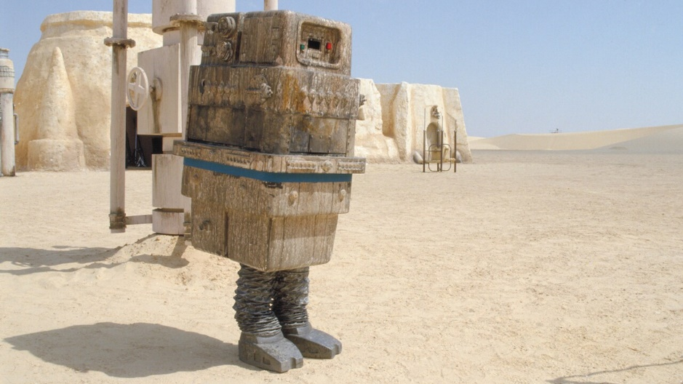

Fig.1: A picture of a Gonk Droid from the Star Wars series. Taken from [3].

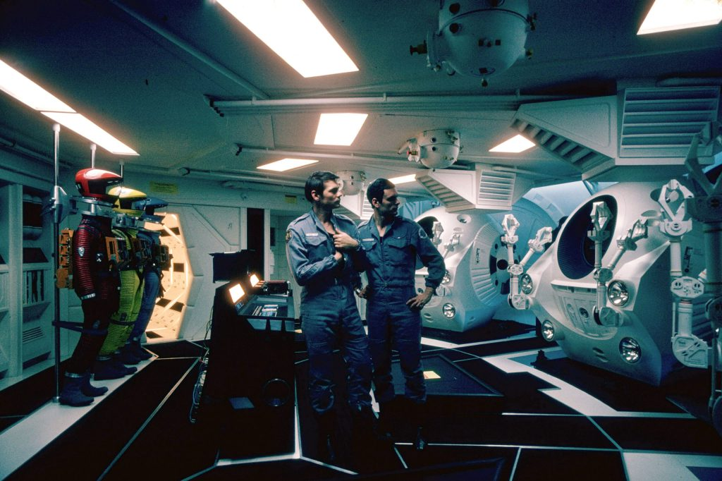
Fig.2: A picture of the space crew from 2001: A Space Odyssey [4]. Taken from [5].

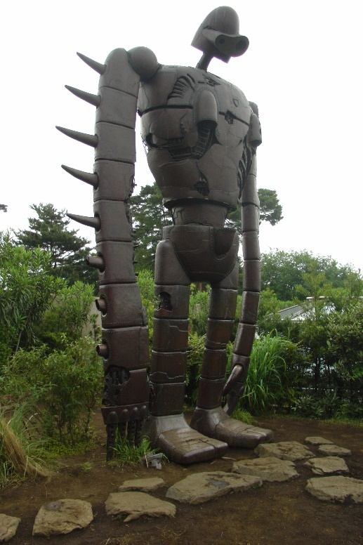
Fig.3: A picture of a golem statue. Taken from [6].

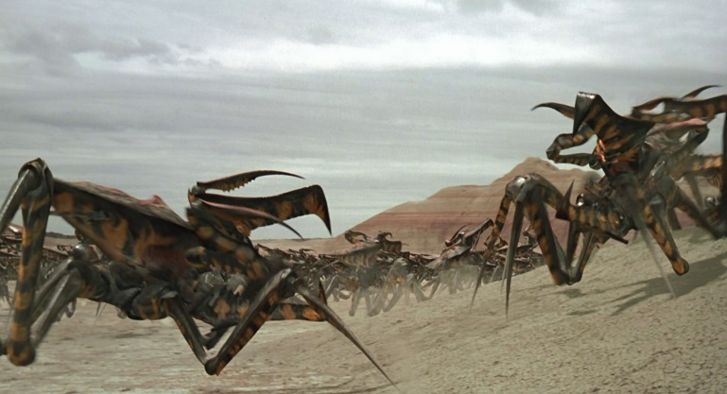
Fig.4: A picture of arachnids from Starship Troopers [7]. Taken from [8].

CHARACTER DOSSIER / DETAILS
SPECIES: | Human
SPECIALTIES: | All-Rounder crew members with base stats.
WEAKNESSES: | All-Rounders, with the positives and negatives that come with it, nothing particularly special about them.

CHARACTER DOSSIER / DETAILS
SPECIES: | Rockmen
DESCRIPTION: | Golem rock creatures, with a look and stature like the image below.  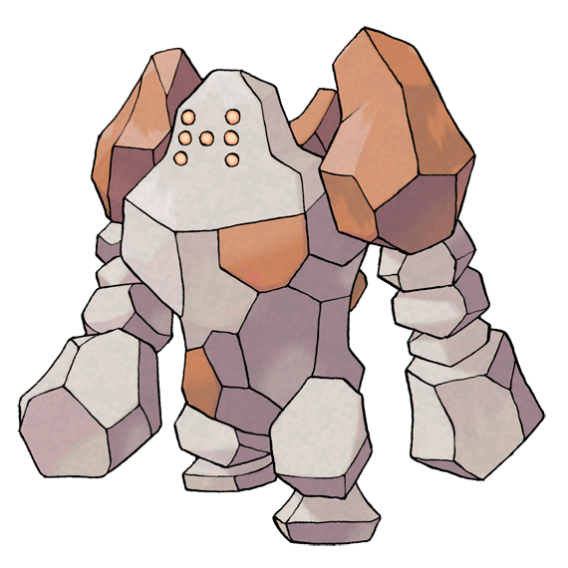  Fig.5: An image of the Pokémon known as Regirock. Taken from [9].
SPECIALTIES: | Are immune to any fire hazards.
WEAKNESSES: | Slow movement speed.

CHARACTER DOSSIER / DETAILS
SPECIES: | Slugs
DESCRIPTION: | Humanoid-like creatures with a slug appearance.
SPECIALTIES: | Cannot be mind controlled, can see into other rooms, tells player about crew info on enemy ships.
WEAKNESSES: | No major stat increases.

CHARACTER DOSSIER / DETAILS
SPECIES: | Mantis
DESCRIPTION: | Mantis bug creatures.  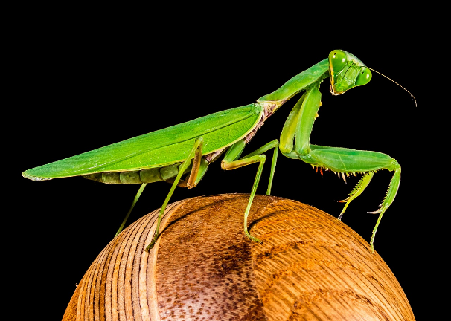  Fig.6: A picture of a Mantis. Taken from [10].
SPECIALTIES: | Fast movement speed and higher combat damage.
WEAKNESSES: | Worse repair and fire fighting speeds than other races.

CHARACTER DOSSIER / DETAILS
SPECIES: | Zoltans
DESCRIPTION: | Green blob creatures with a humanoid appearance.
SPECIALTIES: | Adds an extra bar of power to certain systems, deals damage to nearby enemies if it dies by exploding.
WEAKNESSES: | Lower HP than other races.

CHARACTER DOSSIER / DETAILS
SPECIES: | Engi
DESCRIPTION: | Robotic creatures with a singular screen eye. Stature like Super Battle Droids from Star Wars, as seen below.  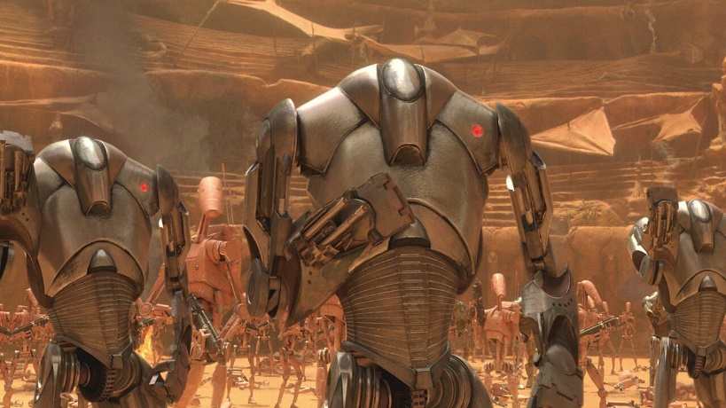  Fig.7: A Super Battle Droid from the Star Wars series. Taken from [11].
SPECIALTIES: | Adds an extra bar of power to certain systems, deals damage to nearby enemies if it dies by exploding.
WEAKNESSES: | Lower HP than other races.

CHARACTER DOSSIER / DETAILS
SPECIES: | Lanius
DESCRIPTION: | Humanoid-like creatures made of metal.
SPECIALTIES: | Cannot suffocate, however will deplete oxygen from the room they’re in.
WEAKNESSES: | Slow movement speed, as well as depleting oxygen.

CHARACTER DOSSIER / DETAILS
SPECIES: | Crystal
DESCRIPTION: | Golem creatures made of crystals.
SPECIALTIES: | Prevents other crew members from leaving certain rooms by blocking all entrance paths with crystals, suffocates less than other races.
WEAKNESSES: | Slow movement speed and firefighting speed.

CHARACTER CONTROLS / PLAYER CONTROLS
This game would be controlled with the keyboard and mouse. The game’s menus, UI and HUD will be designed around this, with things like power systems, map travel, powering and de-powering power systems, dialog choice selection etc., all being controlled by the mouse. The keyboard will be used for hotkeys, such as automatically selecting certain or all crew members. This won’t be needed to play the game, as you can do everything the hotkeys will do with the mouse, but it will give players choice and make certain tasks much quicker to do. This will be configurable by the player.

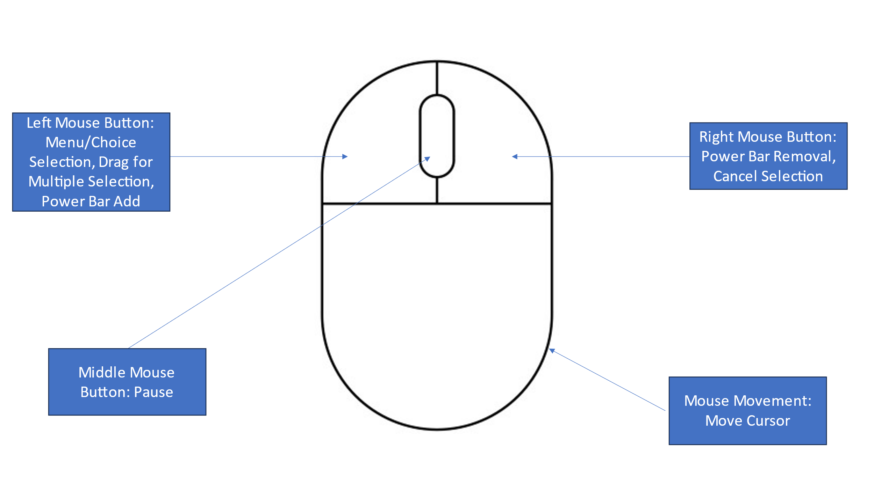
Fig.8: A diagram showing the mouse controls for the game. Mouse vector taken from [12].

CONTRIBUTING TEAM MEMBER: | William Baker Oliver

SECTION 4: GAMEPLAY

SEQUENCE OF PLAY
The game will consist of a multitude of levels known in game as ‘sectors’. The player must go through 7 different sectors, as well as a final sector containing the boss to beat the game. The sectors on the map that you travel to will be randomised each time, each varying in the amount of danger they have. This is the roguelike element of the game, akin to other games in its genre such as Risk of Rain (2013) [13], where the game gives the player a set of randomly generated levels for them to traverse through, with things like enemy spawns, treasure, drones etc., always being different each time you start a new game.

Each sector has a multitude of areas to jump to with your ship, marked on a map, referred to as ‘beacons’ in game. These areas will have different set pieces within each, such as a planet, a store, or a distress signal. Certain beacons will have environmental hazards like asteroids or deadly solar flares. To go to another sector, the ship must first get to the ‘exit beacon’, which will allow them to leave the current sector they are in. Your ship’s interior and its layout will remain a constant throughout each level in the game, with each sector serving as a backdrop for the main level, which will be your ship and other enemy ships you may encounter.

The player will encounter a variety of enemy ships throughout their travels. The game during battles uses Real Time Strategy (RTS for short) elements, where the player can make strategic decisions in order to eliminate any ships standing in their way.

UNIQUE SELLING POINTS (USPs)
The unique selling point of this game will be its blend of RTS and roguelike genres, along with a brutally hard difficulty which will entice players looking not only for a fresh take on said genres, but also a good challenge as well. As with most roguelikes, you must start over again if your ship is destroyed. This makes players want to keep playing, to learn better strategies and overcome the hard challenge within the game.

CONTRIBUTING TEAM MEMBER: | William Baker Oliver

SECTION 5: GAME WORLD

GAME WORLD
The player will find themselves always within the environment of a singular ship, with different rooms. There will be a multitude of different ships for the player to choose from before starting the game, each having their own unique layouts and features.

The ships exterior design will differ too depending on what ship you choose. The design will be inspired by different sci-fi media, such as the ship seen below.

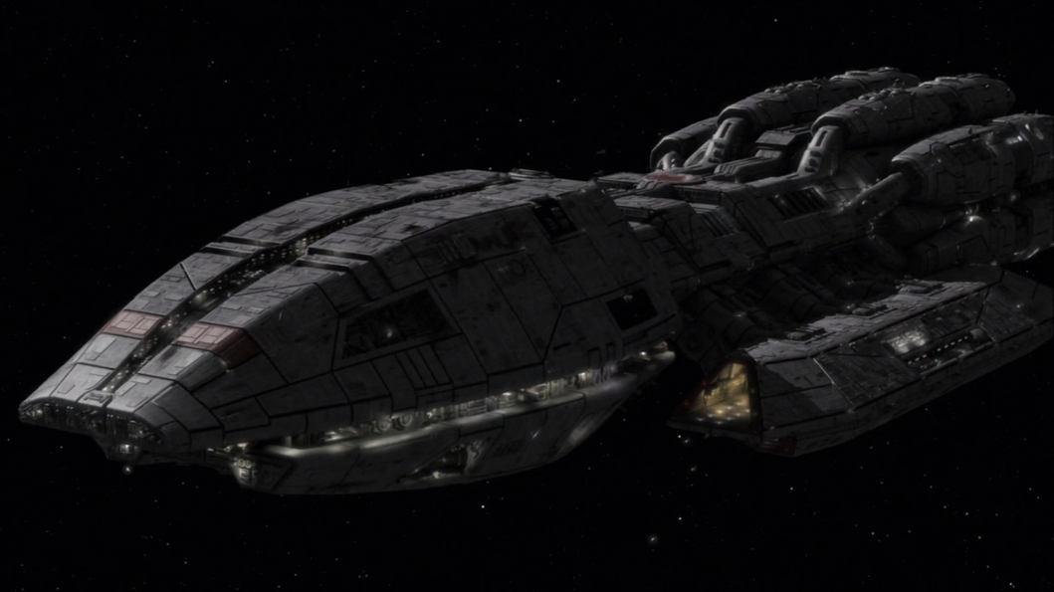
Fig.9: A picture of a Mercury-Class Ship from the Battlestar Galactica series. Taken from [14].

The ship will be seen from a top-down perspective throughout the game. The ship will contain a variety of rooms, with each room containing a ship system, such as one room containing a medbay which heals any crew members inside the room at any given time, another one which manages the ship’s shields, another one controlling the ship’s weapons, etc. Certain systems can be controlled by crew members on the ship. Each room and its system serve a crucial function to the ship which the player will need to use strategically by issuing commands and supplying certain amounts of power to each in order to successfully traverse the galaxy and defeat any oncoming fleets.

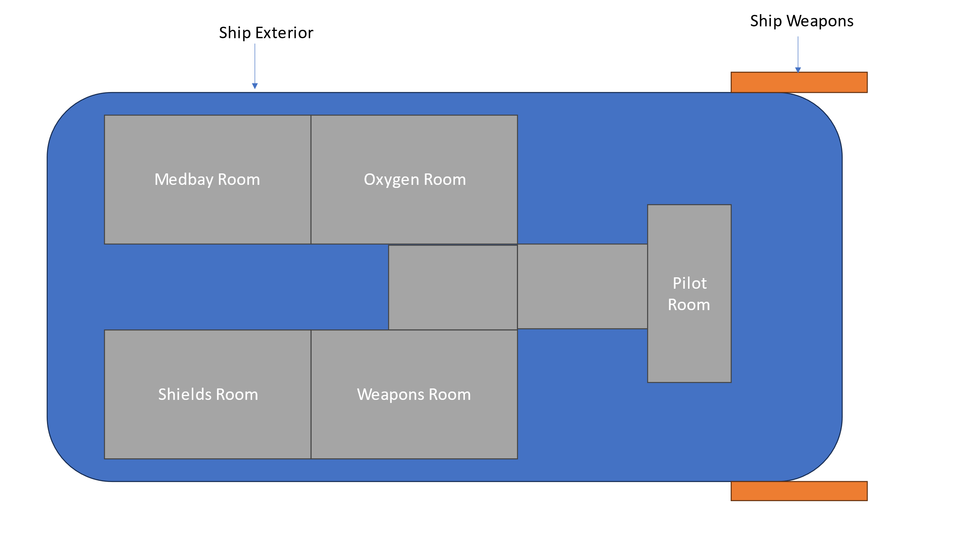
Fig.10: A diagram showing an example of a spaceship’s layout. Created in PowerPoint.

As the ship travels through different sectors and beacons within said sector, the background will change. The background will typically consist of special elements such as stars, galaxies in the distance, nebulas, planets, debris, asteroids, etc. Examples of what we want it to look like can be found below. Depending on what sector the player is currently in, such as a nebula. or if the sector beacon contains certain elements like dangerous stars, the background will change accordingly.
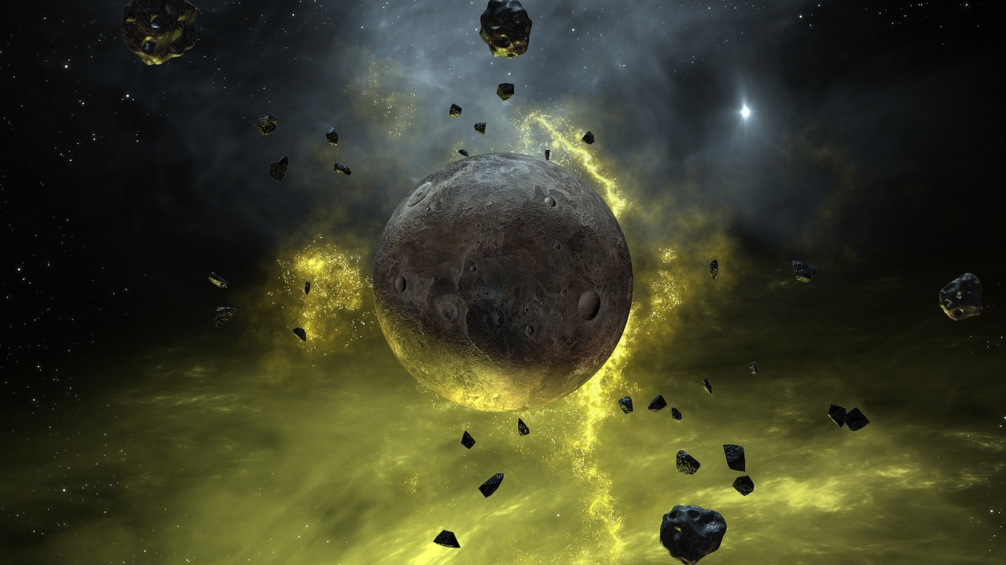
Fig.11: A picture of a planet in space. Taken from [15].


Fig.12: A picture of the earth’s atmosphere in space. Taken from [16].

Below is a diagram showcasing an example of a sector’s map and what the player might expect to find in it.
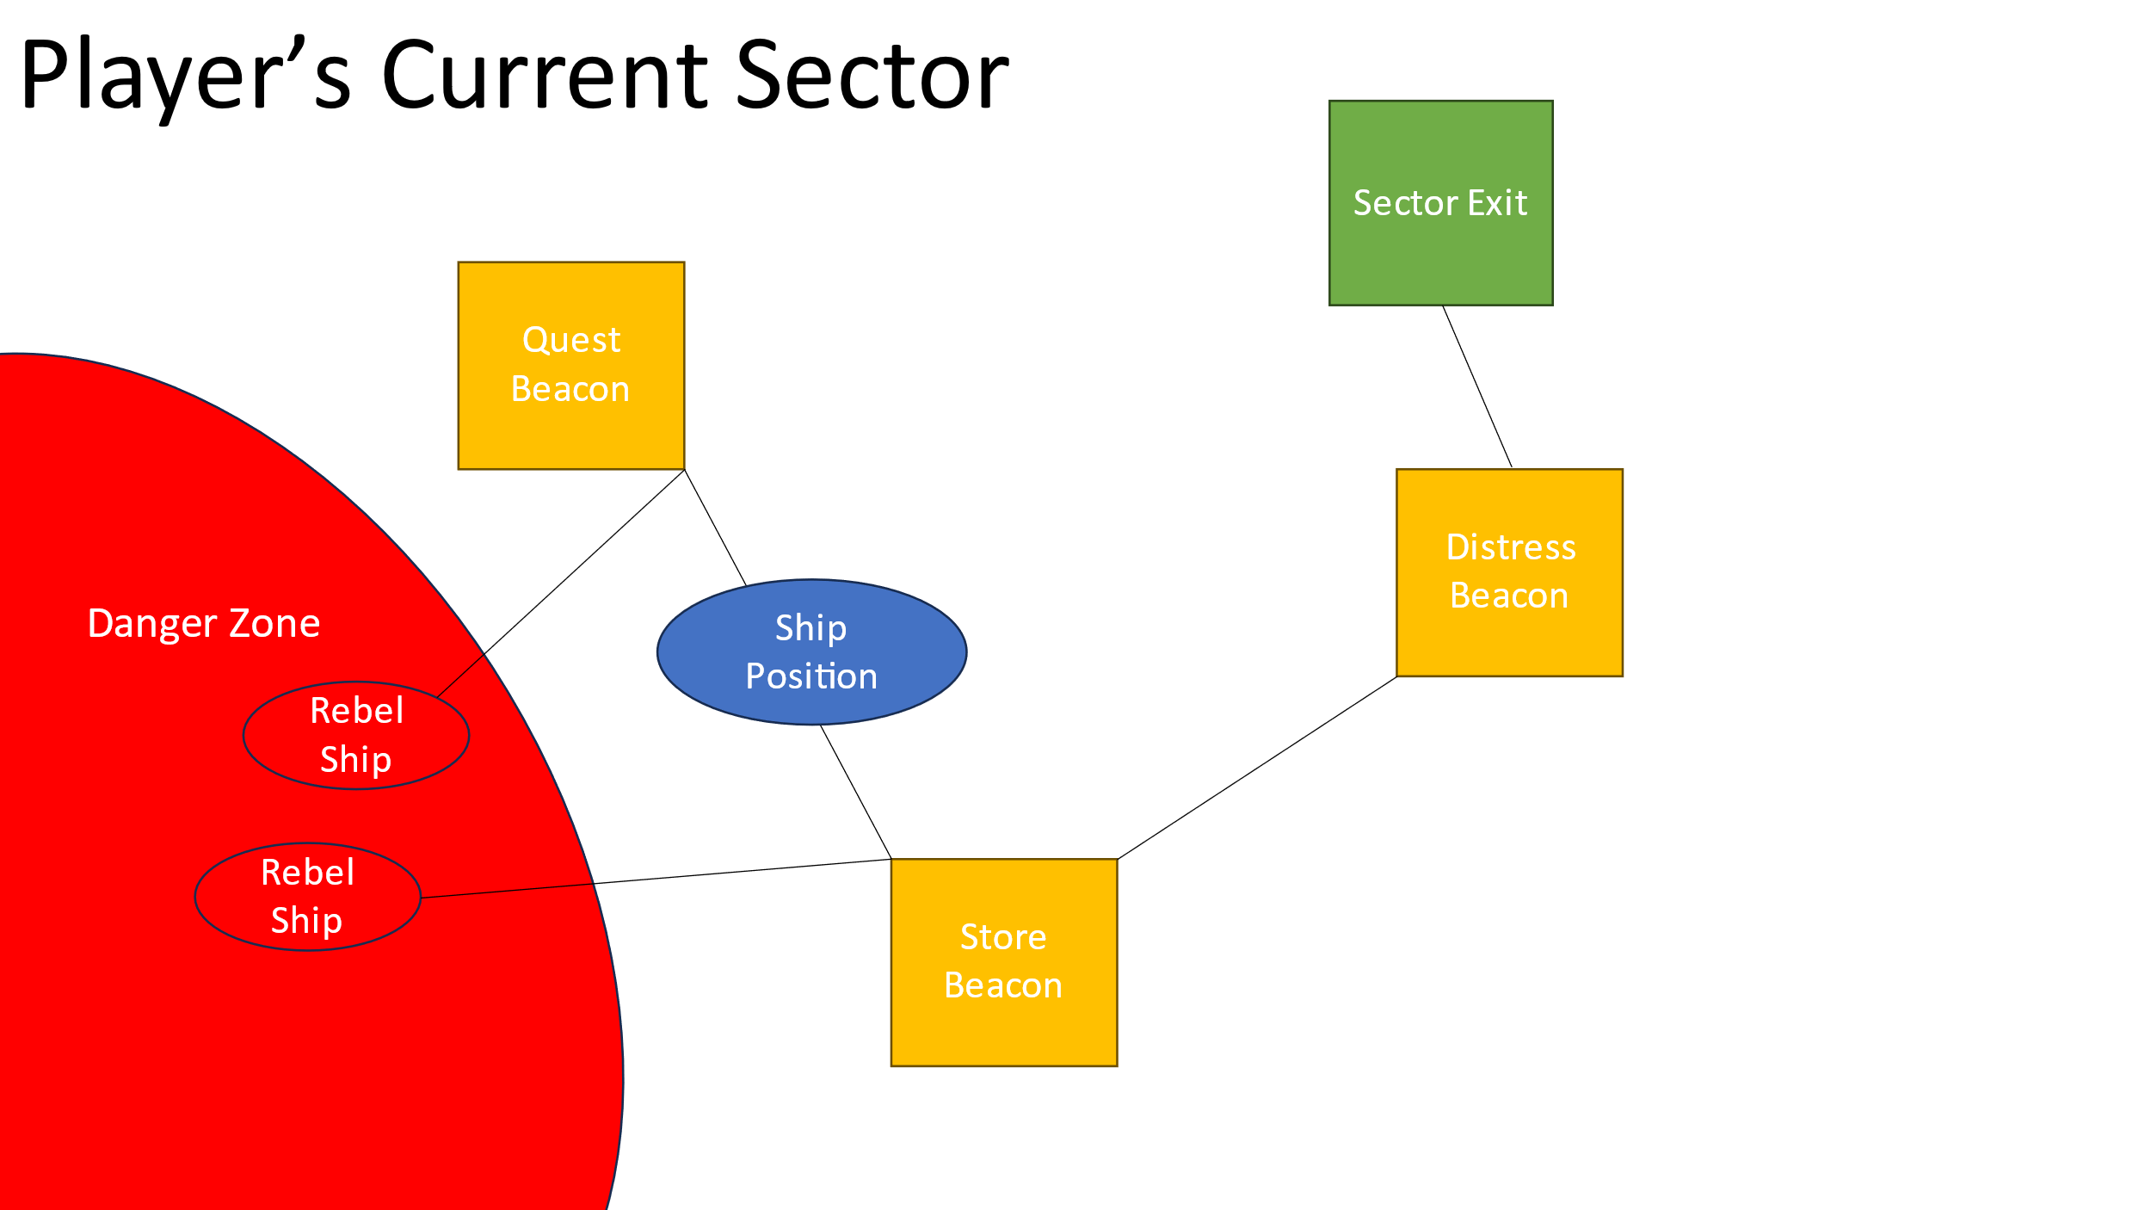
Fig.13: A diagram showcasing an example sector with beacons and enemy ships. Created in PowerPoint.

GAME FLOW
This is a diagram showing an example of how the player might traverse to different sectors.

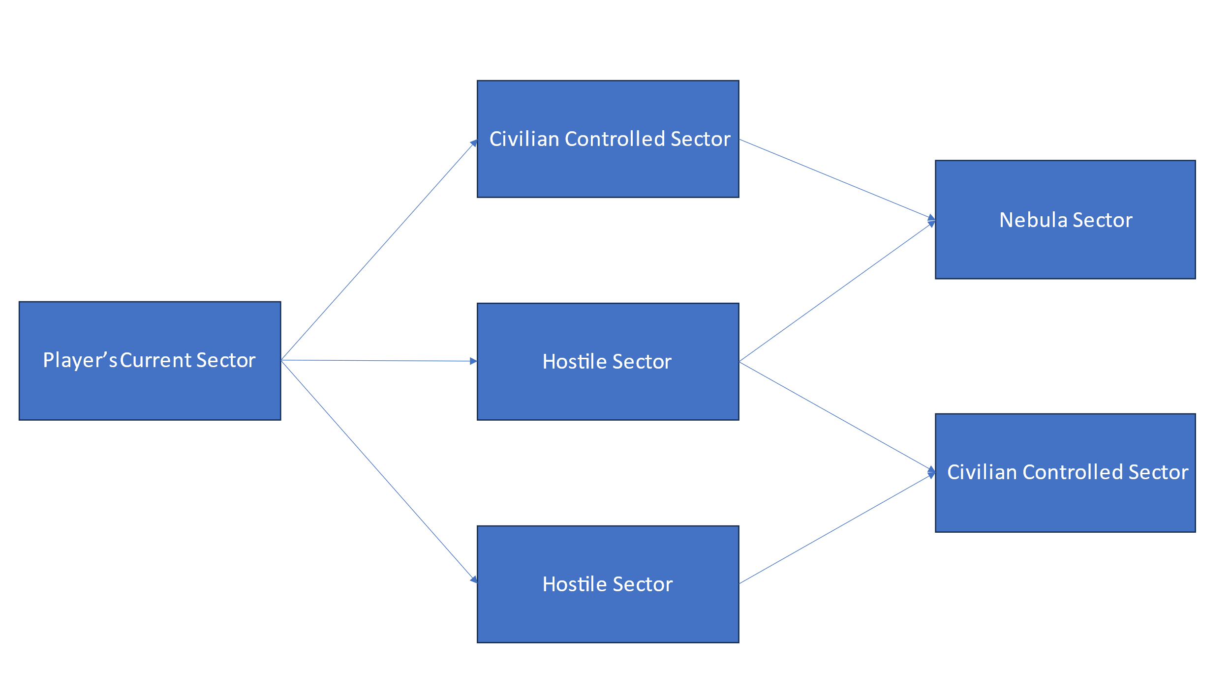
Fig.14: A diagram showcasing how navigation and progression works for different sectors. Created in PowerPoint.

CONTRIBUTING TEAM MEMBER: | William Baker Oliver

SECTION 6: GAME EXPERIENCE

GAME EXPERIENCE
The themes of the game will be adventurous, thrilling and the game will have a sense of tension throughout. No matter where the player is, they will always feel like they’re constantly on their toes, always at risk of being intercepted, but with the excitement and thrill of battling an intergalactic fleet. There will also be a constant state of dread and isolation throughout the game. The game will also have a futuristic yet retro feel.

HOW IS THIS FEELING GOING TO BE PRESENTED TO THE PLAYER?
The backdrops of each sector and their respective beacons will give off a feeling of empty vastness, with the looming backdrop of an infinite space, littered with planets and stars. The combat, gameplay and rampant difficulty of this game will add to the thrill and adventure. The music will also play an important part of emphasising the sense of not only excitement, but also dread and sombreness as well. To convey the futuristic/retro feeling to the player, the game will have a pixel art style, complementing the futuristic setting and levels.

ARE THERE ANY SPECIAL MODES OR INTERFACES FOR GAMEPLAY?
During combat, the player can pause the game and make decisions based on their current enemy situation, such as guiding crew members or firing at enemy ships. The pause screen in this game will be different to other games as it allows players to make decisions which affect the outcome of the game, as opposed to the pause screen just being a way for the player to take a break from the action.

WHAT EMOTIONS ARE MEANT TO BE INVOKED BY THE GAME?
When the player is travelling through different sectors, we want them to feel a sense of unease and urgency, fitting in line with the game’s narrative of having to deliver important info by travelling through a dangerous galaxy. The player will not know what will be in store for them with each new playthrough, what disasters they may encounter, what ships may be attacking them, due to the roguelike nature of this game. This creates a sense of uneasiness, but also a sense of adventure for the player too, like they’re flying through dangerous, uncharted territory. Worry and panic can also be instilled into the player, as they don’t know when or how abruptly their playthrough may come to an end, due to the random nature of the game.

HOW ARE MUSIC AND SOUND GOING TO BE USED?
The game will have an electronic/chiptune soundtrack, giving off a futuristic feel for the player, as well as complementing the pixel art style. The music will give off an ambient feeling of isolation, fear and loneliness in space, but with feelings of hope.

The sounds will be used to drive home this feeling of a sci-fi space setting, with futuristic sounds of spaceships going into lightspeed and coming out the other side, the sounds of lasers bouncing off of shields, all adding to the atmosphere and theme of the game.

HOW DOES THE PLAYER NAVIGATE THE SHELL MENUS/ SCREENS OF THE GAME?
This is a diagram of how the player will navigate the game.

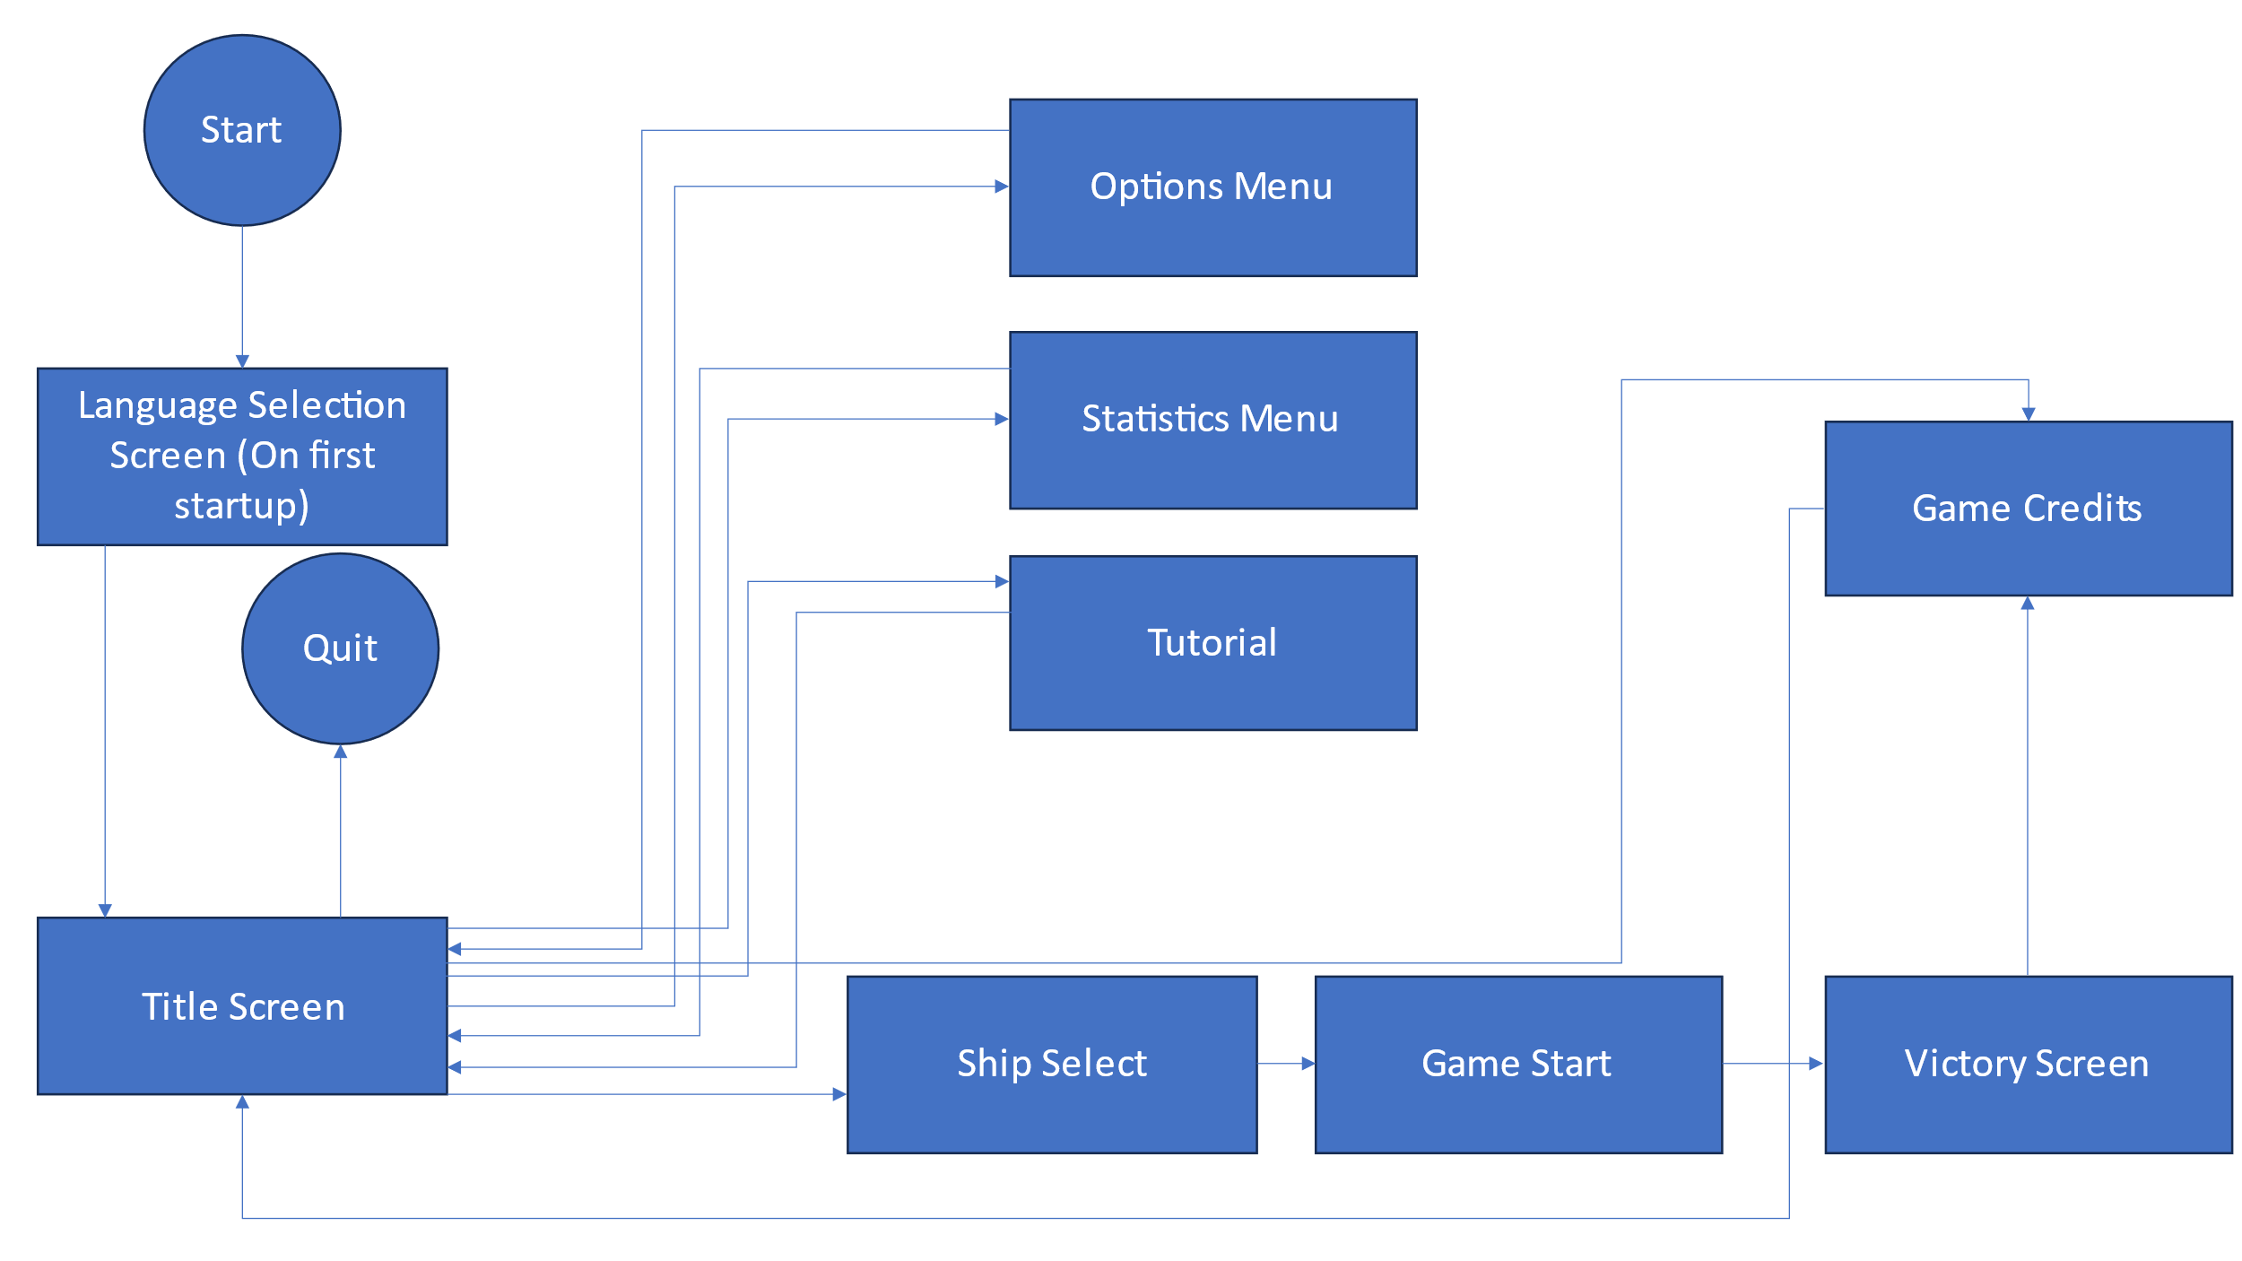

Fig.15: A diagram of the game’s shell screens. Created in PowerPoint.

CONTRIBUTING TEAM MEMBER: | William Baker Oliver

SECTION 7: GAMEPLAY MECHANICS

GAMEPLAY MECHANICS

MECHANIC DETAILS
NAME: | Power Bar
WHAT DOES IT LOOK LIKE? | A green bar on the bottom left corner of the screen.
EFFECT ON PLAYER: | Distributes power to the ship’s systems. The ship has only a limited amount of power that it can allocate to these systems, so the player will need to strategize and direct power to certain systems when they need them.
WHEN WILL IT FEATURE IN THE GAME? | Will be a main mechanic throughout the duration of the game.

MECHANIC DETAILS
NAME: | Drones
WHAT DOES IT LOOK LIKE? | An overhead view of a futuristic flying drone. Will come in many different varieties. The drone system on the ship has the icon of an old-fashioned robot with an antenna on its head.
EFFECT ON PLAYER: | Once the player has a drone system on the ship, they can buy drone schematics to operate a variety of different drones, such as combat drones to attack enemy ships, drones to repair certain parts of the ship, etc. The drones operate themselves, only requiring the drone system to be active and powered. Can be used by players as an important weapon against enemy ships.
WHEN WILL IT FEATURE IN THE GAME? | Will be a main mechanic throughout the duration of the game. Will be available for use once the drone system is on the ship.

MECHANIC DETAILS
NAME: | Skills
WHAT DOES IT LOOK LIKE? | An icon of a wrench.
EFFECT ON PLAYER: | The crew will be able to gain skills if the player makes them perform different actions like piloting the ship for example, the more they do it, the higher amount of skill the crewmate will have. For each skill level a crewmember has, it increases certain stats on the ship, depending on what skill the crewmate has. For example, if they have levelled up by piloting, the ship will have a much higher evasion rate than usual.
WHEN WILL IT FEATURE IN THE GAME? | Will be a main mechanic throughout the duration of the game.

HAZARD DETAILS
NAME: | Fire
WHAT DOES IT LOOK LIKE? | A cluster of flames within a room.
EFFECT ON PLAYER: | Will damage crewmates within the room, slowly destroying the ship’s integrity, systems like the ship’s engine and shields, and oxygen supply. This will force the player to take decisive action and focus efforts on putting out the fire before making decisions elsewhere.
WHEN WILL IT FEATURE IN THE GAME? | Whenever the ship is attacked by enemy forces or is due to certain conditions such as an asteroid hitting the ship or solar flares from stars. Certain weapons and drones may also start fires.

HAZARD DETAILS
NAME: | Asteroids
WHAT DOES IT LOOK LIKE? | Will appear on map as a red warning sign with asteroids on it. Will also be shown directly when travelling in sector beacons with this hazard.
EFFECT ON PLAYER: | Will potentially hit the ship, either weaking the shields or causing damage to the ship’s hull. Can also cause fires. Requires player to either upgrade shields, use something like a drone to destroy asteroids, or avoid certain parts of the sector.
WHEN WILL IT FEATURE IN THE GAME? | Whenever the player goes to a sector’s beacon with an environmental hazard warning.

POWER-UP DETAILS
NAME: | Shields
WHAT DOES IT LOOK LIKE? | An “S” symbol with a crescent or circle surrounding it.
EFFECT ON PLAYER: | Allows the ship to absorb damage from enemy attacks or from asteroids. Player can upgrade it multiple times.
WHEN WILL IT FEATURE IN THE GAME? | Will always be available for use in the main game.

POWER-UP DETAILS
NAME: | Cloaking
WHAT DOES IT LOOK LIKE? | A symbol that looks like an eye, like the picture seen below.  Fig.16: A picture of an eye. Taken from [17].
EFFECT ON PLAYER: | Allows the ship to evade attacks from enemy ships and defend itself. Weapons cannot target a cloaked ship.
WHEN WILL IT FEATURE IN THE GAME? | Will always be available for use in the main game. Must be purchased first.

COLLECTIBLE ITEMS

COLLECTIBLE DETAILS
NAME: | Scrap
WHAT DOES IT LOOK LIKE? | A symbol in the shape of a cog, like the image seen below.    Fig.17: A picture of some cogs. Taken from [18].
BENEFIT FOR PLAYER: | Allows player to buy, upgrade and repair certain items.
WHEN WILL IT FEATURE IN THE GAME? | Will always be available for use in the main game. The player can earn scrap by doing different things such as destroying ships or selling items.
CAN IT BE USED AS CURRENCY? | Main currency used in game.
WILL IT EARN PLAYERS AN ACHIEVEMENT? | Yes, if they collect a certain amount and hold on to it.
COLLECTIBLE DETAILS
NAME: | Fuel
WHAT DOES IT LOOK LIKE? | A symbol in the shape of an atom, like the one seen below.    Fig.18: An image of an atom. Taken from [19].
BENEFIT FOR PLAYER: | Allows the player to use the FTL mechanic, to jump to beacons and sectors. The player needs to conserve their FTLs, as it costs fuel to do so.
WHEN WILL IT FEATURE IN THE GAME? | Will always be available for use in the main game. The player starts out with fuel and collect more in game through different means.
CAN IT BE USED AS CURRENCY? | Can be traded for other items if there is a specific event active.
WILL IT EARN PLAYERS AN ACHIEVEMENT? | No.

GAME ECONOMY
The game will have a currency known as ‘scrap’, which the player can use to buy, upgrade, and repair their ship’s weapons, crewmates, and systems, as well as resources such as fuel. Scrap can be used within stores located at different beacons on the map, with each store having 3 random items for sale. Scrap can also be used within a trading event, where you can buy certain items depending on the event. As the game progresses, depending on what sector you are in, the price of resources and repairs will increase. Purchasable systems, crewmates, and weapons, however, will always be the same price.

The player will mainly gain scrap by destroying enemy ships and crew members onboard the ship. The player will also be able to gain scrap by selling their own resources like their own weapons or even crewmates, however they will be worth half of what they originally cost normally, meaning the player will have to take a loss if they need to sell them. Scrap can also be gained from events, such as an event where you can give a ship some fuel or weapons for example, with your reward potentially being scrap. Depending on what difficulty the player selected at the beginning of the game, the scrap they receive will be different, with the highest difficulty rewarding the player with more scrap than lower difficulties.

If the player holds on to a certain amount of scrap, they can receive an achievement for doing so.

CONTRIBUTING TEAM MEMBER: | William Baker Oliver

SECTION 8: ENEMIES

LIST OF ENEMIES
The main enemies in the game will consist of a variety of enemy ships that the player must battle and destroy throughout their voyage through certain sectors. These ships will vary in terms of looks and design, some with rebel colours painted on them, others belonging to the different alien races in the game. The ship itself uses the exact same mechanics that the player’s ship will use; they’ll have different rooms such as an O2 room or a medbay, they’ll have their own set of weapons just like the player’s ship and will even use the same power systems that the player uses as well.

Enemy ships can belong to different factions, including rebels, the federation, pirates, and other alien races in the game such as Rockmen or Mantises. Which ones you may encounter depend on what sector you’re in and what the conditions currently are.

ENEMY DETAILS
NAME: | Rebel Fighter
WHAT DOES IT LOOK LIKE? | Small spaceship coloured with yellow and blue colour schemes, with 2 engines on each side and a variety of different system rooms
ATTACKS: | Will use the weapons on the ship to attack the player.
WHEN WILL IT FEATURE IN THE GAME? | Will appear as the player is flying through different sectors.
HOW DOES THE PLAYER DEFEAT IT? | The player will need to fight back and use their weapons to damage the ship’s hull, many rebel ships of this type will surrender if you deal more than half damage to their HP.
WHAT DOES THE PLAYER EARN FOR DEFEATING THEM? | Will earn resources such as fuel or scrap for defeating them, with a dialog box telling you what you earned from the battle.

ENEMY DETAILS
NAME: | Rebel Rigger
WHAT DOES IT LOOK LIKE? | Small spaceship coloured with yellow and blue colour schemes, with 2 engines on each side and a variety of different system rooms, shaped like a ‘c’
ATTACKS: | Will use the weapons on the ship to attack the player.
WHEN WILL IT FEATURE IN THE GAME? | Will appear as the player is flying through different sectors.
HOW DOES THE PLAYER DEFEAT IT? | The player will need to fight back and use their weapons to damage the ship’s hull, many rebel ships of this type will surrender if you deal more than half damage to their HP. This ship can use drones against you unlike normal fighters, so the player will need to deal with them too.
WHAT DOES THE PLAYER EARN FOR DEFEATING THEM? | Will earn resources such as fuel or scrap for defeating them, with a dialog box telling you what you earned from the battle.

LIST OF BOSS CHARACTERS
The game will have a final boss, being a large rebel ship that the player needs to destroy to beat the game. The player will need to intercept this ship and fight it in 3 phases to destroy it. The player will have a limited number of jumps, if the player makes too many jumps, it will get closer and destroy their ship, resulting in a loss for the player. Each phase will use a different mechanic, such as one phase using hacking and cloaking, another phase using drones, and another phase using shields. This boss will be the hardest part of the game and will test the player’s skills, using every mechanic that they have learned or used to defeat the boss.

BOSS CHARACTER DETAILS
NAME: | The Rebel Flagship
WHAT DOES IT LOOK LIKE? | A large spaceship with rebel colouring, made to be much larger than typical rebel fleets, with many rooms and weapons.
ATTACKS: | Will use a variety of weapons and systems, such as lasers, missiles, different drones such as a hacking drone and a combat drone, as well as cloaking to defend itself.
WHEN WILL IT FEATURE IN THE GAME? | At the end of the game.
HOW DOES THE PLAYER DEFEAT IT? | Defeating 3 different phases of the boss and avoiding doing too many lightspeed jumps. Each phase uses different weapons and systems.
WHAT DOES THE PLAYER EARN FOR DEFEATING THEM? | The player beats the game for defeating this boss, getting to the victory screen and the credits. A final score will be given at the end which can be viewed on the stats screen.

CONTRIBUTING TEAM MEMBER: | William Baker Oliver

SECTION 9: CUTSCENES

CUTSCENES
This game will not have cutscenes, rather things such as events, arriving to new sectors or beacons or destroying ships for example will be conveyed to the player via dialog boxes. The player will be given 1 or more choices with these dialog boxes, either to continue with the game or to have a certain outcome depending on the player’s choice. Below is an example of what it might look like in game.

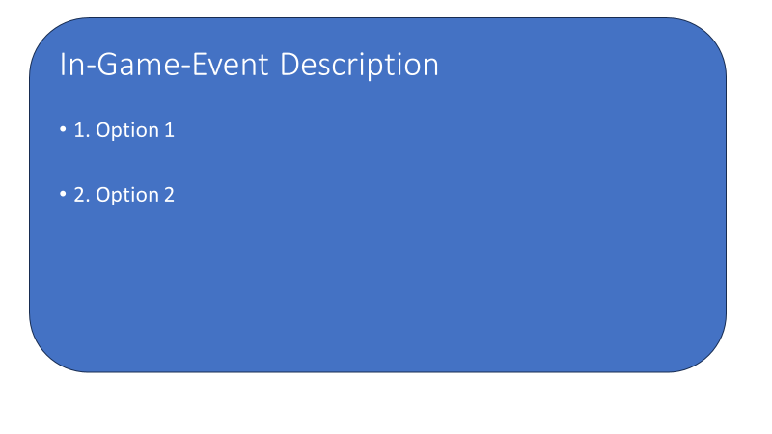
Fig.19: A picture showing what a dialog box may look like in game. Created in PowerPoint.
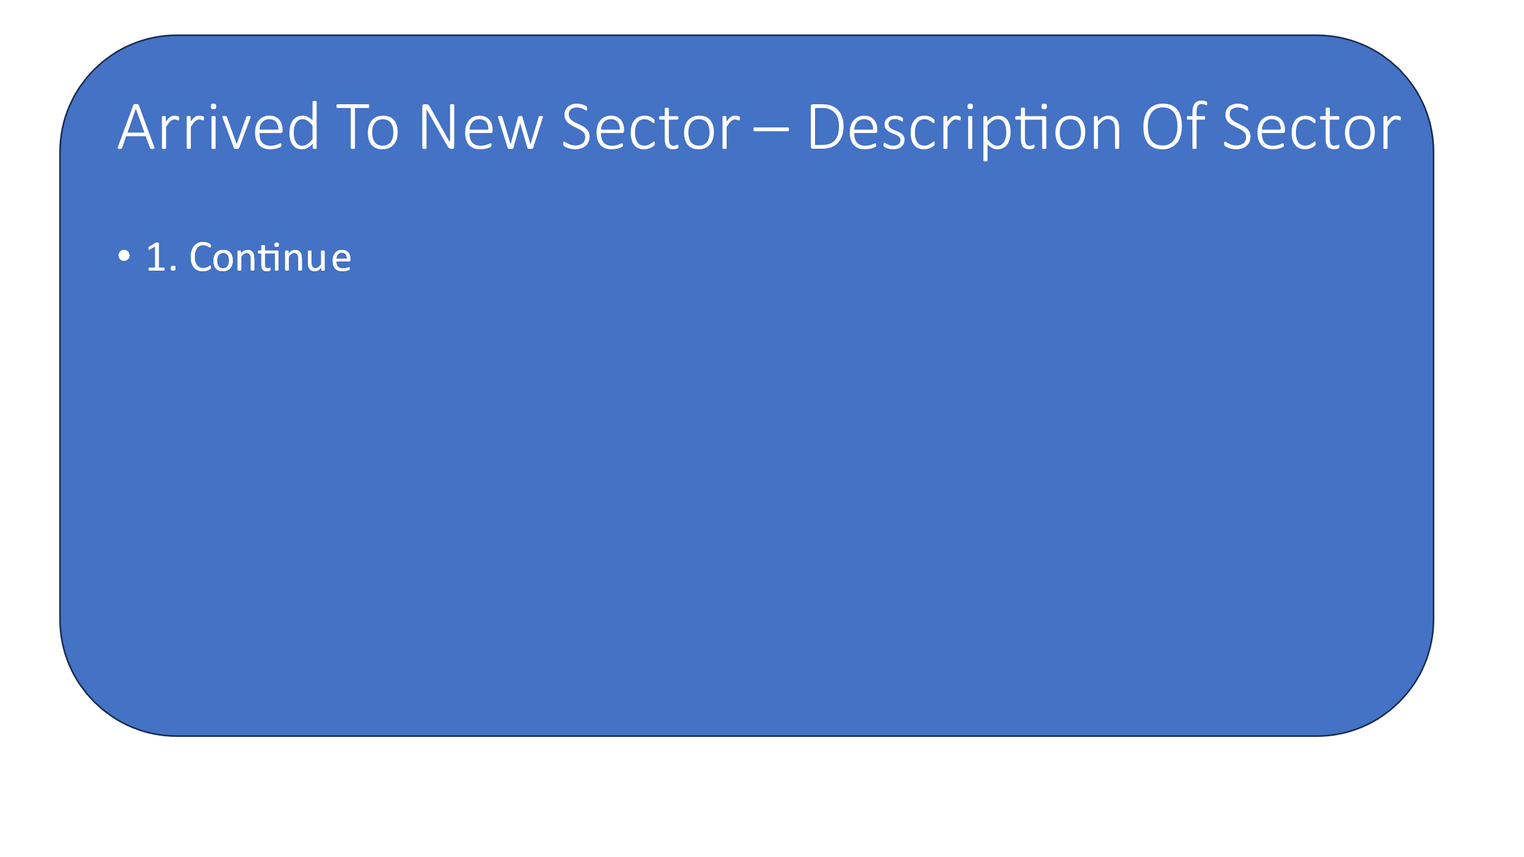
Fig.20: A picture showing what a dialog box may look like in game. Created in PowerPoint.

CONTRIBUTING TEAM MEMBER: | William Baker Oliver

SECTION 10: BONUS MATERIALS

BONUS MATERIALS
This game will have a DLC addon which adds brand new sectors, different types of enemy ships and crew members, different events, etc. This game will also have both achievements for each individual ship model as well as universal achievements for the game, which can be earned by meeting certain challenges or conditions.

REPLAY VALUE
This game will have a statistics screen with different scores for individual ship playthroughs, as well as what sector the player made it to with their ship before being destroyed or beating the game. This will encourage players to want to earn a higher score in subsequent future runs, making them want to optimise their strategies and learn new ones as well. The achievements in game will also encourage player replay value.

CONTRIBUTING TEAM MEMBER: | William Baker Oliver

Bibliography

[1] | FTL: Faster Than Light [Software], Shanghai: Subset Games, 2012.
[2] | "FTL: Faster Than Light," Entertainment Software Rating Board, 27 November 2023. [Online]. Available: https://www.esrb.org/ratings/36247/ftl-faster-than-light/. [Accessed 27 November 2023].
[3] | "GONK DROID," Star Wars, 27 November 2023. [Online]. Available: https://www.starwars.com/databank/gonk-droid. [Accessed 27 November 2023].
[4] | S. Kubrick, Director, 2001: A Space Odyssey. [Film]. United Kingdom/United States: Stanley Kubrick Productions, 1968.
[5] | B. Cosgrove, "LIFE on the Set of ‘2001: A Space Odyssey’," LIFE, 16 January 2020. [Online]. Available: https://www.life.com/arts-entertainment/life-on-the-set-of-2001-a-space-odyssey/. [Accessed 27 November 2023].
[6] | M. B. i. Colorado, "Laputa Castle in the Sky robot at Ghibli Museum," Flickr, 14 Feburary 2011. [Online]. Available: https://www.flickr.com/photos/63042497@N00/5444823728/. [Accessed 27 November 2023].
[7] | P. Verhoeven, Director, Starship Troopers. [Film]. United States: TriStar Pictures, Touchstone Pictures, 1997.
[8] | T. M. Philologist, "Army of Klendathu," Monster Legacy, 7 July 2014. [Online]. Available: https://monsterlegacy.net/2014/07/07/starship-troopers-bugs-klendathu/ . [Accessed 27 November 2023].
[9] | "Regirock (Pokémon)," Bulbagarden, 27 November 2023. [Online]. Available: https://bulbapedia.bulbagarden.net/wiki/Regirock_(Pok%C3%A9mon). [Accessed 27 November 2023].
[10] | Josch13, "Mantis, Catching insect, Green," Pixabay, 29 November 2013. [Online]. Available: https://pixabay.com/photos/mantis-catching-insect-green-220982/. [Accessed 27 November 2023].
[11] | "SUPER BATTLE DROID," Star Wars, 27 November 2023. [Online]. Available: https://www.starwars.com/databank/super-battle-droid. [Accessed 27 November 2023].
[12] | Y. Borysov, "Simple illustration of mouse Personal computer component icon," Vecteezy, 11 March 2021. [Online]. Available: https://www.vecteezy.com/vector-art/3399413-simple-illustration-of-mouse-personal-computer-component-icon. [Accessed 27 November 2023].
[13] | Risk of Rain (2013) [Software], Washington: Chucklefish, 2013.
[14] | "Mercury-class," Battlestar Galactica Wiki, 27 November 2023. [Online]. Available: https://galactica.fandom.com/wiki/Mercury-class . [Accessed 27 November 2023].
[15] | Mikkehouse, "Astronomy, Space, Moon image," Pixabay, 8 March 2018. [Online]. Available: https://pixabay.com/photos/astronomy-space-moon-galaxy-planet-3209688/. [Accessed 27 November 2023].
[16] | Luminas_Art, "Galaxy, Star, Hd wallpaper image," Pixabay, 16 August 2018. [Online]. Available: https://pixabay.com/photos/galaxy-star-infinity-cosmos-dark-3608029/. [Accessed 27 November 2023].
[17] | i. com, "Sign of Eye icon Free Vector," Vecteezy, 13 June 2019. [Online]. Available: https://www.vecteezy.com/vector-art/577226-sign-of-eye-icon. [Accessed 27 November 2023].
[18] | torxodemedia, "Cog Gears Icon royalty-free vector graphic," Pixabay, 20 September 2017. [Online]. Available: https://pixabay.com/vectors/cog-gears-icon-settings-simple-2766559/. [Accessed 27 November 2023].
[19] | OpenClipart-Vectors, "Abstract Art Atom royalty-free vector graphic," Pixabay, 31 January 2017. [Online]. Available: https://pixabay.com/vectors/abstract-art-atom-atomic-2023969/. [Accessed 27 November 2023].

