Introduction
The word communication has become a companion to the most disturbing intellectual experiments, an attractive concept, used with an enviable frequency that can "swallow" anything. "Communication is the conceptual meeting place where interpersonal relationships and technological innovations intersect, political and economic incentives and socio-cultural ambitions, light entertainment and serious information, local environments and global influences, form and content, substance and style" - believes the original researcher James Lull.
Any cultural structure, any individual act related to social behavior involves, in an explicit or implicit sense, communication. Communication is a process of transmitting information between individuals or social groups. Therefore, human relationships can be communicative interactions, so that the concept of communication has become in our time, a universal and wide-ranging, because everything, absolutely everything communicates.
At first glance or superficial, communication is a difficult process to understand.
Human communication through its quality of involving a relationship, is manifested in two major forms:
Direct communication.
Indirect communication.
Indirect communication or Media communication always uses technical support and targets either an individual recipient (phone, letter) or a collective recipient (election posters, television, internet, books, movies, print media, radio) - mass communication. Traditional media - print media, radio and television - which usually do media communication - are only an essential component of mediated or indirect communication.
Essential in understanding communication is the degree of understanding of the content of this process. A second element, along with content, perhaps just as important, is the context of communication.
The transmission or transfer of information from one participant (sender) to another (receiver) takes place through a communication channel (paper, for print media, or waves, for radio)

TRANSMITTER ----- information ---------> CHANNEL ------ information --------> RECEIVER

In the communication process we pursue four essential goals:
to be received (heard or read),
to be understood
to be accepted,
to provoke a reaction - a change in behavior or attitude.

In the study of communication processes, the researchers developed different models, which can be grouped according to the meaning of information exchange, the resulting interactions, etc. In the following we will focus on some of the most representative models of communication, structures with a higher degree of viability for the field of public relations.
The Shannon-Weaver mathematical Model (1949)
During their research into the efficiency of transmitting signals by telephone or radio, engineers C. E. Shannon and W. Weaver, employees of Bell Telephone Laboratories in New York, developed a mathematical theory of communication, which was applicable to a variety of other information transfer situations other than those mentioned above, with the work of R. V. L. Hartley, who was the first to use the term "information" in its mathematical sense, as the starting point (1927). The following is the structure of this theory:
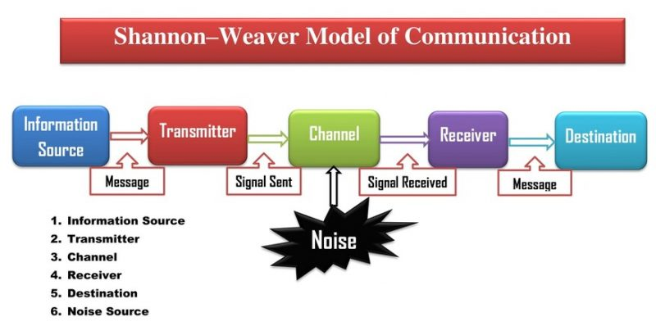
Source: https://newsmoor.com/wp-content/uploads/2021/03/Shannon%E2%80%93Weaver-Model-of-Communication--scaled.jpg

In the Shannon-Weaver diagram, a message is shown travelling from a source to a transmitter as a series of signals that traverse a channel where they may be corrupted by interference from a noise source.
Decoding the message and re-delivering it to the intended recipient is accomplished by sending it to the intended recipient via a receiver. Fundamentally, the scheme's advantage is that, despite its focus on the telecommunications industry, it helps us better grasp the fundamentals of all communication.
Among the most significant differences is between the transmitter and the source. It is the source that creates the communication, but it is the destination that is deprived of receiving it.
An individual or organisation decides whether or not the message should be sent, and the sender transforms the message into an electrical signal that is transmitted to the receiver. What happens next depends on whether or not the transmission is received in its entirety.
The source of the information is the most important component in making a decision. An purposeful communication is assumed by the source, as is the case in this case study.
Communication channel adapts the message to suit the transmission method.
A channel is a means of transmitting signals.
All or part of the channel may be blocked due to interference. Interference can occur when many messages are sent on the same channel at the same time.
Signals are converted into messages that may be read by the intended recipient by the receiver, which is also known as the receiver. When a message is sent, it must first be prepared for transmission or receipt before it can be received by the receiver.
The following methods of communication are available:
Presentation methods include the use of voice, face, or body.
Representation methods (based on representations) like photographs, drawings, books, and comics.
Mechanical and electronic methods like television, telephone, radio, and teletext (mechanical telegraph).
If a message is encoded or decoded incorrectly, it cannot be identified or corrected in the mathematical model, which has flaws in the receiver and transmitter.
When a message is intended for a specific person, it is referred to as the "recipient."
Redundancy and information entropy are also introduced by Shannon, notions that can be explained by the predictability or lack thereof of information.

In a communication, redundancy might be characterised as anything that is expected or typical. To suggest that a message is redundant is to say that it does not add anything new to the conversation at hand.
Low predictability and a great volume of information characterise entropy, the antithesis of redundancy.

Schramm's Modelul (1954)

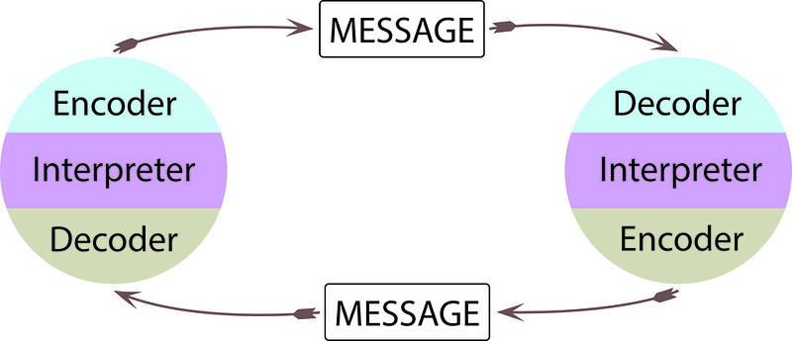

Source: https://socialsci.libretexts.org/@api/deki/files/51308/49532768182_225e7abb46_c.jpg?revision=1

Based on the Schannon and Weaver model, Wilbur Schramm developed his own model, the main merit of which remains the emphasis on the interactive nature of the communication process. Schramm states that in essence, the communication process consists in "agreeing the receiver with the sender, regarding the message", which involves two important moments - encoding and decoding the message.
Coding consists in translating the message into a language appropriate to both the transmission channel and the receiver, ie the transformation of an idea, an opinion, into a message, consisting of signals organized according to the conventions of one or more codes (we will return to broad on the notion of code). In other words, coding means putting signals and symbols in an intelligible, accessible and transmissible form. Decoding refers to the "retranslation" of the message by the receiver, to the extraction of the necessary meanings, ie the understanding and interpretation of the coded signs that make up the message.

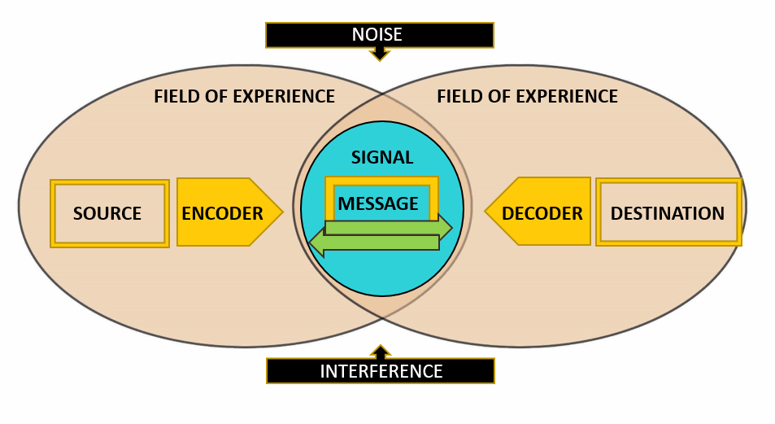
Source: https://1.bp.blogspot.com/-EpPAnmZ9wVc/X837mjf5KeI/AAAAAAAAA5I/GYFWNjfvebI9cmho7x-Xi9X9Q9TMCkLjQCLcBGAsYHQ/w1200-h630-p-k-no-nu/schramm%2527s%2Bmodel.png

The second Schramm model demonstrates the interactive nature of the communication process, which presupposes the existence of an "experience field" at both the sender's and the receiver's level, as an absolutely necessary condition for the "harmonization" of the two. In the drawing below we see an area of ​​overlap of the two fields of experience, so the "cumulative experience" of those who communicate. The larger this area, the more efficient the communication.
In addition to his model, W. Schramm reveals the quality of interpreter of the individual in a communicative relationship: he is both a coder and a decoder of the message.

Berlo's Model of Communication (1960)
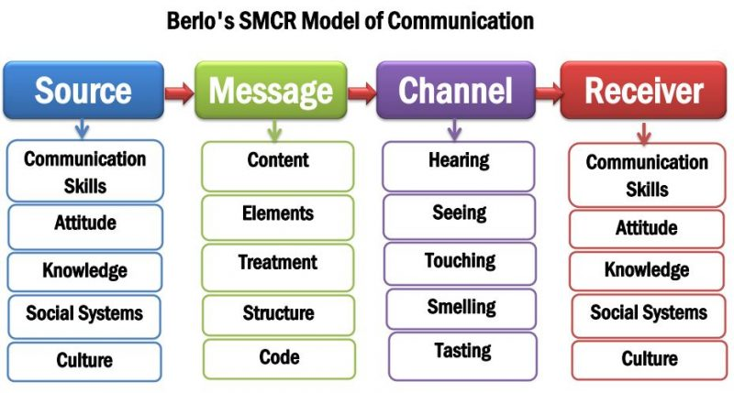

Source: https://newsmoor.com/wp-content/uploads/2021/02/Berlo-SMCR-model-of-communication-scaled.jpg

The SMCR (Source, Message, Channel, Receiver) communication paradigm was developed by David K. Berlo.
According to David Berlo, a message's substance is influenced by the environment in which it is sent and received. Five possible ways of communicating are identified (visual, auditory, tactile, gustatory, olfactory). He believes that the effectiveness of a message is governed by the similarity between the sender's and receiver's attitudes and knowledge.
A central tenet of the Berlo model is that efficient communication necessitates a point of contact between the sender and recipient. First, there must be a means of communication, and then it can take place. Consequently, the source and receiver must be the same in order to be effective.
The template makes it easy to evaluate the content of an email.
Source and receiver have five communication skills: two encoding (speech and writing), two decoding (listening and reading), one that is both encoding and decoded: thinking
It is important to note that a person's communication and conduct are influenced by their knowledge, which includes their attitudes, the manner in which they produce and treat their messages, the choices they make in regards to their communication channel, as well as their message's subject.
code, substance, and treatment of the message - channel - comparison with a parcel sent by mail: dock (encoding / decoding apparatus), boat (channel through which the message is transmitted: the five senses), and water - (support)
Both the sender and the recipient should consider the culture and social structure in which the communication is taking place before engaging in it. At the level of values or attitudes of sender and receiver, Berlo's model emphasises increasing the repertoires of communicators in order to achieve as many linkages and a common repertoire as feasible (these aspects have a special character). It has a significant educational value. For example, if most communication approaches focus on developing effective communication skills, then this author includes some extremely useful factors into the study of the sender (source) and receiver. At the transmitter level, they overlook the reality that the same communication skills must be present at the receiver in order for the communication process to be effective. We treat the formation of favourable attitudes toward communication in both communication partners in the same way..
Let's imagine I have to give a public presentation, and I put in a lot of effort to ensure that the content is conveyed in an efficient manner. However, this is only the beginning. If your audience is unable to comprehend the message you are trying to express or is unable to focus for an extended period of time, the presentation's success will be limited. I also risk that my attitude will be conveyed to the public via other channels, such as nonverbal communication. Regardless of what the speaker does, the listeners will take on their bad state (such as boredom, fatigue, tension, stress, etc.) To the contrary, the winning team's energy, happiness, and commitment to their presentation have the same potential to serve as additional motivators for others to pay attention to their message.

https://en.wikipedia.org/wiki/Sender-Message-Channel-Receiver_Model_of_Communication

https://newsmoor.com/shannon-and-weaver-model-of-communication-explanation-examples/

https://michellemathiasfsp.blogspot.com/2020/12/schramms-model-of-communication.html

https://newsmoor.com/smcr-model-of-communication-david-berlos-smcr-model-of-communication-example/
Lull, J., 2000. Culture in the communication age. 1st ed. London: Routledge.
https://www.toolshero.com/communication-skills/berlos-smcr-model-of-communication/
https://www.communicationtheory.org/berlos-smcr-model-of-communication/

