

How a Positive Mindset Influences Success
In a Working Environment
Level 6 BA (HONS) Business & Management
BMSP6012
DISSERTATION
Sinead Marie James
1910154

Word Count: 12,515
Declaration
- This work has not previously been accepted in substance for any degree and is not being concurrently submitted in candidature for any degree

- This dissertation is being submitted as a partial requirement for the BA (HONS) Business and management degree

- This dissertation is a result of my own, independent work except where otherwise referenced. A bibliography is concluded within this paper

- I hereby give consent for my dissertation, if accepted, to be deposited in the school dissertation library

Signed:

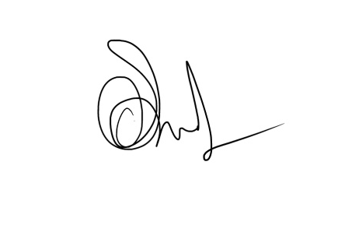
Sinead Marie James
12/04/2022

Acknowledgements
I wish to thank all my lecturers who have aided me in developing my confidence within my work. I wish to apply a special thankyou to Glenn, my dissertation supervisor, for providing me with his support and understanding my reasoning for the topic of this paper. I also want to thank Roisin for allowing me to consistently leave my comfort zone and enter the growth zone. Without Roisin’s work I feel this paper wouldn’t have as much value as necessary.

I thank my family for their support and helping me remain determined and motivated throughout my studies, especially my father who reminded me daily of what I can strive to be and how I can achieve anything I want if I put my heart and head into it, and for my mam who has always believed in my capabilities from a very young age. I owe gratitude to my partner, Stephen, for his patience in me whilst undertaking and prioritising this subject in my life. I would also like to thank my friends for their support, especially my positive mindset tutor Jo, who has helped me grow and take advantage of my capabilities, and my friends Alun and Olga, for believing in me from day one.

I give gratitude towards my peers; I came to the university to study and achieve a degree. However, it was evident that I would also be making friends for life from this academic experience owing a special thankyou to my friend Kasia, for aiding me in remaining sane throughout our journey together with the help of laughter.

I am thankful for Jessica Shores module; changemakers. It is this module that has allowed me to believe that mindset is as important as analytics, sustainability and management approaches, this module really allowed me to create work that has had a positive impact on my confidence and wellbeing.

And lastly, I owe gratitude to DR Bob Proctor, may he rest in peace, for the wealth of knowledge I have gained from him on my journey toward personal development has aided me in truly believing in myself.

Abstract
Our mindsets and wellbeing have seemed to be the least of our concerns when attempting to reach lifetime goals in regard to our working lives, with at least 15% of employees prioritising workloads and deadlines over their own mental wellbeing (MHF, 2022). It can be assumed that every individual can tell a story of a time in their lives where we put ourselves at the very bottom of our list of priorities.

The aim of this paper is to allow the readers to not only identify those times of neglect upon ourselves, or neglect towards ourselves that we have allowed others to carry out, but to also identify the times that we have most often overlooked, the positive times. It is too easy for us as humans to reflect on times of negativity or to take too much notice of others negativity towards us. What we don’t realise as a stereotypical human being is that the negativity we absorb, has an impact on not just our wellbeing but also our future success. The objective of this paper is to spread the word of the benefits practising positivity within a working environment can have on employees, and just how we can take advantage of our newly developed mindsets to aid in success not only within the workplace, but also in other aspects of our lives such as our relationships with others and ourselves, financial, physical and emotional aspects.

Using surveys and interviews to extract quantitative and qualitative data for the analysis provided within this paper, it has enabled this research to reach a vast audience and regain perspectives from more participants than qualitative data could alone within the designated time frame. A mixed method research approach was chosen specifically because it is factual and subjective simultaneously, it allows the researcher to combine the evidence gathered from both analyses and discover patterns within the qualitative data that may be backed up with statistics and truth found in the quantitative data, making the evidence nonbiased and non-subjective. Google analysis is used as the main analysis platform.

There is a new era approaching as individuals become more aware of the importance of practising mindfulness and how such practises can aid in the manifestation of abundance within every area of their lives. Within the research, discoveries such as how organisations are dealing with the wellbeing of the workforce will be presented and findings of existing organisations that already take a more holistic approach to ensuring the workforce remain positive and motivated, will be present.

All forms of personal development are fascinating and without positive reinforcement towards our mental wellbeing, aspects such as our health, wealth and success will deteriorate (Puri, 2020). There seems to be very little recognition within organisations towards this topic, and the researcher is living proof that when an individual focuses on manifesting all that they desire and learns how to do so via an experienced network of like-minded individuals, then that individual learns to know no limitations and instead sees opportunities for growth. This topic should be known by every member of a workforce, at any end of the hierarchal scale. The main objective of this paper is to hopefully acquire evidence to prove beliefs that positive mindset practices within the workplace should be as important as a wage packet, and just as paid sick leave is mandatory, so should be such practices using a holistic approach, as prevention is better than cure.

Contents:
- Introduction………………….………………………………………………………………………………………6
  - Purpose of this paper………………………………………………………………………………………….6
  - Motivation………………………………………………………………………………………………………….8
  - Aims & objectives……………………………………………………………………………………………….9
- Literature review………………….……………………………………………………………………………..9
  - History of practices…………………………………………………………………………………………10
  - The need for a holistic approach………………………………………………………………………10
  - The Chartered Institute of Personal Development………..………………………………….11
  - Theorist’s views……………………………………………………………………………………………….12
  - Culture and religion…………………………………………………………………………………………14
  - Gender and positivity rates……………………………………………………………………………..15
  - Existing practices useful to the workplace……………………………………………………….16
  - Benefits and barriers………………………………………………………………………………………..17
- Methodology…………………..………………………………………………………………………………….18
  - Analysis approach…………………………………………………………………………………………….19
  - Choice of questions used within survey…………………………………………………………….20
  - Choice of questions used in the interviews……………………………………………………….22
  - Time limitations………………………………………………………………………………………………..24
- Findings and discussion…………………….……………………………………………………………..24
  - Visual Analysis of quantitative data…………………………………………………………………..24
  - Thematic analysis of interviews and qualitative data………………………………………..30
  - Findings and discussion post analysis………………………………………………………………..33
- Conclusion…………………..………………………………………………………………………………………37
  - Recommendation 1…………………………………………………………………………………………..39
  - Recommendation 2…………………………………………………………………………………………..39
  - Recommendation 3…………………………………………………………………………………………..40
  - Further research……………………………………………………………………………………………….40
6.0 Bibliography……………………………………………………………………………………………………………41
7.0 Appendices….…………………………………………………………………………………….……………………..45

1.0 Introduction:
As human beings it is easy for us to allow our primitive brains to take over in situations that involve us taking a fight or flight approach. Due to the mass lack of knowledge about how we can use alternative mindset approaches and our intellectual brain in situations that instantly cause panic, the majority result is that individuals allow their adrenaline and cortisol levels to provide a smoke screen to what we, as human beings are able to achieve.

It is only within the situations that involve individuals who are educated on how to overcome our primitive brains taking control, where the true satisfaction of realising how successful we can be is evidenced. Who wouldn’t love to be able to get that promotion? Who wouldn’t love to be able to set up that business? And who wouldn’t love to be able to walk into that interview with ease and reassurance in knowing they already have the job?

  - Purpose of this paper:
The purpose of this paper is to provide knowledge to the readers about how they can overcome their instincts and the use of their primitive brain, to achieve almost anything they desire in life. By using our intellectual brain rather than instinctively using our primitive brain, we can achieve anything we set out to. If we convince ourselves through repetition of practices that we deserve something we desire and we are strong and capable enough to get it, then it is inevitable that our sub-conscious will do everything in its power to discover ways and means around seeking out our desires.

This paper hopes to identify reasons as to why holistic approaches should be available to employees within any organisation, to aid them in overcoming limiting beliefs about themselves, and to ensure that all employees are equipped with the correct knowledge on how to create a strong enough mindset to aid them in climbing the vocational ladder and achieving everything anyone wishes within their working environment, whether that be a promotion, an innovation or the courage to leave a circumstance that no longer serves.

Our sub-conscious brain is extremely innocent yet powerful, sometimes for the bad and sometimes for the better, it does not know right from wrong and assumes everything we input into it to be true. Our sub-conscious listens to every single thought we have about ourselves, whether it be good or bad thoughts, and will do everything in its power to seek out that truth for us. This can work to our advantage if what we are telling ourselves is on the scale of something positive, however, if we are only talking negative about ourselves and using terms such as ‘I can’t’, ‘I probably won’t’ or ‘I will never’ then our subconscious will believe that to be true (Johnson, 2017).
The good news is, this doesn’t have to be the case and we are able to change this if we have the knowledge on how to do so. The work of tapping into our subconscious minds is very repetitive and requires a lot of patience, we must practise methods daily and prioritise them just as much as our basic needs of food and water. Through repeating such practices, eventually we will develop habits, habits that are of a more positive nature and ones that will benefit our lives when our subconscious starts realising these thought patterns are here to stay.

When we start telling ourselves things such as ‘I can’ and ‘I will’, we may not believe it entirely to begin with, however, upon repetition of such affirmations and practices, our subconscious mind will believe these things to be true and work behind the scenes to aid us in finding ways and means to seek out these truths in our daily lives. An example being you wake up for work in the morning late and have missed your alarm, instantly you feel panicked and stressed and things occur that make your morning even worse, things such as dropping toothpaste on your top when you’re in a rush or travelling to work and you get stuck in a traffic jam which makes you even later, or even arriving to work and struggling to find a parking space.

Now this paper needs to be read with an open mind as it may be stated that none of the previous activities can be controlled by our sub-conscious brain, however if we took a different approach to waking up late to our alarms such as saying to ourselves ‘it is what it is’, then maybe the morning would not have spiralled out of control and after contemplating a few of our usual morning routines such as our morning coffee, then there would be no toothpaste on our tops, we would not be rushing to find a clean top to wear resulting in us not hitting the morning traffic, and then because we have not hit the morning traffic, we arrive early enough to find a parking space.

This paper is all about perspective, and hopefully upon reading this paper, it will become clear that by changing our perspective slightly, we may lead ourselves to bigger and better things. Our brains are an extremely complex organ, we are the only species on this planet whose brains have developed to the extent they are at today (Schleifer, 2021). However, this does not mean that we are in full control of how our brain operates, if our brain thinks we are in a situation that may cause us harm, our fight or flight mode comes into operation, cortisol and adrenaline start to pump and it is determined by our sub-conscious mind which step we take next (IDF, 2022).

If our subconscious has not learned alternative methods on how to deal with such situations then we will automatically opt for the ‘flight’ mode and until we learn how to break this habit and train our brain to go into ‘fight’ mode for a more desirable outcome for ourselves, then we will forever be in a cycle of bad habits that do not benefit us and in an emotional sense, living not much different to how cavepeople lived.

1.2 Motivation:
Speaking from experience, when we get too reliant on our primitive brain, this can be a hard habit to break. It will take years of brain training and tapping into our subconscious mind to teach ourselves how to approach situations differently resulting in us receiving a different outcome. An example of this being our weight and how we perceive our bodies, if we tell ourselves for long periods of time that we dislike how we look, no amount of diet and exercise will be able to change our perception because our subconscious mind thinks we like to think of ourselves in this way.

Another example being our vocation, we may repeat daily cycles of going to a job that we strongly dislike and instead of leaving our comfort zones to find new employment, we stay in flight mode and repeat the cycle. The cycle needs to be broken, even if it does cause temporary fear, we must train our minds to believe that it is not all that bad in ‘fight’ mode, for it is in this mode when we grow the most. Therefore, for any transition it is important to think first about how our mindset will react and approach the transition by firstly working on our thoughts.

As another example on how extreme a change in mindset can benefit us is an experience of the authors, she invested everything she own’s into opening a small café in the year 2019, as the time approached for the café to open its doors to the public, a global pandemic struck us all right where it hurt the most, putting everything on the line. In a normal circumstance, our primitive brains would reap havoc in this situation, and for a short while this occurred. However, the author did not want to be another statistic of COVID-19, and she decided that no matter what she did or how she did it, her café will survive this pandemic.

There were times where the author genuinely thought she would not make it another week before needing to go bankrupt, however, somehow, she managed to find ways and means to get her through one week at a time. This is no miracle or stroke of luck, this was down to how she viewed her situation, and when she quickly came to realise that she was not the only one in difficulty and that every business owner in the world was struggling due to the same reasons, selfishly enough this caused reassurance for her, and the panic seeped away and, in its place, came options and innovations on how she and her cafe could survive.

Innovations included a ready meal service, buffets brought to customer’s doors and a delivery on Sunday roasts. Where other businesses in the region decided to close and not risk losing any more of their financial assets, the author decided to put what was left in her account on the line and in the end it paid off, this was solely because her sub-conscious mind was comfortable enough to take a ‘fight’ approach through the reassurance that stemmed from the repetitive practises she was doing in her own time.

1.3 Aims and objectives:
This paper aims to answer five questions throughout, the five questions being:
- How can we teach ourselves to train our subconscious minds to benefit us?
- How will a company and its employees benefit from an improved, positive mindset?
- What aspects affect how our subconscious works?
- How does society and the working environment feel about practising mindfulness to aid future positivity?
- How can we adapt our lives to incorporate these practises on a mass scale?
These questions will be answered throughout the entirety of this paper and evidence of findings will be present in a mixed method analysis. This form of analysis was chosen solely for the reason it is fact-based, non-biased and numerical in its statistics alongside gaining an in-depth perspective via a thematic analysis recovered from interviews. This form of methodology will eliminate findings being subjective as the topic of this paper is taboo enough, it will be fair to the findings of this paper to be backed up with true, fact-based evidence, to do this a survey was conducted and presented to the public on numerous social media platforms alongside interviews taking place online.

2.0 Literature review:
Within this section of the paper, aspects such as gender, culture and religion and how they determine the mindset of an individual will be touched upon, alongside evidence gathered about how certain characteristics within individuals show how much more or less likely it is that individual uses more of their primitive/ intellectual brain. This section will also demonstrate the benefits and the limitations we have regarding practising positivity within our usual, daily routines and how such practises have become more acceptable by society since the approach of the pandemic, specifically focusing on online access to such practises. This section will also demonstrate ancient methods such as the ancient Egyptians and how they used manifestation to maintain their ‘universe’, alongside more modern users such as Dr Bob Proctor and other theorists who have used a more holistic approach to gain success within their lives, and why it is important to take notice of these holistic practises that have been in place for all these years to benefit our own levels of success.

2.1 History of practices:
Practices of mindfulness to aid in success date back to the beginning of mankind, where every culture and ancient civilizations had their own methods and reasoning as to why such practises were important to them. Using the ancient Egyptians as an example of such civilizations, the Egyptians believed that the universe was created by the sun god ‘Atum’ and eight of his descendants that immersed from the waters of the Nile creating four main deities: ‘Shu’ the god of air, ‘Tefnut’ the god of water, ‘Geb’ the god of earth and ‘Nut’ the god of sky. Later deities were created such as Osiris, Isis, Nephthys, Horus and Seth, and the Egyptians believed that the waters of the Nile could demolish the universe just as it created it if ‘Maat’ was not maintained. ‘Maat’ is the meaning of ‘Order’ to the Egyptians, and to do this the Egyptians obeyed what was being ordered of them and manifested that their lives could consistently bring ‘Maat’ by taking directions from their Pharaohs, who were believed to be created by the deities and gods (Kaelin, 2016). Today, the concept of the ancient Egyptians may just seem like an extreme case of control by the pharaohs to the people, but it is evidenced that even in 3100BC, manifestation to achieve all that one desires was important enough to maintain a civilisation.

In a more modern sense, such practises have been given the term ‘the law of attraction’ since approximately 1906, and this is a three-stage method that simplified, means if one asks the universe for what we wish to acquire, believes whole heartedly that we will acquire what we desire, and the result will be in us manifesting what we have asked for in physical form (Byrne, 2016). In explanations from some of the theorists, the method of practising the law of attraction sounds wish-washy and quite frankly, unbelievable.

This is why this paper will be introducing theorists that back up their definitions with science, to achieve everything we want in life it is not as simple as putting out there what it is we wish for and simply sitting back and waiting for it, there is no golden lamp we rub to make a wish, it is simply science of how we tap into our sub-conscious minds to convince ourselves what we are capable of achieving and not stopping until we have acquired what it is we want the most.

2.2 The need for a holistic approach:
There are many reasons as to why individuals should be assisted with improving their state of mindfulness; an increase in positive thinking and motivation and a decrease in depression, anxiety and negativity to name just a few. There are many benefits to providing employees with mindfulness practices for any organisation, such benefits include a workforce who are motivated, positive, efficient, present and open-minded (NHS, 2018). These are all important factors to take into consideration for any company to be sustainable regarding its employees enjoying their workplace. An unhappy workplace could be assumed to be temporary, with staff coming and going.

There are many existing organisations that swear indefinitely using holistic ‘hippy-stuff’ as google brands it, is extremely beneficial for all parts of an organisation’s operations. Google provide thousands of their employees with a ‘search inside yourself’ course that aims to aid the employees to embrace the practises by explaining the neuroscience that backs up and evidences the reason why these practises are of great importance to the human mind. It is considered today that the course provided by google to its employees is the reason why the organisation is so successful regarding employment rates (Stewart, 2015).

2.3 The Chartered Institute of Personal Development:
The Chartered institute of personal development, formally known as the welfare workers association, was founded in 1913 to help people and organisations reach their full potential through the means of human resource management and people development (CIPD, 2022). The CIPD attempt to aid organisations to realise that the wellbeing of their workforce is not only beneficial for the individual employees, but also to the organisation itself regarding organisational performance and productivity, by reducing stress within the workplace and encouraging a positive working environment.

Organisations that contribute to the wellbeing of their workforce can see the bigger picture as to why prioritising employee wellbeing is beneficial as it does not only have a positive impact on workers, but also to the organisation and further afield such as the community local to that organisation and further again to the economy that organisation operates in.

For the bigger picture to be achieved and for employees to flourish, the wellbeing initiatives must be embedded from the hierarchy into the organisational culture, leadership and people management. With organisations evidencing worrying statistics of presenteeism and leavism, management need to look beyond the statistics of employee sick leave and those working whilst sick, and instead get to the root cause to implement strategies that resolve the root reason for absence rather than supress it.

According to the CIPD wellbeing at work leaflet (2021), there are seven domains of workplace wellbeing presented below alongside what the CIPD suggests is included in each domain, also present are the researcher’s suggestions on how organisations can improve on each domain:
- Health- physical, emotional and mental health. Options for improvement include regular employee health checks, health insurance, occupational health support and good rehabilitation practises.
- Good work- working environments, management, expectations, autonomy, adaptation and rewards. Opportunities for improvement include an inclusive culture, responsible and ethical workloads, reasonable working hours, work-life balances, whistle blowing, communication and remuneration practises.
- Values- Leadership, ethical, inclusion and diversity. To grow on these values, an organisation could attempt the following: State clearer objectives, implement strategies that consider health and wellbeing, ensure dignity is present, CSR, cultural engagement and training programmes.
- Social- Employee voice and positive relationships. An organisation should ensure good communication with the workforce, build teamworking skills, adopt a more empathetic management style and encourage healthy peer and management relationships.
- Personal growth- Career development, emotional care, education and creativity. Organisations can implement agendas to improve all these aspects that include factors such as employee coaching, personal resilience training, technical training and innovation workshops.
- Good lifestyle choices- Physical activity and healthy eating. Organisations need to consider the physical wellbeing of the workforce and not just the mental wellbeing, aspects such as organised walks or healthy menu options for the canteen will ensure this.
- Financial wellbeing- Fair pay, retirement planning and financial support. Organisations could improve on these factors by offering above the minimum wage, phased retirement or debt counselling.

2.4 Theorist’s views:
There are many theorists who believe in ‘the law of attraction’ and how a mindset affects our success rates in all aspects of our lives. For the purpose of a word count, only a few well-known theorists will be included within this section. The theorists were chosen based on their success in their own lives by using the teachings of the law of attraction and positivity practises.

It goes without saying that the first theorist to be mentioned should only be Napoleon Hill. Mr Hill was born in 1883 in south Virginia and is best known for his book ‘Think and grow rich’. Hill dedicated his life’s work to teaching his practises that he had learned himself from a Mr. Andrew Carnegie (1903). Carnegie explained the work of the book to Hill when he was just a boy and Hill spent the next twenty or so years of his life learning everything there was to know about the topic, so as he could create a book for all to understand the benefits of the practise. The book describes thirteen key steps to success, the steps are as follows:
- To have a burning desire for what it is you hope to achieve
- To have faith that you will acquire what it is you desire
- Autosuggestion (the platforms for which to train the sub-conscious mind)
- To have specialised knowledge for the topic of your desires
- Use your imagination
- Create an organised plan
- Make time for decision making and procrastination
- Be persistent with your organised plan
- Gain power of your own mind
- Sex transmutation, meaning transitioning the keenness, the courage, the imagination you encounter during sex and putting into another form of creative energy to harness innovations on how to achieve your desires
- Connect to your sub-conscious mind
- Become aware of your thoughts
- Recognise your sixth sense
(Hill, 1937).

Individuals are still using Hill’s thirteen steps to success as a guide to achieve their own desires, Hill believed that everything we need to unlock greatness in our lives already resides within our imaginations’, there is a foundation named Naphill which is dedicated to teaching Hill’s beliefs to those who are ready to listen, however, Hill also once said “Each of us has locked within us all that is necessary to achieve wealth and greatness” , so the Naphill foundation is just another medium to learn how to unlock what we already know (Napoleon Hill Foundation, 2022).

Following on with another theorist, Dr Bob Proctor should be mentioned. Dr Proctor has also spent his life teaching practises of another man, that man being Napoleon Hill. Dr Proctor opened his own online institute called the Proctor Gallagher institute, whose mission statement is to “Wake the world up, so more people can reach their potentials and live the way they really want to by shifting paradigms” (2022), where he provides service users with an online platform full of course materials to learn all there is about manifesting desires into reality.

The difference with Dr Bob Proctor and Napoleon Hill is you can visually see for yourselves the success that Dr Proctor has manifested using his practises, his name appears everywhere when individuals start their self-help journeys and he was also once himself a normal human being like the rest of us, he has practised his beliefs thoroughly to get where he is today. Not everyone believes what Proctor does to achieve his success and earn his money through the promotion of his costly online courses and seminars is ethical, ‘Mike’ reviewed Proctor on trust pilot as ‘deceptive and misleading’ and seemed disgusted by the repetitiveness and unclarity of Proctor’s teachings encouraging users to purchase extra course materials to gain more clarity that they never actually achieve, Mike believes there is a loop to encourage individuals to purchase more materials that will never actually give them ‘the secret’ in layman’s terms, and that everyone already knows how to achieve everything they want by simply working hard for it, branding Proctor’s seminars and courses as “another hype and heart breaking promise” (Trustpilot, 2021).

As mentioned before, the topic of this paper is taboo and needs to be viewed with an open mind, however, with the examples provided of theorists it is plain to see the difficulty individuals encounter when attempting to believe that they have, and always have had, the ability to change their current situations for the better at any moment in time, whether such situations include one’s vocation, finances or relationships. There is Napoleon Hill who has a foundation dedicated to providing free knowledge on the practise, then there is the Proctor Gallagher institute who charge approximately £7000 for users to take part in their courses, leaving users such as Mike on Trustpilot dissatisfied with their purchase as they felt they didn’t gain anything. It can be assumed that if one has the knowledge needed to achieve success and sets out to achieve it, then it could take any amount of time to accomplish this, with or without the help from genuine or fraudulent teachers.

2.5 Culture and religion:
There is a fine line between practising the law of attraction and religion, many Religions believe that there is one deity that we, as humans, pray to when we are wanting to manifest something into our lives. This deity has many names such as God, Allah, Gaia, Buddha and Jehovah and some religions even believe in numerous deities such as the Egyptians, Vikings and Greeks. As some religions believe God is one higher being, others believe there are many higher beings to serve many different purposes such as Freya, the Norse goddess of fertility (McCoy, 2019).

In a nutshell, the new age spiritual religions such as those individuals who practise the law of attraction believe that they are their own deity or ‘God’ and they have the power to decide what is meant for them (Universe Spirit, 2022) by harnessing energy via methods described only in quantum physics, methods such as ‘the observer effect’ where you simply observe a phenomenon which in return influences the paradigm to change its physical appearance (department of physics, 2019). New age individuals that are sometimes branded as ‘hippies’ and expected to wear bamboo slippers and rucksacks made from hemp, when in fact these individuals are businesspeople, such as Henry Ford, Albert Einstein, Thomas Edison, Jim Carrey, Will Smith, Conor McGregor, Oprah Winfrey and Denzel Washington (Positive Creators, 2021).

It is because of this ‘hippie’ branded stigma why society are too worried to start practising what could potentially change their lives, as society seem to be so worried about how they are perceived to the world, if it was well known that even the ‘coolest’ of individuals such as Will Smith practise this topic to gain more of their desires in their own lives, then would we be so ‘stuck’ as human beings and ‘normal’ people? It can be assumed that maybe the media keep this topic quiet just so normal, everyday people don’t learn how to get everything they want, and maybe people like Dr Bob Proctor charge a small fortune to teach society this ‘secret’ just so only those select few individuals who already have the money to afford these small fortunes, or are dedicated in personal development enough can learn? And maybe this practise is not actually a religion and is supposed to be used by everyone but is only being taught to those who can afford it?

2.6 Gender and Positivity rates:
According to Graham (2022), statistics show women to be more positive and happier within their lives than men, however, an interesting fact to add to this statement is that women’s stress hormone, cortisol, that is released from our primitive brains, is higher than men’s and as seen in the below chart, women’s reactions to the release of cortisol is exaggerated compared to men’s reactions (APA, 2012).
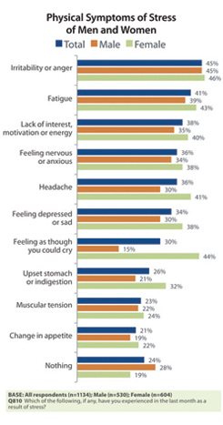
Another statistic to be touched upon is gender and success rates, and according to Besselaar, (2015) from the department of organisational sciences and network institute, men are more successful in regards of career progression and performance than women. Now what does these statistics mean for attracting and manifesting our desires for our working environment into our lives? It means that women may find it more difficult to tap into their sub-conscious minds and convince themselves that they are going to achieve their desires, it means that men are more successful in regard to their careers, however, success isn’t determined by your working status, or your financial status and according to the Cambridge dictionary (2022), success is defined as “the achieving of a desired result”, meaning it is subjective to the individual on how successful they believe themselves to be.

One may not acquire all that society believes is essential to be branded successful, one may only have the clothes on their back and still believe themselves to be successful. It is determined by what is in an individual’s own mind and if that individual believes themselves to be happy, then they may also believe themselves to be successful. Because of the diverse and individual definitions of success from both genders, Hoogendoorn et al, (2013) believes that for an organisation to be successful in terms of progression and performance, it is best to have gender diversity as a priority, therefore results will come from a range of different perspectives, knowledge and skills.

2.7 Existing practices useful to the workplace:
Although practises regarding positive mindset hacks to manifest have been in place for thousands of years it is still of great interest to society today, it seems to be a topic that can never grow old. There are numerous methods of positive mindset practises, and a modern phrase for this form of work is ‘mindfulness’ meaning being completely present with one’s emotions, doing so gives the individual an opportunity to reduce over-reactions and feeling overwhelmed, the individual can instead choose to find a more positive outlook on a situation that will have a very beneficial impact on one’s mental health (Mindful, 2020).

There are many forms of practising mindfulness that are tailored for specific problems, such as anxiety, negativity and depression. Mindfulness-based stress reduction, MBSR for short, is a form of practise that aids service users to become more productive in their day to day lives, reduce negative thinking patterns and boost immunity (Brown University, 2019). ACT, also known as acceptance and commitment therapy, when used within a working environment can improve mental health, reduce statistics of depression and improve creativity amongst team members (Eifert et al, 2005).

Another important version of mindfulness to mention that would aid a working environment is DBT, dialectical behaviour therapy, this form of mindfulness practise was created to aid those who have tried the medicinal route for their state of wellbeing and discovered no progress, DBT reduces anger and negative repetitive behaviours such as overeating and getting angry, resulting in increased awareness of one’s self-management (Mind, 2022).

Recent studies show that the left pre-frontal cortex area of the brain has more activity in those who practise mindfulness than those who don’t, this area of the brain is the area which controls positive thought patterns, so why is it that only 72% of GP’s find it a good enough reason to teach patients mindfulness practises? (MHF, 2010), therefore this paper aims to provide evidence to back up beliefs as to why mindfulness practises should be in place at every working environment, as being more positive is crucial for succeeding and achieving one’s goals.

Positive people prefer to look on the bright side of a situation rather than complain, they are more grateful for what they have rather than taking things for granted, they accept responsibility rather than shift it on to someone else and positive people see barriers as opportunities for growth rather than limitations, they welcome change as an exciting transition that brings them closer to their objectives where as a negative mindset fears change and adaptation, positive people see potential rather than faults (Chong, 2022) what employer would not want this for their workforce?

2.8 Benefits and barriers:
There are many benefits to practising mindfulness within our daily lives, it is proven that mindfulness increases productivity and motivation which in return makes us more successful at something, mindfulness increases our mood and boosts positive thought processes which can enable us as humans to look for the good in situations rather than focusing on negativity, and mindfulness practices also make us more creative as we use our imagination for aspects such as meditation, we then put those developed creative mindsets into our work and create unique innovations that are sometimes ground breaking for an organisation, aside from all of the previously mentioned benefits of practising mindfulness within the workplace, it can be assumed that the most important advantage one receives from practising these methods is gaining empathy, this allows the individual to view other perspectives with an open-mind, resulting in an increase of knowledge and a sense of comfort within the working environment (WEF, 2019).

Of course, as with everything in life there are barriers, even to the most advantageous of factors. One may be assumed to be religious within a workplace if they are seen to be practising mindfulness without the mass of peers taking part also, this is not a bad perception to have of someone however, this depends on the organisational culture and how accepting they are of such methods. For example, it can be assumed that there is a lot of pressure on the younger generation and how they are perceived to society, a ‘GenZ’, which is defined as someone who was born between the late 1990’s to 2010 (Axis, 2022), may not be as accepting of a fellow GenZ practising these methods unless the majority of the team are also practising such methods. This is an assumption of course, but with the use of social media and how it can make or break someone and create a ‘herd mentality’ (National institute of health, 2010), then a GenZ in a similar situation may not wish to express their practises openly for fear of a damaged perception.

3.0 Methodology:
This section of the paper will aim to provide evidence found within the analysis of the quantitative and qualitative data. Both sets of data will be inputted into an analysis platform to discover the evidence in a visual format for later discussion in the following sections of the research paper. All research was carried out with ethics in mind, ethics forms were completed and returned to the researcher before any continuation of interviews.

Using the research onion by Saunders et al (2011), the methodology was broken down into six areas, or layers as the onion suggests: research philosophy, research strategy, research choices, time horizons, techniques and procedures. A mixed method approach was used to combine the positivism and interpretivism positions of the data in the hope to conclude with a clear understanding of the benefits of a positive mindset to the working environment.

The outer layer of the onion, which is where a researcher would peel back first, is the philosophy of the research, whether that be positivism, interpretivism, pragmatism or realism, this paper has taken a more pragmatic approach as the research has used the most appropriate tools possible for the given time frame and incorporated the data into the analysis with a practical point of view. The next layer describes the approach used within the research, in this case the approach was abductive, other approaches the research could have taken was inductive or deductive. The research was abductive as it started off as a small hypothesis and grew with the increased research taking place based on information gained from the qualitative and quantitative analysis.

The research choices are the third layer of the research onion, and it consists of the method used, the research for this paper used a simple mixed method approach of combining qualitative and quantitative data, other choices for research are mono-method quantitative, mono-method qualitative, multi-method qualitative, multi-method quantitative and mixed method complex.
The fourth layer of the onion entails the research strategy and how the researcher plans to carry out the research, this paper used surveys and interviews to form an analysis, other options are case studies, experiments, archival research, grounded theory and ethnography. The fifth layer of the research onion provides the researcher with a time horizon, whether that be cross sectional or longitudinal, this paper has taken a cross sectional approach to the time horizon as there was a specific time frame where the research needed to be carried out.

The sixth and final layer of the research onion contains the data and analysis and evidences exactly why the research has been carried out, this section refers to the primary data and provides a framework for why the chosen methods were carried out, how participants were selected and how the discovered data will be analysed, in this case the surveys were broadcast on social media in the hope to attract a range of demographics, interviewees were chosen specifically for their range in demographics and google analytics was used as the analysis tool. Below is the image of the research onion:
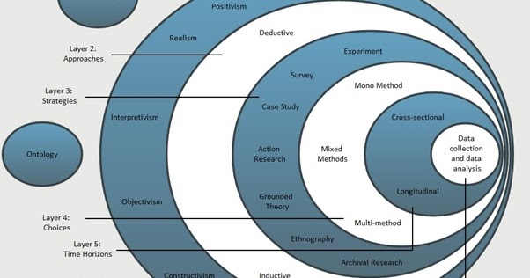
(Saunders, Lewis & Thornhill, 2011).

3.1 Analysis approach:
It was decided to use a mixed method approach regarding the analysis of this research solely because it may seem too bias if a qualitative research approach was used alone, at least with the backup of numerical and visual statistics, this research cannot be branded as subjective. According to McLeod (2019), quantitative data is that which can be measured numerically and statistically, and it takes into consideration and represents participants behaviours. Qualitative data according to Kendall et al (2005), is information extracted personally via emails, interviews, memos, signs et cetera that provide the research with a scope on the thoughts and feelings of participants.

It has been described that combining qualitative data and quantitative data within a research study integrates strengths of each analysis and compliments the research with such strengths (Greene et al, 1989). The reason for using the mixed method approach in this research, is because the topic of this research is not a priority for most, and as the researcher feels strongly that the health and wellbeing of every individual, especially the workforce, should be a priority, for this to be taken seriously and for the importance of this data found to be understood, the qualitative data needed to be combined with quantitative data for both to work together simultaneously and in harmony, to evidence the beliefs of those who already use holistic practises within their daily lives and want the stigma of being a ‘hippy’ to be washed away, as how one is perceived by society may be the root reason why individuals do not follow through with what they believe in for fear of having a bad or stigmatised perception against them.

3.2 Choice of questions used within the survey:
The survey was created using google forms and presented on social media platforms such as Facebook and WhatsApp where ninety participants took the time to complete the survey. Below is a replica of the questions and answers that were available on the survey:
What is your age?
- <20
- 21-30
- 31-40
- 41-50
- 51-60
- 61-70
- 70>
What is your gender?
- Male
- Female
- prefer not to say
What is your religion?
- Catholic
- Christian
- Spiritual
- Hinduism
- Sikhism
- Islam
- Judaism
- Buddhism
- None of the above
- No religion
How do you measure success?
- By how much money I have
- By how many people I know
- By how good my grades are
- By how healthy and fit I am
- By my appearance
- By my job title
- By how happy I am
How do you think you become successful in life?
- By working as hard as I can for it from an early age
- By listening to my elders
- By surrounding myself with like-minded individuals
- By focusing on getting to know myself first
- By focusing on what everyone else is doing and ensuring I am doing the same as them
How successful do you believe yourself to be?
- Very successful
- Somewhat successful
- Not so successful
- Not at all successful
Which of the following best describes your persona?
- I’m a happy go lucky kind of person
- I always look for the positives
- I worry about anything and everything
- I get stressed easily
- I listen to others’ views but always decided to make up my own mind about life
- I think it’s safer to just go with the flow
- We are born, we survive, we die…simple
Do you participate in any of the following activities regularly? (Tick all that apply)
- Affirmations
- Reading a book
- Going for a walk
- Healthy eating
- Journaling
- Expressing gratitude at the end of each day
- Donating to those in need
- Meditating
Did you know that participating in any of the above activities regularly could lead to future success?
- Yes of course I did!
- Hmmm, maybe
- No way!
If it was scientifically evidenced that having a positive perception towards life would aid in future success, would you ensure to make self-care activities a priority?
- Yes
- No
- Maybe
- I don’t think I could fit all those activities into my life right now
- I am already making it a priority
The above questions were chosen specifically to accompany the analysis with findings such as the comparison between gender and success rates, religion and wellbeing statistics, how society makes suggestions of how the wellbeing of a workforce can be improved and how they would prioritise activities in their daily lives that aid with their wellbeing.

3.3 Choice of questions used in the interviews:
Once an ethics form was completed the interviews took place. There were six participants in total, chosen specifically for the range in demographics, the interviewees identification is protected for ethical reasoning, therefor pseudo names will be used, and the interviewees will be referred to as participants A, B, C, D, E and F. Before the commencement of the interview, the interviewer assured the interviewees that they were under no obligation to answer any questions and they could leave the interview at any time. There were sixteen questions in total;
- what is the interviewees age?
- What is the interviewees occupation?
- Has the interviewee ever felt pressured by society to behave a certain way?
- Does the interviewee feel comfortable expressing their true selves within their working environment?
- What does the interviewee believe will happen to the perception of them if they do act in a way that resembles their true self?
- Has the interviewee ever considered attending health and wellbeing sessions?
- Does the interviewee believe more help for employee wellbeing should be available?
- What form of help would be useful if offered to them?
- Does the interviewee believe themselves to be a more positive or negative individual?
- Why does the interviewee believe themselves to be more positive/negative?
- Why is maintaining that positive/negative mindset important to them?
- How do they carry out this maintenance daily?
- How does the interviewee believe their mindset affects those around them?
- How would the interviewee describe an individual who uses holistic approaches such as meditation and yoga to aid in their wellbeing?
- What is the interviewees definition of success?
- How successful do they believe themselves to be?

Throughout the interviews, prompts such as ‘how?’, ‘why?’, and ‘what?’ were used to encourage the interviewees to broaden their answers and avoid single answers such as yes and no, without influencing them to provide answers deemed more suitable to the research. This way the interviewees were able to provide their own opinions, in their own way, without worry of bias or subjectiveness. However, this has resulted in the qualitative data being solely based on the opinions of six individuals, all with mixed points of views.

The reason these individuals were chosen were specifically because of the vast mix of demographics, for the purpose of this research it was needed to compliment the analysis as closely as possible due to the short time limitation and restricted word count, ideally a more extensive interview process with more participants would have been undertaken to get a clearer definition of individuals’ points of views regarding the topic of this paper and accompany the qualitative data.

Due to these restrictions, this was unable to take place, hence the mixed method approach to justify the findings from the qualitative data analysis with findings from quantitative data. The demographics of the interviewees differed regarding age, gender and employment status. However, care needed to be considered when choosing interviewees as the research may be accused of ‘sampling’ to influence the research in a way that voids the research as being equal, sampling can take place when one is bias about the topic of the paper and the reasons why interviewees are chosen may be to benefit the researcher’s point of view. On the other hand, sampling can be beneficial in a way that it is able to take a few select individuals, selected to represent a mass of individuals with similar backgrounds, circumstances and demographics (Saunders et al, 2012).

The interview ended with an express of gratitude for the interviewees and their time, and a reassurance that once the research was completed, the recordings of the interviews will be destroyed.

3.4 Time limitations:
Given a time frame of just below one full academic year to carry out research and analysis of the topic of this paper, it was evident that only what were considered the most important factors could be present, these factors included culture, gender and benefits to the workplace. Research needed to be organised and well-structured for the purpose of this topic to be simplified, as the topic of this paper can be researched in depth and after a lifetime everything will still not be known.

Using a GANNT chart that was created by Henry Gantt (1910), to measure the amount of activity against the amount of remaining time (APM, 2022), workloads were made clear in a structured way month by month, and it allowed the research to stay on a steady track without any distractions. If there were more time to carry out more research, then potentially a poll would have taken place on more social media platforms to get an even broader response from participants, and there would also be a broader research process with a lot more interviewees.

4.0 Findings and Discussion:
Within this section of the paper, the analysis of both quantitative data extracted from the surveys and the qualitative data, discovered within the interviews, will be analysed and presented. This will give the research an opportunity to prove that the success rates of the working environment are determined by a positive or negative mindset. This section will also aid in decision making for organisations to implement strategies that aid and improve the mindset of the workforce. Visual formats for the analyses are presented within this section to provide this research with a more understandable, and clear insight into what the findings have discovered, as it is believed that a picture is worth a thousand words. Also, it is proven that 80% of individuals take more notice to a piece of information that is visually presented, rather than information that is heard or read (Arnold, 2015).

4.1 Visual analysis of quantitative data:
Below are findings of the information extracted from the surveys, presented in a visual manner. This part of the paper can be assumed to be the exciting part, the part where all is revealed, the part where discoveries are made to back up or deny the statement of the paper that suggests a mindset can be the reason why the success of a working environment is thriving or whether it ceases to exist.

Beginning with the age of participants and how they perceive themselves to be, the below chart shows which age ranges believe themselves to be happy go lucky, more positive, worriers, stressed, those who likes to listen to others’ ideas but will always make up their own minds, those who like to go with the flow and those who are sceptics and set within their beliefs that we are simply here to be born, survive and die.
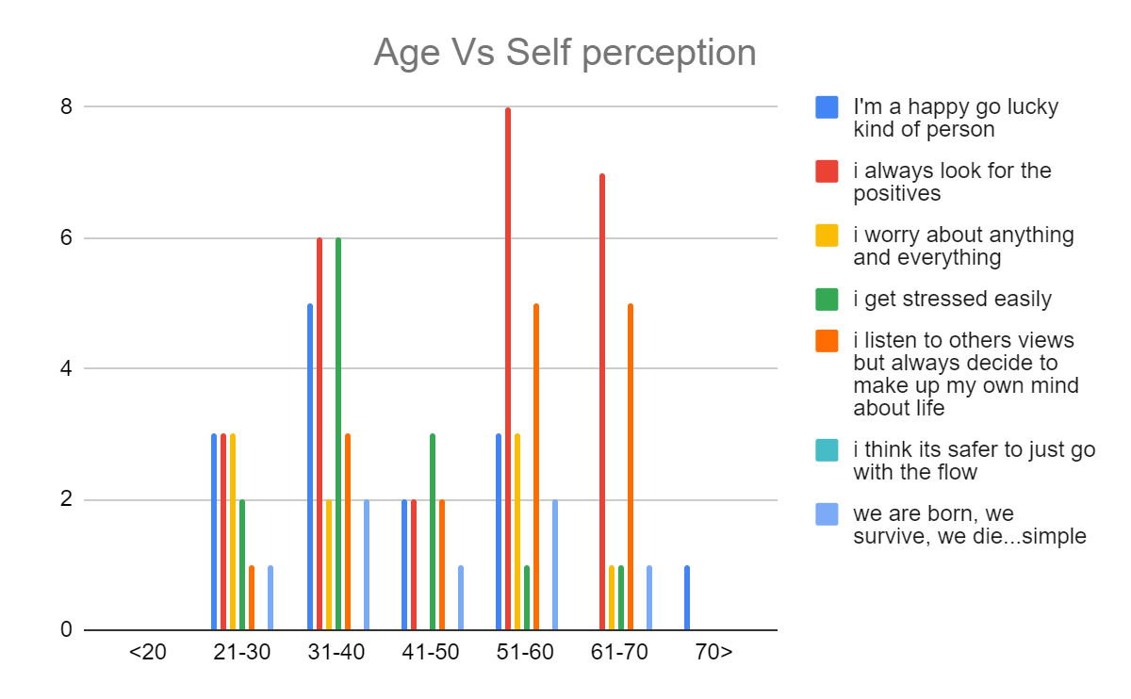
As can be viewed from the above chart, the X-axis shows the options for age ranges those participants had when taking part in the survey. It is evident from the analysis and the above image, that no one under the age of 20, ‘<20’ as pictured in the chart, took part in the survey. It is also evident that only 1 individual above the age of seventy, ‘70>’ as shown in the chart, took part in the survey and this individual’s perception of themselves was that they feel they just go with the flow daily.

Looking at the red within the chart which represents individuals that always look for the positives within their daily lives, this can be seen to be increased within the ages 31-40, 51-60 and 61-70, with it being extremely high within the ages 51-60. Out of curiosity, and to aid this research, the next chart shows how the above age ranges that believe themselves to be very positive individuals, compare their levels of success:
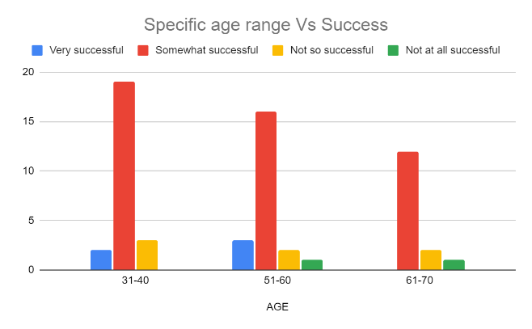

Going by the findings discovered within the above chart, the participants who previously stated they perceive themselves to be of a more positive nature, only perceive themselves to be ‘somewhat successful’. However, somewhat successful may not be sufficient enough to evidence the topic of this paper that a positive mindset is what determines success within the workplace, ‘somewhat successful’ may be deemed to be achievable by anyone, positive or not.

Another analysis needed to take place to put into consideration that this specific age range that declare themselves positive yet only somewhat successful, may be lacking confidence enough to realise how successful they really are, or they may be too far conditioned to understand that the concept of talking about success openly being a ‘bad taste’ conversation, is just old news and a new era of being open to success is upon us. Or, unfortunately for this paper, it may just be factual that a positive mindset in fact, does not determine how successful we are within our working environments. To add to the above findings, another cross-analysis that consisted of the same specific age ranges and their definitions of success takes place and can be viewed below:
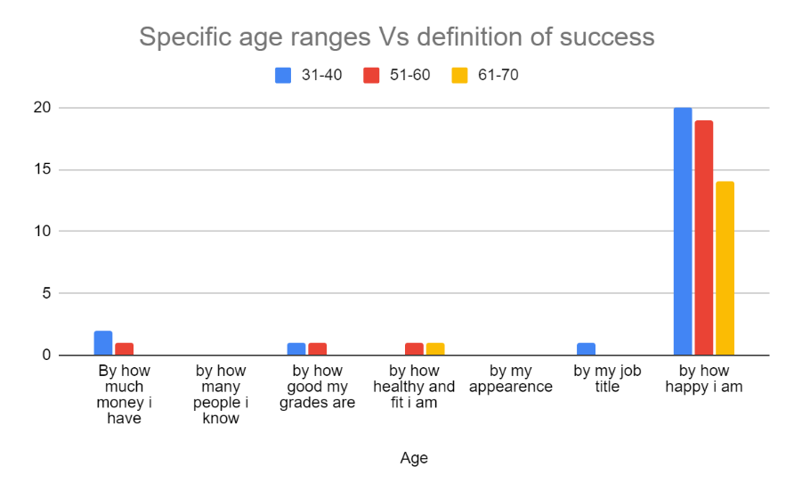
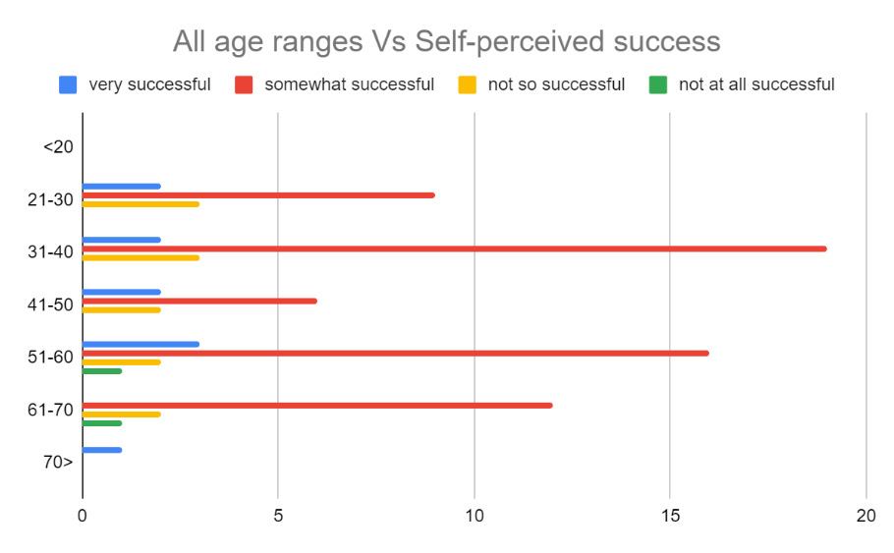
It can be clearly stated that regarding the specific age ranges of 31-40, 51-60 and 61-70 all whom declared themselves as being of a more positive persona, the majority of all three age ranges judge their success by how happy they are, with the younger generations of 31-40 also taking into consideration that success means vocational, academic and financial aspects, whereas the oldest generation of 61-70 solely base their success around health and happiness.

Reflecting on above statements made about ‘somewhat successful’ not being sufficient enough to evidence that a positive mindset is the root reason as to how successful we are, if the majority are basing success on happiness alone, then it can be assumed that as we are only human we cannot be happy all the time and we always assume we can be happier than what we presently are, so somewhat successful is sufficient enough…it would merely be impossible to be happy all the time as human beings, and according to Soleil (2016), there are seven reasons as to why it is impossible for humans to be in a constant state of happiness, these reasons are as follows:
- Frankly, individuals chose not to be constantly happy
- Lifestyle circumstances such as inner struggles
- An individual may be in a growth phase that challenges them
- There may be a mental illness preventing happiness
- Steps toward happiness are misunderstood
- Self-entitlement is preventing them from being happy
- Not one human being is perfect
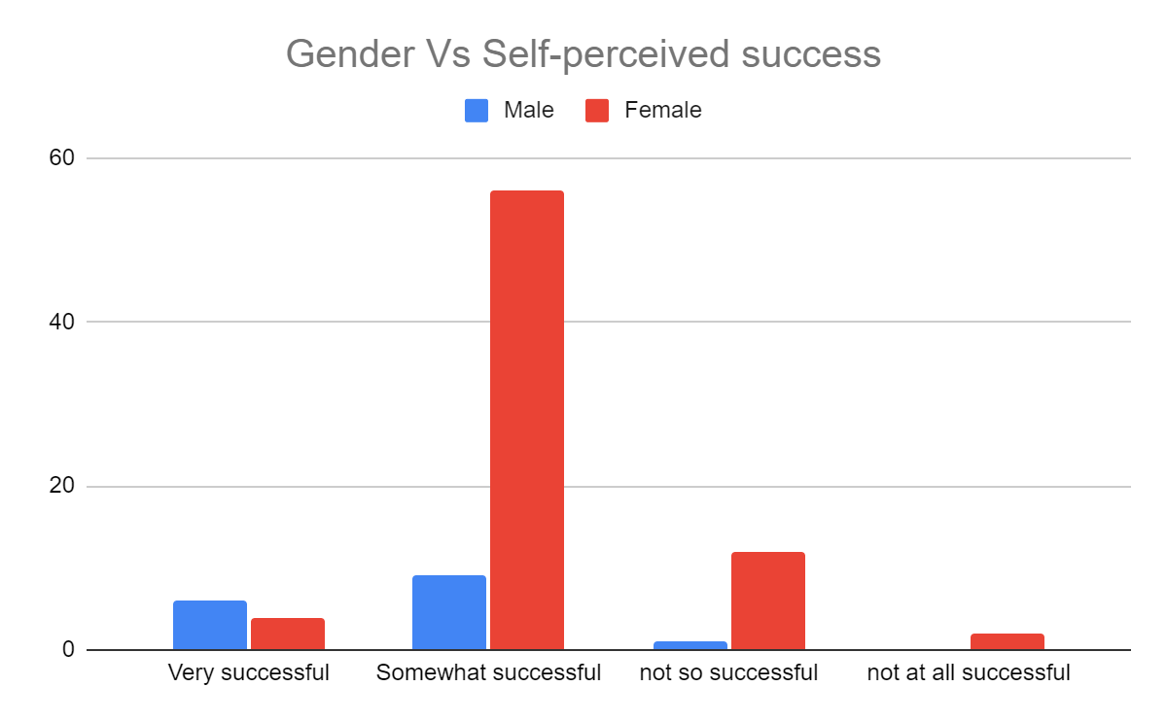

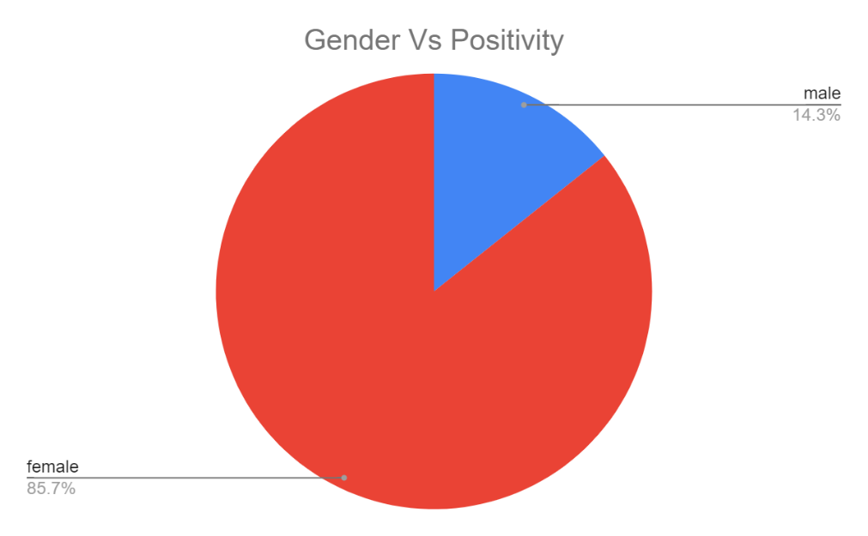
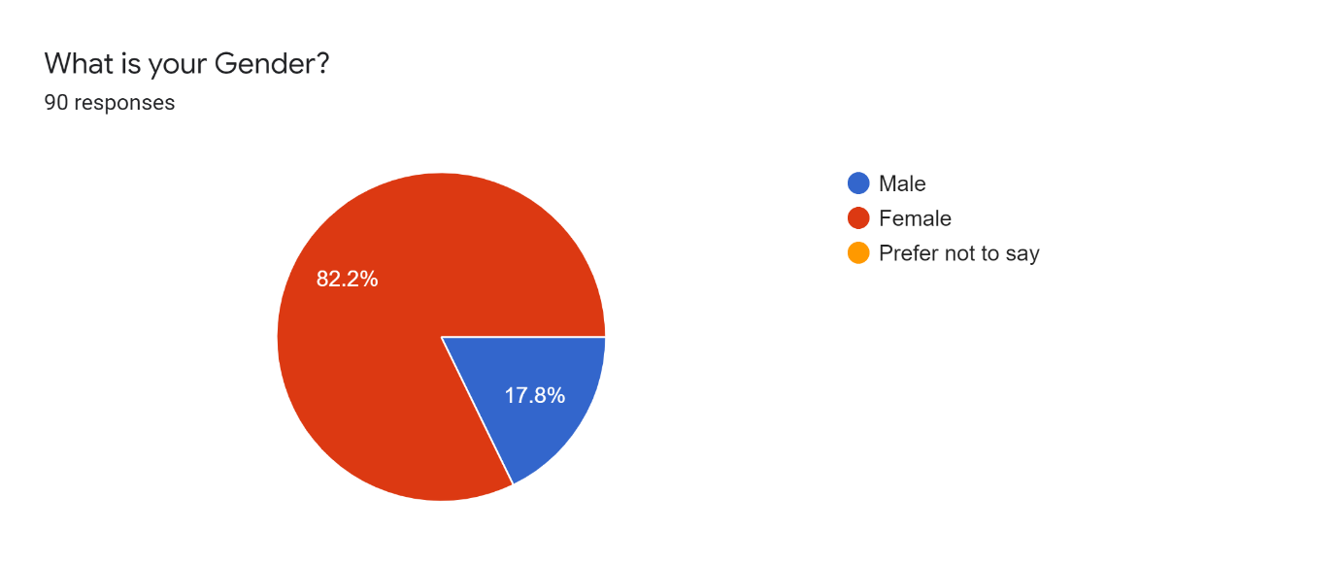
According to the above findings, it is evident that of the 90 participants taking part in the survey, it was females who perceived themselves as both more successful and more positive. However, it must be considered that 82.2% of the participants were female as discovered in the above pie chart. Due to these statistics, the fact that females perceive themselves to be more successful and positive, should be eliminated as evidence from this paper until further research can back up these statistics to avoid sample bias taking place in this research.

What can be taken into consideration, however, is how all the participants, both male and female of all ages, implement activities to aid personal development such as affirmations and meditations in their daily lives to aid them with their wellbeing. With 94.4% of participants undergoing these strategies of wellbeing with the knowledge that they are possibly beneficial for our health, 41.6% knowing for a fact whilst 52.8% found the concept convincing, with physical aspects such as going for a walk, donating to those in need and reading a book being the most popular forms of implementing personal development into the lives of the participants: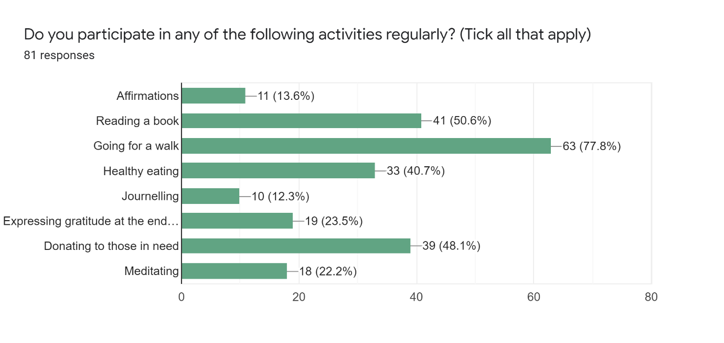
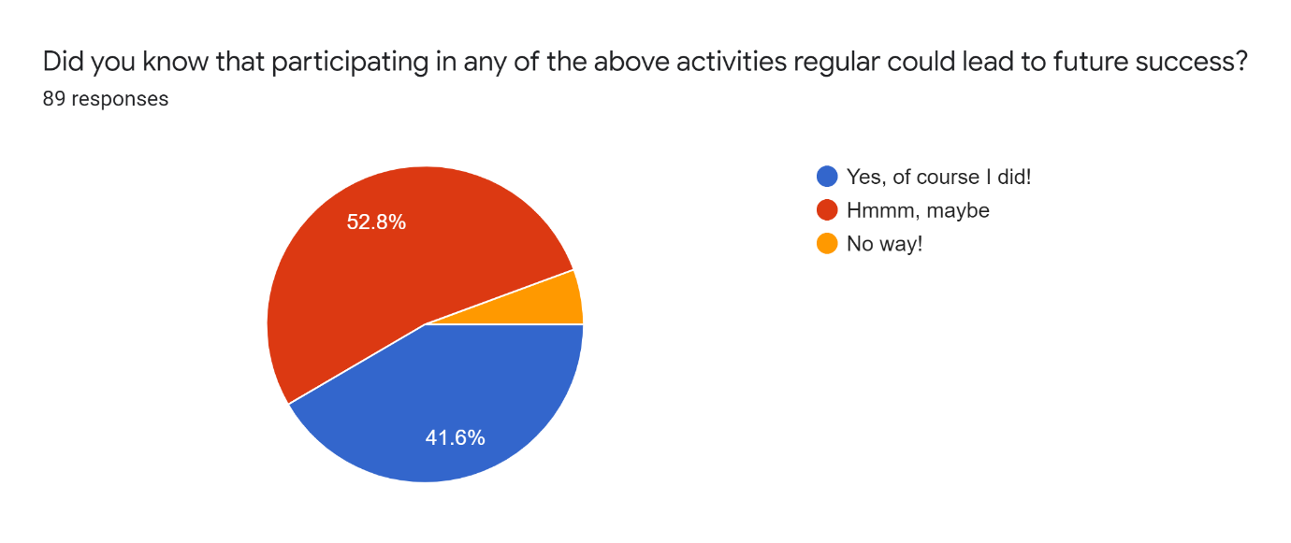

4.2 Thematic analysis of interviews and qualitative data:
In this section of the paper, the findings from the interviews and thematic analysis will be discussed, within the appendices section there is a table of the thematic analysis used to carry out this section. There were six participants in total, ranging from ages 21 to 68, with an array of occupations and opinions of this topic. For the purpose of data protection and to carry out this research with ethics in mind, participants will be labelled as participant A, B, C, D, E and F.

Participant A:
To begin this analysis, participant A’s interview will be discussed first. Participant A is a 65-year-old, retired male. Upon enquiring as to how participant A feels about the pressure of society to be a certain way and if these pressures are applied to him, participant A replied with he did not feel that any societal pressures would make him behave or act in a way that did not resemble his true self, and he believed that even though he behaves in a way that is true to him, he is not concerned about his perception being damaged by society.

However, participant A has felt the need to seek help with his well-being whilst he was part of a working environment and he does believe that there should be more help available to assist working individuals to be more positive about their working lives, the help that participant A suggests would be useful within organisations, is improved HR to aid in everyday problems to avoid the workload being affected by something that starts off so small.

Participant A was quick to respond to the question ‘do you perceive yourself to be more positive or negative?’ with a readily ‘positive’ response, as he believes in his own words that ‘negativity breeds contempt’. Participant A states that every day is a new day, meaning new opportunities for growth and if he can make one person’s mindset improve then he is happy. Participant A advises that in order to maintain his positive mindset he always looks on the bright side of situations.

Participant A’s views of someone who implements practises such as meditation and practising the art of gratitude daily, is that these people are indifferent. When asked to define the word success and what this means to the interviewee, Participant A replied with his version of success is when you complete a hard day’s work and get rewarded at the end of the day, monetary or other means, and participant A believes himself to be very successful.

Participant B:
Participant B is a 30-year-old male who is a self-employed builder. Participant B does not see himself as neither positive nor negative, he explains that he is of a more neutral balance of both. Upon asking participant B if there were any societal pressures that made him behave in a way that does not resemble who he truly is, this participant was unsure of how to respond. It seemed the participant felt like he should be unaffected by society but somewhere on his face told otherwise, his response to the question as to if he behaves in a way that resembles his true self was ‘that’s a tricky one’.

However, this participant does see himself as mostly positive as he views situations as ‘glass half full’ rather than half empty. Participant B has felt the need to seek help for his wellbeing in the past and states that more help needs to be available for employees of any workforce, participant B suggests that counselling could help and improve the wellbeing of the working environments. Participant B says that he attempts to cut down on worry and stress and see every day as a day to focus on the good things so that he doesn’t feel overwhelmed in his daily life.

Participant B describes the use of new age methods to implement positivity used by those branded as ‘hippies’ as ‘whatever works for them’, he adds that he doesn’t think such strategies’ would work for him, however. Participant B’s definition of success is to live life to the fullest of one’s abilities and he believes himself to be moderately successful.

Participant C:
Moving on to participant C, who is a 68-year-old multiple business owner, he does not feel any pressure from society, and he believes he always provides others with a true perception of himself. Participant C has never felt the need to seek help for his own wellbeing but believes that in certain cases, more help should be available within working environments.
Participant C states he is more positive than negative and the reason being is that he believes in himself and his abilities and the importance of maintaining his positive mindset is because it makes him ‘good at business’. Participant C believes that by simply getting out of bed in the mornings means one is on the right path to being more positive and successful, and by just being himself daily, he says he hopes this positivity and success makes others feel the same way about themselves. Participant C defines success as being able to care for his family and he modestly states that he is quite good at this. He adds that he has never practised alternative methods of self-care as he has never felt like he has needed to do so.

Participant D:
Participant D is a 30-year-old female business owner, who has self-admitted that she does feel societal pressures about behaving a certain way, however, she does not allow these pressures to change how she behaves within society, she has also added that in previous times, she would have allowed societal pressures to mould her behaviour, but since working on her mindset to improve confidence this is no longer the case.

Participant D has explained that she has had to seek help for her wellbeing within previous working environments and is certain that more help for employee wellbeing needs to be offered, participant D suggests having someone to talk to may help employees. Participant D believes herself to be more positive after working on her mindset within the Covid-19 lockdown of 2020, this was important for her so she could look after her family and have a better life.

Participant D implements daily strategies such as journaling and expressing gratitude routinely and believes this was how she achieved success in starting her own business in the year 2021. She also believes that by being positive, this has a ripple effect on those around her and results in those she loves being positive also, participant D’s definition of someone who uses alternative methods of personal development was somebody who is ‘grounded’ and content within themselves. The meaning of the word success to participant D was being happy with the life one is living, and participant D believes herself to be 100% successful.

Participant E:
Participant E is a 61-year-old female whose occupation is a post awards officer for a large university. Participant E also feels no pressures from society to behave a certain way and believes that the perception of her is true. Participant E has never felt the need to seek help for her wellbeing but states that there should be more help available for those who do feel they may need it, the help participant E suggests is having someone readily available to talk to and voice any concerns.
Participant E believes herself to be more positive than negative and she has always felt this way as she believes it is better to look at the positives in a situation rather than the negatives. To maintain her mindset, Participant E attends the gym and treats herself to a health spa weekly so as she feels refreshed for the up-and-coming weeks. Participant E believes that one’s vibes can rub off on another person and make them feel negative/positive also.

Participant E believes that it is each to their own when choosing methods to aid in improving one’s mindset, she has stated that she physically cannot meditate or take part in yoga herself, but she makes up for this in other activities such as walking. Participant E’s definition of success is to be successful in all parts of one’s life, to not have to worry about anything whether that be financial, health associated and vocational. Participant E believes herself to be successful regarding her definition.

Participant F:
Participant F is a 21-year-old female who has been promoted to bar manager within her family run business. Participant F states that she sometimes feels societal pressures because of social media and that she doesn’t behave in a way that resembles her true self on social media platforms or within society, however, participant F states that she is not concerned about the perception of her being damaged if she were to act her true self within society.

Participant F has never felt the need to seek help for her own wellbeing but strongly believes that more help needs to be available, help such as having someone to speak to who is trustworthy. Participant F believes herself to be of a more positive nature as she states she is always thriving to help others be more positive and maintaining this mindset is important to avoid feeling ‘down’ about anything.

Participant F suggests that to maintain this positive mindset for the long-term, it is important to get rid of toxic and negative people from one’s daily life as she accepts that her mindset is determined by those around her and vice versa. Participant F perceives herself to be very positive and her definition of success is when one has all they ever wanted in life, whether that be monetary or something else. Participant F rates herself on the scale of 1 to 10, with 1 being not so successful and 10 being very successful, as a 7.

4.3 Findings and discussion post-analysis:
This section will discuss the findings from the qualitative and quantitative analysis and attempt to compare similarities found within the two so as organisations can take into consideration this evidence to further improve their health and wellbeing options for their employees, in the hope improved rates of happiness can aid employees and their organisations on the path to success.

Quantitative data findings:
As is discovered within the quantitative analysis of this paper, the older generations, specifically those between thirty and seventy years of age, found themselves to be more positive than negative. The younger generations were evenly split between being positive and worrying about anything and everything whilst worrying decreased by 60% in 41–50-year-olds and by 100% by the age of seventy.

According to the national institute of health (2003), younger generations are more at risk of getting addicted to media and following a ‘herd mentality’, thus resulting in younger generations being more concerned and worried about what others may perceive them as. This may be the reason why the analysis discovered that the younger generations were more prone to worry than the older generations.

The synchronicity between the youths that worry, and their success rates were outstanding, the analysis discovered that 21% of participants opted for the option that they are ‘worriers’. Interestingly enough, it was that exact figure of 21% of participants that perceived themselves to be ‘not so successful’. This figure cannot be determined that it was the same individuals that perceived themselves to be worriers as those who perceived themselves as not so successful, however for the purpose of this research, and the topic of this paper, it is assumed that those findings are more than a coincidence.

As there were more female participants than male, the findings from gender vs success rates will be eliminated from this analysis, as it can be stated equality of points of view from both demographics was non-existent within the quantitative data. Therefor the analysis will focus more on age Vs positivity rates and success.

A finding that brings to light the quote ‘with age comes happiness’ (APS, 2013), and is backed up with statistics discovered within the world economic forum (2015), happiness increases as we get older as worry decreases. The below charts that have been extracted from the forum evidence the surge in happiness after the ages 45-54 and the decline in worry after the ages of 35-44. It is not coincidental that as our worry decreases, our happiness increases.

This is vital information as it backs up that the older generation do need to be listened to, their advice is essential to change these statistics and just as the younger generation may like to believe they know everything, they clearly do not. Social media is after all, a front, as it does not represent one’s true self. Every organisation should take into consideration these statistics when implementing strategies for the wellbeing of their workforce. A combination of online options and traditional face to face may benefit both the older and younger members of any workforce to open themselves up to reap benefits from both ends of the spectrum.
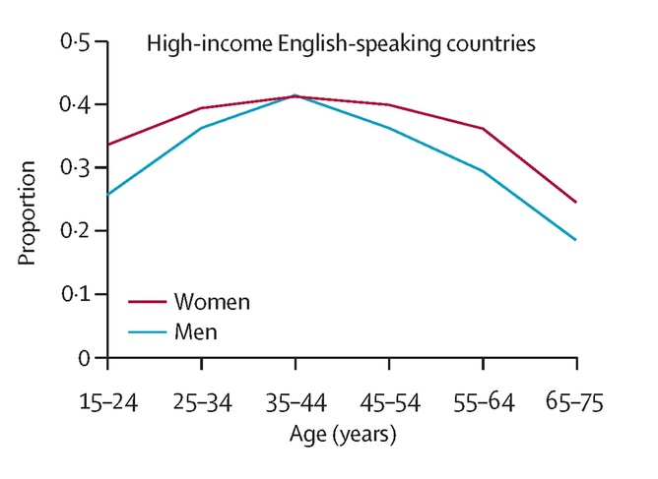
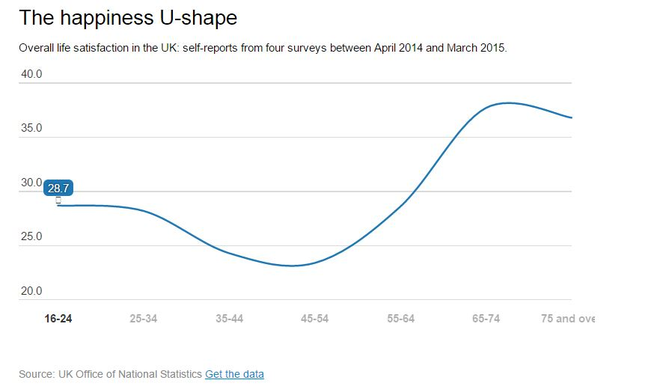
(World economic forum, 2015)
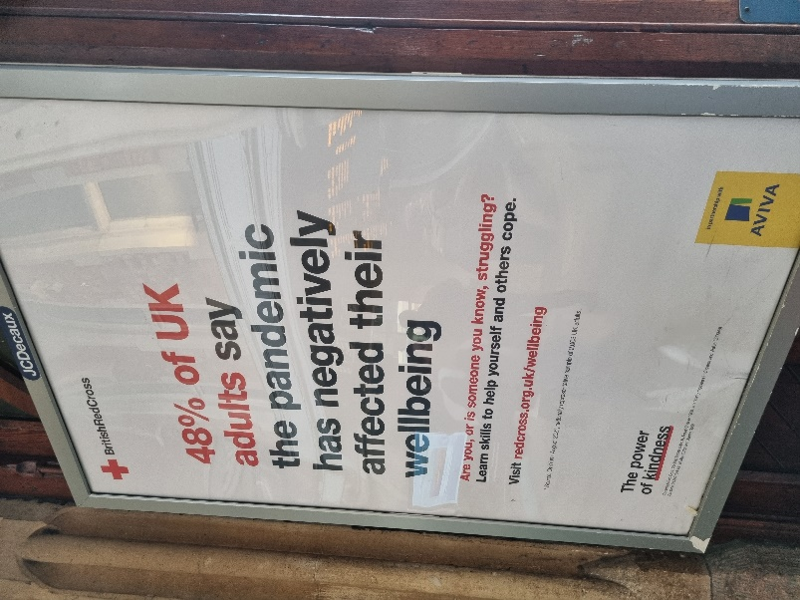
Another important factor to touch upon regarding the findings within the analysis, is that 41.6% of participants knew that alternative methods of self-care such as meditation, practising the art of gratitude, journaling and yoga were all methods that can enable a positive mindset, resulting in the individual taking part in such activities to be more prepared to seek out their success. However, judging by the qualitative data analysis, a more practical alternative to providing employees with support to maintain and improve their mindset was suggested by all interviewees, and this suggestion was to simply have someone to talk to.

Even though such a large proportion of individuals agreed that alternative methods of self-care aid in seeking success, it was devastating to discover that only 25% of organisations within the UK provide such means of wellbeing support to their employees (Churchill, 2019). Taking into consideration the Covid-19 pandemic, wellbeing needs to be a priority for organisations as just under 50% of the UK adults has been drastically affected by this (British red cross, 2021).

Qualitative data findings:
The analysis of the qualitative data backs up that which was found within the quantitative analysis about older generations being less worried. However, the qualitative data refines this to the older generation being less worried about societal pressures rather than worrying in general. Again, this could be down to how the younger generations worry about their perceptions to society.

Referring to the thematic analysis table found within the appendices section of this paper, the participants were of a range of age, gender and employment status and even though only 50% of interviewees admitted they have needed to seek help for their wellbeing regarding their working environments in the past, all interviewees agreed there needed to be more help available and provided by organisations. All participants added that the main source of help that would be beneficial would be having a professional available to talk to within a working environment rather than a suggestion of holistic methods.

The male participants who made up 50% of the overall participants, stated they felt no pressure from society to behave in a way that did not resemble their true self, where the other 50% which were females said they feel the societal pressures regularly, all added that with or without pressure from society, they did not change their ways and were not worried about a damaged perception for not doing so. All participants agreed they were more positive than negative, however, to maintain this mindset they took part in a range of daily rituals such as physical exercise, writing down feelings and avoiding stress and negativity where possible, as they all believed that positive and negative energy can be consumed by an individual, they just chose to surround themselves with people of a more positive perception.

50% of interviewees said that alternative methods such as meditation et cetera, may work for others but they felt it would not work for them, while the other 50% said they were opened to try anything that helped. Interestingly, the 50% that were closed off to the idea of alternative and holistic methods were all male whilst the 50% open to such methods were female. A recent article published in the national library of medicine (2019), suggest this is because women are more health conscious and aware of the benefits that can be achieved by complementary and alternative medicine. Further study by the national health interview survey (2012) found that 50% less men than women took part in mindfulness and holistic approaches due to physical activities i.e., running, walking et cetera, being more appealing to men than silent meditations.

All participants believed themselves to be more positive than negative and taking into consideration their own definition of success and what the term meant to them, they all believe themselves to be successful. It was another factor that evidences the relationship of positivity synchronising with self-perceived success.

Even though all interviewees had their own reason as to why being positive is important to them and they each had different methods of maintaining that mindset that was unique to them, all participants agreed that one’s mindset certainly affects those around them. Organisations should consider this evidence and implement ways to keep employees motivated, as it may seem that lack of motivation may spread.

5.0 Conclusion:
To conclude this paper, reflecting on the aims and objectives in section 2.2 which were to prove holistic approaches toward employee wellbeing should be more considered by organisations, were in fact non-evidential throughout both the qualitative and quantitative data. However, the participants of both research methods clearly agreed that more help was needed and that more verbal communication available would help solve problems and avoid situations spiralling out of control.
Information should still be taken into consideration however, that macro-organisations such as Google, who use holistic methods within their employee schemes mentioned in section 2.2, state the view that their organisational growth and success is because of such schemes. The information provided by Google should speak volumes to other companies that feel they may benefit from having more motivated, alert and positive employees, and even though this information was not sufficiently evidenced within this paper, organisations should take into consideration implementing such strategies, or even giving their workforce the option to choose as it may not work for all companies, such as those which are male dominant who may need to implement more physical means of practising mindfulness such as a walking event, as the qualitative analysis discovered that the male participants were less likely to take part in holistic activities and suggested that just having someone to talk to is sufficient enough.

Another factor that was evidenced throughout this paper that backs up the research question of if a positive mindset aids in success within our lives, was the findings from the qualitative data where all participants deemed themselves positive and successful, even though all participants defined the term success differently, this has concluded the research paper with a clear response to the research question, the response being an indefinite yes. However, with the limited number of interviewees, to get organisational benefits would mean to interview on a mass scale.

Below are three recommendations that organisations could consider to improve the wellbeing of their employees’ mindsets and result in future success, according to the department of health (2022), an improved mindset affects motivation, performance and overall satisfaction within a working environment. All the data analysed backs up claims that those who are of a more positive nature consider themselves to be more successful also. Below is also a supply and demand curve that represents the potential welfare gains to an organisation if the below recommendations are taken into consideration and implemented into a strategy. Demand curves are used in economics to find out the relationship between price and demand and whether a negative or positive externality is present (Mindtools, 2022), in this case the externality is positive.

As can be seen within the image, the marginal social benefit is higher than the marginal private benefit, this evidences the fact that external and welfare gains will be present within an organisation that prioritises social benefit for the workforce, the increase of external and welfare gains can be viewed within the yellow triangle as point ‘B’ is the new equilibrium and point ‘A’ is the original equilibrium before any changes that involved prioritising social benefit were made. The image also evidences that the marginal private costs would be higher if the organisation prioritises social benefits, this is where an organisation would need to compromise cost and benefit for a better outcome for employee satisfaction and wellbeing, the organisation will benefit from this as the workforce becomes more productive and motivated. Governmental aspects such as subsidies for businesses who incorporate employee wellbeing could be considered to lower the cost curve.

Welfare gains
[Cite your source here.]
Price, Cost & Benefit
Marginal Private Costs =Marginal Social costs = Supply
P*
B

P1
A
Marginal Social Benefit

Marginal Private Benefit
Q*
Q1
Quantity

5.1 Recommendation 1:
The first suggestion made will be reflecting on Napoleon Hill’s thirteen steps to success that are mentioned in section 2.3 of this paper. All thirteen steps can be summed up and narrowed down into three simple aspects, those aspects being motivation, repetition and time. If an organisation puts a plan into place to provide their employees with constant access to professionals with specialised knowledge regarding how to improve one’s mindset, and the employees attend face to face and online sessions with such specialised tutors, this will aid in achieving that burning desire that Hill talks about and is presented in section 2.3 resulting in employees having increased motivation. With repetition of these sessions and these sessions being available whenever needed, this will aid employees to be continually motivated resulting in increased performance, reputation and overall occupational health and happiness. The only factor organisations must consider is time and setting aside time within their strategic plans to ensure the wellbeing of their employees is catered for.

5.2 Recommendation 2:
Amongst an existing wellbeing plan designed by organisations for their workforce, access to mindfulness education as part of a training programme would be extremely beneficial to employees not only whilst they are working but also throughout their lives. As mentioned in section 2.6, practises such as mindfulness-based stress reduction, acceptance and commitment therapy and dialectical behaviour therapy, will all benefit the organisation as their employees become more motivated, creative and innovative. However, such practises will also provide value for employees as they educate themselves with such therapies, as they keep this knowledge in mind for the rest of their lives. The perception of an organisation that cares this much for employee health will surely attract an abundance of prospects which will bring with it better brand recognition, reputation and higher profit margins.

5.3 Recommendation 3:
If an organisation were to innovate a combined plan of making their wellbeing strategy available both online and face to face, this would cater for the younger generations who, reflecting on the analysis, were more worried about their perception due to social media, and it would also cater for the older generations who prefer a more traditional approach of talking to someone as found within the qualitative analysis. If an organisation could promote their plan and encourage both the young and older generations to be more readily open to different avenues of support, then not only would this allow employees to leave their comfort zone and enter their growth zones which have an abundance of advantages alone, but it would also aid in encouraging change and adaptation with the fear factor taken away, as employees would be positive enough to know that they are well equipped mentally to deal with anything. As adaptation is key in a consistently changing market, a mentally well-equipped workforce will give any organisation the upper hand above competitors.

5.4 Further research:
For further research regarding the topic of this paper, a longitudinal research approach would be more relevant over a cross-sectional approach as it was the given time frame for this paper that provided the research with limitations. Further research is necessary to gain perspectives of those under the age of twenty, as there were no participants within this age range in neither the quantitative nor qualitative data collection. For further analysis, comparisons could be made regarding extracting data from employees of organisations who already implement wellbeing strategies for their workforce and those organisations who do not, to understand the difference in productivity, motivation and efficiency within those organisations. Research into costs for businesses to start a wellbeing programme for their employees would spark curiosity, and further research into governmental schemes or subsides for existing organisations that implement wellbeing at the workplace would be beneficial to the study also.

6.0 Bibliography:
APA, (2012). A 2010 study of stress in America: Gender and stress, Retrieved from: 2010 Gender and Stress (apa.org)
APM, (2022). What is a GANTT chart? Retrieved from: What Is A Gantt Chart? | Definition & Examples | APM
APS, (2013). With age comes happiness, Retrieved from: With Age Comes Happiness – Association for Psychological Science – APS
Arnold, G. (2015). 5 Reasons why images speak louder than words, retrieved from: 5 Reasons Why Images Speak Louder Than Words (linkedin.com)
Axis, (2022). Understanding generation Z culture, Retrieved from: Strengths and Weaknesses of Generation Z | Parent's Guide (axis.org)
Besselaar, P. (2015). Gender differences in research performance and its impact on careers, Retrieved from: Gender differences in research performance and its impact on careers: a longitudinal case study (nih.gov)
British red cross, (2021). Are you or someone you know struggling? Retrieved from: www.redcross.org.uk/wellbeing
Brown University, (2019). MBSR: Mindfulness-based stress reduction, Retrieved from: MBSR: Mindfulness-Based Stress Reduction | Mindfulness Center | Brown University
Byrne, R. (2016). The secret, p47-52, Simon & Schuster publications, CBS, Creste LLC, London
Cambridge Dictionary, (2022). The definition of success, Retrieved from: SUCCESS | meaning in the Cambridge English Dictionary
Carnegie, A. (1903). The Carnegie Dunfermline trust, Retrieved from: The Carnegie Trust (carnegiedunfermlinetrust.org.uk)
Chong, C. (2022). 8 Crucial differences between positive people and negative people, Retrieved from: 8 Crucial Differences Between Positive People And Negative People (lifehack.org)
Churchill, F. (2019). Just 1 in 4 UK businesses have wellbeing programmes, survey suggests, Retrieved from: Just one in four UK businesses have wellbeing programmes, survey suggests (peoplemanagement.co.uk)
CIPD, (2021). Wellbeing at work, Retrieved from: Wellbeing at Work | Factsheets | CIPD
CIPD, (2022). Our history, Retrieved from: Our History | CIPD
Department of Health, (2022). A positive and proactive workforce, Retrieved from: A positive and proactive workforce (skillsforcare.org.uk)
Department of physics, (2019). The observer effect, Retrieved from: Q & A: Observer Effect? | Department of Physics | University of Illinois at Urbana-Champaign
Eifert, G. H. & Forsyth, J. P. (2005). Acceptance and commitment therapy for anxiety disorders: A practitioner’s treatment guide to using mindfulness, acceptance, and values-based behaviour change strategies. Oakland, CA: New Harbinger Publications, Inc.
Gantt, H. (1910). Henry Laurence Gantt, the Gantt chart, Retrieved from: Henry Laurence Gantt The Gantt Chart (managers.org.uk)
Graham, C. (2022). Are women happier than men? Retrieved from: Are women happier than men? Do gender rights make a difference? (brookings.edu)
Greene, J. C., Caracelli, V. J. & Graham, W. F. (1989). Toward a conceptual framework for mixed method evaluation designs. Educational and policy analysis, 11th ed, p255-274
Hill, N. (1937). Think and grow rich, 1st ed, Napoleon Hill Foundation Publications
Hoogendoorn et al, (2015). Business teams with an equal number of women and men perform better in terms of sales and profits than male dominated teams, Retrieved from: The Impact of Gender Diversity on the Performance of Business Teams: Evidence from a Field Experiment | Gender Action Portal (harvard.edu)
IDF, (2022). Our three brains, Retrieved from: Our Three Brains - The Reptilian Brain | Interaction Design Foundation (IxDF) (interaction-design.org)
Johnson, L. (2017). Your sub-conscious is listening, Retrieved from: Your Subconscious is Listening (hippocratesinst.org)
Kaelin, O. (2016). Gods in ancient Egypt, Retrieved from: Gods in Ancient Egypt | Oxford Research Encyclopedia of Religion
Kendall et al, (2005). System analysis and design, p140, 8th ed, pearson publications
McCoy, D. (2019). Norse Mythology: Freya, Retrieved from: Freya - Norse Mythology for Smart People (norse-mythology.org)
McLeod, S. (2019). What is the difference between quantitative and qualitative data? Retrieved from: www.simplypsychology.com
MHF, (2022). Mental health statistics: mental health at work, Retrieved from: Mental health statistics: mental health at work | Mental Health Foundation
MHF, (2010). Mindfulness report 2010, Retrieved from: Mindfulness_report_2010.pdf (mentalhealth.org.uk)
Mind, (2022). DBT- Dialectical behaviour therapy, retrieved from: What is dialectical behaviour therapy (DBT)? | Mind, the mental health charity - help for mental health problems
Mindful, (2020). What is mindfulness? Retrieved from: What is Mindfulness? - Mindful
Mindtools, (2022). What are supply and demand curves? Retrieved from: What Are Supply and Demand Curves? - From MindTools.com
Napoleon Hill Foundation, (2022). Teaching the philosophy of success, Retrieved from: The Napoleon Hill Foundation (naphill.org)
National health interview survey, (2012). National centre for health statistics, Retrieved from: NHIS - 2012 Data Release (cdc.gov)
National institute of health, (2003). How media affects children and youths, Retrieved form: Impact of media use on children and youth (nih.gov)
National institute of health, (2010). Herding, social influence and economic decision-making: socio-psychological and neuroscientific analyses, Retrieved from: Herding, social influence and economic decision-making: socio-psychological and neuroscientific analyses (nih.gov)
National library of medicine, (2019). Gender differences in prevalence, patterns, purposes and perceived benefits of meditation practises in the USA, Retrieved from: Gender Differences in Prevalence, Patterns, Purposes, and Perceived Benefits of Meditation Practices in the United States - PubMed (nih.gov)
NHS. (2018). Mindfulness, Retrieved from: Mindfulness - NHS (www.nhs.uk)
Positive creators, (2021). 10 Famous people who use the law of attraction, Retrieved from: 10 Famous People Who Use The Law Of Attraction | Positive Creators
Proctor Gallagher Institute, (2022). Tell us what you want, and we will show you how to get it, Retrieved from: Proctor Gallagher Institute
Puri, N. (2020). Be Kind to yourself: 10 top tips, Retrieved from: Be kind… to yourself: 10 top tips (bupa.co.uk)
Saunders, M. Lewis, P. & Thornhill, A. (2012). Research methods for business students, 6th ed, Pearson publications
Saunders, M. Lewis, P. & Thornhill, A. (2011). Research methods for business: The research onion, p160, 6th ed, Pearson publications
Schleifer, B. G. (2021). Human mind vs. Animal brain, Retrieved from: Human Mind vs. Animal Brain – Why So Different? (rcg.org)
Soleil, V. (2016). 7 Psychological reasons why people can’t be happy all the time, Retrieved from; 7 Psychological Reasons Why People Can't Always Be Happy - Learning Mind (learning-mind.com)
Stewart, H. (2015). 5 big companies that swear by mindfulness, Retrieved from: Five Big Companies Who Swear By Mindfulness (linkedin.com)
TrustPilot, (2021). Deception, bad endorsement and misleading, Retrieved from: Bob Proctor Reviews | Read Customer Service Reviews of proctorgallagherinstitute.com (trustpilot.com)
Universe Spirit, (2022). Master list of names for God from world’s religions, Retrieved from God Names: Master List of Names for God From World's Religions | Universe Spirit
World economic forum, (2015). At what age does happiness peak? Retrieved from: At what age does happiness peak? | World Economic Forum (weforum.org)
WEF, (2019). These are the benefits of practising mindfulness in the office, Retrieved from: This is how you can practice mindfulness at work | World Economic Forum (weforum.org)

6.0 Appendices:
Thematic analysis table used to carry out analyses of the qualitative data:

QUESTION | A | B | C | D | E | F
What is your age? | 65 | 30 | 68 | 30 | 61 | 21
What is your occupation? | Retired | Builder | Farmer, publican, landlord, | Self employed | Post awards officer at the university | Bar manager
Do you feel pressure from society to behave a certain why? | No | Not particularly | No | Yes I do, sometimes | I don t | Sometimes with social media
Do you feel you behave in a way that resembles your true self? | Yes, I say what I think, and I do what I mean | That s a tricky one, yeah I m mostly true to who I am | Yes | Yes, now I do that wasn t always the case I used to act to who I was associated with at the time | I think I do yes | No
Do you feel that if you did behave in a way that resembles your true self, the perception of you will be damaged? | Not really no, | No | No | I m not sure, it wouldn t bother me anyway, it would have before | I don t think so, I think I act myself, I don t change | No
Have you ever felt the need to seek help for your wellbeing? | Yes, | Yes | No | Yes | No | No
Do you think there should be more help available for employee wellbeing? | Yes, | Yes | Yes in certain cases | Definitely | Definitely | Yes
What help should you think should be more available? | Human resource help for different problems daily, problems that people keep to themselves and it do affect their work | Counselling, |  | Someone to talk to | People feel isolated and as everyone is so busy, I don t think there is enough resources to speak to people | Having someone you can talk to and trust
Do you perceive yourself to be a positive or negative person? | Positive | Mostly positive | Positive | Positive | I think I m more positive than negative | Positive
Why do you believe this to be true? | Negativity breeds contempt | Because I look at things glass half full | I believe in myself | I changed my mindset in 2020 and that s the way I view life | Iv always felt this way because I can always see something positive | I just like to help other people and always think positively
Why is maintaining this mindset important to you? | Every day is another day | So things don t overwhelm me | It makes me good at business, its important to be positive | For a better wellbeing and life for my kids and myself | , I think it s best to look at the positive side than the negative side | So you don t feel down about anything
What do you do daily to maintain this mindset? | Always look on the Brightside | Cut down on worry and stress and always focus on the good things | Get up in the morning | Journaling, write everything down, say what I m grateful for every morning and every night before I go to sleep | I go to work, home, gym and then at the end of the week I go to the health suite to refresh me for the next week | Get rid of toxic and negative people
How do you think your mindset affects those around you? | I don t really think about how others feel, I try and look on the positive side of things and encourage others to do the same, my positivity rubs off on others and makes them feel positive | Easy going, easy to be around, placid, not highly strung, people aren’t on eggshells | I hope it makes them feel positive | I think my mindset affect those around me, like a ripple effect, if you act negative then it’s going to rub off on somebody else, I believe and if you act positive that will also rub off on people | Well, if your negative you give off negative vibes and affect those around you | It depends what mindset you’re in, if your negative you bring other people down and if you positive you cheer people up, my mindset rubs off on those around me
How would you describe someone who practises yoga, meditation and affirmations? | I would say indifferent | It’s what works for them, it doesn’t work for me but whatever gets people through the day | Never done it never needed it so I can’t speak for somebody else | Grounded, somebody who is contempt with themselves | That’s the type of thing that helps them chill out, I can’t do yoga or meditation I have tried, each to their own, I don t see any difference | Very positive
Define the word success and what it means to you | Success is when you complete a day s work and are rewarded for it, and in life in general you are awarded at the end of what you are doing, monetary or other | Living your life to the fullest of your abilities, you can set your mind to do whatever you want | Means I can feed my family and keep them well | Happy with the life their living | Success would be success in life with everything, Success to me is being able to get up in the morning and not worrying about the day ahead, or money or people in my life and everybody is happy and healthy, and I have my job | Having everything you have ever wanted, monetary, family, friends
How successful do you perceive yourself to be? | very | Moderately successful | Quite | 100% Successful because I am happy with the life, I have got | I feel as if I have everything I need so I feel I am successful | 1 being not so and 10 being very I would say I am 7

