Abstract
Emma Moseley (2317703), Amina Ganni (2319000), and Sarah Butler (2315177)
BEng Embedded Electronics Systems Engineering
July 9, 2025
Modular RF Robot
Group Project
This project explored the design and development of a modular, wirelessly driven controlled robot capable of providing real-time audiovisual feedback in hazardous or inaccessible locations. Originally imagined as a microcontroller-based RF system with a USB RF-dongle, the project shifted mid-sprint to a Raspberry Pi 5 with Wi-Fi TCP connection. The prototype was created within a six-day agile sprint and features a modular Python GUI, camera and audio modules, and a socket-based networking framework. Despite unresolved motor control concerns, the project displayed modular design, environmental feedback, and a scalable architecture that allows for future module improvement and addition within a unified system.

Contents
1 Introduction 7
1.1 Research Question 7
1.2 Aim 7
1.3 Objectives 7
1.4 Report Structure 7
1.5 Appendices Overview 8
2 Research 8
2.1 Background Research 8
2.1.1 RF Communication and Frequency Considerations 8
2.1.2 Hardware and Circuitry Considerations 8
2.1.3 Robot Design and Use Cases 9
2.2 Literature Review 10
2.2.1 RF Communication Techniques for Robot Control 10
2.2.2 Modular Robot Design Principles 10
2.2.3 Embedded Systems Integration for Cameras and Microphones 11
2.2.4 Remote Control Software for Movement and Real-Time Streaming 11
3 Development Method 12
3.1 Project Planning and Development Method 12
3.2 Advantages and Disadvantages of Methodology 12
3.3 Team Structure and Role Assignment 13
3.4 Project Timeline and Sprint Plan 13
3.5 Procurement and Budgeting 14
3.6 Ethics and Risk Management 16
3.7 Tools and Collaboration Strategy 16
3.8 Hardware Sprint Planning 17
3.8.1 Design Choices and Rationale 17
3.8.2 Task Allocation 17
3.8.3 Evaluation and Success Criteria 18
3.9 Software Sprint Planning 18
3.9.1 Design Choices and Rationale 18
3.9.2 Task Allocation 18
3.9.3 Evaluation and Success Criteria 19
3.10 Testing Sprint Planning 19
3.10.1 Design Choices and Rationale 19
3.10.2 Task Allocation 19
4 Design and Implementation 20
4.1 Project Design and Implementation Overview 20
4.2 Hardware Design and Implementation 20
4.2.1 Implementation Details 20
4.2.2 Implementation Challenges 21
4.3 Software Design and Implementation 21
4.3.1 Implementation Details 21
4.3.2 Implementation Challenges 22
4.4 Testing Design and Implementation 22
4.4.1 Implementation Details 22
4.4.2 Implementation Challenges 23
5 Results and Analysis 23
5.1 Functional Testing Results 23
5.2 Analysis 25
6 Conclusions and Evaluations 25
6.1 Conclusions 25
6.2 Recommendations 26
6.3 Reflections 26
6.3.1 Sarah’s Reflections 26
6.3.2 Emma’s Reflections 27
6.3.3 Amina’s Reflections 27
7 References 29
8 Appendix A – Report Contributions 32
9 Appendix B – Project Logbook 34
10 Appendix C – Hardware Sprint Plan 40
11 Appendix D – Software Sprint Plan 42
12 Appendix E – Testing Sprint Plan 44
13 Appendix F – Repository Overview and Access 46
14 Appendix G – Software Application Code (Python) 50
15 Appendix H – Raspberry Pi Firmware Code (C/C++) 60
16 Appendix I – Unit Testing Code (Python) 70
17 Appendix J – Transmitter Mini Project 76
18 Appendix K – Receiver Mini Project 82
19 Appendix L – Ethics Form 85

Table of Figures
Figure 1: Overall Project Gantt Chart 14
Figure 2: Sprint Gantt Chart - Shows the set days for each sprint. 14
Figure 3: Final prototype of the modular robot system (W.R.A.I.T.H.5). 23

Table of Figures
Table 1: Summary of Components Procured for Hardware Sprint 15
Table 2: Additional Components Procured Following Hardware Redesign 15
Table 3: Summary of Functional Testing Outcomes 24

Introduction
This project focuses on developing a modular robot capable of wireless control and real-time feedback in hazardous or inaccessible environments. The initial concept included a GUI-based Python control program, a custom USB RF dongle, and a microcontroller-driven robot. Due to time, hardware, and integration constraints, the design changed to using a Raspberry Pi 5, enabling Wi-Fi communication via TCP sockets over 2.4GHz. The final system, completed during a six-day agile sprint, maintains the project’s goals of modularity, wireless control, and environmental feedback.

Research Question
How can a modular, wirelessly controlled robot deliver real-time feedback in environments hazardous or inaccessible for humans?

Aim
To prototype a modular robot system demonstrating wireless control, environmental feedback, and flexible hardware/software architecture.

Objectives
- Design a modular robot with interchangeable components.
- Develop wireless communication between the robot and a remote device.
- Create a software application for wireless control.
- Enable real-time visual and audio feedback.
- Ensure the hardware supports easy upgrades.
- Structure the software for modular expansion.

Report Structure
The report reviews key research on RF systems, modular robotics, and embedded design. It then outlines planning methods, development phases, hardware/software implementation, and testing. Final sections evaluate system performance and present conclusions.

Appendices Overview
Appendix A details authorship of each report section; Appendix B includes the project logbook. Appendices C–E show individual sprint plans. Appendices F–L contain technical documentation: source code, circuit schematics, and the approved ethical review form.

Research

Background Research

RF Communication and Frequency Considerations
This project explores RF communication to provide wireless control and data transmission for a robot. Based on existing hardware examples, a USB dongle using RF modules such as the Laipac RLP/TLP433A was considered [1]. This developed the early design of creating a USB-based RF dongle to build a communication link between the robot and control application.
The frequency choices focus on the UK's approved ISM (Industrial, Scientific, and Medical) bands. According to Ofcom's UK Frequency Allocation Table, the 433MHz and 868MHz bands are license-free in region 1 (Europe), if devices tolerate interference and do not broadcast beyond their allocated range [2][3].
The 433MHz spectrum is primarily used for low-cost, short-range applications. The 868MHz band (863-870MHz) is used for a variety of applications, including audio systems, RFID, and general telemetry [4]. 868MHz has superior dependability and decreased interference and improved regulatory support. This has led to its rising use in Europe and has helped to increase usage in sectors like smart metering and automation [4]. Knowledge of ISM band rules, frequency characteristics, and components helped in choosing to use the 868MHz frequency.

Hardware and Circuitry Considerations
There are many ways to enable communication between software and the hardware of a wirelessly controlled robot. One common approach is using an RF dongle, a compact device that transmits and receives radio signals via a microcontroller and RF module [1].
An example of this is a project by user Midilec on RC Groups, where a custom USB dongle was built to connect a transmitter to a computer for controlling RC flight simulators, treating the computer as a joystick [5]. This dongle used a CC2500 RF module and an ATmega8 microcontroller, alongside supporting circuitry such as resistors and capacitors tailored to system needs. Understanding this approach and the component choices informed the communication method used in this project.
In similar projects, the 8051 microcontroller is often chosen for its simplicity and suitability for controlling motors and processing sensor or button inputs. For instance, a Nevon Projects user created a wireless robotic vehicle with metal detection, where the 8051 interpreted RF signals to drive movement [6]. Seeing the microcontroller used successfully in this context influenced the decision to incorporate it into this project.

Robot Design and Use Cases
Additional research concentrated on modular robotics, wireless control techniques, and real-world robotic applications. This involved reviewing a variety of existing projects to gain a better understanding of control systems, sensor integration, and potential ethical issues. These examples influenced early concepts about functionality, safety, and adaptability.
General development guidelines highlight key stages of remote-controlled robot design, including component selection and iterative testing [7]. This validated the decision to use a live-build methodology and a modular framework. The addition of audio and visual modules was influenced by specialised examples, such as surveillance and firefighting robots, which demonstrated how wireless connection and embedded sensors enable operation under hazardous settings [8][9].
Microcontroller-based systems with DTMF and RF transmission provided insight into short-range control techniques. Nevon Projects' RF-enabled metal-detecting robot demonstrated the potential of low-cost microcontrollers equipped with RF transceivers for responsive control [6]. ElProCus' guidance emphasised the value of adaptability, modularity, and real-time data handling [10].
Research into military robots highlighted ethical concerns about live audio-visual capture, prompting an early GDPR compliance assessment [12]. Overall, the case studies confirmed the practicality of the project's planned hardware and communication strategy.

Literature Review

RF Communication Techniques for Robot Control
Wireless communication is essential for remote robot control, and technologies such as Bluetooth, Wi-Fi, and Zigbee are commonly used. Mansor et al. observed that Bluetooth's restricted range and interference led to the introduction of XBee Zigbee modules, which provide bidirectional communication, unique addressing, and error checking, making them suited for dependable robot networks [13]. Olchanski et al. used 868 MHz RF modules or Bluetooth dongles to connect PCs to microcontrollers [14].
Custom 2.4GHz transceivers, such as the nRF24L01, are popular for low-latency control. Mahbub (2019) combined them with Arduinos to create a wireless joystick system, highlighting its affordability and adaptability for hobbyist applications [15]. Each RF option has trade-offs in range, power, and bandwidth: Zigbee provides resilient mesh networks at moderate speeds, whereas Wi-Fi handles high-bandwidth tasks such as video at the expense of power and potential delay. Many systems balance performance by combining technologies, such as low-power RF for control and Wi-Fi for data [13][14]. Real-time protocols (such as UDP or RTP over Wi-Fi) are increasingly being used to reduce lag in teleoperated systems [16].

Modular Robot Design Principles
Modular robots rely on standardised, interchangeable components with robust connection interfaces. Liu et al. (2016) state that system flexibility depends on module design—form factor, mechanical coupling (e.g. latches, magnets), and shared power/data lines [17]. These must remain reliable through repeated use. Reconfigurable systems often use hybrid connectors for alignment and stability [18].
Boston Engineering describes systems where sensors or actuators can be swapped to change function [19], while Harvard’s “robot-factory” study recommends alignment guides and minimal fasteners to simplify human/machine handling [18]. Across research, strong couplings, standardised electrical interfaces, and tool-free swapping are essential for rapid reconfiguration and field adaptability [17][18].
For terrain adaptability, two main strategies emerge: hybrid mobility and modular swappable components. Jin et al. (2022) propose a “coupled wheel-track” system that allows fast switching for different terrain types without hardware changes [20]. WheTLHLoc adds leg-based movement for greater versatility [21].
Commercial robots like the ROVVER X use tool-free wheel kits for quick terrain adaptation [22]. Swapping wheels, tracks, or full drive units is common in field robotics. However, building interfaces that are both durable and user-friendly remains a key challenge [17][18].

Embedded Systems Integration for Cameras and Microphones
Integrating audio/visual peripherals into embedded robot platforms presents both hardware and software issues. Single-board computers (SBCs), such as the Raspberry Pi or BeagleBone Black, are commonly used for video and audio processing, whilst microcontrollers handle motor control and low-level I/O [23]. SBCs include common interfaces (USB, Ethernet, and CSI) that make it easier to integrate high-bandwidth devices. According to Rademacher (2017), these boards allow plug-and-play camera setups via USB or GigE, as well as open-source video capture libraries [24]. Despite its low power consumption, a BeagleBone Black can successfully stream high-resolution GigE camera data [25].
Microcontrollers alone do not often have the capability to handle audio/video streaming. However, some modules (such as ArduCam or OmniVision with inbuilt DSP) support basic picture capture via SPI or parallel interfaces. Microcontrollers can handle basic audio input via I²S or ADC, but advanced processing often requires an embedded Linux system or DSP [26].
SBCs and microcontrollers are frequently used together, with each performing tasks according to its capabilities. To maintain control and feedback, subsystem integration relies on well-defined interfaces, which are frequently backed by APIs or middleware. Effective system design requires distributing processing tasks, using appropriate communication protocols, and ensuring coordinated data management.

Remote Control Software for Movement and Real-Time Streaming
Remote robot control requires careful design to allow low latency communication and responsive user engagement. Most systems use a client-server approach, where the robot provides live media to the operator's computer, which sends control commands back. Interfaces include real-time video and directional control input devices [16]. Usability is dependent on reducing delay, as latency can damage performance or cause instability [15].
RTP, RTSP, and WebRTC are popular protocols for media streaming due to their low latency architecture [15]. Many systems use MJPEG or H.264 over UDP, which are supported by libraries like GStreamer and FFmpeg. Audio can be integrated similarly, allowing for two-way interaction. In one case study, a Raspberry Pi-based robot streamed video and audio while receiving control signals via WebSocket, with buffering and adaptive handling to account for varying Wi-Fi bandwidth [16].
Teleoperation modules are available in frameworks like ROS to speed up development, but custom systems can accomplish similar results by using socket-based loops for command transmission and actuator control. Real-time feedback, especially video, is essential for responsive adjustment, which needs synchronised, low-jitter data handling. Safety features like 'emergency stop' and command timeout watchdogs are also important. Effective remote-control systems regularly prioritise low latency, robust media handling, an intuitive user interface, and built-in fault tolerance [15][16].

Development Method

Project Planning and Development Method
The project followed an Agile sprint structure, with a six-day active build phase divided into three two-day sprints: hardware, software, and testing. This structure provided flexibility, rapid development, and integration under time constraints.
SCRUM leadership rotated by domain expertise: Emma led software, Sarah handled hardware, and Amina oversaw testing. Each SCRUM master planned tasks, managed priorities, and ensured scope control. Incomplete work was not carried forward, encouraging realistic planning and time management.
A live development approach was used, which meant that components were integrated and programmed in real time during sprint days rather than being pre-assembled beforehand. This decision was taken to test flexibility under tight timescales and imitate real-world development issues, which aligns with the module's objectives.

Advantages and Disadvantages of Methodology
Advantages:
- Short sprints helped maintain focus and drive.
- Rotating leadership enabled equal contribution and skill development.
- Live development encouraged rapid decision-making.
- Sprint cutoffs helped prioritise tasks and manage scope.
- Team members gained experience in Agile project planning and cross-domain skills.
Disadvantages and Mitigation:
- Risk: Tight deadlines risked incomplete modules.
Solution: Minimum viable functionality was agreed in advance. SCRUM leads structured tasks accordingly.
- Risk: Live coding increases pressure and chance of error.
Solution: Pre-sprint planning reduces uncertainty; tasks aligned with each member’s strengths.

Team Structure and Role Assignment
Roles were assigned based on strengths while maintaining cross-domain contribution.
- Emma led software planning and overall project management
- Sarah handled hardware development and procurement.
- Amina managed testing and ethics documentation.
Despite these lead roles, collaboration was high throughout. SCRUM masters structured tasks during their respective sprints, drawing on prior planning discussions. Leadership responsibilities shifted fluidly, encouraging shared learning and accountability.

Project Timeline and Sprint Plan
The workflow was as follows (see Figures 1 & 2):
- Ideation and concept development
- Research and planning
- Procurement and scheduling
- Six-day sprint execution
- Final reporting and evaluation
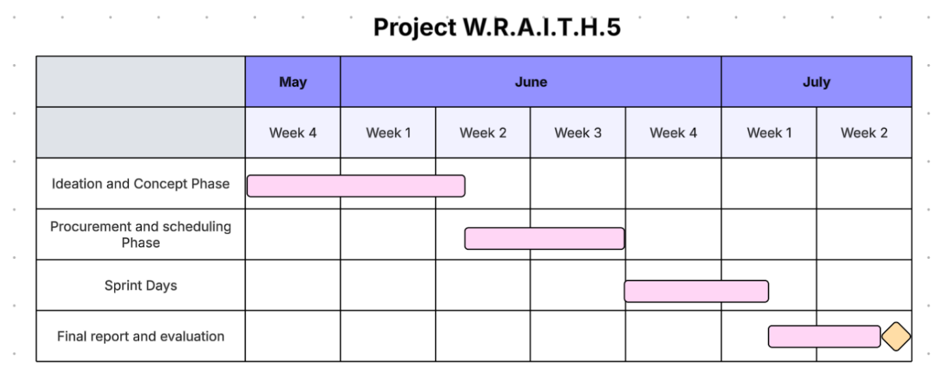
Figure 1: Overall Project Gantt Chart
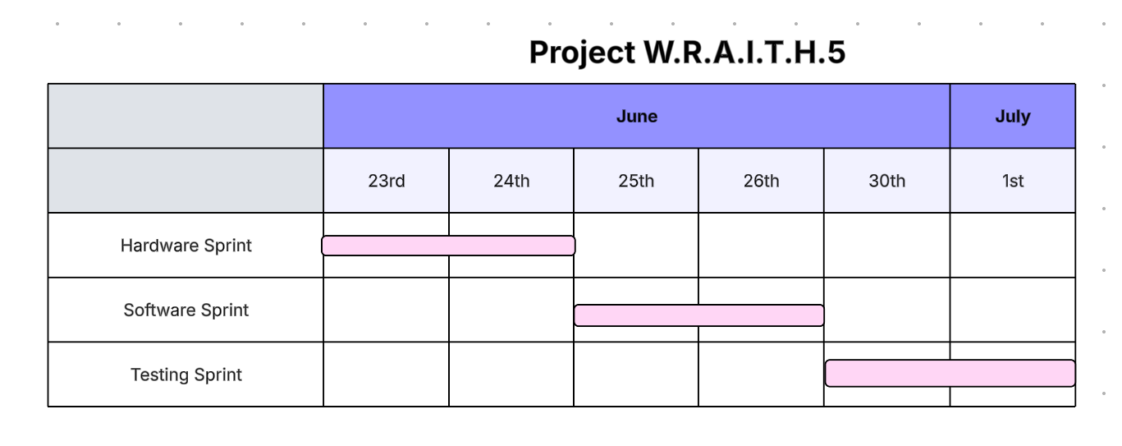
Figure 2: Sprint Gantt Chart - Shows the set days for each sprint.

Procurement and Budgeting
Component procurement was led by Sarah, who researched projects to guide selection. After identifying the key parts, the team met to discuss the rationale behind each choice. All purchases followed employer procurement procedures, including sourcing from approved suppliers and submitting the necessary documentation. Where needed, equivalent components were substituted. Once the list was finalised and approved, and delivery timelines confirmed, the hardware sprint could be formally planned. A summary of the components is shown below in Table 1.
Table 1: Summary of Components Procured for Hardware Sprint
Component selected | Quantity | Total Price | Reasoning
Sunhayato Matrix Board | 5 | £3.65 | Used to quickly prototype and solder circuits without needing to design a custom PCB.
LoRa Module Transceiver | 2 | £28.64 | One for the dongle, one for the RC car, enabling wireless RF communication.
868 MHz RF Transmitter | 1 | £23.95 | Paired with the receiver to form the transmitter circuit.
Microchip PIC16F628A 8bit | Pack of 5 | £11.95 | Chosen as the main microcontroller for the transmitter, receiver, and dongle.
RC Car | 1 | £11.99 | Selected for its 2.4GHz operation and low cost, making it suitable for modification
868MHz RF Receiver | 1 | £22.99 | Paired with the transmitter for RF-based control.
8051, AT89 Microcontroller | 1 | £3.10 | Used for the onboard control system on the RC car.

Unforeseen hardware issues led to a full project redesign. A team meeting was held to reassess the challenges and explore a new direction. With tighter time constraints, sourcing suitable components from suppliers while ensuring functionality and timely delivery proved more difficult. As the project followed a live build format, additional parts were needed throughout, particularly given the shift in design and limited prior research. Table 2 outlines the components procured during the redesign phase and the corresponding solutions.
Table 2: Additional Components Procured Following Hardware Redesign
Component Selected | Quantity | Total Price | Reasoning
Raspberry Pi 5 4GB | 1 | £60 | Chosen for its up-to-date compatibility with project modules and future expansion.
Raspberry Pi Camera Module v2 | 1 | £14.98 | Selected for Pi 5 compatibility (via adapter) and affordability without sacrificing quality.
Mini USB Microphone | 1 | £4.95 | Plug-and-play compatibility with Raspberry Pi OS reduced setup time.
Robot Chassis MS | 1 | £19.70 | Provided space for circuit integration and flexibility for custom motor setup.
Jumper Wires | Pack of 40 | £3.45 | Enabled easy live-working and modular connection changes during prototyping.
TB6612FNG Motor Drivers | 2 | £9 | Matched the voltage/current needs of the chassis motors to prevent damage.
4x AA Battery Pack | 3 | £6 | Supplied required 6V power for both motors and the Raspberry Pi.
Q-Connect MicroSD Card 64GB | 1 | £4.43 | Essential for installing and running the Pi’s OS and firmware.
22-pin 0.5mm Pitch FPC Flex Cable | 1 | £1 | Required to bridge the Pi 5 and the camera module via converter.
Camera Cable Joiner for Raspberry Pi - 15-pin to 22-pin | 1 | £3 | Enabled physical connection between the Pi camera and Pi 5.
Total Spend | £232.78

Ethics and Risk Management
The inclusion of live audio and video streaming raised ethical concerns around privacy and consent, as live feeds risk capturing individuals without approval. An ethics form was submitted and approved during the design phase, in line with university policy and UK GDPR (Appendix L). To comply, modules were tested only in controlled environments with team members, and all media was streamed live without any recording or storage.
Safety was prioritised throughout. A lab risk assessment was completed before hardware work began, and all team members received training on soldering, and electronic handling. Hardware was managed to prevent overheating or faults. Technical safety was also addressed early, incorporating encrypted transmission, secure software practices, and restricted system access. While security features remain basic, the system is designed to support future upgrades as functionality expands.

Tools and Collaboration Strategy
A shared Google Drive was used to coordinate plans, keep records, and save important information. While Emma proposed the sprint-based methodology and acted as coordinator, the project was developed collaboratively. Sarah supervised procurement and assisted the team in getting components, while Amina oversaw ethical compliance and risk assessments. During the sprint phase, each member served as the SCRUM master for their area of expertise, assigning tasks and managing progress based on prior planning discussions. In-person collaboration was a core strategy, with regular meetings arranged and lab access secured to allow hands-on development. All lab procedures and risk assessments were followed to ensure a safe working environment.

Hardware Sprint Planning
The hardware sprint focused on designing circuits and assembling the robot base. It included theoretical planning and practical work to ensure shared understanding. Prior to the sprint, key tasks such as procurement, lab access, and RF research were completed to support a smooth build.

Design Choices and Rationale
- Proteus was used for schematic design and simulation, based on team familiarity.
- PIC16F628A was selected for its built-in oscillator, USART, and flexible I/O.
- CCS Compiler was used for firmware, supporting low-level control needs.
- Perf boards enabled flexible circuit assembly during testing.
- An RC car was chosen for integrating the transceiver and for structural mounting.
- Basic components such as resistors, capacitors, oscillators, and RF modules were pre-sourced to support rapid circuit assembly.
- Soldering tools and draft schematics were prepared in advance.

Task Allocation
- Amina: Receiver schematic, receiver PIC programming, receiver soldering, RC car transceiver circuit.
- Emma: Transmitter schematic, transmitter PIC programming, transmitter soldering, Proteus simulation.
- Sarah: RC car transceiver integration, USB RF dongle schematic and hardware assembly.
This task division ensured each member contributed to circuit design, programming, and hands-on lab work.

Evaluation and Success Criteria
- RC car base supports forward/reverse/turning.
- Completed transmitter and receiver with working signal transmission.
- Transceiver circuit integrated into the RC car.
- RF dongle prototype at partial or complete assembly stage.
The full sprint plan appears in Appendix C.

Software Sprint Planning
The software sprint focused on building the control application and firmware for a modular system. It aimed to support movement, real-time media, and network communication.

Design Choices and Rationale
- Python was chosen for fast development and media/networking support.
- Embedded C was chosen for firmware due to low-level hardware control and compatibility with RF microcontroller-based systems.
- GitHub was selected for version control due to collaborative workflow and structured commit logging.
- Pygame was chosen to build the GUI due to its simplicity and ability to quickly create graphical feedback for directional commands, camera feed, and mic status.
- Socket communication was chosen for straightforward TCP communication.

Task Allocation
- Emma: GUI, audio streaming, and all networking logic in Python and embedded C.
- Sarah: Motor control via GPIO and firmware support.
- Amina: Camera control in both Python and embedded firmware.
Each team member was given ownership of a specific module, with the flexibility to assist with integration and cross-module support during the sprint phase.

Evaluation and Success Criteria
- A working GUI with directional input and real-time feedback.
- Socket communication between GUI and firmware.
- Embedded code able to interpret commands and control motors.
- A modular and well-documented codebase for future testing.
The full sprint plan appears in Appendix D.

Testing Sprint Planning
Testing was integrated into all development phases to verify the function of each module before full system integration. Early testing helped identify potential issues and reduced the risk of major failures later.
A consistent, well-documented testing process improved repeatability and error tracking. Testing goals were aligned with the robot’s functional requirements and broken into manageable phases to support clear task delegation.

Design Choices and Rationale
- A private room was booked for controlled testing of camera and audio modules.
- Electrical tools (e.g. multimeter, oscilloscope) were used to verify circuit behaviour and signal integrity.

Task Allocation
- Emma: Unit and functional testing of the movement module.
- Sarah: Unit testing of the camera module.
- Amina: Unit testing of the audio and network modules.
In addition to automated and scripted tests, manual testing was essential once the hardware was assembled. The team collectively tested:
- The software’s ability to control the robot (movement commands to firmware).
- Live camera and microphone functionality.
- Real-time network performance across firmware and Python layers.
This final integration testing was performed collaboratively to confirm full system behaviour.
The full sprint plan appears in Appendix E.

Design and Implementation

Project Design and Implementation Overview
The final prototype is a modular robot remotely controlled via a Python GUI and 2.4GHz Wi-Fi. It provides real-time audio and visual feedback using a USB microphone and Pi-compatible camera, with a Raspberry Pi 5 as the central controller.
Originally planned around an RF-based microcontroller system, the project pivoted mid-sprint due to hardware limitations and time constraints. The Pi-based setup enabled faster development and better support for modular integration. While directional movement remained non-functional due to unresolved power and signal issues, the system successfully demonstrated wireless media feedback and modular architecture.

Hardware Design and Implementation
The initial goal of the hardware sprint was to modify an RC car to integrate a transceiver circuit, enabling communication via the RF dongle. However, due to the complexity of modifying the car’s existing circuitry and the challenges in integrating the transceiver, this approach was changed. The focus moved to a more practical solution within the given timeframe, using a Raspberry Pi with Wi-Fi communication, which could support the planned modules.

Implementation Details
Proteus and CCS were used to design and compile the transmitter and receiver circuits (See Appendices J -K). Perf boards allowed flexible live-build assembly, suitable for testing and redesign. The RC car was disassembled to examine its circuit layout and identify potential integration points, but this proved too complex to adapt.
Due to these challenges, the hardware sprint was changed mid-process. The team used a modular robot chassis kit from The Pi Hut with four simple motors, enabling quicker integration with the components. Raspberry Pi 5 replaced the original microcontroller setup, using Wi-Fi for communication as a practical alternative to the planned RF dongle.
The Pi camera module v2, and mini-USB microphone was selected for their compatibility with Raspberry Pi OS. All components were individually tested using terminal commands (e.g. arecord, libcamera-hello) and verified for voltage compatibility before full assembly.
Jumper wires and battery packs were used to connect modules to the chassis. Each part was secured and tested before the software sprint began.

Implementation Challenges
The most significant challenge during implementation was with the RC car. The original plan to modify its internal circuitry proved too complex, prompting a shift in approach.
The Raspberry Pi Camera Module v2 was selected for video demonstration and required an adapter ribbon to connect to the Pi 5. While initially recognised by the system, the camera later failed to maintain a stable connection during testing.
Power delivery also posed a problem. Although the Raspberry Pi operated reliably when connected to mains power during early testing, the system failed when transferred to the robot chassis and powered by battery packs. The supplied voltage was insufficient to run the Pi, halting further wireless operation until the issue could be resolved.

Software Design and Implementation
The software application was created during the two-day software sprint. Originally planned for a microcontroller-based RF system, the firmware plans were altered for the Raspberry Pi midway through development. This required a change in the way firmware modules were compiled and tested, but the original architectural goal was preserved: a modular Python GUI would connect with backend movement, audio, and camera modules, which were powered by embedded C/C++ software running on the Pi.

Implementation Details
PyCharm and VSCode were used for Python and C/C++ development, with GitHub for version control and GCC for compiling firmware. Libraries included pygame, socket, opencv-python, libgpiod, libcamera, and arecord.
Modules were developed and tested individually, then committed to GitHub. Emma managed integration, resolving merge conflicts and updating the GUI to include all modules. Basic validation (GUI response, audio input, socket comms) was completed during the sprint.
Full source code is in Appendices F–H.

Implementation Challenges
- The switch from microcontroller to Raspberry Pi led to firmware reorganisation and setup delays, such as OS installation, and setting up a mobile hotspot for connectivity.
- Network configuration issues, such as port binding and IP/firewall conflicts, were overcome using static IP settings and mobile tethering.
- Firmware needed to be modified for Pi-specific components such as the GPIO motor pins and Camera Module 2.
- PyCharm occasionally failed to properly install packages, requiring manual fixes.
- The MakeFile required path modifications due to compiler errors, especially for OpenCV.

Testing Design and Implementation
The testing phase was amended from the microcontroller-based RF system to a Raspberry Pi 5 board. This meant the testing methods were modified and to exclude additional methods to factor in time constraints. The tests were refined without changing the overarching objectives and aims to ensure the functionality of the modular robot. This led the focus of the tests to be on network connection, movement, camera and audio modules whilst using the Raspberry Pi 5 in-built capabilities and operating system.

Implementation Details
- Testing used manual input, unit testing (Appendix I), and multimeter readings.
- Socket connections were verified using static IPs and manual port binding.
- Movement was tested by sending GUI commands and monitoring GPIO outputs.
- Audio was tested via arecord to confirm microphone detection and function.
- Camera testing used libcamera-hello and OpenCV scripts for basic validation.
- Each module was tested individually before full integration.

Implementation Challenges
- The testing plans had to be amended as the RF dongle was no longer being used. Testing methods were researched to see what works best with the Raspberry Pi board and had to reduce testing methods.
- Functional retesting of the camera module showed the camera could not be detected using the libcamera-hello framework. The issue was troubleshooted and the camera ribbon was inspected for damage and nothing was apparent. Further troubleshooting ruled out any issues with the Raspberry Pi board or power supply.

Results and Analysis

Functional Testing Results
A photo of the completed robot prototype is shown in Figure 3, highlighting the mounted camera, Raspberry Pi 5, and labelled chassis used during hardware integration and testing.

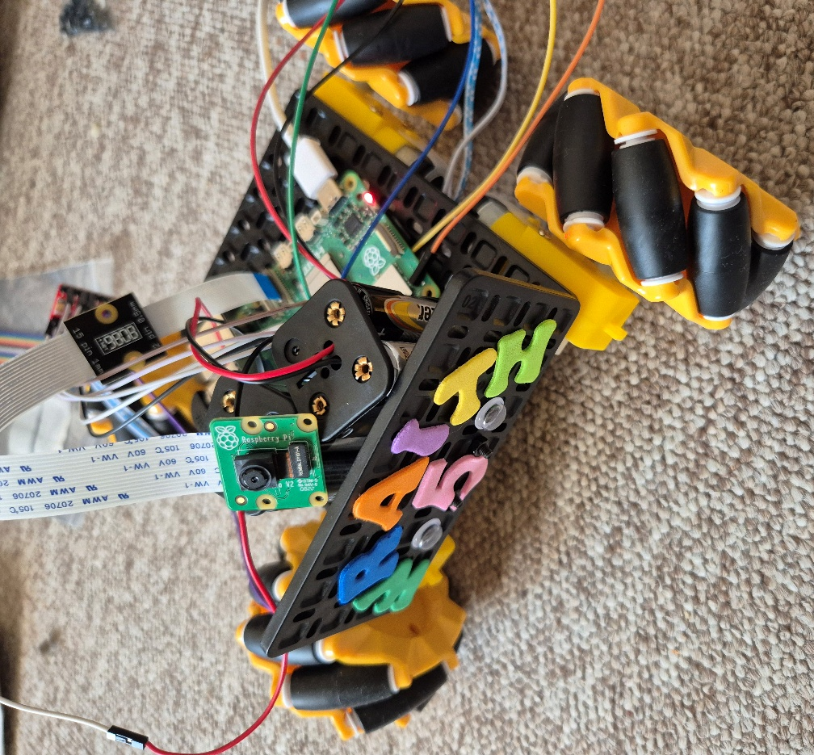
Figure 3: Final prototype of the modular robot system (W.R.A.I.T.H.5).
The following table summarises the results of functional testing across the movement, audio, and camera modules, comparing expected outcomes with actual system performance.
Table 3: Summary of Functional Testing Outcomes
Test Category | Test Method | Expected Outcome | Actual Result
Movement | Chassis connected to power | Wheels move | Working
 | Forward command | Robot moves forward | Not working – Pi receives command
 | Backward command | Robot moves backward | Not working – Pi receives command
 | Left command | Robot moves left | Not working – Pi receives command
 | Right command | Robot moves right | Not working – Pi receives command
 | Stop command | Movement halts | Not working – Pi receives command
Audio | Detect USB mic using arecord | Device is detected | Working
 | Stream live audio to GUI | Audio streams with clarity and minimal latency | Working
 | Integrate audio with GUI | Functional audio module within interface | Working
 | Audio while robot in motion | Audio remains stable | Not verified due to motor issues
Camera | Detect Camera Module 2 using libcamera-hello | Camera is recognised | Detected
 | Still image capture (OpenCV) | Captures still image | Working
 | Live video stream on GUI | Real-time camera feed appears | Not tested
 | Stream camera + audio + movement | All systems function together | Not tested due to motor issue

Analysis
- Movement: The GUI successfully sent commands, and the Raspberry Pi terminal logged them correctly, confirming working socket communication. However, the motors did not activate. The likely causes include motor driver wiring issues or inadequate power delivery from the battery packs.
- Audio: Fully functional. The USB microphone was detected by the Pi and streamed clear live audio through the GUI, meeting the audio module’s success criteria.
- Camera: The camera was detected, and a still image was captured using OpenCV. However, real-time video streaming was not tested due to hardware limitations and unresolved connection stability issues.
- Overall: While full integration could not be achieved, most individual modules operated as intended. Software components were modular, testable, and communicated successfully via sockets. Hardware constraints, particularly around movement and camera, limited full system validation.

Conclusions and Evaluations

Conclusions
Despite significant technical and structural challenges that led to mid-sprint adjustments, the project achieved its core objectives. The original plan to use a microcontroller and custom RF dongle was replaced with a more practical Raspberry Pi 5 solution, enabling socket-based Wi-Fi communication while preserving the aim of a modular, remotely operated robot with real-time feedback.
The hardware sprint delivered a working robot chassis with integrated camera, microphone, and control circuit. While the RC car adaptation failed, switching to a modular chassis kit improved compatibility and sped up integration. The software sprint produced a functional Python GUI, stable network communication, and working audio streaming. Camera and motor features were partially tested - still image capture succeeded, but full video and movement validation were limited by unresolved hardware issues.
Testing evolved alongside the project, focusing on key modules to ensure independent functionality before integration. This approach reinforced the value of continuous, early-stage testing over late-phase validation.
Overall, the six-day sprint produced a functional prototype with modular architecture, clean documentation, and room for future development. The agile structure, rotating SCRUM leadership, and Git-based collaboration supported steady progress and effective teamwork.

Recommendations
To improve future iterations of this project, several key adjustments are recommended:
- Allow more time for hardware integration and testing, especially on a sprint-based timetable. Delays in hardware had an impact on testing and software validation.
- Strengthen modularity by further isolating hardware and software modules. This would support future goals of modularity.
- Enhance the GUI by adding error handling, real-time diagnostics, and system status indicators. These enhancements would make the system more reliable and easier to diagnose.
- Secure critical components sooner, particularly those with power delivery limits. Early procurement would allow for extensive pre-sprint validation while reducing configuration time throughout development.

Reflections

Sarah’s Reflections
Leading the hardware sprint was both an enjoyable and challenging experience. Working under such a short time frame was difficult at times, but it pushed the team to make more efficient decisions, resulting in a smoother transition to a new hardware approach. However, I recognised that more planning and pre-sprint testing may have prevented many of the issues we encountered. While I enjoyed the live-working method because I prefer hands-on trial and error, more preliminary testing might have produced better results. Throughout the sprint, teamwork was highly effective. Everyone contributed unique skills and perspectives that supported each other. I learnt a lot about project management and the SCRUM master job by witnessing Emma, and I now feel much more secure in that capacity.
Despite obstacles, I am pleased with the project's outcome and believe our ultimate strategy was correct. If given the opportunity to start over, I would follow that strategy from the beginning. Even if things didn't go exactly as planned, I found the concept to be strong. Mentoring peers was a new experience for me, and it helped me understand more as I learnt how to properly explain complex ideas. At the same time, being mentored in coding was beneficial, since having a like-minded peer explain things in a targeted way allowed for a more personalised and successful learning experience.

Emma’s Reflections
Leading the software sprint provided a great opportunity to practise working under pressure while handling collaborative code contributions. Having defined evaluation points helped keep the sprint focused and allowed for swift decision-making when original plans needed to be changed. Adapting to the Raspberry Pi mid-sprint introduced a learning curve, particularly with configuring tools. Although time restrictions prevented extensive testing, the use of a modular design and flexible planning allowed us to create a functional prototype with room for additional growth.
The team worked well together throughout the project, with each member offering specific strengths to both technical and creative tasks. With prior experience with agile workflows and SCRUM, I took the lead in software development and sprint coordination, guiding decision-making and maintaining project momentum. Despite the change in direction mid-sprint, we adjusted swiftly and made constant progress.

Amina’s Reflections
Leading the testing sprint expanded my appreciation for the importance of continuous testing throughout the development life cycle. It highlighted the importance of thorough research, early preparation, and the need to remain adaptable. I also discovered how important it is to rely on teammates for assistance, both in sharing ideas and learning from their different skill sets. Open communication and collaboration increased my confidence and broadened my understanding of the testing procedure.
The project was a rewarding experience due to the team's strength and the diversity of ideas offered. I enjoyed contributing to project planning throughout the development cycle and learning how to break down large tasks into manageable chunks. Despite the technical challenges we had, I got significant knowledge of various communication technologies. The team continually supported one another, mentoring across specialities and allowing everyone to contribute throughout the development process. This highlighted the importance of solid planning and documentation, not only for this project, but also for making future iterations easier to copy and expand.

References
[1] “RF Serial Data Link through USB,” Instructables. [Online]. Available: https://www.instructables.com/RF-Serial-Data-Link-%7Bthrough-USB%7D/.
[2] Ofcom, UK Frequency Allocation Table (UKFAT), 2017. [Online]. Available: https://www.ofcom.org.uk/__data/assets/pdf_file/0025/102613/uk-fat-2017.pdf.
[3] Ofcom, ISM Frequencies in the UK, Aug. 2022. [Online]. Available: https://www.ofcom.org.uk/__data/assets/pdf_file/0023/263748/fat-ism-frequencies.pdf.
[4] Aegis Systems Ltd., 863–870 MHz Short Range Device (SRD) Market Research: Final Report, Ofcom, 2015. [Online]. Available: https://www.ofcom.org.uk/__data/assets/pdf_file/0016/71345/aegis_srd_report.pdf.
[5] “DIY FrSkyRX USB dongle,” RC Groups, Jun. 2022. [Online]. Available: https://www.rcgroups.com/forums/showthread.php?2810707-DIY-FrSkyRX-USB-dongle.
[6] “Robotic Vehicle with Metal Detection Project,” NevonProjects, 2024. [Online]. Available: https://nevonprojects.com/robotic-vehicle-with-metal-detection-project/.
[7] “8 Steps to Design a Remote Control Robotic Kit,” ElProCus, [Online]. Available: https://www.elprocus.com/infographic-8-steps-make-remote-control-robotic-vehicle/
[8] “Fire Fighting Controlling Robots Used to Track Dangerous Situations,” ElProCus, [Online]. Available: https://www.elprocus.com/robots-used-dangerous-situations/
[9] “Robots in Military, How a War Field Spying Robot Night Vision Cam Works,” ElProCus, [Online]. Available: https://www.elprocus.com/robots-in-military-a-spying-robot/
[10] “Robotics Project Ideas for Final Year Engineering Students,” ElProCus, [Online]. Available: https://www.elprocus.com/robotics-project-ideas-for-engineering-students/
[11] “Latest DTMF Based Projects Ideas List for ECE/EEE Engineering Students,” ElProCus, [Online]. Available: https://www.elprocus.com/dtmf-based-project-ideas/
[12] “Attack of the Flying 18650s,” Hackaday, 03-Mar-2021. [Online]. Available: https://hackaday.com/2021/03/03/attack-of-the-flying-18650s/
[13] S. Manikandan, R. Saravanan, and S. N. Sivanandam, “A Remote Control System for Real Time Robot Application Using Wireless Technology,” International Journal on Advanced Science, Engineering and Information Technology, vol. 2, no. 2, pp. 10–14, 2012. [Online]. Available: https://ijaseit.insightsociety.org/index.php/ijaseit/article/download/153/158/164.
[14] D. Olchanski, “Wireless Serial Communication Using Low-Cost RF Modules,” in Proceedings of the 15th International Workshop on Robotics in Alpe-Adria-Danube Region (RAAD 2006), Balatonfüred, Hungary, 2006. [Online]. Available: https://uni-obuda.hu/conferences/raad2006/Olchanski.pdf.
[15] M. B. Putra and D. P. Sari, “Design and Implementation of Multipurpose Radio Controller Unit Using nRF24L01 Wireless Transceiver Module and Arduino as MCU,” Research & Reviews: Journal of Engineering and Technology, vol. 7, no. 3, 2018. [Online]. Available: https://www.rroij.com/open-access/design-and-implementation-of-multipurpose-radio-controller-unit-using-nrf24l01-wirelesstransceiver-module-and-arduino-as-mcu.php?aid=87542.
[16] Netmaker, “Teleoperation: Meaning, Applications & Network Protocols,” Netmaker.io, 2023. [Online]. Available: https://www.netmaker.io/resources/teleoperation.
[17] J. Baca, C. A. Monje, M. A. Arteaga, and C. Balaguer, “Survey on Research and Development of Reconfigurable Modular Robots,” ResearchGate, Jul. 2016. [Online]. Available: https://www.researchgate.net/publication/305489022_Survey_on_Research_and_Development_of_Reconfigurable_Modular_Robots
[18] M. Melenbrink, R. Nagpal, and J. Werfel, “Design Principles for an Extendable Framework to Study Collective Construction,” IEEE/RSJ International Conference on Intelligent Robots and Systems (IROS), 2022. [Online]. Available: http://people.seas.harvard.edu/~jkwerfel/iros22melenbrink.pdf
[19] Boston Engineering, “Modularity and Adaptability - Robotics,” Boston Engineering, 2024. [Online]. Available: https://www.boston-engineering.com/solutions/technical-innovation/robotics/robotics-electromechanical-capabilities/modularityand-adaptability/
[20] Y. Jin, C. Liu, and X. Wang, “Research and application of a coupled wheel-track off-road robot based on separate track structure,” ResearchGate, 2023. [Online]. Available: https://www.researchgate.net/publication/384043962_Research_and_application_of_a_coupled_wheel-track_offroad_robot_based_on_separate_track_structure
[22] H. Kim et al., “Functional Design of a Hybrid Leg-Wheel-Track Ground Mobile Robot,” Machines, vol. 9, no. 1, p. 10, Jan. 2021. [Online]. Available: https://www.mdpi.com/2075-1702/9/1/10
[23] S. Pritchin, “Design and Implementation of a Remote-Control Robotic Audio-Visual Real-Time System,” Theseus – Laurea University of Applied Sciences, 2024. [Online]. Available: https://www.theseus.fi/bitstream/10024/883762/2/Pritchin_Sergey.pdf.
[24] A. Wilson, “Integration of Vision in Embedded Systems,” Vision Systems Design, Oct. 2005. [Online]. Available: https://www.vision-systems.com/embedded/article/16737644/integration-of-vision-in-embedded-systems.
[25] A. Espinoza, J. D. Reyes, and J. F. Gómez-Aguilar, “Embedded Microcontroller with a CCD Camera as a Digital Lighting Control System,” Electronics, vol. 8, no. 1, p. 33, Jan. 2019. [Online]. Available: https://www.mdpi.com/2079-9292/8/1/33.
[26] É. Brière, J.-M. Valin, and F. Michaud, “Audible Communication for Mobile Robots,” in Proc. IEEE Int. Conf. on Robotics and Automation (ICRA), Pasadena, CA, USA, May 2008. [Online]. Available: https://jmvalin.ca/papers/ICRA2008Briere.pdf.

Appendix A – Report Contributions

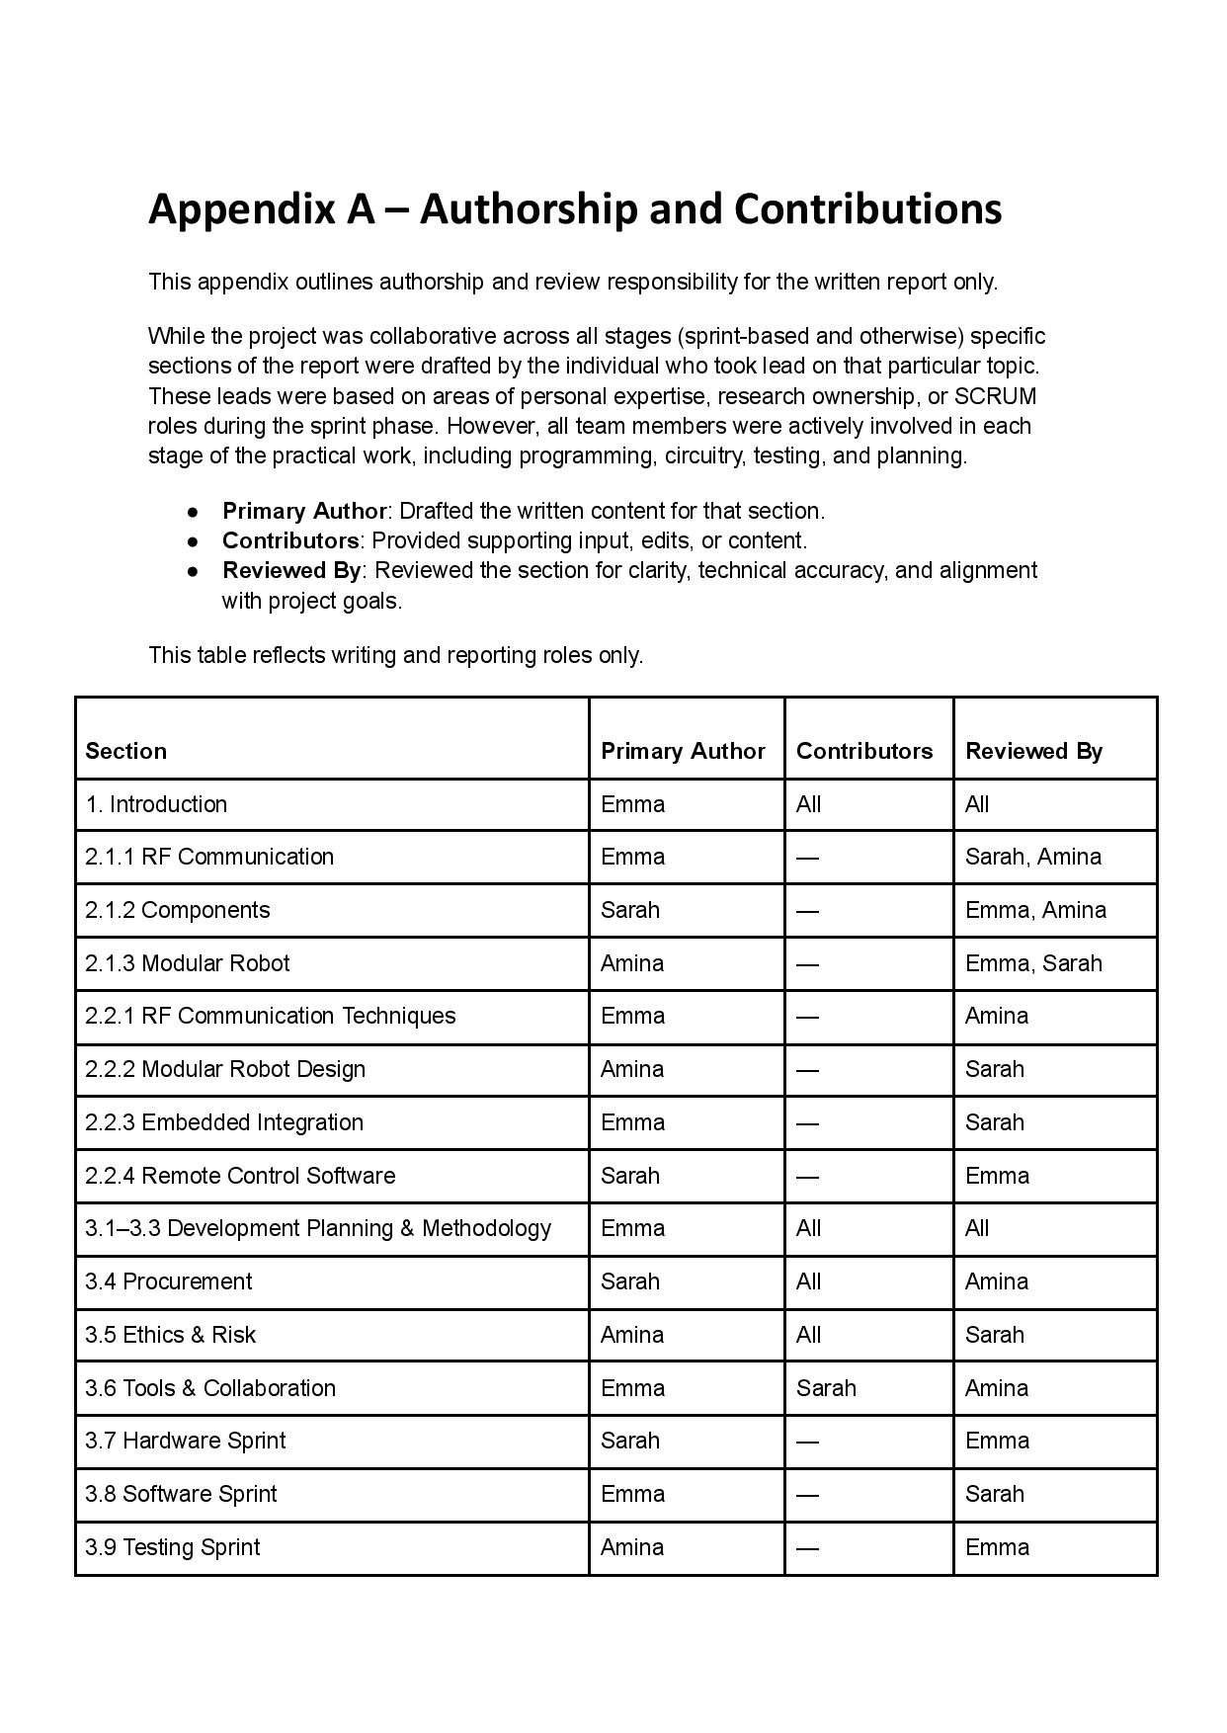
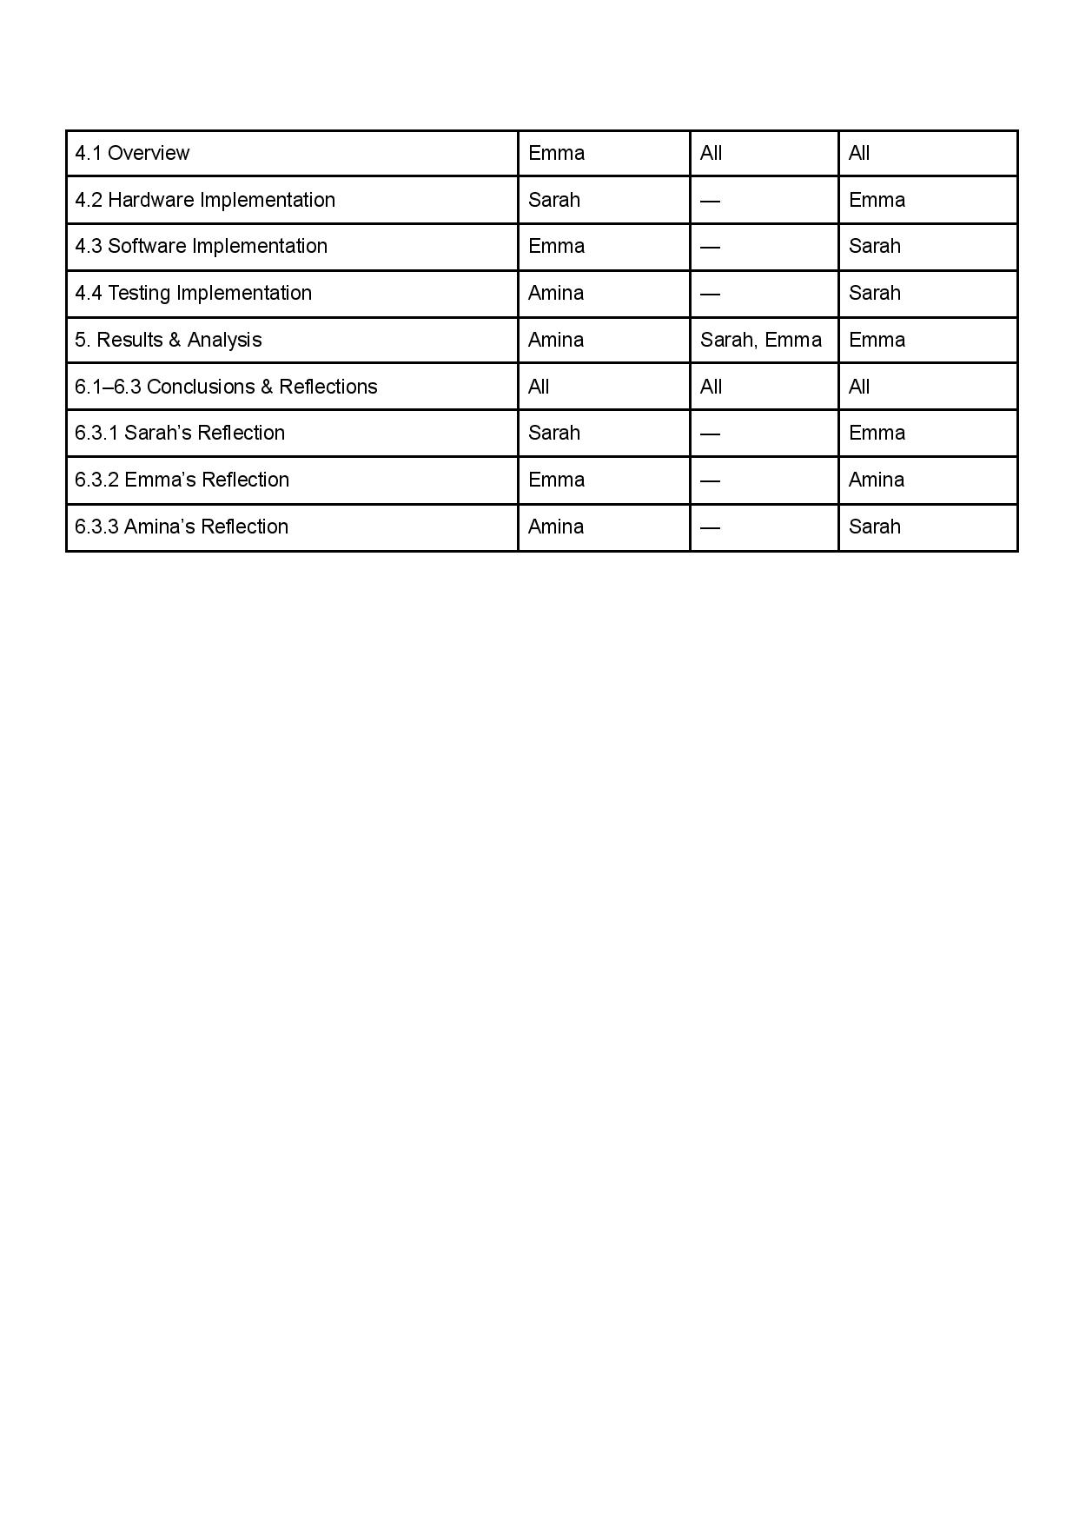

Appendix B – Project Logbook
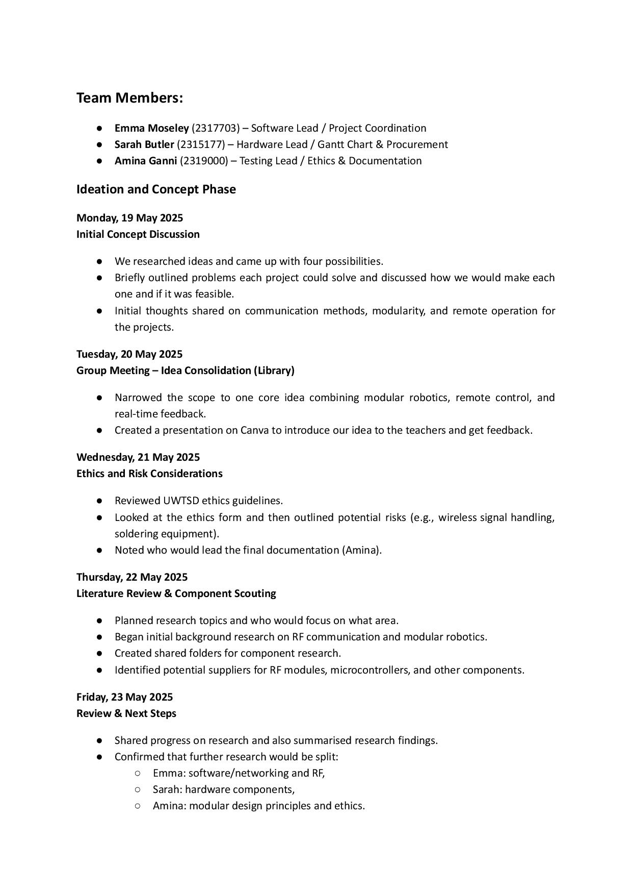
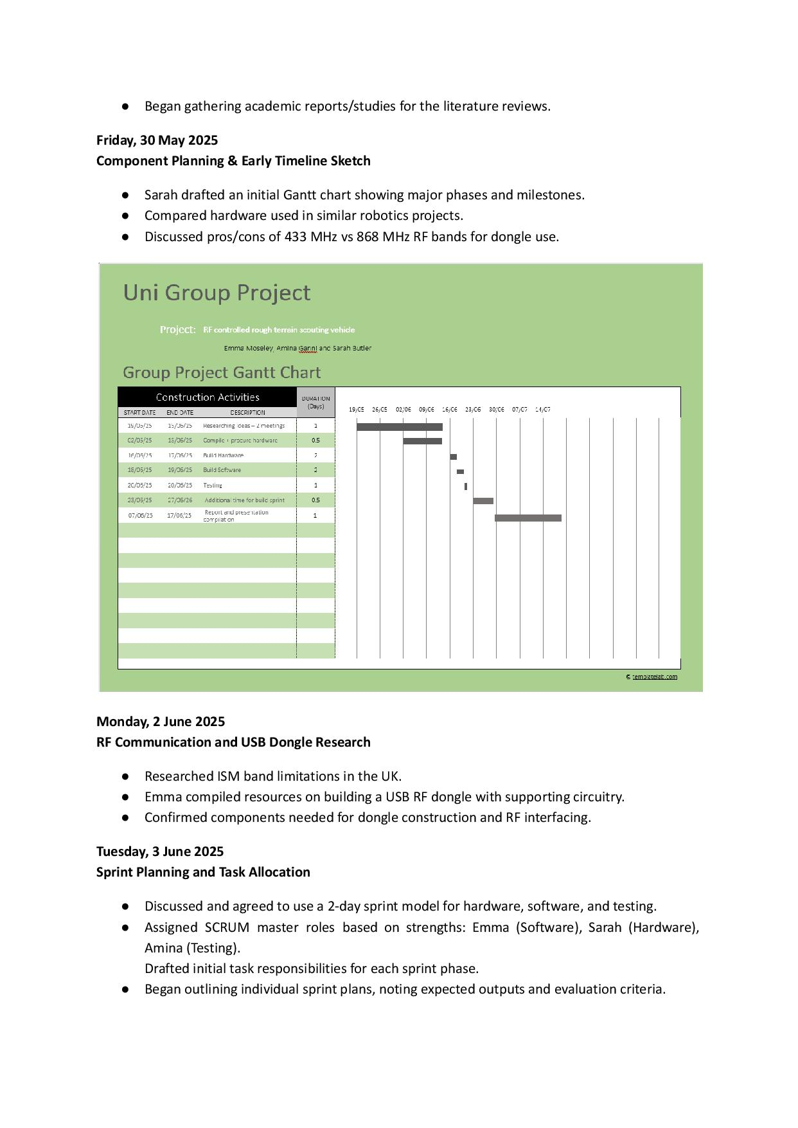
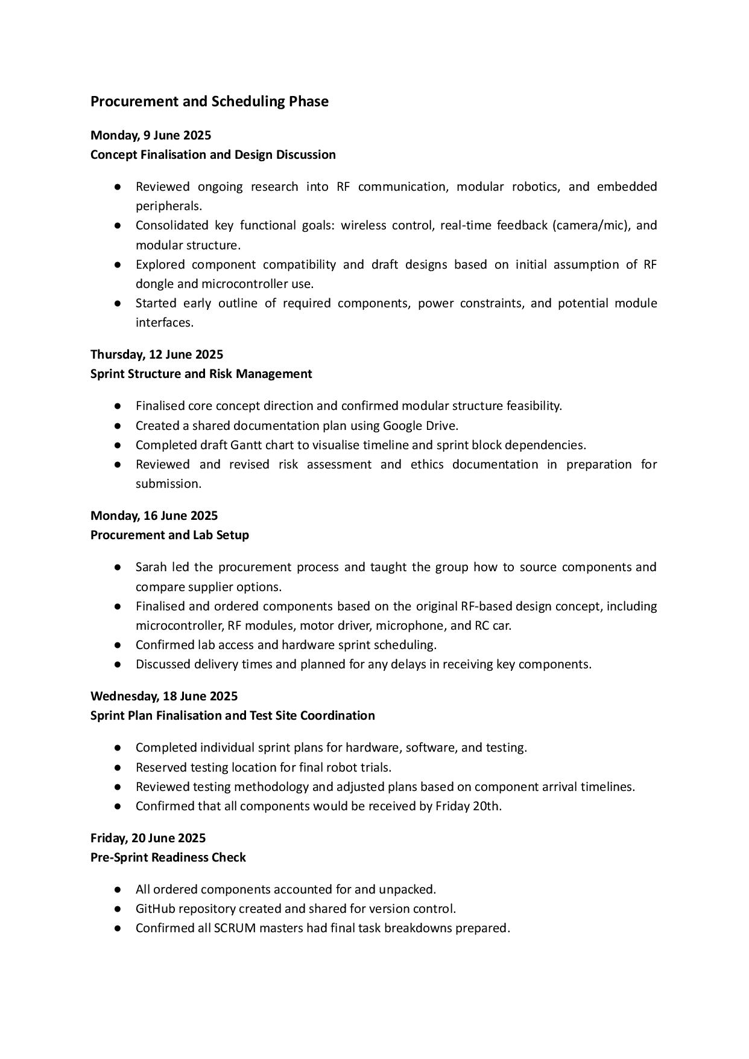
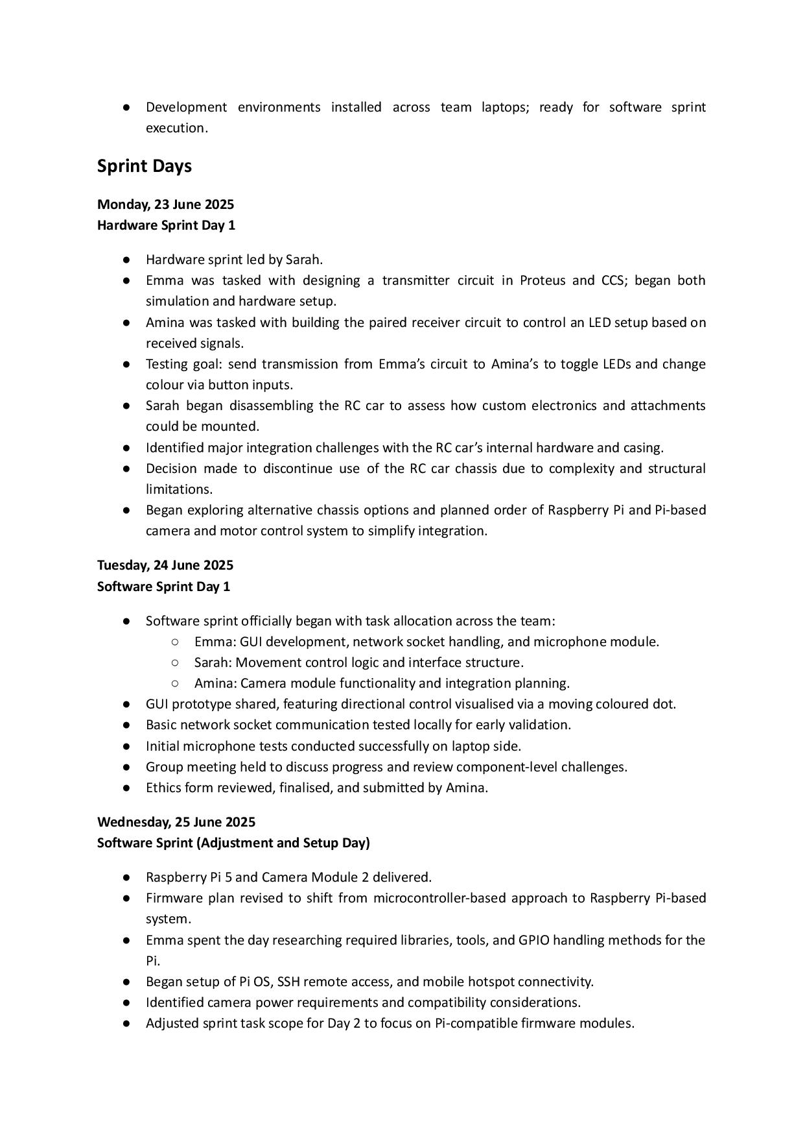
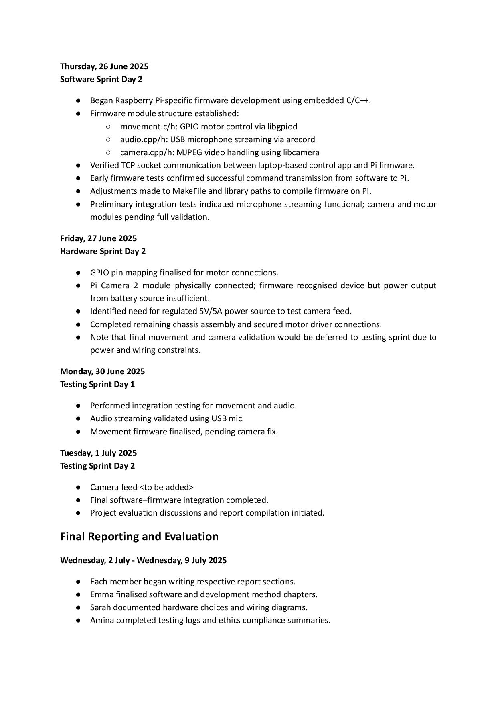


Appendix C – Hardware Sprint Plan
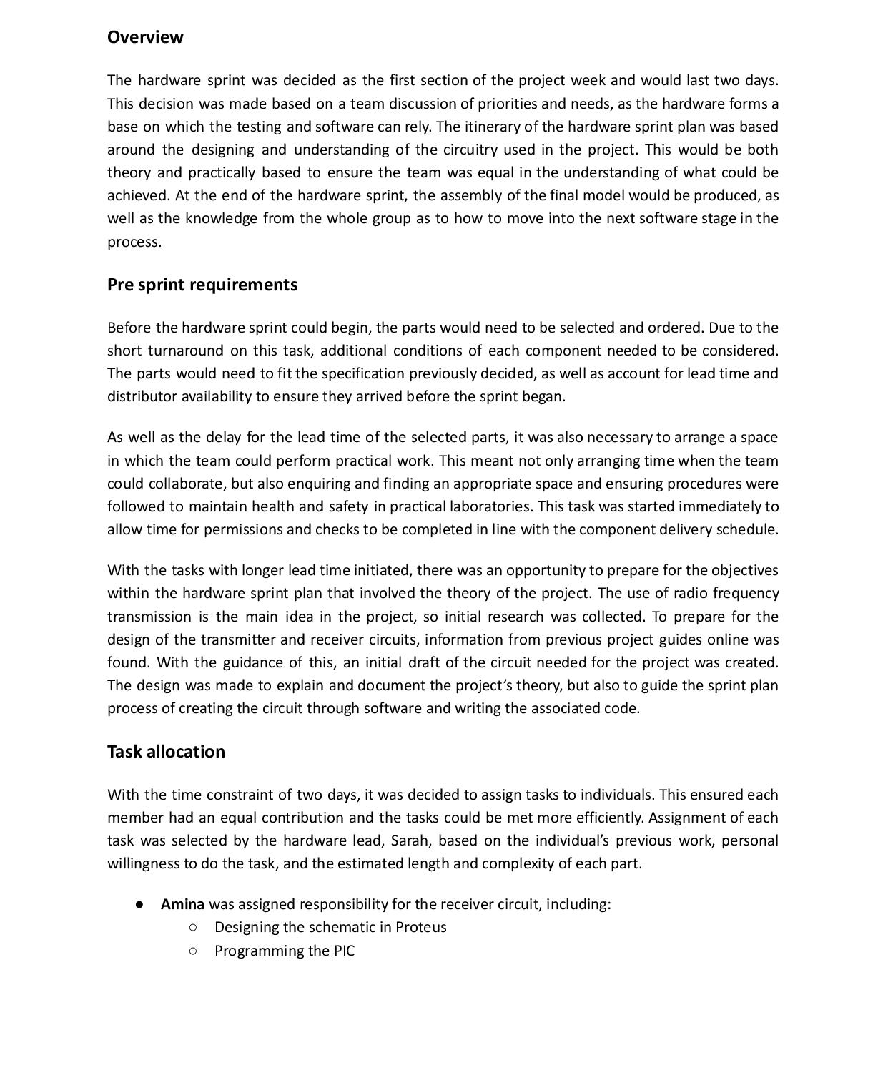
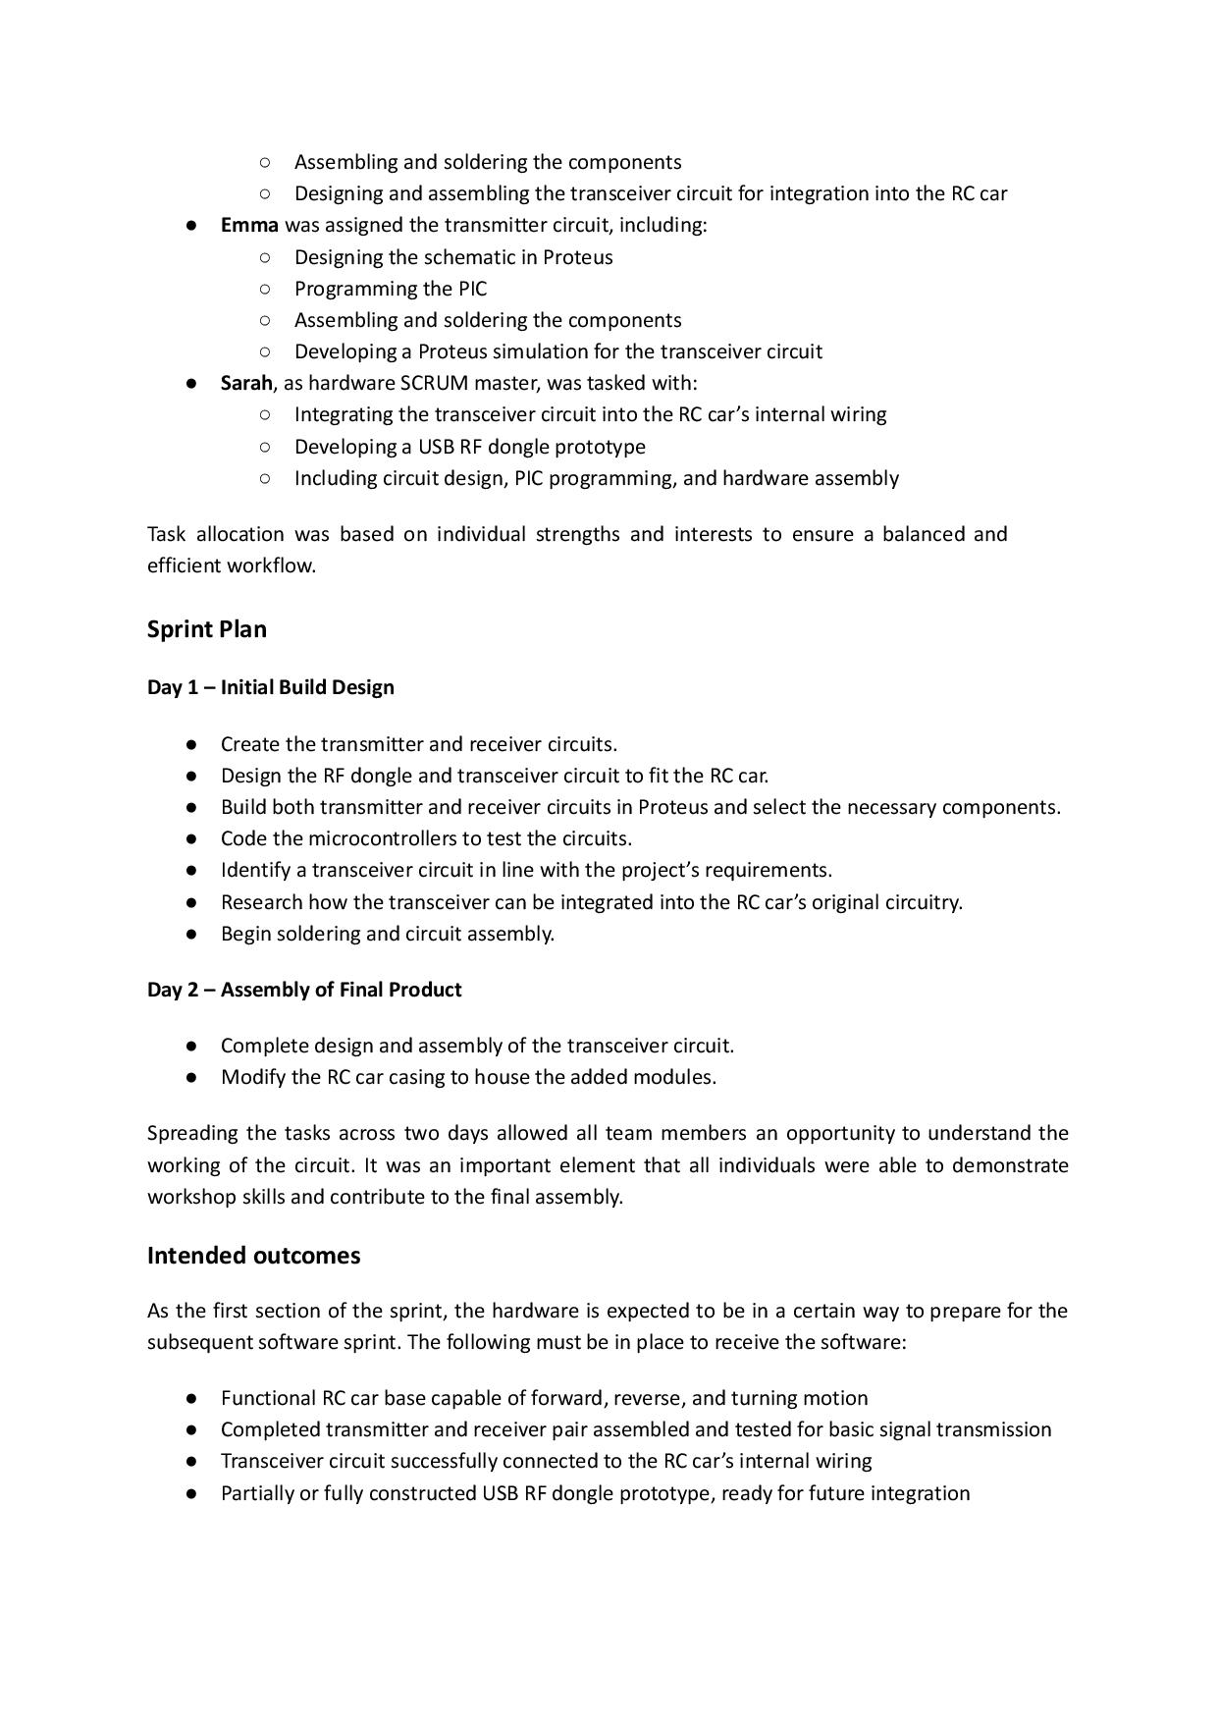

Appendix D – Software Sprint Plan
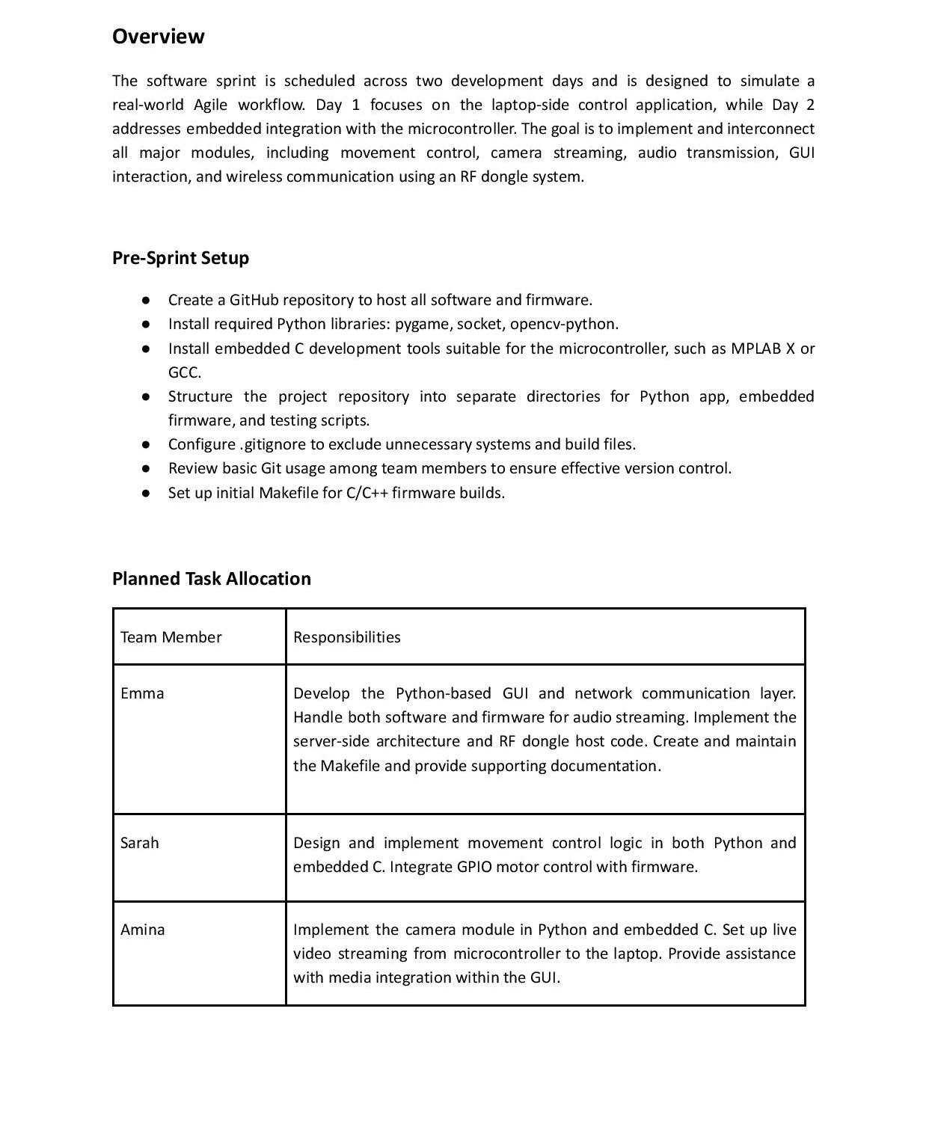
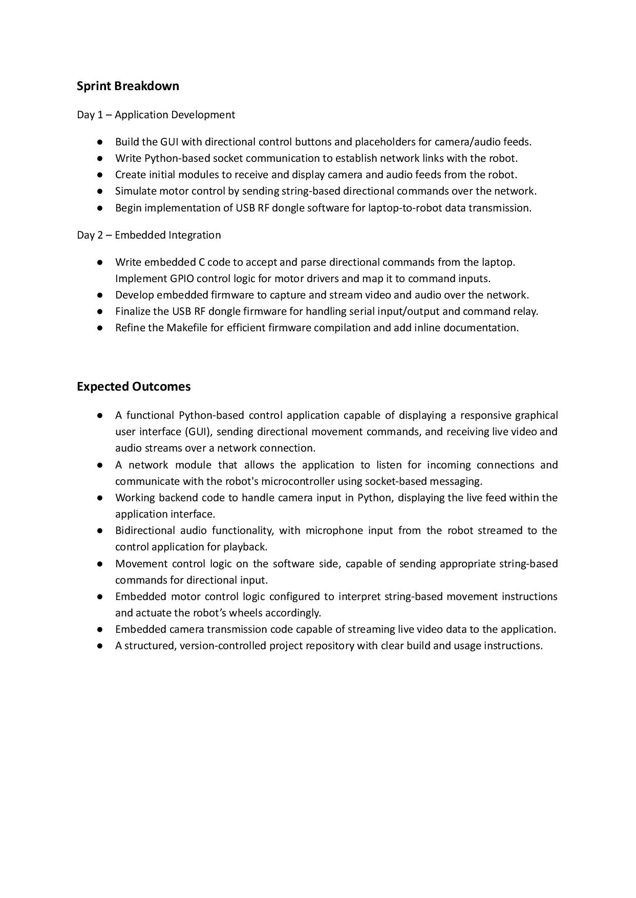

Appendix E – Testing Sprint Plan
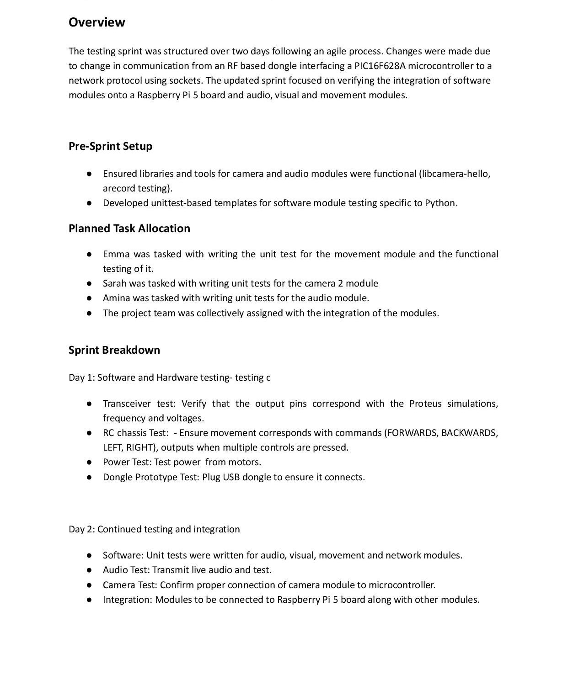
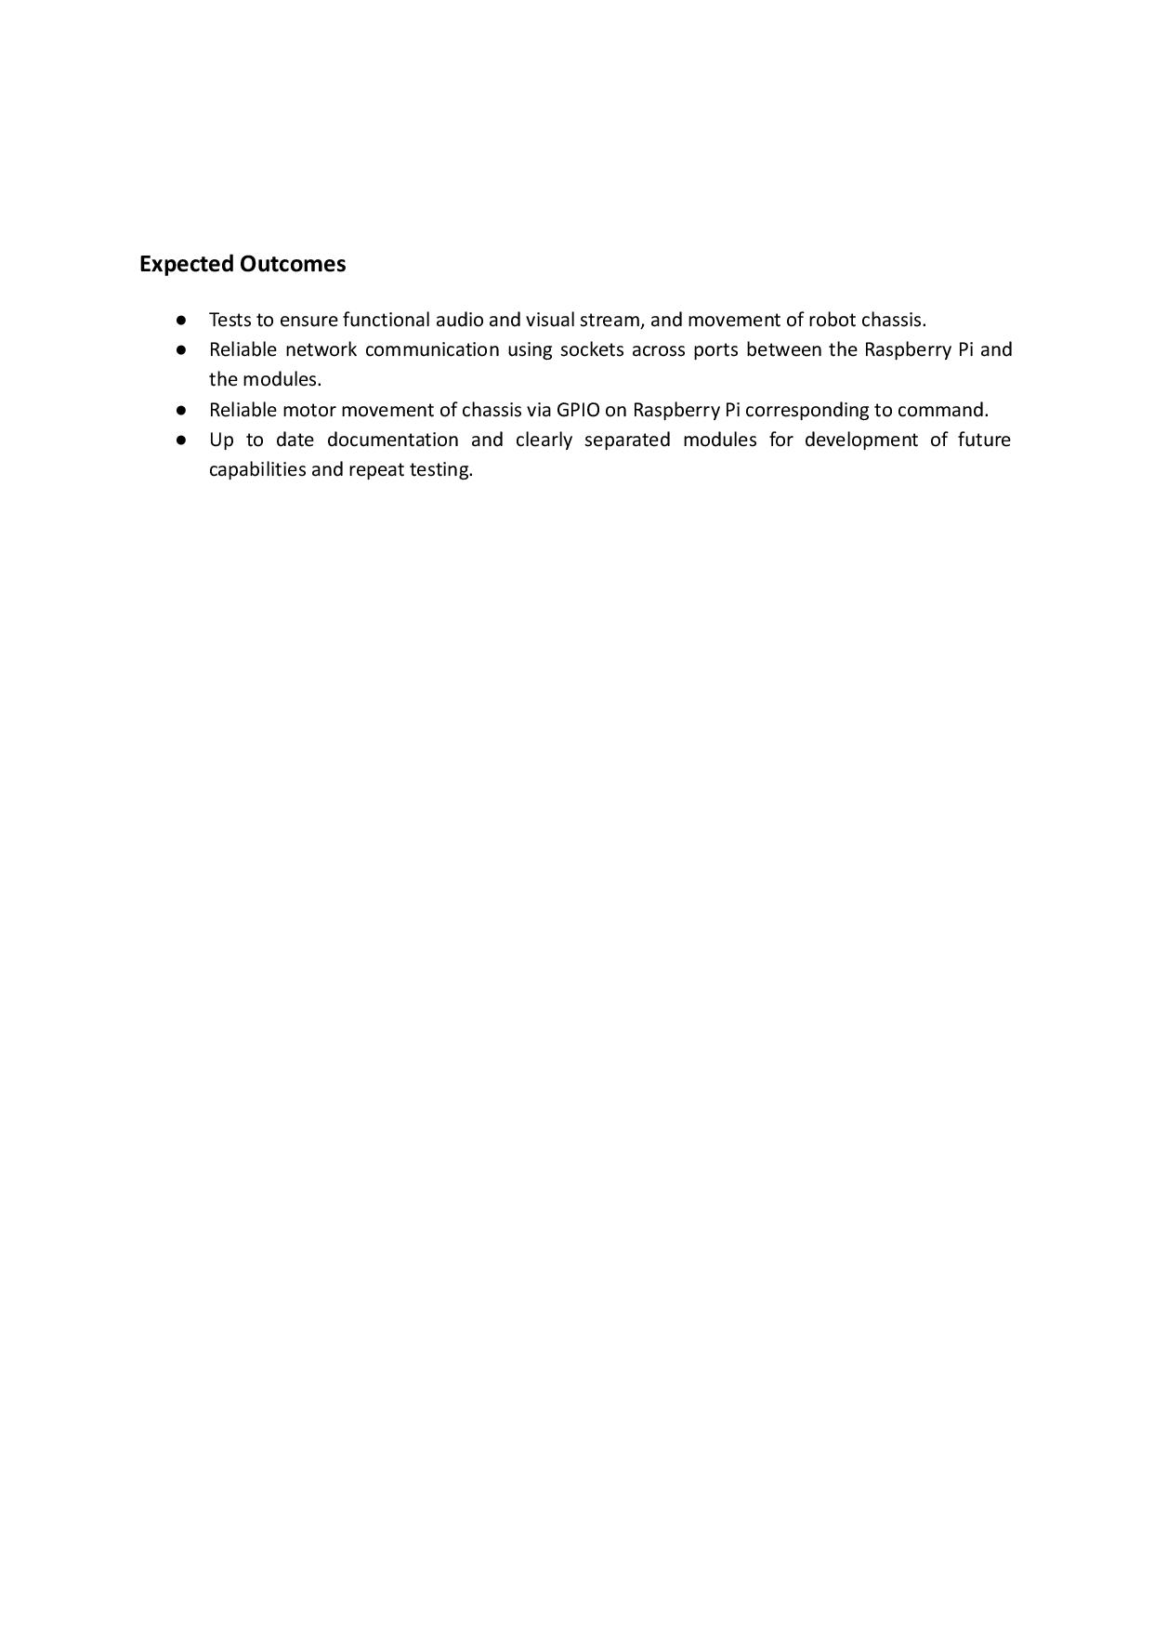

Appendix F – Repository Overview and Access
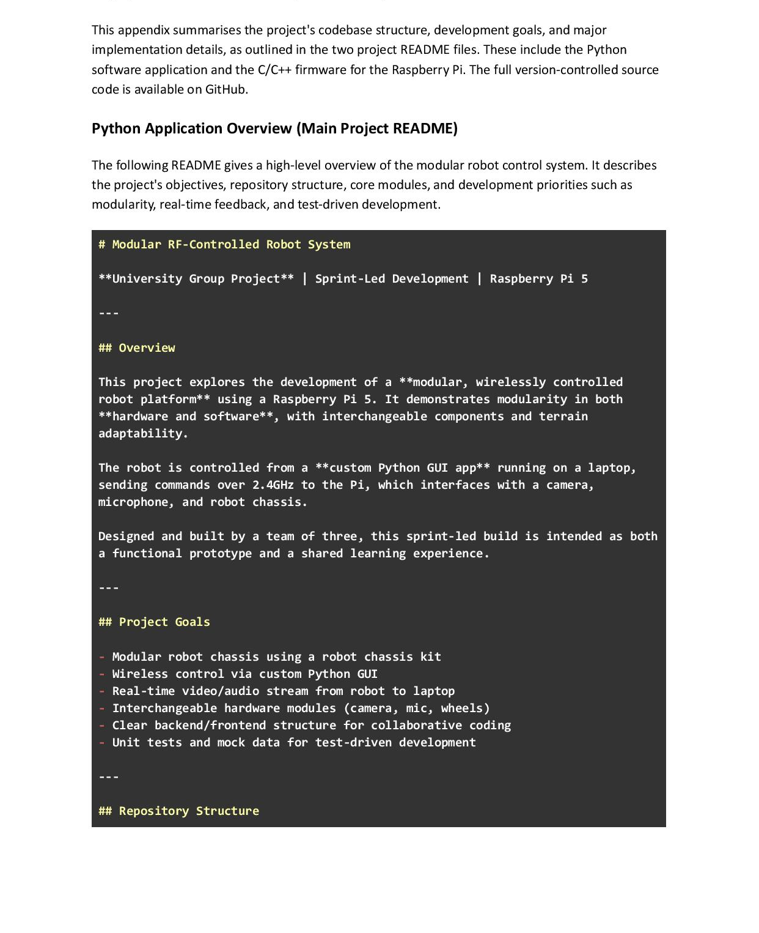
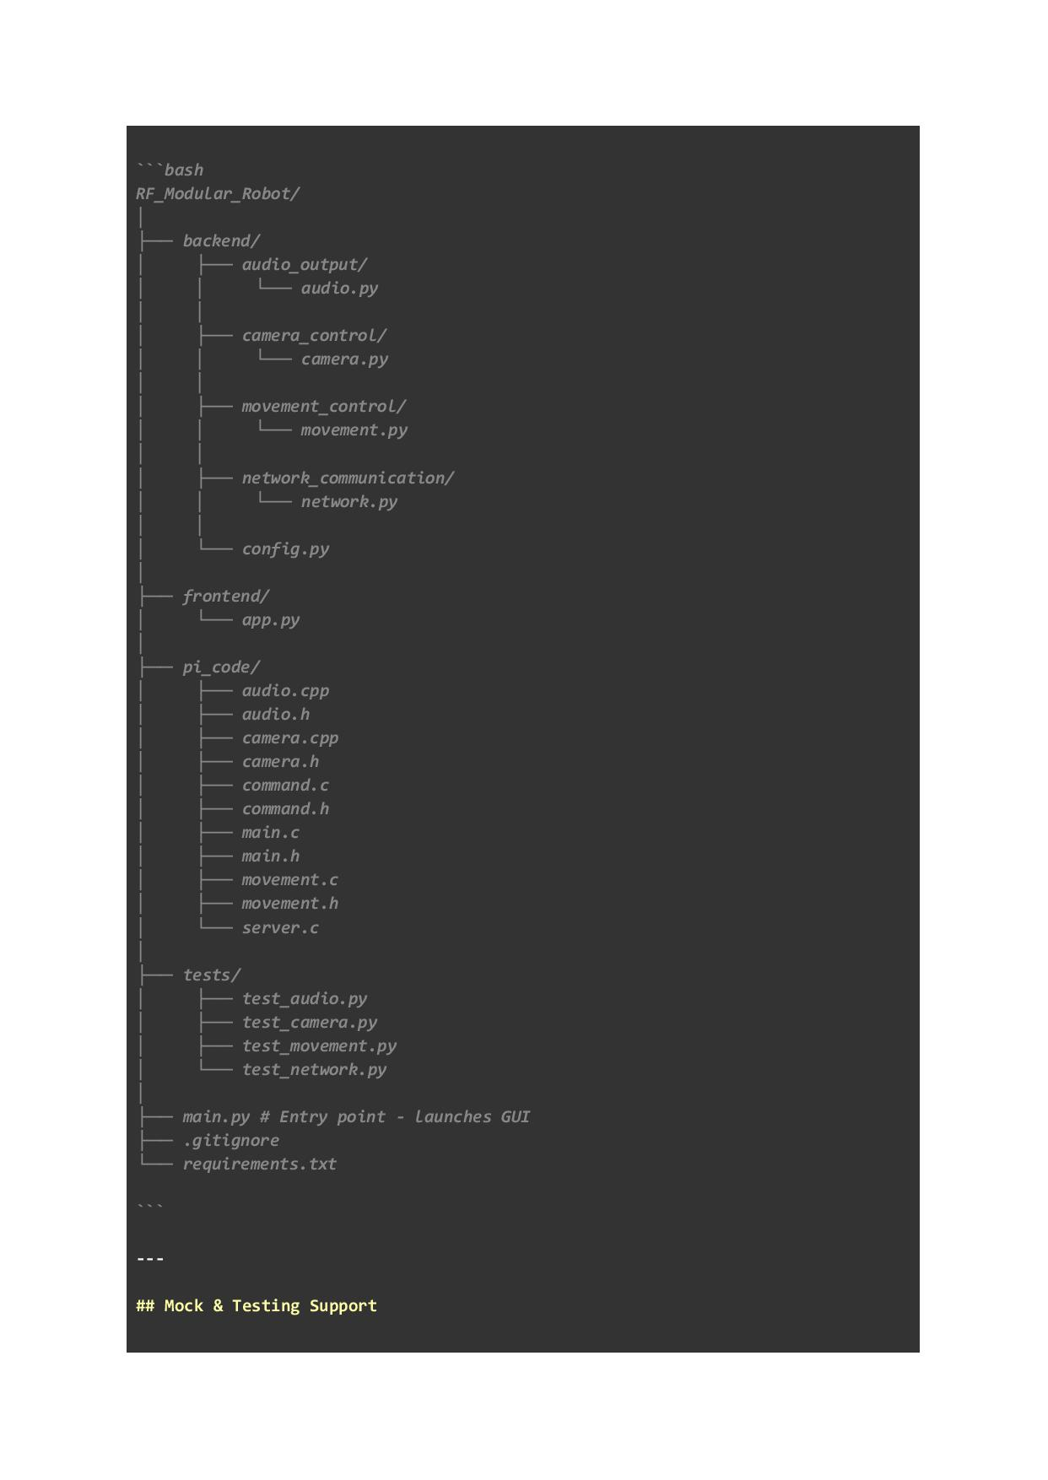
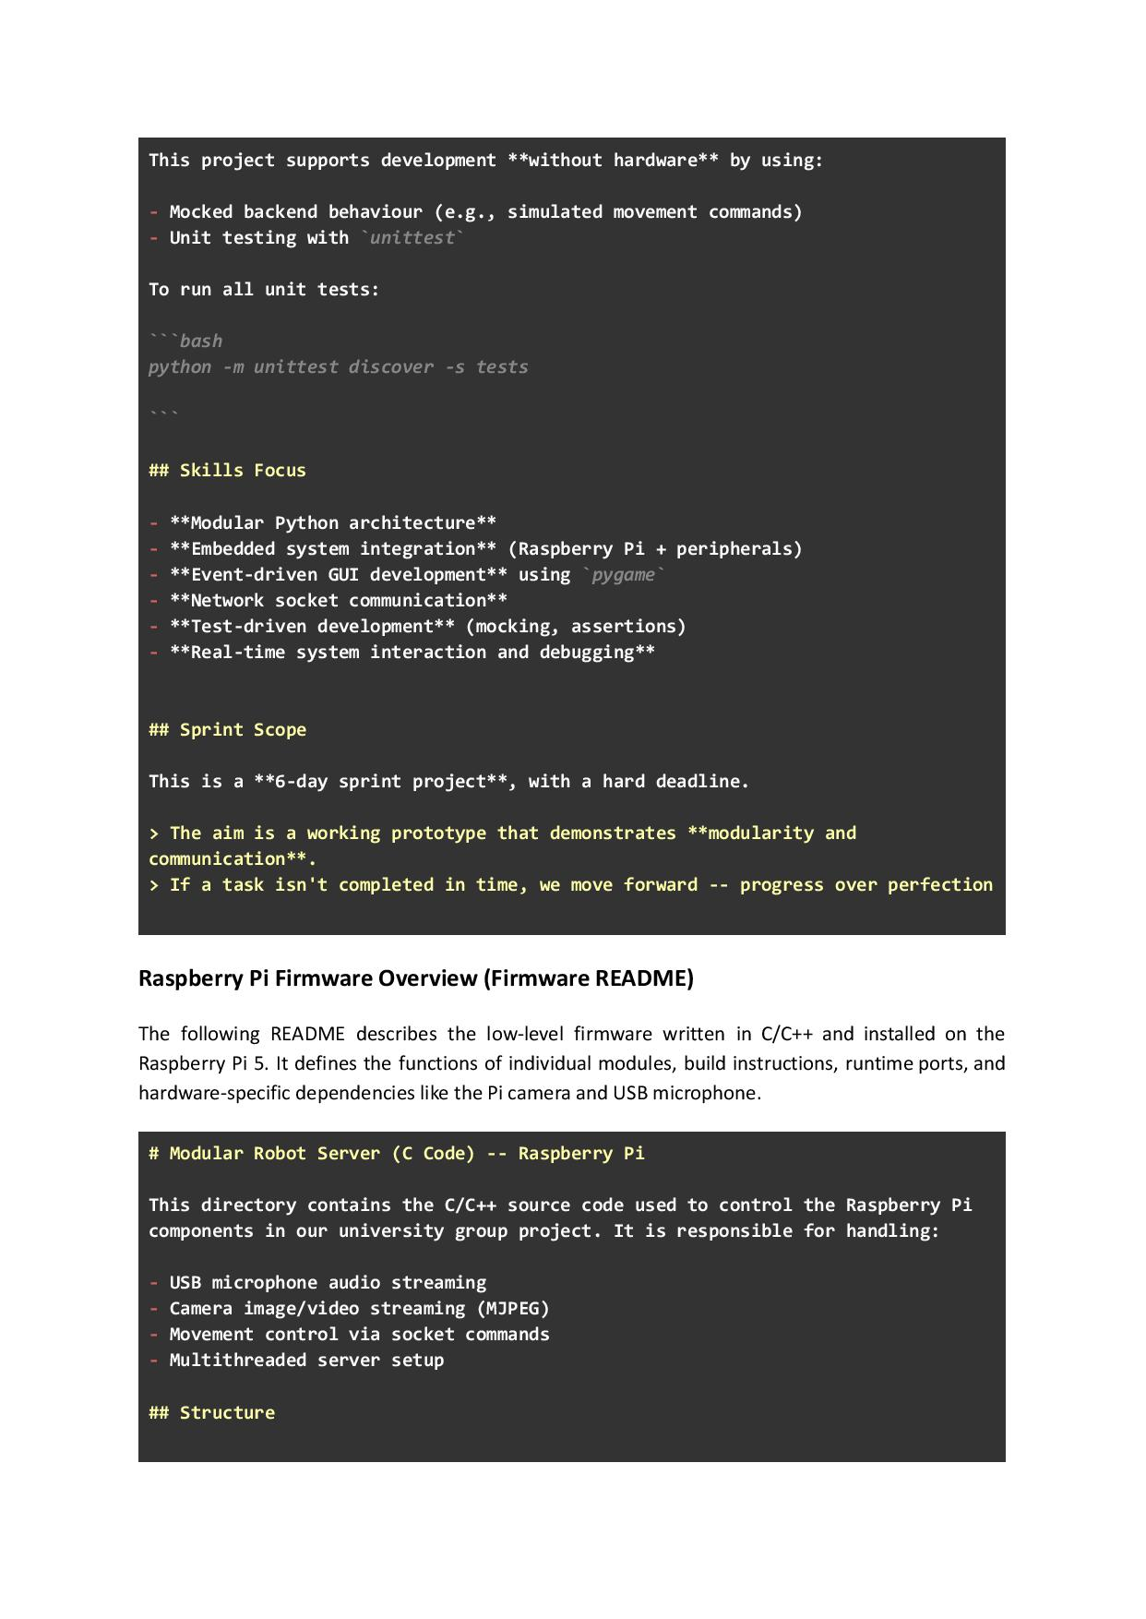
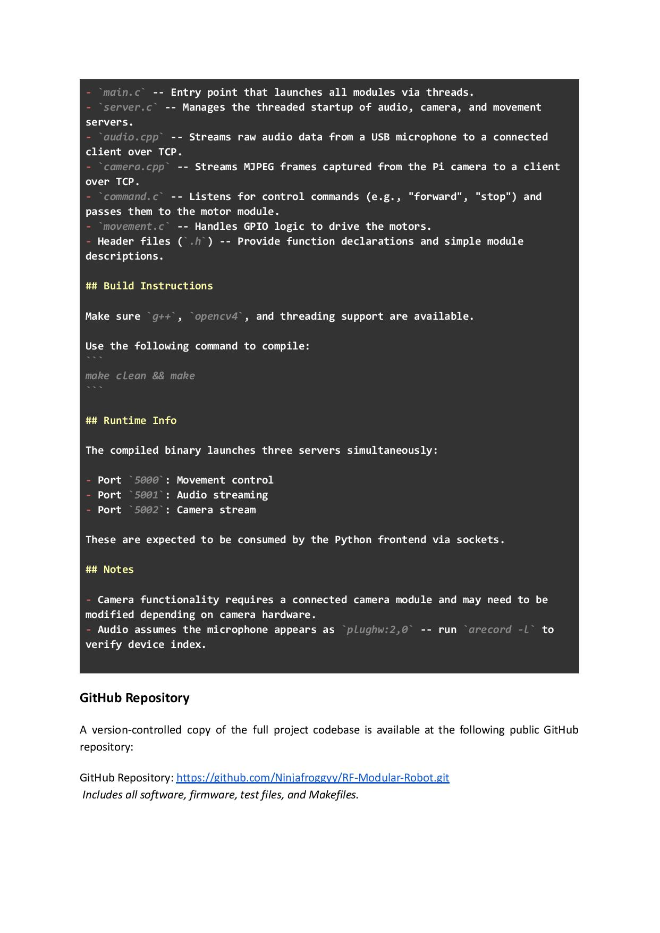

Appendix G – Software Application Code (Python)
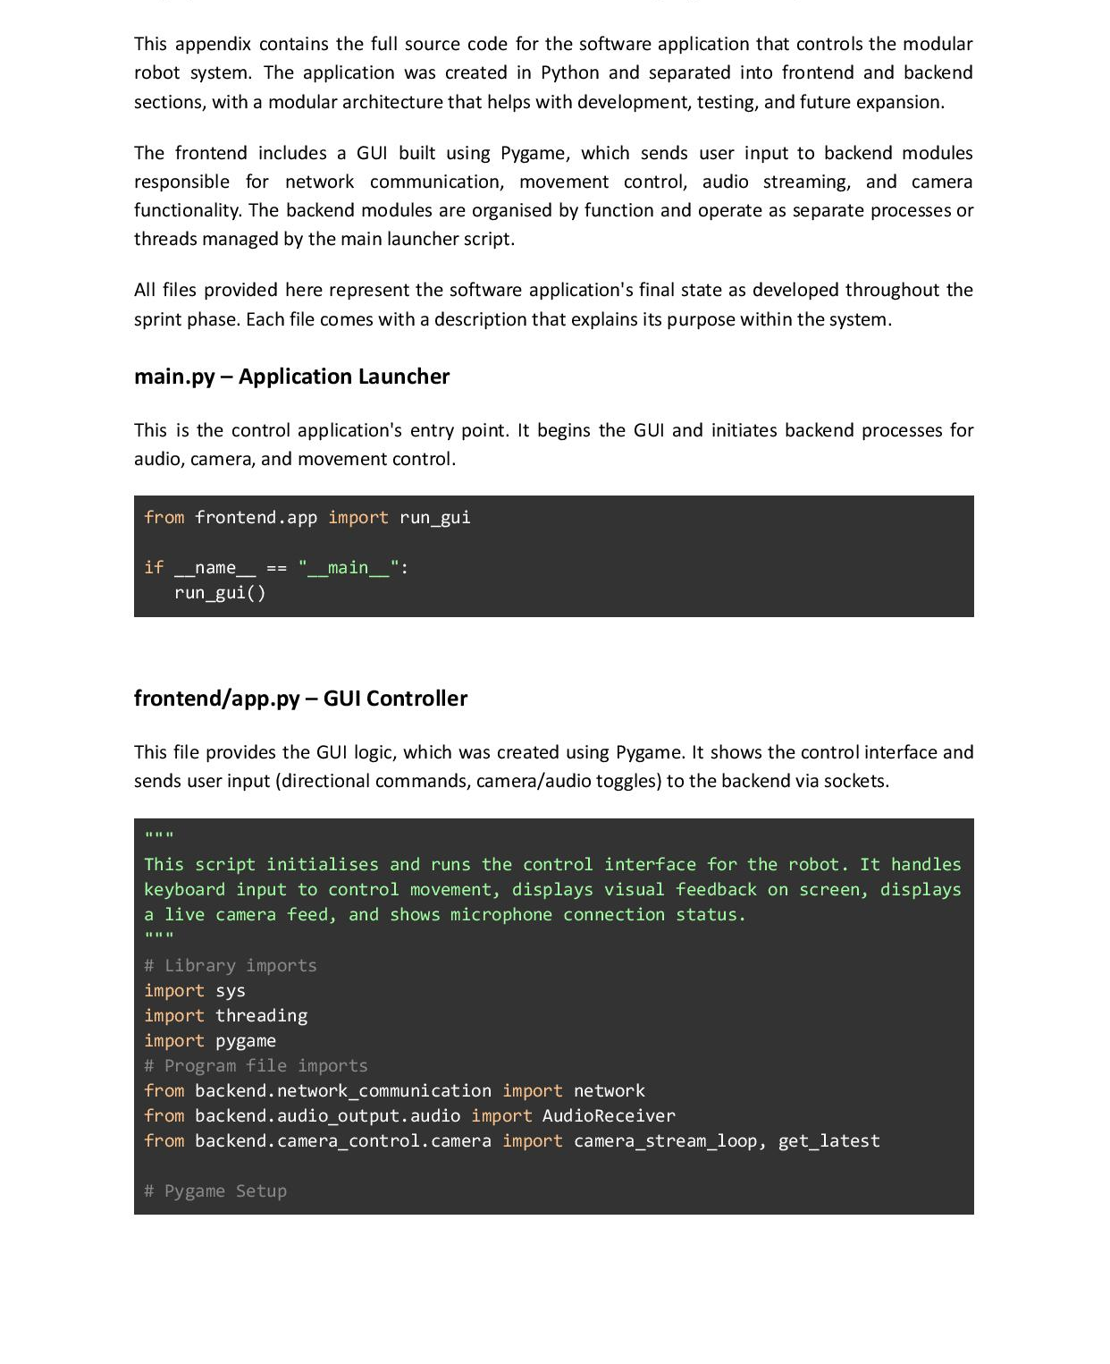
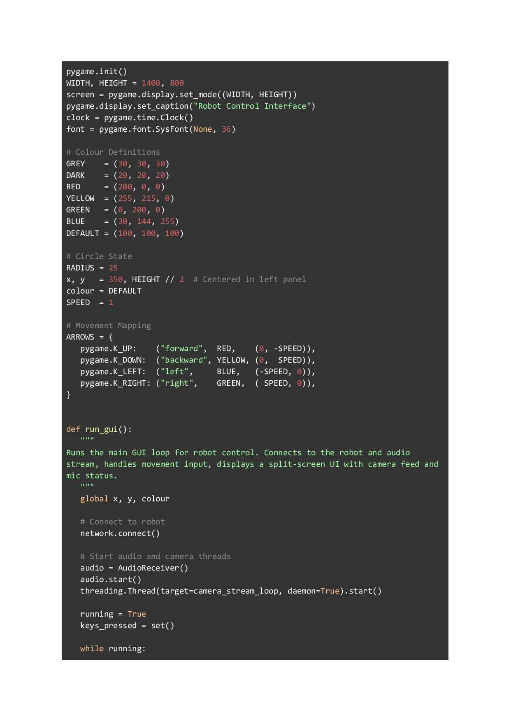
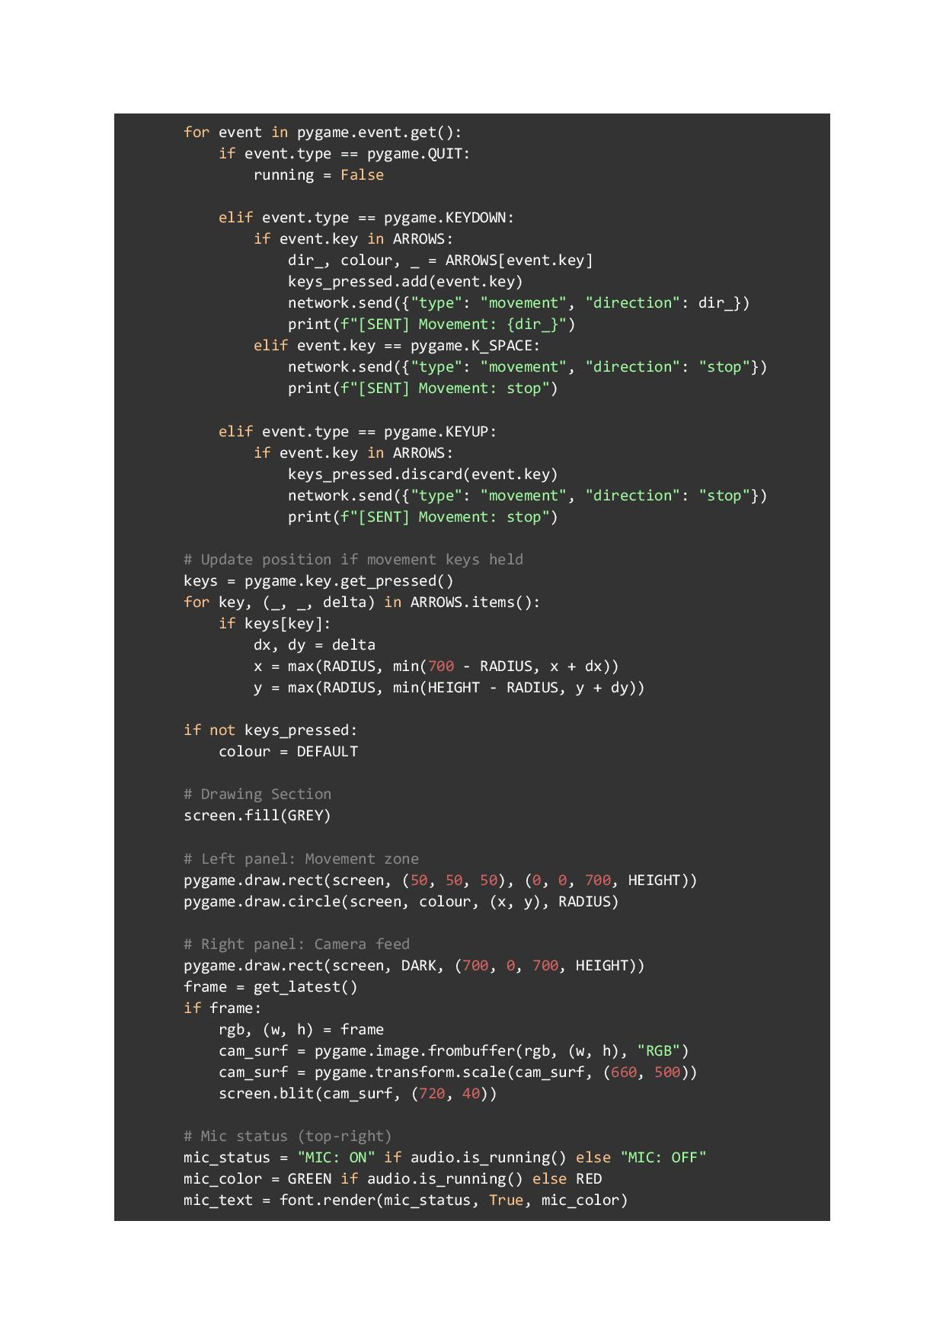
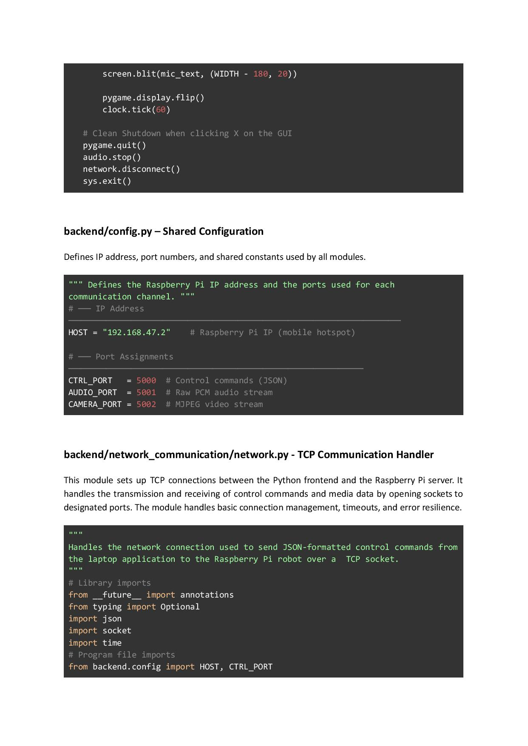
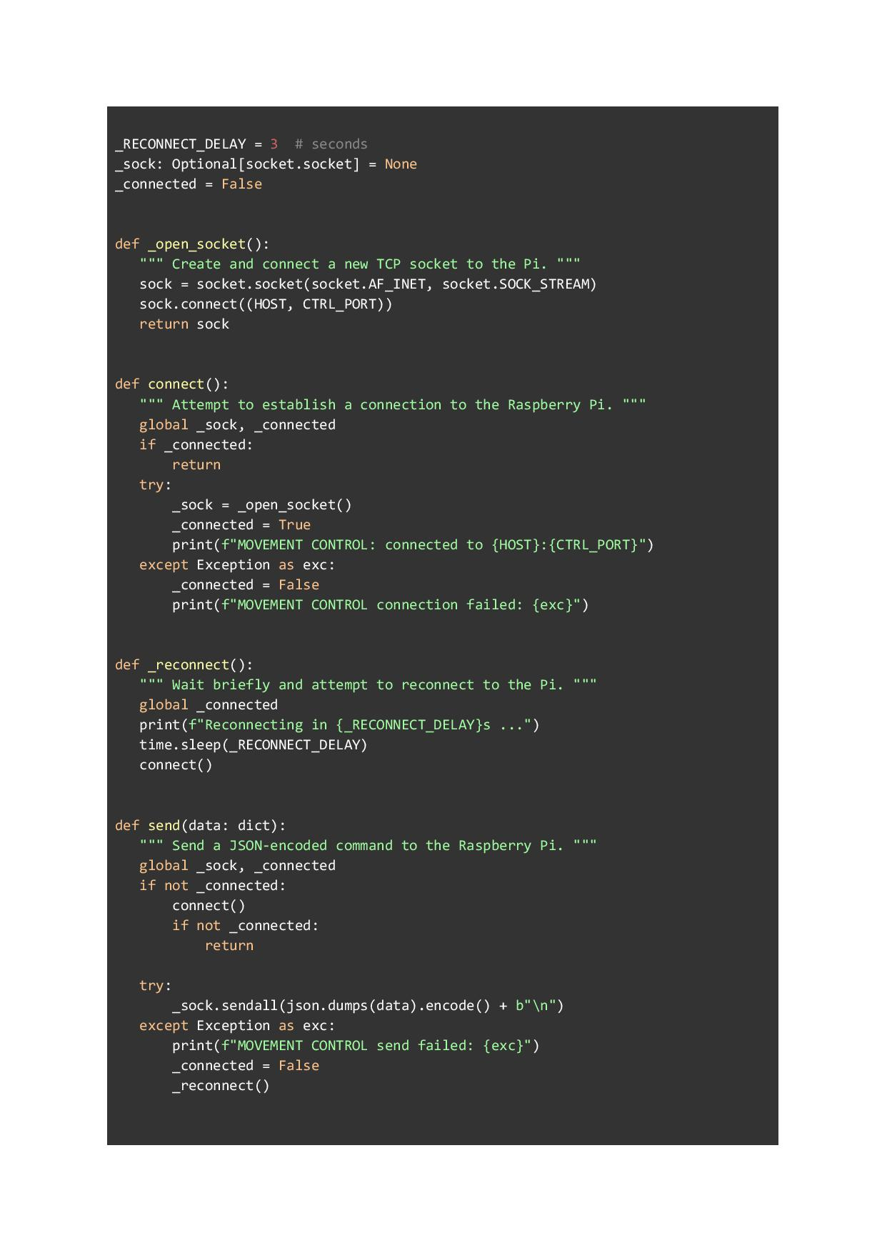
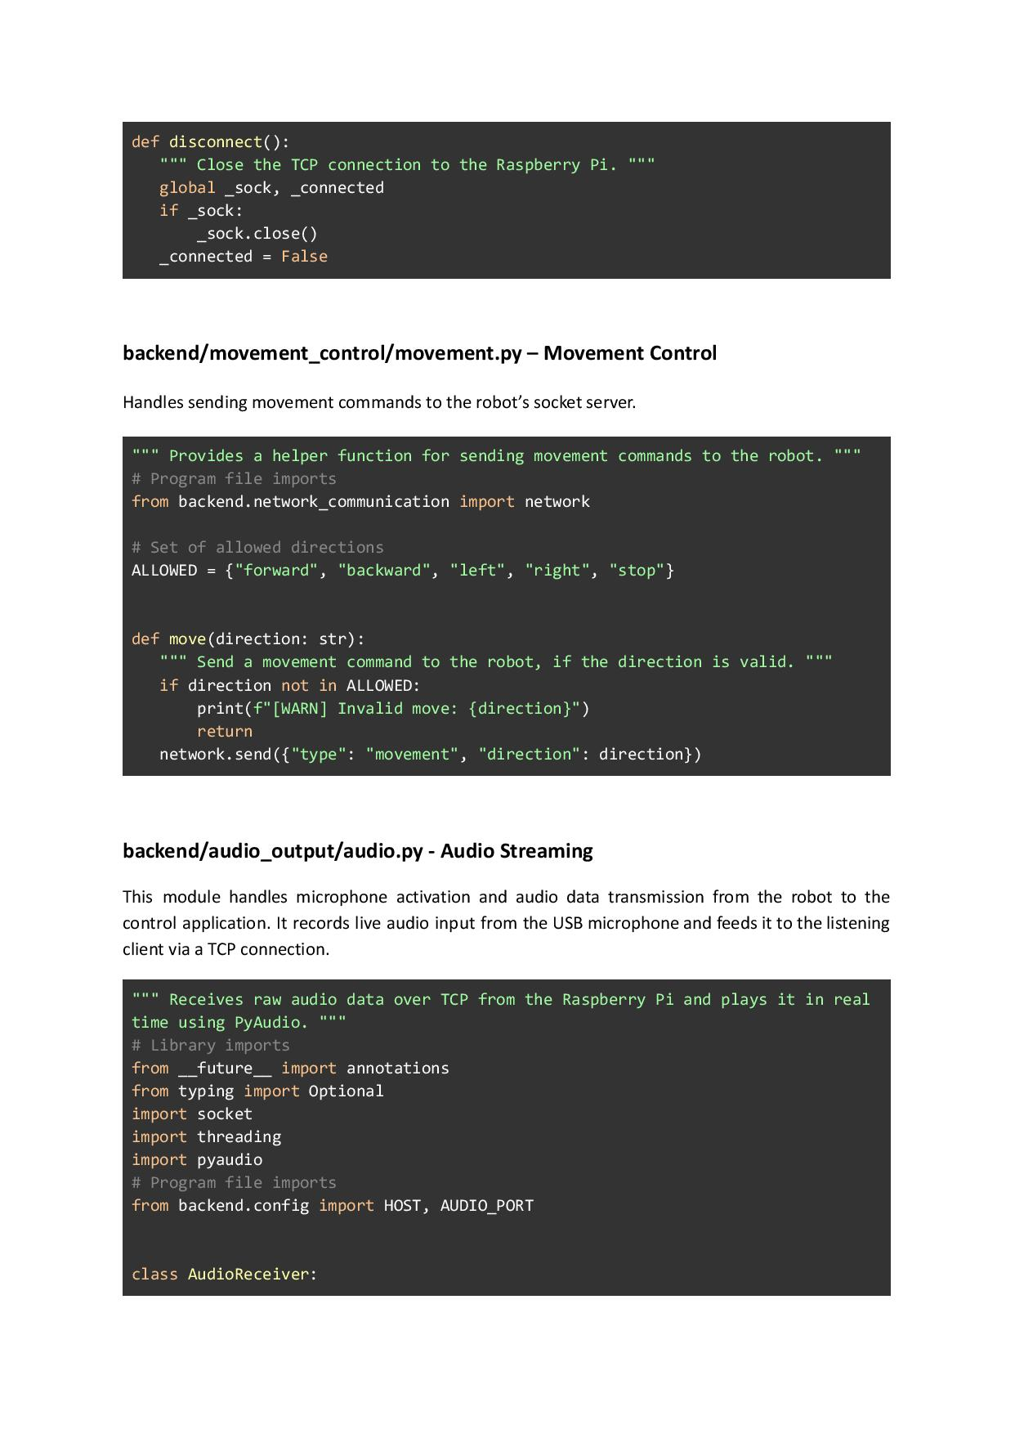
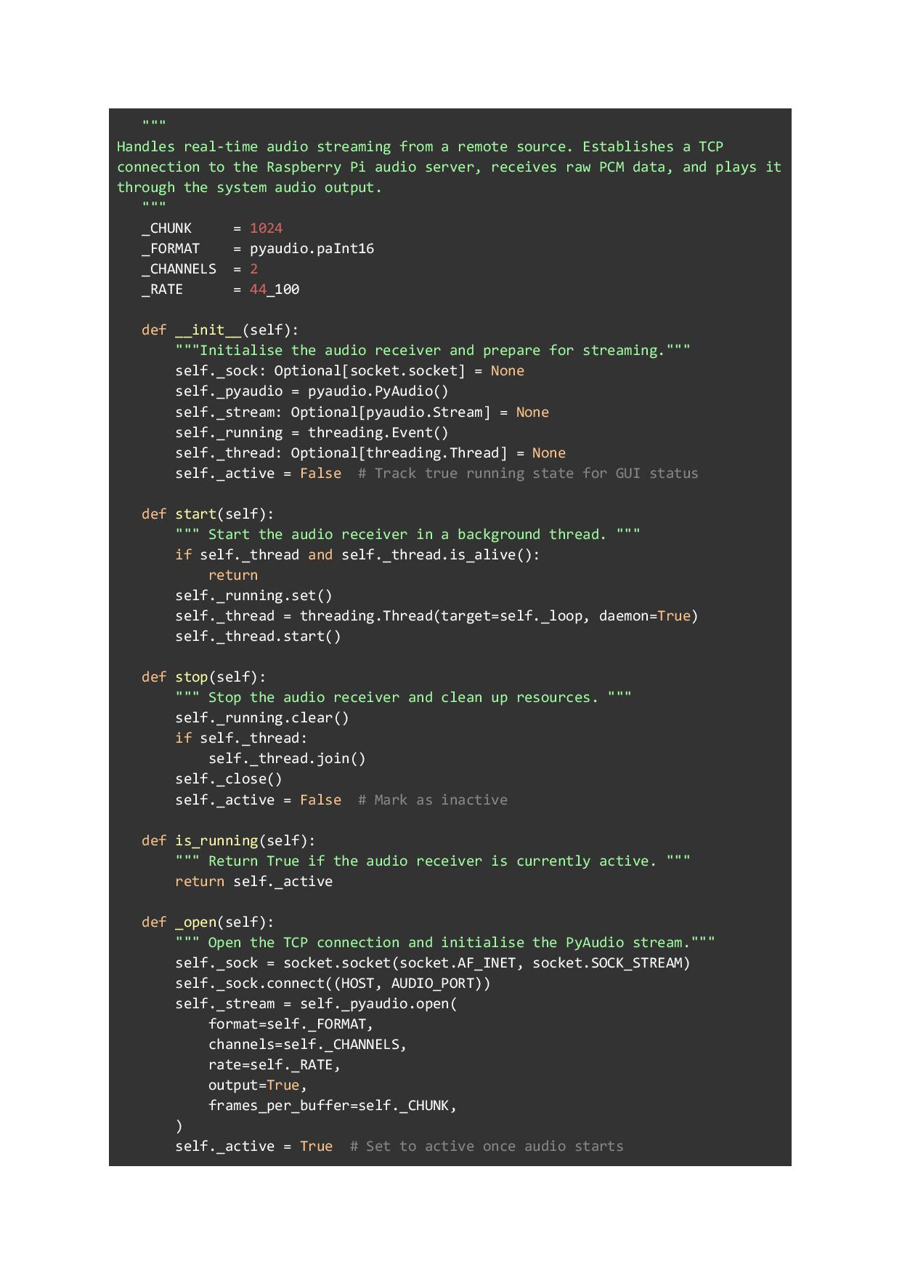
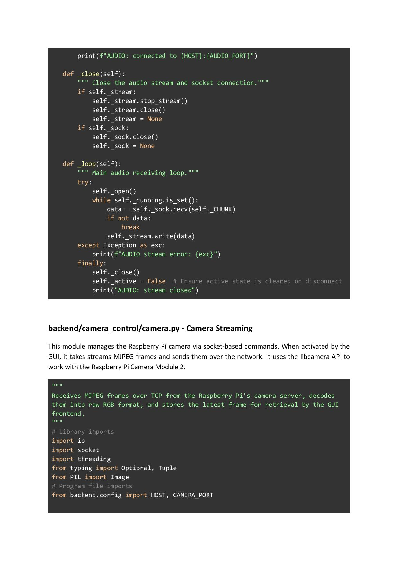
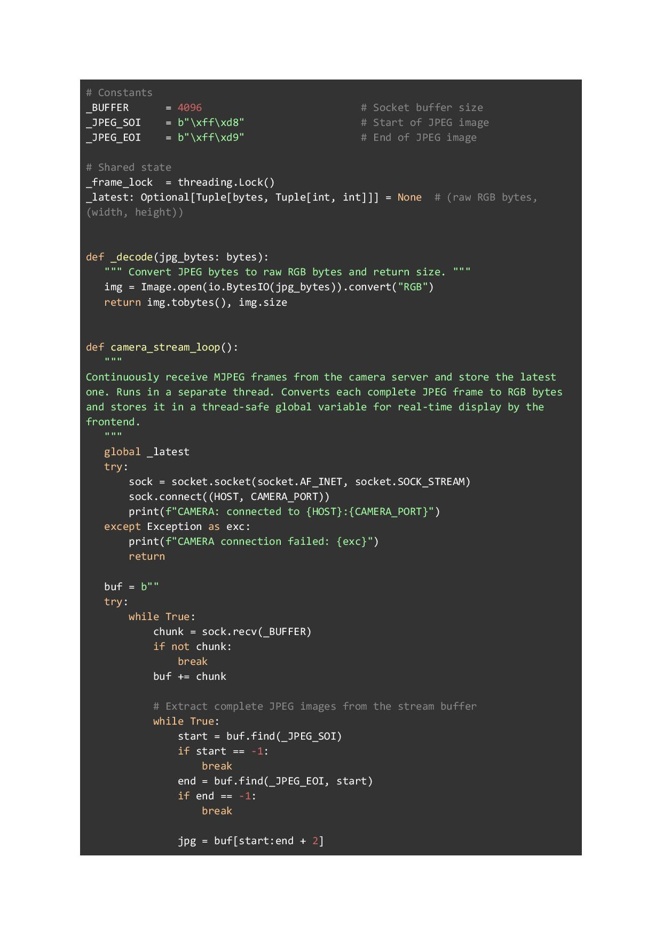
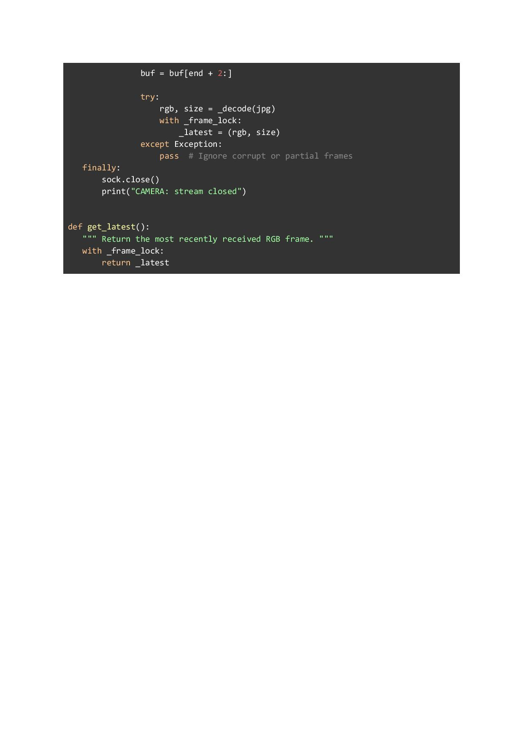

Appendix H – Raspberry Pi Firmware Code (C/C++)
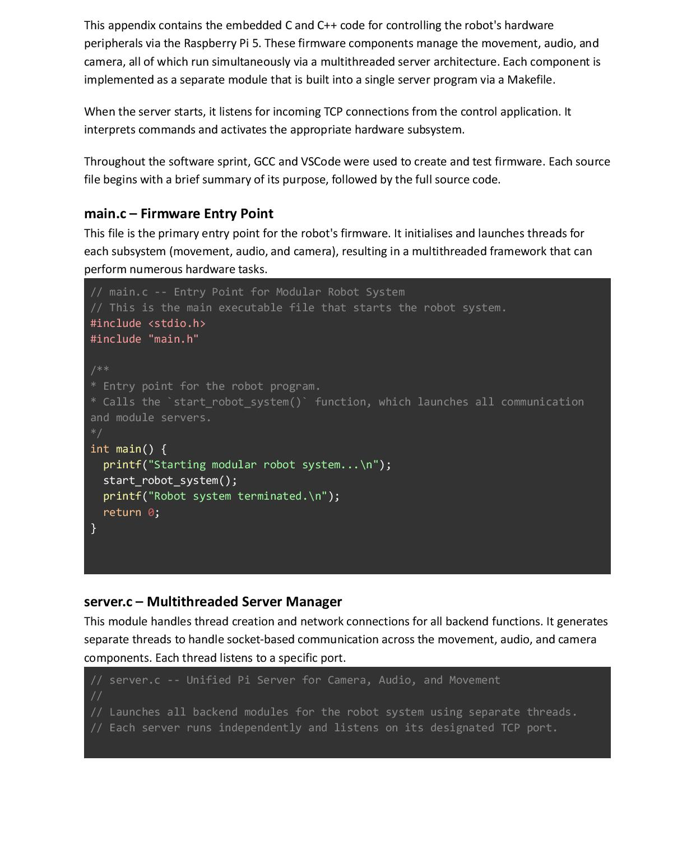
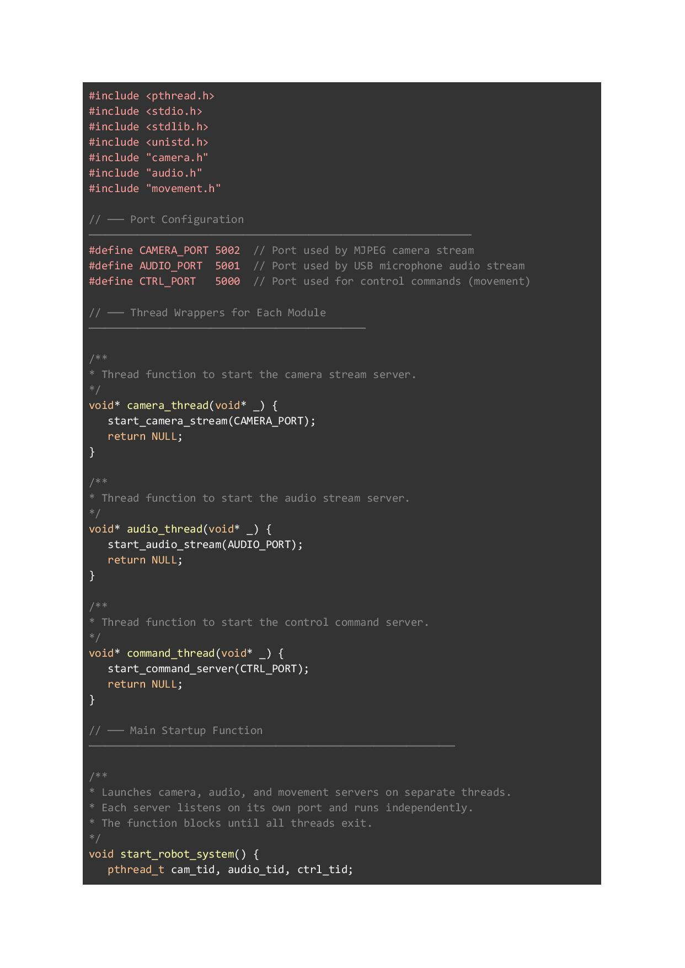
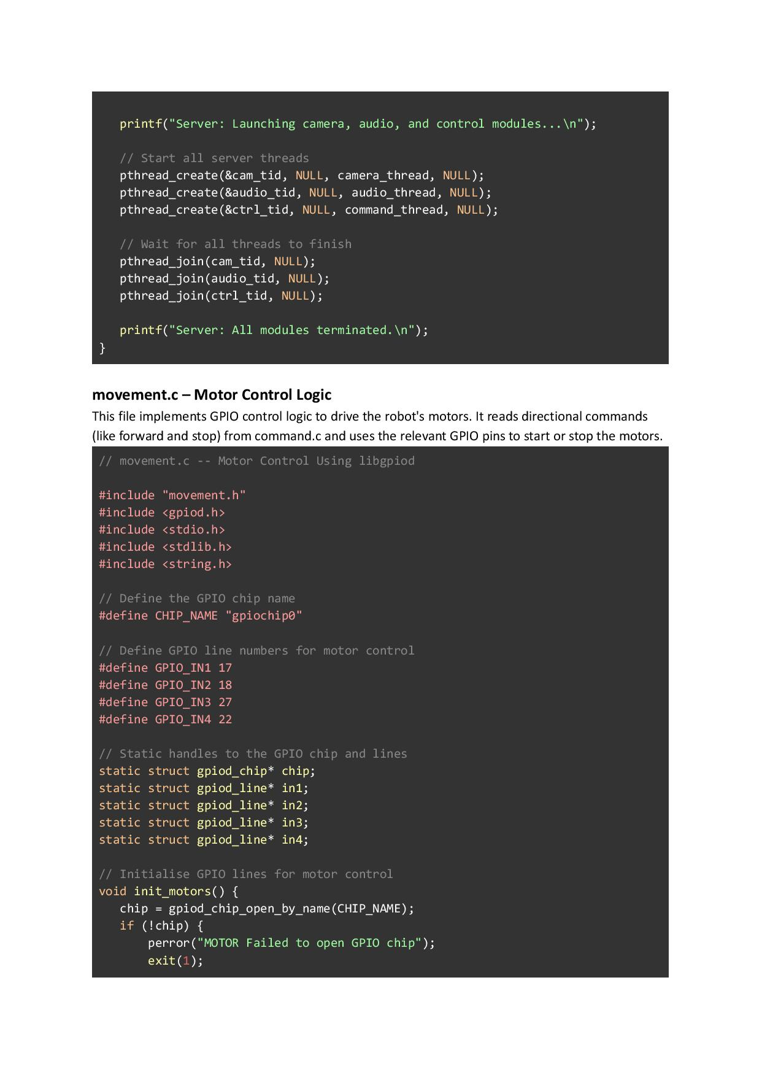
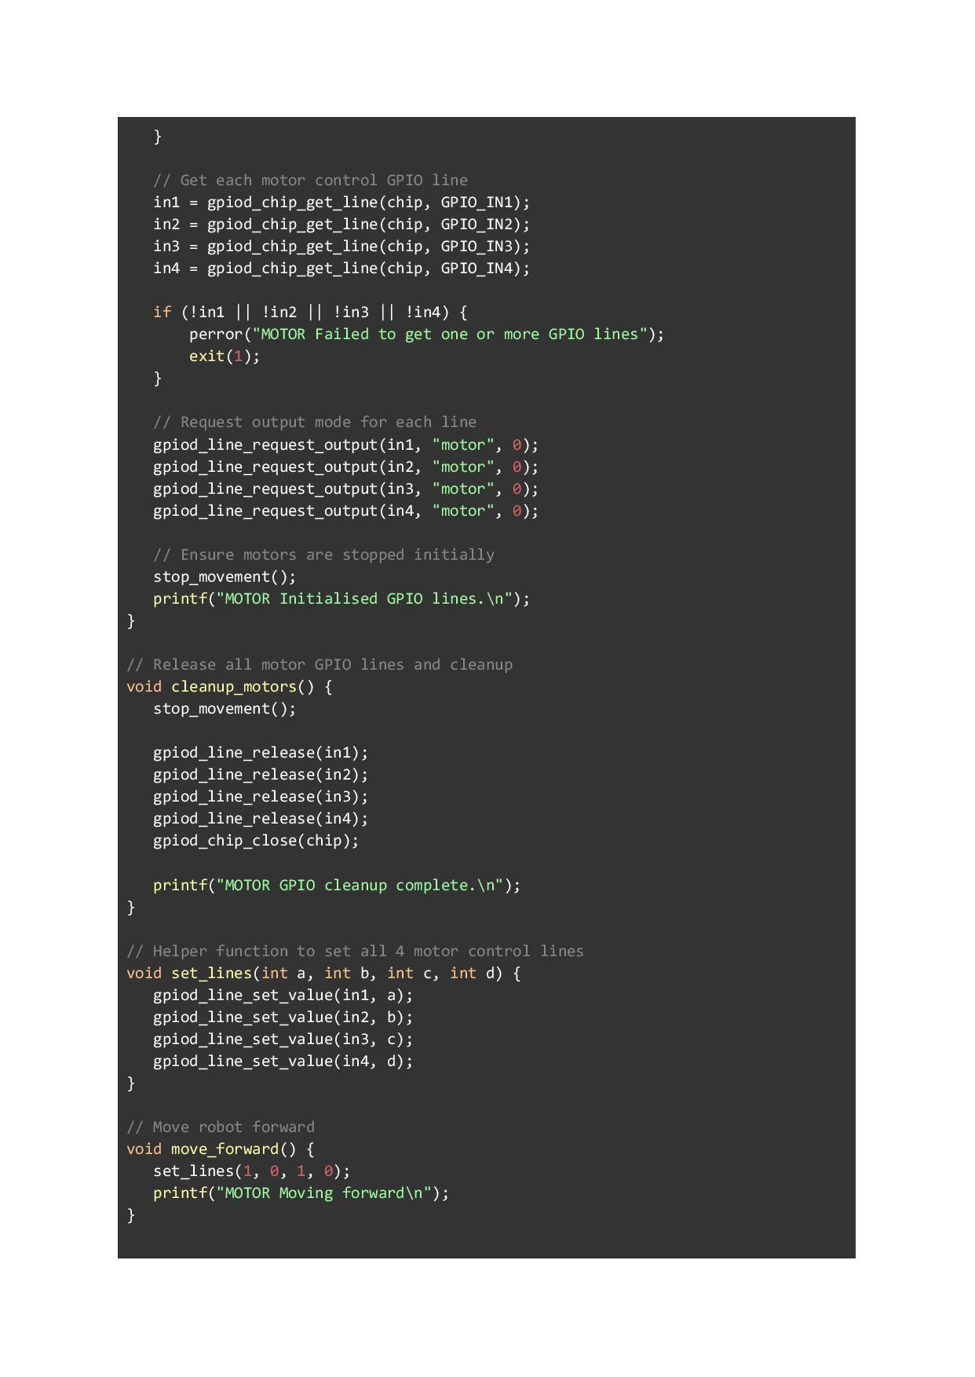
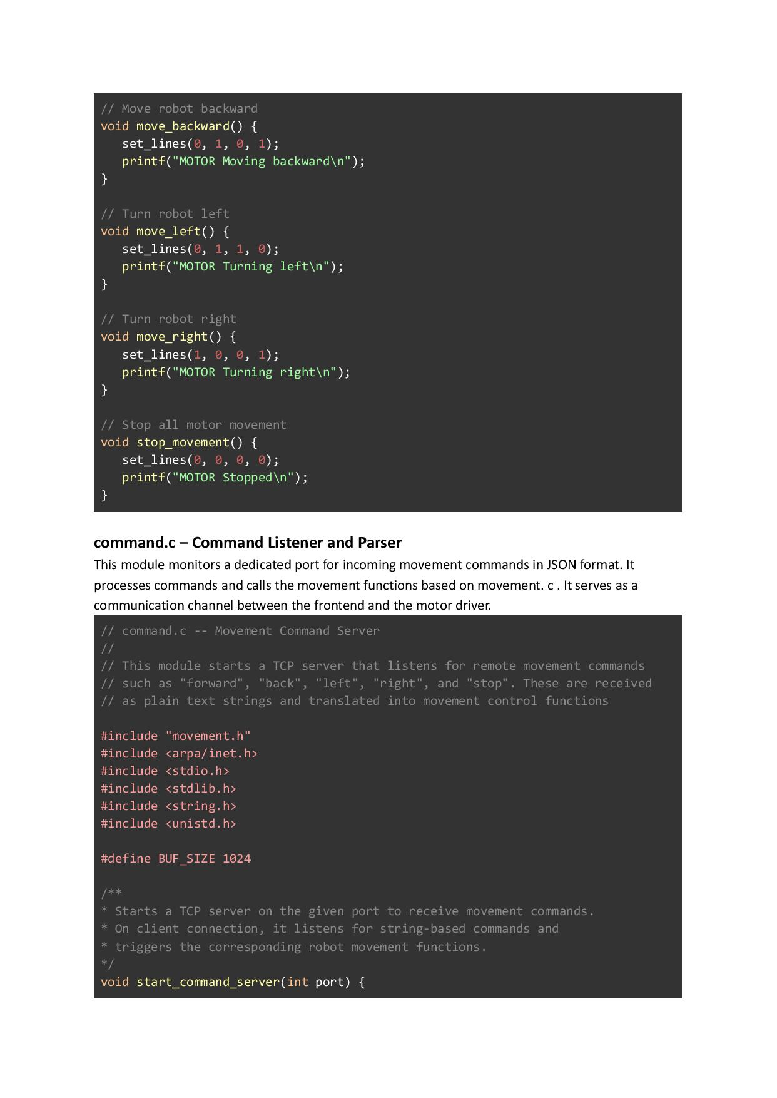
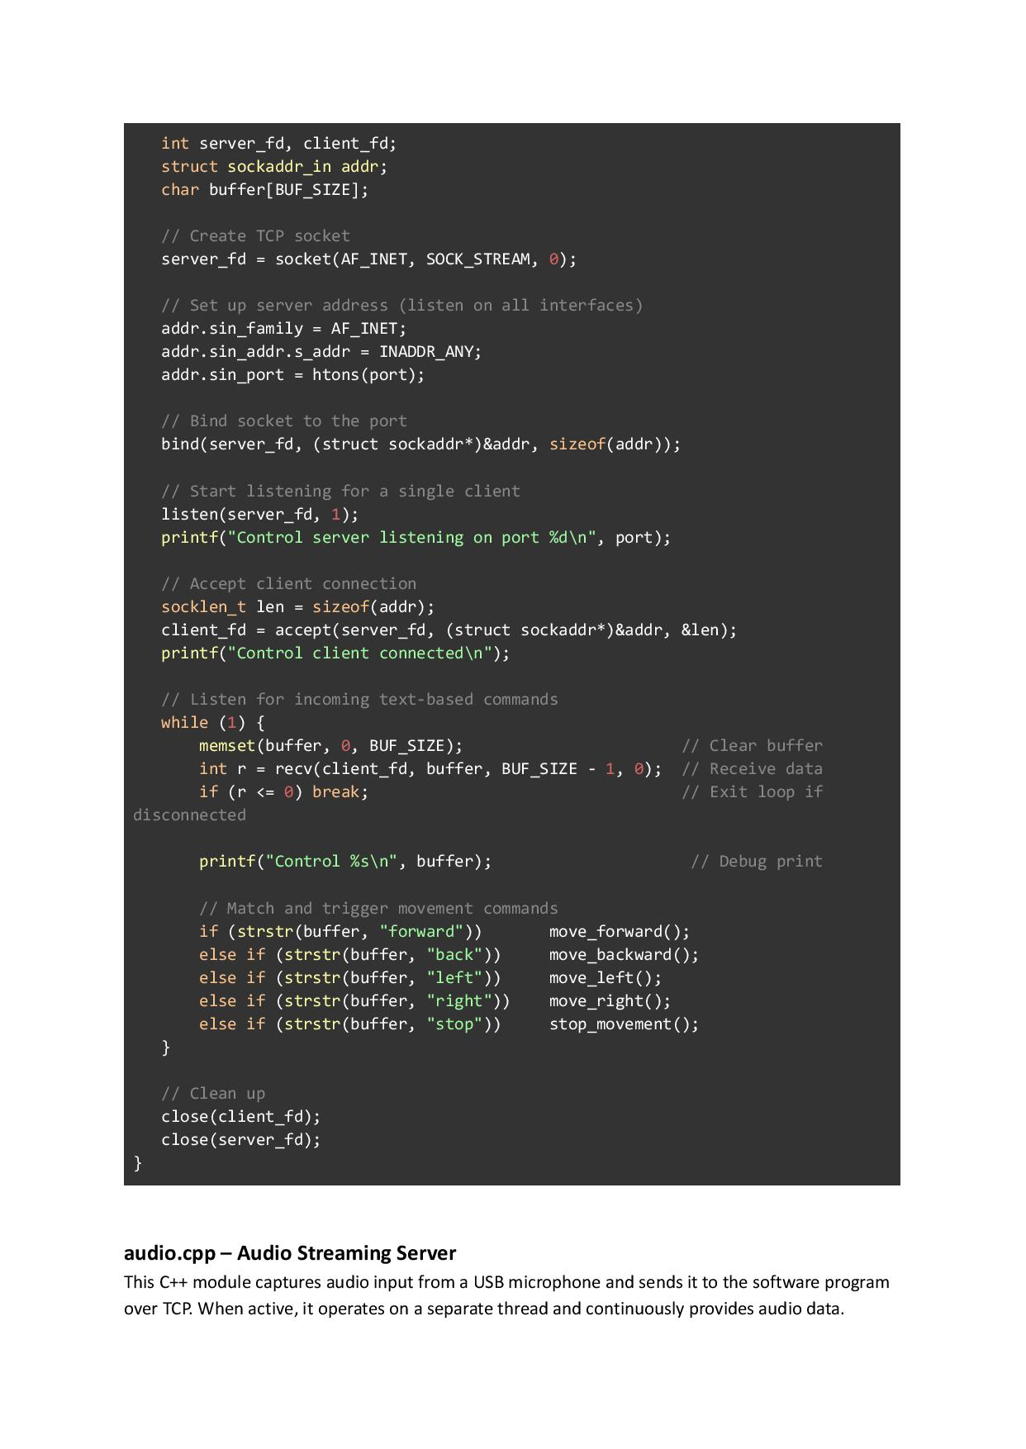
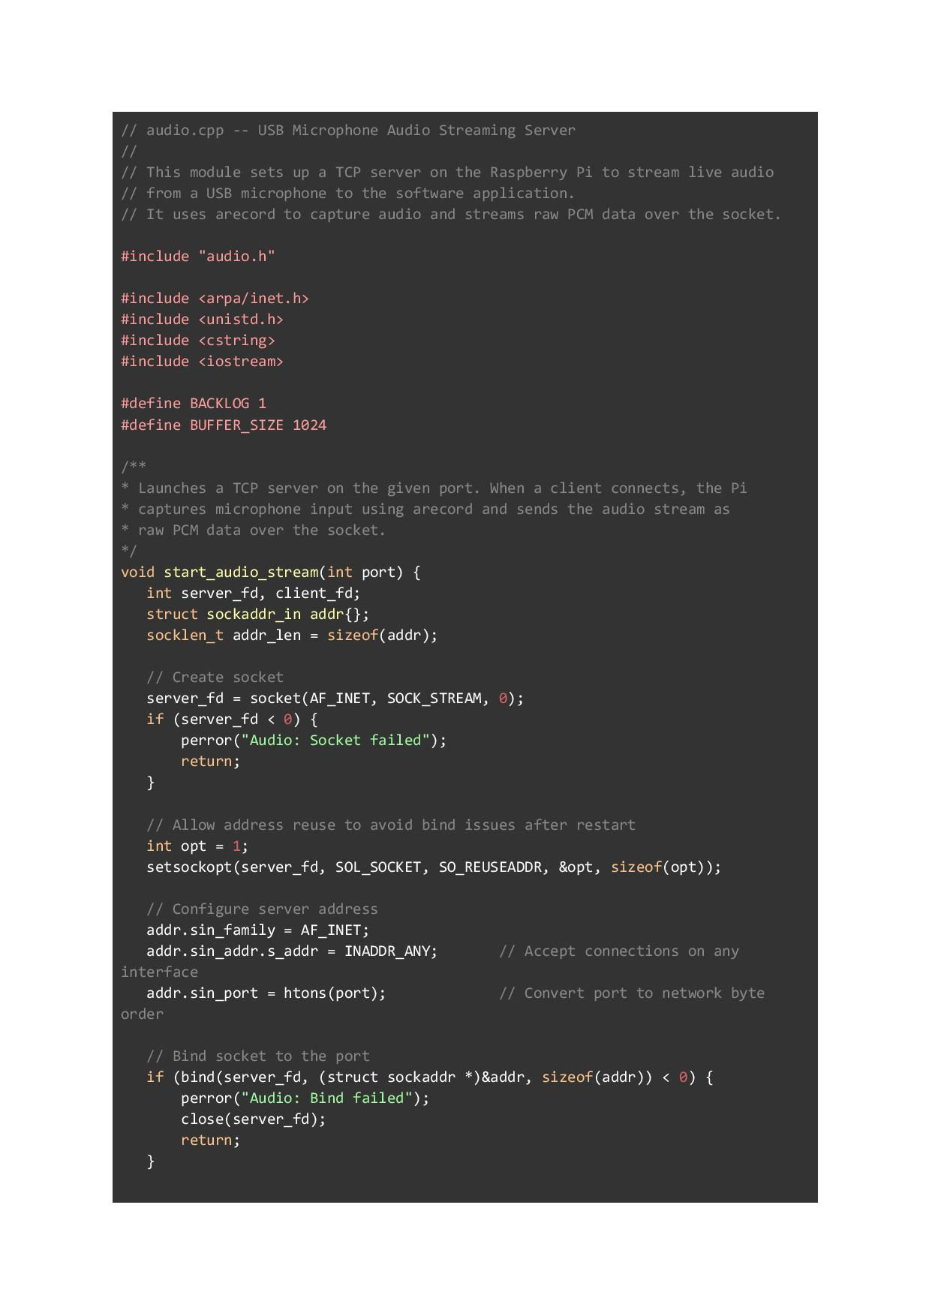
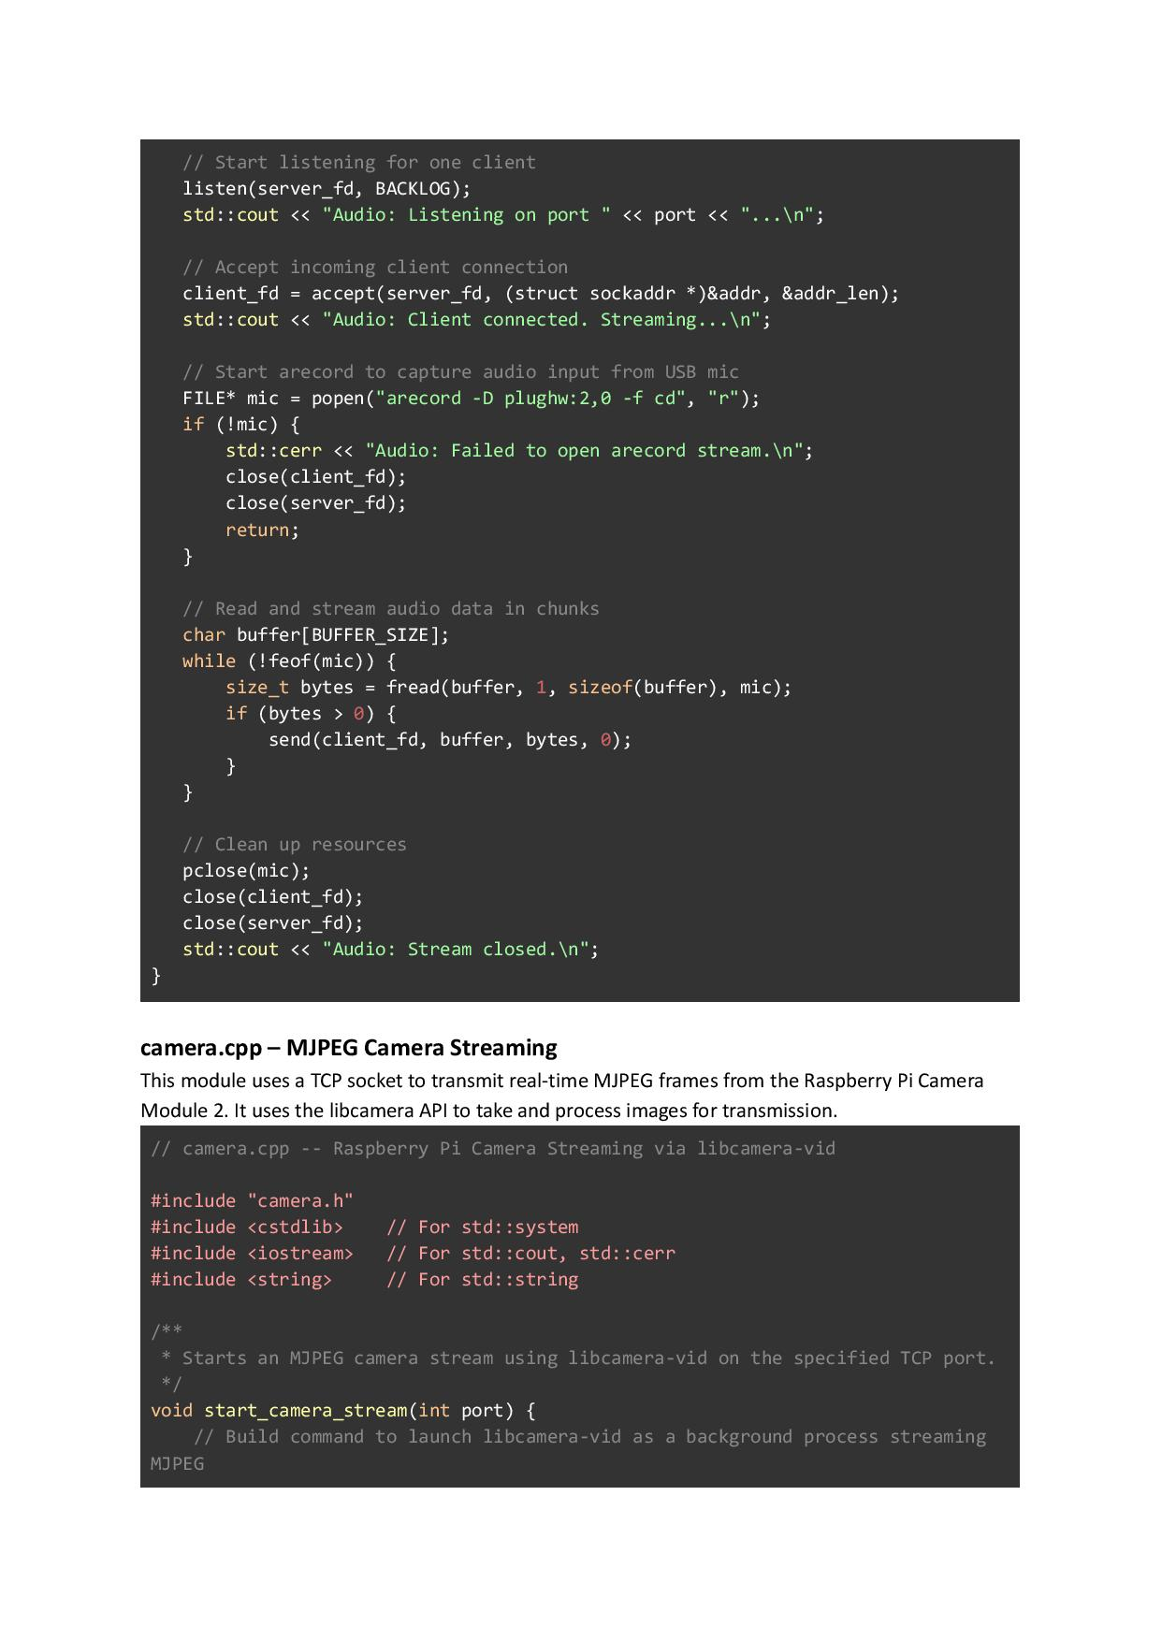
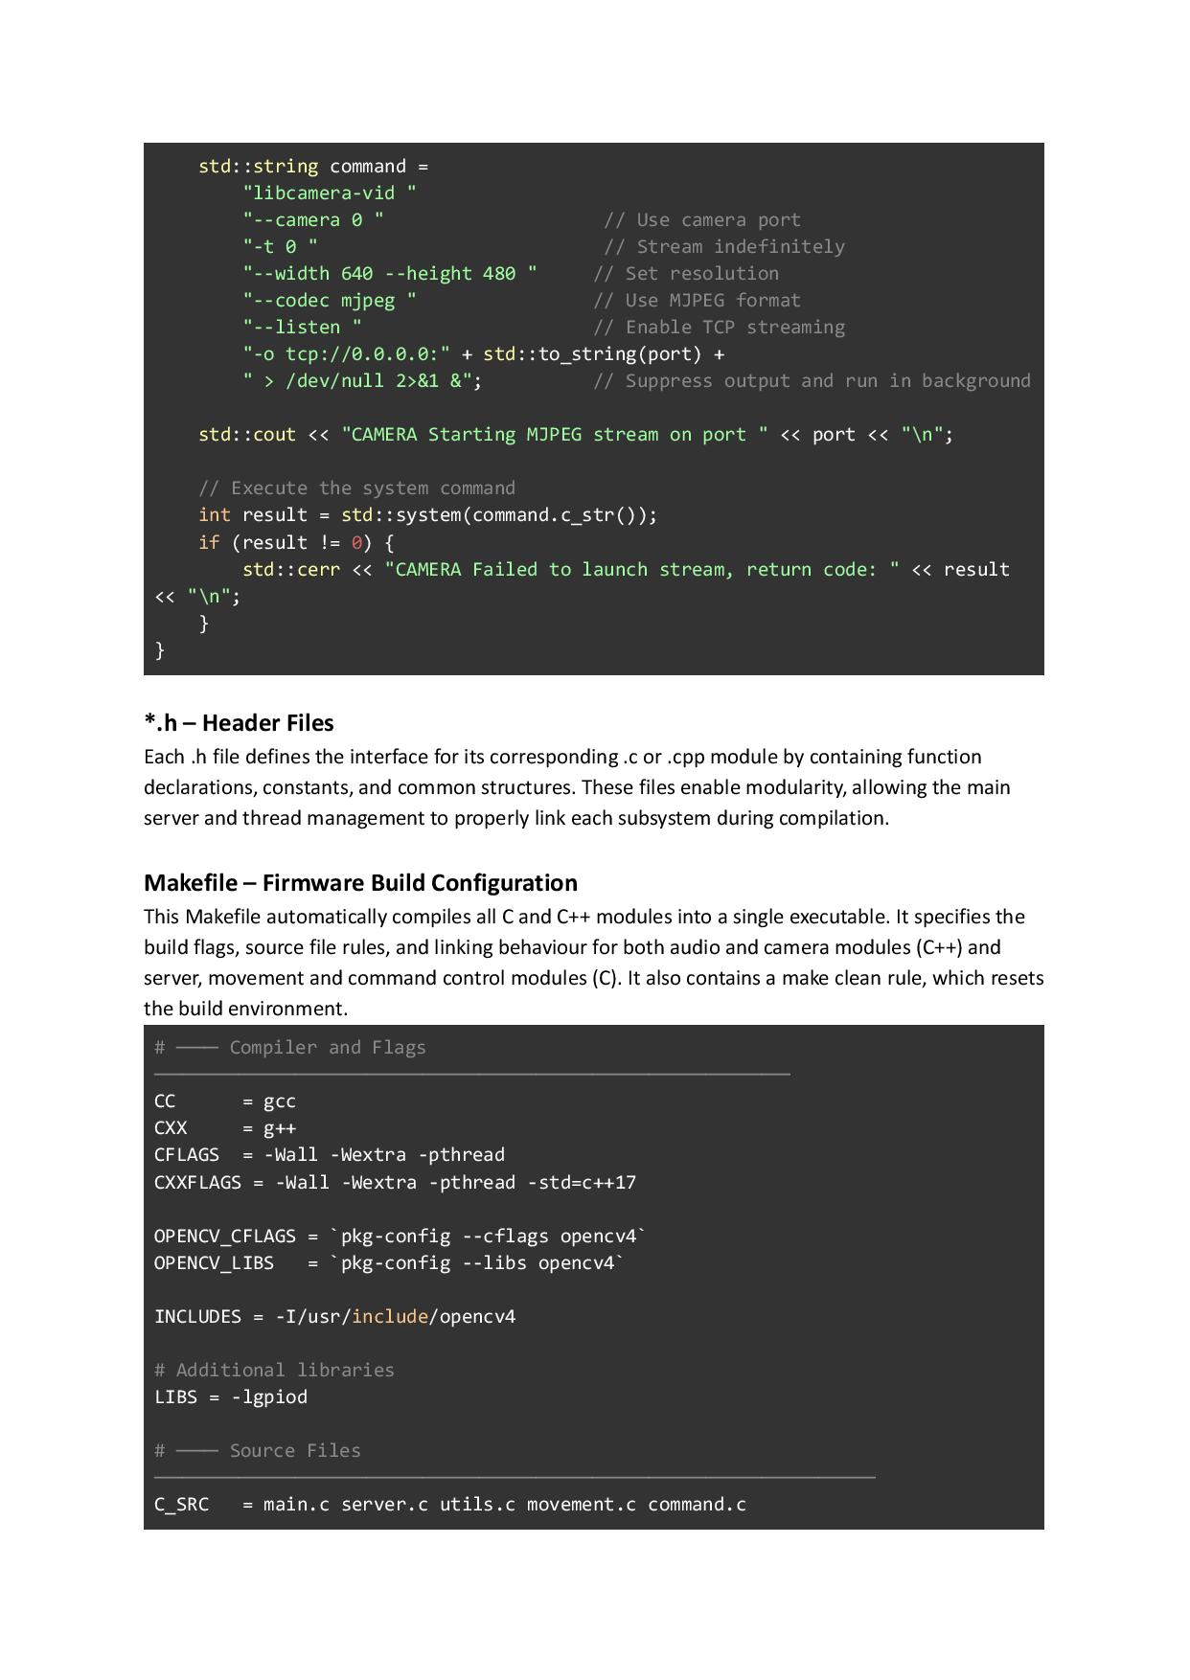
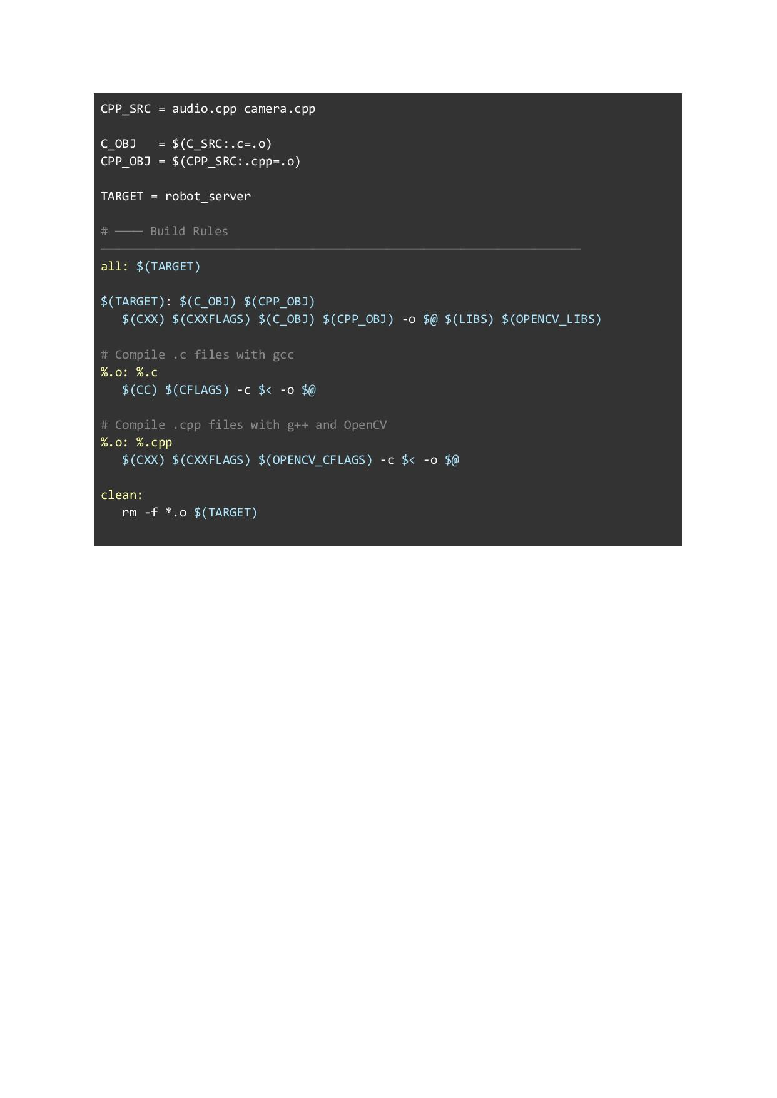

Appendix I – Unit Testing Code (Python)
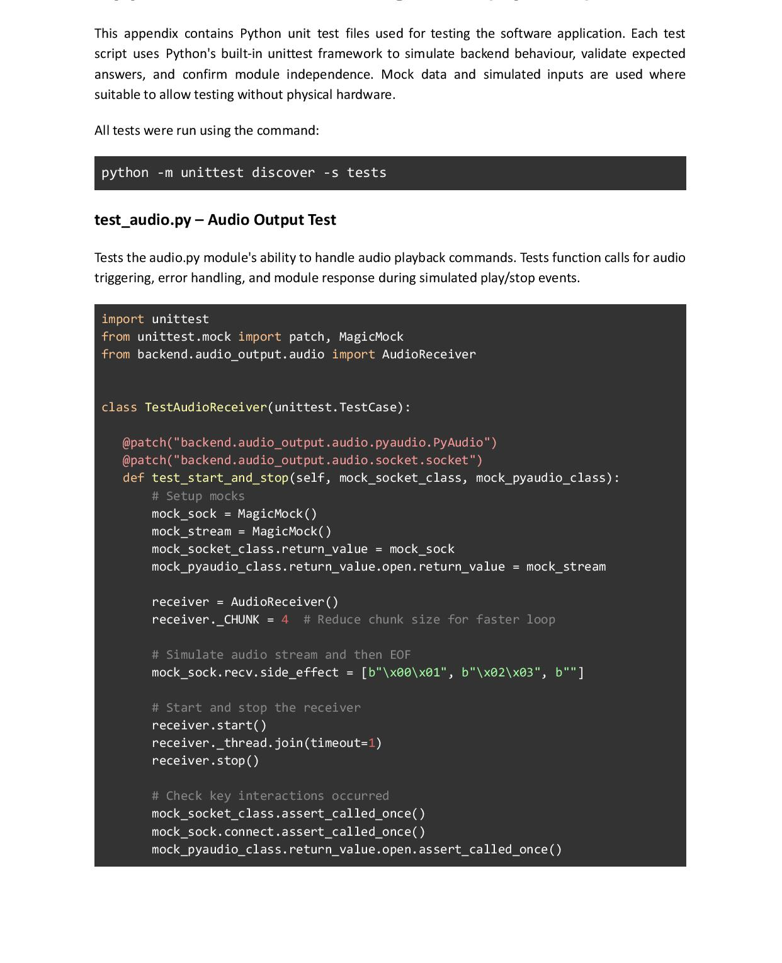

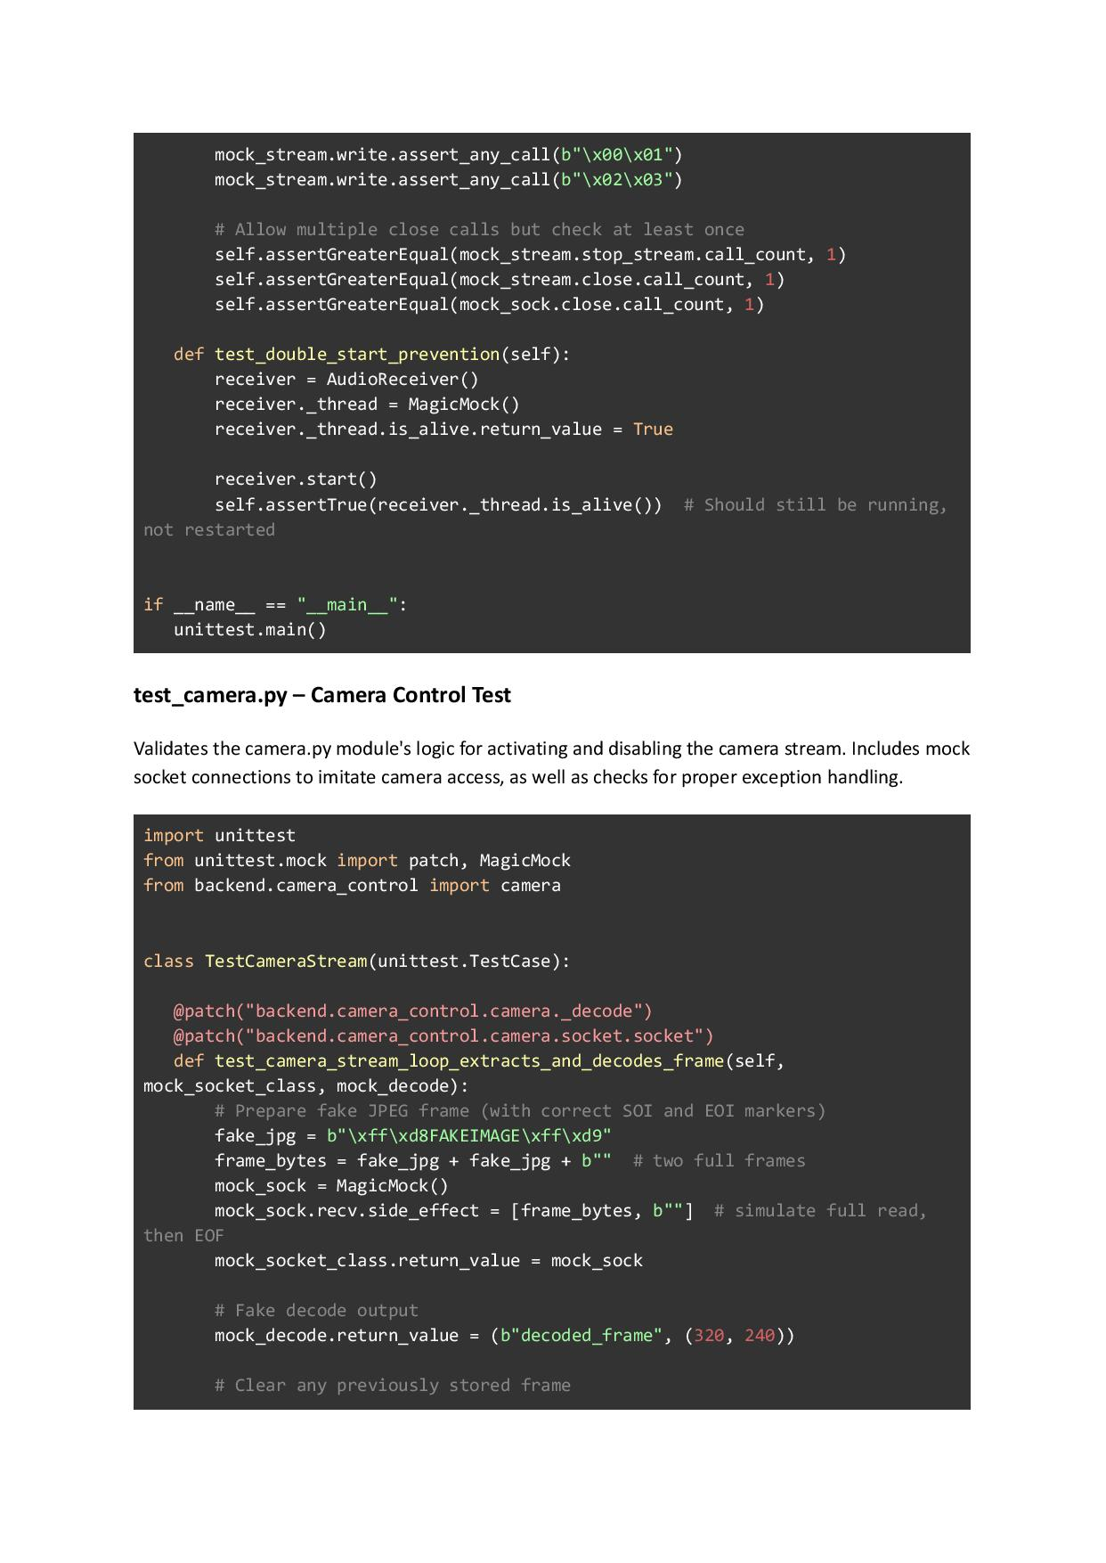
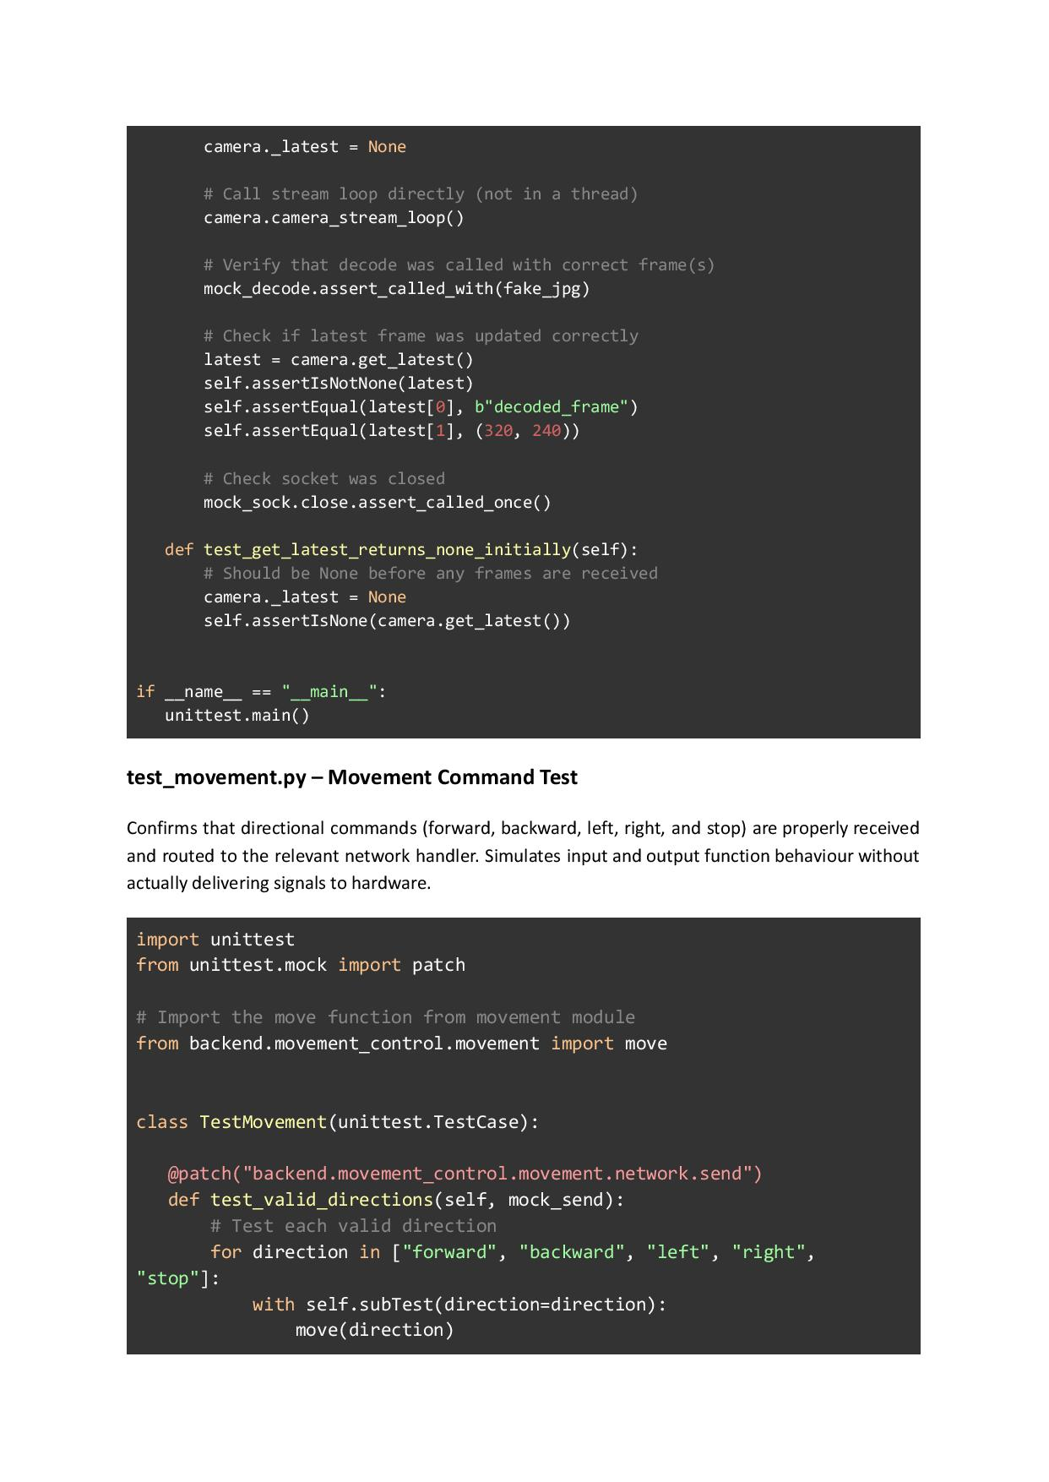
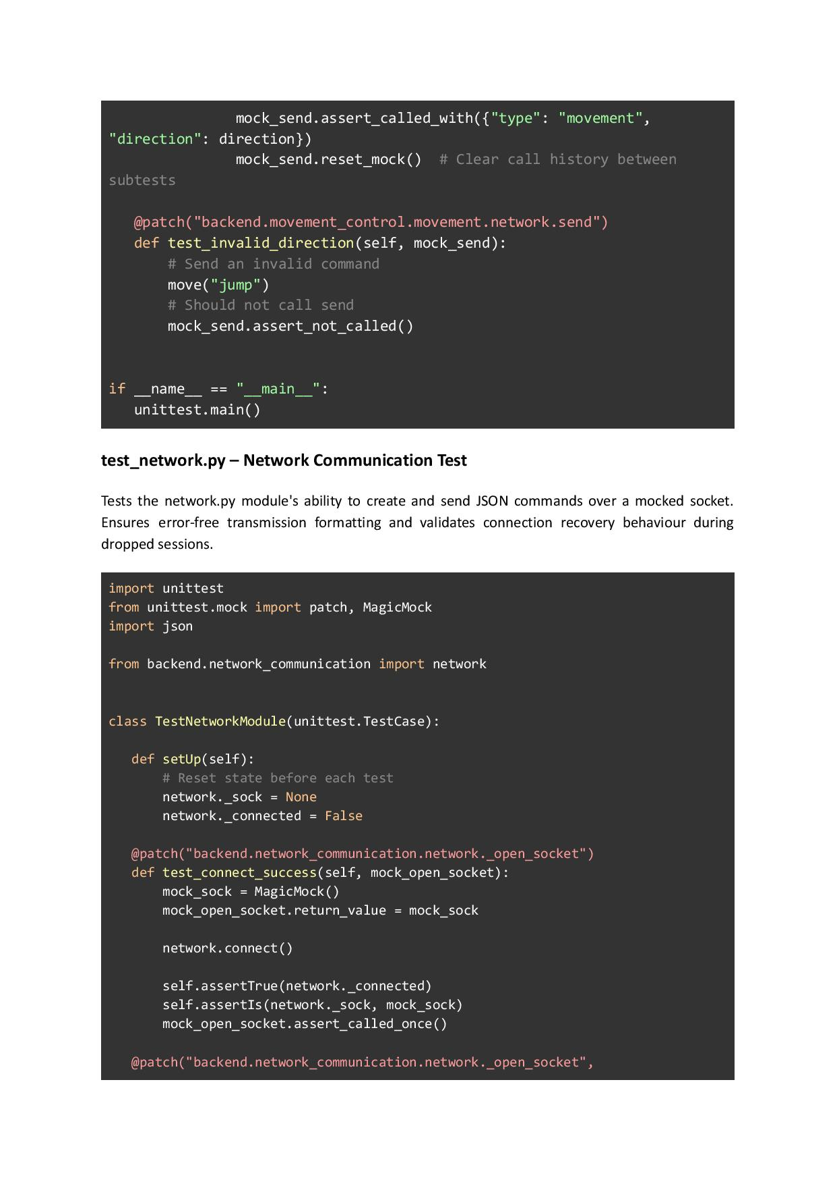
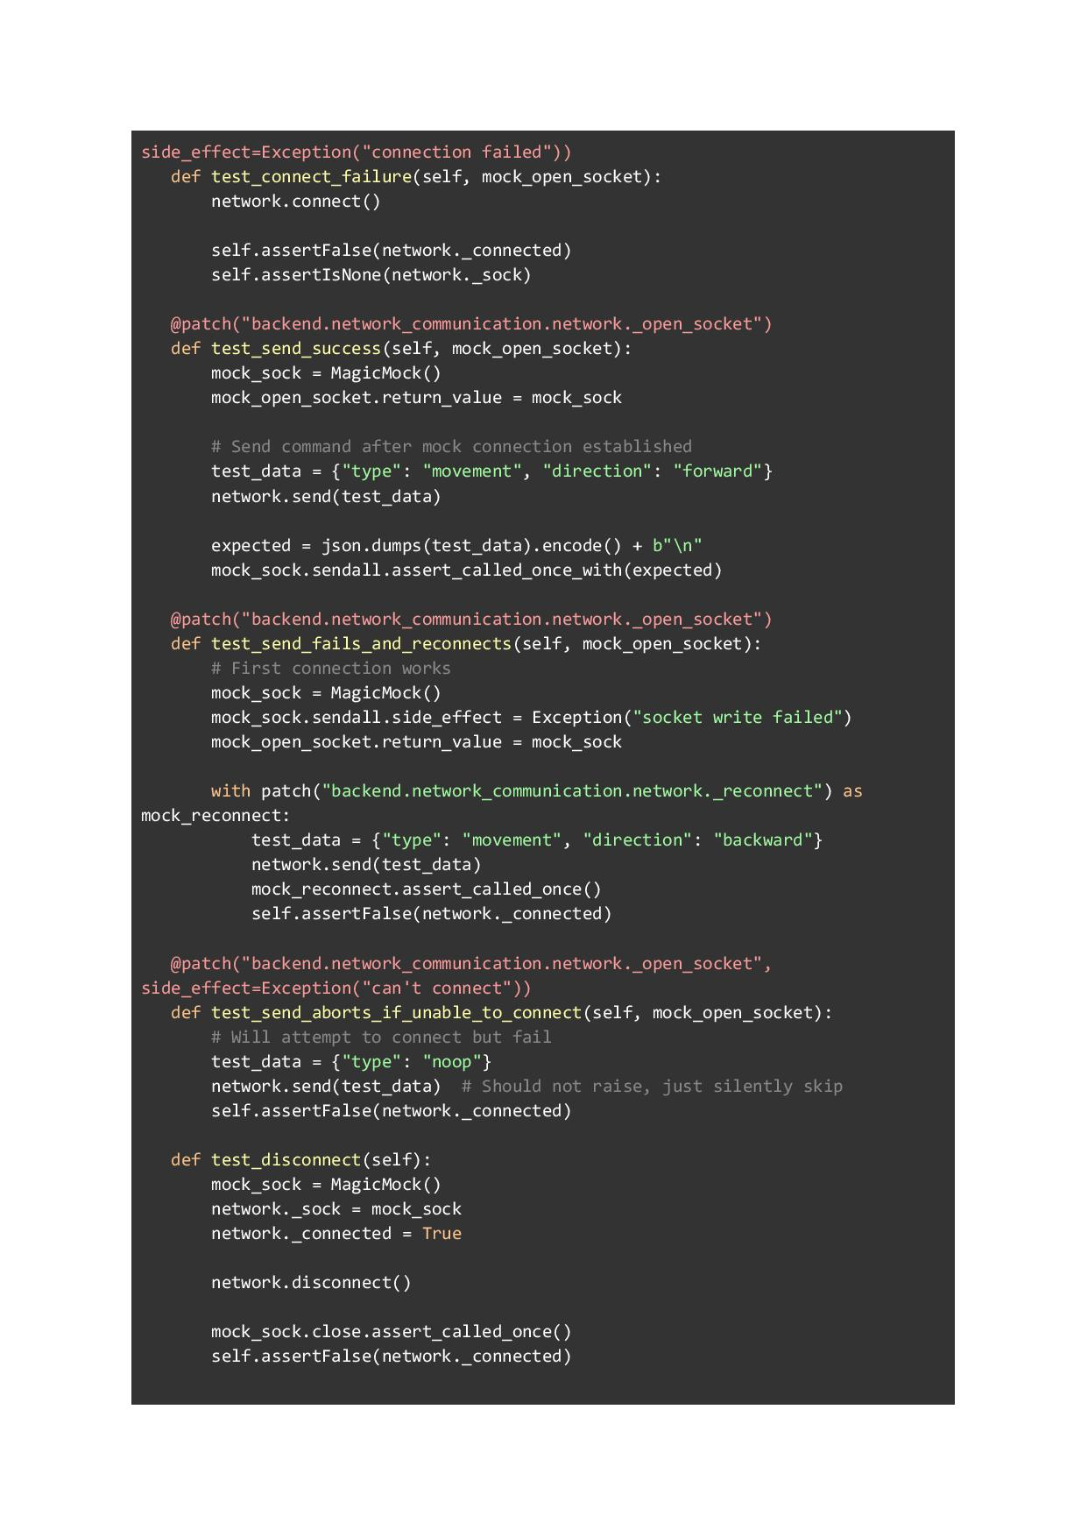
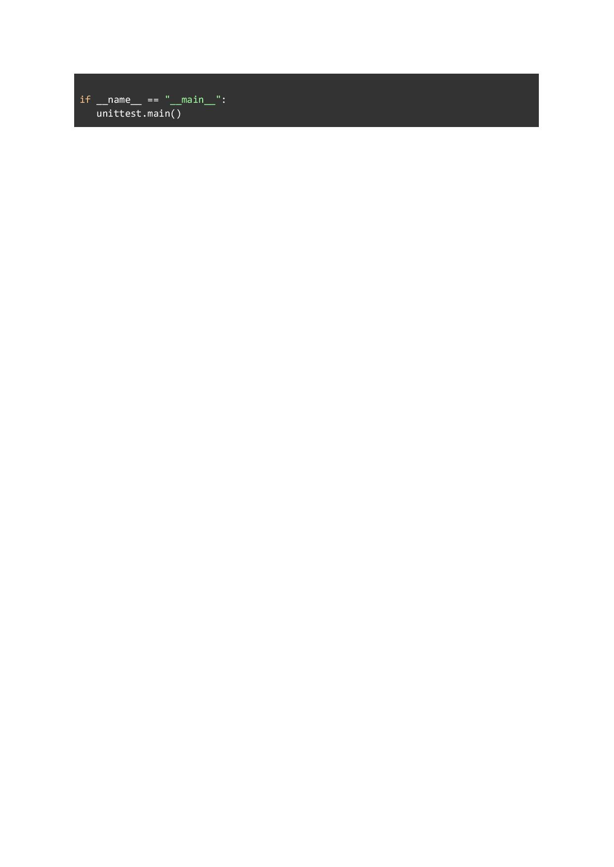

Appendix J – Transmitter Mini Project
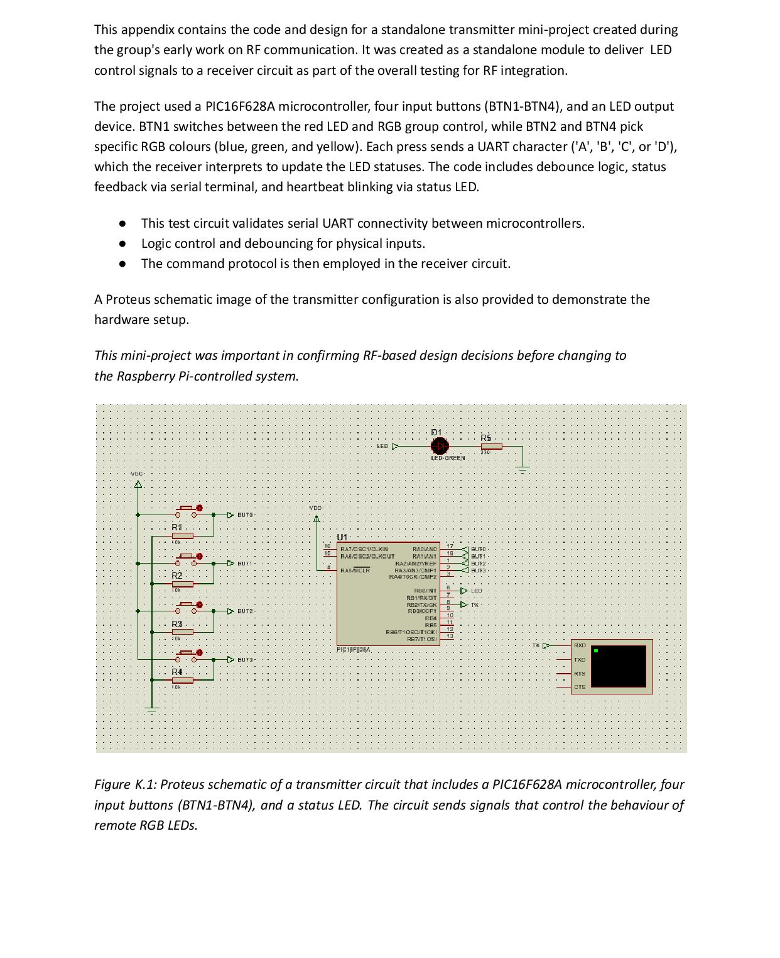
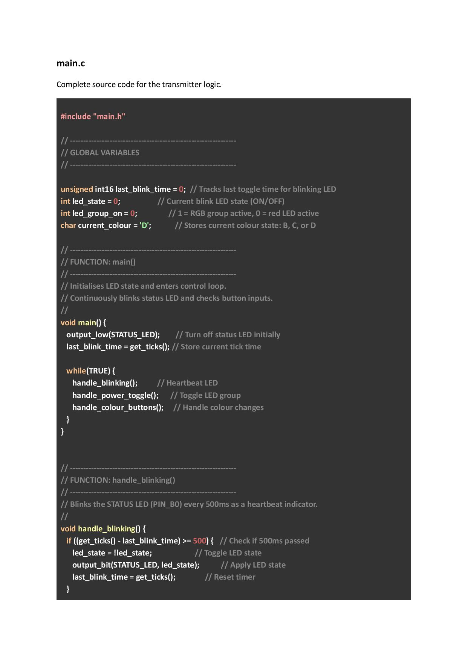
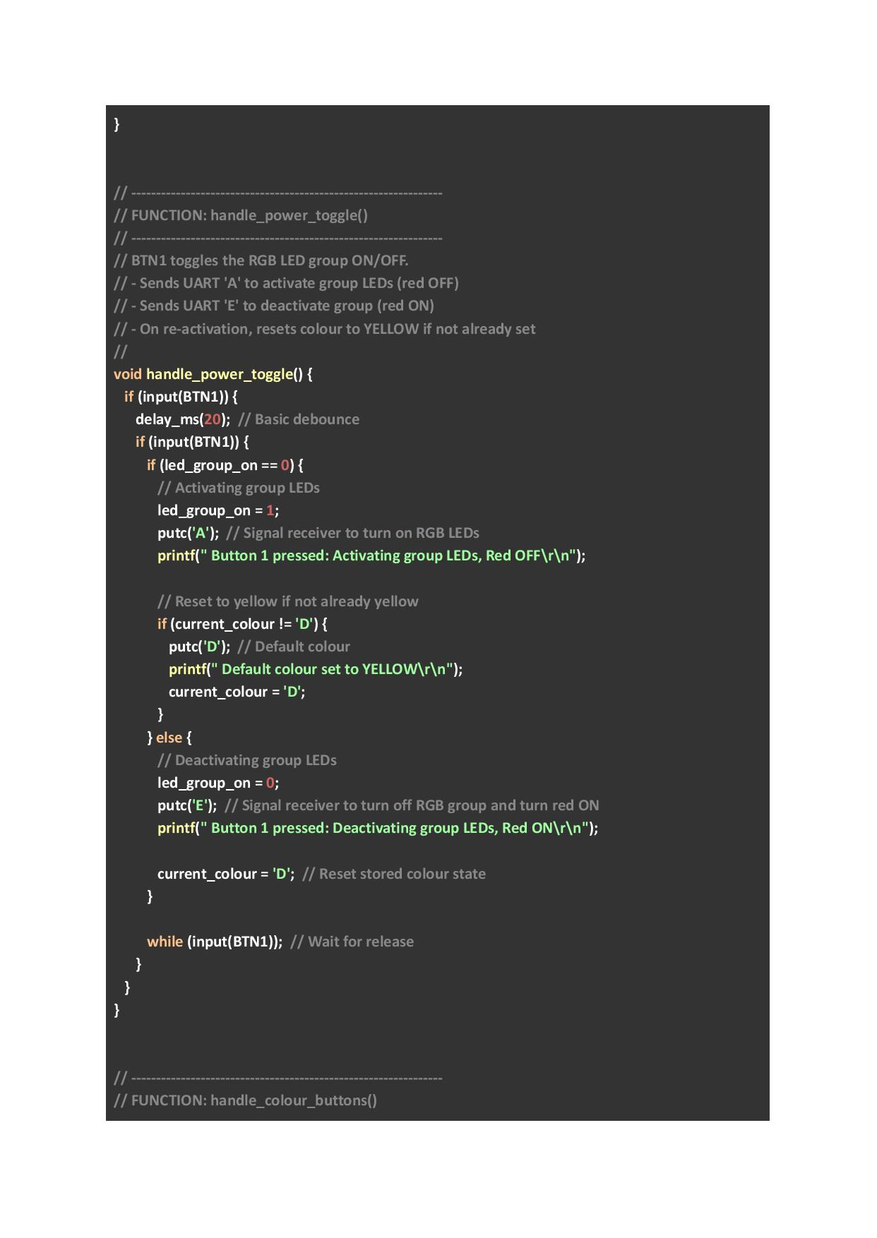
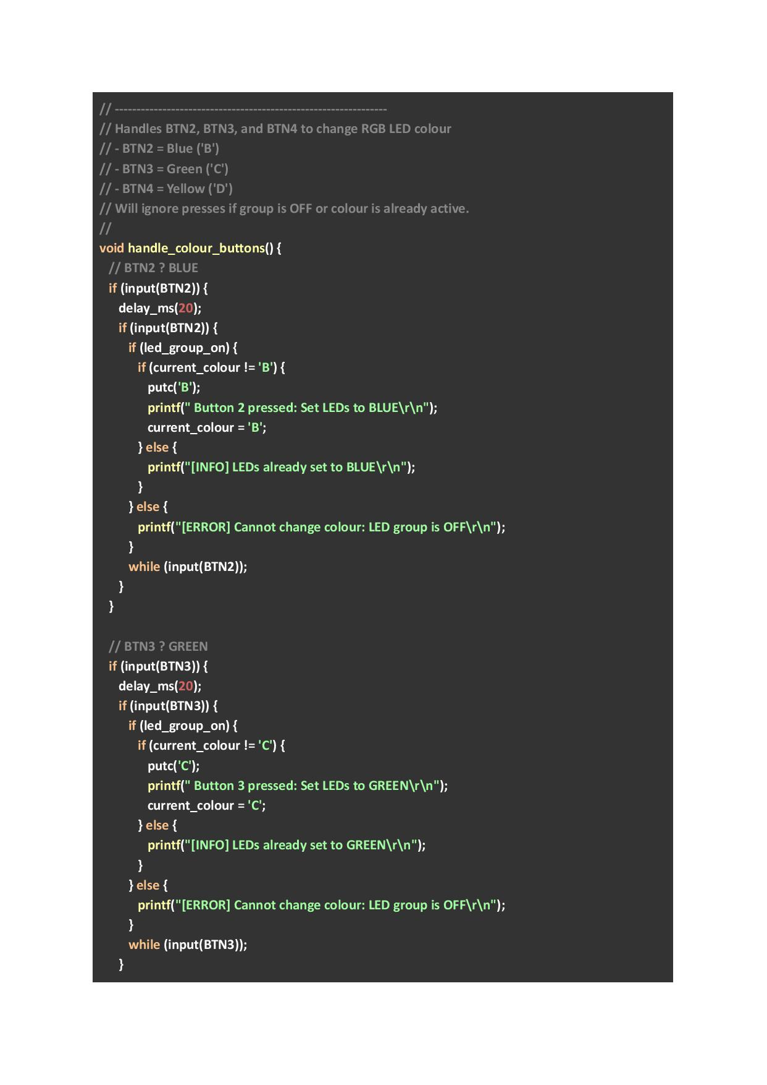
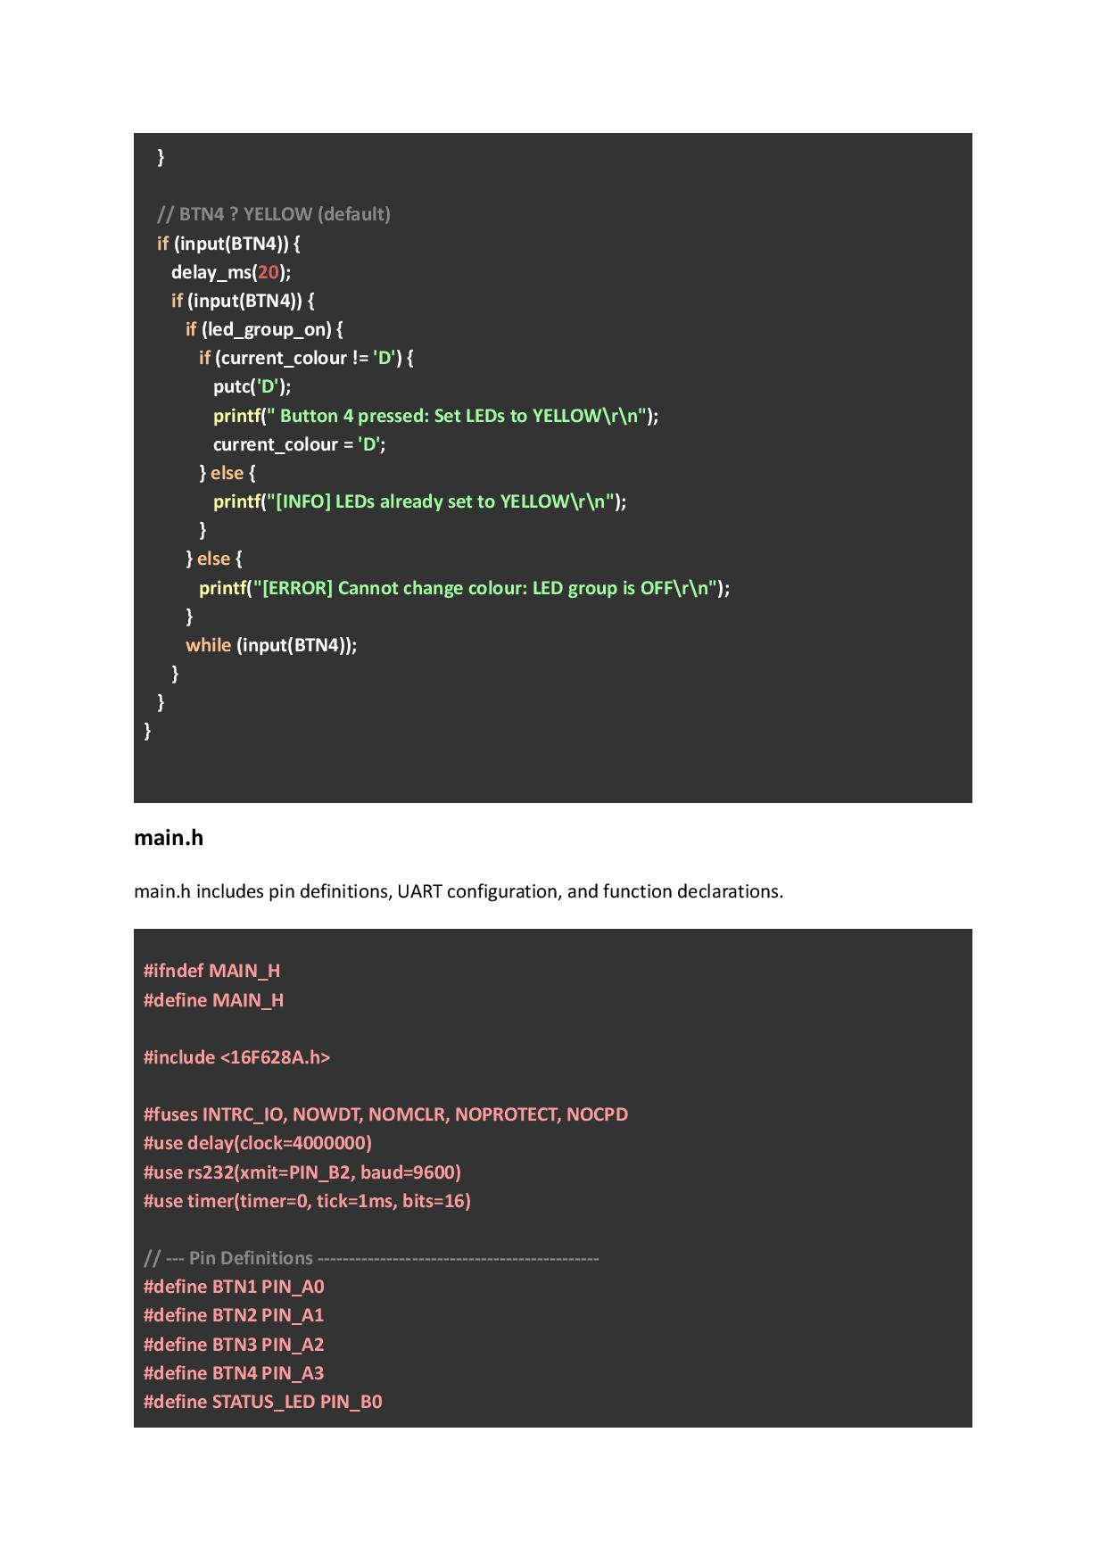
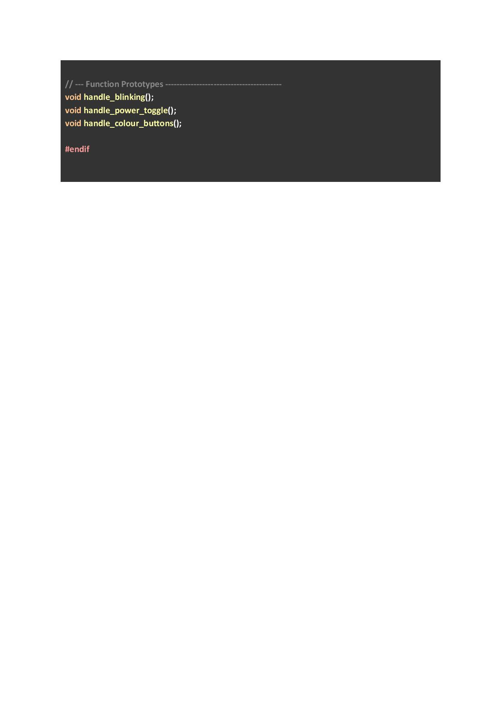

Appendix K – Receiver Mini Project
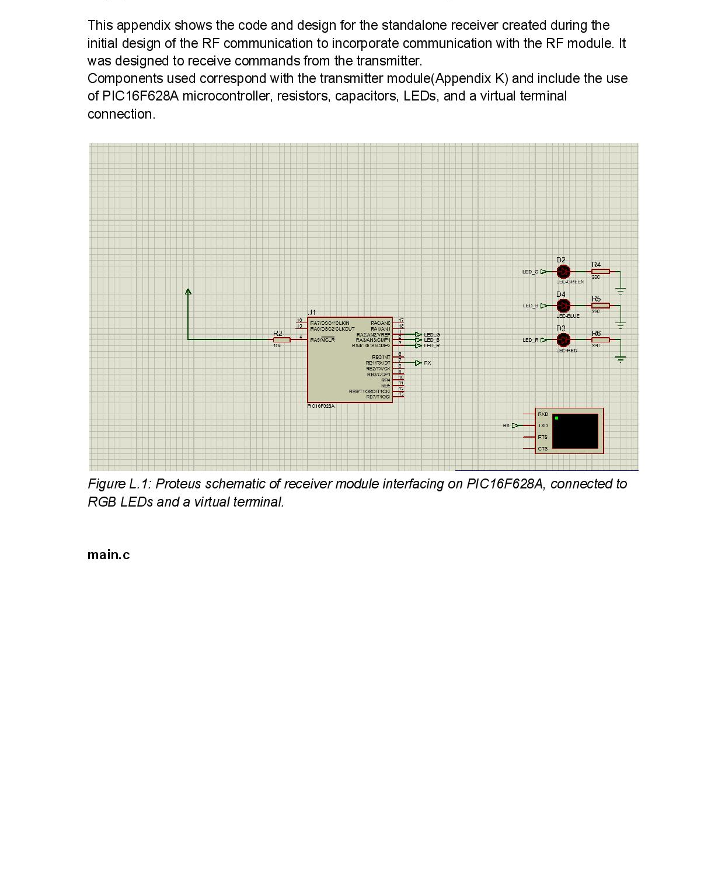
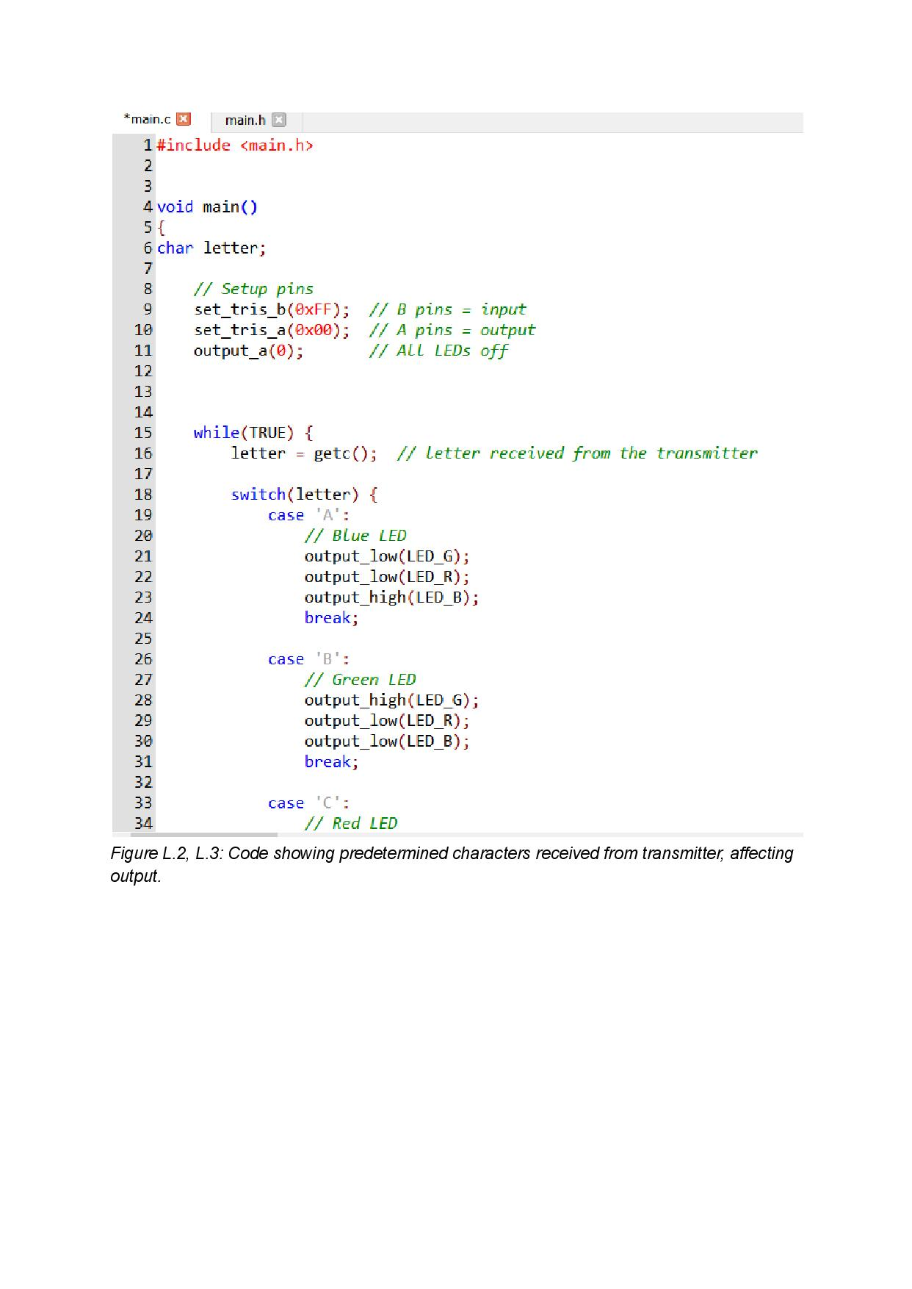
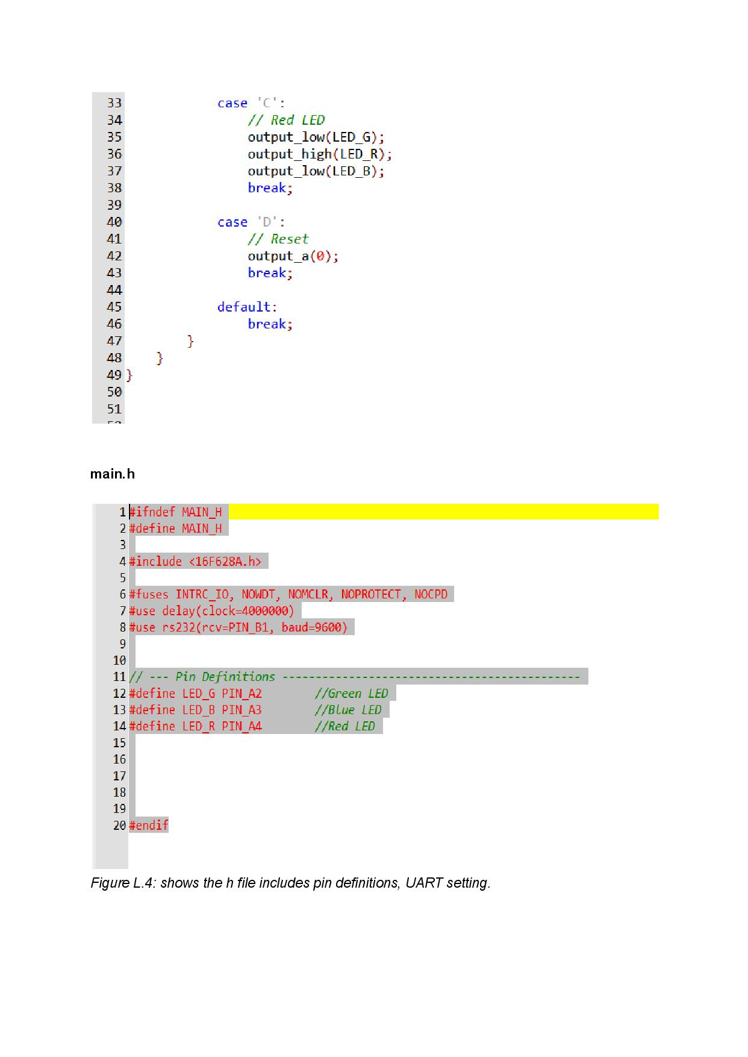

Appendix L – Ethics Form



