A Report on the Gender Pain Gap
I chose to create a case study on concerns about women – specifically on how women access and receive adequate healthcare to tie into the overarching themes of this module. This stemmed from reading an article from the BBC on the gender pain gap, which outlined this issue in terms of what is currently being done to combat it, such as women sharing “their experiences of the health system as part of a government strategy to address inequalities”. However, it did not conclusively answer what the gender pain gap is to those unaware, and it also gave the impression that the gender pain gap is something that is purely limited to reproductive issues; I believe it is far more and so I hope to explore this further in my subsequent essay.
In this preliminary data collection process, I found multiple news articles that were published over several years, with simply the intent of raising awareness. The provided historical background of this issue in the form of written opinion pieces was surprising in itself, as it would something one would assume would not be brought to the fore in news up until more recently. In particular, an article from the Independent contained a more in-depth study, which allowed readers to understand that “gender stereotypes are particularly decisive in the estimation of patients’ pain” and as a result, women’s pain can be more easily discounted due to “the false belief that women are oversensitive to pain, and express or exaggerate it more easily”. Not only is this pain discounted due to the healthcare professional’s underestimation, it is often also undertreated, to the point where it is far more common for “psychological rather than analgesic treatment” to be suggested to female patients. This observer bias creates mistaken beliefs about a woman’s sensitivity to pain, their willingness to report this pain, and ultimately their supposed capacity to endure such pain; all the while being compared to men as the norm or ideal for the correct amount and type of pain to be experiencing and ultimately how to respond to this pain. However, this is somewhat flawed as men do also suffer under these binding ideals – as seen in research conducted on pain which reported that men "felt an obligation to display stoicism in response to pain”. As mentioned in The Girl Who Cried Pain: A Bias against Women in the Treatment of Pain, this fascinating “interplay between behavio[u]r and the value systems of a culture is complex and may influence pain perception in many ways”. A major component of this interplay is the fashion in which we bring up our children and how it can cause boys to perceive their pain differently, as highlighted by Pollack’s study in the United States. This study goes on to report that male infants are more emotionally expressive than female infants from birth, but lose this quality by the time they reach elementary school, which usually starts for American children at the age of five. It is not difficult to see how we get our pain dismissed both internally and externally as a result of the environment that we are brought up in, and in turn how this would affect both our own perception of pain, and the doctor’s own perception.
While there is some discussion and variation of ideas contained within this topic in terms of whether the gender pain gap is purely associated with strictly women’s issues such as fertility, pregnancy and menopause, it is obvious that everyone inevitably suffers when harmful stereotypes are included in the field of medicine.

Studies on gender bias in medicine
“There is also evidence that women, for no apparent medical reason, are not offered the same treatment as men, a phenomenon that raises the question of gender bias. Many studies, for example, show that women are less likely than men to receive more advanced diagnostic and therapeutic interventions.”
While interpretations and views on such a subject can be negotiated, research articles provide a factual base from which to work from. In the research article Implicit bias in healthcare professionals: a systematic review, a simple question is asked – do trained healthcare professionals display implicit biases towards certain types of patient? By using an empirical study that relied on various methods to identify implicit rather than explicit examples of bias within a specific number of peer-reviewed studies which were then reviewed and compared. Researchers independently screened 3767 titles, which was then whittled down by a number of criteria to 42 articles and studies. These chosen articles were published over a ten year period, between 1st March 2003 and 31st March 2013, and examined twelve biases, the most frequently examined being racial bias and gender bias. The tables below display some of the findings from this study.
Four of the assumption studies reviewed in this comprehensive study compared their findings from multiple countries so that they could best explore the differences in our healthcare systems and how this may affect the way men’s and women’s pain are treated in terms of cultural and societal differences, and what external influences may change our bias. Other types of studies were used, such as implicit-association test (IAT) studies which measured both implicit prejudice and implicit stereotypes. To explain simply, implicit prejudice is measured through an exercise where participants have to match words or images from one category with positive or negative words, and implicit stereotypes are measured by have participated match words or images from one category with words from a conceptual category. Nine IAT studies went on to combine implicit association “with a measure of physician behaviour or treatment decision to see if there were correlations between these and levels of implicit bias”.
In short, this overarching study found conclusive evidence of “implicit biases among healthcare professionals and [that] a negative correlation exists between level of implicit bias and indicators of quality of care”. However, it does also highlight that there were multiple limitations in the way the data was collected:
“Some studies failed to report response rates, or to provide full information on statistical methods or participant characteristics. Some had very small sample sizes and the majority did not mention calculating the power of their sample. Some authors explicitly informed participants of the purpose of the study, or gave participants questionnaires or other tests that indicated the subject of the study before presenting them with the vignette.”
As such more uniform methods of research are needed “to enable better comparison and communication between researchers interested in different forms of bias.”

Report continues on next page, see below.
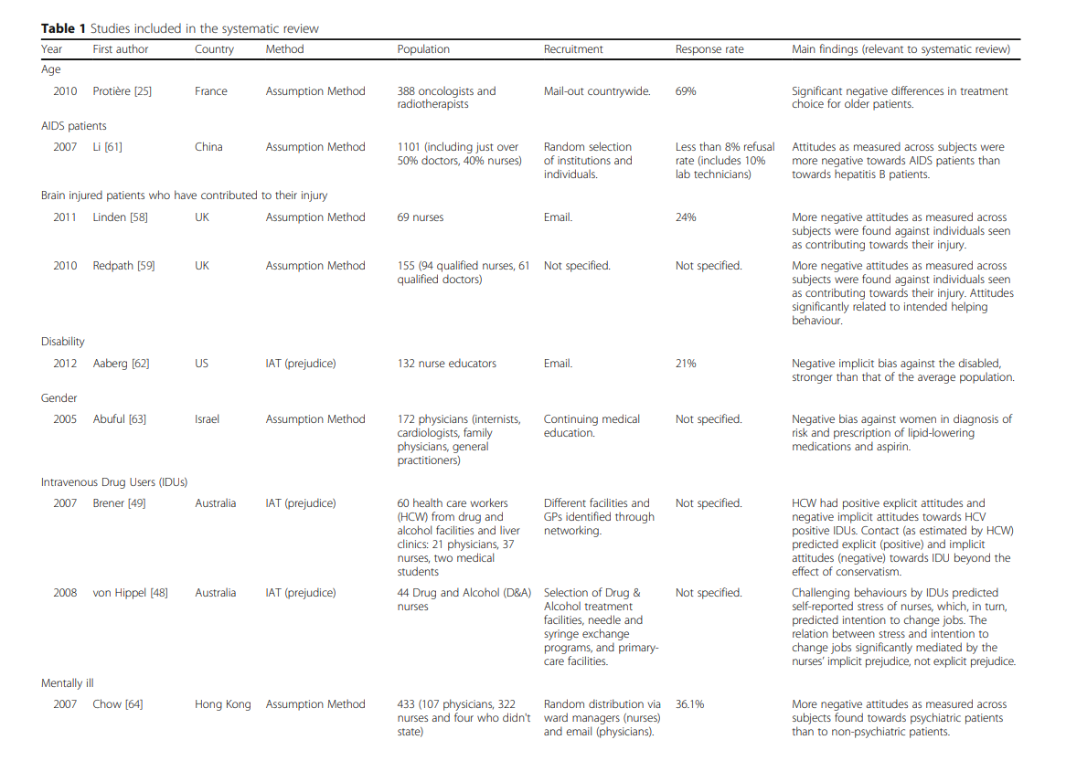
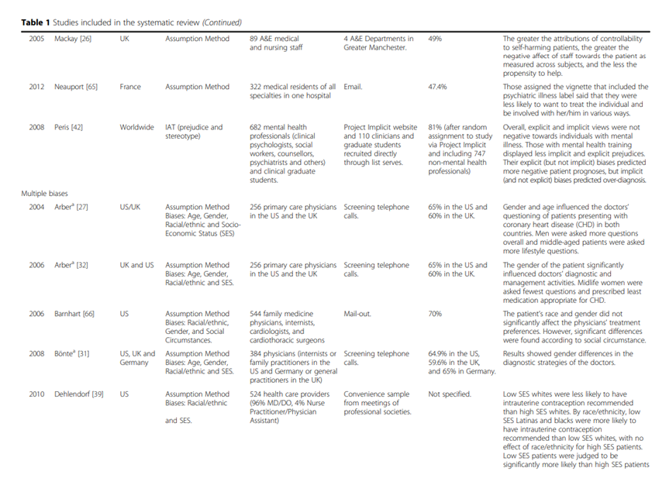
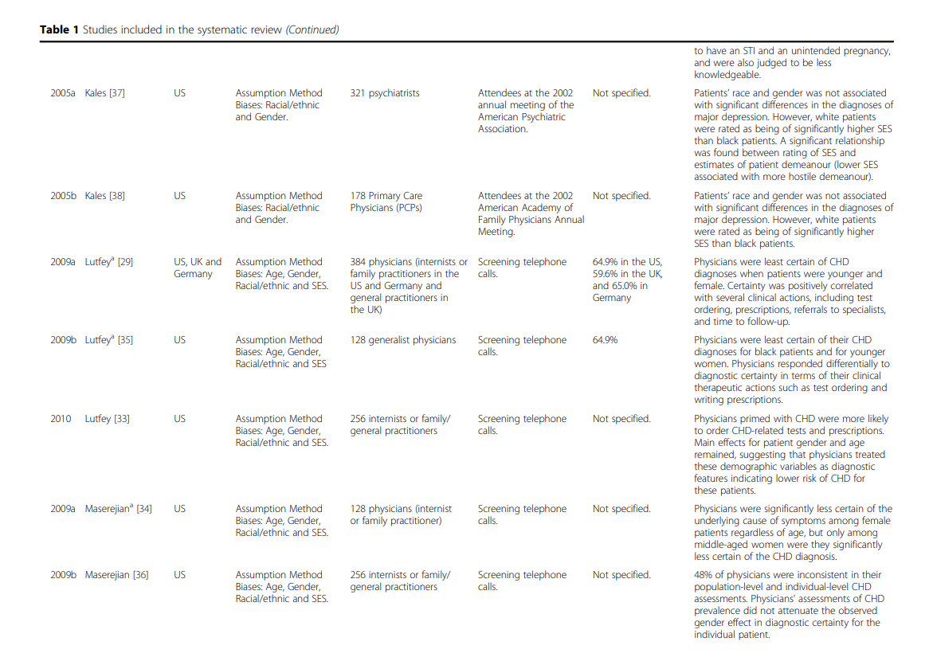
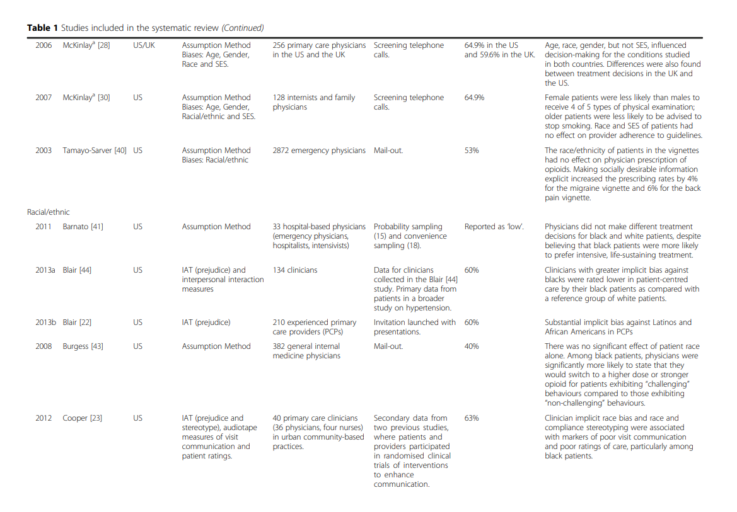
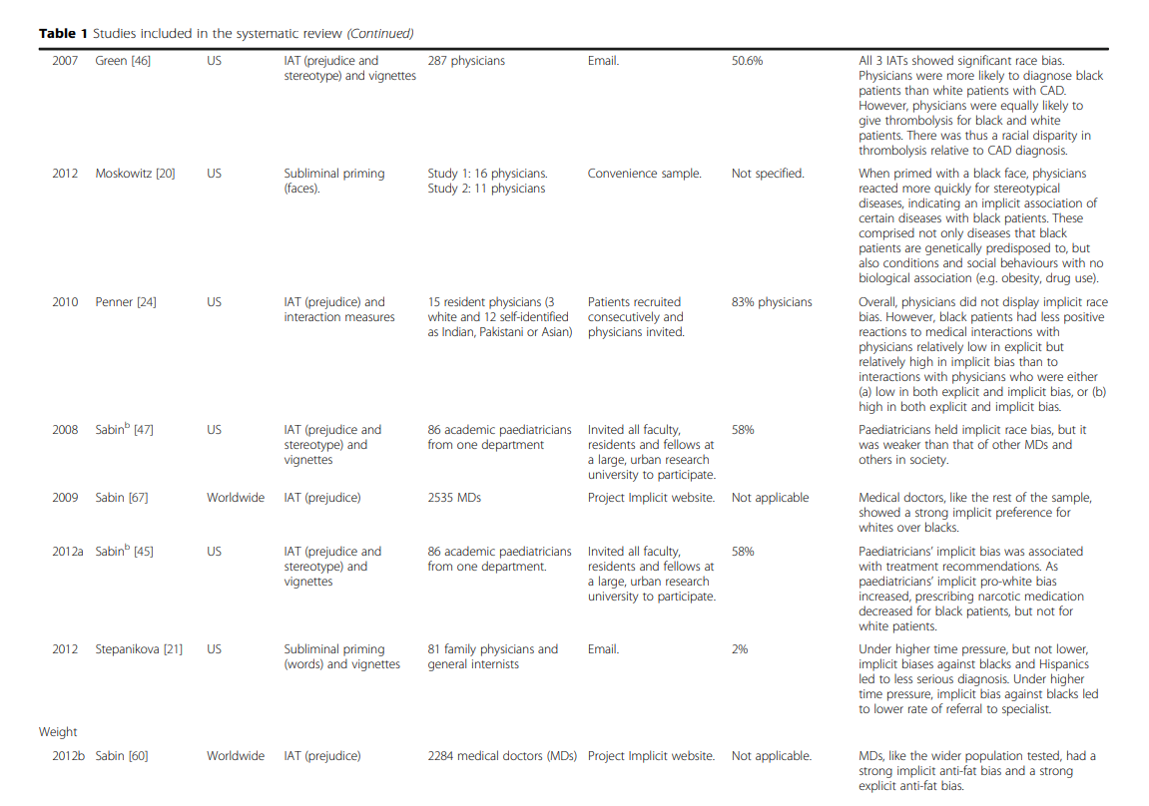

Social and racial bias
One has to also consider that as in many things in life, women of colour are often placed at a far greater disadvantage especially in accessing and receiving the correct treatment for heath issues. The experiences of white women will obviously be different in comparison to women of colour, thanks to subtle racism displayed by healthcare practitioners and historical delusions such as that black people do not feel pain – as such I feel I would not be correctly understanding and exploring the nuances of this subject if I did not cover this in more detail in my essay.
Even one of my original sources for the case study, the Independent article, notes that the pain expression database from which the featured study on pain bias was based upon, consists mainly of middle aged white Canadians. Therefore, little opportunity is provided “to explore another very consistent bias in pain assessment and treatment: discounting of the pain of black and Asian or other non-white patients” which more often than not, according to various research studies, leads to “shocking shortcomings in treatment”.

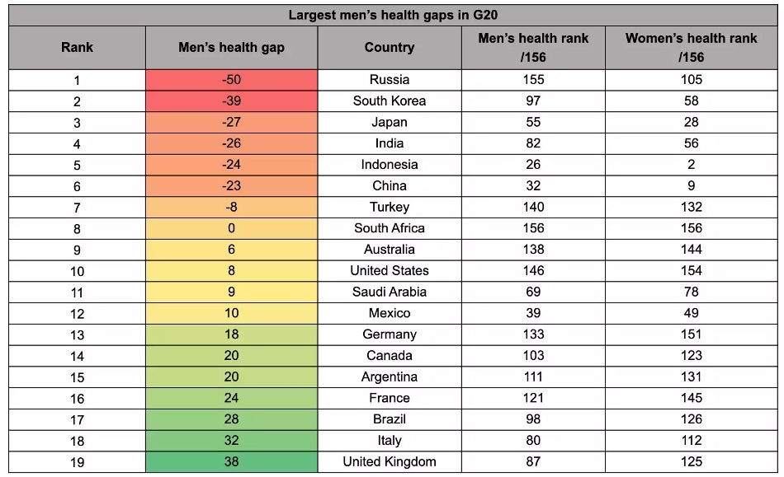
Alternative Perspectives

It was initially quite difficult to find perspectives that contradicted my original findings, but this article offers a more global perspective and framework from which to work from, as it proposes that globally there is a larger gap between men and women in terms of actually receiving support and treatment, with men facing greater health risks in 58% of the 156 countries studied. However, it was also speculated that some of the factors influencing these statistics are that women are “more likely to seek healthcare support, disclose symptoms and receive a higher number of preventative diagnoses”. From this we can gather that women are often heard but not believed when explaining symptoms with the intent of accessing treatment, and that men are often pressured by societal expectations to not speak about their pain but are otherwise likely to be believed by doctors. However one chooses to look at it, this issue is far more nuanced than I originally perceived it to be and I hope to explore further into each subset of this issue in my essay.

Bibliography
BBC News. 2021. Women's health: Female patients to be asked about 'gender health gap'. [online] Available at: <https://www.bbc.co.uk/news/health-56300404> [Accessed 19 April 2021].
BlackDoctor.org. 2021. Doctors Still Believe Black People Don't Feel Pain; And It's Being Taught In Medical School | BlackDoctor.org - Where Wellness & Culture Connect. [online] Available at: <https://blackdoctor.org/black-people-pain-bias-being-taught-in-med-school/> [Accessed 25 April 2021].
Bruchmüller, K., Margraf, J. and Schneider, S., 2012. Is ADHD diagnosed in accord with diagnostic criteria? Overdiagnosis and influence of client gender on diagnosis. Journal of Consulting and Clinical Psychology, 80(1), pp.128-138.
FitzGerald, C. and Hurst, S., 2017. Implicit bias in healthcare professionals: a systematic review. BMC Medical Ethics, 18(1), pp.1-18.
Hamberg, K., 2008. Gender Bias in Medicine. Women's Health, 4(3), pp.237-243.
Hoffmann, D. and Tarzian, A., 2001. The Girl Who Cried Pain: A Bias against Women in the Treatment of Pain. Journal of Law, Medicine & Ethics, 29(1), p.17.
Jha, A., Varosy, P. and Kanaya, A., 2004. Differences in medical care and disease outcomes among black and white women with heart disease. ACC Current Journal Review, 13(1), p.22.
Kiesel, L., 2017. Women and pain: Disparities in experience and treatment - Harvard Health Blog. [online] Harvard Health Blog. Available at: <https://www.health.harvard.edu/blog/women-and-pain-disparities-in-experience-and-treatment-2017100912562> [Accessed 25 April 2021].
Łyszczarz, B., 2017. Gender bias and sex-based differences in health care efficiency in Polish regions. International Journal for Equity in Health, 16(1).
Macfarlane, M. and Knudson-Martin, C., 2003. How to Avoid Gender Bias in Mental Health Treatment. Journal of Family Psychotherapy, 14(3), pp.45-66.
News-Medical.net. 2020. UK has the largest gender health gap in G20, study reveals. [online] Available at: <https://www.news-medical.net/news/20200522/UK-has-the-largest-gender-health-gap-in-G20-study-reveals.aspx> [Accessed 21 April 2021].
News-Medical.net. 2020. UK has the largest gender health gap in G20, study reveals. [online] Available at: <https://www.news-medical.net/news/20200522/UK-has-the-largest-gender-health-gap-in-G20-study-reveals.aspx> [Accessed 21 April 2021].
Norman, J., 2004. Gender Bias in the Diagnosis and Treatment of Depression. International Journal of Mental Health, 33(2), pp.32-43.
Parmar, A., Baum, S., Reuter, E., Vaidya, A. and Vinluan, F., 2021. Exploring Gender Bias in Healthcare - MedCity News. [online] MedCity News. Available at: <https://medcitynews.com/?sponsored_content=exploring-gender-bias-in-healthcare> [Accessed 22 April 2021].
Rrustemi, I., Locatelli, I., Schwarz, J., Lagro-Janssen, T., Fauvel, A. and Clair, C., 2020. Gender awareness among medical students in a Swiss University. BMC Medical Education, 20(1).
Sabin, J., 2020. How we fail black patients in pain. [online] AAMC. Available at: <https://www.aamc.org/news-insights/how-we-fail-black-patients-pain> [Accessed 25 April 2021].
Samulowitz, A., Gremyr, I., Eriksson, E. and Hensing, G., 2018. “Brave Men” and “Emotional Women”: A Theory-Guided Literature Review on Gender Bias in Health Care and Gendered Norms towards Patients with Chronic Pain. Pain Research and Management, 2018, pp.1-14.
Williams, A., 2021. Gender pain gap: Why stereotypes are still harming women’s health. The Independent, [online] Available at: <https://www.independent.co.uk/health_and_wellbeing/women-pain-underestimated-male-stereotypes-b1828978.html> [Accessed 19 April 2021].

(Women's health: Female patients to be asked about 'gender health gap', 2021)
(Williams, Gender pain gap: Why stereotypes are still harming women’s health, 2021)
(Williams, 2021)
(Williams, 2021)
(Williams, 2021)
(Hoffmann and Tarzian, The Girl Who Cried Pain: A Bias against Women in the Treatment of Pain, 2001. p. 17)
(Hoffmann and Tarzian, 2001. p.16)
(Hoffmann and Tarzian, 2001)
(Hoffmann and Tarzian, 2001)
Hamberg, ‘Gender Bias in Medicine’, 2008. p.237)
(FitzGerald and Hurst, Implicit bias in healthcare professionals, 2017. p.4)
(FitzGerald and Hurst, 2017. p.5)
(FitzGerald and Hurst, 2017. p.4)
(FitzGerald and Hurst, 2017. p.15)
(Sabin, How we fail black patients in pain, 2020)
(Doctors Still Believe Black People Don't Feel Pain; And It's Being Taught In Medical School, 2021)
(Williams, 2021)
(UK has the largest gender health gap in G20, study reveals, 2020)

