Module: Introduction to the web and database
Assignment: HTML & CSS Web Development
Student Name Maryam Ali Zoda
Student ID:2531289
Course ID: ACCA4023
Submission Date:14/08/2026
 | Module: Introduction to the web and database  Maryam Ali Zoda (2531289)  course ID. ACCA4023

Table of contents:
1 Introduction
2 Requirements
3 Target Audience
4 Implementation
5 HTML and CSS Validation
6. Evaluation
7 compares
8 Accessibility
9 What I have learned
10 conclusions
11 References

Introduction:
This paper outlines the process for designing, developing, implementing, and evaluating the Dartford Corner Maryam Bakery website. This website has been designed in accordance with current web standards using HTML5 and CSS3. The website was coded by hand without using any website-building applications or software that generates code automatically. The intention of this project was to design a responsive website that promotes a local bakery and provides information to its customers.
The website consists of three major web pages: Home, Menu, and Contact. Each page has an identical navigation menu, which makes moving around the website very easy. On the Home page, visitors are introduced to the bakery through pictures and descriptions of the baked goods. The Menu page showcases the various cakes at the bakery, and the Contact page has the address, phone number, email, social media accounts, and Google Maps of the bakery
In the design process, emphasis was placed on simplicity, clarity, and easy navigation. The website has been developed to cater for users with varying levels of computer expertise and to operate efficiently on all computer systems, whether desktop, tablet, or mobile.
This report outlines the website requirements, how the website was implemented, the validation results, and evaluates the website using usability, accessibility, and SEO principles. Lastly, two current websites will be compared to point out good web design practices.

2. Requirements
This website was made specifically for Dartford Corner Maryam Bakery, a bakery that specialises in cakes, pastries, cookies, and other sweet treats. The primary objective of this website is to create a promotional site for the bakery and provide its customers with useful information before they visit. It serves as a promotional tool for the bakery by showcasing beautiful images of bakery items and providing essential contact information.
Today’s customers always check things out online before going to any local business. So, having a professional website not only increases customers’ trust but also improves their communication with the bakery [1].

2.2 Target Audience
The website has been developed for a number of users. The first set of target audience is the residents from Dartford who would like to purchase fresh bakery products. The second group of users of the website are families who would like to purchase cakes for birthdays or other special occasions since the bakery sells customised cakes for special events. Students and people working in offices may visit the website to know more about pastries and desserts that are available throughout the day. Moreover, visitors to the town may visit the website to learn about the bakery and its contact details.
The website has been developed with a simple layout, headings, and easy navigation [2].

3. Implementation
I have used NEXPAD++ to create my website, and it was easy to use.

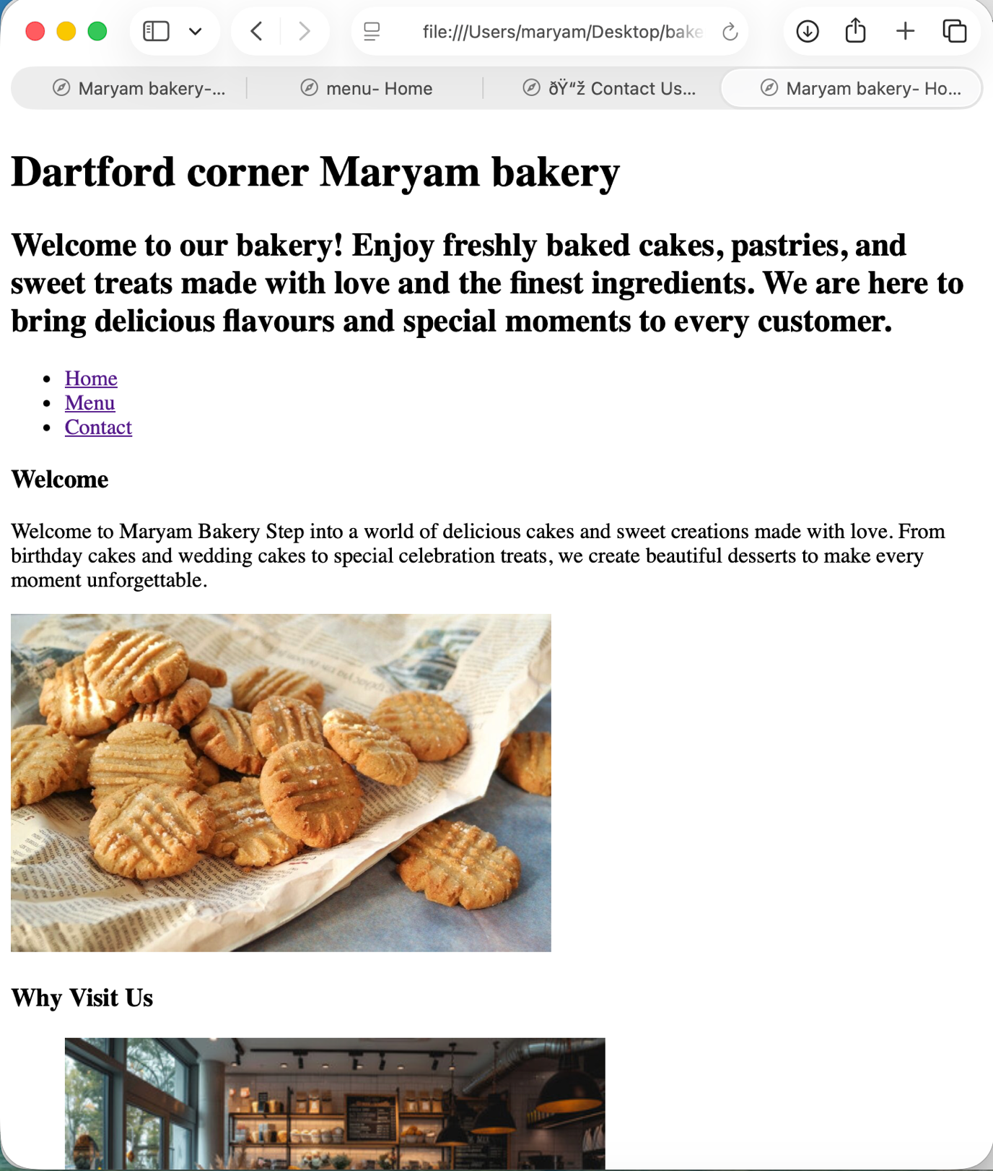
Figure 1 shows the home page.

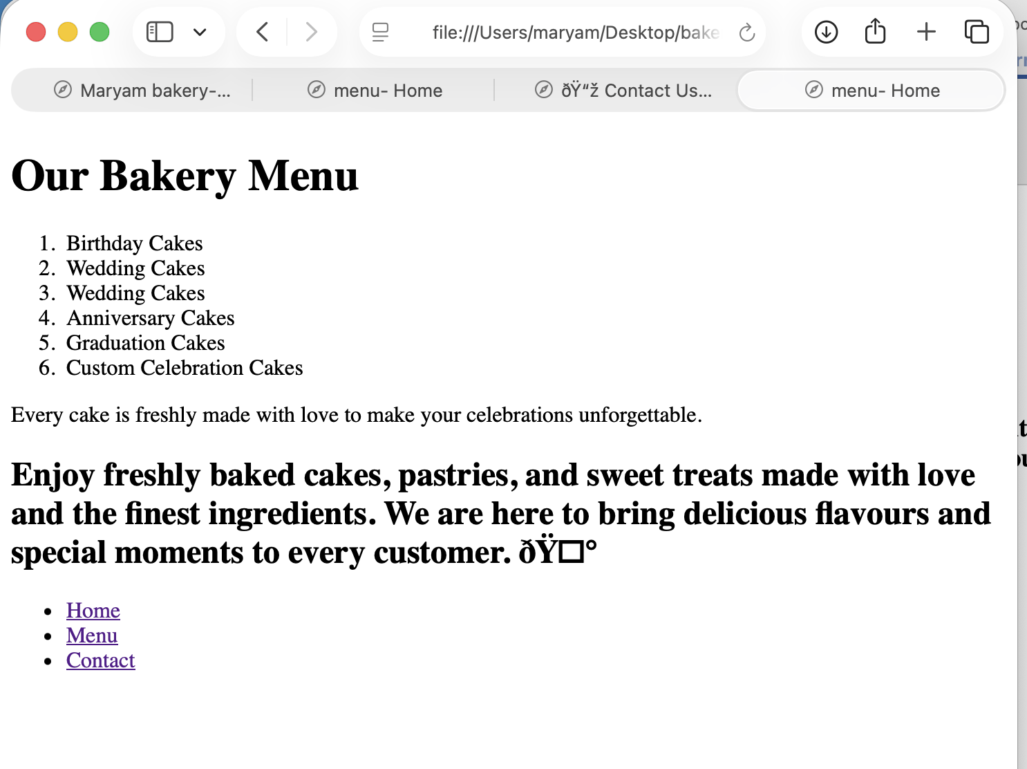
Figure 2: Shows the menu page.

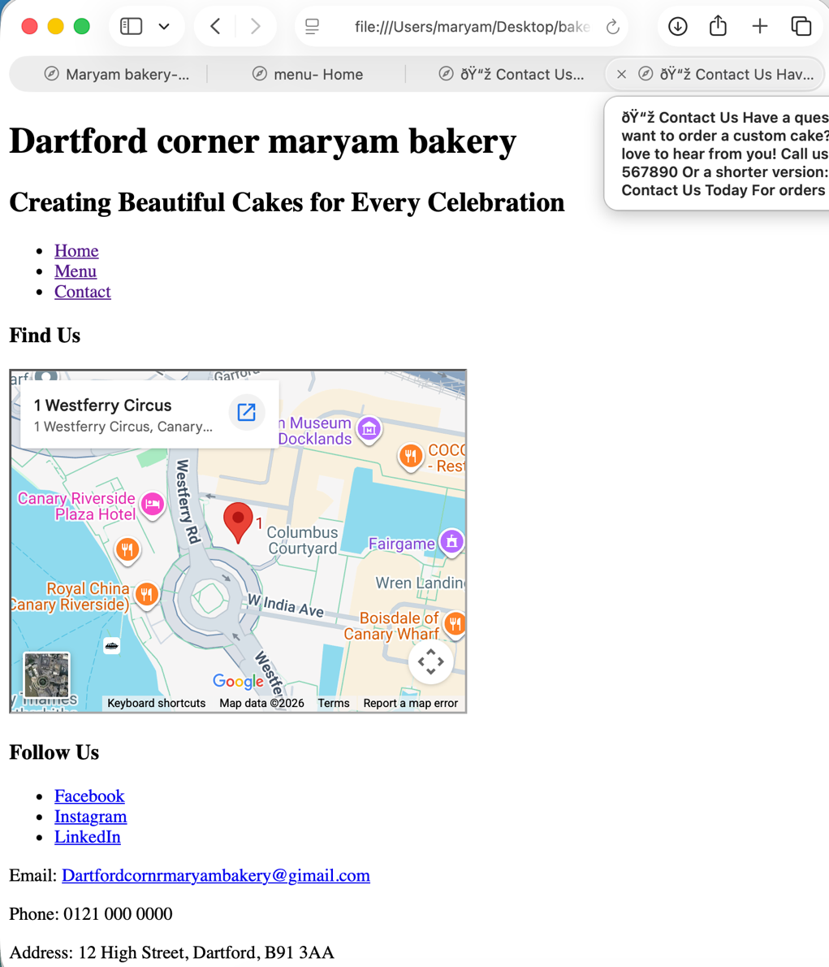
Figure 3: shows the Address Page.

3.3 HTML and CSS Validation
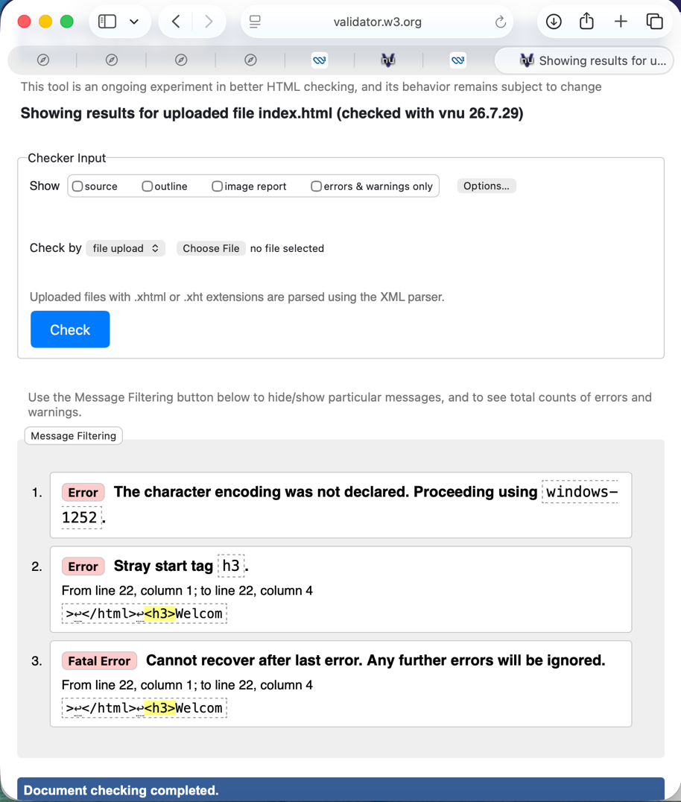
Figure 4: shows that there is something wrong with the HTML code, which it shows that I have three errors that need to be fixed.

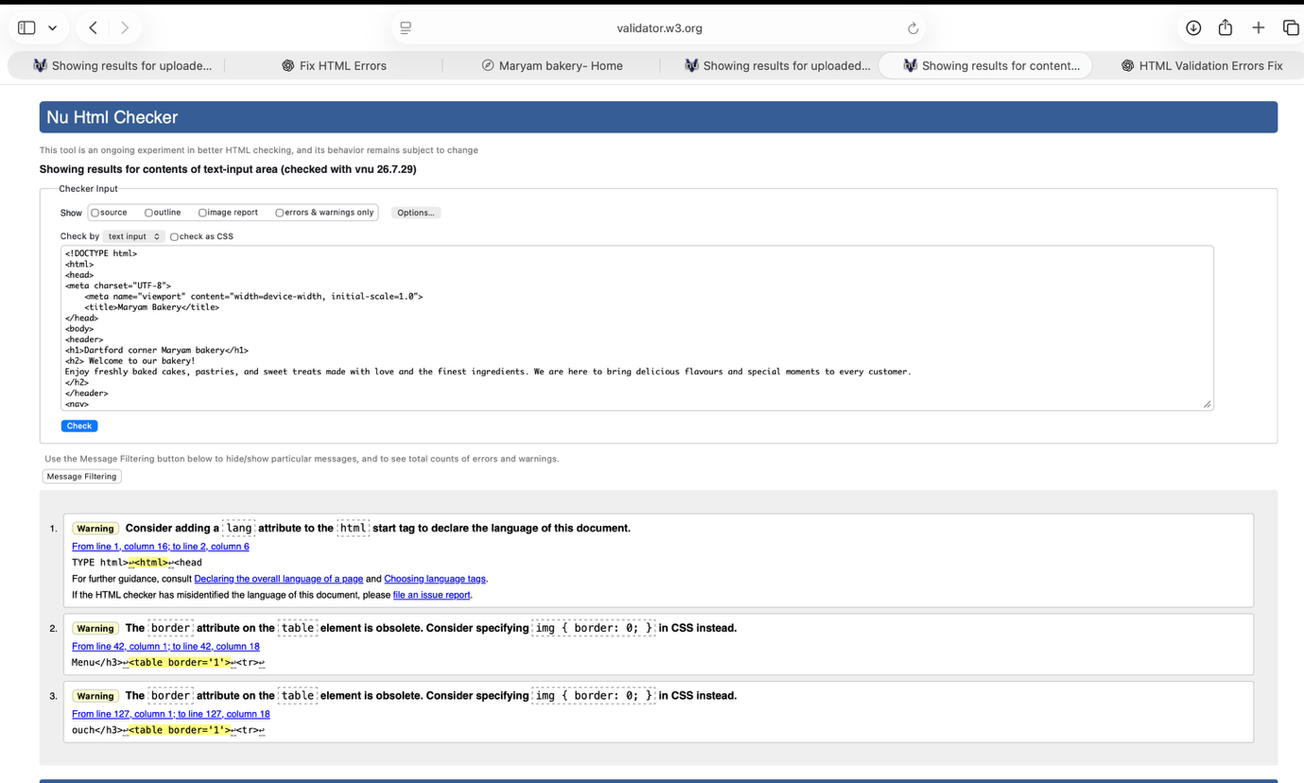
Figure 5: shows I have corrected the code and it is complete

4. Evaluation and usability:
Dartford Corner Maryam Bakery was designed to be very user-friendly by maintaining simplicity and consistency in its website design [3]. It consists of three pages: Home, Menu, and Contact, which are linked via the navigation bar. This makes it easy for the user to navigate from one page to another without getting lost. On the Home Page, there is a brief introduction to the bakery together with the products and services offered. The Menu page lists different types of cakes, including birthday, wedding, anniversary, and graduation cakes. The Contact page provides necessary details like the address of the bakery, email address, phone number and Google map.
The website also uses large headings, short paragraphs, and clear language, making the content easier to read and comprehend. Pictures of baked goods have been added to the website to make it more visually appealing and to motivate visitors to explore the available products. During the website's development, HTML validation was performed to detect coding errors and ensure the website worked as intended across various web browsers.
Although the website is user-friendly, certain aspects could be improved for usability. The website could be enhanced by incorporating pricing details and product descriptions that will enable customers to make their purchase decisions more easily. Call-to-action buttons like "Order Now" or "Book a Celebration Cake" will motivate the customers to interact with the website.
Accessibility:
Accessibility entails creating websites that can be accessed and used by everyone, including those with disabilities. This is because the Web Content Accessibility Guidelines (WCAG) have been formulated by W3C, and they require that sites be perceivable, operable, understandable, and robust. By observing these guidelines, websites are made accessible by people with visual, auditory, motor and cognitive impairments.
Accessibility has been considered during the development of the Dartford Corner Maryam Bakery site. First, headings have been used on the pages so as to make them easy to understand and interpret. The English language used is simple such that the customers can understand all the information on the website. The site offers various ways of communicating with customers via emails, phone calls and physical addresses.
There are images that show cakes and bakery products that make the website look more attractive. To make the site more accessible, alt text is provided for each image so that a screen reader can describe it to blind users. The website uses black text on a white background, which means that there is sufficient contrast of colours.
During testing, a character encoding error occurred – some symbols that could not be rendered were visible on the web pages. It was possible to fix the problem by including the UTF-8 Character encoding in the HTML document. The website was designed using responsive design principles so that it looks good on any computer, tablet, or smartphone screen.
Search Engine Optimisation:
Search Engine Optimisation (SEO) is the practice of enhancing a website to rank well on search engine results pages. Through effective SEO, companies can increase their online visibility, attract more visitors to their sites, and ultimately attract potential customers. SEO can be either on-page, like using headers and keywords.
Dartford Corner Maryam Bakery website has incorporated some of the basic SEO techniques. The website contains descriptive headers such as Dartford Corner Maryam Bakery, Our Bakery Menu and Contact Us to assist search engines in determining what the website is all about. Relevant keywords such as bakery, cakes, birthday cakes, wedding cakes, pastries and Dartford have been used within the website.
The website also has internal links from the Home, Menu and Contact pages. This facilitates navigation on the website not only for visitors but also for search engine spiders. The Contact page lists the business's physical address, phone number, and email, which helps establish its locality for local SEO. The Google Maps integration on the website enhances local search visibility by letting customers know about the location of the bakery.
priority to mobile-friendly websites, responsive web design should continue to be followed.

This is the website which I want to compare with my website
https://gails.com/?srsltid=AfmBOoqVV4V1DhPBqsTKcZmNVnYvmO9vBk4WciC1elzdAaxOeCFajjSd
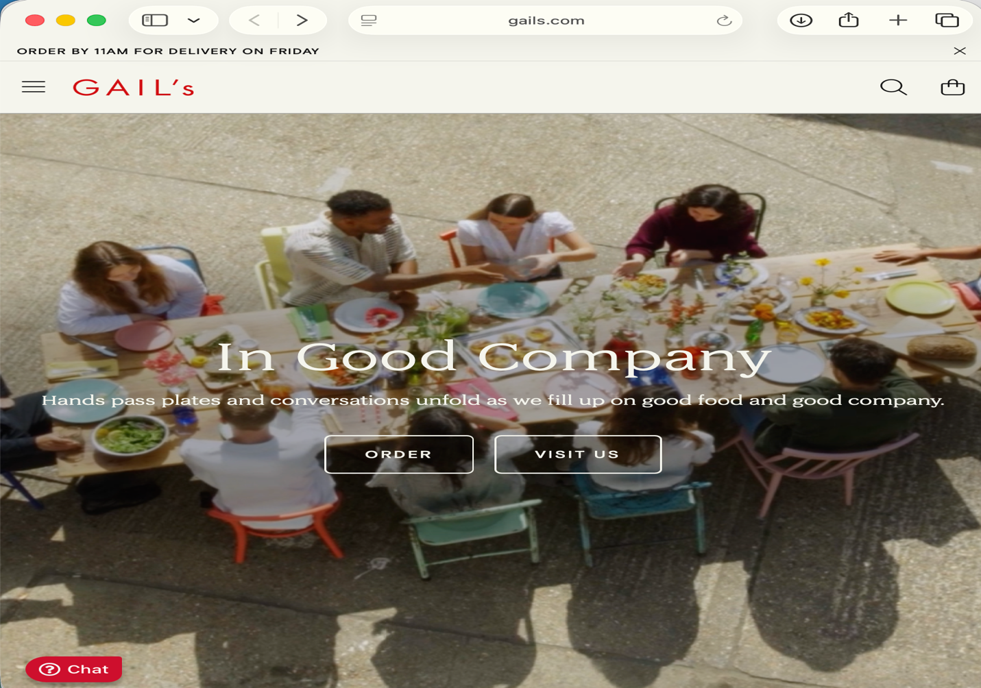

compare:
The first difference between the websites of Dartford Corner Maryam Bakery and GAIL's Bakery is the nature of their businesses. A significant bakery chain with multiple locations throughout the UK is called GAIL's Bakery. Therefore, by providing online ordering, bakery search, incentives, and company information, the bakery's website seeks to support a national business.
On the other hand, the website of Dartford Corner Maryam Bakery was designed for a small local bakery. In this sense, the website's main goal is to showcase the company, its bakery goods, costs, and contact details. The website does not make use of sophisticated internet features.
The amount of information offered on each website can also be distinguished. The many sections of GAIL's Bakery include comprehensive details about the business, sustainability, seasonal goods, bakery locations, career possibilities, and
client support. Such a wealth of data aligns with the needs of a nationwide company that serves clients across several regions.
Dartford Corner Maryam Bakery, on the other hand, has fewer pages because its primary audience is local. It just presents the most important details about the menu, deals, hours of operation, and contacts.
The general design aesthetic is another distinction between the two designs. Large photographs, contemporary layouts, and other graphic elements that strengthen its branding give GAIL's Bakery a very polished appearance. The design of Dartford Corner Maryam Bakery is more straightforward, with bakery hues, eye-catching product photos, and a pleasing arrangement. Although it is suitable for a tiny, independent bakery, the design is not as intricate as that of GAIL's Bakery. It fosters a welcoming atmosphere for the patrons.
Generally, GAIL's Bakery was the source of inspiration while developing the site of Dartford Corner Maryam Bakery.
The layout, excellent culinary photography, user-friendly navigation, and welcoming style of the website were all taken from the GAIL's Bakery website. However, all of these elements have been streamlined to satisfy the needs of the local bakery and the project. Dartford Corner Maryam Bakery has successfully developed a professional website with suitable services for its clients, whereas GAIL's Bakery provides additional services as a nationwide organisation.

What I have learned:
I learned how to create a website that is aesthetically pleasing, easy to use, and responsive across a variety of devices through this project. When I compared my website to GAIL's Bakery's, I became aware of how important it is to have a visually appealing layout, easy-to-use navigation, and high-quality photographs to provide users with a positive experience.
Other ideas I acquired from this project included usability, accessibility, and SEO. A website can be made more user-friendly and search engine visible by using readable typefaces, proper title tags, semantic HTML, and effective colour contrasts.
In addition to testing and assessing the website, this assignment has given me the opportunity to study HTML and CSS.

In conclusion
Ultimately, by producing an efficient, responsive, user-friendly, and educational advertising website, the Dartford Corner Maryam Bakery website development effectively fulfilled the project objectives. Web standards were used in creating the website to ensure accessibility and usability. Additionally, SEO factors were considered when developing the website in order to increase visibility in search engines. Overall, the developed website effectively serves as the bakery's online presence, where customers can find information about its products and services.

References:
[1] Google, How people decide what to buy using Google Search, Google Think with Google, 2023. [Online]. Available: https://www.thinkwithgoogle.com/. [Accessed: Aug. 4, 2026]
[2] Interaction Design Foundation, User-Centred Design (UCD), 2024. [Online]. Available: https://www.interaction-design.org/literature/topics/user-centered-design. [Accessed: Aug. 4, 2026].
[3] Interaction Design Foundation, User-Centred Design (UCD), 2024. [Online]. Available: https://www.interaction-design.org/literature/topics/user-centered-design. [Accessed: Aug. 4, 2026].

Appendix HTML


