Module Name: Community Engagement
Assignment Title: Coursework - Portfolio
Student Name: Silviu Pirvu
Student ID:2315010

Table of Contents
Introduction 3
Element 1: Community outreach 4
Element 2: Stakeholders mapping exercise 6
Element 3: Stating the community engagement plan 9
Element 4: Benefits of engaging with the stakeholders and personal experiences as a member of the community 16
Conclusion 20
References 21

Introduction
Community engagement is a crucial abstraction that ensures mutual growth and development of the domain in a holistic way. Being a part of a specific community comes with some responsibilities and standards to be followed properly. This context will show the pile of processes included in the task of community involvement and growth. The atmosphere of a university is considered here to focus on the community of that particular field. The notion of community outreach will be showcased here by illustrating the steps included. The stakeholders mapping format will also be demonstrated in this portfolio to showcase the collaborative actions and communication process there. Commencing all these measures the issues present in this path will be evaluated along with stating some ways to mitigate those. Furthermore, a general discussion will be presented at the end of this study. It will show the benefits of these procedures and the reflective experience of being a member of the community.

Element 1: Community outreach
The community of a university is quite a diverse field that is associated with integral growth and development. It is a place where some people are desiccated to learn new things, and some are fixed to teach and train. It creates such a positive and intellectual environment that impacts the adjacent social circumstances as well (Hayes et al., 2024). The people or stakeholders of this type of community include the students, teachers or faculties, the staff, passed-out students and many more. Here is the division of the demographic features of this community. Understanding the qualities of these divisions is important to make rational decisions and reach the target of mutual enrichment (Hayes et al., 2024).
Demographic features of the university community
1. Age:
The majority of people in this community belong to the category of students whose age lies in the range of 18 to 24 years. Then coming to the faculties, there is the new generation as well as millennial people as well whose age range varies from 30 to more than 50 years old (Hayes et al., 2024). The stretch of the age range is quite in this case as people related to different sections of the university like lab attendants, clerks and many more come into the section.
2. Gender:
This is a fact that most of the universities have male students, especially in rural areas like in the case of this community. The alumni record and the present count of students suggest that the number of female students is low as compared to males (Craig et al., 2024). It is a contradictory instance that the number of female faculties is greater here unlike the proportions of students. In the case of other staff, males are predominant again related to various portions like the food canteen of the college and many more (Craig et al., 2024).
3. Race and culture:
This very university is located in a rural or a sub-urban place from most of the students come to this institution. The culture of the surroundings lacks the touch of digitalisation and liberal thoughts which can be witnessed from the attire styling and cultural upbringings of the students (Baker, 2024). The local communities around the university celebrate several types of festivals which influence the internal state of the university. It is reported that fewer numbers of students stay present on those days and the availability of transportation services also hindered the teachers from coming there (Baker, 2024).
4. Socioeconomic condition:
The location of this university is not an urban place and most students do not have affluence of economic resources to spend on studies. This is the reason why most of the students do not get the chance to get admitted in expensive courses. Some streams of learning are related to additional expenses other than books and teaching fees (Baker, 2024). For example, the course of science is relatably higher than other subjects as it is associated with laboratory work, computer usage and many more.

Element 2: Stakeholders mapping exercise
The key stakeholders can be identified from the discussion above who form a university community and influence one another. The sections of the core stakeholders are displayed articulately here to point out their significance in the community.
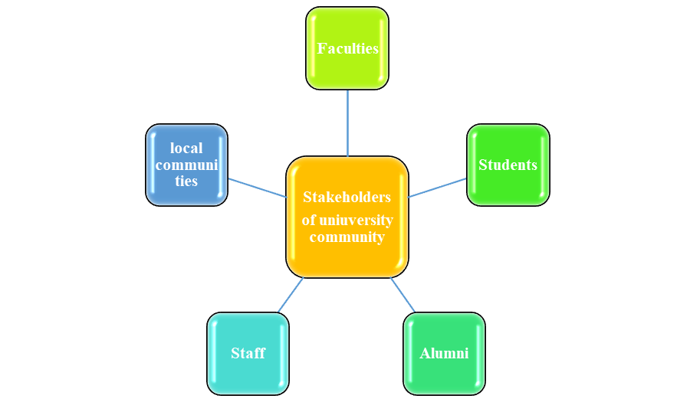
Figure 1: Stakeholders of the university community
Source: (Self-created)
Students
The community is made up of people from different segments that directly and indirectly connect with the university. Students form the most firm and dynamic segment of the community as they are the working force of the entity. Their performance, engagement in the college and educational advancement impact the sides of other stakeholders as well (Compan et al., 2024). Their state also judges the efficacy of the teachers and the offerings of the educational institution. Their additional activities such as civic behaviours, attire and many more also influence the social environments around them. They can take various bold moves to solve the issues and voids in the group of the university. They can positively impact the social and economic environment by taking charge of some revolutionary campaigns with broader goals (Compan et al., 2024).
Faculties
The teachers are important in building a positive and disciplined environment in the community. They train the students and teach life lessons as well beyond the chapters of books of fixed contents. The capability and experience of the faculties decide the future and intellectual extent of the pupils of the university (Kelly and Given, 2024). The way the teachers treat the students and motivate them to address the situations strengthens the core of the university group. The initiatives and programmes created by them also had a positive impact on the surrounding nature of the college (Kelly and Given, 2024).
Alumni
The status of these students matters for the university as the success of the alumni people glorifies the reputation of the university. The members of the community are impacted by the activities of these people to make up their minds before getting new admissions to the college (Lowe and Wright, 2024). For instance, if most of the previous students get prosperous in life after passing out from this university, would encourage more students to come here. They will also get motivated after knowing the success stories of the seniors. It also can provide the university with financial affluence if the testimonial funds are given by the alumni (Lowe and Wright, 2024).

Staff
Another potential stakeholder that plays a crucial role in the success of community engagement is the staff of the university. It is to be said that the staff are engaged with the main activities of the organisation and hold a potential role. The staff members who are directly connected with the activities of the university carry effectual insights into the strengths and weaknesses of the institution (Stocker et al., 2020). They can significantly extract their knowledge for the betterment of community engagement by sharing such expertise. Another potential factor that can be evaluated by the staff is the active communication. They can highly help in the execution of the community engagement programs and the initiation through delivering their services. As they interact with most of the individuals, they will also be able the evaluate by collecting feedback and identifying the issues (Stocker et al., 2020).
Local communities
These respective stakeholders are the individuals who are located within imminent reach. They are crucial as they hold potential information and knowledge about their requirements and difficulties. Community engagement is conducted for the betterment of the communities which is majorly recognised by these local communities (Rogers et al., 2021). They are the potential sources of building social capital through evaluating the sense of belonging. The local communities allow the activities to situate with the trust which eventually enhances the cooperation by the other individuals towards the university. Apart from that, the local communities are also responsible for enhancing the support of the initiatives of the community engagement programs as well (Rogers et al., 2021).

Element 3: Stating the community engagement plan
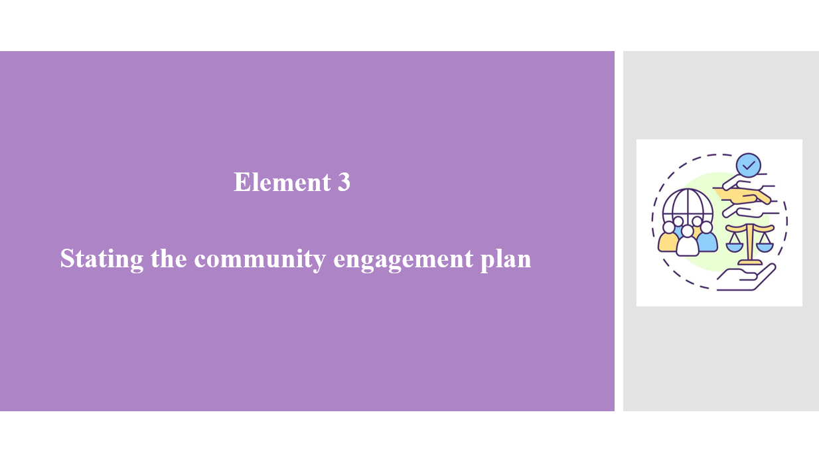

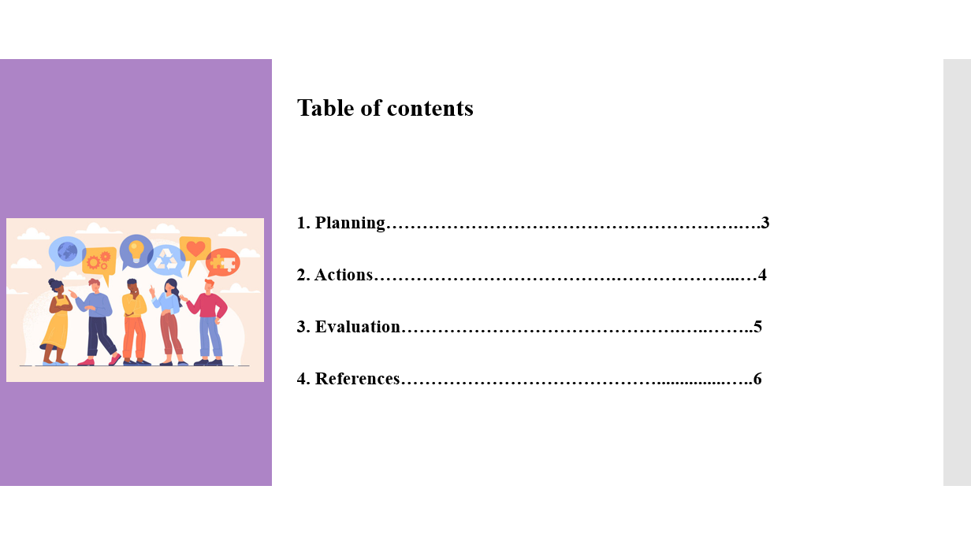

Slides:
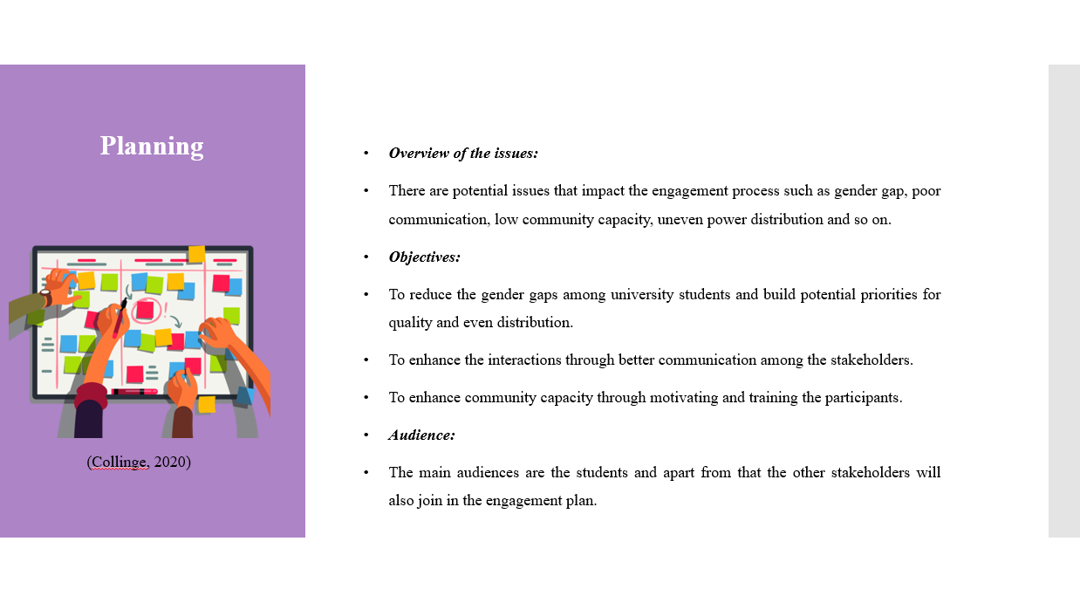
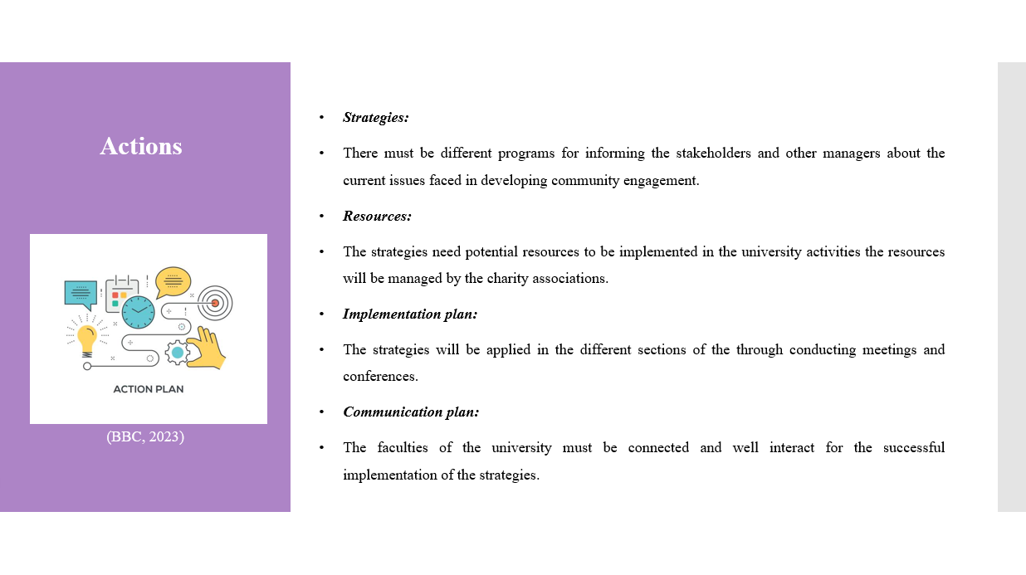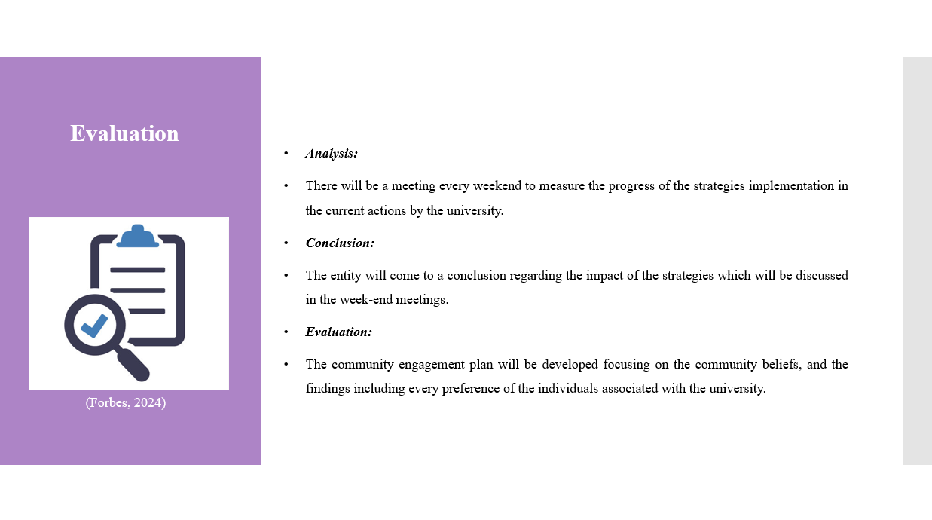
Notes:
The above passage has derived the stakeholders in a community such as the students, faculties, staff, alumni and local communities. It is to be said that community engagement requires a lot of potential to be maintained effectively and efficiently. A community engagement plan according to the issues is represented below.
1. Planning:
Overview of the issues:
There are potential issues that impact the engagement process such as gender gap, poor communication, low community capacity, uneven power distribution and so on (Stocker et al., 2020).
Objectives:
1. To reduce the gender gaps among university students and build potential priorities for quality and even distribution.
2. To enhance the interactions through better communication among the stakeholders.
3. To enhance community capacity through motivating and training the participants.
Audience:
The main audiences are the students and apart from that the other stakeholders will also join in the engagement plan. The approach will be an inclusive approach to developing strategies complementing diversity measures (Collinge, 2020).
2. Actions:
Strategies:
1. There must be different programs for informing the stakeholders and other managers about the current issues faced in developing community engagement. The seminars must state that there are potential gender gaps identified among the students that might impact the further development of society (Collinge, 2020).
2. The university will be directing different standards such as restrictions for equal distribution for every individual associated with the university.
3. There are potential impacts of the cultural standings of the sub-urban place, thus the entity will be performing research analysis to satisfy the individuals (Collinge, 2020).
4. The entity will focus on its alumni tracking their current standing and contacting them to share their experience for a better understanding of the community engagement strategies.
5. The university will be providing the lab facilities with an affordable range for better performance of the students even having economic constraints. It will also benefit the social aspects by motivating them to attend university premises (BBC, 2023).
Resources:
The strategies need potential resources to be implemented in the university activities the resources will be managed by the charity associations. Apart from that, there will be testimonial funds from the passed-out students (BBC, 2023).
Implementation plan:
The strategies will be applied in the different sections of the through conducting meetings and conferences. The strategies will be implemented following the restrictions such as respecting all others, holding equal distribution of the powers and so on (BBC, 2023).
Communication plan:
The faculties of the university must be connected and well interact for the successful implementation of the strategies. They can unitise technological advancement such as using different software or applications to continue informing each other about the progress. The university will also collaborate with their previous students to situate a strong understanding of community engagement as well (Forbes, 2024).
3. Evaluation:
Analysis:
There will be a meeting every weekend to measure the progress of the strategies implementation in the current actions by the university. Respective individuals will be allocated for tracking the progress which will be reported in the meetings. This way the strategy for developing community engagement can be achieved through effective collaborations (Wadesango, 2023).
Conclusion:
The entity will come to a conclusion regarding the impact of the strategies which will be discussed in the week-end meetings. Focusing on such factors the entity will be forming further activities and changes according to the requirements.
Evaluation:
The community engagement plan will be developed focusing on the community beliefs, and the findings including every preference of the individuals associated with the university. This will let them maintain inclusivity and diversity in their approach (Forbes, 2024).

Element 4: Benefits of engaging with the stakeholders and personal experiences as a member of the community
Students
1. Gender gap: The number of female students is less than the number of male students in this particular university. The gender gap is a traditionally common problem in the societies of the United Kingdom. The local community of the specific college is male-oriented and the people highlight the education of males most (Maclaren et al., 2024). Due to this bias of society, the number of male students increased than the number of female students. The senior students also face this problem that when a female student is going to take admission in the college the management of the college prioritises a male student on a female student if there is only one sit is available.
2. Affordable life:
The people are all from the nearby small rural towns and the college campus is also in a particular rural area therefore the students of the college are benefited from the affordable life. The colleges in big cities are very expensive the students of those rural area cannot afford this easily. Maximum students come from financially backward families and the college is financially responsible for those types of students (Cleland et al., 2024). This is a very big advantage for the students of the rural areas. Financial responsibility of the college during the time period of the study helps set up for the life after graduation. This also saves the lives of the students from the sky-high cost of living in rural areas.
Local communities
1. Close-Knit community:
One of the most important advantages of this rural college is that it has a very strong sense of community. This college provides a very supportive and intimate environment with its smaller population of students. The close-knit circumstance permits students to make meaningful relationships with their staff, peers and professors. Personalised attentiveness from the faculty increases the learning experience of the local students (Sabet and Khaksar, 2024). This college also provides various opportunities which can be very tough to find in the urban colleges. A strong circumstance of the college assists in building skilled students who are able to earn money from various industries. Consecutively, it enhances the upgradation of the local community in a proper manner.
2. Access to outdoor activities:
The location of the particular college is in a rural area and therefore it is surrounded by natural beauty and offers the students very easy access to various outdoor activities such as hiking, fishing, and biking (Heley et al., 2024). The management of this college has to pay for those activities to the local businessmen for several things such as food or for using a particular area, therefore this helps to upgrade the finance of the local community.
Faculties
1. Empowerment:
The number of female professors of this college is more than the number of male professors of this particular college. It is proven that women are more loyal to any organisation than men and they remain in a similar organisation for a very long time period (Parker et al., 2024). Work-life balance is better for female professors and management respects their viewpoint more which helps in women's empowerment.
2. Image of the community:
The organisation is showing the world that it always gives value to equality. This particular thing does not harm the business of the particular community. Being a diversity-positive recruiter, the community inspired a large number of applicants to apply for the vacant positions with the organisation (Maclaren et al., 2024). Women become financially stable for their activities and this helps to upgrade the entire society also.
Alumni
1. Memorable experience:
The alumni participate in the present occasions of the particular college and this assists them to meet their old friends and teachers. These students have very fulfilling and memorable experiences in college which are built on more than what they have learnt in their classes (Souto-Otero et al., 2024). Those students have learnt in nurturing and safe circumstances of the rural area and as per their opinion it does not astonish for spirit, body and mind. The life of a student is a very important portion of the whole lifecycle of a particular human being in which they develop not only their skills but also their health. The area of the college is not so chaotic with noise, traffic and other such distractions. It has helped the students more in the time period of their study and they have been told that they have a healthy lifestyle while studying in their student life.
2. Glorious academic origin:
The college monitors each and every student strictly and they solve their confusion in their classes very carefully. According to these students currently, they are established in their lives and they are recruited in various large industries of the country as they are supported by the faculties very carefully in their learning period (Estima, 2024). The more the college becomes famous and upgraded the more it will impact their professional career. The well-established students donate to the college to make the community better.
Other staff
1. Loan in Financial emergency:
The particular community always helps their staff as much as possible and this is the reason why any student in that locality or nearby locality always wants to be recruited in this college. The management takes care of all the staff of the community whether he or she is a group d staff a security guard or a clerk (Greenhalgh et al., 2024). They can apply for emergency leave and also, they can get loans for any urgent need of money in their personal life from the college fund. The interest they have to provide is much less with the particular capital.
2. Proper increment of the salaries:
The increment of the salaries of the other staff has been fixed by the management of the company. This should be done in a proper manner and they also get benefit from this in their personal life as well.
Personal experience
I am a student at this college and I have a very good experience in my student life. The previous year I could not take the books from the libraries to my home for study purposes and I had to write all the notes. However, this year the community provided the opportunity to carry the books from the libraries with the students and this has made the process of study easier than previous years. The support of the teachers and the doubt-clearing session after each class helped me a lot in my studies.

Conclusion
The context concludes that stakeholders play a crucial role in community engagement measures. There has been a community outreach described in the context of different community stakeholders. It has discussed the ethical considerations and also their social, economic and cultural considerations. This information has been used for further infographic statements in the context. It has explained the different intentions of the different stakeholders stating their interest groups and collaborative partners. Apart from that, it has also stated the ways to situate interaction with the stakeholders. The context has represented a presentation portraying a community engagement plan. It has derived the planning of the strategies aiming for substantial objectives, potential collaborations and so on. There has also been an inclusivity and diversity approach in the consideration of situating the planning. Furthermore, there has been a practical discussion representing the advantages of active engagements to the stakeholders with self-experience.

References
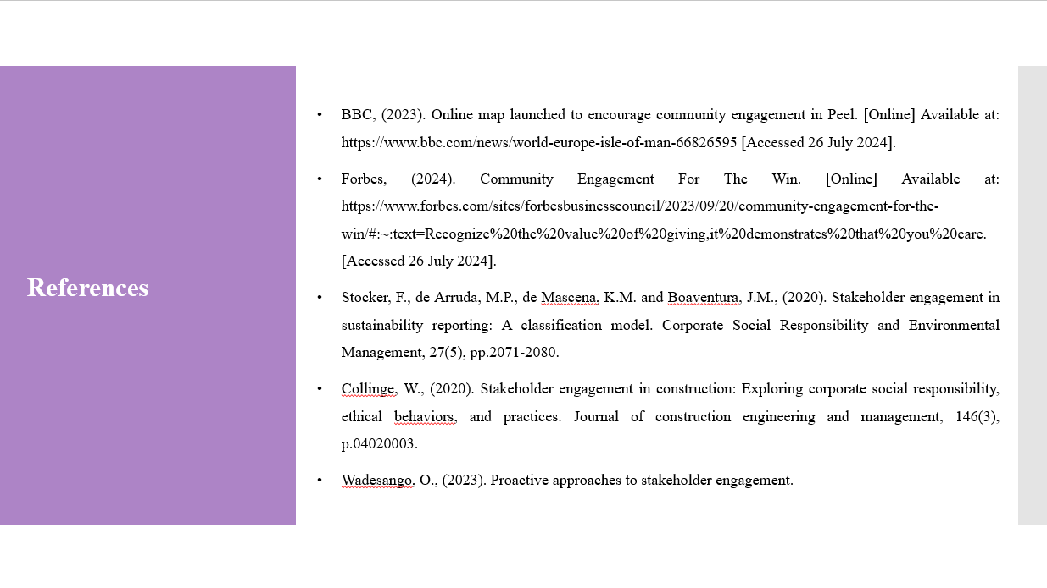
Baker, D.G., (2024). Race, ethnicity and power: A comparative study. Taylor & Francis.
BBC, (2023). Online map launched to encourage community engagement in Peel. [Online] Available at: https://www.bbc.com/news/world-europe-isle-of-man-66826595 [Accessed 26 July 2024].
Cleland, J., Buxton, J., Hughes, E. and Patterson, F. (2024). Translating government policy into practice: How new UK medical schools enact widening participation. Medical Education.
Collinge, W., (2020). Stakeholder engagement in construction: Exploring corporate social responsibility, ethical behaviors, and practices. Journal of construction engineering and management, 146(3), p.04020003.
Compan, P., Kongyok, C., Prommachan, T., Rodsaard, N. and Socheath, M., (2024). Developing and Validating Sustainability Indicators for Measuring Social Impact of University–Community Engagement Programs. Sustainability, 16(12), p.5232.
Craig, S.L., Eaton, A.D., Brooks, A.S., McInroy, L.B., Lozano-Verduzco, I., Austin, A., Dentato, M.P., Mendoza Perez, J.C. and McDermott, D.T., (2024). Building bridges and breaking down silos: A framework for developing interdisciplinary, international academic-community research collaborations for the benefit of sexual and gender minority youth. Psychology & Sexuality, 15(1), pp.19-37.
Estima, A. (2024). Blended Learning in Marketing Education: Using Alumni Experiences to Increase Student Motivation. Journal of Higher Education Theory & Practice, 24(6).
Forbes, (2024). Community Engagement For The Win. [Online] Available at: https://www.forbes.com/sites/forbesbusinesscouncil/2023/09/20/community-engagement-for-the-win/#:~:text=Recognize%20the%20value%20of%20giving,it%20demonstrates%20that%20you%20care. [Accessed 26 July 2024].
Greenhalgh, T., Payne, R., Hemmings, N., Leach, H., Hanson, I., Khan, A., Miller, L., Ladds, E., Clarke, A., Shaw, S.E. and Dakin, F. (2024). Training needs for staff providing remote services in general practice: a mixed-methods study. British Journal of General Practice, 74(738), pp.e17-e26.
Hayes, D., Camacho, E.M., Ronaldson, A., Stepanian, K., McPhilbin, M., Elliott, R.A., Repper, J., Bishop, S., Stergiopoulos, V., Brophy, L. and Giles, K., (2024). Evidence-based Recovery Colleges: developing a typology based on organisational characteristics, fidelity and funding. Social psychiatry and psychiatric epidemiology, 59(5), pp.759-768.
Heley, J., Sanders, A., Caerwynt, F., Zaidi, N. and Power, S. (2024). The royal Welsh agricultural society: Patronage and the reproduction of elites in rural Wales. Journal of Rural Studies, 108, p.103291.
Kelly, W.B. and Given, L.M., (2024). The community engagement for impact (CEFI) framework: an evidence-based strategy to facilitate social change. Studies in Higher Education, 49(3), pp.441-459.
Lowe, T. and Wright, S., (2024). Mapping the student experience: A framework for assessing student support, success, community and voice. Student Success, 15(1), pp.92-98.
Maclaren, A.S., Locock, L., Skea, Z., Cleland, J., Denison, A., Hollick, R., Murchie, P., Skåtun, D., Watson, V. and Wilson, P. (2024). ‘Moving to the countryside and staying’? Exploring doctors’ migration choices to rural areas. Journal of Rural Studies, 108, p.103210.
Parker, L., Richardson, T., Hunnisett, C. and Armstrong, K. (2024). On a Commercial Scale–Archaeological Geophysics in England. In World Archaeo-Geophysics: Integrated minimally invasive approaches using country-based examples (pp. 215-241). Cham: Springer International Publishing.
Rogers, M., Johnson, A., Bird, J., Serow, P., Harrington, I. and Bible, V., (2021). Stakeholder engagement in an online community education project via diverse media engagements. Issues in Educational Research, 31(2), pp.626-643.
Sabet, N.S. and Khaksar, S. (2024). The performance of local government, social capital and participation of villagers in sustainable rural development. The Social Science Journal, 61(1), pp.1-29.
Souto-Otero, M., Donnelly, M. and Kanol, M. (2024). A transactional or a relational contract? The student consumer, social participation and alumni donations in higher education. British Journal of Educational Studies, 72(1), pp.85-107.
Stocker, F., de Arruda, M.P., de Mascena, K.M. and Boaventura, J.M., (2020). Stakeholder engagement in sustainability reporting: A classification model. Corporate Social Responsibility and Environmental Management, 27(5), pp.2071-2080.
Wadesango, O., (2023). Proactive approaches to stakeholder engagement.

