

Student Name: Swasti sakariya
Student ID: 2532368
Module Name: Ethical Hacking
Module Code: ACCA7033
Lecturer’s Name: Dr. Anum Paracha
Word Count: 5200
Term 1

Executive Brief
The simulated Red Team exercises on the ABCD Ldt clearly show that the existing security defences are very weak against the modern cybersecurity threats and adversary tactics. The main business risks are basically the severe data loss and the operational downtime which has been found in this exercise. This can significantly help the attackers to move laterally in the network system for the public-facing web servers to the internal domains controller with little detection, respectively. This also increases the risk of the Living-off-the -Land techniques here, the legitimate systems tools to hide the malicious activities.
The organisation must have to implement the Zero Truist Architecture and also applies some strict rules like network segmentation to reduce the blast radius of any cyber-attack in the network system. It can also implement the phishing-resistant Multi-Factor Authentication which is very important to stop any kind of the unauthorised access. In order to fix current gaps, it is very important to improve the detection capabilities with the help of the telemetry collection and updates to the Endpoints Detection and Response configuration. These are some of the key investments which need to be focused by the organisation in order to reduce the future cyber risks and also strengthen the defences of the organisation.

Table of Contents
Task 1: Strategic Threat Analysis - From Headlines to TTPs: A Strategic Analysis 5
1. Introduction 5
2. Incident Overview and Timeline 5
2.1 Incident Summary 5
2.2 Timeline of Events 6
3. Adversary TTP Mapping 7
3.1 Attack Chain Mapping 9
3.2 Privilege Escalation, Lateral Movement and Impact 9
4. Root Cause and Security Control Failure 12
4.1 Technical Failure 12
4.2 Organisational Failure 12
4.3 Human Factor 13
5. Threats Actors Profile and Motive 13
6. Detection and Response Analysis 14
7. Strategic Recommendations 15
7.1 Prevention 15
7.2 Detection 15
7.3 Response 16
8. Conclusion 16
Task 2: Red Team Engagement: ABCD Ltd — Complete Penetration Testing 18
1. Introduction 18
2. Rule of Engagement 18
3. Threat Emulation Plan 19
3.1 Objectives and Success Criteria 19
3.2 Attack Phase and MITRE ATT&CK Mapping 19
4. Lab Environment 21
4.1 VM Configuration 22
5. Exploitation Requirements 31
5.1 Exploit A- Remote code execution against the web application on VM-2 31
5.2 Exploit B – Privilege escalation or lateral movement inside the Windows domain (VM - 1) 37
5.3 Exploit C: Client-side or service-side exploit to access sensitive files on VM-3. 47
6. Operational Execution 51
7. Tools and Techniques 53
8. Containment and Safety 54
9. Conclusion 55
References 56
Appendix 59
Appendix - A 59
Appendix B: RoE and Threat Emulation Plan 60

Task 1: Strategic Threat Analysis - From Headlines to TTPs: A Strategic Analysis

1. Introduction
The report, which will be designed here, clearly analyses the cyber-attack campaigns which mainly involve Mark & Spencer and Co-operative Group, which are reported here as part of coordinated threat activity, respectively. Several modern cybersecurity landscapes are increasingly shaped by highly sophisticated adversaries which carries out targeted attacks to the large retail organisations. This often uses multi-stage intrusion techniques to gain some financial or operational disruptions, respectively. Apart from this, it also analyses the incident timeline, adversary tactics, techniques, as well as procedures using the MITRE ATT&CK framework, respectively [1]. The main aim is to create the structures understanding of how the attack is done and also identify several vulnerabilities which can be further exploited. It also determines the effectiveness of detection and response mechanisms, respectively. Findings are also supported by current research, industry reports and cybersecurity frameworks, which can ensure that a comprehensive and evidence-based evaluation of the incident.

2. Incident Overview and Timeline

2.1 Incident Summary
The cyber incident which has been occurred in Mark & Spencer and Co-operative Group has done serious disruption to the UK retail operations, respectively. In the analysis of this incident, it has been found that the incidents are part for the campaign targeting the retail stores and their operations, respectively. According to the several reports, it has been found that the attackers have gained unauthorised access to the internal parts of the system, respectively [2]. This significantly done the operational delays and exposed several sensitive data points. The attackers have used several techniques in this incident which are lateral movement in the network, phishing and exploiting vulnerable services, respectively. This clearly show that how the modern cyber-attacks can exploit technical weakness, human factors and gaps, respectively.

2.2 Timeline of Events
The timeline event gives a proper structured review of how the cyber-attack on Marks & Spencer and Co-operative Group unfolded, respectively. It also shows that the progression of the attack from initial access to the final redemption clearly helps to understand the attacker’s behaviour and also the organisational responses, respectively.
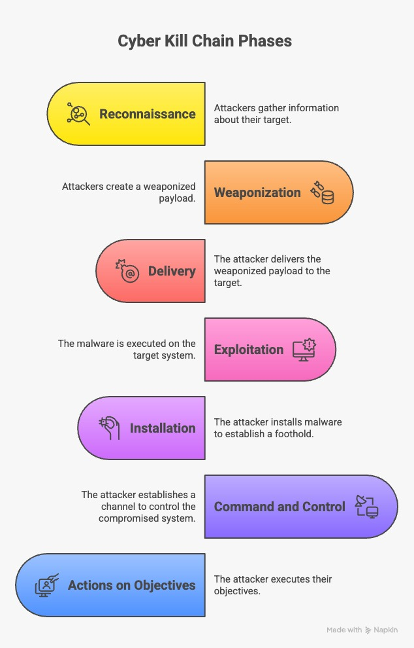
Figure 1: Stages of Cyber Kill Chain

- It is very important that after analysing the issues, the actions must be taken to control and also reduces the damage. This mainly includes isolating affected systems, assessing the scope of the breach and starting the recovery, respectively. After this the incident must be disclosed to the public, and also try to work on recovery as soon as possible.
- As the attack progressed and the adversary executed activities such the unauthorised data access and potential data exfiltration, and systemic disruption. Furthermore, the incident was ultimately identified through either internal security detection systems or external notification channels, thereby initiating the response phase. In numerous instances and these actions may persist covertly over an extended duration due to inadequate monitoring or insufficient logging mechanisms [3].
- Here the attacks start in the initial access phase by using several techniques like phishing or exploitations of several vulnerable systems, respectively. After this, the attacks move to the lateral movement into the network, and then the attackers gain unauthorised access to the system [4]. In this stage he attackrs often go undetected and exploit the weaknesses.
- This clearly show that the delay in the detection as well as the response have increased the impact of the attack on the organisations. Respectively. This clearly shows the importance of proactive monitoring and a rapid incident response strategy is required, respectively [5].

3. Adversary TTP Mapping
The attacks which are done in these organisations are mainly done by the group named Scattered Spider group. This group has basically used a DragonForce ransomware, which clearly show a modern multi-stage intrusion campaign. This group has used social engineering, credential misuse and also ransomware deployment, respectively [6]. Here in this section, the MITRE ATT&CK framework is used to clearly show how the cyber-attacks have happened in these organisations, respectively.
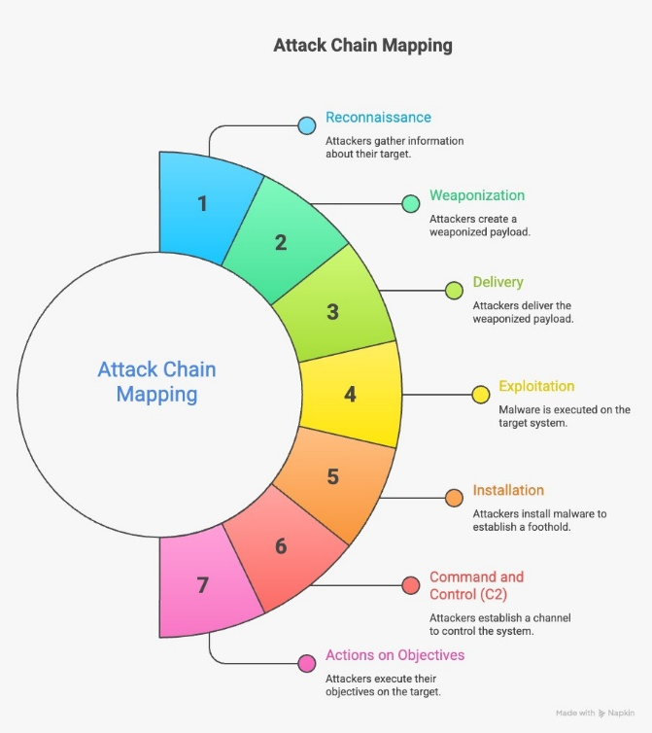
Figure 2: Attack Chain Mapping

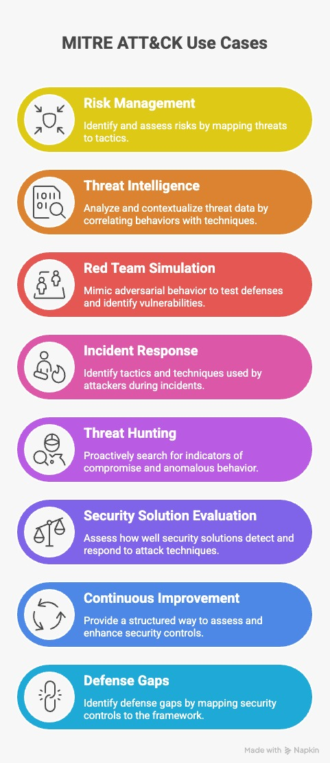
Figure 3: MITRE ATT&CK Framework
The above diagrams clearly show the sequential progression of the attack and the relations with the MITRE tactics, respectively.

3.1 Attack Chain Mapping
The attacks on these organisations are done by the Scattered Spider which uses phishing, SIM-Swapping and also MFA fatigue attacks which gain unauthorised access, respectively [7]. Several pieces of evidence show that the attackers pretended to be employees and tricked IT help desk staff into resetting passwords, allowing them to successfully bypasses authentication controls, respectively. The attackers used real stolen login details (T1078) to enter internal systems without setting off any alerts. The attack started with the initial access where they used social engineering and phishing methods (T1566) to trick users and gain entry.
Research shows that attackers often mix credential harvesting with session hijacking techniques to keep continuous access [8]. The growing use of legitimate administrative tools also shows the shift Living-Off-the-Land strategies and are widely recorded in recent cybersecurity literature as a salient method of avoiding endpoint detection systems. Proof of session hijacking is limited in this case; the continued access seen suggests that similar identity persistence mechanisms may have been used along with Valid Accounts (T1078).

3.2 Privilege Escalation, Lateral Movement and Impact
The attackers are moving the stolen passwords and username in the network by using the remote access tools “T1021”, respectively. The attacks have finally over when the data has been successfully sent out with the help of the command-and -control channels “T1041”, respectively. This significantly make the attacks spread all over the network without being noticed quickly. The DragonForce ransomware has blocked the system and also interrupted the daily business activities, respectively. The attackers have significantly increased their presence in the system because they have stayed longer period of the time using the Exploitation of Privilege Escalation “T1068”. These mainly includes hiding their activities which clearly avoids detection and also uses the normal built-in system tools, respectively. These methods are very sophisticated and can easily bypass several traditional security systems and monitoring tools that can detect and respond to malicious behaviour, respectively. The attackers have also used the evasion techniques “T1027” to stay hidden.

Tactic | Technique | ATT&CK ID | Evidence-based Justification
Initial Access | Phishing / social Engineering | T1566 | Help desk impersonation enabled credential reset
Initial Access | Valid Accounts | T1078 | Use of stolen credentials to access systems undetected
Execution | Command & Scripting Interpreter | T1059 | PowerShell used for malicious execution (Yulianto et al., 2025).
Persistence | Account Manipulation | T1098 | Accounts modified to maintain long-term access
Privilege Escalation | Exploitation for Privilege Escalation | T1068 | Privileges elevated after initial compromise
Credential Access | Credential Dumping | T1003 | Active Directory credentials extracted
Discovery | Network Service Scanning | T1046 | Internal systems scanned to identify targets
Lateral Movement | Remote Services | T1021 | Movement across systems using valid credentials
Defence Evasion | Obfuscated Files or Information | T1027 | Use of stealth techniques to avoid detection
Exfiltration | Exfiltration over C2 Channel | T1041 | Data theft and ransomware deployment

Table 2: Attack Chain Phase Mapping:
Attack Phase | Description | Associated TTPs
Initial Access | Social engineering and credential compromise | T1566, T1078
Execution | Malicious script execution | T1059
Persistence | Maintaining access | T1098
Privilege Escalation | Gaming admin-level access | T1068, T1003
Discovery | Network reconnaissance | T1046
Lateral Movement | Spreading across systems | T1021
Defence Evasion | Avoiding detection | T1027
Exfiltration & Impact | Data theft and ransomware | T1041

4. Root Cause and Security Control Failure

4.1 Technical Failure
The main issues were here is that the implementation of identity and access management controls is very poor and also lacks several uses of the multifactor authentication, respectively. This incident clearly show the adhere are several serious technical weaknesses that help the attacks tore enter the system easily and operate in the network environment, respectively.
This allowed attackers to use compromised credentials without any extra verification [9]. Apart from this the poor network segmentation let attackers move laterally across systems without facing significant barriers, thereby causing a deleterious impact on the overall breach level. The use of the legacy systems and possible unpatched vulnerabilities can also increase the risk of attacks, respectively. This will significantly make the exploitation much easier.

4.2 Organisational Failure
After the analysis it has been found that there were a lack of a regular and systematic audits which can details the risk assessment, respectively. Apart from this, the incident response planning is very weak and also not properly implemented in these organisations, respectively. There was also a lack of the cybersecurity governance framework and also a very weak enforcement of then security policies [10]. This can significantly create a vulnerability and can be easily exploited by the attackers, respectively. Apart from this, it has also been found that there was a very limited implementation of smart detection system like SIEM and EDR solutions because these systems are very important to identify the complex attacks, respectively. There are also very poor communication gaps between the IT and security teams, which can affect the response process and also create a huge dilemma in these types of critical moments. The organisation problems play an important role in the success of the attack.

4.3 Human Factor
It is very important to understand that the human factor is also one of the key factors in the incident because in the initial phases of attacks, several humans have made several mistakes, respectively.
- Low awareness of phishing and impersonation attacks
- Too much trust-based processes in IT support functions
- Failure to properly identify any suspicious behaviour or unusual requests.
- Insufficient training on verifying identity before resetting credentials.
- These weaknesses show importance of ongoing security awareness training and stricter verification procedures to reduce the risk of human-related vulnerabilities here.

5. Threats Actors Profile and Motive
There is a threat group whose name is Scattered Spider, and this group is responsible for the cyber incidents which has happened in Mark & Spencer and the Co-operative Group, respectively [11]. This group is basically a financially based cybercriminal collective, respectively. Their actions are basically linked with the ransomware-as-a-service models which are DragonForce and this allows a scalable and coordinated attack, respectively. This group often targets large organisations that are mainly linked with the telecommunications sectors, respectively.
The Scattered Spiders have highly skilled hackers who are trained to bypass several traditional security systems using identity-based attacks, respectively. The main motive of this group which has done the attack is for the financial gains which is achieved through the data exfiltration and also a ransomware deployment, respectively. This group mainly focuses on exploiting human weaknesses and organisation, respectively.
Attribute | Details
Type | Cybercriminal groups
Common Techniques | Phishing, credential abuse, and lateral movement
Target Sector | Retail, telecommunication
Motivation | Financial gains like data theft
Capability Levels | Advanced because they use social engineering and TTPs
Associated Malware | DragonForce ransomware
Threat Actor | Scattered Spider

This attack clearly show that it was very well-organised and a profit-based motive and it use the technical and human vulnerabilities, respectively.

6. Detection and Response Analysis
One of the main problems was low visibility of identity-based attacks. Lack of behavioural analytics further caused the inability to detect anomalies in user actions, a paradigm issue overall, respectively [12]. Because attackers used valid credentials, common security tools found it hard to tell malicious behaviour from normal user activity. Poor logging and monitoring of privileged accounts lowered chances of early detection.
It has been analysed that the detection and response to the M&S and Co-op cyber incident clearly show that there are several gaps in technical monitoring and organisational preparedness, respectively. This clearly shows some of the latent weaknesses in real-time monitoring and also a lack of the co-relations between security events, respectively [13]. There are some suspicious activities are also identified when the attackers are able to operate inside the network for more time before it is detected, respectively.
There are some gaps which are:
- Failure to detect unusual help desk activities
- Absence of a real-time threat intelligence integration
- Inadequate logging of authentication and access events.
- No proper advanced monitoring tool like SIEM and UEBA
When there is a delay in response then it will give time to the attackers to move laterally [14]. There were also several gaps in the communication between the teams and it was not well coordinated which clearly showed some lack on mitigation effort, respectively.

7. Strategic Recommendations

7.1 Prevention
To prevent these types of similar attacks, the organisations have to fortify identity as well as the access management controls. It is very important to do regular patch management and also the vulnerability assessment, which will significantly help to reduce attacks, respectively. Using phishing-resistant multi-factor authentication in all systems is very important, which will significantly reduce the credential-based attacks, respectively [15]. Network segmentation will also be applied to limit lateral movement, which will help to prevent attackers from reaching the critical systems, respectively. Apart from this, the Zero Trust Architecture can also be used to verify the user from various levels, respectively.

7.2 Detection
The organisations must implement monitoring, logging and checking of the security systems by implementing better detection systems, respectively. There are several Real-time threat intelligence integrations that can help to spot known attack indicators early, respectively [16]. Continuous monitoring of privileged accounts and also the authentication logs can be analysed to identify any kind of suspicious behaviours, respectively.
SIEM System | Purpose | Priority
SIEM System | Centralised log analysis | High
Threat Intelligence | Identify known threats | Medium
Log Monitoring | Track system, activities | High
UEBA | Detect abnormal user behaviour | High

7.3 Response
It is very important to have clear communication channels between the IT, security and also the management teams which are very essential for the smooth coordination, respectively [17]. Apart from this, the successful plan must be created after this incident was oven and a review should be carried out to clearly understand what the weaknesses were and what needs to be improved, respectively. A proactive and strictures response strategy is very important for reducing the operational disruptions [18]. It also helps in reducing and controlling the overall impact of the cyber attacks in the systems, respectively. A good response framework must focuses on the fast containment and also a well-coordinated actions in a clear and organised way, respectively.

8. Conclusion
There are several outcomes which clearly show that the old security methods are no longer relevant to use because they often fail to protect against the identity based or stealth-based attacks, respectively. The main significance of the user awareness, robust identity management and continuous monitoring, respectively. Linking the incident to the MITRE ATT&CK framework gave an understanding of the adversary’s tactics, techniques, and procedures, while also exposing critical weaknesses in technical controls, organisational practices, and human awareness. The attack showed a clear step-by-step movement across the attack chain, using social engineering, credential abuse, and lateral movement to reach its goals. The organisation must have to use more proactive and layered security approaches that significantly combines the strong and preventive controls, respectively. Apart from this, the study of the cyber incidents impacting Marks & Spencer and the Co-operative Group shows the rising multifaceted of modern cyber threats, especially those caused by financially motivated threat actors.

Task 2: Red Team Engagement: ABCD Ltd — Complete Penetration Testing

1. Introduction
This report here clearly determines a controlled red team engagement that is done in the virtual lab environment, respectively. This is done for ABCD Ltd to evaluate its security posture of the organisation. Here in this project, a simulation of realistic cyber-attacks was done against several key systems, which mainly include the web-server, client machine and Active Directory domain controller, respectively [19]. A structured methodology is successfully used here covering reconnaissance, initial access, privilege escalation, lateral movement and data access, respectively. Here the virtual setup which is designed here clearly tells several details and helps to gain several knowledge, respectively. This report also shows several detection gaps and also provides recommendations to strengthen its defensive capabilities and also enhance the overall organisational security resilience against the new cyber-attacks [20]. The main thing that is done here is following ethical hacking principles and adhering to predefined rules of engagement for safety and authorised testing, respectively.

2. Rule of Engagement
The Rule of Engagement clearly explains the scope of the limits for authorisation, and it also show that how the red team assessment in the ABCD Ltd virtual lab environment, respectively. Tese rules significantly ensures that the assessment remain fully controlled and ethical and also aligns with the professional penetration testing standards, respectively. The engagement is restricted in the scope system and this mainly includes the web-server, client machine and Active Directory domain controllers, respectively. Apart from this there is a clearr5t table which is made in then Appendix which shows the scope, allowed and restricted activities, safety measures, communication protocols, and also recovery procedures, respectively [20]. This structured limitation of scope ensures methodological rigour and prevents any deviation from predefined ethical and technical boundaries. There are also several snapshots are provided here to maintain the operational safety, respectively.
There are several activities which mainly include reconnaissance, vulnerability assessment, controlled exploitation, privilege escalation as well as the lateral movement, respectively [21]. Apart from this, there are several harmful methods which are not used here for testing like data corruption, denial-of-service attacks and ransomware attacks, respectively.

3. Threat Emulation Plan

3.1 Objectives and Success Criteria
There are several evidences which must be collected to confirm that each step has been successfully completed and these evidences will basically have session access, screenshots, extracted data and the command output, respectively. This also show that how the attackers avoid any kind of detection and take control over the system for a longer period of time. In this time the attackers will do several activities like accessing credentials, accessing sensitive files, move laterally to another system in the network and also take advantages of the weak systems, respectively. The main purpose of creating the threat emulation plan is to exactly cop each and every scenario of a real-cyber-attacks situations inside the ABCD Ltd virtual lab environment, respectively [22]. The main activity here is to clearly show the full attack lifecycle which starts from the external reconnaissance, and then it moves step by step slowly towards the sophisticated systems. This can also compromise the internal data and these types of attacks must be carried out in controlled manner without affecting any kind cos system availability, respectively [23].

3.2 Attack Phase and MITRE ATT&CK Mapping
Attack Phase | Description | MITRE ATT&CK TTP
Initial Access | Exploit a vulnerable web application or services | T1190 – Exploit Public-Facing Application
Privilege Escalation | Gain higher-level permissions using vulnerabilities | T1068 – Exploitation for Privilege Escalation
Execution | Run malicious commands or payloads on affected systems | T1059 – Command and scripting
Reconnaissance | Identify targets, services and vulnerabilities through scanning | T1595 – Active Scanning
Credential Access | Extract stored or memory credentials | T1003 – OS Credential Dumping
Collection | Gather sensitive data from affected systems (Abo El Rob et al., 2024). | T1005 – Data from Local Systems
Exfilteration | Transfer the collected data the network | T1041 – Exfiltration Over C2 Channel
Lateral Movement | Move across systems using valid accounts or remote services | T1021 – Remote Services
Persistence | Maintain access using backdoors or schedule tasks | T1053 – Scheduled Task
Resource Development | Prepare tools or payloads required for exploitation | T1587 – Develop Capabilities

4. Lab Environment
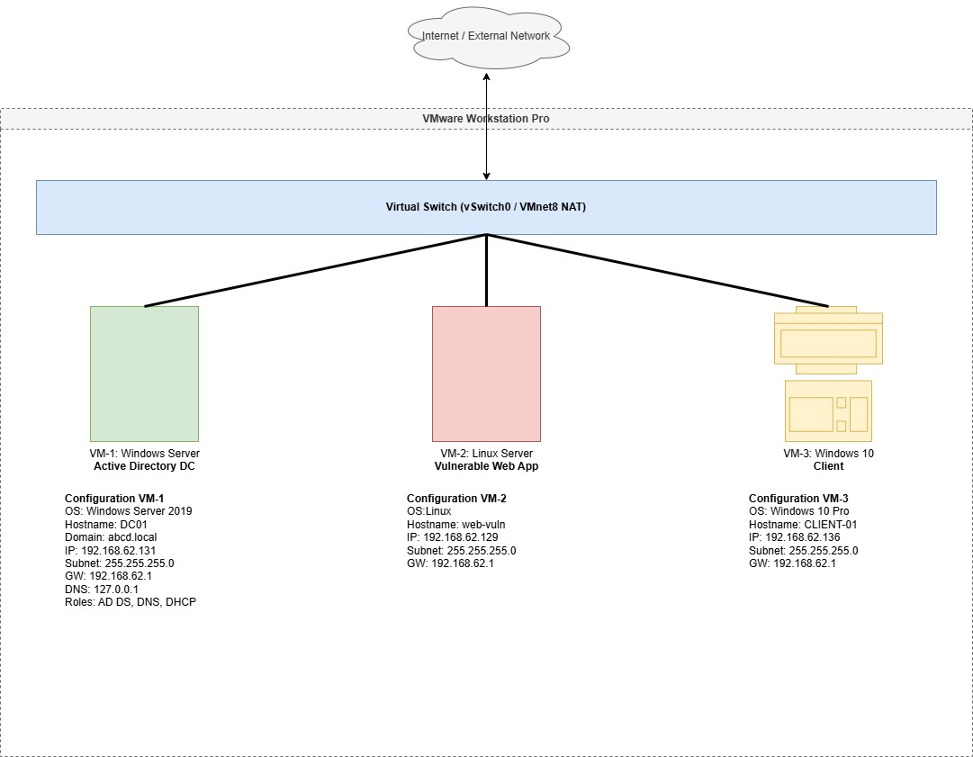
This diagram is basically a network diagram that is drawn here to clearly demonstrate the controlled virtual lab built in VMware Workstation, which mainly uses a NAT-based virtual switch, respectively. As per this diagram, there are mainly 3 machines which are connected, which are mainly Window Server domain controller, a Linux web hosting and a Windows client, respectively. Here, each of the systems is assigned with the static IP address in the same subnet ranges. According to this diagram the system which is created here is very sophisticated and clearly meet the requirement, respectively.

4.1 VM Configuration

4.1.1 VM-1 – Windows Server
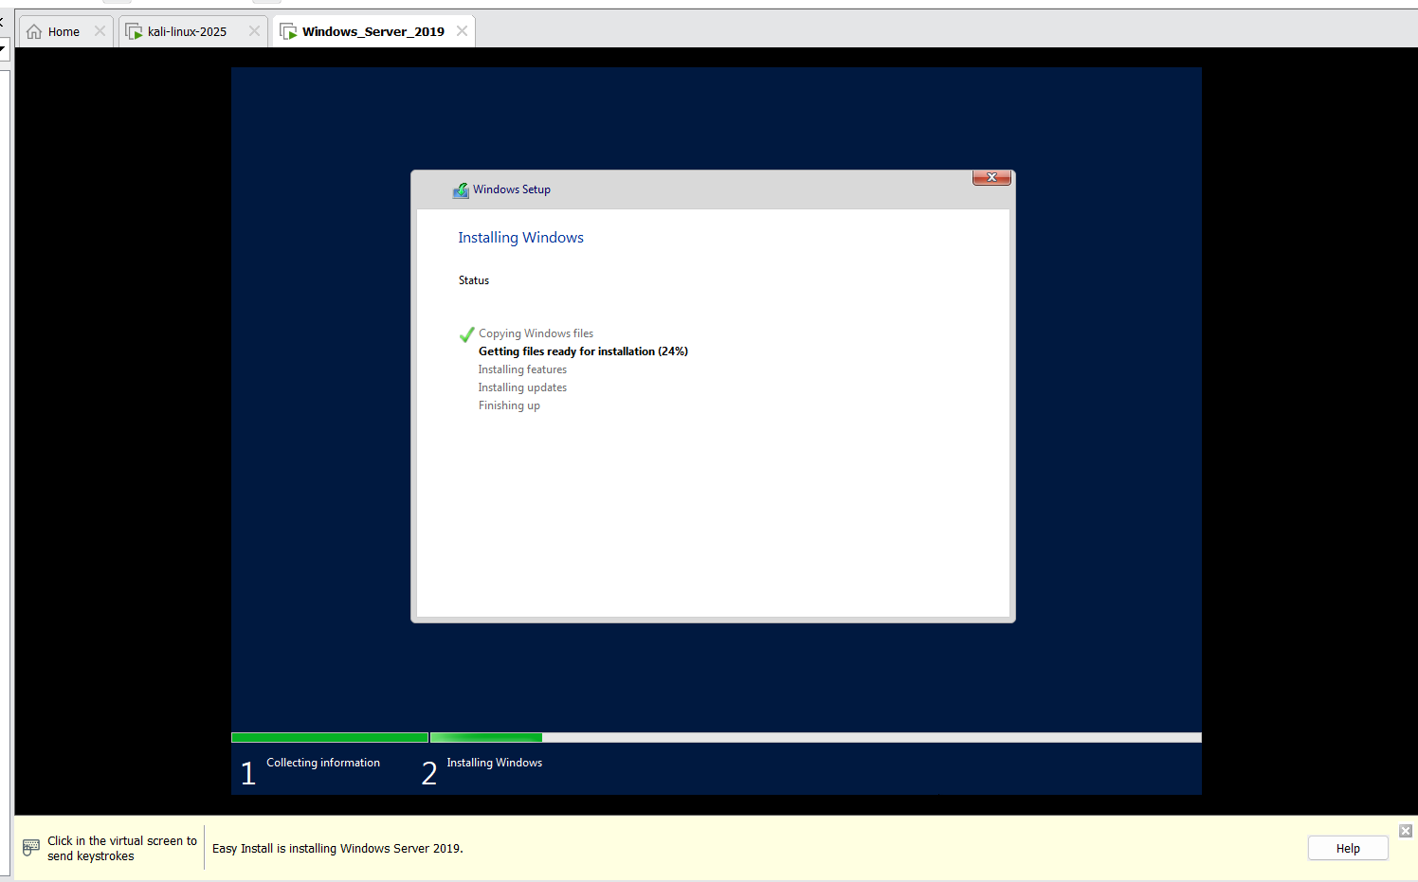
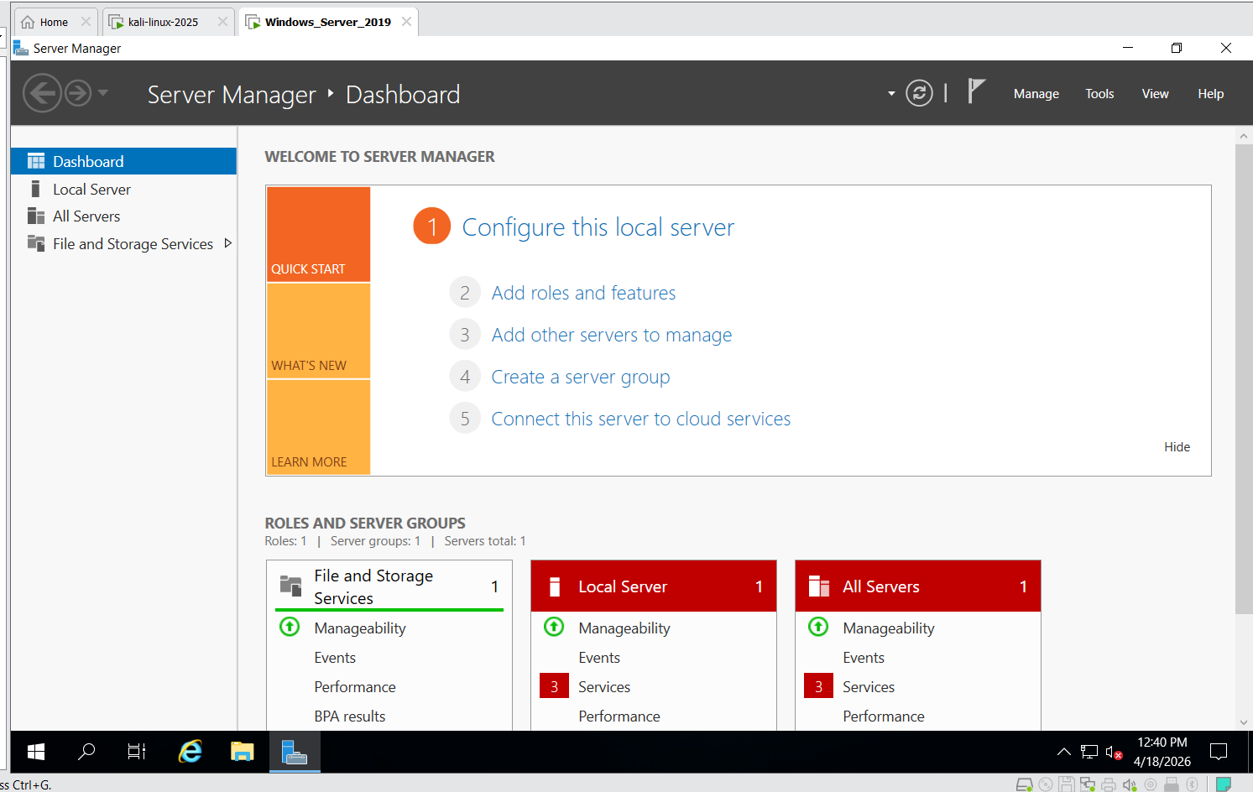
The above images clearly determine the first step and active management of the VM-1. In the first image there is a Window Server 2019 installation which is shown [24]. The second image shows the Manager Dashboard, which means the environment is ready for the Active Directory configurations.
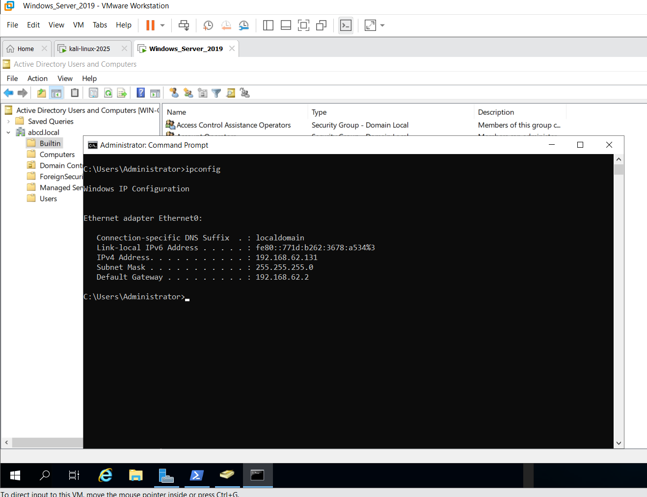
Here it successfully shows that the network setup of the VM-1 network is installed, respectively. The initial images clearly shows that a static IPv4 address which is basically 192.168.62.131 is used by the ipconfig.
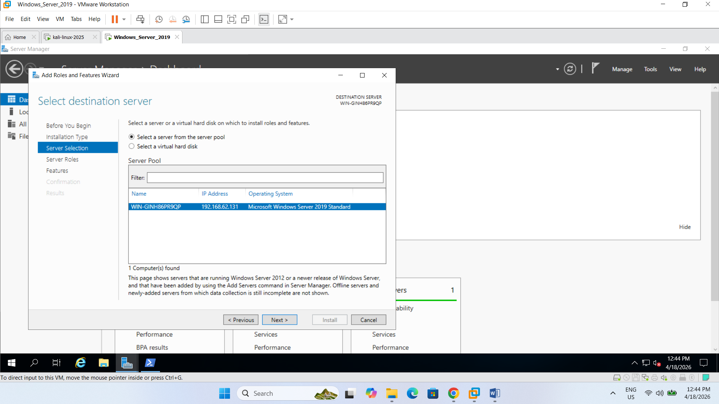

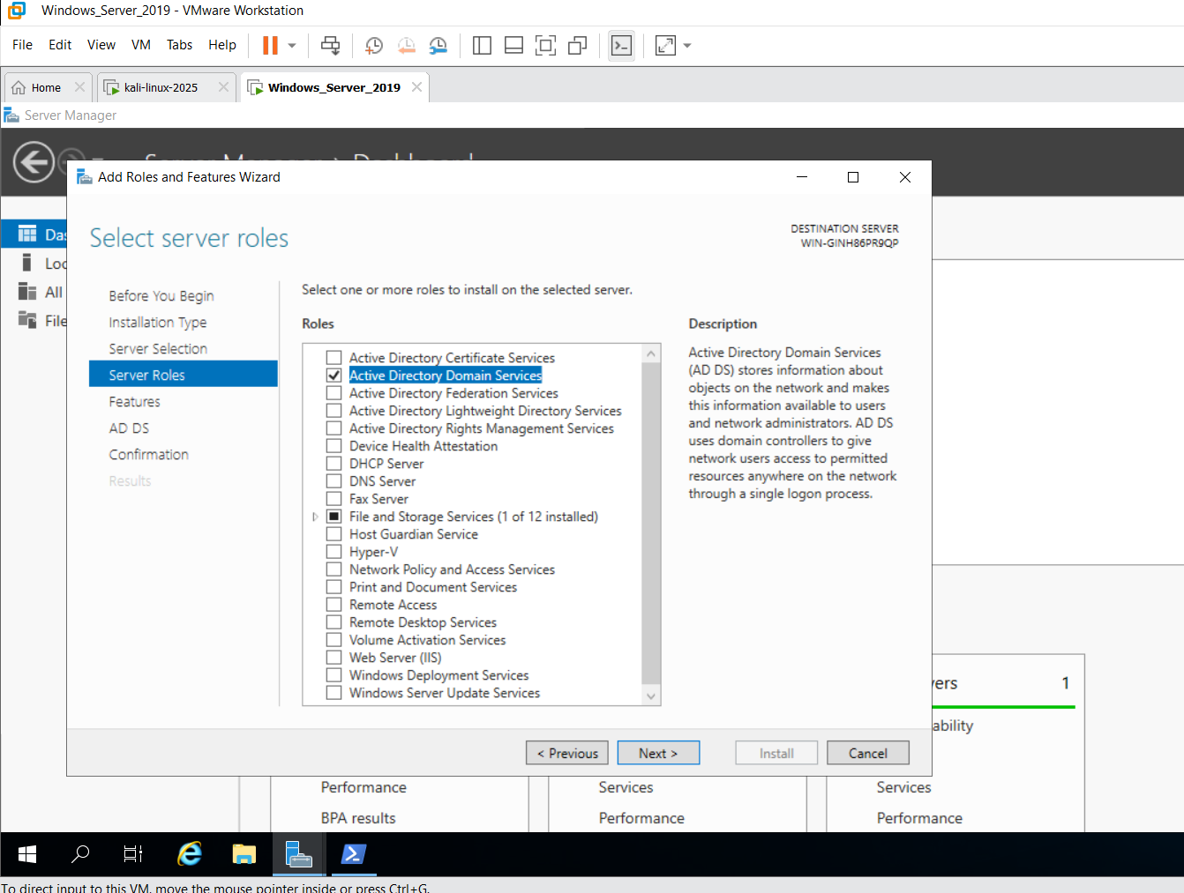
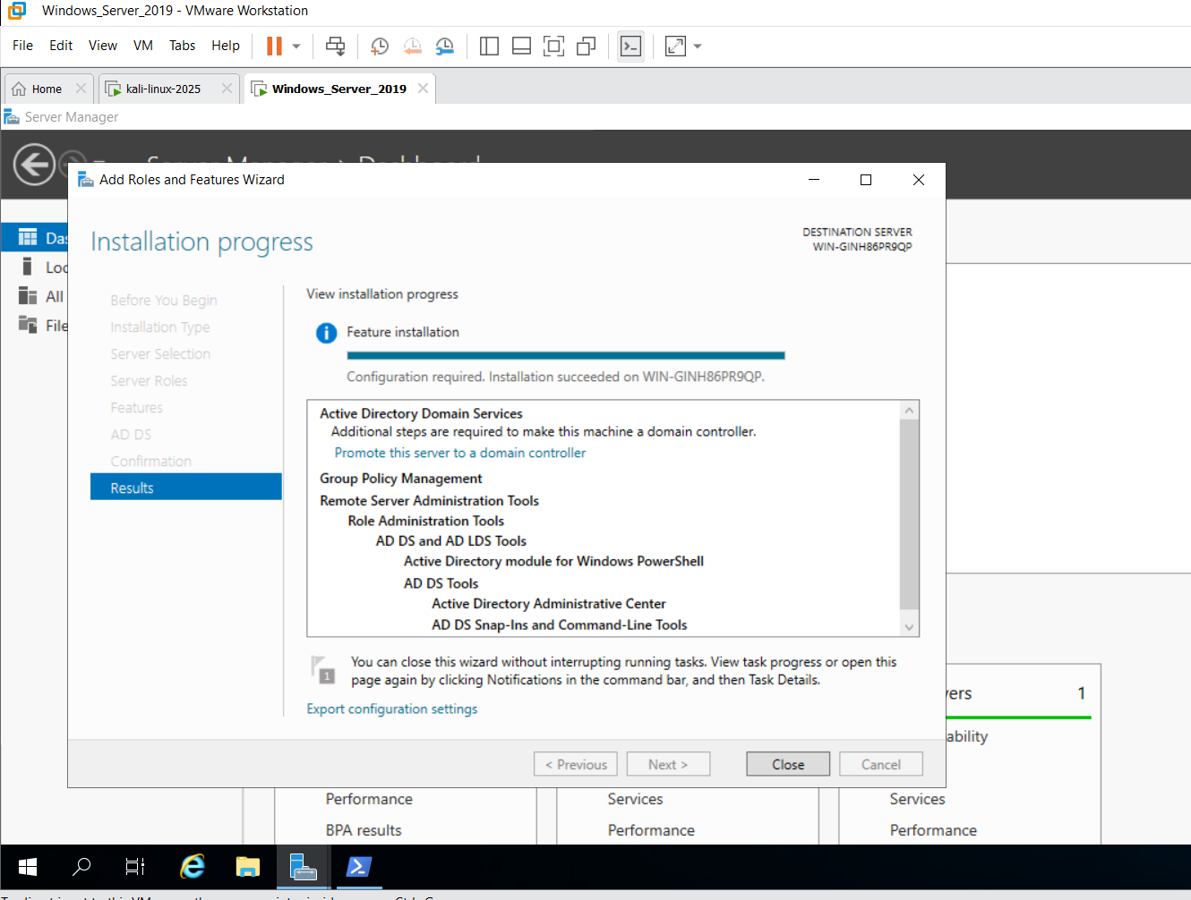
Thes images show the final promotion phase of the VM-1 to a Domain Controller. The first picture shows the Add Roles and Features Wizard selecting the local server for Active Directory integration is successful [25]. The deployment of the new forest is designated as ABCD.local. Then another image shows a successful installation of the DNS Server role and global catalogue which establishes the foundational identity infrastructure needed for ABCD Ltd, respectively.

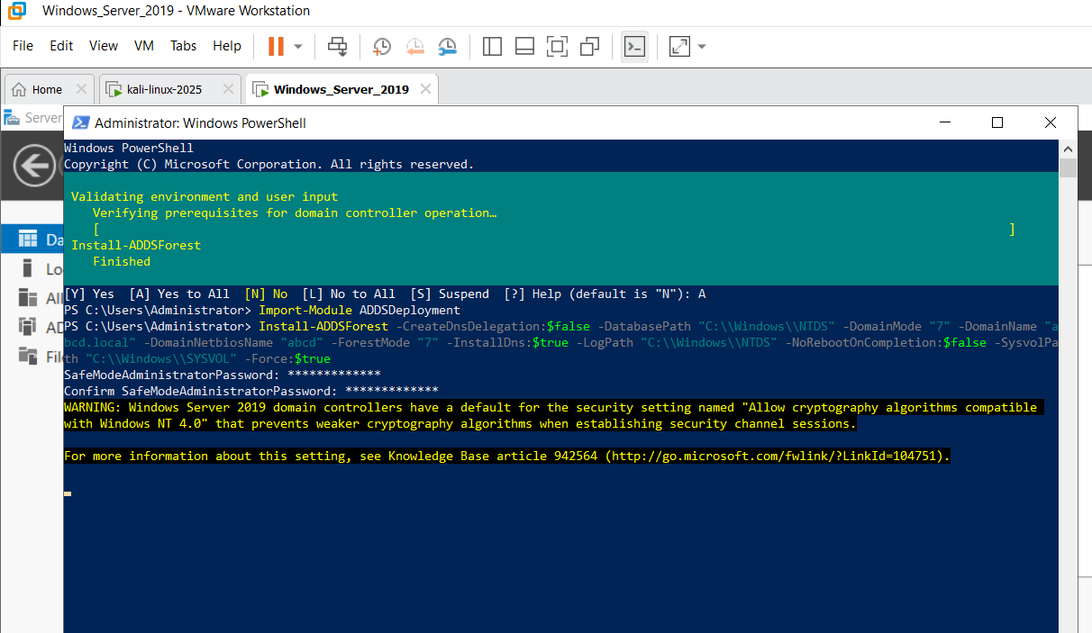
This clearly shows that there is an Active Directory as well as the Computer console, and this also confirms the ABCD.local domain structure which is created here, respectively [26].
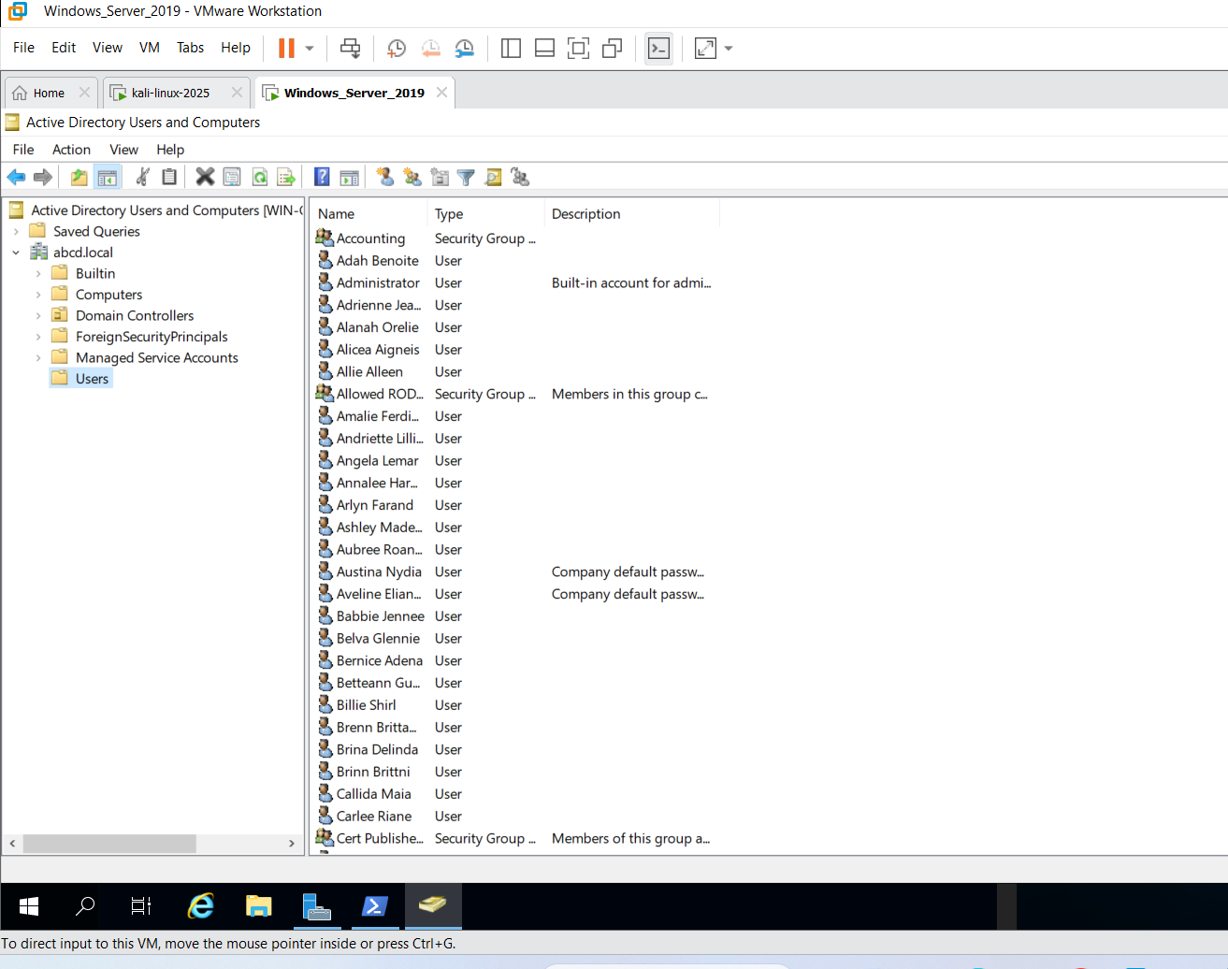
This above image clearly shows that there are several users, groups and organisational units are successfully configured and created here.

4.1.2 VM-2 – Linux Server
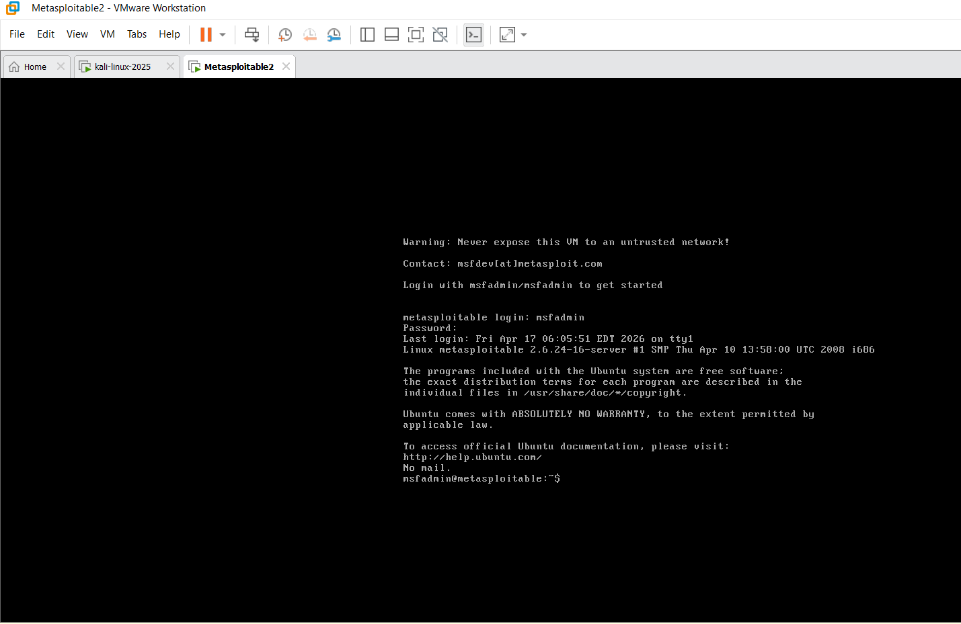
This choice that here a complete setup of the VM-1 linusx has been successfully completed which is a Linux-based web-server. However, it also shows that the Ubuntu 22.04.3LTS is also successfully setup and is currently operating and also provides a needed platform which will host the vulnerable application.
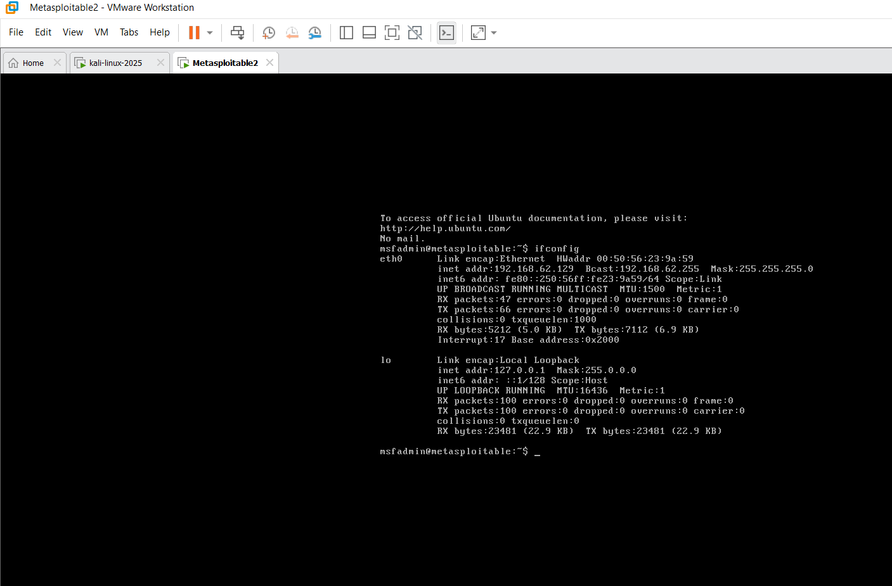
The image shows the network setup for VM-2 using ifconfig. The ens33 interface has the static IP address 192.168.62.129 and which helps maintain connectivity for the hosted vulnerable application inside the simulated ABCD Ltd hybrid corporate network environment.

4.1.3 VM-3 Windows Client
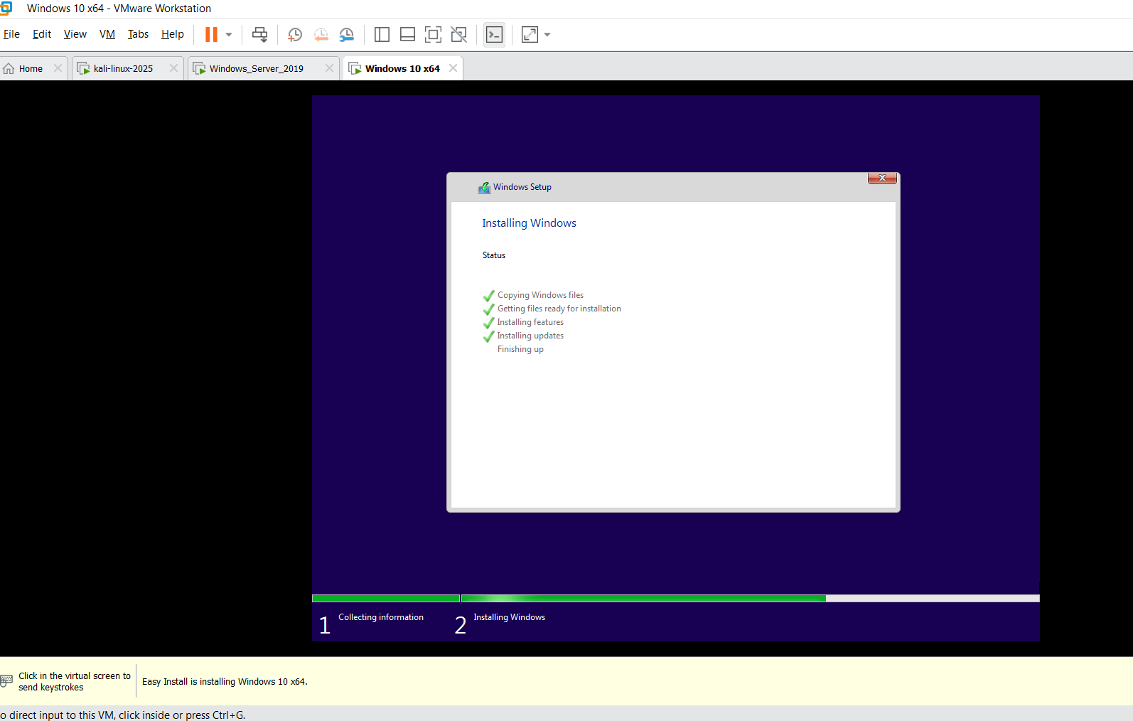
This show that there is a final installations steps was performed here and it clearly show that the files, features and also updates are properly installed here. The screenshot clearly shows that this is an automatic setup of a windows 10 in Virtual Machine in the VMware Workstation, respectively.
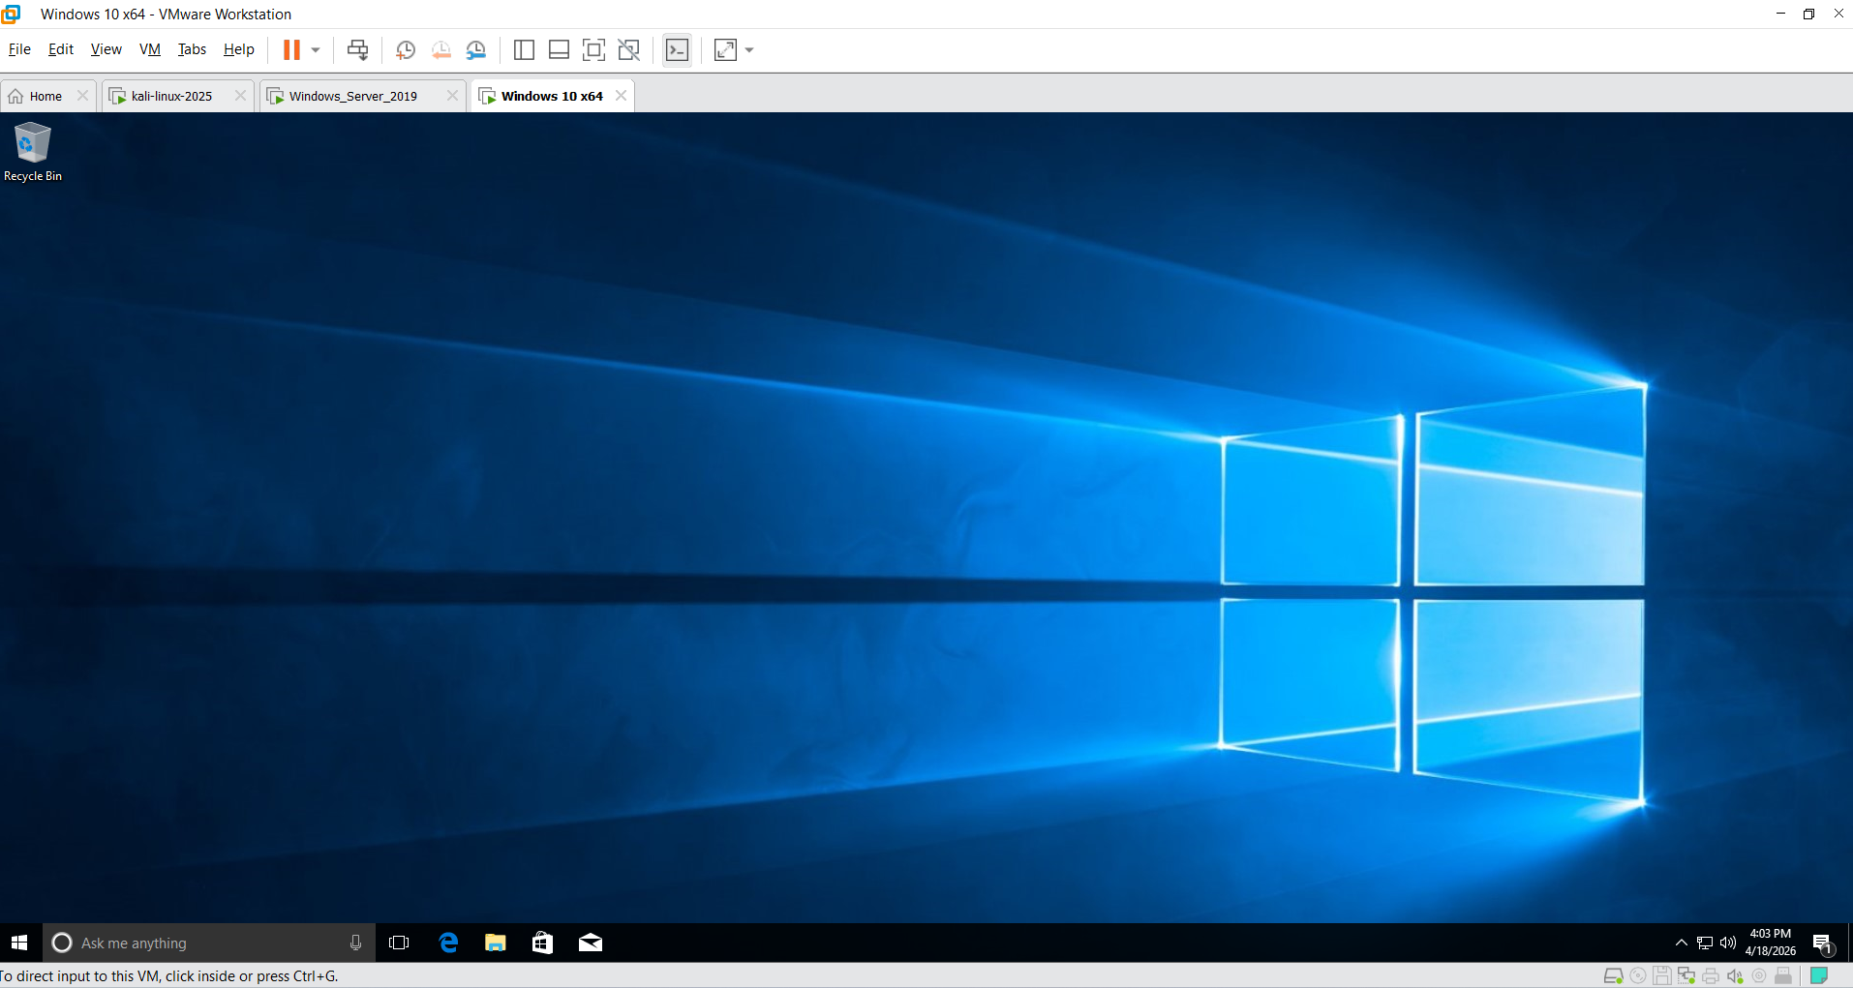
The screenshot shows the successfully completed installation of a Windows 10 x64 virtual machine within VMware Workstation.

5. Exploitation Requirements

5.1 Exploit A- Remote code execution against the web application on VM-2
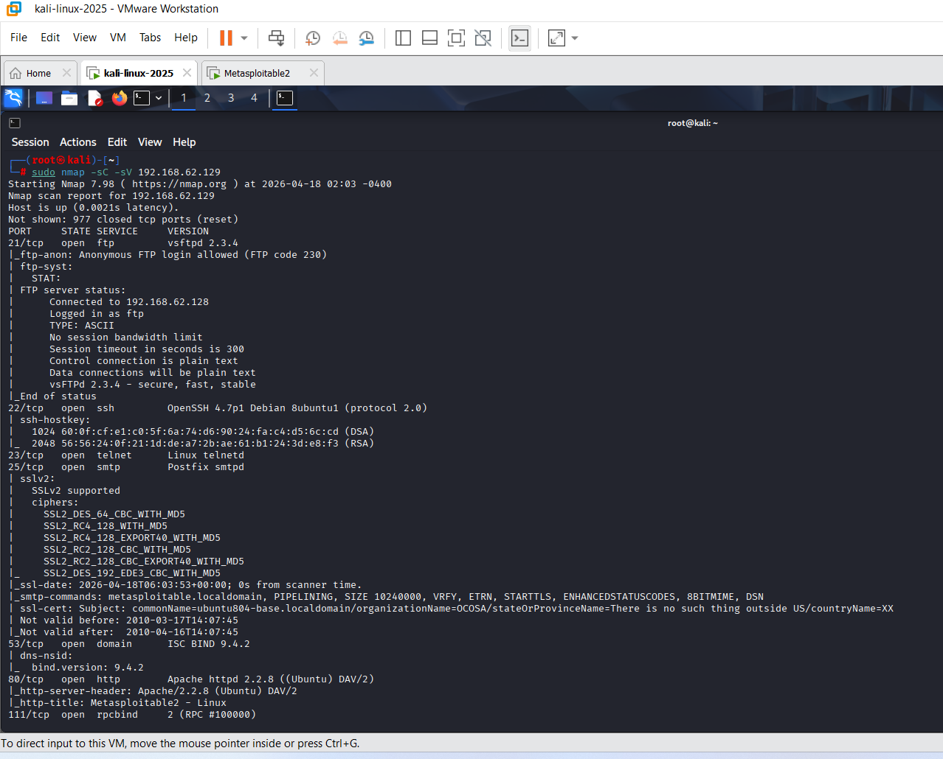
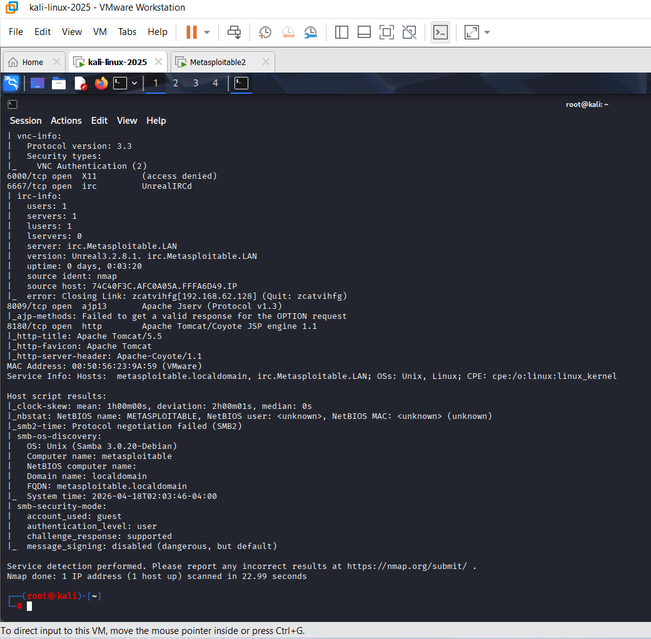
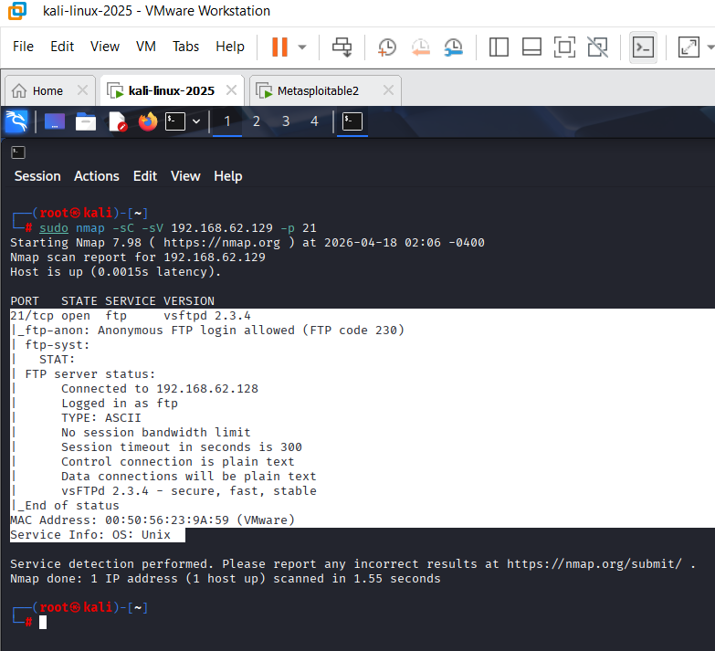
It clearly shows that the is a exploitations has bees started here successfully and the first image confirms that the Nmap output with a proper screenshot, respectively (Singh et al., 2024). The second image show a aggressive service scan done by “-sV” on the IP 192168.62.129. It also shows that there are many ports which are open like Telnet, SMTP, DNS, HTTP. It also runs Apache, respectively.
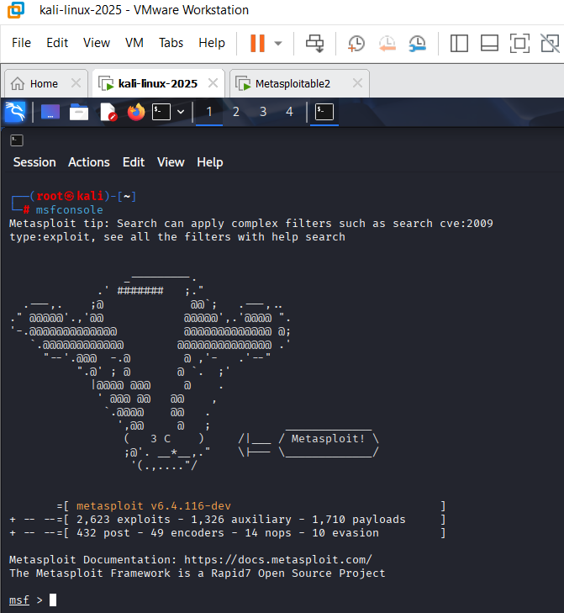
It tells us that there is a console which clearly show that 2623 exploits and also 1326 auxiliary modules are ready for the VM-2 REC attacks. The user can properly start the Metasploit Framework on the Kali for the exploitation.
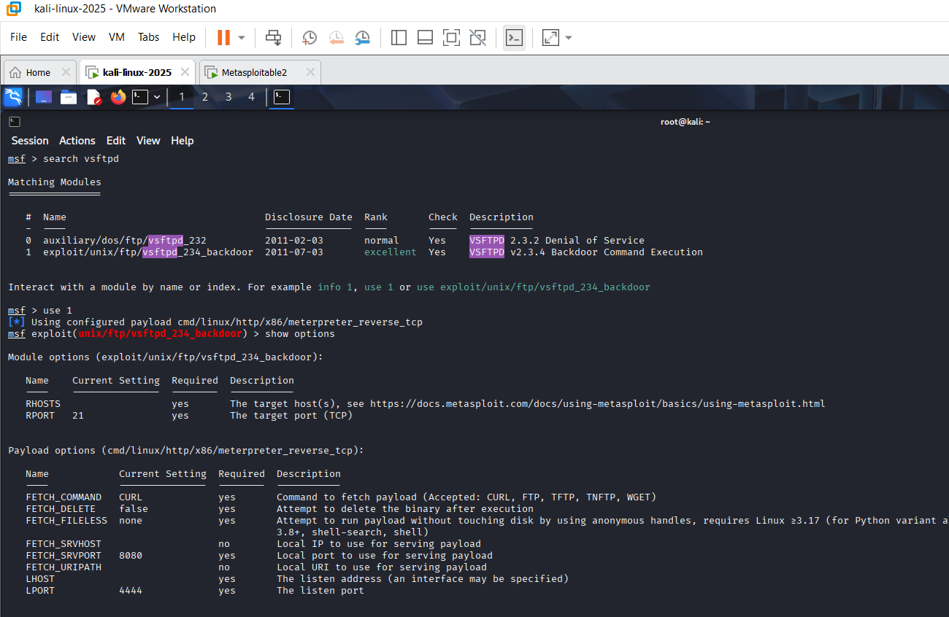
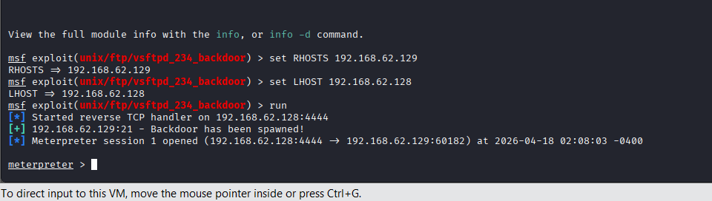
The user here identifies the vftpd_234_backdoor. This is the payload which is set on the port 4444. With the help of the “metermeter_reverse_tcp” there are various items which are running as RHOST and PORT 21 settings, respectively.
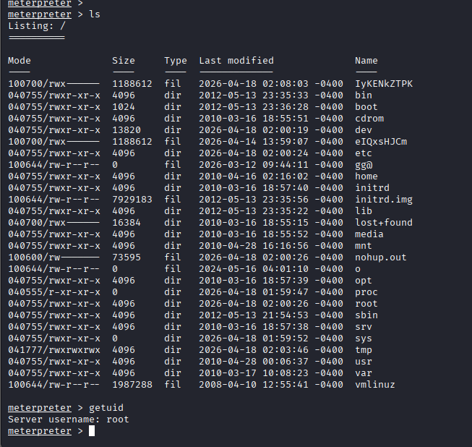
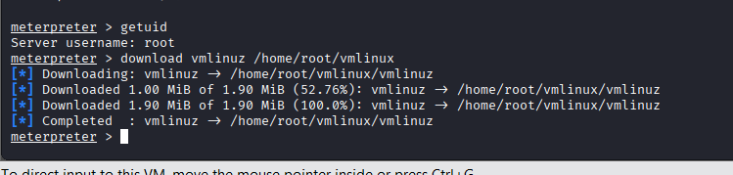
The above image clearly shows several results like the system accounts which have the root, daemon, bin and also the sys. This gave the full system read access remotely. The image show that the Ls command is used and this helps to get a successful root-level directly access on the VM 2. There is one another imager which show that the command has successfully extracts all the target passwords with the help of the Meterpreter.

5.2 Exploit B – Privilege escalation or lateral movement inside the Windows domain (VM - 1)
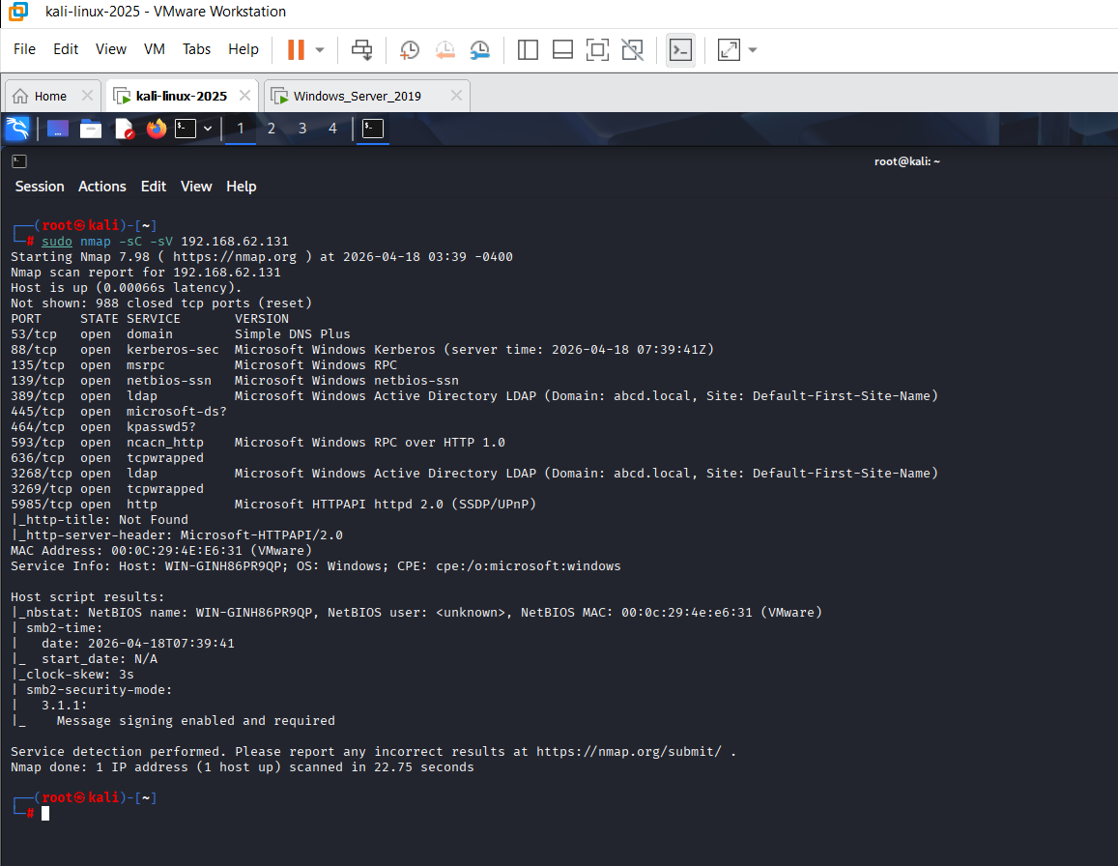
The nmap scan of 192.168.62.131 reveals an Active Directory Domain Controller for abcd.local with open ports including 88, 389, and 445.
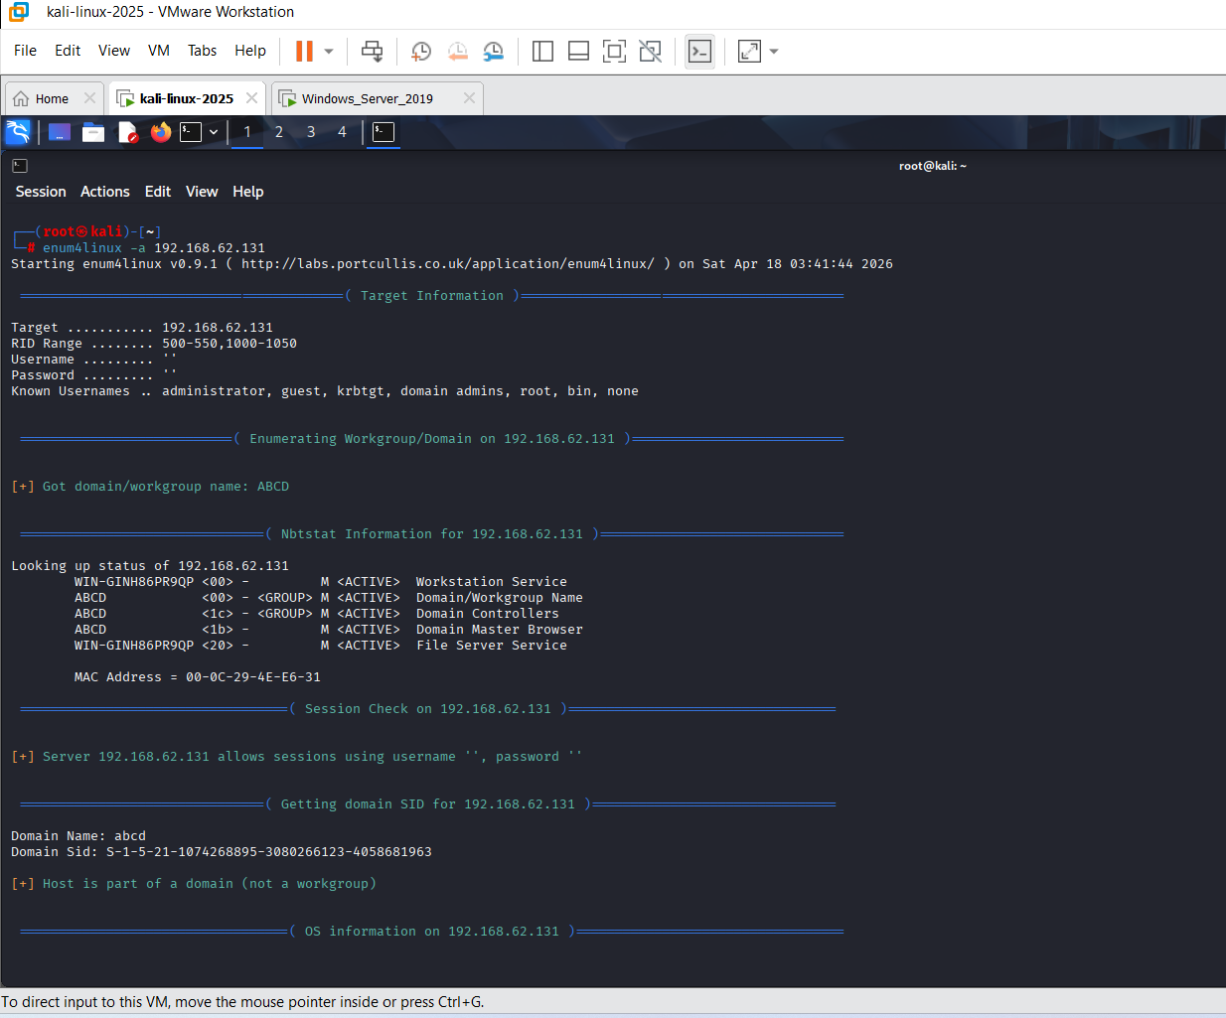
This image show that the enum4linux scan of 192.168.62.131 confirms the ABCD domain, retrieving the SID S-1-5-21-1074268895-3080266123-4058681963 and identifying active null session support.
LDAP enumeration-

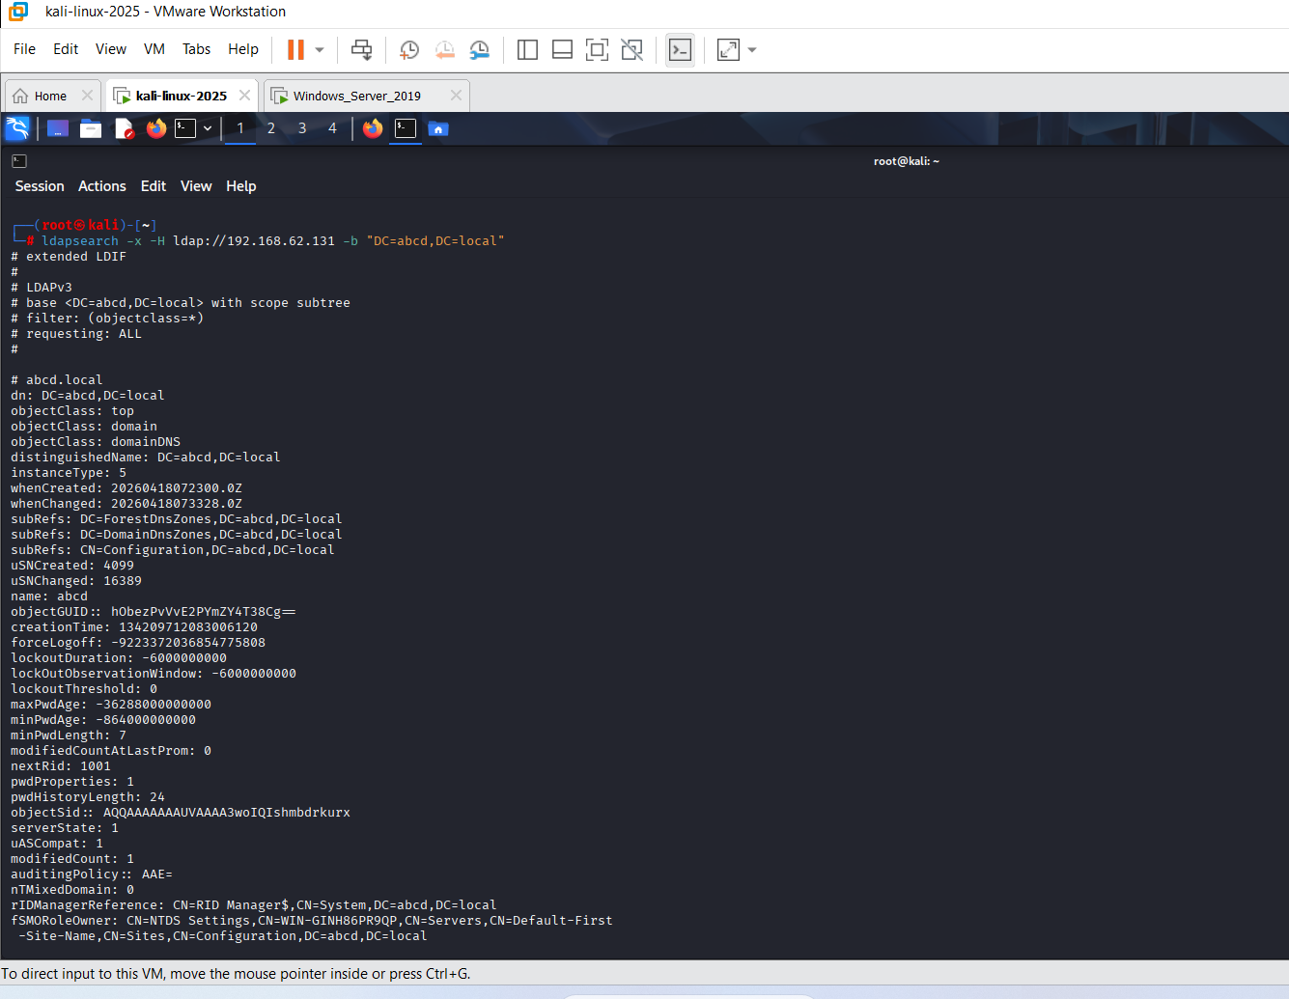
The above image shows the entire configuration of the domain like minimum password length, max password length, objectClass and so many other things. These informations are highly relevant.
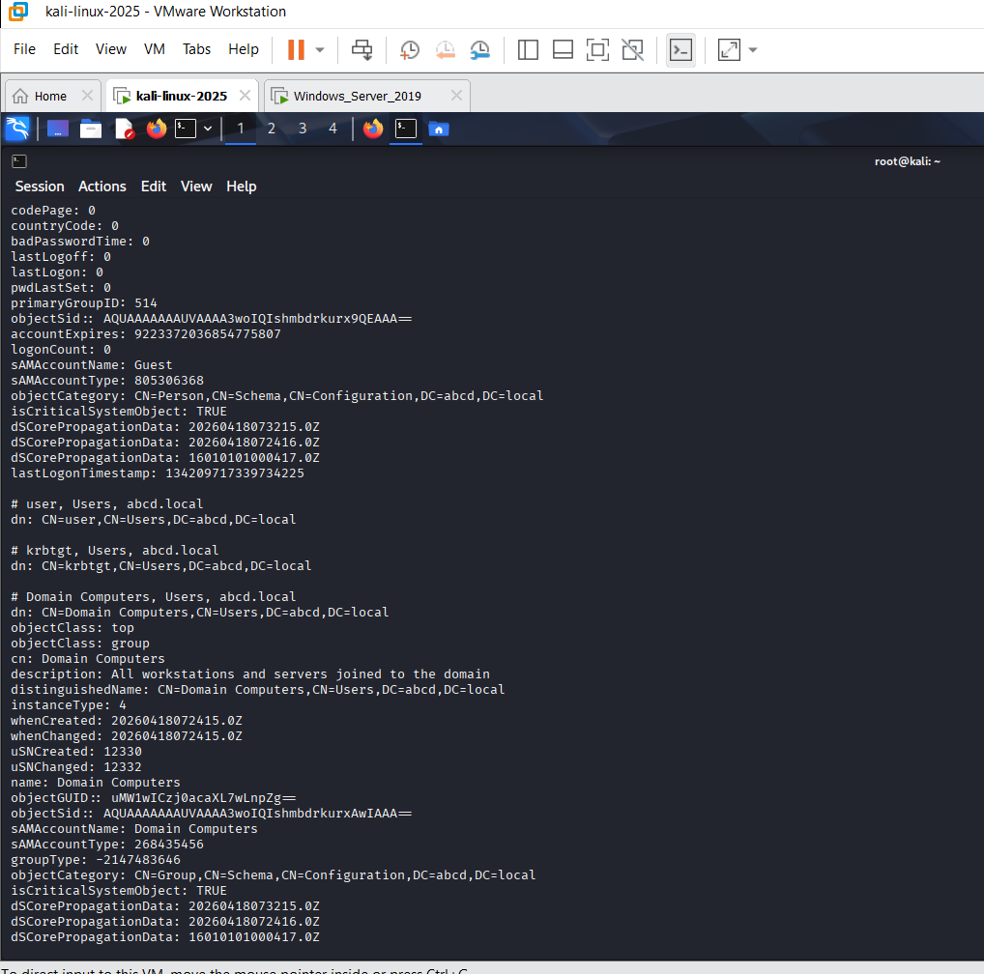
These above images says that the LDAP search results for 192.168.62.131 detail the DC=abcd, DC=local naming context, exposing critical domain attributes like minPwdLength: 7 (Meghana et al., 2024). Further enumeration reveals the Guest account and Domain Computers group, alongside the objectSid and FSMO role holder WIN-GINH86PR9QP for the simulated network.

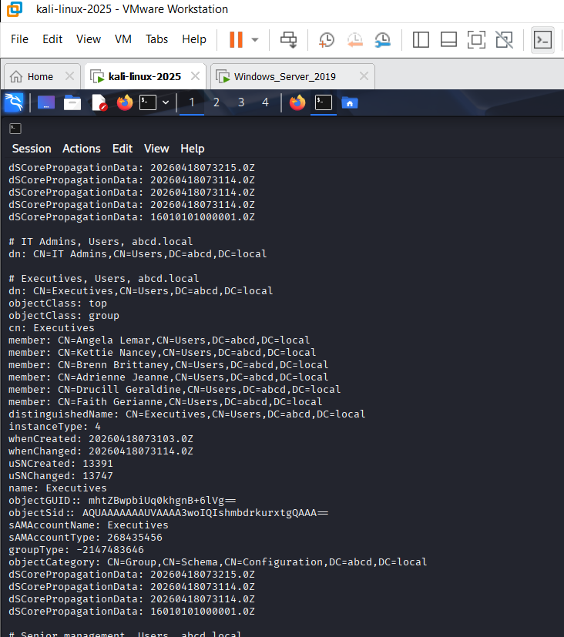
This image clearly tells that all the details of the groups are also exposed like “Executive” group. There are several members of this group whose information are also revealed, like names and also there are several information about the marketing group as well. This all information has come out after the successful LADP scans.
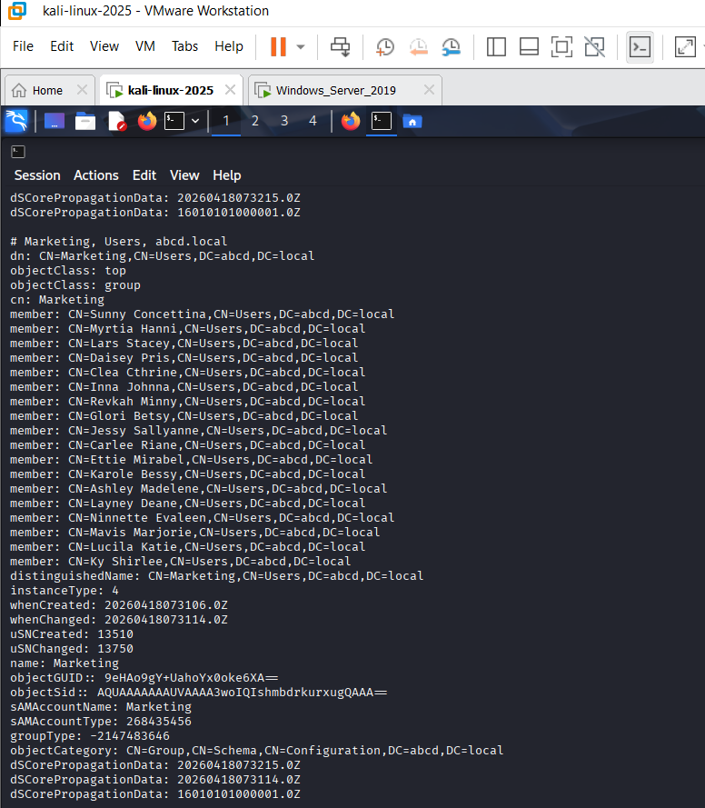
The above images can clearly show that there is a LADP search tools is used. This tool is used to scan the Active Directory on the IP address “192.168.62.131”. It also show that there is a domain object which has the guest account “RID 501” and also gives the objetSid.
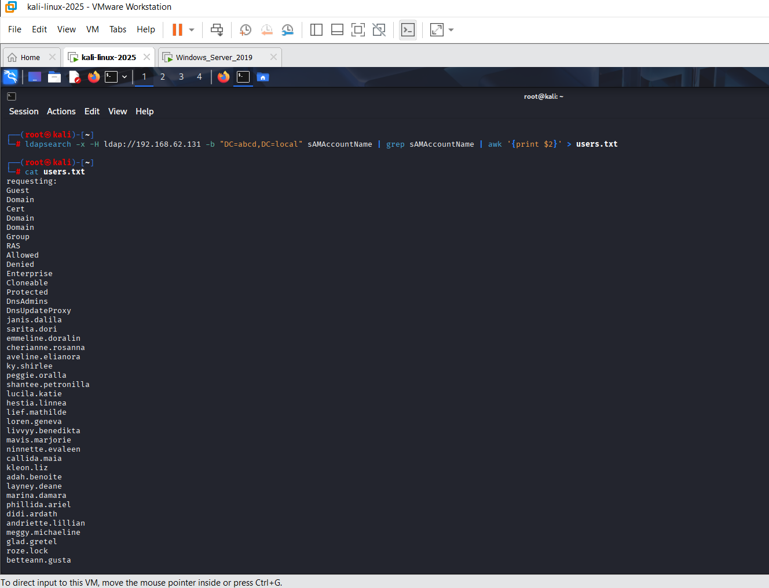
Here, all those users whose passwords are unknown, those users are stored in a single file.

Extract password from description-
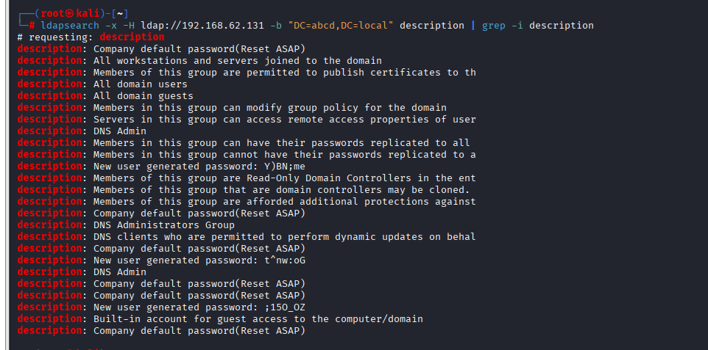
The above image clearly shows that when any new users are created, then along with this, their password is also revealed. This happens because the system where new users are generated is vulnerable, respectively.
Find service accounts-
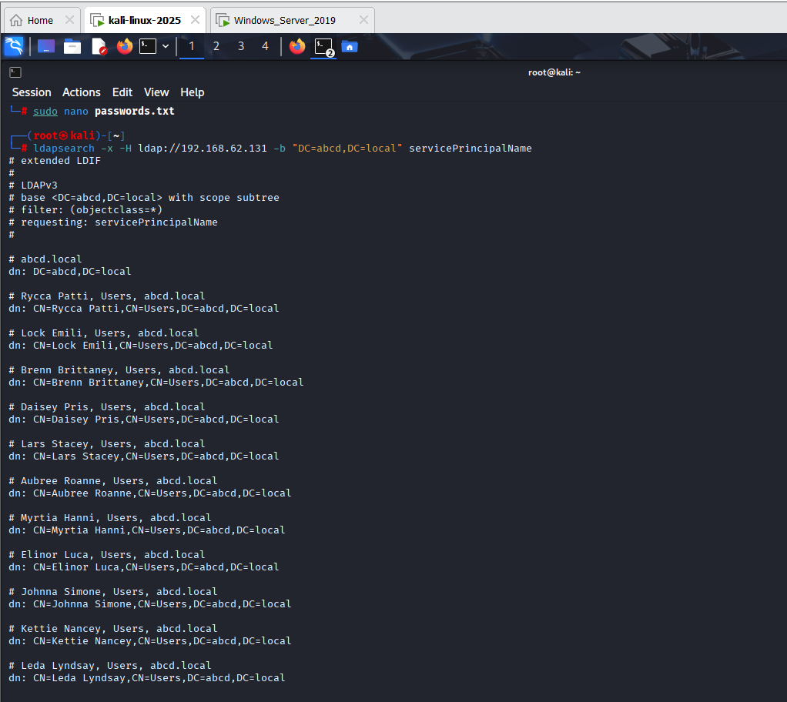
This above image show that when the service account is scanned there there are several usernames like Brenn Brittany, Aubree Roanne and so many more which are recovered successfully.
Cracking password-
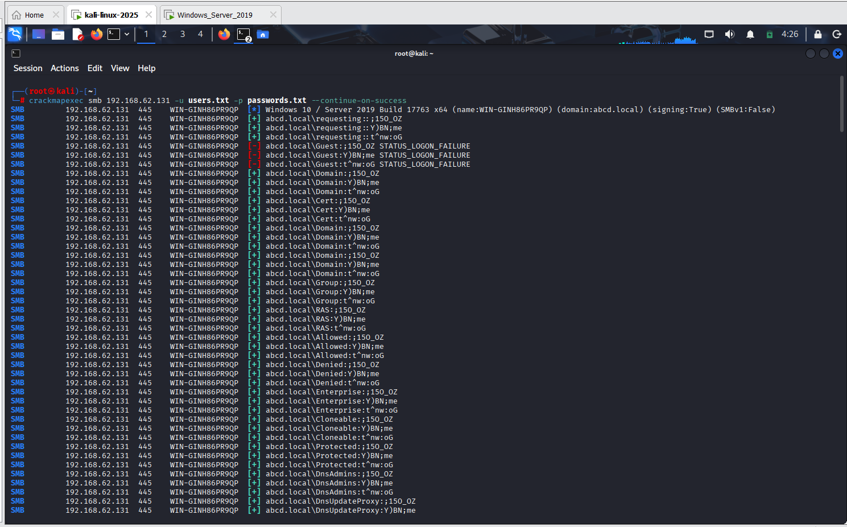
Here a command is successfully used here which will perform this password spraying and also the enumerations, respectively. It used the crackmapexec smb 192.168.62.131 “-u users.txt -p password.txt”, respectively. This image show th eusuage of the crackmapex which focuses on SMB at 092.168.62.131 and also helps to successfully logging into the domain accounts, respectively.

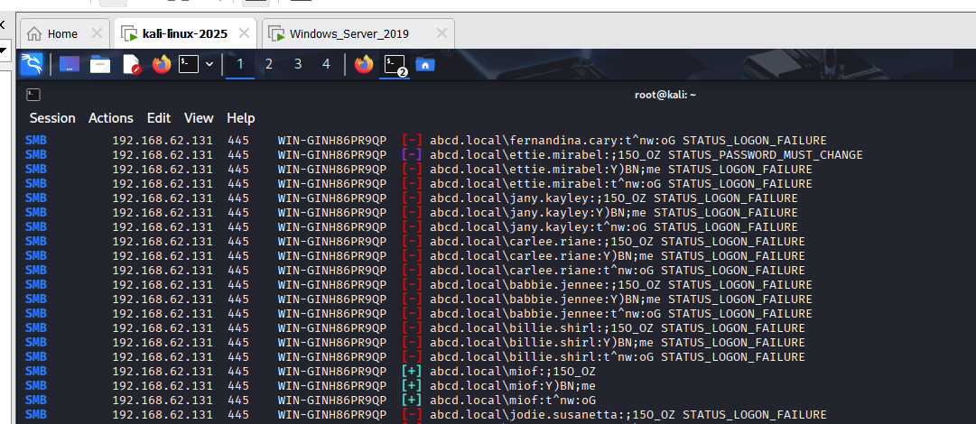

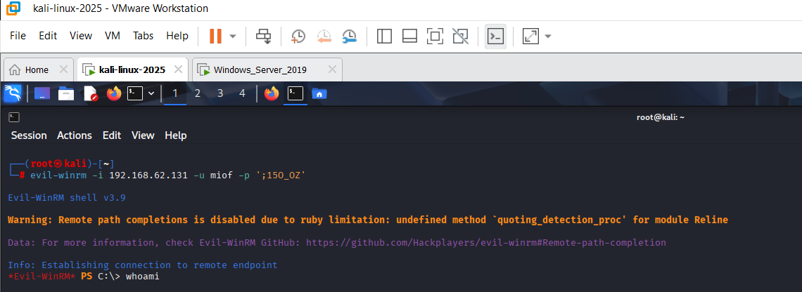
The above images reveals that the there are several passwords has been recovered, like the username “miof” the password recovered is “;150_OZ”. The second image shows that the operator has got the remote access to this user account.

5.3 Exploit C: Client-side or service-side exploit to access sensitive files on VM-3.
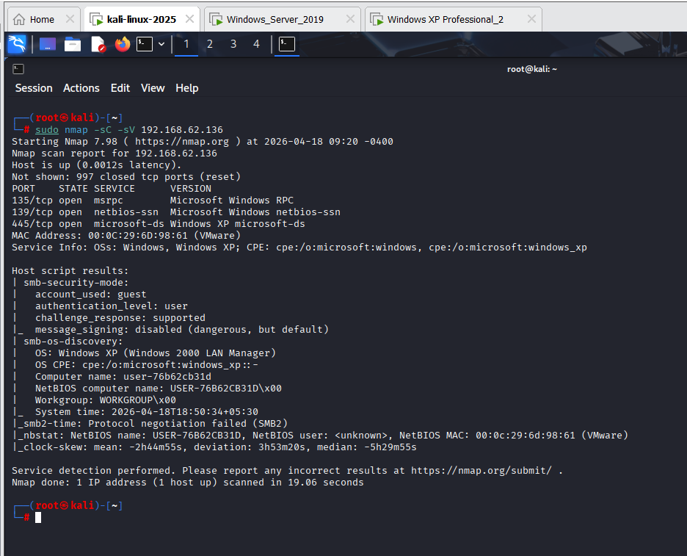
This image here tells that there is a successful nmmap scan in the -sC -sV 192.168.62.136. After the command the nmap scanning has start and it shows several open ports like 135/tcp or 139/tcp. Here, port 135/tcp will be exploited where the Microsoft Windows RPC service is currently running. This attack is done to extract several sensitive files from this port.
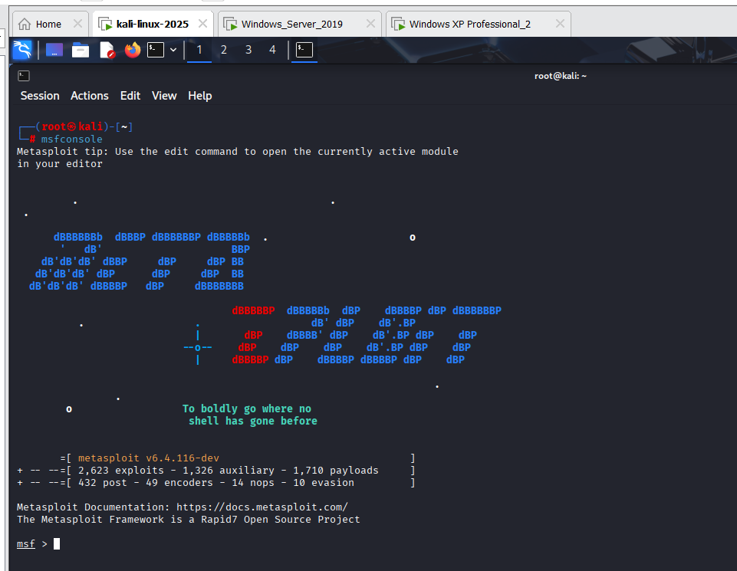
This image shows that a Metasploit framework is used to perform an attack on the port 135/tcp to steal several sensitive information.
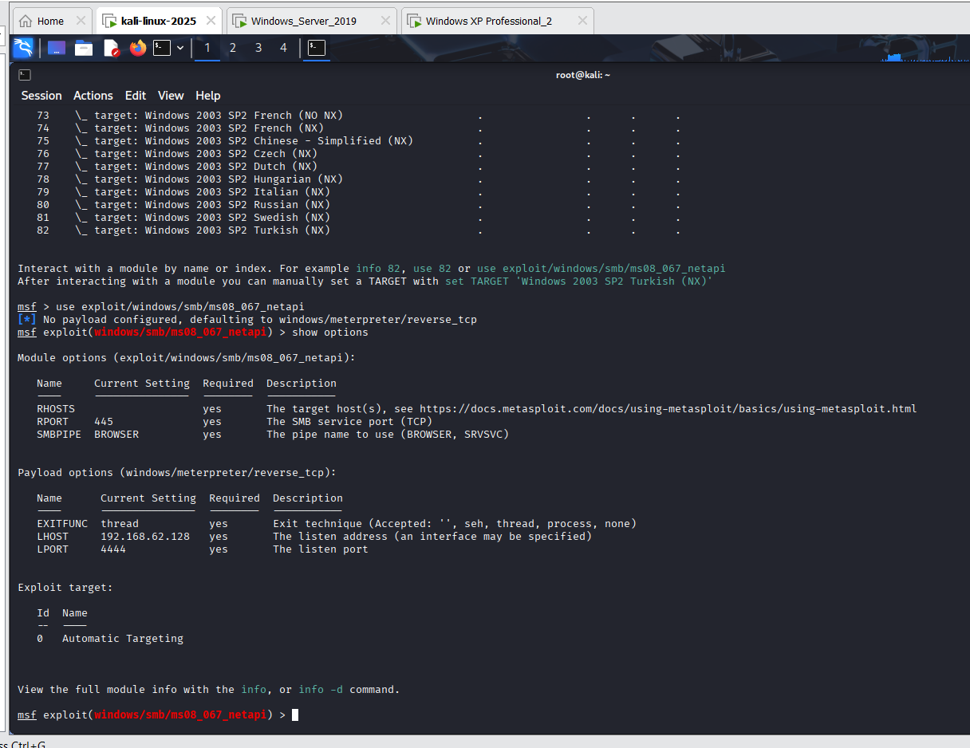
This shows that the module used in the Metasploit framework is for the attack is the “exploit/windows/snb/ms08_067_netapi”
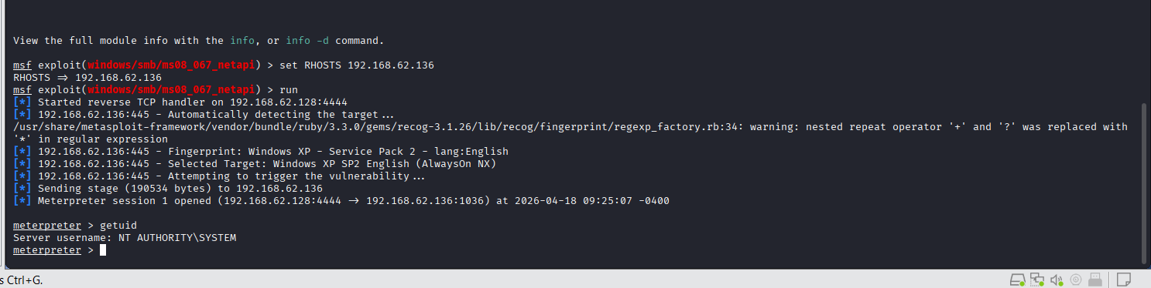
This image show a successful configuration of the RHOST and target machine IP, respectively.
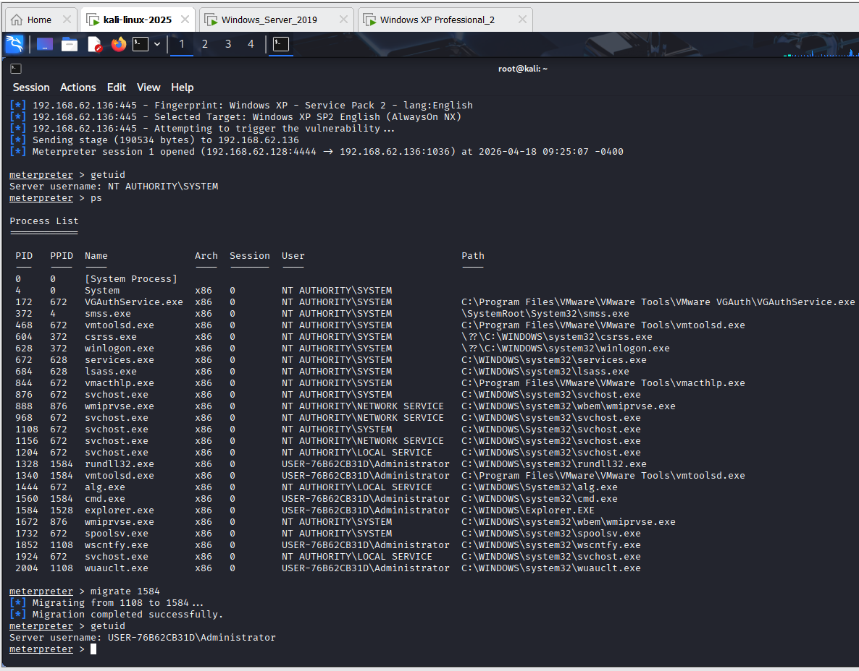
Download remote file-
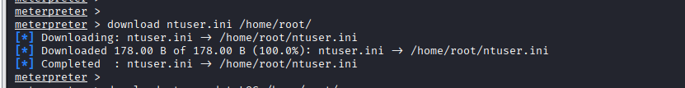
This image clearly shows that all the sensitive data is successfully downloaded after the exploitation.

6. Operational Execution
This image here clearly shows the successful Operational Execution, which clearly captures the Meterpreter session on a compromised Linux target. This evidentiary screenshot verifies that the successful exploitation provides the necessary technical artefacts for the final report. Here it executes “ls/” which clearly shows the root directory structure and “getuid” confirms the root-level privileges.
The above images here shows that the Operational Execution phase, which uses CrackMapExce to perform password spraying against the Windows Server 2019 target. Multiple successful credential matches for the “abcd.local” domain, which provides the necessary lateral movement and privileged access required to fulfil the technical report.
The above pictures clearly show that the Operational Test of the penetration test has been done here. It uses the Metasploit’s Auxiliary modules for scanning and SMB enumeration. These steps confirm the active service on the target network, which provides the critical elementary and technical evidence needed.

7. Tools and Techniques
There is a structured method which provide a clear connection with the help of the standard penetration testing framework. Apart from this it also shows that the attackers can significantly maintain the unauthorised access which weas taken earlier for a long period of time without being noticed and control the entire systems, respectively. There is an Nmap tool which is also used here for the reconnaissance and this significantly helps to identify the active host in the network [27]. This also identifies the open port and also show various services which are currently running in the network. Apart from this the Metasploit is also used here for the primary exploitation tool framework and it perform the controlled attacks on detected vulnerabilities, respectively [28]. There is also a CrackMapExce tools is also used here to effectively check the credential reuse and also supporting the lateral movement in the network.
Tool | Purpose | Attack Phase
Nmap | Network scanning and service discovery | Reconnanance
LADP Search | Active Directory enumeration | Resonnaiance
Evel-WinRM | Remote command execution | Post-Exploitation
Metasploit | Exploit | Exploitation
CrackMapExce (SMB) | Credential testing and lateral movement | Lateral Movement

8. Containment and Safety
There are several incremental backups and these are always kept in several important stages of the process and this is done to protect the data and this also helps to ensure continuity, respectively. This setup is done to restrict any kind of outbound attacks outside the host environment [29]. There are several snapshots which has significantly helped to make a reliable system, and this significantly helps in recovery in case of any kind of failure [30]. It akso show that how well a lab can be setup, respectively. The lab which is setup here is separate from other external systems which significantly helps to avoid any kind of attacks in those systems. Here a high-end firewall is used here to lower the access level and this implementation is done in the network configurations, respectively [31]. Apart from this, there is a NAT virtual network which is setup here and it does not use any kind of port forwarding. Hence all the virtual machines can communicate only in the internal subnet.

9. Conclusion
This project clearly shows that the red team engagement can be done is controlled lab environment. The main aim of this project is to exploit the security weakness for ABCD Pvt. ltd, respectively. The mapping of the activities can significantly help to understand about the working of a real-world cyber-attack. It also helps to show how different techniques can fit into the each and every stage of the attack, respectively. This project significantly helps to gain knowledge about the virtual machine, respectively. This project successfully went through the main stage of the attack lifecycle, which mainly includes reconnaissance, enumeration, exploitation as well as post-exploitation by using several tools that are relevant and industry-based, respectively. This assessment successfully shows the significance of proactive security testing in order to find various types of risks even before they are used in a real environment, respectively. Applying several controls can help them to improve the monitoring systems and the carrying out the regular security assessment is very important. It also helps the organisation to improve the security system.

References
[1] R. V. D. Heuvel, “The Financial Impact of the Cyber Security and Resilience Bill (CSRB) on Shareholder Value in the United Kingdom: An Event Study,” Master’s thesis, 2025.
[2] R. R. Ranasingh, “Dark Web Threat Landscape 2025: An Analytical Report on Cybercrime Trends, Data Breaches, and Emerging Digital Risks,” Jan. 2026.
[3] A. Kurtz and K. Krawiecka, “Who Governs the Machine? A Machine Identity Governance Taxonomy (MIGT) for AI Systems,” arXiv preprint arXiv:2604.06148, 2026.
[4] D. G. Birch and L. Grosclaude, “Why cash alone won’t cut it: Practical strategies to increase resilience in European payment infrastructure,” Journal of Payments Strategy & Systems, vol. 19, no. 3, pp. 234–246, 2025.
[5] I. Aryasatya, S. Riyanta and E. Daryanto, “Analisis Kebijakan Keamanan Siber Indonesia dalam Strategi Nasional Keamanan Siber,” Jurnal Impresi Indonesia, vol. 5, no. 3, pp. 1411–1427, 2026.
[6] Lockheed Martin, “Cyber Kill Chain,” [Online]. Available: https://www.lockheedmartin.com/en-us/capabilities/cyber/cyber-kill-chain.html. [Accessed: 2026].
[7] S. M. Oyekunle et al., “Enhancing data resilience in cloud-based electronic health records through ransomware mitigation strategies using NIST and MITRE ATT&CK frameworks,” Journal of Engineering Research and Reports, vol. 27, no. 3, pp. 436–457, 2025.
[8] S. Yulianto et al., “Enhancing cybersecurity resilience through advanced red-teaming exercises and MITRE ATT&CK framework integration,” Cyber Security and Applications, vol. 3, p. 100077, 2025.
[9] P. R. Vaka, “Cyber security in the retail industry,” International Research Journal of Modernization in Engineering Technology and Science, vol. 7, no. 2, pp. 939–946, 2025.
[10] J. Fuentes et al., “Cybersecurity threat detection based on a UEBA framework using Deep Autoencoders,” arXiv preprint arXiv:2505.11542, 2025.
[11] I. R. Yadav and K. Wanjale, “UEBA-Integrated Intelligent Hybrid AI-Based Intrusion Detection System,” in Proc. ICCCBEA, IEEE, Aug. 2025, pp. 1–6.
[12] H. S. Lallie et al., “Analysing cyber attacks and cyber security vulnerabilities in the university sector,” Computers, vol. 14, no. 2, p. 49, 2025.
[13] C. R. Aare, “UEBA-Integrated Data Warehouse Architecture for Advanced Threat Detection in DAM Systems,” Journal of Multidisciplinary, vol. 5, no. 7, pp. 1047–1055, 2025.
[14] Z. Babar et al., “AI applications in emerging tech sectors: A review,” ASRC Procedia, vol. 1, no. 1, pp. 16–33, 2025.
[15] A. Boumezoued, Y. Cherkaoui and C. Hillairet, “Cyber Risk Frequency Modelling Using Hawkes Processes,” 2025.
[16] M. Suorsa and P. Helo, “Cybersecurity risks and defense for a European energy retail business,” Information Security Journal, vol. 35, no. 2, pp. 261–289, 2026.
[17] M. Ryana, “Comparative Analysis of Incident Reporting Frameworks Against MITRE ATT&CK,” 2025.
[18] C. Thomas, “The MITRE ATT&CK Framework in CTI,” in The Art of Cyber Threat Intelligence, Berkeley, CA: Apress, 2026, pp. 183–187.
[19] A. M. Sadykov et al., “Cyber Threat Intelligence Technologies from Open Sources using MITRE ATT&CK,” Vestnik of Volga State University, no. 65, pp. 55–69, 2025.
[20] F. Amin, N. Daudpota and A. Khan, “A complete penetration testing framework using Kali Linux and Metasploit,” Spectrum of Engineering Sciences, pp. 386–407, 2025.
[21] S. Tyagi and G. Murugesan, “Measuring ransomware lateral movement susceptibility,” arXiv preprint arXiv:2508.21005, 2025.
[22] M. Sivamanikanta et al., “Exploring the capabilities of the Metasploit framework,” Data Science and Network Engineering, p. 457, 2023.
[23] C. Smiliotopoulos, G. Kambourakis and C. Kolias, “Detecting lateral movement: A systematic survey,” Heliyon, vol. 10, no. 4, 2024.
[24] Y. Jiang et al., “MITRE ATT&CK applications in cybersecurity and the way forward,” arXiv preprint arXiv:2502.10825, 2025.
[25] J. G. V. Felicite et al., “Detecting Pass-the-Hash Attack in a Microsoft Active Directory Environment,” in Proc. CONISOFT, IEEE, Oct. 2024, pp. 175–184.
[26] M. Kadam and P. Dhotre, “Active Directory – Attacks and Defense,” in World Conference on Information Systems, Springer, 2025, pp. 21–34.
[27] A. Singh et al., “Automated Network Vulnerability Assessment with Nmap,” in Proc. ICACCTech, IEEE, Nov. 2024, pp. 208–214.
[28] C. Kumar et al., “Active Directory and its security testing,” in International Conference on Advanced Communications, Springer, 2023, pp. 523–534.
[29] T. J. Singhdeo et al., “Penetration testing of web server using Metasploit framework and DVWA,” in Frontiers of Intelligent Computing, Springer, 2023, pp. 189–199.
[30] M. F. Abo El Rob et al., “Application of MITRE ATT&CK framework in mitigating cybersecurity threats,” Issues in Information Systems, vol. 25, no. 3, 2024.
[31] S. Brabetz, Penetration Testing mit Metasploit, MITP-Verlags GmbH, 2022.

Appendix

Appendix - A
This appendix shows some relevant sources which are used to construct the cyber incident timeline for Marn & Spencer and Co-operative Group.
Timeline Order | Incident Phase | What Happened | Source | Year
01 | Persistence | Attackers maintained access through valid accounts and credentials misuse | ENISA Threat Landscape Report | 2024
02 | Initial Access | Attackers gained access using phishing or the exploitation of vulnerable services | ITV News – M&S & Co-Operative report | 2025
03 | Detection | Attack identified after unusual system activity or external reporting | ComputerWeekly- incident coverage | 2025
04 | Response | System isolated breach contained, recovery initiated | UK cyber incident response analysis reports | 2025
05 | Lateral Movement | Attackers moved across internal systems using stolen credentials | CISA Advisory on identity-based attacks | 2024
06 | Initial Compromises | Help desk impersonation used to reset credentials and gain entry | ComputerWeekly – UK retail cyberattack analysis | 2025
07 | Data Access | Sensitive data accessed and potentially exfiltrated | Reuters cybercrime report on retail attacks | 2025

Appendix B: RoE and Threat Emulation Plan
Section | Description
Scope Definition | In-scope assets: Web Server VM, Client Machine VM, Active Directory Domain Controller VM. Out-of-scope: Host machine, external networks, internet-facing systems.
Permitted Activities | Network scanning, enumeration, vulnerability assessment, controlled exploitation, privilege escalation, and lateral movement within the lab environment.
Prohibited Activities | Denial-of-Service attacks, use of destructive malware or ransomware, data deletion or corruption, and attacks on systems outside the defined scope.
Safety and Control Measures | Use of VM snapshots before testing, immediate halt in case of system instability, and avoidance of persistent changes beyond the testing session.
Communication Protocol | All actions and commands must be recorded, findings should include timestamps, and critical issues must be reported immediately.
Rollback and Recovery Plan | Systems can be restored using snapshots, configurations reverted to baseline, and functionality verified after testing.
Legal and Ethical Compliance | Testing is fully authorised, limited to the lab environment, and follows ethical hacking standards and academic integrity guidelines.

