My experience with University and how Changemakers changed my Life!

It is within the nature of every human being to advance and improve throughout their lifetime – be it in their careers, education or family life. This strife for a better life and success Is a long challenge-filled journey which is specific and different for everyone. However thorny this path is there are some tips and tricks that anyone can adopt to make it just that bit easier on themselves.

Within this post I would like to share with all of you how my university education and the course
Changemakers: Building your Personal Brand for Sustainable Employment changed my views and helped me to better identify and realize my potential. I will share my experience and key takeaways from the module hoping that everyone will find fond something of use.

The course was split in four separate modules where a lecturer delivered a lecture along with some activities. Additionally, there were weekly self-help topics that had to be researched individually.

Within the first module, appropriately named “Brand You” I learned the following potentially life-changing steps you can take today to improve your employability and life in general:
- Identify what makes you feel like you are “In the Zone” – the wide-spread term of being in the zone suggests that time is altered when you perform something that you enjoy and makes you feel good. You should identify the steps you need to take so you move in your zone. Be ambitious as this is no longer seen as a negative characteristic. Be yourself and never give up upon failure – learn from past mistakes and cash in on the experience you’ve gained throughout so you can ensure that your next shot is a bullseye!
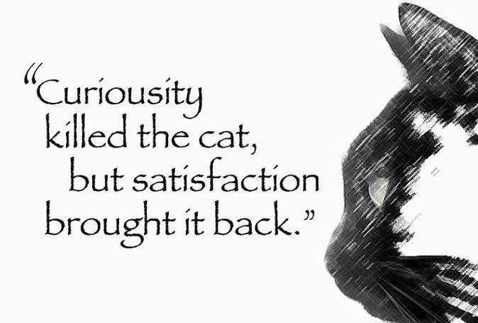
- Curiosity killed the cat… No more! – Be curious and inquisitive. Always! Nothing in life will change if you keep doing everything by the textbook or just because someone said so. You will be surprised of the outcome and the experience you could gain if you just took “that one” risk… Just make sure those risks are measured and the potential reward is equal or outweighs the potential loss.

The second module was called “It’s a small World” and was focused on the importance of creating and diversifying your network and the importance of doing so. Some of my personal takeaways from the module are:
- Create a diverse social network – we all are social being and need contact with other people. And not only people that you have everything in common with – quite the contrary. Look for acquaintances that don’t think like you and see everything through different lenses. They might just show you a whole new world and give you a different perspective. You might not be able to choose your relatives, but you can surely choose your friends as AgeUK suggests (2020).


- Step out from your cage – we all have our own safe and cosy comfort zone that constantly draws us to its centre. While this might make us feel safe we should actively try to take a stroll away from it. Taking risks is the fast lane for getting you somewhere new and exciting! Mark Twain said (n.d) it – “…in 20 years you will be more disappointed in the things you haven’t done than by the ones you did do…”.

The third module (“Opportunity Knocks”) was all about luck… or how it might not be as random as it appears and how we might be able to influence it.



- You’re as lucky as you feel! – we need as much of fate’s luck as the one we create for ourselves. Luck is not just rolling the dice or playing Russian roulette. An easy thing you could do to test your luck is flip a coin and bear in mind that if you feel that you have ANY affinity towards one of the incomes, this was not luck – it was your desire. Make it happen!

- Hey, I’m HERE – Establish your presence! Nowadays everything goes online – even you. Establish your presence online and make sure everyone sees you in the light you want to be seen in. Create social media profiles and personal website – make yourself known to the world the way YOU like to be seen. Further tips available HERE (Greenawald, 2014)

The last module was named In Pursuit of happiness and was an amalgamation of the previous three. It was aimed at showing how all the above-mentioned tips could change your whole life and the way you see the world. It suggests that if you could just look back at yourself from the future and observe the small steps you have taken to achieve your goal, you could see how establishing some achievable short-term goals could lead you to achieving your dreams!
Bibliography
- Age UK (2020). The benefits of social connections. [online] Age UK. Available at: https://www.ageuk.org.uk/information-advice/health-wellbeing/mind-body/staying-sharp/looking-after-your-thinking-skills/social-connections-and-the-brain/.
- Careathers, L. (2019). How to Write a Blog Post in 2019: The Ultimate Guide • Smart Blogger. [online] Smart Blogger. Available at: https://smartblogger.com/how-to-write-a-blog-post/.
- Greenawald, E. (2014). 6 Things You Should Put on Your Personal Website—and 6 Things to Avoid at All Costs. [online] Themuse.com. Available at: https://www.themuse.com/advice/6-things-you-should-put-on-your-personal-websiteand-6-things-to-avoid-at-all-costs.
- Quoteinvestigator.com. (2011). Twenty Years From Now You Will Be More Disappointed By The Things You Didn’t Do Than By The Ones You Did Do – Quote Investigator. [online] Available at: https://quoteinvestigator.com/2011/09/29/you-did/.
- Singla, A. (2021). 103 Actionable Blog Content Writing Tips (for 2023). [online] Master Blogging. Available at: https://masterblogging.com/blog-content-writing-tips/#:~:text=103%20Actionable%20Blog%20Content%20Writing%20Tips%20%28for%202022%29 [Accessed 22 Feb. 2023].

