Method Statement and Project Report
Presented by: Joshua Albrighton
Presented to: Rhodri Thomas
Date Due: 04/04/2023

Contents
Method Statement for Road Construction- Page 3
Purpose- Page 3
Scope- Page 3
Reference to Law- Page 4
Communication-Page 4
Responsibilities- Page 5
Equipment- Page 6
Work sequence and Methodology- Page 6
Setting out- Page 6
Excavation- Page 8
Asphalt & Bitumen Placement- Page 9
Handling And Storage- Page 10
Control of Noise Emissions- Page 10
Disposal of Waste- Page 11
Maintenance- Page 11
Services Installed- Page 11
Project Report- Page 12
References- Page 15

Method Statement for Road Construction
Purpose
This method statement is applicable for the construction of the highway access road onto Fabian way only. This method statement covers the planning, installation, security measures and maintenance procedures involved in completing this project.
This method shall provide for:
Setting out of roadworks,
Excavation,
Asphalt and Bitumen placement.
Scope
This section describes the supply and construction process for the completion of highway access road in line with the project’s requirements.

Working hours on site will be between:
Monday-Friday 8:00-18:00 hrs
Saturday 8:00-14:00 hrs
Sunday- No working
Bank Holidays- No working

Reference to Law
Highway Act 1980- Section 278
Environmental Protection Act 1990
Waste (England and Wales) Regulations 2011
Hazardous Waste (England and Wales) Regulations 2005
CDM Regulations 2015
Health and Safety Working at Heights Act 1974
COSHH 2002
PUWER 1998
Environmental Protection (Duty of Care) Regulations 1991
Environmental Protection Act 1990, Part II
Controlled Waste (Registration of Carriers and Seizure of Vehicles) Regulations 1991

Communication
The contents of this method statement must be explained as well as demonstrated if necessary to all involved in each specific task. Site engineer’s/supervisor’s signature must be taken on approval of this method statement to keep record and hold accountability. Before every shift supervisors and safety engineers must brief all labour based employees on the activity to be undertaken on that shift and they must collect employees signatures to guarantee compliance of site rules and understanding of responsibilities. All briefings must be complete on site before the beginning of a shift.

Responsibilities
Project manager
Work progress should be carried out as per planned program and any equipment needed should be in good order to ensure work continues.
Attention to health and safety as well as site rules must be taken into consideration and be enforced on site.
Construction Manager
Responsible for supervising any work on site.
Site Engineer
Must be in constant communication with safety engineer and construction manager.
Distribute any information to construction team such as plans or provisions.
Provide reports to his superiors.
Ensure implementation of any requests made by consultant.
Coordinate with quality assurance and quality control engineer to ensure work is complete to the correct standard.
Quality control/ Quality assurance Engineer
Monitoring all works complete on site to ensure that they are up to the project’s standards.
Carry out all relevant tests to project requirements.
Site Foreman
Ensure all resources are available in coordination with site engineer.
Provide daily report to show sites progress for clients and consultants.
Incorporate any requests made by quality assurance/quality control engineers.
Safety Engineer
Implement any safety measures required by HSE.
Ensure all work force is informed of safety measures.
Inspect site for any safety hazards regularly.
Give any site-specific training required.
Ensure all concerned persons are using correct PPE.
Ensure any high areas or drops are properly secured using barricades to block off or signs to warn.
Ensure safe access to work site.
Labourers
Follow safety protocols laid out by safety engineer.
Complete work according to site foreman and relevant engineers.

Equipment
- Excavator
- Dump truck- for removing excavated materials.
- Asphalt paver- used for spreading and levelling.
- Bitumen Distributor- Application of bitumen material
- Water Bowser- used to fill up the roller and clean the surfaces.
- Hand Sprayer- For spraying bond coat
- Steel tyred roller- for compacting.
- Pneumatic tyred roller-Secondary Compaction
- Plate Compactor- For edge compaction
- Air Compressor- Clean the surface.
- Rolling Straight Edge- Measure the tolerance.
- Hand tools- shovels, hand compactors, pavement saw machines, heaters, cleaning tools, rakes, levelling and smoothing tools, hand brooms, small vibratory compactors, liquid asphalt painting, and any other tools that may be needed.
(QA/QC Civil Engineering | Quality in Construction, n.d.)

Work Sequence and Methodology
Setting out
all materials to be delivered by agreed supplier.
Moisture density tests to be conducted prior to work being carried out to ensure that either the soil beneath the road is able to be used or if new subsoil must be ordered.
Optimum moisture content to be decided after soil testing is complete but must comply to Highway acts 1980 to ensure road strength.
Site is to be set out according to agreed drawings (including toilets, site access, any offices required, signage, storage areas, loading bays, and parking.)
All site layout plan must be in accordance with relevant laws.
Sub-base to be tested prior to work beginning and will comply with project specifications.
A preliminary survey will allow us to discover any service lines beneath the surface in order to work safely around them.
- Setting out will be complete in accordance with dimensions specified in drawings.
Setting out process will use the profile board method. All boards will be set up exactly 1 metre above the completed construction level. they will be placed in intervals showing the required height. A traveller will be used to show the exact height and showing excavated levels between profile boards. The traveller board will be placed between two profile boards to see whether the excavation has been carried out to the right level.

Profile boards will be set up using a string and a spirit level to ensure they are all level.

This method of setting out can be applied to the straight road, the turning into the housing estate, and the junction (Designingbuildings.co.uk, 2016).

Excavation
There are 3 types of excavation that is required for road construction.
- Topsoil excavation is the removal of any of the earths exposed surfaces. This includes vegetation or any decaying material that could make the soil more compressible therefore making it unsuitable to support the weight of people and cars.
- Earth excavation is the removal of any soil that lies directly beneath the topsoil. This material can be stored and used for later projects.
- Rock excavation is the removal of any igneous, metamorphic or sedimentary rock that lies beneath the surface. Specialised materials such as pneumatic drills or hydraulic rippers will be used to remove the larger rock materials. (Designingbuildings.co.uk, 2016)
Excavation will need to be complete in this project to make way for sub-base and asphalt and bitumen roads.
A backhoe will be used to excavate topsoil, earth, and smaller rocks to create a trench of the approved depth to create the piping system for water or electricity lines.
If the subgrade meets the approved strength requirements then a grader will be used to compact and level the subgrade. If the subgrade does not meet the approved strength, then it will be removed, or sand wicks will be used to assist in water drainage.
Subsoil drainage will be implemented along both sides of the trench to assist in the drainage of water including water that seeps through the road.
Any material removed is to be used for embankment or will be stored for later use on site.
There is to be no material disposed of without first consulting project managers.
Subgrade will be used as in-fill to increase trench to correct levels before roadworks can continue.

It is in our best interest to create a strong subgrade. This can be achieved by:
- Removing poor material from subgrade
- Compacting the subgrade with little moisture in it
- Providing the best possible subsoil drainage
- Possible use bituminous materials or chemicals to strengthen the subgrade.
- Using plastic covers to prevent the subgrade getting overly wet.
(Designingbuildings.co.uk, 2016)

Asphalt & Bitumen Placement
Asphalt/ bitumen base course that is approved by both client and consultant to be used.
Surface/ wearing course will also meet specifications approved by client and consultant.
Civil engineer to inspect ground before any surfacing work takes place to ensure ground is ready for asphalt mix.
A prime coat of bitumen will be applied over the aggregate road base at a rate of 1.13 to 2.26 litres per square metre. At least 48 hours curing time must be left before work continues on the road.
A paver will be used to lay bituminous material and will be compacted using the steel wheel tandem vibratory rollers and pneumatic tyre rollers.
The initial compaction will be completed by the tandem vibratory rollers in static mode and then will be further compacted in vibratory mode. This will be complete to the project specification.
Further compaction will be done using the pneumatic tyre roller to ensure the material is compacted to the required level.
Before laying the surface/ wearing coat a layer of bitumen will be applied to ensure strength and ductility.
The surface course will be laid using a paver and will also be compacted using the steel wheel tandem vibratory rollers and pneumatic tyre rollers.
The same process used to compact the base course will be used here to compact the surface course.
Automatic level sensing technology will be equipped to paving machines to ensure the road is level.
(QA/QC Civil Engineering | Quality in Construction, n.d.)

Handling and storage
Safe handling and storage of hazardous materials is vital for this project in terms of environmental impacts and health and safety procedures. Procedures to be followed include:
- Keeping a chemical inventory (up to date)
- Chemicals labelled properly.
- Providing proper storage for chemicals
- Keeping incompatible chemicals separate
- No ignition sources should be in area.
- No smoking or naked flames near the chemicals
- Proper ventilation if storage is inside.
- Sheltered storage to keep chemicals out of direct sunlight.
- Appropriate funnels should be available.
- Checks for leaks often.
- No lifting containers manually
- Appropriate warning signs near chemicals and around site
- Capable and trainer employees operating machinery
- No intoxicated staff on site
- Drug testing policies apply.

Control of Noise Emissions
As the planned work will be taking place in a residential neighbourhood not only will working hours be between 8:00-18:00 hours but where practical, all guidance will be followed to avoid noise emissions and being nuisance to locals:
Noise will be controlled at the source (when possible),
Selection of quietest equipment possible when applicable,
On site employees will wear ear protection to avoid damage to ears,
Handling all materials in a way that will suppress noise i.e., no dropping materials from height.

Disposal of Waste
No waste is to be disposed without first consulting with appropriate consultants or consulting client agreement.
Any excess material is to be stored in a dry, covered place for future use by the company.
These documents must be complete and kept on site for inspection:
- Quantity of waste produced, reused, recycled, and sent to landfills.
- Targets for waste minimisation
- Hazardous waste notes

Any waste disposed must comply with relevant waste laws.

Maintenance
According to section 278 of the Highway Act 1980 the local council has agreed to maintain the road after the project is complete however the developer may be asked for payment for the maintenance work and the developer completely understands and will comply.

Services Installed
- According to section 278 of the Highway Act 1980, once the planning permission is granted, a 4-week formal technical consultation must begin. This may mean that the scheme may be re-appraised with Bus operators, Emergency services, Taxi operators, Haulage companies, cyclists, and any other interested parties (Legislation.gov.uk, 2020).
This may add extra costs on to the construction process however the re-appraisal has not been decided yet.
- Streetlights must be installed by SCC street lighting service provider according to section 278 of the Highway Act 1980 and it is down to the developer to procure the contract (Legislation.gov.uk, 2020).

Project Report
This project started on March 6th 2023 and using Microsoft project I have created a Gantt chart and a resource page to allow the team to track the project including the cost, time taken/remaining and the resources allocated/used.
(See attached Gantt Chart for further detail)

Above is an estimated cost analysis for the project showing the estimated cost of the whole project as well as the completion status and the cost so far. It also allows the team to see the cost remaining so that the client and the consultant can see if the project is on track with the budget. As you can see here the costs so far for the project are exactly as projected so the project is going well in terms of cost, meaning that the team are efficiently working and there is little waste.
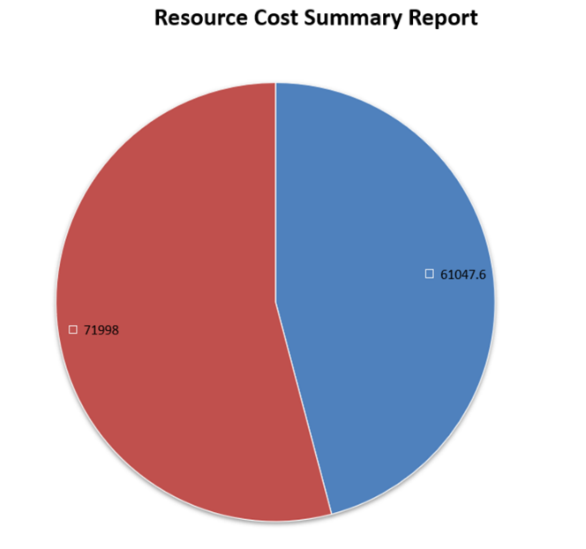
This chart shows the allocation of costs, comparing the costs between the resources and the labour spent at this point of the project (April 4th, 2023).
The blue side of the chart shows the cost spent on labour (£61,047.60) and the red side shows the money spent on materials (£71,998).
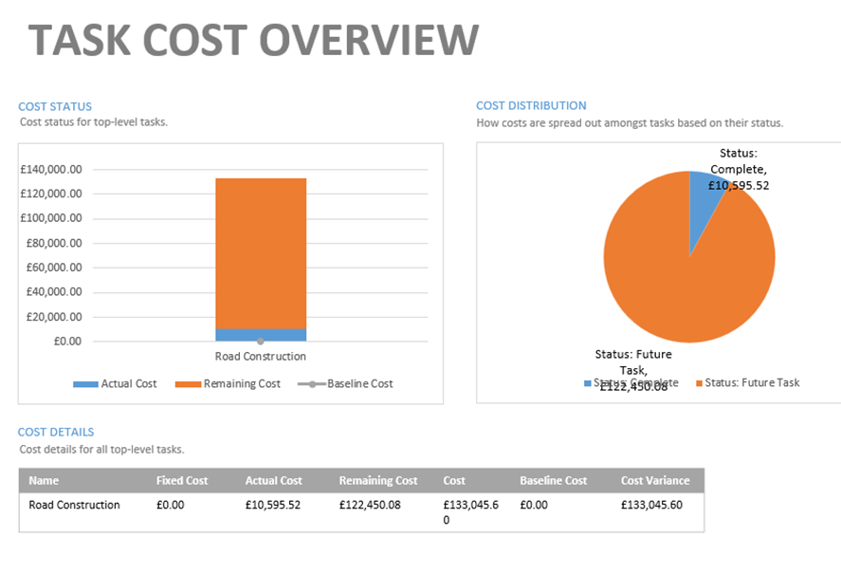

The pie chart on the left of these charts is another useful tool to allow client and personnel to see the current cost of tasks compared to the cost of future tasks. This allows them to see if they are on track with budget.
As you can see the current amount spent is £10,595.52 and the remaining future cost is 122,450.08.
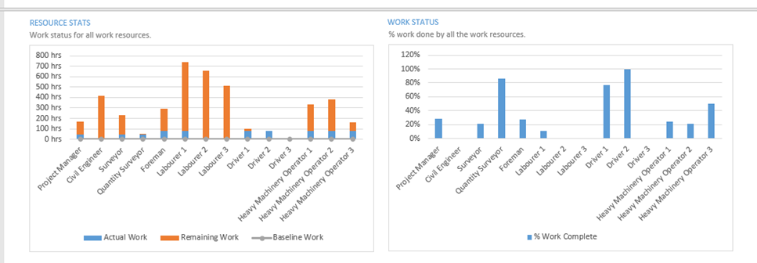
These graphs allow the team and clients to look at how much of their specific tasks each worker has complete so that they can potentially move them on to other projects when they have finished all their tasks on this project.
Attached below is a table showing when each member of the team will be needed on site and how many hours they will be working. Not only is this useful for resource management but it is another tool that will allow the client to look at how their budget is matching up to the costs of the project.
an example of this table being useful can already be seen. As you can see driver 3 is not being used at all so there is no need for him to be employed on this project. This will save the client money allowing for the budget to be freed up into other projects.
This table also shows that the labouring team will be the most used on site. This is cost effective for the client as they are the least paid of the work team involved in the project.
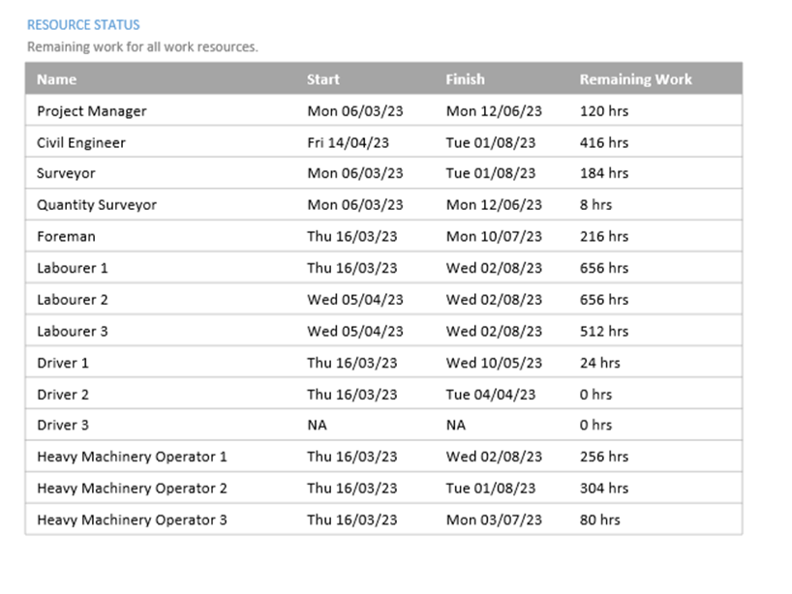
References
Designingbuildings.co.uk. (2016). Road construction - Designing Buildings Wiki. [online] Available at: https://www.designingbuildings.co.uk/wiki/Road_construction.
Designingbuildings.co.uk. (2016). Types of excavation. [online] Available at: https://www.designingbuildings.co.uk/wiki/Types_of_excavation.
Dorritt, R. (n.d.). Highways in England and Wales. [online] www.designingbuildings.co.uk. Available at: https://www.designingbuildings.co.uk/wiki/Highways_in_England_and_Wales.
Lee, E. (2022). Construction Waste Disposal. [online] CPD Online College. Available at: https://cpdonline.co.uk/knowledge-base/health-and-safety/construction-waste-disposal/.
Legislation.gov.uk. (2020). Highways Act 1980. [online] Available at: https://www.legislation.gov.uk/ukpga/1980/66/section/278.
QA/QC Civil Engineering | Quality in Construction. (n.d.). Method Statement for Road and Paving Works | Work Procedure. [online] Available at: https://www.qaqccivilengineering.com/2022/02/Method-Statement-for-Road-and-Paving-Works.html.
Spons Architectural, Brian Spain, 2023

‌

‌

‌

