3/24/2025
University of Wales Trinity Saint David
London campus
E-Portfolio Link: Introduction | My Site 1
Module Name: Learning In the Digital Era
Module Code: ACCA 4025

Student Name: Raymark Karl Navarro Limson
Student ID:2538132
Group: 1

Lecturer’s Name: Koushik Modak

LDE Assignment 1
E-Portfolio
Table of Contents
Introduction 2
Main Body 2
Task 1: Essential Academic and Employment Skills for the future career Path 2
Task 1 (a): Report on Essential Academic and Employment Skills 2
Task 1 (b): Evaluation of Task 1 (a) based on Similarity report 2
Task 2: Collaborative Mind Map and Individual Poster 2
Mind Map (Collaborative) 2
Poster (Individual) 2
Task 3: Virtual Collaboration and RefWorks 2
Report on Virtual Collaboration 2
Step-by-step process of using RefWorks with visuals 2
Task 4: E-Portfolio Creation and Evaluation 2
Task 4 (a): E-Portfolio Creation 2
Task 4 (b): Illustrative Review of E-Portfolio tool Selection 2
Conclusion 2
References 2
Task 1 References: 2
Task 3 References: 2

Introduction
The field of software engineering is an ever-growing discipline where graduates need to have the combination of technical competence along with important employability skills to cope with the changing workplace environment. Universities give students the necessary theoretical background and fundamentals for their career need, but there is always a disparity between university education and employment skills that the industry professionals from potential employees. Thus, Knowledge of the key areas in the software culture and possession of important transferrable experience like communicating, solving problem are one of the importance. Therefore, the knowledge of key knowledge areas in the software industry along with other essential transferrable skills becomes crucial.

Main Body

Task 1: Essential Academic and Employment Skills for the future career Path

Task 1 (a): Report on Essential Academic and Employment Skills

Essential Academic and Employment Skills
Software engineers in various industrial sectors often face difficulties after beginning their professional careers due to misalignment of the skills I learned during the university education with what is expected in the workplace. Software engineers graduating from university face certain difficulties since the set of acquired skills does not always correspond to the needs of the software industry [1]. 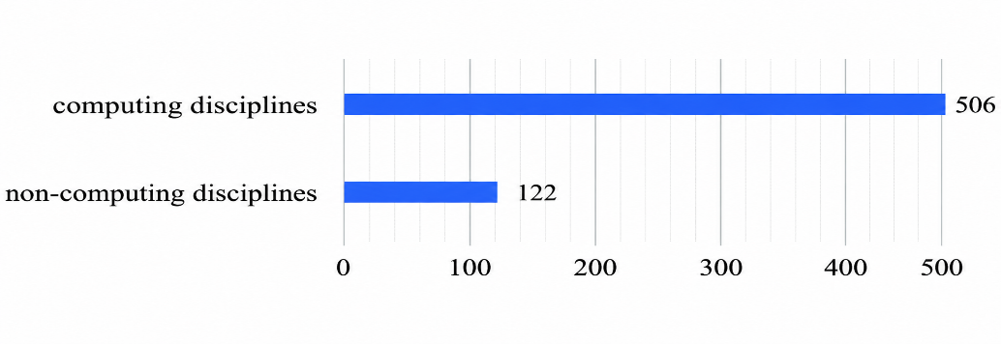
Figure 1: Numbers of Studies [1]

Figure 1 As is evident from, the largest or biggest number of survey participants 506 belonged to computing disciplines, whereas only 122 participants had non-computing disciplines.

In the literature, several studies surveys and interviews I have been conducted to determine the critical skillset both hard and soft skills and the gap between software industry and academia. In this section I present the studies, which I benefit from during the design phase of my survey [2].
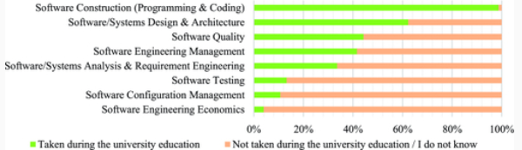
Figure 2: Comparison of Software Engineering Topics Taught [2]

Figure 2 Above, I compare the software engineering topics that have been taught in universities versus those not adequately taught.
My main goal, which is to identify the expected SE skillset in the industry by measuring knowledge gaps in the curriculum, is decomposed into two sub goals [3].
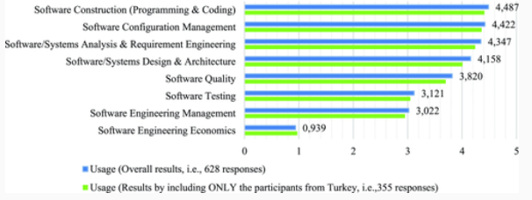
Figure 3: Comparison of Knowledge [3]
Figure 3, Shows that software construction Programming and Coding is the most applied knowledge Configuration management and software requirements engineering software engineering.

As a first question I asked the respondents what country they work in. Most respondents. In this section, note that the usage of these Kas also reveals their importance in the software industry [4].
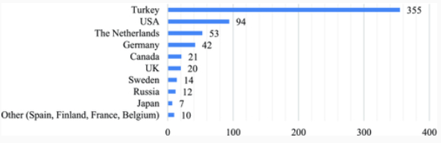
Figure 4: Geographical Distribution [4]

Figure 4 Highlights the geographical spread of the survey respondents, the greatest number of respondents 355 came from turkey, followed by USA, the Netherlands, Germany, Canada, and the United Kingdom. The implication here is that the results of the survey are gently affected by the experiences of software engineering experts based in turkey.

Task 1 (b): Evaluation of Task 1 (a) based on Similarity report
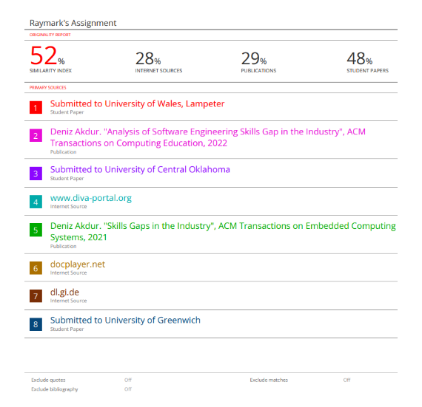
Nevertheless, the Turnitin report for the similarity of the first part is as follows the similarity percentage is 52% which is quite high compared to the recommended percentage for academic writing. The percentage was made up of 28% of internet sources, 29% of publications and 48% of student writings. Even Though the similarities resulted the use of academic terms, this is indeed a percentage showing that task contained wording almost like that of other sources.
Keeping in view the Turnitin report, there is enough evidence to prove that the student has knowledge about the issue, but further effort must be made regarding the originality of content. The coursework will secure a Passing grade between 50% - 60%.

Task 2: Collaborative Mind Map and Individual Poster
Collaborative Mind Map
Mind Map Link: https://www.mindmeister.com/app/map/4053137546
Mind Map Image: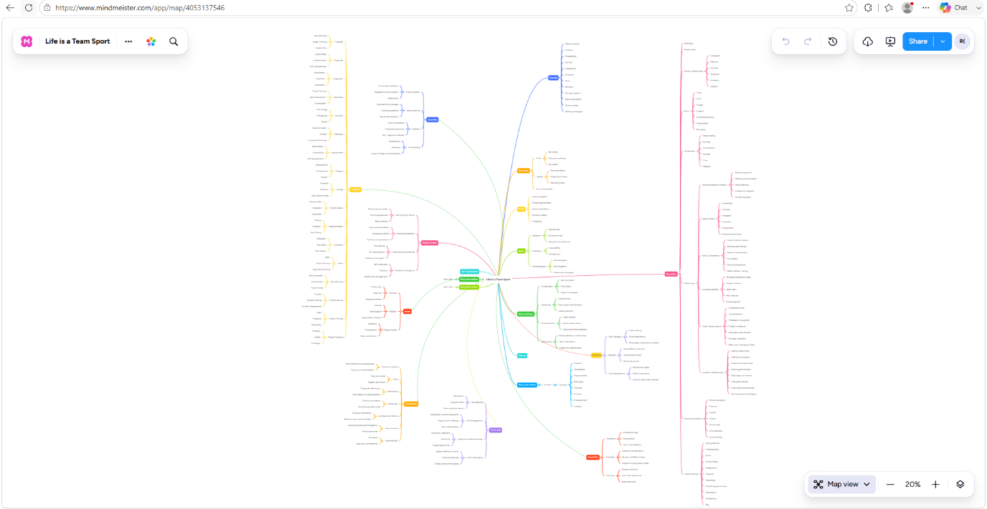

Individual Academic Poster:
Poster Link: CANVA
Poster Image:
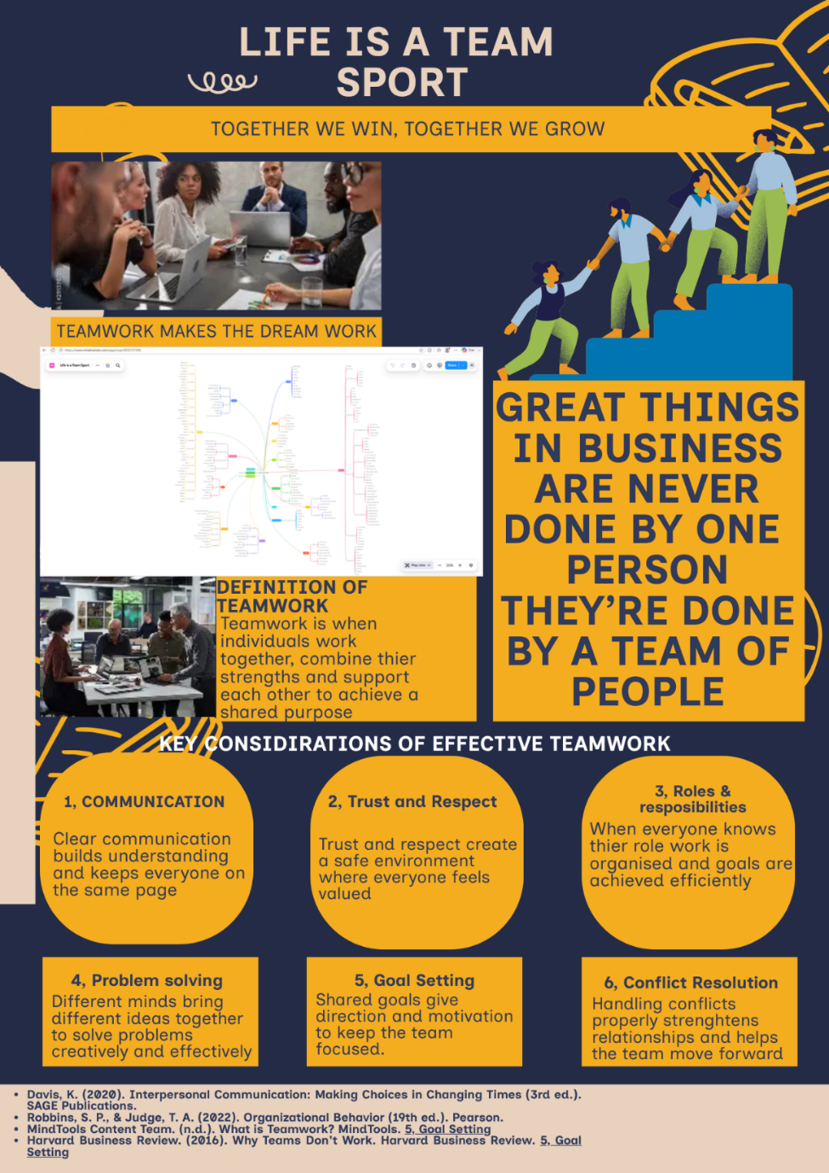

Task 3: Virtual Collaboration and RefWorks
Topic 4: Lights, camera, action!
Virtual collaboration is described as the process where people engage in collaboration through different technologies rather than face to face interactions. virtual collaboration has become very important in the sphere of education and in the present-day workplace particularly in the information technology industry. [1]The educational learning task that we have undertaken titled lights camera action shows the significance of effective team collaboration that requires avoiding incorrect decision making.
One of the main challenges of virtual teamwork is how to keep the group aligned with its objectives. [2]Sometimes, the team members may focus more on maintaining consensus rather than expressing their different opinions. Such as tendency is known as group link. When the group reaches a stage of group link, people start to be afraid of expressing their concerns or suggesting different solutions for the problem.
Upon completion of this section, you will have Developed a deeper understanding of inattention results, group link and ways to Overcome them. It is important the teams work together to overcomes inattention to results to function properly and focus on achieving a collective goal or mission.
To avoid Group link, every member of the team should be able to speak freely about their thoughts. [3]During online meeting with the help of applications such as Microsoft teams and zoom, it is vital that every one of the team be able to speak freely about their opinion before the team leaders to create an environment where criticism is accepted.
Collaboration virtually is a key ability for the learners as well as professionals of today’s digital age. Mere communication alone does not suffice to bring about effective collaboration between people. It is essential to focus on the objectives of the team and motivate all the individuals within the team to come forward with their opinions. And Helpful person or students for a better understanding.
On top of that, there is a chance for developing many kinds of competencies necessary in the current workplace settings through virtual collaboration these include competencies in communication, Problem solving, and teamwork even if the members of the team are in different geographical locations, Collaboration leads to efficiency and innovation.
Step-by-step process of using RefWorks with visual
Step 1: Access the RefWorks
Use your web browser to access the RefWorks home page either through your university library or the RefWorks login page. you can login to RefWorks using your university email id or make a new account in RefWorks if you are new user. RefWorks is used by student to organize their references online
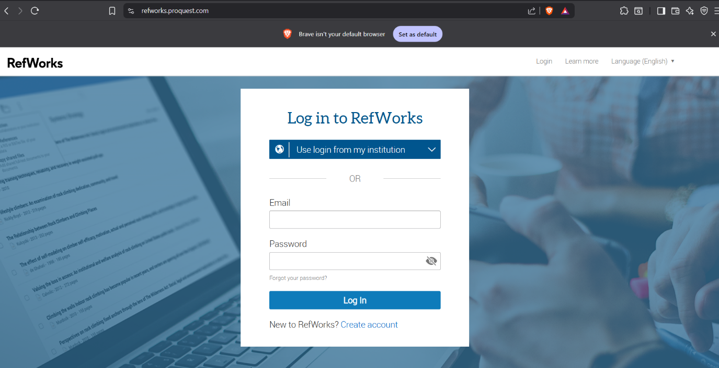
Step 2: Create RefWorks Account
Once you go log into your RefWorks account. You will be required to use your university login credentials. Once logged in you will be taken to your dashboard where you will have all you your references and folders.
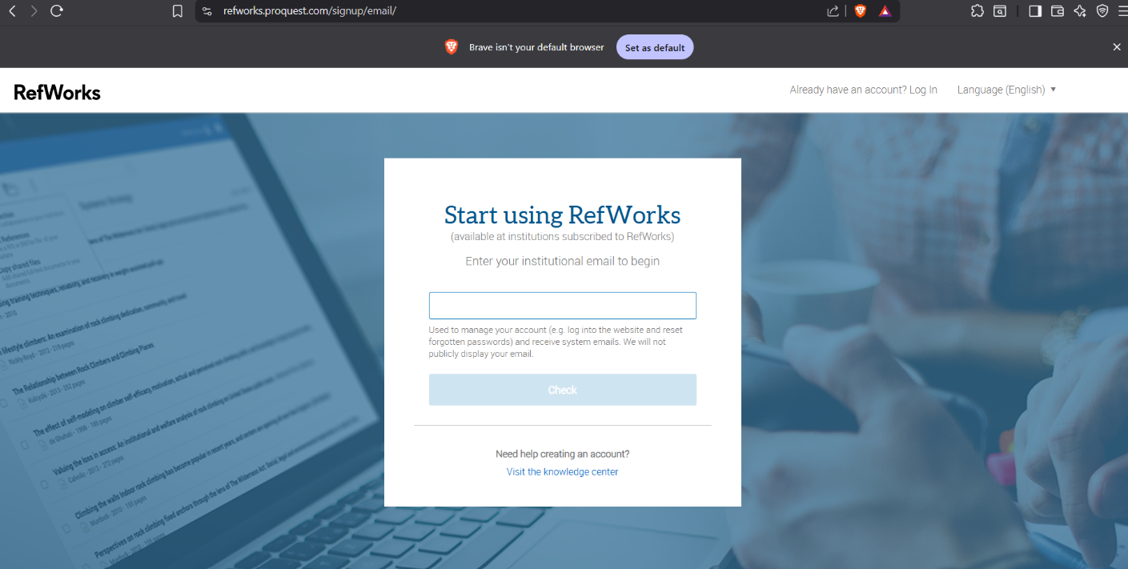

Step 3: Make or create a new folder
Create a folder by clicking on “Create Folder” and adding a meaningful name or topic folders help to organize references according to the task or topic.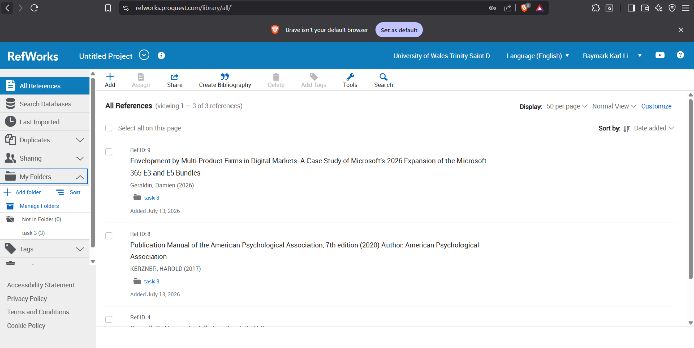

Step 4: Create a Reference or Citation
Click on “Add” and select “Create new Reference” In the drop-down list. Choose the suitable reference base on your topic such as book, journal article, website, etc, Enter bibliographical details including author’s name, title of work, year of publication, publisher, etc.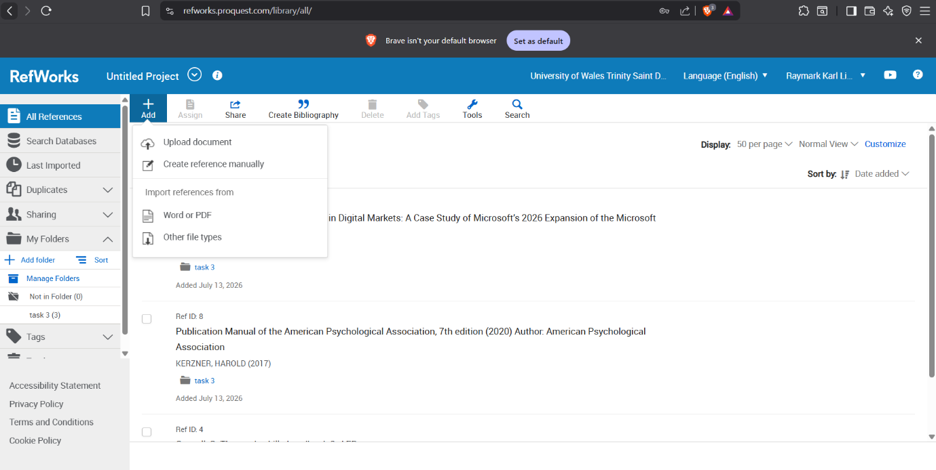
Step 5: Save the references
Once you provided all the necessary information, it is important to spend some time verifying the correctness of all the data you have entered. Click on the save button on citation can be edited, filed, shared, and used for inserting references in your assignment.
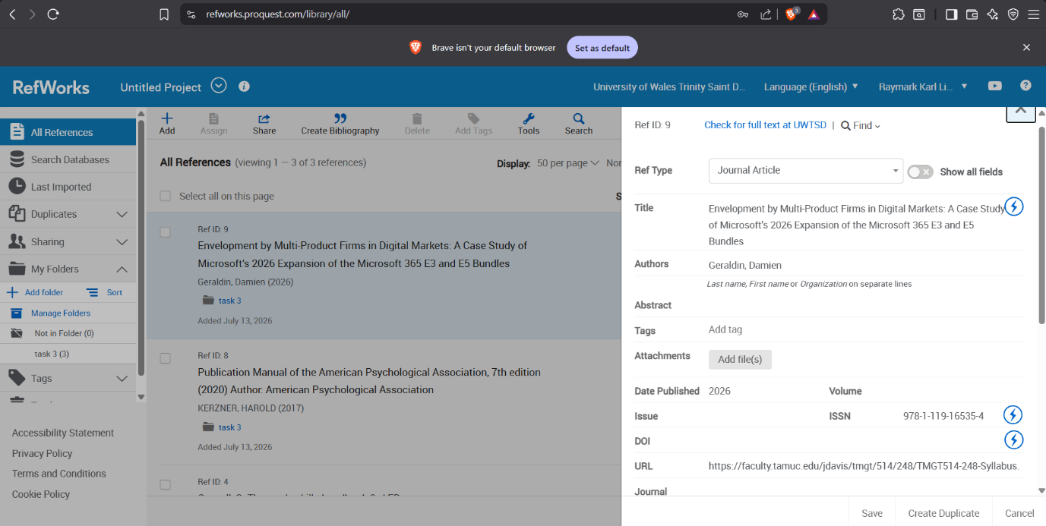
Step 6: Installing Citation Manager
To facilitate references. Use the RefWorks Citation Manager plugin for Microsoft word. This feature helps to insert in-text citations in your assignment as you write. It will also create an automatic bibliography for you depending on your choice of referencing.
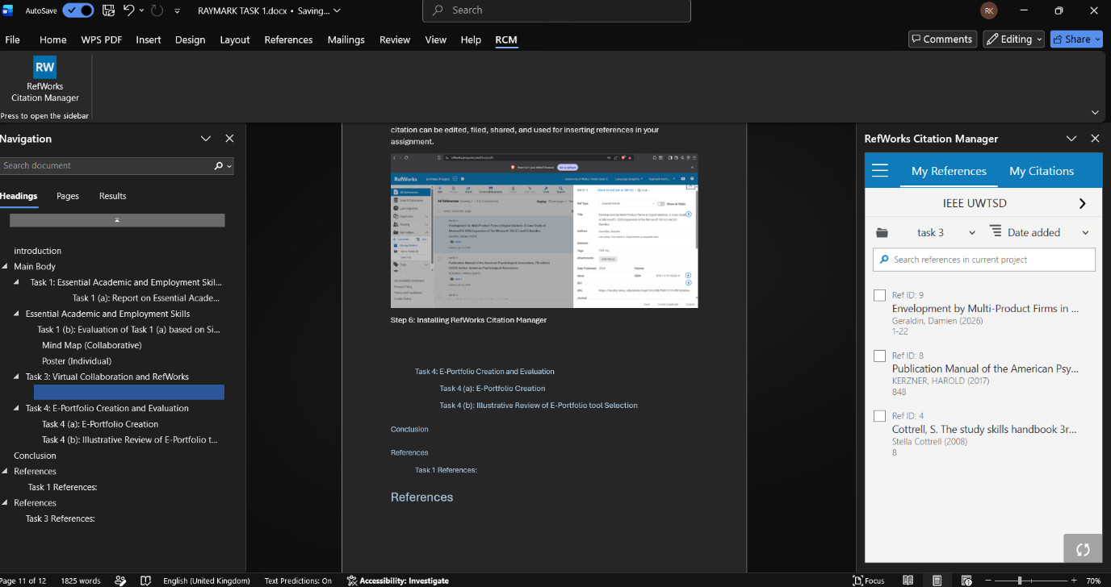
Step 7: Inserting an in-Text citation
In your Microsoft word, open your assignment file and then choose the point the assignment where you wish Citation manager and find your citation. Simply Go to RefWorks Citation manager and find your reference click on “Insert Citation.
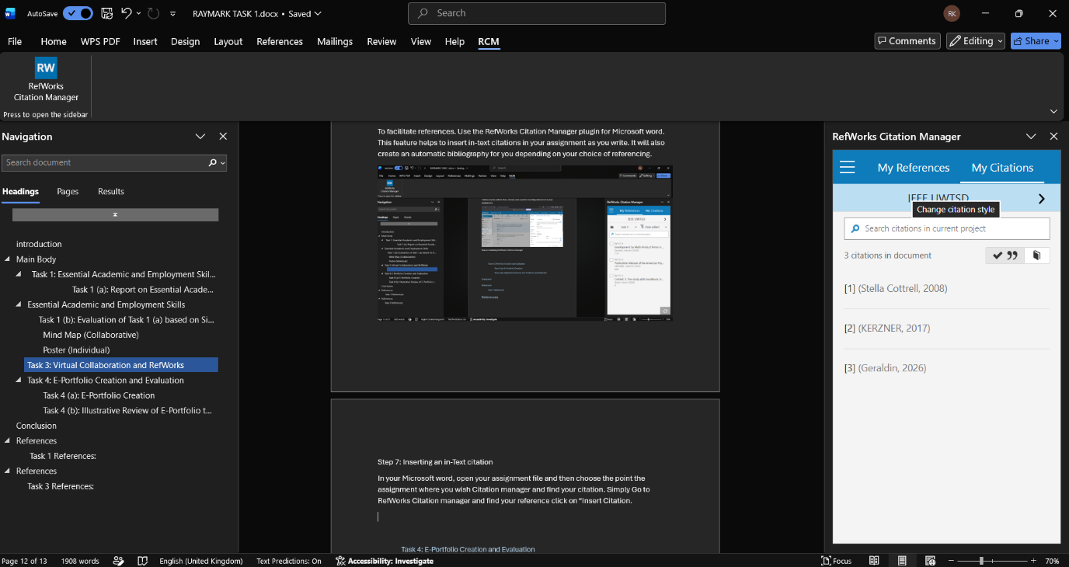
Step 8: Enabling the Auto bibliography ON
Once you enter all your references. Choose “Insert bibliography” from the RefWorks citation manager tool. The RefWorks Citation Manager Will Generate an automatic references list in your chosen style format such as IEEE or Harvard style.
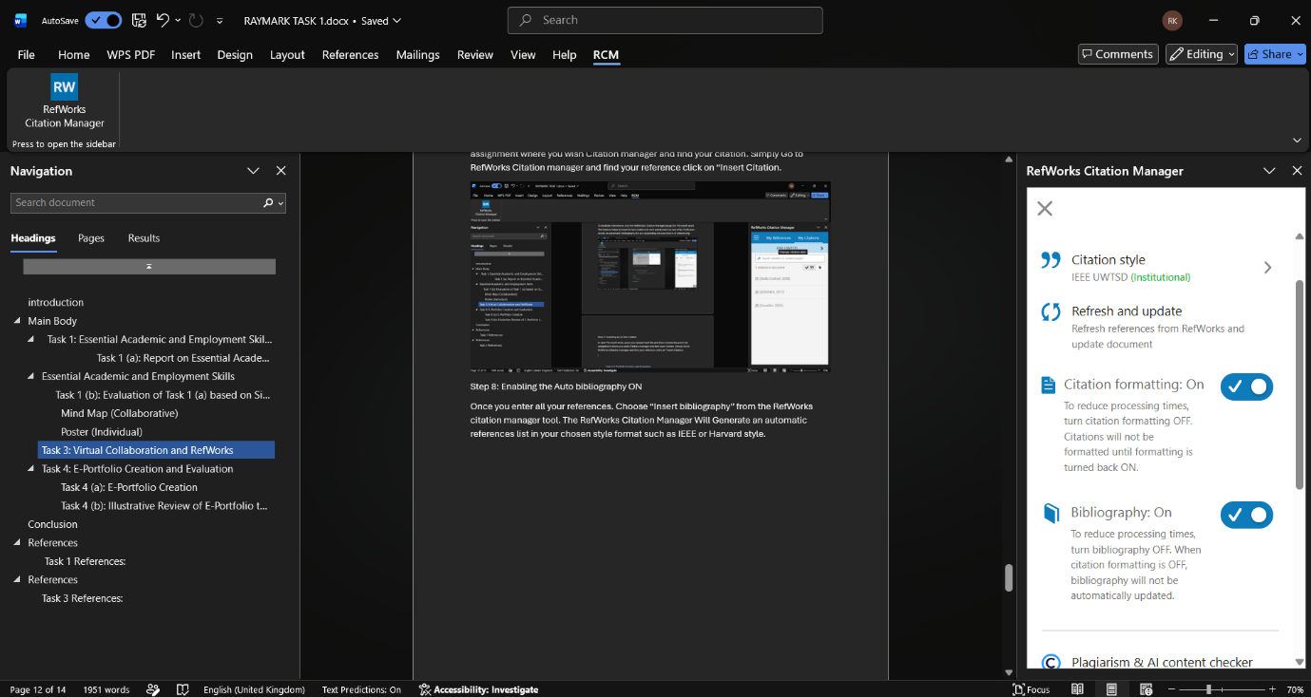

Step 9: Check and Backup your file
Make sure That you have checked your citations and references for proper formatting. Also, save your file to avoid any data loss and back up your work using cloud storage like OneDrive or Google Drive.
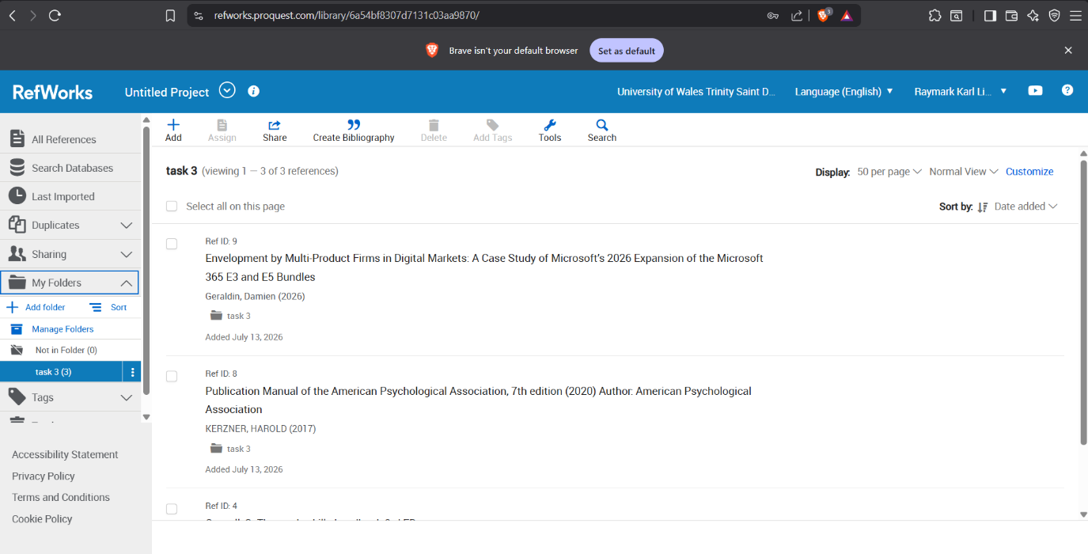
Step 10: Saving your final document
In Conclusion, save your completed document assignment once you are satisfied that all the Citations and references are done correctly. It would be also helpful to make a Backup of your assignment by storing in on the drive.
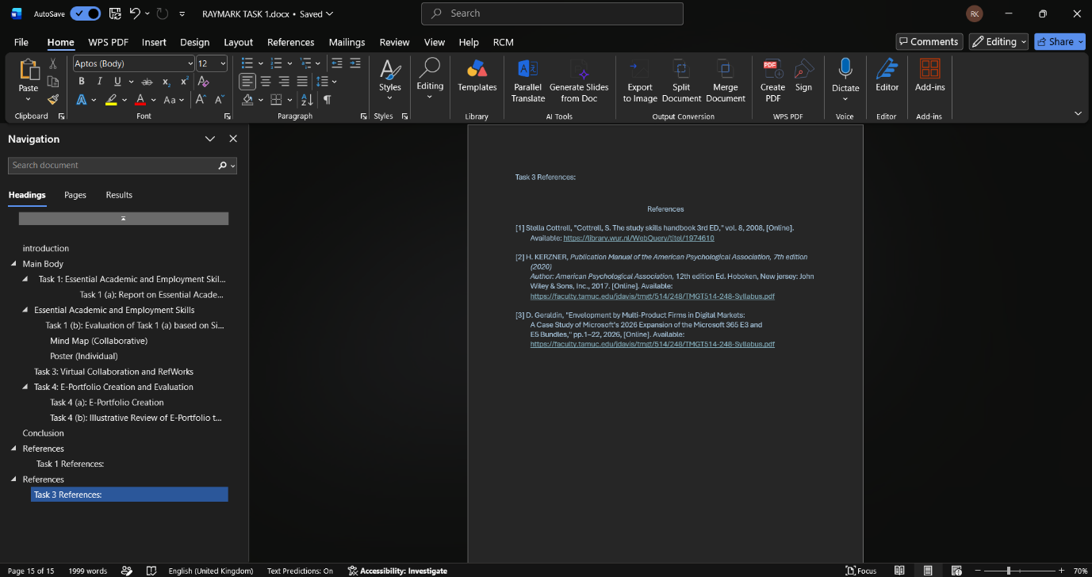

Task 4: E-Portfolio Creation and Evaluation

Task 4 (a): E-Portfolio Creation
This is My E-Portfolio
My E-Portfolio link: Introduction | My Site 1

Task 4 (b): Illustrative Review of E-Portfolio tool Selection
An e-portfolio refers to a compilation of information about the student's academic progress, accomplishments, and personal development, E-portfolios give students the opportunity to showcase their learning journey in a professional manner which they can share with their tutors and prospective employers, as a student of Information Technology, having an e-portfolio is essential to show both technical and general skills. In this task, I decided to use Wix since it is easy to use and does not need to any special web designing skills.
Reason for choosing Wix for this e-portfolio
My choice of Wix was based on the ease of use and availability of several professional templates that I would be able to personalize. Being able to drag and drop the objects meant I was able to make the website without knowing anything about codes. Moreover, it is possible to insert pictures, videos, documents and links using Wix. Being a computer science major, I require a website from where I can keep updating my portfolio depending on the additional courses that I undertake. Using Wix gives me an opportunity to update my portfolio and publish information instantly because webpage creation using Wix is easy.
Features
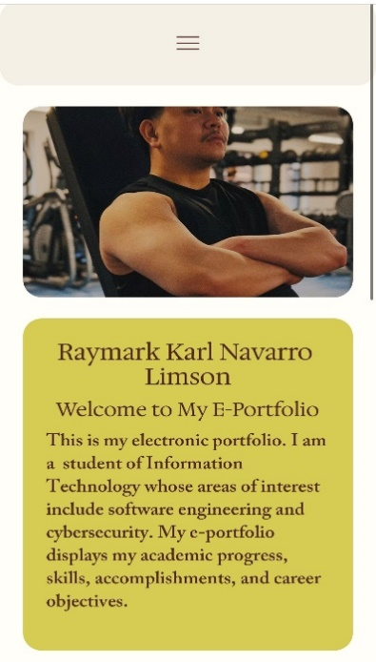
There are many good aspects of Wix which makes it easy for the creation of e-portfolios of the students. One of them is professionally designed templates which make sure that the website is designed in a very modern way. In addition to that one can upload files including PDF documents, images, presentations, and videos on Wix websites. What’s more, Wix websites are compatible with mobile, tablets, and computers as well which makes it possible for visitors to visit an e-portfolio website through any gadget.

Figure 1: Mobile View
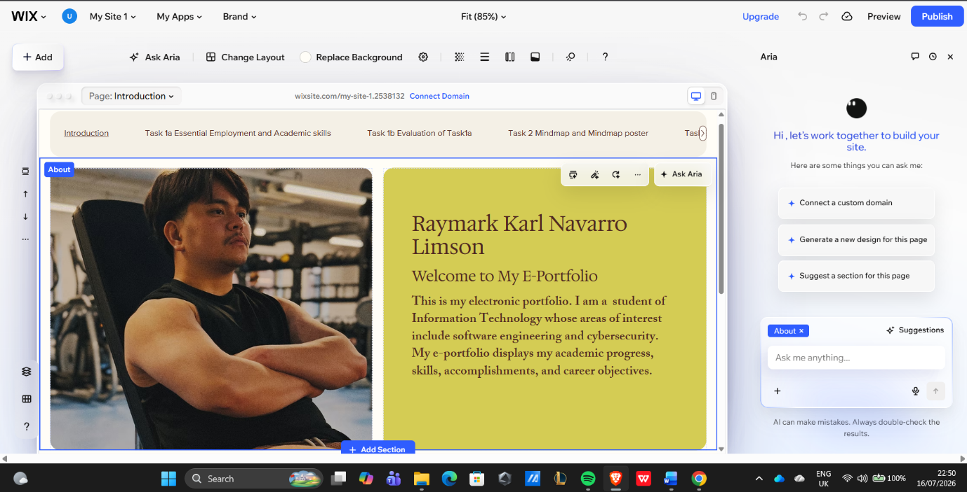
Figure 2: Wix Website
Benefits of Wix
One of the key advantages of Wix is that it has a user-friendly interface. Namely, it provides the drag-and-drop editor which allows creating a professional website even if one does not know how to code. This will save time and allow concentrating on the presentation of results of one's work instead of studying web programming languages. The second advantage is that there is a wide range of templates which can be customized with different colours, fonts, images, and layouts. Wix supports multimedia content which will help to post on the page videos, photos, certificates, downloaded files, and links to the pages on GitHub and LinkedIn.
Drawbacks or Disadvantages of Wix
However, despite all advantages provided by the service, there are certain disadvantages. Free account includes Wix ads and uses Wix domain, rather than one’s own personal one. In addition, there are other features, extra storage and business-related resources which become available when using a paid account. One of the cons of using Wix consists in the fact that after selecting a certain template and working on it, one cannot later change his or her mind and switch to a different template.
Wix is suitable for IT Student
The reason why Wix is suitable for an IT student is that it offers a platform where everything connected with the academic performance of the person and the work he or she did could be displayed in a professional manner. For the employer, it would be helpful to get some visual representation of your skill and achievements, and this portfolio would serve as proof that you managed to complete all the assignments successfully.
To summarize, Wix is the one of the websites that can be used to build an e-portfolio. The ease of using it and ability to incorporate multimedia content are among the main characteristics that make it suitable for different users. Despite the basic version not having everything, it has the necessary tools that help to demonstrate one’s academic success and technological skills. Thus, Wix is the right website for building my e-portfolio.
Conclusion
The portfolio has assisted me in developing skills and knowledge needed in pursuing a career in information technology. In the process of completing the four tasks, I have been able to learn about the importance of academic and job skills, teamwork, virtual teamwork, referencing, and skills development. The four tasks have assisted me in developing certain skills that will assist me in my learning and future career life.
Task one has assisted me in learning about some of the academic and job skills required of a person in pursuit of a career in information technology. Some of the academic and job skills required for success in learning institutions and at work include communication skills, problem-solving skills, research skills, teamwork skills, technical skills, and time management skills.
About task two, there is improvement in my creativity, communication and team working skills through the creation of collaborative mind map and a personal poster. Working with other people enables me to develop ideas, organizing data and appreciate the role of collaboration in ensuring success of projects.
Regarding task three, I have been given an opportunity to learn many things such as virtual teamwork and RefWorks. Some of the things that I have learned include virtual communication tools for teamwork, avoiding group think, importance of monitoring and RefWorks citations. In the final task, i.e. Task 4, I have had the chance to develop my portfolio with the use of the software Wix. Through developing my portfolio, I have shown all the achievements that I have done in both my academic and professional sphere. Furthermore, I have analysed how effective it is to use the Wix software to show my achievements and future career.
In conclusion, by means of the portfolio, I have developed my self-confidence, computer skills, research skills, communication skills, and organizational skills. Moreover, I have understood the significance of lifelong learning and professional development. The knowledge I have gained from my portfolio will prove to be useful in making myself a competent IT student in the future.

Task 1 References:

References

[1] | C. Aasheim, J. Shrospshire, L. Li and C. Kadlec, “Knowledge and Skill Requirements for Entry-Level IT Workers: A Longitudinal Study,” Journal of Information Systems Education, vol. 23, no. 2, 12 November 2019.
[2] | P. Bourque, R. Dupuis , A. Abran, J. Moore and L. Tripp, “The guide to the Software Engineering Body of Knowledge,” IEEE Software, vol. 16, 31 Dec 1999.
[3] | P. Mertens and B. Schmitzer, “What knowledge is important to a software professional? von Timothy C. Lethbridge,” WIRTSCHAFTSINFORMATIK, vol. 42, no. 5, 01 10 2000.
[4] | B. a. Kitchenham, D. Budgen and Pear Brereton, Evidence-Based Software Engineering and Systematic Reviews, November 4 2015.

Task 3 References:

References
[1] Stella Cottrell, "Cottrell, S. The study skills handbook 3rd ED," vol. 8, 2008, [Online]. Available: https://library.wur.nl/WebQuery/titel/1974610
[2] H. KERZNER, Publication Manual of the American Psychological Association, 7th edition (2020)
Author: American Psychological Association, 12th edition Ed. Hoboken, New jersey: John Wiley & Sons, Inc., 2017. [Online]. Available: https://faculty.tamuc.edu/jdavis/tmgt/514/248/TMGT514-248-Syllabus.pdf
[3] D. Geraldin, "Envelopment by Multi-Product Firms in Digital Markets:
A Case Study of Microsoft’s 2026 Expansion of the Microsoft 365 E3 and
E5 Bundles," pp.1–22, 2026, [Online]. Available: https://faculty.tamuc.edu/jdavis/tmgt/514/248/TMGT514-248-Syllabus.pdf

