The University of Wales Trinity Saint David
2022

ADAD 7014
Understanding and thinking about intangible cultural heritage through self-analysis

Yingtong Zhao 2207792
Words:

Contents

1. Self-analysis
1.1 experience 3
1.2 Why study for Intangible cultural heritage 9

2. Basic research
2.1 Definition of intangible cultural heritage 12 2.2 The protection status of intangible cultural heritage
in different countries 15
2.3 The value of intangible cultural heritage 18
2.4 Design of intangible cultural heritage 19
2.5 Cantonese Embroidery in Intangible Cultural Heritage

2.6 The Economy of Intangible Cultural Heritage
3. Conclusion
- List of figures
5.References

- Self-analysiss

1.1 Personal experience
The things a child is exposed to will affect a person's growth and career choices in the future. According to research, children develop career expectations as their self-awareness grows and perceives the impact of society on life roles, and parents play a role in socializing children's work. to a key role (Oliveira et al., 2020). Understanding their cultural norms Heritage can assist them in maintaining a sense of continuity with their past and place in the world (leaflet). At the same time, Tanya Evans proposes that family micro histories and global macro histories are interconnected, and that family histories are critical to personal identity and national history play an important role (Evans, 2021). Changes in societies and countries are interrelated with global development, and the degree to which societies and countries pay attention to social phenomena will also affect the development of things and individuals. Some scholars have proposed that for children, from the macro to the micro, from the national level, the global level to myself. Recalling my past growth environment, learning process and work experience, after careful consideration, I can not only grow by myself, but my perception of the surroundings and the environment have such a huge impact on me. The recent study gave me an opportunity to unravel the cocoons. After exploring myself, I analyzed my heart. What is my identity of my personal identity? To understand why I made these research choices? What influences my choice? What do I hope I can achieve? In order to achieve the goal I envision, I need to understand and research the methodological direction.

Why is self-analysis so important? This allowed me to find my identity. Childhood My childhood memories are scattered, hidden in the depths of memory, very vague, and I don't even actively think about it. Practicing embroidery was not difficult for me when I took an embroidery class as an undergraduate. In particular, the professor introduced some traditional embroidery stitches, which I learned very quickly. I know I have learned these stitches before. With in-depth study, I learned some new terms, Cantonese embroidery and intangible cultural heritage(ICH). These nouns were only imprinted in my mind when I was in college, and I didn't think deeply about them. As more and more design projects come into contact with after work, our team needs to find a lot of background information for each ICH design project we come into contact with, go to the local area for research, discuss with craftsmen and learn techniques, so as to It is convenient for us to accurately express the original techniques, artistic concepts, etc. during the design process, so as to achieve the purpose of protecting ICH techniques. At this point, my childhood memories slowly surfaced. When I was young, I was very interested in the pattern paper brought by my aunt.
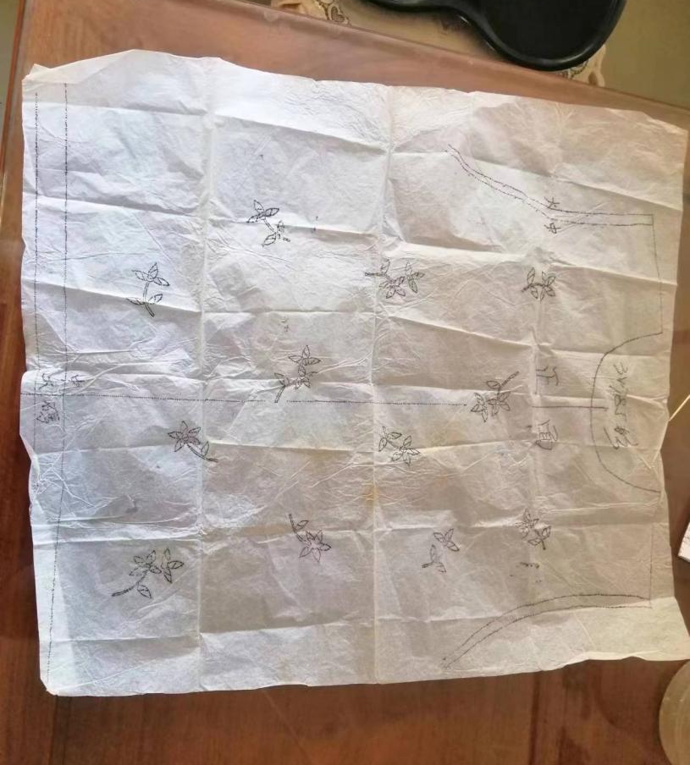
Figure 1: Pattern paper

The pattern of flowers was interspersed through embroidery, using cloth as paper, needle and thread as brush, and patterns were left on the cloth in a short while. I also try to practice and try to do it. These are the fragments of my memory. Later, after my in-depth understanding of Guangzhou embroidery, I discovered that my family is one of the participants in the production of Guangzhou embroidery. My family is in the hinterland of the Pearl River Delta, where the business culture is profound.

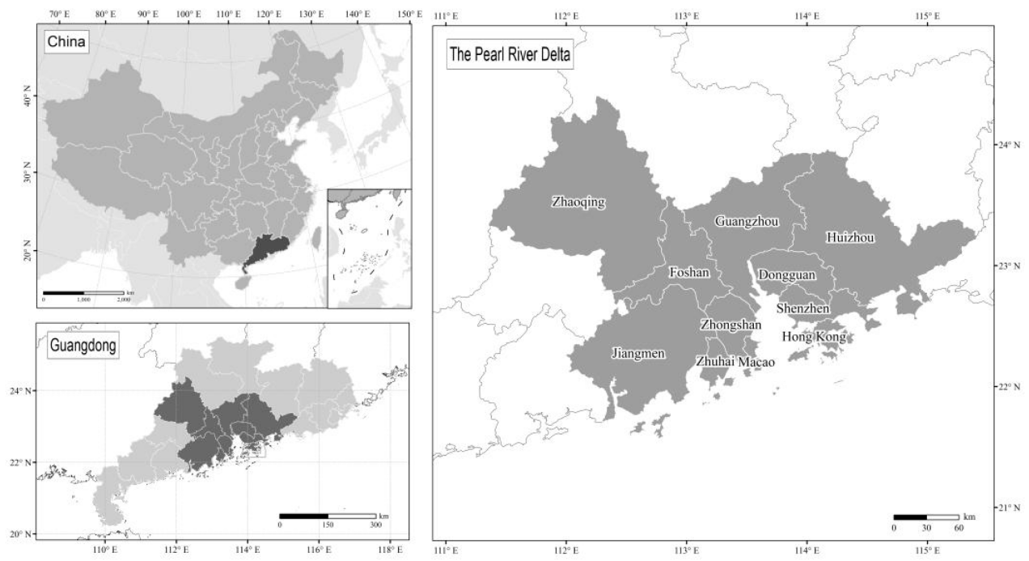
Figure 2: Location of the Pearl River Delta.

Guangzhou is located in the center of the Pearl River Delta, with well-developed waterways. The Pearl River eventually flows into the South China Sea. Guangzhou communicates with inland areas internally and connects with ocean-going merchant ships externally, effectively transporting domestic and foreign goods. Moreover, the low latitude of Guangzhou has warm and humid air blowing from the Pacific Ocean, so the port does not freeze all year round. Ability to conduct commerce and trade year-round. Such a unique natural geographical environment and long-standing business traditions have made Guangzhou a prosperous place since ancient times. From the beginning of the pre-Qin period to the prosperity of the Maritime Silk Road in the Tang Dynasty, Guangzhou is one of the important ports on this golden waterway in the Qianlong period of the Qing Dynasty, after the Canton system, Guangzhou became an important window for China's foreign trade. At the end of the 1990s, China's economy was developing at a high speed after the reform and opening up, and a large number of products were exported. Guangzhou and Nan-pan-shun(Nanhai, Panyu and Shunde) area are the leading areas for foreign trade, and 70% of the Spanish shawl market is occupied by Shunde. Shunde's production and sales model is mainly based on factory batch production and outsourcing production (Hu, 2019). My family is near Shunde, so my family can receive outsourcing orders from the factory. At that time, I found that there were many round bamboo baskets in my house, and there were some drawings of flowers in the middle of the bamboo baskets, including finished and semi-finished products. At that time, I just saw that the pattern was beautiful, and I was curious about how to use thread and needle to pierce up and down to form a beautiful pattern, so I also asked for some drawings, and my mother taught me how to complete a pattern. My family has a subtle influence on me, and this kind of learning has formed a brand in the depths of my memory. According to Walter E. Bratcher, environmental variables, cultural expectations, social status, family background, financial circumstances, ethics, gender, and certain other elements are all thought to impact professional selections (Bratcher, 1982). , I learned the reason why I am interested in Cantonese embroidery, and deeply studied the background and technology of Cantonese embroidery, and understood the reason why Cantonese embroidery is protected as one of the ICH. When I encountered other similar technical intangible cultural heritage design projects during my work, I gained some design experience from them, and wanted to understand the role of design in promoting the protection of ICH.

1.2 Why study for Intangible Cultural Heritage
In order to better improve myself and increase the value and significance of the output, I need to understand things neutrally and objectively. From my previous limited thinking, I now need to observe the research and cases of different countries from different angles, hoping to have in-depth research collisions and enlightenment. I learned that different ICH in China face different protection situations. The Cantonese embroidery ICH technique I have been exposed to the most is currently strongly supported by the government, and it has protection support from all levels of technology, market, and culture. But observed over time, these protections have not fully shown results. A person's strength is weak. I don't expect that I can bring much change to Cantonese embroidery or ICH by myself. I hope that one more person can understand and use the products of Cantonese embroidery or Cantonese embroidery culture, so that the culture can be passed on , The continuation of the protection of skills takes time to accumulate, the enthusiasm of the society, the demand of the market, the innovation of technology, and the support of data all play a positive role in the continuation of protection. On the one hand, the current situation that Chinese design art is facing is that traditional values have almost disappeared, new design values are just beginning to be established, and Western design values have matured (Yuan, 2012). The conflicts between tradition and modernity, between the center and the periphery, all of which need to be observed and understood from the perspectives of China and the West; Opinions, differences among different nationalities, cultures, and regions, gaps between scholars and ordinary people, etc., spark debates. Many scholars have conducted critical research on the divisive nature of the Chinese Communist Party's ideology, cultural policies, and political system. These studies help to understand cultural heritage policy and management (Svensson and Maags, 2018) play an active role in promoting the practice of Chinese ICH design art.

I still need to analyze different perspectives on the discussion of ICH. In 2013, some scholars criticized the voice of Eurocentrism in heritage research (Winter, 2013). The impact of globalization and the increasing importance of non-Western modern societies require examination from the perspective of Western centrality, globalization, and Westernization (Delanty, 2009). At the end of the 20th century, the successful protection models of Japan and South Korea were at the forefront of the protection of ICH in the world, and the Asian model of intangible cultural heritage provided a new framework (Stefano, Davis and Corsane, 2012). As a cultural power, China has always been popular for discussions with local characteristics, but the influence of globalization cannot be ignored, and global and regional forces influence each other. The study of ICH requires researchers to study from interdisciplinary, Eastern and Western perspectives. A critical look at the socio-political complexities deeply associated with intangible cultural heritage can positively advance current and future research on cultural and environmental sustainability, economic inequality, conflict resolution, social cohesion, and the future of communities effect.

- Basic research

2.1 Definition of intangible cultural heritage
Before the concept of ICH was formed, ICH, as a phenomenon of human activities, was reflected in different nations, countries, ethnic groups, communities or various species with its own independent law of emergence, development, decline or extinction. From the stone tool manufacturing skills of the primitive society, or the Wenfeng Festival celebrated by the ancient Egyptians with a calendar of thousands of years to celebrate the coming of the Spring Festival. These creations often originate from human beings adapting to and transforming the environment. Human beings have created intangible cultural heritage with national, regional or local characteristics or characteristics according to the unique natural environment or conditions. These traces of human activities have their own history of occurrence and development. Throughout the long history, intangible cultural heritage has been used for cultural exchanges, learning, imitation and promotion in groups or communities. Due to its uniqueness of practicality or value, it has been widely used and Utilization or dissemination, the process of the survival of intangible cultural heritage and the process of being recognized by the public has a long history and has an impact on human activities. These forms created by humans have cultural attributes (Chen, 2021). Culture allows us to enhance our understanding of ourselves, others, and other communities, increasing cultural self-identity (National Geographic, n.d.). In the basic understanding of international law, cultural heritage has a form of inheritance and is related to group identity. Cultural heritage symbolizes and constructs the cultural identity of self-identifying groups (Blake, 2000). In other words, people are the main body of ICH, protection and inheritance need people, inheritors and the whole society are intertwined and affect each other, and cannot be discussed separately.

In the past, the use of the term "intangible cultural heritage" in academia and public life has been increasing. The meanings represented by non-material are very vague, such as spirit, form, thinking, skills, production and reproduction of art, etc. At present, A more detailed description is provided in UNESCO's. In 2003, the 32nd General Conference of the United Nations Educational, Scientific and Cultural Organization passed the Convention for the Safeguarding of the Intangible Cultural Heritage (UNESCO, 2003). The Convention states that "Intangible cultural heritage' refers to cultural legacy that is acknowledged by numerous community groups and occasionally individuals as part of their cultural heritage." Various social activities, ideas, expressions, information, skills, tools, handicrafts, and sartorial This intangible cultural treasure is passed down from generation to generation in communities and organizations that are suited to their surroundings and have linkages to nature and history. Interactions are continuously reinvented in order to offer these groups and masses with a consistent sense of increasing identity, he tolerance for cultural variety and human ingenuity (Gong, 2019). The categories include i oral traditions and expressions, ii performing arts, iii social practices, rituals, festivals, iv knowledge practices about nature and the universe, v traditional crafts and vi cultural space (Gong, 2019).

2.2 Comparison of intangible cultural heritage protection
in multiple countries
The "Cultural Property Protection Law" promulgated by Japan in 1950 formally proposed the concept of "intangible cultural property(文化財保護法)" to ensure the development of Japanese cultural genes, and gradually began to protect Chuan Heng. In 1961, South Korea promulgated the "Act N.961 for Cultural Property Preservation" after the influence of the concept of "intangible cultural property" in Japan. After that, the Philippines, Thailand, the United States, France and other countries successively promulgated laws and regulations. Promoted by Japanese scholars such as Minister of Intangible Culture Noriko Aikawa and former Director-General Koichiro Matsuura, this concept was absorbed by UNESCO, and the concept of intangible cultural heritage was confirmed in 1998 (Liu, 2017 ).

British Intangible Cultural Heritage
Britain joined the Convention on the Protection of World Cultural and Natural Heritage in 1984, but did not join the Convention on the Protection of Intangible Cultural Heritage. The UK's view on the protection of cultural heritage is "tangible", which can be understood as monumental buildings, ruins, archaeological sites and primitive landforms. Only "tangible" cultural heritage can be managed and preserved, based on Western archaeology, art history and naturalism The described preservationist ethos in Europe and North America has had an impact on the understanding of cultural heritage (Stefano, Davis and Corsane, 2012), which is a different way of thinking about ICH in the UK, but it does not deny the existence of ICH in the Convention (Zhou, 2013). Although the UK has not joined the Intangible Cultural Heritage Convention, it attaches great importance to the protection of ICH. The Department of Culture, Media & Sport in the UK has also introduced policies to protect cultural heritage and creative industries. For example, "United Kingdom Copyright, Designs and Patents Act 1988" protects literary, dramatic music and artistic works. “Heritage Protection for the 21 Century” regards the protection of the historical and cultural environment as the core figure. Regarding the language and traditional crafts in the concept of ICH mentioned by the United Nations, the British government has also issued legislative documents such as the 2009 Scotch Whiskey Regulations and the 2011 Welsh Language Measures.

China's Intangible Cultural Heritage
The protection and inheritance of ICH in China is not only for the ICH itself or for cultural activities aimed at the nation itself. China's rich cultural heritage is an important spiritual pillar of the nation. However, due to China's rapid development, the pace of rapid urbanization has seriously affected China's cultural assets, and there is even a risk of over-development and degradation. Some government officials, environmentalists and community groups are working to protect China's cultural heritage against the above threats (Ebbe, Licciardi and Baeumler, 2011). According to the "Opinions on Strengthening the Protection of my country's Intangible Cultural Heritage" issued by the General Office of the State Council in 2005, it is pointed out that ICH is an important part of China's excellent traditional culture, and the country should take the lead in protecting, inheriting and utilizing intangible cultural heritage. cultural heritage. Promoters who do the above work well can bring about the continuation of history, the strengthening of self-cultural self-confidence, and the promotion of mutual exchanges between civilizations. The people's sense of participation, sense of gain and sense of identity are also taken into consideration.

There are many classifications of China's ICH. According to the "Intangible Cultural Heritage Law of the People's Republic of China" passed on February 25, 2011, ICH refers to various traditional cultural expressions passed down from generation to generation by people of all ethnic groups and regarded as an integral part of cultural heritage, as well as traditional cultural expressions Form-related objects and places. Including i traditional oral literature and language as its carrier; ii traditional art, calligraphy, music, dance, drama, folk art and acrobatics; iii traditional skills, medicine and calendar; vi traditional etiquette, festivals and other folk customs; traditional sports and entertainment; others ICH(Intangible Cultural Heritage Law of the People’s Republic of China).
2.3 The existence value of intangible cultural heritage
Industrialization, urbanization, immigration, armed conflict, environmental degradation, excessive tourism and other factors that lead to cultural unity pose serious threats to ICH. As a result, non-legacy has changed in its actual function, social significance and presentation. If we allow the ICH to perish and not pass on, then our life will become dull. The disappearance of traditional literature, song and dance, fine arts, and festivals will make the national understanding gradually disappear, and the spiritual emptiness will make the nation more likely to tear apart The crack cannot continue. ICH is based on the long-standing skills in people's lives, historical traditions, and the lack of ideology will stimulate people to find their own roots, have a strong interest in their own history and traditional culture, and find deep resonance from ICH. A civilization's respect and understanding of its own development is of great significance for people to deepen their sense of identity, enhance their historical memory and enhance their sense of well-being. Each ICH is different and has its own unique method of inheritance and protection. Commercial intervention is one of the effective methods. The redesign and marketization of ICH can be effectively integrated into the daily life of modern people. Instead of making sleeping history in museums, it is better to keep them alive in people's lives. This is also one of the manifestations of the reason why ICH can continue into our current society.

2.4 Design of intangible cultural heritage
Design is a very important tool to be elevated to a prominent position by stakeholders. In the face of the stimulation of globalization and the rapid development of modern society, people's current production base, system structure, and operation mode have undergone tremendous changes. Foreign cultures threaten local culture, and society lacks ideology. We need to re-establish a new understanding and understanding of the concepts, methods, tools and meanings in the modern design process (Li, 2011). The shaping of values, the lack of design resources, and the imbalance of inner emotions have become contemporary and global design cultural issues. It is not only a contrast between Chinese and Western cultures, but also a worldwide conflict of design values (Yuan, 2012) . The designer's intervention can play a linking role. Use design means to help intangible cultural heritage inheritors express their thoughts and cultural connotations, and play a role as a link among intangible cultural heritage inheritors, consumers, and producers. Be it experience design or product design. The trend of design reflects the evolution of society and the trend of culture, can reflect the form of society and cultural concepts, and is the manifestation of design values. Design means is an important point that needs to be discussed in the study of intangible cultural heritage. Design can serve people's production and life, and also has extensive and macro social responsibilities. The object of design is the product, but the ultimate goal of design is not the product itself, but the need to meet people's needs. The reason why intangible cultural heritage needs to be protected is that one of the status quo of intangible cultural heritage is gradually fading out of the needs of human life, and design means can discover the needs of life and spiritual needs.

From a design point of view, the above-mentioned British current view on the protection of cultural heritage is "tangible", and only "tangible" cultural heritage can be managed and preserved. Intangible cultural heritage, in other words, intangible heritage. So what I think is that intangible heritage can be observed, researched and analyzed from multiple angles. Including but not limited to language, text, pattern, and video can be recorded, and when recorded, there will be a visual presentation, from which elements of expression form or style characteristics are extracted, and modern creative thinking and expression techniques are used to carry out meaningful and effective Aesthetic expression and creation. When the secondary vision is presented, there will be a pattern, and the pattern can be designed and processed, and then the basic design can be carried out. The experience of China's cultural heritage protection projects supported by the World Bank shows that people's appreciation of cultural heritage is getting higher and higher (Ebbe, Licciardi and Baeumler, 2011), which shows that Chinese people's aesthetic level is constantly improving. It is very important for intangible cultural heritage workers to maintain aesthetic form and aesthetic sensitivity in their work, and the inspiration cultural symbols and meanings provided by intangible cultural heritage itself are helpful. As an intangible cultural heritage mainly represented by images, Guangzhou embroidery is easier to discuss from the perspective of design. Cantonese embroidery patterns have their own unique features. During the design process, available elements can be extracted from traditional patterns, so that the finished products will not lose the original style of Cantonese embroidery. Combining art and daily necessities makes daily necessities artistic, ornamental and practical. Increase the connection between people and people, people and things. The transformation from "intangible" artistic style and thoughts to "tangible" forms of expression is also in line with Britain's current attitude towards cultural heritage.

2.5 Cantonese Embroidery in Intangible Cultural Heritage
According to the introduction in "Guangzhou City Chronicle · Arts and Crafts Chronicle", the composition of Cantonese embroidery is full, vivid, clear texture, rich color, and diverse stitches. Because of the unique geographical and climate environment in Lingnan area, flowers and birds are the main theme. He is good at integrating auspicious and good wishes into embroidery (Guangzhou Local History Compilation Committee, 1998), which originates from life and values tradition in creation. After the Ming and Qing Dynasties, the exchange of cultural commodities between China and the West increased day by day. In the huge export market, Cantonese embroidery is unique (Huang, 2009). At the same time, Western art should be applied to the production of Cantonese embroidery, among which the Rococo style has the deepest influence (Mei and Wang, 2018), and the tones and expressiveness of Cantonese embroidery are more abundant (City University of Hong Kong, n.d.). The British East India Company played a role in promoting the demand for Cantonese embroidery products in Western society. It not only purchased traditional Cantonese embroidery products, but also customized patterns and samples for processing (City University of Hong Kong, n.d.). In addition, Cantonese embroidery has a wealth of usage scenarios, and the methods of Cantonese embroidery used in different scenarios are different, one is silk embroidery, the other is thread embroidery, the third is nail gold embroidery, and the fourth is the combination of silk embroidery and nail gold embroidery . Three and four have relatively fixed use scenarios, such as traditional Chinese wedding dresses and worship supplies, etc., and the first and second types need to be considered more. Silk embroidery and thread embroidery are currently more acceptable embroidery forms in the market. Among them, silk embroidery is embroidered with untwisted silk thread. It is very easy to be hooked and damaged. It needs skilled craftsmen to embroider. Both the production process and the use process need to be carefully cared for. Compared with the other three methods It is a more luxury type, and it is more widely used in luxury custom clothing and decorations. Compared with the second type of thread embroidery, the price is higher and it takes more time. For the design, more details need to be paid attention to to present the advanced sense of silk embroidery. The thread embroidery is embroidered with twisted and twisted thread, which is not easy to damage, suitable for daily use and easy to integrate into people's lives.

The embroidery has a strong cultural background and it is our responsibility to perpetuate this intangible cultural heritage. Research and studies point out that three basic conditions are required for the survival and continuation of traditional crafts i practitioners who possess traditional skills or complete craftsmanship, ii market consumption demand iii raw materials. The indicator for identifying traditional crafts is handicraft (Zheng, 2017). Here I raise some questions about whether the handcrafted nature of traditional crafts can be sustained if precious materials disappear or if the theoretical rationality of materials necessitates a change in the materials currently used. ii Craftsmanship is not only a pursuit of high skill, but also a competition with machines for the initiative in today's industrial production. iii Will the large number of artisans who need craftsmanship due to changes in market consumption trends maintain the current iii Will a large number of craftspeople who need to work with their hands have to maintain their current methods of work? With the support of today's new technologies, the innovation and preservation of craftsmanship has allowed traditional culture to be integrated into people's daily lives (Liang, 2021).

Currently in Cantonese embroidery faces several different situations. One of them is the different performance of the motifs in people's aesthetic process. Traditional silk embroidery has a stronger sense of pattern, pattern, subject matter, different arrangements more like illustrations, with a relatively fixed pattern of expression and a stronger sense of decorative stitching. Modern silk embroidery has a broader range of motifs, not limited to traditional auspicious motifs, but also to contemporary themes of life and even to the popular cartoon themes of young people. Modern silk embroidery is more realistic in its reference patterns than traditional embroidery, and the colour variations are more complex, requiring a higher degree of colour perception on the part of the maker. The Nan-Pan-Shun region is located in the developed Pearl River Delta hinterland, where production and labour costs are increasing. This is the first time that a factory has been set up in the Guangdong region.) It is evident that the product characteristics of Cantonese embroidery are not shifted by regional changes, and embroidery with the aesthetic characteristics of the art of Cantonese embroidery can be produced in different locations. It is interesting to note that the delicate embroidery of the Manila shawl, for example, which is one of the favourite costumes of Spanish women and one of the traditional features of the Spanish national treasure and a world class non-patrimonial flamenco dance, originated in Cantonese embroidery, and that the traditional motifs of the shawl were created in China according to Spanish folklore, and the embroidery was done in a region, with techniques and craftsmanship that are all Chinese. Cantonese embroidery is flexible and adaptable, able to incorporate local design styles and colour preferences.

2.6 Economy of intangible cultural heritage
Industries related to art and culture are called creative industries. Creative industries can create employment opportunities, attract investment, and drive purchases to stimulate tourism to increase economic benefits (Ebbe, Licciardi and Baeumler, 2011). ICH is a part of the creative industries . As the driving force of economic development, intangible cultural heritage has economic and non-economic value.

Peggy Clark, vice president of policy programs at the Aspen Institute and director of the Alliance for Artisan Enterprise pointed out that many people do not understand the promotion of artisan enterprises to economic development and job creation (Foote, 2015), that is to say, the economic value behind artisan enterprises not understood by the public. According to data from the Inter-American Development Bank, looking at the economic situation of the artisan industry from the perspective of a country, the artisan industry is equivalent to the fourth largest economy in the world, has the fourth largest labor force, and is an important part of the global creative economy. The core figures are craftsmen who have mastered the skills of their predecessors. The handicraft sector has a very large untapped potential to further increase global income and employment through job creation and export earnings. Consumers, investors, business leaders and policymakers can all help realize this potential, with profound social and economic impact (Foote, 2015).

After decades of research, researchers have found a very clear relationship between economic development, knowledge workers and creative industries. According to the World Bank, China's creative industries are growing rapidly, especially in media, culture, information and entertainment. At present, China's population is young, the middle class is rising rapidly, the economy is full of vitality, and the creative industry continues to grow (Ebbe, Licciardi and Baeumler, 2011). The consumer market can guide the production and planning of intangible cultural heritage craftsmen and designers. According to the survey, 91% of Chinese consumers are willing to buy branded products with a sense of social responsibility (Shaalan, 2022), and 36% of Chinese consumers are willing to use brands Come to customize personalized products or enjoy customized services (Kelter, 2022). The characteristics of intangible cultural heritage products are very in line with the expectations of Chinese consumers, and intangible cultural heritage handicraft products need to balance the mass market and craftsmanship.People's purchase behavior can achieve economic benefits, and secondly, they can virtually participate in the protection of intangible cultural heritage. The promotion of purchase can awaken the innovative spirit of intangible cultural heritage inheritors. It is not enough to please the masses with the beauty and function of the product in the past. It is necessary to respect the cultural background and maintain its own cultural characteristics on the basis of good product beauty and function. , needs to follow modern business rules, flexibly borrow modern technological means of expression, accept new ideas and diverse expressions, deconstruct and reshape its own craft characteristics and cultural background, and only through creative transformation and innovative development can it break through regional restrictions and become a The content and form of products that the public loves to see. The experience of China's cultural heritage protection projects supported by the World Bank shows that people's appreciation of cultural heritage is getting higher and higher (Ebbe, Licciardi and Baeumler, 2011), which shows that Chinese people's aesthetic level is constantly improving. It is very important for intangible cultural heritage workers to maintain aesthetic form and aesthetic sensitivity in their work, and the inspiration cultural symbols and meanings provided by intangible cultural heritage itself are helpful.

- Conclusion
Extending from my own experience to the observation of the development of intangible cultural heritage, including the protection, inheritance and development of intangible cultural heritage. To understand the relationship between the value of intangible cultural heritage, policy, and economic design, and to complete my research with the assistance of iconography and family micro-history.

- List of figures
6.References

1Oliveira, Í.M., Porfeli, E.J., do Céu Taveira, M. and Lee, B., (2020). Children's career expectations and parents' jobs: intergenerational (dis) continuities. The Career Development Quarterly, 68(1), pp.63-77.

2 Evans, T. (2021). How Do Family Historians Work with Memory? Journal of Family History, 46(1), 92–106. https://doi.org/10.1177/0363199020967384

5 Hu, Q. (2019). The Status Quo and Outlet of Intangible Cultural Heritage - Canton Embroidery as an Example. Think Tank Era, [online] 15, pp.177–194. Available at: https://www.ixueshu.com/document/035f7dd25a73b91175ae4b52dcf9e178318947a18e7f9386.html.

5.1 Svensson, M. and Maags, C., (2018). Mapping the Chinese heritage regime: Ruptures, governmentality, and agency.

6BRATCHER, W.E. (1982). The Influence of the Family on Career Selection: A Family Systems Perspective. The Personnel and Guidance Journal, 61(2), pp.87–91. doi:10.1002/j.2164-4918.1982.tb00734.x.

6.1 Winter, Tim (2013). Clarifying the Critical in Critical Heritage Studies, International Journal of Heritage Studies, 19 (6): 532-545.

6.2 Delanty, G., (2009). The cosmopolitan imagination: The renewal of critical social theory. Cambridge University Press.

7Gong, S. (2019). Research on the method of image recording of intangible cultural heritage. [online] media.people.com.cn. Available at: http://media.people.com.cn/n1/2019/0806/c429118-31277894.html [Accessed 15 Nov. 2022].
7.1 Blake, J. (2000). On Defining the Cultural Heritage. The International and Comparative Law Quarterly, [online] 49(1), pp.61–85. Available at: https://www.jstor.org/stable/761578 [Accessed 10 Jan. 2023].

7.8Liu, R. (2017). On the protection of traditional handicrafts in intangible cultural heritage from the comparison between China and Japan. [online] www.izhsh.com.cn. Available at: http://www.izhsh.com.cn/doc/346/3494.html [Accessed 1 Dec. 2022].
Stefano, M. L., Davis, P. and Corsane, G. (2012) “Touching the Intangible: An Introduction,” in Stefano, M. L., Davis, P., and Corsane, G. (eds) Safeguarding Intangible Cultural Heritage. Boydell & Brewer, pp. 1–6.

Chen, H. (2021). Creation and Inheritance: Cultural Attributes of Intangible Cultural Heritage. [online] www.ihchina.cn. Available at: https://www.ihchina.cn/Article/Index/detail?id=22468 [Accessed 16 Nov. 2022].
263 Barbero, J. L., Casillas, J. C., and Feldman, H. D. (2011) Managerial capabilities and paths to growth as determinants of high-growth small and medium-sized enterprises, International Small Business Journal, 29(6), pp. 671–694. doi: 10.1177/0266242610378287.

UNESCO (2003). the Convention for the Safeguarding of the Intangible Cultural Heritage. [online] United Nations. Available at: https://www.un.org/zh/documents/treaty/ich.

8.0 Zhou, F. (2013). Features of British Intangible Cultural Heritage Protection and Its Enlightenment. Journal of Xi’an Jiaotong University（Social Sciences）, Vol.33(Sum No.122), pp.96–103. 1008-245X(2013)06-0096-06.

8.1Ebbe, K., Licciardi, G. and Baeumler, A. (2011). Conserving the past as a foundation for the future : China-World Bank partnership on cultural heritage conservation (Chinese). [online] World Bank. Available at: https://documents.worldbank.org/en/publication/documents-reports/documentdetail/230781468024310270/conserving-the-past-as-a-foundation-for-the-future-china-world-bank-partnership-on-cultural-heritage-conservation [Accessed 1 Dec. 2022].

8.2 Yuan, X. (2012). ‘Design Axiology’: The Philosophical Height of Design. [online] www.izhsh.com.cn. Available at: http://www.izhsh.com.cn/doc/11/1669.html [Accessed 28 Nov. 2022].

Chen, H. (2009). A New Chapter of Introduction to Culture. Capital economic and trade university press.
(Chen, 2009)

10 Chen, H. (2021). Creation and Inheritance: Cultural Attributes of Intangible Cultural Heritage. [online] www.ihchina.cn. Available at: https://www.ihchina.cn/Article/Index/detail?id=22468 [Accessed 16 Nov. 2022].

11 National Geographic (n.d.). Cultural Identity | National Geographic Society. [online] education.nationalgeographic.org. Available at: https://education.nationalgeographic.org/resource/resource-library-cultural-identity.

13Zheng, L. (2017). Analysis of elements of evaluation of traditional handicraft status in the perspective of intangible cultural heritage protection. Journal of Suzhou College of Education, Vol.34(4), pp.89–97. doi:10.16217/j.cnki.szxb.2017.04.008.

13.1Liang, Y. (2021). Creativity + Fashion + Technology! Traditional handicrafts rejuvenate Shenzhen. [online] News Tencent. Available at: https://new.qq.com/omn/20211025/20211025A0EMWP00.html.

14Stewart, J. (1989). Theory of Culture Change. Translated by G. Zhang. Yuan-Liou Publishing Co., Ltd.

15Ma, Z. (2011). Confusion and exploration of intangible cultural heritage protection. [online] China Folklore Net Work. Available at: https://www.chinafolklore.org/web/index.php?Page=2&NewsID=8405 [Accessed 24 Oct. 2022].

16 Foote, W. (2015). Tapping The Potential Of The Artisan Economy. [online] Forbes. Available at: https://www.forbes.com/sites/willyfoote/2015/09/29/tapping-the-potential-of-the-worlds-fourth-largest-economy/?sh=ecc127e1aa28 [Accessed 17 Nov. 2022].
17 Kelter, D. (2022). Power to the People. [online] clients.mintel.com. Available at: https://clients.mintel.com/content/trend/power-to-the-people [Accessed 30 Nov. 2022].
17.1 Shaalan, S.A. (2022). International Localism. [online] clients.mintel.com. Available at: https://clients.mintel.com/content/trend/international-localism [Accessed 30 Nov. 2022].
260 Bamiatzi, V. C. and Kirchmaier, T. (2014) ‘Strategies for superior performance under adverse conditions: A focus on small and medium-sized high-growth firms’, International Small Business Journal, 32(3), pp. 259–284. doi: 10.1177/0266242612459534.

20Zhou, X. (2013). Philosophical Reflection on Contemporary Design Concepts. [online] www.izhsh.com.cn. Available at: http://www.izhsh.com.cn/history/4/2379.html [Accessed 27 Nov. 2022].

ccaha.org. (n.d.). Light Exposure for Artifacts on Exhibition | Conservation Center for Art & Historic Artifacts. [online] Available at: https://ccaha.org/resources/light-exposure-artifacts-exhibition.

Britannica (2019). Iconography | visual art. In: Encyclopaedia Britannica. [online] Available at: https://www.britannica.com/art/iconography.
Wang, W. (2008). Protection of Intangible Cultural Heritage and Fieldwork Methods. 1st ed. Cultural and Art Publishing House, p.12.
Wu, Y., Ma, Y. and He, S. (2022). A craftsman at the tip of a needle - Wang Xinyuan, an inheritor of the intangible cultural heritage of Canton embroidery. [online] tv.cctv.com. Available at: https://tv.cctv.com/2022/08/06/VIDE1f4u8wD64BdfCQj7ScCQ220806.shtml?spm=C53074552346.PGsnLDSQL24T.0.0 [Accessed 19 Jan. 2023].
Gao, L. (2011). The School of Art and Design establishes an off-campus practice base for graduate students. [online] news.gzhu.edu.cn. Available at: http://news.gzhu.edu.cn/info/1004/4245.htm [Accessed 19 Jan. 2023].

Li, L. (2011). Design Axiology. Beijing: China Architecture & Building Press.

Zou, Z. and Leng, W. (2009). Shunde Canton Embroidery - Western High Society Luxury. [online] www.guangxiuzhuang.com. Available at: http://www.guangxiuzhuang.com/m/show.php?id=785 [Accessed 20 Jan. 2023].

Guangzhou Local History Compilation Committee (1998). Guangzhou City History · Arts and Crafts. Guangzhou Publishing House.

Process Investigation Group of Guangdong Light Industry Department (1961). Investigation on the situation of drawnwork embroidery in Guangzhou (November 20, 1961). Guangdong Provincial Archives, pp.286–1263–7379.

Huang, B. (2009). Jin xiu ling nan : Guangdong Embroidery. Guangzhou: Guangdong Education Publishing House, pp.30–31.

Mei, B. and Wang, J. (2018). The artistic characteristics of practical wide embroidery. Beauty and Times · Creativity, [online] 1, pp.33–34. Available at: The artistic characteristics of practical wide embroidery

City University of Hong Kong (n.d.). Splendid Art of Lingnan: Cantonese Embroidery. [online] canton-embroidery. Available at: https://dannaxue.wixsite.com/canton-embroidery/qing-period

