University of Wales Trinity Saint David
Wales Institute of Science and Art



Electronic Circuits Testing and Applications
ACHA4010

Jack Purnell
2205053
March 2023
Contents
1 Task 1 3
1.1 A 3
1.2 B 3
1.3 C 3
1.3.1 I 3
1.3.2 II 3
1.3.3 III 3
1.3.4 IV 3
1.4 D 3
1.5 E 3
1.6 F 3
1.7 G 3
2 Task 2 4
2.1 Scope Time Division Calculations 4
2.2 Function Generator Output Sine Wave 4
2.3 Unsmoothed Rectifier Wave 4
2.4 Smoothed Rectifier Wave 4
2.5 Drop In Voltage Question 4
2.6 Rectifiers Use in Automotive Application Question 4
2.7 Probing Question 4
3 Task 3 5
3.1 Scope Time Division Calculations 5
3.2 Function Generator Output Sine Wave 5
3.3 Capacitor charge and Discharge Wave Marked at Correct Points 5
3.4 Basic Capacitor Calculations 5
3.5 Capacitor Discharge Table 5
3.6 Gradient Plot and Calculations 5
3.7 Inaccuracies Question 5
4 Reference List 6

Task 1

A
$V=IR$
$R= \frac{V}{I}$
$R= \frac{12}{0.5}$
$R=24Ω$

B
$0.5A-0.3A=0.2A$
$\frac{0.2}{2}=0.1A each$

C

I
$P= I^{2}R$
$R= \frac{P}{I^{2}}$
$R= \frac{0.9}{{0.3}^{2}}$
$R=10Ω$

II
$P=VI$
$P=12×0.1$
$P=1.2W$
$R= \frac{P}{I^{2}}$
$R= \frac{1.2}{{0.1}^{2}}$
$R=120Ω$

III
$R_{Total}= \frac{1}{\frac{1}{R_{1}}+ \frac{1}{R_{2}}+ \frac{1}{R_{3}}}$
$R_{Total}= \frac{1}{\frac{1}{10}+ \frac{1}{60}+ \frac{1}{60}}$
$R_{Total}=7.5Ω$
$V=IR$
$V=0.5×7.5$
$V=3.75v$

IV
$R= \frac{V}{I}$
$R= \frac{5}{0.1}$
$R=50Ω$

D
$12V-2V=10V$
$R= \frac{V}{I}$
$R= \frac{10}{0.5}$
$R=20Ω$

E
$V=IR$
$V=0.5 ×6$
$V=3v$
$12v-3v=9v$v

F

G

All baseline equations can be sourced from (James, 2023).

Task 2

Scope Time Division Calculations
$$f=10Hz$$
$$Period= \frac{1}{f}$$
$$Period=0.1s$$

Function Generator Output Sine Wave
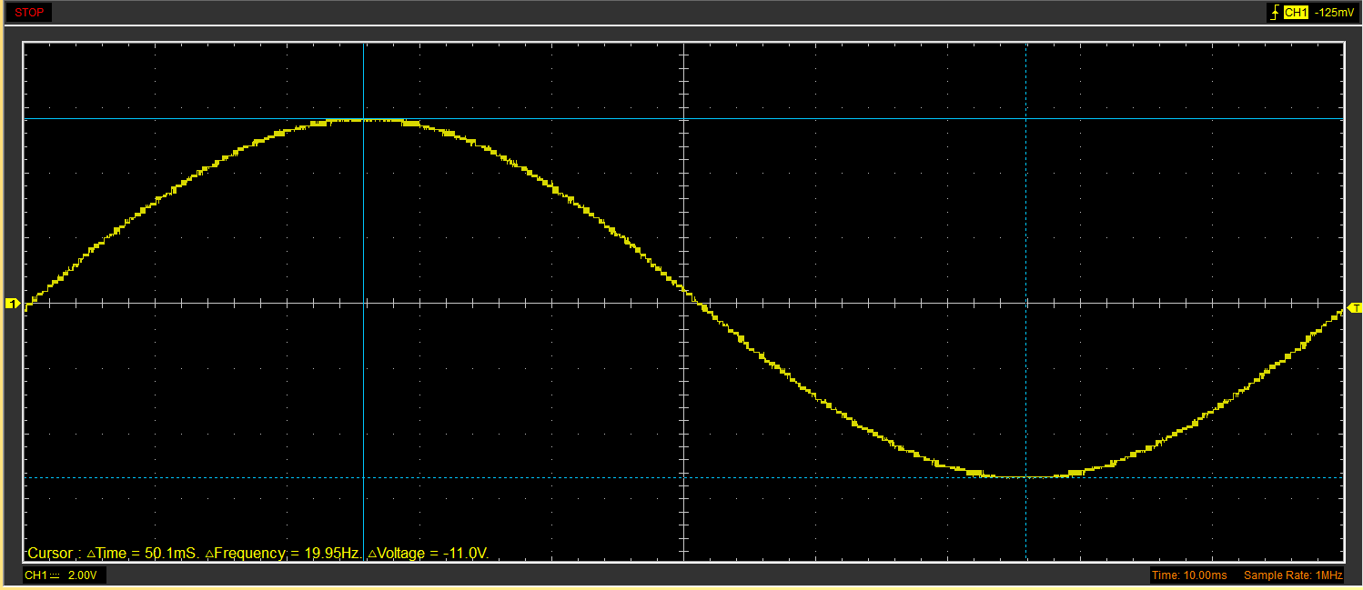
Figure 1 - Function Generator Output Sine Wave

Unsmoothed Rectifier Wave
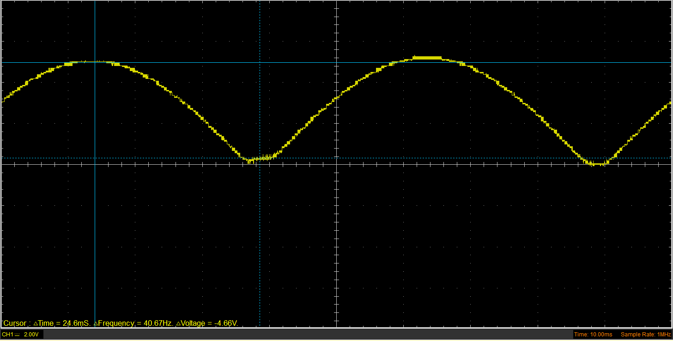
Figure 2 - Unsmoothed Rectifier Wave

Smoothed Rectifier Wave
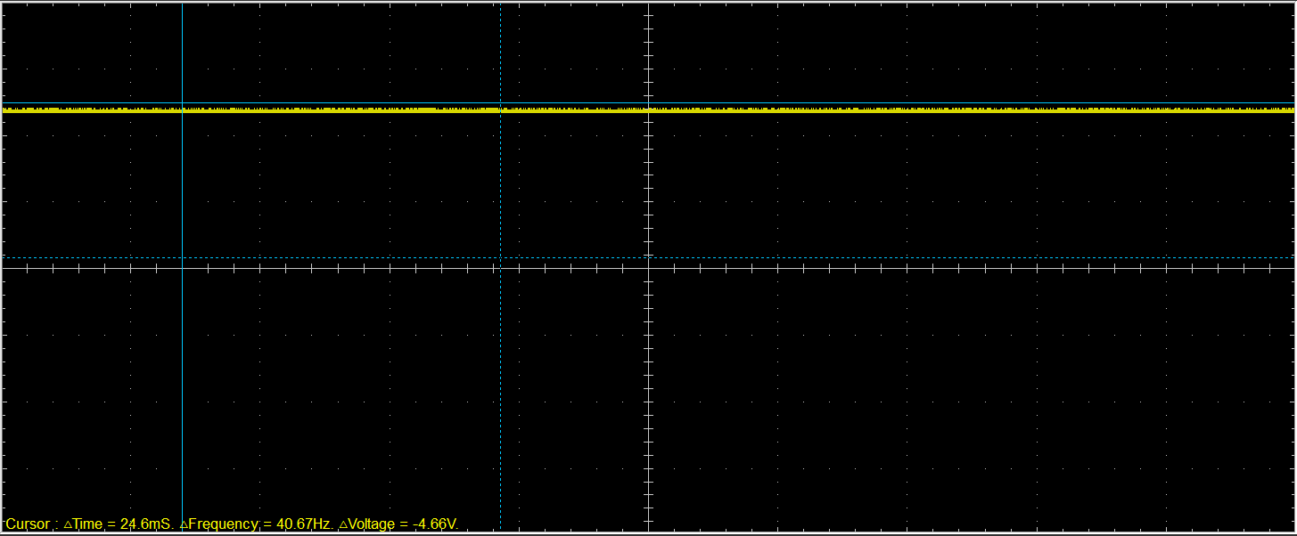
Figure 3 - Smoothed Rectifier Wave

Drop In Voltage Question
It can be observed that there is a drop in voltage over the rectifier. This can be caused by a variety of factors. The first main factor is that the rectifier uses diodes in order to convert the electricity from AC to DC. As taught in lectures, diodes have to overcome a certain voltage in order to allow the energy to flow through. As well as this, at lower voltages, bridge rectifiers are observed to possess higher internal resistance, which would directly correlate with the voltage drop (Zhao, n.d.).

Rectifiers Use in Automotive Application Question
One extremely significant use of rectifiers within an automotive application is when used on the output of a vehicle’s alternator (Shetty et al., 2018).This is because an alternator produces AC voltage, meanwhile, the car battery outputs a DC voltage and as is commonly known, the two are incompatible.
A further use of rectifiers within the automotive industry is heavily linked to the charging of new electric vehicles. The rectifiers are used in order to achieve regulation and stability of the output voltage from the charger, and allowing fast-charging to be available, all whilst remaining grid-friendly (Yan et al., 2020).

Probing Question
With the equipment provided, students were not able to simultaneously probe the output of the sine wave function generator and the rectifier output.

Task 3

Scope Time Division Calculations
$R=1000Ω$
$C=1×{10}^{-6}$
$t= ΩC$
$t=1000×{10}^{-6}$
$t=0.001$
$20t=0.02$
$p= \frac{1}{0.02}$
$p=50hz$

Function Generator Output Sine Wave
Figure 4 – Function Generator Output Sine Wave

Capacitor charge and Discharge Wave Marked at Correct Points
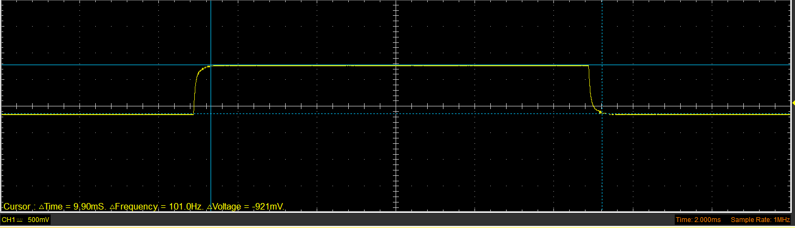
Figure 5 - Capacitor Charge and Discharge Wave Marked at Correct Points

Basic Capacitor Calculations
$t=RC$
$t=1000×{10}^{-6}$
$t=0.001$

Capacitor Discharge Table
Table 1 - Capacitor Discharge Table

Gradient Plot and Calculations

Figure 6 - Graph showing Voltage over Time

Figure 7 - Graph showing the log of Voltage over Time

Inaccuracies Question
Whilst conducting the investigation, it is entirely possible that inaccuracies may be recorded or calculated. One example of this, is that the peak to peak measurement, recorded from the oscilloscope, may be inaccurate due to tuning the probe incorrectly. It was taught that the probe must be tuned before any waveforms are taken, however it is possible that whilst probing, the tuning slightly uncalibrated.
As well as this, it is also possible that there are inaccuracies within the excel document and tables constructed from it. There are a range of variables that could cause this; looking at the wrong data range, misunderstanding the data and therefore manipulating it incorrectly and possible errors in the equations used to calculate some values.
Furthermore, the equipment itself may have a level of inaccuracy. Floating point inaccuracies are prevalent within numerical code as rounding can only be done to a certain degree, as finite precision is used to give the user a complete figure or value (Yi et al., 2018).

Reference List
James, R. (2023). Formula Part 1. In UWTSD Handout.
Shetty, A., Fernandes, B. G., Ojo, J. O., & Ferreira, J. A. (2018). Three phase PWM rectifier with integrated battery for automotive applications. 2018 IEEE Industry Applications Society Annual Meeting, IAS 2018. https://doi.org/10.1109/IAS.2018.8544681
Yan, X., Qin, F., Jia, J., Zhang, Z., Li, X., & Sun, Y. (2020). Virtual synchronous motor based-control of Vienna rectifier. Energy Reports, 6, 953–963. https://doi.org/10.1016/J.EGYR.2020.11.098
Yi, X., Chen, L., Mao, X., & Ji, T. (2018). Efficient Global Search for Inputs Triggering High Floating-Point Inaccuracies. Proceedings - Asia-Pacific Software Engineering Conference, APSEC, 2017-December, 11–20. https://doi.org/10.1109/APSEC.2017.7
Zhao, H. (n.d.). Rectifier Circuit: The General Basics, Working, and Requirements Explained. WellPCB. Retrieved March 29, 2023, from https://www.wellpcb.com/rectifier-circuit.html

