Juliette McManus
Student Number: 2502030
BA Animation & VFX

May 2026

eNVIRONMENT dESIGN
ACCA4032 - 3D Diorama and Presentation

Video Presentation
YouTube Link: https://youtu.be/TPYpfycYYEk
Screenshots
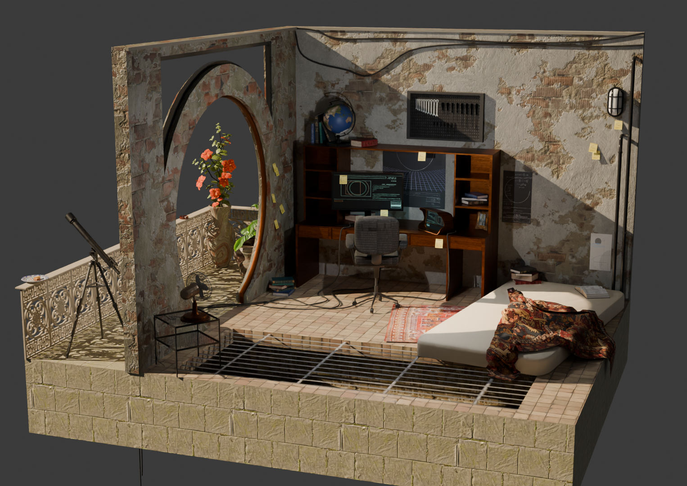
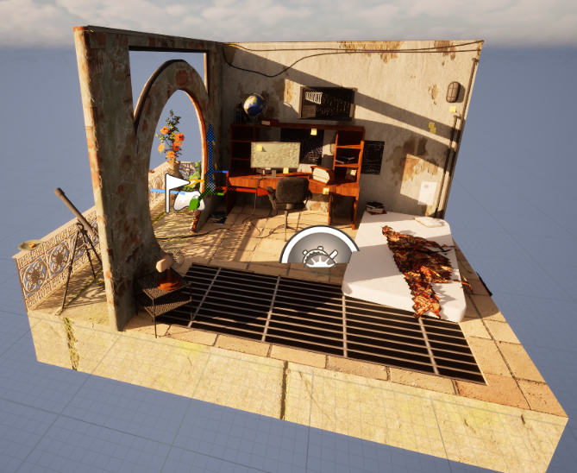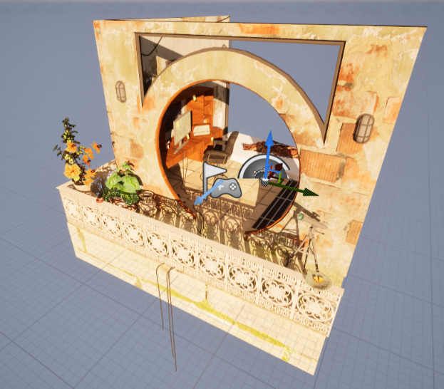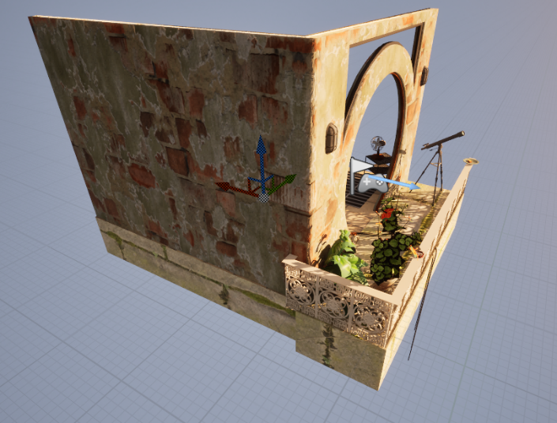
Bibliography
[1] M. Kruichenko, “Persian rover with bright red pattern”, Dreamstime. [Photo]. Available: https://www.dreamstime.com/persian-rover-bright-red-pattern-empty-blank-big-fashion-turkey-home-asia-age-folk-wool-cotton-knit-knot-weav-plaid-shawl-image244777601 (accessed May. 2, 2026)
[2] suuubdude, “Admiring some of the cityscapes of mass effect”, Reddit, 2021. [Photo]. Available: https://www.reddit.com/r/masseffect/comments/1aqxl37/admiring_some_of_the_cityscapes_of_mass_effect/ (accessed Feb. 15, 2026)
[3] “Igenix 16-inch Oscillating Desk Fan”, ChapmansIronMongers. [Photo]. Available: https://www.chapmansironmongers.co.uk/household-goods/igenix-16-inch-oscillating-desk-fan?srsltid=AfmBOooo1y7Gx2Igw4MpgBLLi0D1iPJ67ugPLAYWVVMbdIjpAFxDsnQU (accessed Feb. 26, 2026)
[4] Dotstudio, “Net shape texture design”, Magnific. [Photo]. Available: https://www.freepik.com/free-vector/net-shape-texture-design_853770.htm#fromView=keyword&page=1&position=4&uuid=208b985f-0f53-4653-a4e8-9afb14271019&query=Mesh+texture+transparent (accessed Mar. 05, 2026)
[5] BlenderVitals, “Create Open/Closed Books in Blender!” YouTube, Jul 8, 2024. [Video]. Available: https://www.youtube.com/watch?v=te0FyaZ8Kco (accessed Apr. 02, 2026)
[6] “Camping Table Folding Aluminium Portable Picnic Foldable BBQ Desk”, Decathlon. Available: https://www.decathlon.co.uk/p/mp/camping-table-folding-aluminum-portable-picnic-foldable-bbq-desk/e42a7d36-456a-40ca-aa35-9d1837ac4897/c1 (accessed Mar. 9, 2026)
[7] “AmbientCG”, AmbientCG. [Online]. Available: https://ambientcg.com/ (accessed Apr. 4, 2026)
[8] DECODED, “Change your understanding of Topology in Six Minutes”, YouTube, Nov 27, 2026. [Video]. Available: https://www.youtube.com/watch?v=HGL6QpVRyXk (accessed Apr. 20, 2026)
[9] “Home”, Hackertyper. Available: https://hackertyper.net/ (accessed, Feb. 22, 2026)
[10] H. Maunder, “Detail of Victorian ornate iron fence of a pavilion at the Anzac Memorial Park”, Alamy. [Photo]. Available: https://www.alamy.com/stock-photo-detail-of-victorian-ornate-iron-fence-of-a-pavilion-at-the-anzac-memorial-49872792.html?imageid=4F6145C1-16EA-4400-85E7-AC82DE792D62&pn=1&searchId=68dda5e081cf1ad3818f2023d4630343&searchtype=9 (accessed May. 10, 2026)
[11] ScienceShepherd, “‘Less than Perfect’ Fundamentals of chemistry textbook”, Scienceshepherd. [Photo]. Available: https://scienceshepherd.com/products/less-than-perfect-fundamentals-of-chemistry-textbook (accessed: Apr. 15, 2026)
[12] Generic, “Telescope 1.25 inch Wide Angle Eyepiece with High Magnification UWA82 Accessory for Astronomical Telescopes 4/7/16 mm/Metal Green Film (16 mm)”, Amazon, Aug 21, 2025. [Photo]. Available: https://www.amazon.ie/Telescope-Magnification-Accessory-Astronomical-Telescopes/dp/B0FN7M67C3?th=1 (accessed Mar. 18, 2026)
[13] “Solar Textures”, Solarsystemscope. [Photo]. Available: https://www.solarsystemscope.com/textures/ (accessed: Apr. 10, 2026)
[14] S. Sarkar, “A green tropical leaf isolated on transparent background Free PNG”, Vecteezy. [Photo]. Available: https://www.vecteezy.com/png/59322702-a-green-tropical-leaf-isolated-on-transparent-background (accessed Apr. 15, 2026)
[15] rawpixel, “Hibiscus leaf png sticker plant cut out transparent background” Magnific. [Photo]. Available: https://www.magnific.com/premium-photo/hibiscus-leaf-png-sticker-plant-cut-out-transparent-background_414494401.htm#fromView=keyword&page=7&position=36&uuid=a9e8e4b3-9c21-4c5c-aa60-289a6671ef15&query=Perilla+leaves (accessed Mar. 5, 2026)
[16] M.Vladimir, “Turkish Havuc Dilim Baklava with pistachio, Carrot Slice Baklava…”, Shutterstock, Nov. 22, 2022. [Photo]. Available: https://www.shutterstock.com/image-photo/turkish-havuc-dilim-baklava-pistachio-carrot-2229596025 (accessed Mar. 18, 2026)
[17] “Cigarette Paper Texture – Photo”, depositphotos. [Photo]. Available: https://depositphotos.com/photo/ciggarette-paper-texture-8947228.html (accessed Apr. 24, 2026)
[18] Gaagart, “Gaagart Yuvarlak Temperli Gerçek Cam Tablo Kırmızı Laleli Çini Desenli, 50 X 50”, Amazon. [Photo]. Available: https://www.amazon.com.tr/Gaagart-Yuvarlak-Temperli-K%C4%B1rm%C4%B1z%C4%B1-Desenli/dp/B0F4RFVDYV (accessed Apr. 14, 2026)
[19] Favourite Davinsi, “An ashtray made of glass full of cigarette butts and ashes”, Shutterstock, Mar. 20, 2023. [Photo]. Available: https://www.shutterstock.com/da/image-photo/ashtray-made-glass-full-cigarette-butts-2277867949 (accessed Apr, 2, 2026)
[20] TooEazyCG, “How to Properly Import Models AND Textures into Unreal Engine 5 from Blender”, YouTube, Mar. 22, 2024. [Video]. Available: https://www.youtube.com/watch?v=9q0Jrgu6wEw (accessed Mar. 25, 2026)
[21] EZUnreal, “FIX No Smoothing Group Information Was Found in This FBX Scene in Unreal Engine 5”, YouTube Jun. 20, 2024. [Video]. Available: https://www.youtube.com/watch?v=nIBSKIs1zmg (accessed Mar. 26, 20260

