Change Management of Microsoft

Zhangjian wei
2229980
3 May 2023

3675 words

Abstract
This paper focuses on Microsoft's change history and analyzes Microsoft's change from various aspects such as its history, development trend, change model, drivers, and resistance factors. Microsoft has experienced different levels of change and challenges in the PC era, mobile era and cloud computing era, but under the leadership of its new CEO Satya Nadella, it has successfully transformed from Windows OS to cloud computing through strategic repositioning and organizational culture change. Microsoft used different change models such as planned change and incremental change and faced multiple drivers and resistances in the change process, which were overcome by adopting appropriate solutions to successfully advance the change process. Microsoft's successful change was the result of a combination of factors, including leadership, organizational culture, technological innovation, strategic planning, and teamwork. （Shahzad，2017）The article concludes with recommendations for Microsoft in the era of the epidemic and Brexit, including strengthening digital transformation, focusing on remote work, focusing on the EU market and enhancing social responsibility to maintain its competitive advantage and sustainability.（Dwivedi，2020）
Key words：change management、key change management models

Contents
Abstract 2
1、Introduction 4
2、Main body 5
2.1 Types of changes 5
2.2 Force Field Analysis 6
2.2.1 Driving Forces of Change 6
2.2.2 Restraining Force of Change and Solutions 7
2.3 Stakeholder Analysis 7
2.4 Lewin's change process 10
2.5 Kotter's eight-step model 11
2.6、Assessment of Change 12
3、Conclusion 13
4、Recommendation 14
References 15

1、Introduction
Microsoft is a multinational technology company with a focus on software development and technology services, and its development history can be divided into the PC era, Internet era, mobile era and cloud computing era. However, Microsoft suffered a huge setback in the mobile era, as it failed to gain a firm foothold in the mobile device market due to its over-reliance on PC-based products and lack of innovation, leading to a steady decline in benefits.
At this time, Satya Nadella took over as CEO in 2014 and launched the strategy of "Mobile First, Cloud First" and the vision of "Achieving the Extraordinary", reorienting Microsoft's strategy to focus on cloud services, and reorienting Microsoft's strategy through organizational and cultural changes. Nadella's leadership is considered to be the most important factor in the company's growth.（Ouyang，2023）
Nadella's leadership is considered to be one of the key factors in the success of Microsoft's transformation. His open-mindedness, promotion of a diverse culture and focus on self-reflection broke down the company's closed organizational culture and bureaucracy, stimulated the innovative potential of employees, and brought about a comprehensive transformation for Microsoft. As cloud computing and artificial intelligence technologies continue to develop, Microsoft is increasing its investment in these areas and driving new business development, such as virtual reality and the Internet of Things, in order to diversify its operations. Microsoft's future growth prospects are promising and it is expected to continue to maintain innovation and leadership.(Microsoft，2023)

2、Main body

2.1 Types of changes
According to the classification table of Hodges and Gill (2015), we can analyze the types of change at Microsoft as follows:

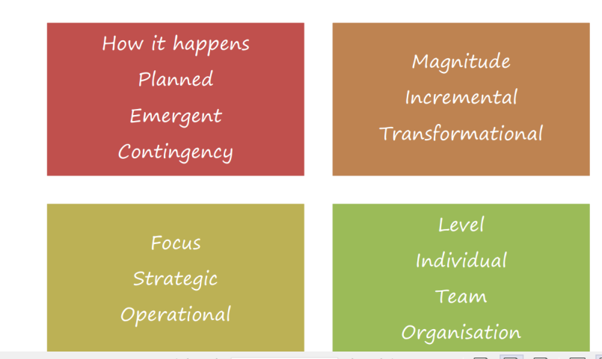
typology of change（Hodges & Gill，2015）
Planned: Microsoft's changes are planned, such as Satya Nadella's "Mobile First, Cloud First" strategy released in 2014.
Incremental: Microsoft's changes are incremental, achieving strategic goals gradually over time. For example, during the transition, Microsoft shifted its business focus from Windows OS to cloud computing. Microsoft's change is also transformational in that it changes the company's business model and strategy, such as Microsoft's cloud computing strategy.（Skelly，2014）
Strategic: Microsoft's change is strategic in that it implicates the company's long-term direction and goals, such as the transformation of cloud computing.
Organization: Change at Microsoft requires the involvement and collaboration of the entire organization to ensure the success of the change.

2.2 Force Field Analysis
Lewin's force field analysis model, proposed in 1951, is a change management tool that helps to analyze the various forces affecting a particular issue or problem. The model divides these forces into two categories: driving forces, which encourage change, and restraining forces, which oppose it. The analysis aims to identify and evaluate these forces to determine which ones need to be strengthened or weakened to facilitate successful change. The model provides a structured and systematic approach to understanding the underlying factors that influence change and helps to identify the most effective strategies to achieve the desired outcome.（Lewin's，1951）

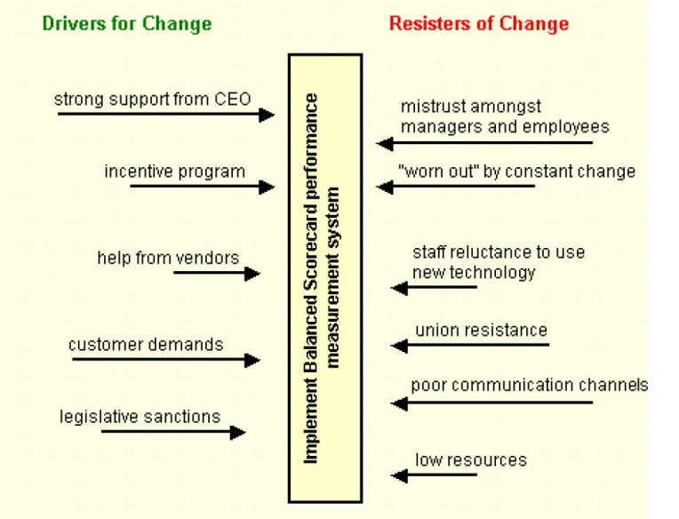
（Lewin's，1951）

2.2.1 Driving Forces of Change
According to Lewin's (1951) force field analysis model, drivers are the forces that facilitate organizational change. For Microsoft, the following are possible drivers:
Technology trends: With the development of Web 3.0 technologies, Microsoft needs to keep up with the trends in order to meet the needs of its customers.
Competitive pressures: Microsoft is highly competitive in the cloud computing space and needs to continue to innovate to maintain its market position.
Revenue growth: By expanding the share of its cloud and services business, Microsoft can achieve higher revenue growth.
Partner ecosystem: Microsoft needs to expand its partner ecosystem to provide more solutions and value-added services to win more customers.
Strategic realignment: Microsoft needs to shift its business focus to focus on the cloud and services business as it relies too heavily on the Windows operating system for revenue.
These drivers are driving Microsoft to make changes to maintain its competitive advantage and deliver better products and services.（Markovic，2013）

2.2.2 Restraining Force of Change and Solutions
According to Lewin's force field analysis model, restraining forces are the factors that resist or oppose change. In the case of Microsoft's transformation, some of the restraining forces could be:
Resistance to change from employees who prefer the status quo and are comfortable with traditional ways of working.
Fear of job loss or redundancy due to automation or other changes in the organization.
Legacy systems and processes that may not be compatible with the new changes and require significant time and resources to modify or replace.
To overcome these restraining forces, Microsoft can implement several solutions, such as:
Communicating the benefits of the change to employees and providing training and support to help them adapt to the new ways of working.
Offering career development opportunities to employees, which may include upskilling and reskilling to enable them to take on new roles and responsibilities.
Developing a roadmap for phasing out legacy systems and processes, and investing in new technology and infrastructure that can support the new changes.
By addressing these restraining forces through these solutions, Microsoft can successfully navigate through the change and achieve its transformational goals.

2.3 Stakeholder Analysis
The Stakeholder Analysis model is a management tool for identifying and assessing stakeholders who have influence on organizational goals and decisions. It helps organizational managers to better understand the relationships and needs of different stakeholders and take steps to address issues related to them.（Varvasovszky，2000）
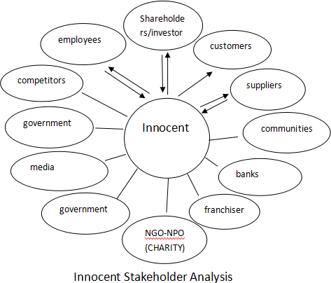

Stakeholder analysis is a tool used to identify and evaluate the interests, needs, and concerns of different stakeholders involved in a particular project or decision. In the context of Microsoft's transformation, the stakeholders can be identified as follows:
Employees: Microsoft's transformation would have a significant impact on its employees, including changes in job roles, responsibilities, and work culture. The interests of the employees need to be taken into account during the change process.
Customers: Microsoft has a diverse customer base, ranging from individuals to large corporations. The company's transformation should be aligned with the changing needs and preferences of its customers.
Shareholders: Microsoft's transformation has a direct impact on its financial performance, which affects the interests of its shareholders. The company needs to ensure that its transformation results in sustainable growth and profitability.
Partners: Microsoft has a large network of partners, including software vendors, hardware manufacturers, and service providers. The company needs to ensure that its transformation does not negatively impact its partnerships.
Regulators and Government: Microsoft operates in a highly regulated industry and is subject to various laws and regulations. The company needs to ensure that its transformation complies with all applicable laws and regulations.
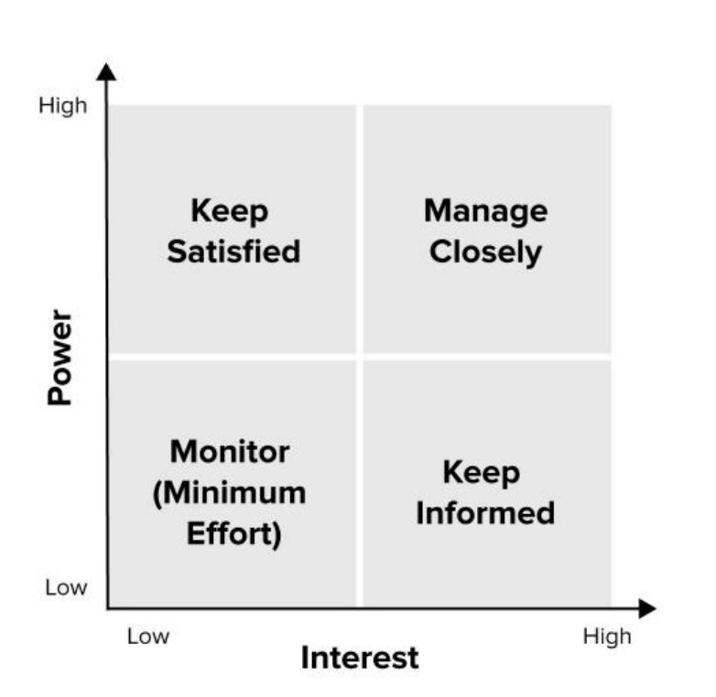
(Cameron & Green, 2012）
Low power and low interest stakeholders: These stakeholders may include smaller technology companies, individual developers and consumers who may not have a significant impact on Microsoft's decision-making process. However, it is important for Microsoft to monitor these stakeholders as their views and opinions can still impact the company's brand image and reputation.
High power and low interest stakeholders: These stakeholders may include the government, media, and financial institutions. Microsoft needs to keep them satisfied to ensure that they do not become obstacles to the company's change initiatives.
High interest and low power stakeholders: These stakeholders include Microsoft's employees, customers, and partners. Microsoft needs to keep these stakeholders informed of the changes taking place in the organization to ensure they are aligned with the company's goals and objectives.
High power and high interest stakeholders: These stakeholders are Microsoft's shareholders, investors, and key customers. They have the power to significantly impact the company's decision-making process and must be managed closely. Within this group, there may be individuals who support the change and others who oppose it.
To successfully manage these stakeholders, Microsoft may need to employ various change management strategies, such as stakeholder engagement, communication, and collaboration. By effectively engaging with each stakeholder group and addressing their concerns and needs, Microsoft can minimize resistance to change and achieve its desired outcomes.

2.4 Lewin's change process
Lewin's change model, also known as the "unfreeze-change-refreeze" model, is a widely used framework for understanding and managing organizational change. The model consists of three key stages: unfreezing, changing, and refreezing. Unfreezing involves preparing the organization for change by identifying the driving and restraining forces at play and building support for the change. The changing stage involves implementing the change, which may involve modifying organizational structures, processes, or culture. Finally, the refreezing stage involves embedding the change into the organization's culture and ensuring that it becomes the new norm. The model is based on the idea that change is a process that requires careful planning and management to be successful.(Cummings,2016)
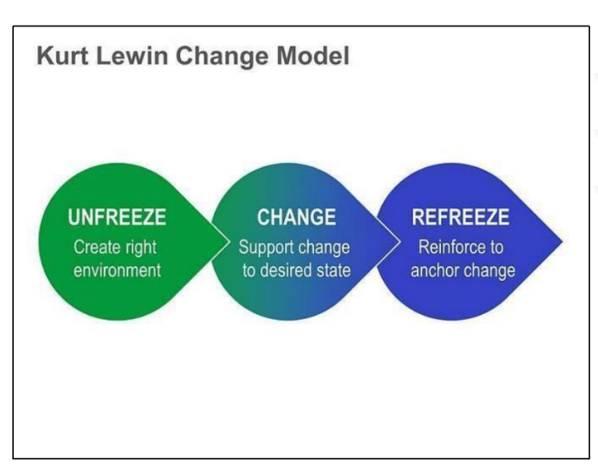
In the freeze phase, Microsoft needs to identify the goals of the change and assess the current state. During this phase, Microsoft can look for drivers and constraints to change. Drivers of change at Microsoft include the drive of digital trends, changing consumer needs, and increased competitive pressures. Constraints may include organizational structure, culture, and employee attitudes. During this phase, Microsoft needs to prepare for the change, including communicating the change, training and preparing employees, aligning the organizational structure and culture, and determining the timing and scope of the change.(Hayes,2022)
In the mobile phase, Microsoft needs to implement the change. This phase involves implementing a plan, executing the change, and identifying and solving problems. For Microsoft, it may be necessary to invest in digital technology and artificial intelligence, reshape the organization, improve the culture, and enhance employee skills to achieve the change goals. Microsoft can use project management techniques and human resource management techniques to ensure that the change plan is implemented.
During the reinvention phase, Microsoft needs to consolidate the results of the change and integrate them into the day-to-day operations of the organization. This means that Microsoft needs to ensure that the results of the change meet expectations and are embedded in the organization's structure, culture, and processes. Microsoft can ensure the sustainability of the change results by setting performance metrics, continuously training and developing employees, and creating incentives.
In summary, Microsoft needs to carefully consider the three phases of Lewin's change model and develop appropriate strategies and measures at each phase to ensure the success of the change.

2.5 Kotter's eight-step model
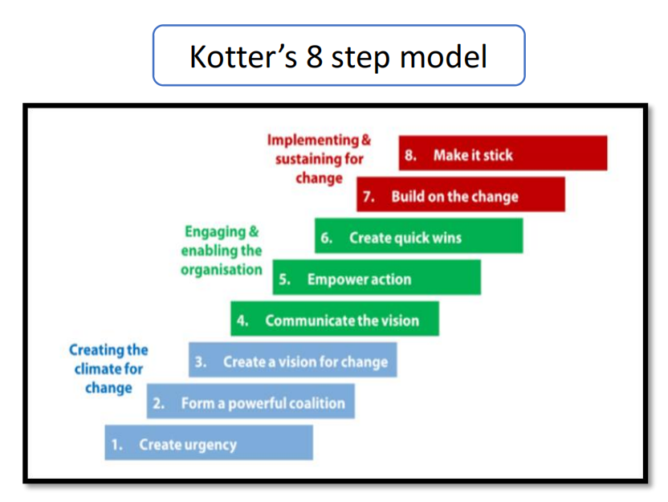
- Establish a sense of urgency: Microsoft recognized the need to adapt to the changing market and stay competitive. They identified the threat from competitors such as Google and Apple and the need to focus on mobile devices and cloud computing.
- Form a powerful coalition: Microsoft's leadership team, led by CEO Satya Nadella, worked together to create a vision for the company and communicate it to employees and stakeholders. They also formed partnerships and alliances to strengthen their position in the market.
3、Create a vision for change: Microsoft's vision was to empower people and organizations to achieve more through technology. They focused on cloud computing, mobile devices, and artificial intelligence to drive growth.
4、Communicate the vision: Nadella and other leaders communicated the vision to employees, stakeholders, and the public through speeches, interviews, and other forms of media. They also created internal communication channels to ensure everyone was informed and aligned with the vision.
5、Empower others to act on the vision: Microsoft empowered employees to take ownership of the vision and make it a reality. They encouraged innovation, experimentation, and risk-taking to drive change.
6、Create short-term wins: Microsoft celebrated small successes along the way, such as the launch of Office 365 and the acquisition of LinkedIn. These wins helped build momentum and keep employees motivated.
7、Consolidate gains and produce more change: Microsoft continued to build on their successes and drive further change. They acquired new companies, expanded their product offerings, and invested in emerging technologies.
8、Anchor new approaches in the company's culture: Microsoft embedded the new approaches and vision into their culture, values, and practices. They created a growth mindset and culture of innovation that continues to drive the company forward.
Overall, Microsoft used Kotter's eight-step model to successfully drive change and transform the company's focus and direction. They established a sense of urgency, created a powerful coalition, communicated a clear vision, empowered others to act, celebrated short-term wins, and anchored new approaches in the company's culture.（Hodges，2016)

2.6、Assessment of Change
Microsoft's successful transformation has been evident since its implementation, making it a leader in the Web3.0 era. The company has achieved outstanding results in market value, business focus, cloud capability, and ecosystem cooperation. Its market value has grown 6.8 times, making it the world's largest software group and a leader in cloud services. The successful reduction of its dependence on the Windows operating system has resulted in more than 3 times growth. Its cloud business is also impressive, surpassing Amazon AWS to become the world's highest revenue cloud service provider, accounting for 18% of the global cloud computing market. Furthermore, Microsoft has fully embraced the ecosystem, collaborating closely with more than 72,000 cloud partners worldwide, with over 17,000 partners in the Greater China region.(Microsoft，2023) By 2023, the company's partner revenue is expected to double, demonstrating Microsoft's significant achievements in ecosystem cooperation. In conclusion, Microsoft's successful transformation has brought it great success and will continue to lead the technology transformation trend in the future.（Ouyang，2023）

3、Conclusion
Overall, Microsoft, as a multinational technology company, has been in a constant state of change over the past decades. With the development of Internet and cloud computing technologies, Microsoft has also gone through a transformation process from the PC era to the mobile era and then to the cloud computing era. Microsoft has faced great challenges and difficulties in the mobile era, but under the leadership of new CEO Satya Nadella, Microsoft has repositioned its strategy and put forward the slogan of "Mobile First, Cloud First", and through organizational and cultural changes, it has successfully achieved the following Microsoft has successfully transformed its strategy from Windows OS to cloud computing through organizational and cultural changes.(Microsoft，2023)
Microsoft adopted various change models, including planned change and incremental change, with a focus on strategic change, which required the support and participation of the entire organization. During the change process, Microsoft faced many drivers and resistances, such as drivers of technology trends, competitive pressures, revenue growth, partner ecosystems and strategic restructuring, and resistances such as employee resistance to change, fear of job loss and legacy systems and processes. Microsoft has successfully advanced the change process by overcoming these resistances through force field analysis and adopting appropriate solutions.
Overall, Microsoft's successful change was the result of multiple factors, including leadership, organizational culture, technology innovation, strategic planning, and teamwork. Microsoft will also continue to invest in areas such as cloud computing and artificial intelligence in the future to drive new business development and maintain its innovation and leadership position. In the post-epidemic and Brexit era, Microsoft will also need to carefully address future challenges and opportunities to ensure successful change and sustainable business growth.

4、Recommendation
In the post-epidemic and Brexit era, Microsoft needs to be careful about the challenges and opportunities ahead. The following are some recommendations:
Enhance digital transformation: With the outbreak, digital transformation has become a necessary initiative for businesses. Microsoft can better shift its business to online platforms by enhancing digital transformation to meet the needs of its customers. In addition, Microsoft can improve the company's digital capabilities and competitiveness by increasing its investment in artificial intelligence and cloud computing.（Putritamara，2023）
Focus on remote work: Remote work has become a trend, and the epidemic has accelerated this trend. Microsoft can enhance its support for remote work to improve employee productivity and satisfaction. Based on this, Microsoft can develop more remote working related tools and applications to meet customers' needs.
Focus on the EU market: Brexit will make Microsoft need to reconsider its layout in the EU market. Microsoft can adapt to the new market environment by strengthening its investment and expansion in Europe. In addition, Microsoft also needs to focus on EU regulatory policies for digital markets to ensure its own compliance and sustainability.
Strengthen social responsibility: In the context of global epidemics and social unrest, companies need to pay more attention to social responsibility. Microsoft can promote social good by strengthening cooperation with public institutions and non-profit organizations. In addition, Microsoft also needs to pay more attention to its social, environmental and governance responsibilities in order to achieve sustainable development.
In conclusion, Microsoft needs to maintain a prudent approach to future challenges and opportunities, strengthen digital transformation, focus on remote work, focus on the EU market, and enhance social responsibility in order to maintain its competitive advantage in the post-epidemic and Brexit era.

References

Behnam Tabrizi.（2023）How Microsoft Became Innovative Again， [Online] Available at: https://hbr.org/2023/02/how-microsoft-became-innovative-again

Cameron, E. & Green, M. (2015), Making Sense of Change Management: A Complete Guide to the Models, Tools and Techniques of Organisational Change, 4th edition.

Carnall, C. A. (2007). Managing change in organizations. Pearson Education.

Carnall, C. (2018). Managing change. Routledge.

Cummings, S., Bridgman, T., & Brown, K. G. (2016). Unfreezing change as three steps: Rethinking Kurt Lewin’s legacy for change management. Human relations, 69(1), 33-60.

Daryl Ullman(2018).Why is Microsoft so successful? [Online] Available at: https://www.computerworld.com/article/3247650/why-is-microsoft-so-successful.html

Donaldson, T. & Preston, L. (1995). The Stakeholder Theory for the Corporation: Concepts, Evidence, Implications. Academy of Management Review, Volume 20, pp. 65-91.

Dwivedi, Y. K., Hughes, D. L., Coombs, C., Constantiou, I., Duan, Y., Edwards, J. S., ... & Upadhyay, N. (2020). Impact of COVID-19 pandemic on information management research and practice: Transforming education, work and life. International journal of information management, 55, 102211.

Grant, M. T. (2016). Managing Change in IT Projects: Using Kotter's Eight Step Process to Examine Lewin's Unfreeze-Move-Refreeze Theory. Northcentral University.

Hayes, J. (2018), The Theory and Practice of Change Management, 5th edition, Basingstoke: Palgrave Macmillan

Hodges, J & Roger , G, 2015. Sustaining Change in Organizations. 1 ed. London: Sage Publications Ltd.50-55.

Hodges, J. (2016). Managing and leading people through organizational change: The theory and practice of sustaining change through people. Kogan Page Publishers.

Jansson, E. (2005). The stakeholder model: the influence of the ownership and governance structures. Journal of Business Ethics, 56, 1-13.

Kotter, J. P. (2009) Leading Change, Mass :Harvard Business Essentials

Kortesalo, E. (2014). Comparing Directory Assistance Change to Kotter's Eight Step Model of Company's Successful Change Adaptation.38-42.

Krupp, S., & Schoemaker, P. J. (2014). Winning the long game: How strategic leaders shape the future. Hachette UK.34-38.

Lauer, T. (2010). Change management. Springer Berlin Heidelberg.55-78.

Libby, B. H. (2017). Examining Faculty Perceptions of Community College Institutional Effectiveness Using Kotter's Eight Step Model of Change. ProQuest LLC.12-25.

Markovic, D. S., Zivkovic, D., Branovic, I., Popovic, R., & Cvetkovic, D. (2013). Smart power grid and cloud computing. Renewable and Sustainable Energy Reviews, 24, 566-577.

Microsoft. (n.d.). Microsoft website. Available at: https://www.microsoft.com/zh-cn/about

Ouyang, 2023, Microsoft: Successful change under "cloud-first", [Online] Available at: https://www.cnii.com.cn/gxxww/txqygl/fxgc/202302/t20230223_449212.html

Prosci.(2023).Success Spotlight: Leader of Change Management at Microsoft, [Online] Available at: https://www.prosci.com/blog/spotlight-leader-of-change-management-at-microsoft
Putritamara, J. A., Hartono, B., Toiba, H., Utami, H. N., Rahman, M. S., & Masyithoh, D. (2023). Do Dynamic Capabilities and Digital Transformation Improve Business Resilience during the COVID-19 Pandemic? Insights from Beekeeping MSMEs in Indonesia. Sustainability, 15(3), 1760.

Rittinghouse, J. W., & Ransome, J. F. (2016). Cloud computing: implementation, management, and security. CRC press.22-53.

Swanson, D. J., & Creed, A. S. (2014). Sharpening the focus of force field analysis. Journal of change management, 14(1), 28-47.

Shahzad, F., Xiu, G. and Shahbaz, M. (2017) Organizational culture and innovation performance in Pakistan's software industry. Technology in society, 51, pp. 66-73.

Skelly, P., Hester, S., Ryan, T., Underwood, J., Bowden, E., Evans, T. K., ... & Shiflett, C. (2014). The New Business Operating System: Combining Office 365 and the Microsoft Cloud Ecosystem to Create Business Value. 68-75

Tahir Abbas.（2023）.Microsoft Change Management Case Study, [Online] Available at: https://changemanagementinsight.com/microsoft-change-management-case-study/

Varvasovszky, Z., & Brugha, R. (2000). A stakeholder analysis. Health policy and planning, 15(3), 338-345.

Xu Peiyi. (2018). Embracing Change Microsoft CEO Nadella goes behind the scenes in Embracing Change. English in the air classroom: advanced edition. Pang Monghui English, (3), 16-17.

