Module name: Changemakers: Creativity and Value Creation

Module code: BMHP5014_BIRM
Lecturer’s name: Azora Hurd

E-Portfolio Evidence of Learning Comprising of 2 Separate Artefact Items

Student’s Name: Marilena Anghel
Student number: 2020324
Date: 15/07/2022

Introduction
The purpose of this E-portfolio is to raise awareness for mental health among teenagers.
The idea came from the perspective of a group leader that tries to promote his project in front of a community to gain new audience in the local area.
The main goal of the project is to create an organization that will use volunteers to run its activities.
The organization created will use methods of promotion and awareness such as:
A mind-map because it’s an easy way to highlight the important facts and to show the overall structure of mental health.
A flyer because from flyers and leaflets people can gain information, flyers have the ability to arouse compassion,are affordable.

Mind Map

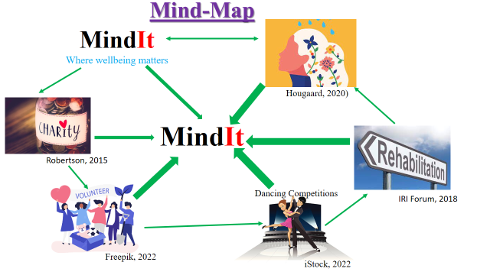
1
2
3
4
5
6
Notes:
The project is aimed at creating awareness of depression among teenagers. Notably, many teenagers are depressed, and this has been increasing cases of social problems such as teenage suicides and increased drug abuse (Tillmann et al., 2018). Teenagers need to be aware of this social problem and how it can be solved. To create awareness on mental an organization will be formed. The organization will be called MindIt and it will operate on charity. Donations will be used to run the charity organization.
The organization will use volunteers to run its activities. Volunteers will include students and graduates who have studied mental health-related courses such as counselling psychology. The organization will advertise volunteer opportunities through its website and social media sites such as Facebook and LinkedIn. University students and graduates will apply to volunteer at the organization. The organization will use money donated to organize events such as dancing competitions to allow teenagers to come together and create awareness through this event.
The target audience, teenagers, like dancing competitions and it will be easy to attract them to dancing competitions that will be held in various locations of the country. Through these dancing competitions, speakers will give speeches on mental health. They will tell teenagers that depression is real and advise them how they can seek help when they are depressed. MindIt will also counsel youths who are depressed and it will build a rehabilitation centre for youths who are highly depressed.
Social media accounts of the organization and the website will also be used create awareness of mental health. Teenagers will get directions on how they can get assistance through the organization. Notably, drug abuse and mental health are closely related. Teenagers get into drug abuse when they are depressed and drug abuse may lead to mental unrest. The organization will have a special focus on teenagers who are engaged in drug abuse activities. It will hold free counselling sessions for teenagers who have signs of depression.
Mindit will also target high schools where the highest number of students in high schools are teenagers (Aguirre et al., 2020). It will book time with school heads to hold dancing competitions in the schools as volunteers give speeches on mental health and advice the students on how they can combat depression. The activities of the organization, especially dancing competitions, will help create awareness of mental wellbeing among many teenagers that are affected by the issue and help to prevent problems associated with mental health in the future. It will also give chance to university students and recent graduates to practice their work and gain experience on matters related to mental health, helping them to get employment in other organizations after the voluntary service at MindIt.

Flyer
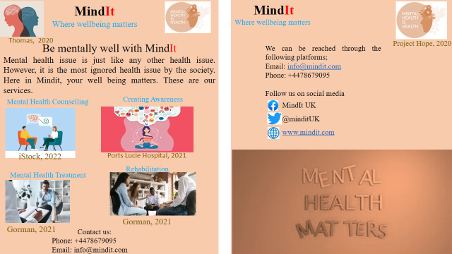

Notes:
Mental health is one of the major problems that our society has failed to put enough focus on. We are creating awareness on the matter as well as help people in communities to fight the problem. Awareness will be created using various ways. One of the key methods that will be used to sensitise teenagers is using flyers. The advantages of flyers are that they are cheap and progress can be easily monitored (Benedict et al., 2019). One needs to design and print flyers. This is a cheaper method of creating awareness than sponsoring ads on media platforms and firms. Moreover, one can easily monitor the success based on the number of flyers distributed. If one million flyers are distributed, it will be known that one awareness has been created in at least one million teenagers. Flyers are also great for short-notice events targeting young people. It will be easy to remind people on mental health awareness events that the organization seeks to accomplish. Flyers also contain the contact details of the sponsoring organization. This makes it easier for the target audience to contact the organization if more information is required.
Moreover, social media advertising will be used. Notably, over 90% of UK youths are on social media. The most used social media platforms used in the UK are Facebook and Twitter. These are the platforms that will be used to reach the teenagers in sensitizing them on mental health issues. The flyers will not only contain the email and phone number of the organization but will also contain its social media platforms to allow the target audience to follow it through social media. Social media ads and posts sensitizing people on mental health will frequently be posited on social media. The audience will also be engaged through social media.
Social media is important in this matter because of various reasons. Firstly, it is a low-cost form of marketing. It will not cost anything to post mental health awareness messages on Facebook or Twitter. Secondly, social media allows instant feedback (Arigo et al., 2018). The target audience can respond to the message and get replies through social media. Thirdly, social media has a high conversion rate as users can be led by a link to the company’s website. A person who is using the internet will easily log into the company’s website and learn more about mental health. Moreover, social media is used by many people and it has high geographical coverage (Sengar, 2021). A single message will be able to reach many teenagers in the UK, regardless of the user’s location. This makes social media an effective method of creating awareness on mental health. Facebook and Twitter have user-friendly allowing the various forms of messaging such as using photos or written text.
References
Arigo, D., Pagoto, S., Carter-Harris, L., Lillie, S. E., & Nebeker, C. (2018). Using social media for health research: Methodological and ethical considerations for recruitment and intervention delivery. Digital health, 4, 2055207618771757.
Benedict, C., Hahn, A. L., Diefenbach, M. A., & Ford, J. S. (2019). Recruitment via social media: advantages and potential biases. Digital health, 5, 2055207619867223.
Gorman, G. (2021). What do Mental Health Counselors Do? Role & Responsibilities. Available at https://www.northeastern.edu/graduate/blog/what-do-mental-health-counselors-do/
iStock, (2022). Mental Health Counseling stock illustrations. Available at https://www.istockphoto.com/illustrations/mental-health-counseling
Ports Lucie Hospital, (2021). What is mental health awareness and why does it matter. Available at https://www.portstluciehospitalinc.com/what-is-mental-health-awareness-and-why-does-it-matter/
Project Hope, 2020. World Mental Health Day 2020. Available at https://www.projecthope.org/world-mental-health-day-2020/10/2020/
Sengar, A. S. (2021). The impact of social media on business growth and performance in India. Asian Journal of Research in Business Economics and Management, 11(12), 27-31.
Thomas, L. (2020). Mental Health Comorbidities. Available at https://www.news-medical.net/health/Mental-Health-Comorbidities.aspx
Aguirre, A., Cruz, I. S. S., Billings, J., Jimenez, M., & Rowe, S. (2020). What are the barriers, facilitators and interventions targeting help-seeking behaviours for common mental health problems in adolescents? A systematic review. BMC psychiatry, 20(1), 1-22.
Freepik, (2022). Volunteer Vectors. Available at https://www.freepik.com/vectors/volunteer
Hougaard, R. (2020). Three Lessons Of Mental Well-Being That Rarely Get Talked About. Available at https://www.forbes.com/sites/rasmushougaard/2020/10/08/three-lessons-of-mental-well-being-that-rarely-get-talked-about/
IRI Forum, (2018). The Role of Institution-Based Rehabilitation. Available at https://iriforum.org/2018/01/24/the-role-of-institution-based-rehabilitation/
iStock, (2022). Dance Competition stock illustrations. Available at https://www.istockphoto.com/illustrations/dance-competition.
Robertson, J. (2015). 9 Positive Effects of Donating Money to Charity. Available at https://www.thelifeyoucansave.org/blog/9-positive-effects-of-donating-money-to-charity/
Tillmann, S., Tobin, D., Avison, W., & Gilliland, J. (2018). Mental health benefits of interactions with nature in children and teenagers: A systematic review. J Epidemiol Community Health, 72(10), 958-966.

