ASSESSMENT

TO

MARKET RESEARCH & WEBSITE DESIGN

Name : Alexei Moroz
Student Number : 2115517
Programme : Skills for the Workplace (CertHE)
Module : Digital Skills & Research Methods
Module Code : BMSW4003
Word Count : 1064
Lecturer : Christian Felices
Date of Submission : 08/07/2022

WEBSITE Login Details:
Login: moroz.aleksei.igor@gmail.com
Password: UK2022CF

Introduction
In this report I will design the website of my company “RapidX Freight”, and will show how primary research helped me to create it.
Questionnaire design & Analysis
Primary research is a data collection method where the researcher gathers all the data him/herself without relying on data acquired in previous studies. That means the collected data can be used to investigate a specific problem or a relationship between different variables. (Walker, 2022)
Research is something that everyone can do, and everyone ought to do. It is simply collecting information and thinking systematically about it (Connell, 2022).
Questionnaire
We created a questionnaire which took average of 7 minutes to be completed.
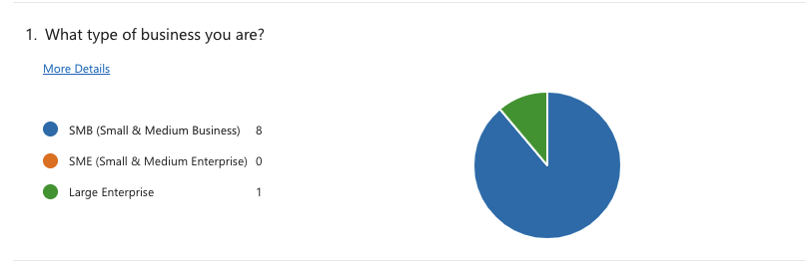

Figure 1

In above figure we tried to find out what types of business our customers have.
We can see from chart that most of answers we received are Small and Medium Businesses which are interested in international freight, summarised that 8 are Small and Medium businesses and just 1 is a Large Enterprise.
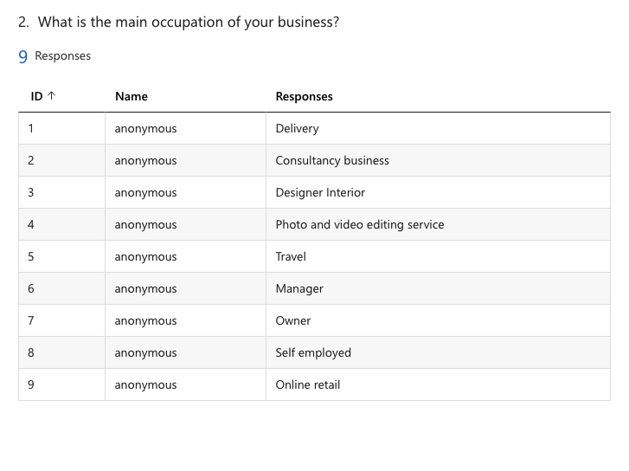
Figure 2
In second question we tried to understand the main occupation of companies which are interested in freight transfer. So from what we can see from the figure above, we can state that types of the businesses which are interested are different occupations one from another. Based on their occupation they all need delivery services.
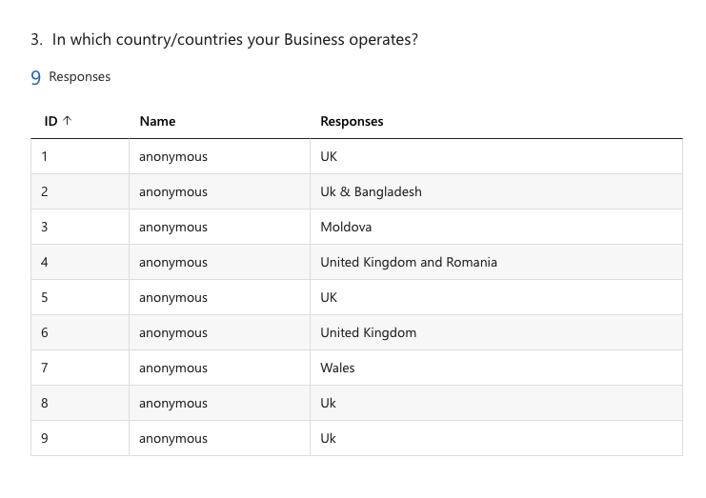
Figure 3
In above figure we focused on area of were each business operating. From answers which we received we can state that just 3 businesses are based in Moldova, Romania and Bangladesh, and rest of them based in UK. This figure will help RapidX Freight to know where to open collection and receiver hubs.
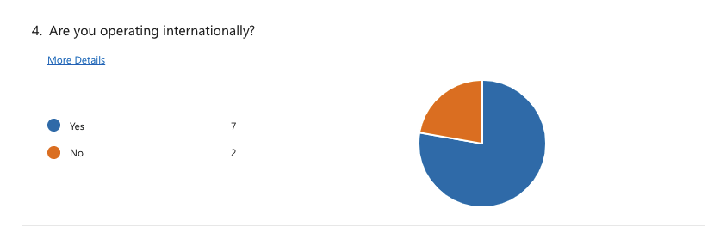
Figure 4
In above figure we tried to understand if companies are operating internationally. From answers we received, we can state that 7 of them are operating internationally, 2 of them operating just in UK.

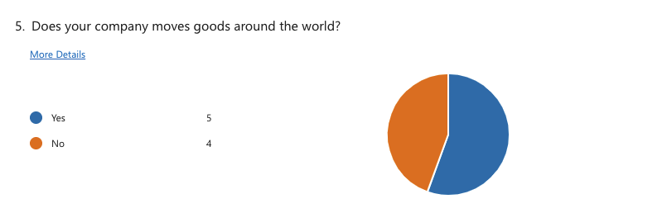
Figure 5
In above figure we asked companies if they are moving goods internationally. So, from answers which we received, businesses categorized as 5 to YES and 4 to NO.
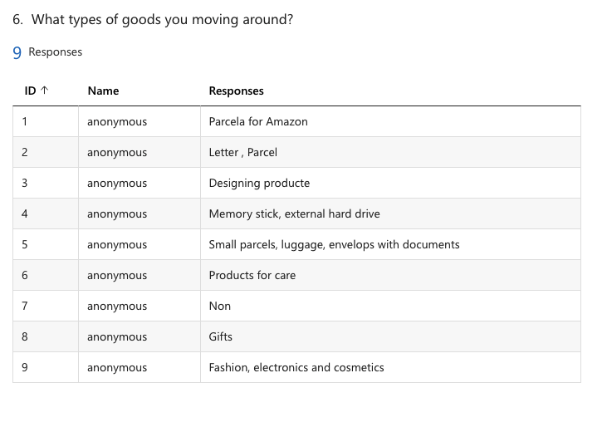
Figure 6

In above figure we tried to find out which types of goods asked companies are moving in UK/EU/International. From answers which we received we can see that 8 out of 9 will need delivery services, which is a good start for RapidX to grow based on Small & Medium Businesses.

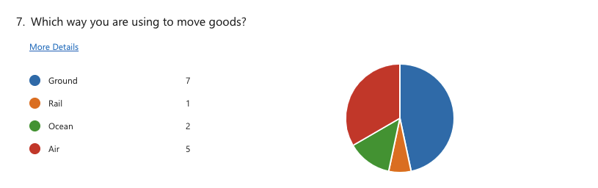
Figure 7

In this figure we tried to find out which freight delivery ways are using our customers. It has been summarized to the, 7 are using ground way, 5 are using air way, 2 are using ocean way, and just 1 is using rail way. Based on this answers, RapidX can understand which ways is better to improve and prioritize in regards to make better customer satisfaction.

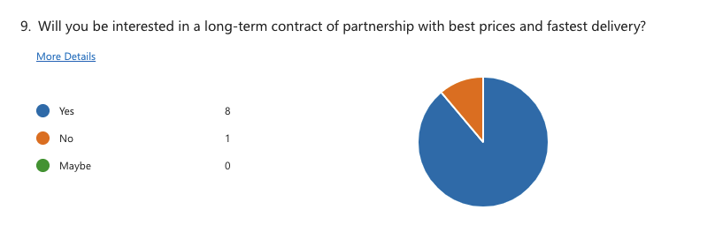
Figure 9

In this figure, we asked our clients if they are looking at long partnership with RapidX. From answers which we received, is summarized that 8/9 are interested and just 1 is not. This will help our company to create a set of discounts and promotions in regards to keep a long and strong relationship with clients.

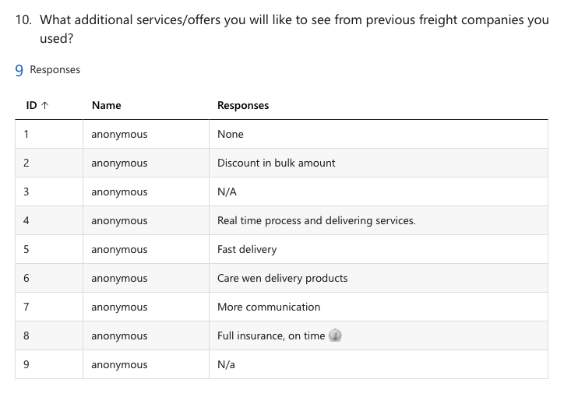
Figure 10

In above figure we tried to understand and to find out what our clients will like to see different with us than with previous companies they worked with. We received 6 out of 9 answers. From answers we received we can say that all our customers are looking for the same. Fast delivery, insurance, safe and secure. This are 4 things which our clients prioritize.

Website Design
Based on the interpretation of primary research and questionnaire technique, we created a website for our company. Questionnaires influenced the design of the company website. The questionnaires data influenced the website design or patterns because of usability,
which plays an important role to accept the important thing (Sünkler, Yagci and
Lewandowski, 2021).
In summary, the client questionnaire enables us to dig deep into the real reason a new website is needed, so we created a design that is well-tailored to tour goals. By gaining a solid understanding of our client’s business, audience, and needs, we avoided building a website that is visually appealing but fails to achieve their objectives.
Childers and Skinner (1996) suggest that color, attractive design and other factors
associated with the appearance of a questionnaire affect respondents’ perception of the
survey’s professionalism. This perception, they argue, results in a greater feeling of trust
and higher levels of cooperation. We used a set of dark colours and white font to be clearly for readers and not stressful for eyes.
We minimalized amount of text on website and included the key points which our clients are in need.

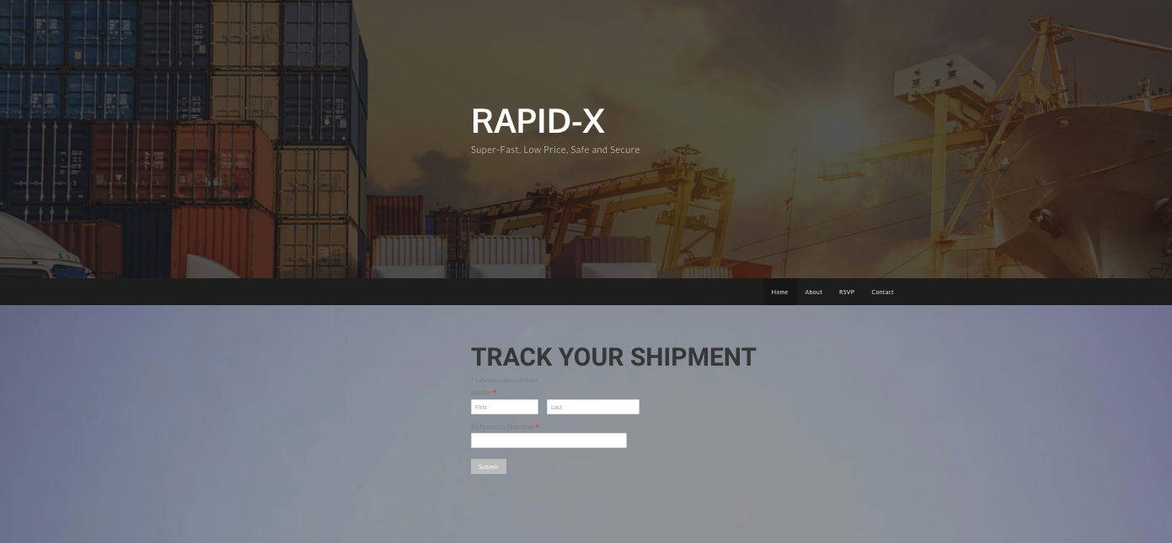

On above picture is shown home page of our website, which including our company name and company 4 key words. Also on the homepage we added to track the shipment of our clients.
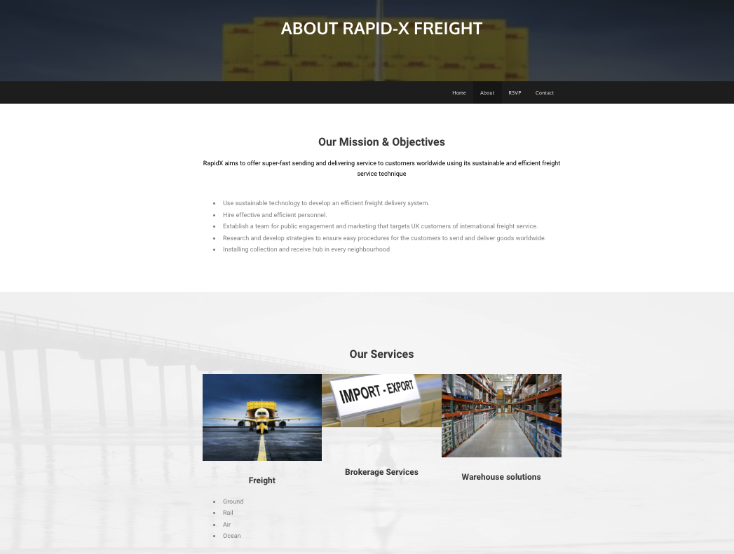

Figure 2

On this figure is the section About. We included our missions and objectives and also we added the most important services we are offering to our clients.

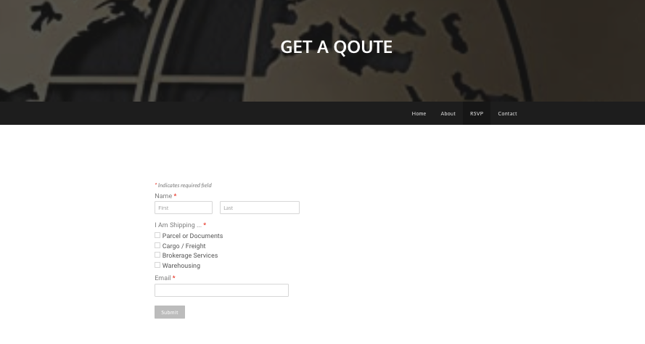
Figure 3

In above figure in RSVP section we included our quotes. It’s easy for all customers just to fill all details in and they will receive a quote and price list of all what is required.

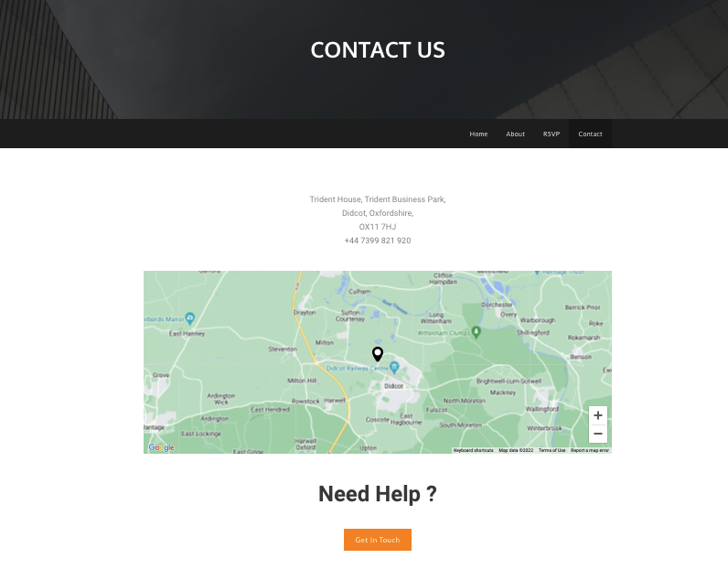
Figure 4

In Above figure is section “Contact”. Here our clients can see the address of the business and contact details. Also if customers have something to ask which they didn’t found on website, we created for them a button which they will get in touch with us through email.

References:
Connell, R., 2022. 17 Research Quotes to Inspire and Amuse You - Qualtrics. [online] Qualtrics. Available at: <https://www.qualtrics.com/blog/research-quotes/> [Accessed 8 July 2022].
Walker, J., 2022. Advantages of Primary Research. [online] Research Prospect. Available at: <https://www.researchprospect.com/advantages-of-primary-research/> [Accessed 8 July 2022].

Childers, T.L. and Skinner, S.J. (1996). Toward a Conceptualization of Mail Survey Response Behavior. Psychology and Marketing, 13, 185–209.

Sünkler, S., Yagci, N. and Lewandowski, D., 2021. Development and software
implementation of a preliminary model to identify the probability of search
engine optimization on webpages.

