REPORT TITLE:

ACADEMIC, EMPLOYABILITY SKILLS, SWOT AND PDP ANALYSIS TO GET EMPLOYMENT IN HOSPITABILITY AND HOTEL INDUSTRY
Business Skills for the International Hotel Industry
M. code M4X01917_LON

Volen Duz

1815121
Lecturer: Dale Clark
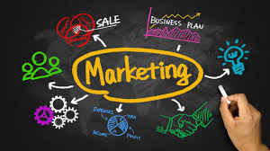
Written Assignment part 1

Contents

Introduction…………………………………………………………………………………………………………………………..
Skills……………………………………………………………………………………………………………………………………….
Swot Analysis…………………………………………………………………………………………………………………………
Personal Development Plan…………………………………………………………………………………………………
Objectives…………………………………………………………………………………………………………………………….
Conclusion……………………………………………………………………………………………………………………………
References……………………………………………………………………………………………………………………………

Introduction :
Introduction :
For my first assessment I'm going to write about my – Strengths, Weaknesses, Opportunities Threats and then I will analyze and focus on my general Academic and Employability skills. Next part of my assessment is to create my own Personal development plan, where I need write that skill I have and I need to improve also I need to create my goals plan and write with which steps and how I will find the what to my master plan. when I'm writing PDP also I will look at these skills
In this assailment, I will present my Personal Development Plan and Swot where I will identify my Weakness and Strengths. Later on, I will look at, what kind of skills I need to have/get to work in the hospitality industry.

I'm 25 years old and right now on BBC Television. I have been working on this Television
Company from 1 year, before that I have been working for the second biggest Television
Company (ITV).When I start in ITV company I worked as a runner in the production office. Art department like an assistant. One year ago I have been moved to BBC Studios, where
my current role is in the art department as an assistant.

Learning skills, including communication, speaking, writing is called also Academic.
That skills which help you to become a better employee for industry such as teamwork, presentation, and speaking skill are called employability skills.

skills.

- Communication Skills
I think personally that I have very good communication skills, which I achieve while I was doing my hobby. I m doing photography which works for me because that gives me the opportunity to go and meet new different people, also new people. Meeting all those people from different background give me that ability to have important information on different areas.
- Customer Services Skills
Working in the hospitality industry for two years give me opputinitey to give to the guests the highest customer services which they deserve. I have been working in a hotel and trying to give to our guest the best experience that they can have.
- Leadership Skills.
When I start in the hospitality business I begin in the team with 10-15 people. We get friends with each other and we make very good team relationship. After 5,6 mounts I get to be supervisor position
Where I need to manage 5-8 people and to make a timetable for them. I manage when some problem comes to our department.
- Creative Skills
My creative skills I achieve while I was doing my final year at college. Then I have to do a lot of posters. We make a lot of different teamwork. Also, my photography background helps me. At this moment I'm working in the Art department in television production where my job is to create different things for the show. Also, all the time when was Valentines days or Halloween or charisma, I was managing all personal and give them for decoration.

- Problem Solver Skills.
I think that I have this skill because from my experience, I know the right people and way how to sol the problem.
- Finance Skills.
I think I have also finance skills because in photography business you working with people also with money. I manage every time how much money I spend where/and for what.

- -Public Speaking.
One of the most important thinks one good manager needs to have is to be a good public speaking. Personally, I don't think I have that skill and I think that I need to improve it.

- Writhing
I'm in the UK from 3 years and I finish College here. I think personally I have to improve my writing skills.

- Time Management
I'm not very good with Time management. And I have a lot of times when I get late with a lot of meetings in past.

Opportunities:
Opportunities:
-Now in university, I will have a chance to have more opportunity to improve my time management, when it came the time for submission about any assailant.
-Also, university going to improve my writing skills, with communication with all of my classmate
Going to improve my speaking skills. These presentation project will help a lot for my Public Speech.

Swot Analysis
This well know system and helps in times when someone what to get information about some firm.
That system focuses on that to show the positive and negative part of this specific firm.
After my explanation on a definition of what is Swot and which component include with this system.im continue with my given assailment task which is to create my own swot system. I will start with my strengths.

In the whole meaning of the swot abbreviation is including four different element and they are:
- Strengths (positive)
-Weaknesses (negative)
-Opportunities (positive)
-Threats (negative)

In the whole meaning of the swot, the abbreviation is including four different elements and they are:
- Strengths (positive)
-Weaknesses (negative)
-Opportunities (positive)
-Threats (negative)

Many firm use swot analize.This system advantages infron of other system are that swot can show you easy the right information just when you use really easy diagram where you write your own or company detail.

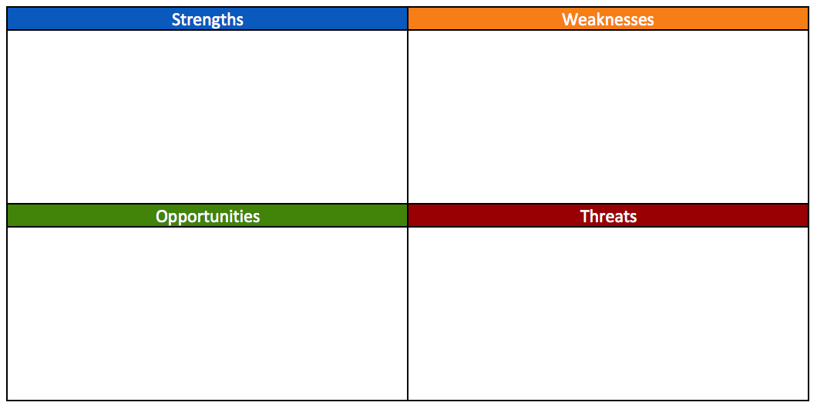
My strengths are:
I am creative
I have excellent IT Skills
I have very good customer service.
I'm critical.
Weaknesses:
- My weaknesses are:
- I am not organized.
- I'm not very good with time management.

- Opportunities:
- My opportunities are:
- I will try to improve myself.
- I will try to read and understood everything involving hotel system).
- Meeting different people.
- Threats
- No qualification- without a certificate at this time puts me at a disadvantage as other persons who has a certificate.

- Lack of time keeping skills- mean that I'm not going to be able to manage my time management

PDP
Abbreviature of PDP means Personal Development plan. This plan with the help of diagrams helps to create a personal development plan. It has 3 different sections where its start with short term plan, following with mid-term plan and the last section which is Long-term plan.
Usually, short term plan it's from 6 to 12mounds, Midterm its from 1 to 2 years , a Long term its from 5 to 10 years.

DEVELOPMENT PLAN

 | (6-12m)  Short-Term Time Frame | (1-2y)  Mid-Term Time Frame | (5-10y)  Long-Term Time Frame
My Goals  What are my overall goals that I want to accomplish in this time period? | To get into the hospitality system also hotel industry. | To finish my graduate. | To have a good work place and lovely family.
Skills and Knowledge to be learned  What specifically do I need to learn? What project do I need to work on? | Time management  .  Organisation | Creativity  Problem Solving.  Buissnes  Finance Skills  Different Languages. | .
Next Steps  How am I going to acquire the skills and knowledge?  How am I going to do this project? | Listening and learning. | Listening and learning practice. | Listening practice.

.
My Personal Objectives
Short-term 6 to 12 months
-In this period of time I what to get more in the hospitality industry and how it works

Med-Term 1-2 year
-In this period of time I what to finish my degree.

Long term (5-10years )
-I want to work in a good position in the hospitality industry, also to have a good family.

EMPLOYMENT IN HOTEL AND HOSPITALITY INDUSTRY

After research, I understand that employers in Hotel and hospitality industry are
Looking in a specific skill that their employee need to have and they are really important
Is that they to have excellent communication, writing, presenting, problem solver, leadership, also teamworking skills. The right personal need to have training, also to have different skills.
They need to be flexible and reliable. Employers are looking for staff who have perfect customer service.
While I'm going to my university, I will improve my hospitality skills. After when I will finish my
Graduate I will try to find a good position in the Hotel industry.

Conclusion

First thing I do when I was started with this assignment was to make a
A wide range of research I explain what is the definition of Academic and Employability skills.
Next step was to create personal Swot analyze where I was written my Strenght, Weakness points. Fowling part of my assignment was to create a Personal Development Plan.
Where I write my goals and how I'm going to achieve to get there.In this project
I learn a lot of elements of the business industry.

REFFERENCES :
https://www.mindtools.com/pages/article/newTMC_05.htm
(example Swot image https://www.aha.io/roadmapping/guide/templates/swot-analysis )

Alan Sarsby(2016)”Swot Analysis ” https://books.google.co.uk/books?id=Yrp3DQAAQBAJ&printsec=frontcover&dq=swot&hl=bg&sa=X&ved=0ahUKEwjDlJDwj_jgAhV5RxUIHekrApQQ6AEIMjAB#v=onepage&q&f=false

James Smith(2011)” Personal Development Planning - What You Need to Know: Definitions, Best Practices, Benefits and Practical Solutions”
https://books.google.co.uk/books?id=M7IoYAAACAAJ&dq=Personal+development+plan&hl=bg&sa=X&ved=0ahUKEwiJkKDilPjgAhWUThUIHQKbAyMQ6AEIKTAA

Stella Cottell(2003) “Skills for Success: Personal Development and Employability”

Kerry L.Sommerville (2007)’ Hospitality Employee Management and Supervision: Concepts and Practical’

