Title: A comparison of the marketing methods of two multinational hotel brands.

Name: Danu Mihalachi
Student ID number: 2022840

The module title: Marketing Essentials BMIH4005

Lecturer’s name: Scott James
Word count: 1491 words

Table of Contents
1 Introduction 3
2 Discussion 3
3 Conclusion 6
4 References 7
5 Appendices 9
5.1 Appendix 1 9
5.2 Appendix 2 9
5.3 Appendix 3 11

Introduction
The essay aims to compare two multinational hotel brands, Holiday Inn and Six Senses by resting a major focus on their marketing strategies and tactics. The hotels are evaluated due to the fact that both hotels are able to recognize the importance of marketing in order to target a wider audience and stay competitive within the hospitality industry. Six Senses being a luxury resort, and five-star hotel primarily caters to luxury travelers and tourists (Six Senses 2023). Additionally, Holiday Inn positions itself as an affordable option for travelers and believes in the joy for travelers (IHG Plc 2023). However, to analyze the similarities and differences between these brands, the essay will investigate their marketing mix, segmentation, targeting, and positioning (STP) along with a focus on conducting SWOT analysis, and PESTLE analysis. By examining these aspects, the essay will be able to gain insights into how these hotels maintain their strategic positions in the global market.

Discussion
One of the biggest advantages of the Six Senses hotel is the luxuries it offers to its customers, as the spas and resorts of the hotel are extremely grand. In addition to this, the hotel also has a high profit margin that significantly help the business to contribute to the economy of the UK. However, there are some weaknesses of the Six Senses as well; such as, the price for the products of the hotel is also very high, which makes it unaffordable to a whole class of people. Nonetheless, the hotel can develop personalised services which would help the business of the hotel in increasing their sales and generate higher profit, which is also a bit of a threat for the hotel in case the service fails (Six Senses, 2021). The staff of the hotel Holiday Inn is highly trained and knowledgeable which helps the hotel in providing better experience to their guests. Moreover, the work force of the hotel is also huge. However, the hotel has been facing some difficulties in satisfying their customers as the feedback and reviews of the customers were a bit negative, which elaborates on the weakness of the hotel. Nonetheless, the hotel can always improve the quality of their services and grow their business in other markets as well, which would greatly help the company in increasing the rate of profitability along with productivity of the business. However, the biggest threat of the business is the competitors in the industry (IHG plc, 2022).
In the UK, the government has a strong hold on the hospitality industry, which is why they can easily increase the rate of tax in the country and the hotels would have to submit to that. The industry also contributes to the national economy as it is one of the biggest investment sectors for the investors all around the world. During the peak season hotels in the industry usually runs out of rooms and subsequently they increase the price of their services, which leads the customers to switch hotels. This indicates that the demand for the industry is growing rapidly in society as people prefer cheaper hotels for their stay (Arif and Hossin, 2016). Furthermore, it is also essential that the hotel uses the latest technologies introduces in the market in order to make the experience of their guests remarkable. Therefore, there are numerous hotels that use CCTV cameras, lifts, intercom, and many other technologically advanced devices (Brito and Harkiolakis, 2017). Other than this, it is also necessary for the hospitality industry of the UK to fulfil all of the legal requirements of the government in order to run their business smoothly in the country. This means that the hotel need to oblige the legal policies of the government regarding the hotel industry. In spite of all this, the environmental factor of the hospitality sector is one of the most crucial one as people have become highly sensitive about their environment and health safety. Therefore, the hotels in the industry need to ensure the minimal carbon emission of during the activities of the hotel and reduce the use of disposable items (Bertozzi et al., 2020).
To analyse the impact of external and internal environment on the two-hotel brand, the use of marketing mix element is essential. Hanaysha et al. (2021) provided that marketing mix is essential for firms as it helps identify the set of actions and tactics that are essential for a firm to reach potential customers. Both Six Senses and Holiday Inn hotels reveals distinct approaches to the 7Ps of marketing mix. For the product element, both hotels offer accommodations, amenities, and services, the differences lie in the way that Six Senses focuses more on luxury experiences highlighting sustainability and building sublime experiences (Zhang et al., 2020). Contrary to this, Holiday Inn emphasizes affordability and comfort with products including 224,381 open rooms along with well-maintained suites and food facilities (Statista 2023). Similarly, their pricing strategies differs greatly, as Six Senses positions itself as a high-end brand targeting luxury traveller who are willing to pay premium for convenient services. Contrary to this, Holiday Inn targets budget-conscious travelers and focus on competitive pricing strategy. In terms of place, both hotels have global presence and caters to different locations and target markets. According to CNN News (2022), there are about 1200 Holiday Inn established worldwide under the IHG hotels and resorts. In addition to this, when it comes to promotion, Six Senses heavily relies on digital marketing and consumer engagement via the use of online channels. The hotel initiated #AtHomeWithSixSenses at the time of pandemic to indulge with the guests and communicate with them via online tutorials and video content. This helps the hotel maintain a clear line of communication (Six Senses 2020). Contrary to this, Holiday Inn could benefit from placing a stronger emphasis on digital marketing and utilizing social media (Refer to Appendix 1). The personnel aspect also differs for both brands, with Six Senses focusing entirely on highly trained staff that aims to provide with personalized experiences, while Holiday Inn highlights friendly and efficient service (He et al., 2021). For the physical evidence, both hotels strive to create visually appealing and comfortable environments, as Six Senses often integrating natural and sustainable elements. The last element, the process of service delivery varies, with Six Senses offering exclusive and customized experiences, while Holiday Inn focuses on efficiency and streamlined service.
Furthermore, the two brands are compared on the basis of their urge towards segmentation, targeting and positioning. In terms of targeting, Similar Web (2023) presented that the main target consumers of Six Senses are 51.12% male and 48.88% female. About 32.71% of the participants belongs to the age group 25-34 suggesting towards the business travelers and middle to higher class individuals. In addition to this, the focus of Holiday Inn is focused on 49.53% of females and 50.47% of males with age group belonging from 25-54 years. The brand targets the audience by making use of exceptional services that cater to the needs and wants of the changing consumers. Pichler (2022) presented that by segmenting the target audience, a brand is able to visualize appropriate tactics to reach out to the set population and ensure that desired outcomes are generated. The urge toward segmentation and targeting also helps a brand to position itself well against the competitors. For example, Six Senses, targeting luxury consumer positions itself as a brand with convenient services that aims to attract high-end consumers who prefer comfort with wellness services. Therefore, the brand realise the importance of using social media channel to reach wider audience and has positioned itself well on these platform to bridge communication gaps and ensure that constant interaction is maintained. Contrary to this, the focus of Holiday Inn to reach out consumer preferring affordability has allowed the business to extend services and position itself as a brand that is light on the pocket. This has helped the brand to ensure that the right services and quality is maintained but the overall cost is worth the experience. Hence, the positioning of both the brands compared to the competitors is presented using perceptual map (Refer to appendix 3). The map reflects how Holiday Inn is able to position itself amongst the competitors with low prices and high-quality services. Thus, the two brand reflects two poles in terms of segmentation, targeting and positioning aspects.

Conclusion
From the overall essay, it can be concluded that Holiday Inn and Six Senses are two distinct hotels employing unique services, different approaches to target different customers segment and uses exceptional promotional strategies. However, there are some similarities that exist in terms of amenities and services, a notable difference lies in their marketing communications due to the differences in segmentation. Six Senses portrays a strong inclination towards digital marketing tactics and engages through online channels, especially evident during the pandemic. Therefore, it is important for Holiday Inn to line up digital marketing, particularly using social media, to enhance its growth potential.

References
Arif, T.M.H. and Hossin, M.Z., 2016. A comparative analysis of internal and external environments between Hotel Hyatt, UK and Hotel The Cox Today, Cox’s Bazar, Bangladesh. IOSR Journal of Humanities and Social Science, 21(6), pp.13-22.
Bertozzi, F., Ali, C.M. and Gul, F.A., 2020. RESOURCE BASED VIEW OF AN ORGANIZATION AND PEASTEL ANALYTICAL TOOL; AN ANALYSIS OF HOTEL CORALLO, RIMINI. EPH-International Journal of Science and Engineering, 6(1), pp.30-39.
Brito, T.L.D. and Harkiolakis, N., 2017. Influence of UK economic and market policies on a small wine merchant. International Journal of Teaching and Case Studies, 8(1), pp.29-45.
CNN News 2022. How Holiday Inn revolutionized 20th century travel. [Online] Available at https://edition.cnn.com/travel/article/holiday-inn-70th-anniversary/index.html [Accessed on 15 May 2023].
Hanaysha, J.R., Al Shaikh, M.E. and Alzoubi, H.M., 2021. Importance of marketing mix elements in determining consumer purchase decision in the retail market. International Journal of Service Science, Management, Engineering, and Technology (IJSSMET), 12(6), pp.56-72.
He, J., Morrison, A.M. and Zhang, H., 2021. Being sustainable: The three‐way interactive effects of CSR, green human resource management, and responsible leadership on employee green behavior and task performance. Corporate Social Responsibility and Environmental Management, 28(3), pp.1043-1054.
IHG plc 2022 InterContinental Hotels Group plc, Annual Report. Available at: https://www.ihgplc.com/en/-/media/ihg/annualreports/2022/annual-report-2022.pdf (Accessed: 15 May 2023).
IHG Plc 2023. Holiday Inn. [Online] Available at ihgplc.com/en/our-brands/holiday-inn [Accessed on 15 May 2023].
Pichler, R., 2022. Strategize: product strategy and product roadmap practices for the digital age (Vol. 2). Pichler Consulting.
Similar Web 2023. Holiday Inn. [Online] Available at https://www.similarweb.com/website/holidayinn.com/#demographics [Accessed on 15 May 2023].
Six Senses 2020. Staying #AtHomeWithSixSenses. [Online] Available at https://www.sixsenses.com/en/trade-enewsletter/staying-athomewithsixsenses [Accessed on 15 May 2023].
Six Senses 2021 2021 Annual report launched by Mui – six senses laamu, Coral Glass. Available at: https://coralglass.media/news/2021-annual-report-launched-by-mui-six-senses-laamu (Accessed: 15 May 2023).
Six Senses 2023. About Us. [Online] Available at https://www.sixsenses.com/en/about-us [Accessed on 15 May 2023].
Statista 2023. Number of Holiday Inn hotel rooms worldwide 2008-2022. [Online] Available at https://www.statista.com/statistics/223376/number-of-holiday-inn-hotel-rooms/ [Accessed on 15 May 2023].
Zhang, Y., Xiong, Y. and Lee, T.J., 2020. A culture-oriented model of consumers’ hedonic experiences in luxury hotels. Journal of Hospitality and Tourism Management, 45, pp.399-409.

Appendices

Appendix 1
Social media use at Six Senses
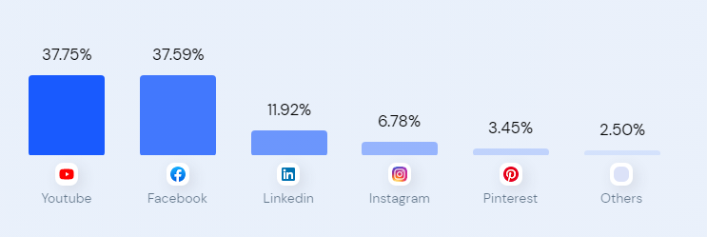
Social Media use at Holiday Inn
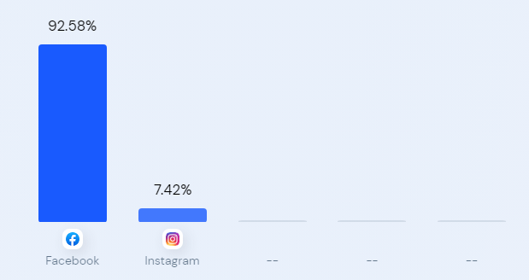

Appendix 2
Gender and Age Distribution at Six Senses
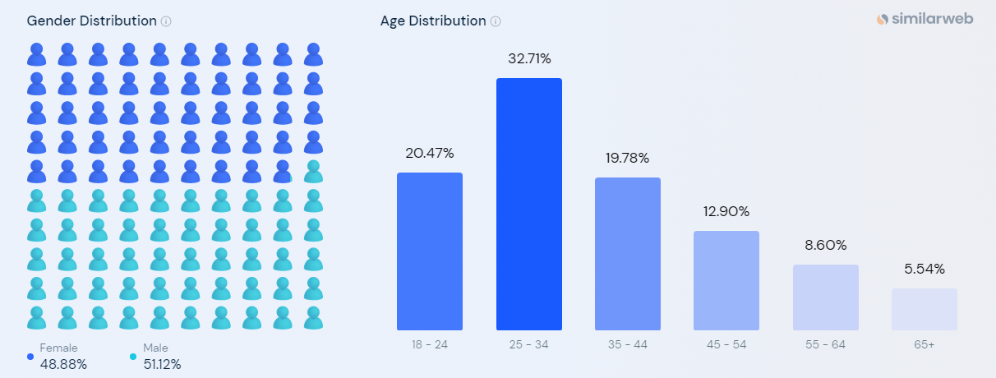
Gender and Age Distribution at Holiday Inn
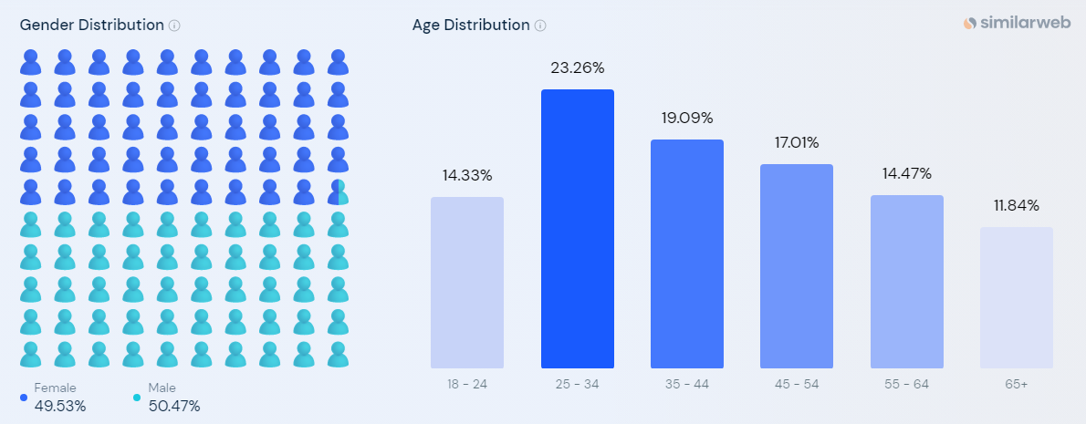

Appendix 3


