
reflective portfolio
Task 3


Professional career development Task 3

Module code: BMSW4005

Lecturer Name: Olubukola Adegbite

Student Name: Andrei Codrin Sarateanu
Student id: 1911512
University: UWTSD Birmingham Learning Centre

TABLE OF CONTENT:

1. INTRODUCTION: 2
2. PERSONAL DEVELOPMENT PLAN: 3
2.1 Job description: 4
2.2 My Personal development Plan: 5
2.3 Requirements vs. where I am: 6
3. LEARNING STYLES 7
3.1 Kolb’s learning style: 8
3.2 Honey & Mumford learning stye: 10
3.3 Neil Flaming’s learning style: 11
4. REFLECTION 13
REFERENCES: 15

1. INTRODUCTION:
The porpoise of this report is to identify the skills learned in class following the module Professional Career Development and the skills required for a chosen future job that we would like to apply.
In the second part of the report we will be impersonating a role of Assistant Manager tasked to assess the learning and development of new employees who are due to start inside our organisation. For this task we will use theories and learning styles used in class, followed by explanations and evaluation of the theories that we have used in order to achieve the task assigned to us.
In the third part of the report we were asked to write a reflection of the skills that we had before following the Professional Career Development and after the course.

2. PERSONAL DEVELOPMENT PLAN:
In the first part of this report we will try to identify and analyse the required skills for a future job of our choice that we want to apply for using the tools learned in class and then comparing them with the required skills that the future job/company demands that we have in order for our application to be successful.
The first tool that we are going to use is Personal Development Plan (PDP).
A PDP (Professional Development Plan) is used to document and formulate a strategy in order to achieve your career goals, also known as an employee development plan or an individual development plan.
It takes time and preparation to build a PDP.
However, writing and implementing a PDP can help you identify, develop and maintain professional skills to achieve your goals. This is an important process which helps you to realize your potential, meet your goals and take responsibility for your career.
Now is the time to reflect on where your future will take you.
You have a responsibility for your professional development. While your employer may require you to create a PDP as part of your performance assessment process, the chances are that you will clear away your current company goals.
Writing your own private PDP can help you plan to achieve your long-term career objectives and help to identify the skills and actions needed to achieve them.
In order to achieve your goals toward your dream career and have the required skills for your next job we should consider a few steps:
1.Evaluate where you are now.
2.Identify your particular career objectives.
3.Collect the data.
4.Identify your previous professional skills and which one you need to work on.
5.Choose how you're going to achieve your objectives.
6.Evaluate your plan.
7.Measure the progress you have made.

2.1 Job description:
As my future career I would to become a manager for the company that I’m working at the moment (Amazon).
After doing some researches about the company and what is life inside Amazon and what it means to be a manager for amazon, here below I listed what I found:
The required tasks for a manager are:
- Supervision of the process that focuses on the distribution of Amazon orders directly to clients.
- Help the Shift Managers staff and the Operations Leadership Team in regular distribution station administration, including assigning tasks, leading sessions, assigning task tasks, and working with internal and external vendors, including members of agency management and their drivers.
- Looking objectively and paying attention to detail and desiring to motivate others with excellent leadership abilities.

The main qualifications required in order to become a manager are:
- Degree qualification or equivalent
-Has direct-to-customer fulfilment knowledge and experience as well as outstanding technical, problem-solving and communication skills.
-Experience in project definition, requirement collection, process solution design
-A forward thinker with an ability to manage and thrive on change at high levels of ambiguity.
-Excellent written and verbal communication skills; ability to communicate effectively and build relationships with both representatives of agency management and their providers of delivery.
-Output metrics knowledge and method optimization of demonstrable problem-solving ability and analytical capabilities
-Capacity to work with multiple executives: we shift executives around to satisfy company needs and as
-Our organization is growing and you have to respond to management changes.
-Outstanding talents and interpersonal abilities in customer service

2.2 My Personal development Plan:

GOAL:
Become an area manager for Amazon UK

WHAT TO DO FIRST: | DEADLINE: | OBSTACLES TO OVERCOME: | HOW TO OVERCOME OBSTACLES:
Learn about the skills required to be a manager | Next year | Lack of time due to workplace long hours and in parallel studying at university | Dedicate the free time that I have to following a course to become a manager
Do a lot of research online and from books about a manager’s job in amazon | No deadline for doing research. At amazon things are always changing ad there is always something new to learn | Balance the time between work, family, and spending time doing research | Renounce at going out with friends and spend more and more time online doing research,
Get the necessary qualification in order to apply for a manager role | January 2021 | Finish the academic year and turn in all the assignments | Spend late evenings in a non-distractive place such as studio to finish all the assignments
Apply for the role and pass the interview | March 2021 | Create a strong CV relevant to the job that I want to apply | Prepare for the interview and have a strong can-do attitude. Prepare for any questions that might appear during the interview and have relevant answers based on previous experience

2.3 Requirements vs. where I am:
Reading trough, the job advert that I wish to apply for and looking on to my PDP plan the differences are the following:
I need to work on my direct-to-customer knowledge skills.
I need to work on my forward thinking and not just on-the-moment tasks.
I need to work on my building relations skills with the employees under my command as future manager.
I need to work on my flexibility to work between different departments of the company.

On the other hand, some of the skills that I already possess are the following:
Excellent written and verbal communication skills.
Degree qualification or equivalent.
Output metrics knowledge and method optimization of demonstrable problem-solving ability and analytical capabilities.
Experience in project definition, requirement collection, process solution design.
Always open to learn new processes inside the company that I will be working for.

3. LEARNING STYLES
In the second part of this report we where asked to impersonate an Assistant Manager, which was tasked to asses the learning and development training methods for the new employees who are due to start in the nearest future inside the company.
Before being able to make these decisions and explain why I decide to use one method among the others, I will explain the main learning styles learned in class:
- Kolb’s learning style.
- Honey & Mumford learning style.
- Neil Flaming’s learning style.

Once described these three learning style, I will choose one and explain why I think is the most suitable for the required task.

3.1 Kolb’s learning style:
In 1984, David Kolb published his model of learning styles, from which he created his inventory of learning styles.
The experiential theory of Kolb functions on two levels: a four-stage learning loop and four different modes of learning. Most of the philosophy of Kolb is dealing with the internal processing functions of the learner.
Kolb says that learning requires the development of abstract principles which in a number of contexts can be implemented flexibly. In the theory of Kolb, new encounters provide the impetus for the creation of new ideas.
Knowing your own learning style helps learning to be orientated according to the desired process.
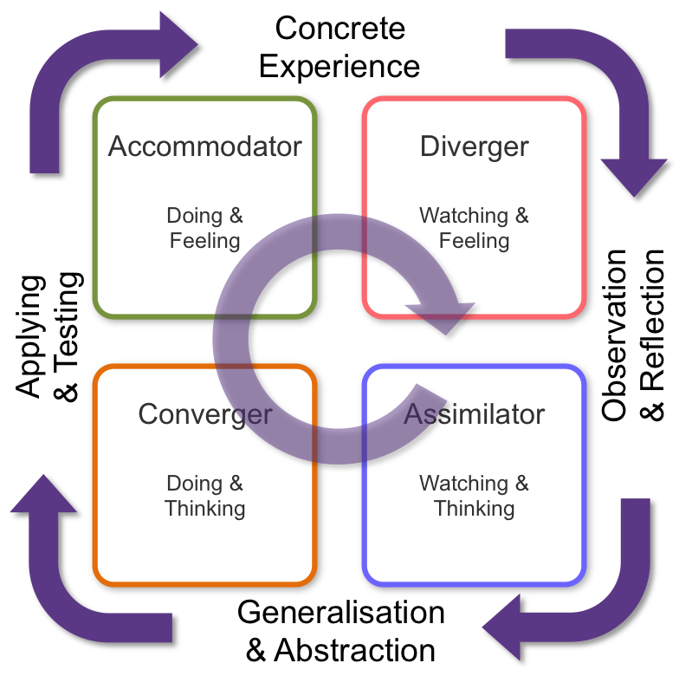
That said to one degree or another, everybody reacts to and requires the reinforcement of all forms of learning styles: it is a matter of using focus that suits best with the condition offered and the interests of an individual's learning style.

3.1.1 The 4 phases of Kolb’s learning style:
• Diverging (feeling and watching - CE/RO): from multiple backgrounds, these persons are able to look at items.
They are fragile and tend to observe rather than do, tend to collect data and use creativity to solve problems.
From several different points of view, they are best at viewing realistic scenarios.
They are fascinated in individuals, they emotional and creative, and are really skilled in the arts.
People with diverse personalities enjoy collaborating in groups, listening with an open mind and getting personal input.

• Assimilating (watching and thinking - AC/RO): this category's' favourite includes a succinct, rational method.
Rather than a realistic incentive, these persons need good straightforward clarification. They excel at interpreting and arranging wide-ranging knowledge in a simple logical structure.

• Converging (doing and thinking - AC/AE): Individuals with a converging style of learning will overcome challenges using their learning to discover answers to realistic problems.
They choose technical roles and are less familiar with individuals and facets of interpersonally.
By finding answers to questions and challenges, they will solve problems and make choices.

• Accommodating (doing and feeling - CE/AE): the method of learning is 'hands-on,' which focuses on instinct instead of logic.
Those persons use the study of other people, and tend to take a realistic, adaptive strategy. They are drawn to fresh problems and perspectives, and to the execution of plans.

3.2 Honey & Mumford learning stye:
While there are several different ideas and concepts concerning learning styles, four different ways to learning new knowledge were defined by Peter Honey and Alan Mumford, in 1986:
• Activist: this category of people enjoys the difficulty of new interactions and most of the time, are guilty of behaving until they believe.
They learn by doing and may not learn well from knowledge instruction, philosophy, reading or study.

• Theorist: a theorist enjoys understanding the principle behind behaviour, prototypes, concepts and facts and loves analysing and synthesising testable assumptions.

• Pragmatist: these individuals need to be able to see how they are adapting their qualifications to the real world. If they do not see how it applies, abstract definitions are meaningless.
And when targets and guidelines are vague, or when it is strong on philosophy, they do not happily participate.

• Reflector: by evaluation and contemplation on consequences, they observe and choose to watch from one side, and they take data from multiple points of view and arrive to a conclusion.
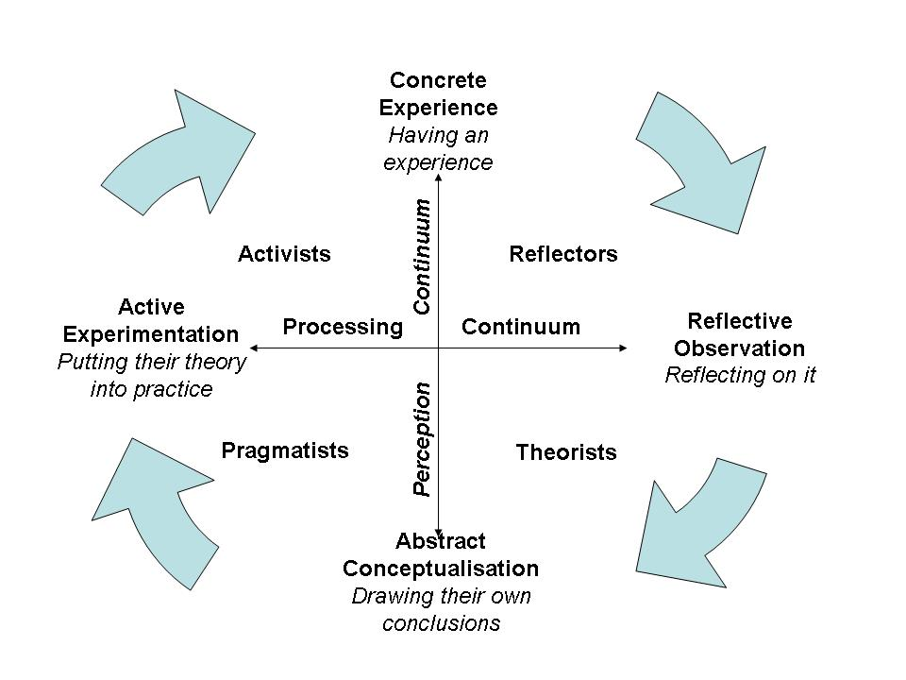
Reflectors, with no preparation, are not good at leading activities or being rushed.

3.3 Neil Flaming’s learning style:
In 1987, an academic, Neil Fleming, who has dedicated his career to researching modes of learning and deciding how individuals learn by choices in modality, developed the VARK learning style.
The VARK acronym stands for: visual, aural, read/write, kinesthetic.
Here below is the explanation of each of the four components:
• Visual: a visual person learns by watching.
Visual people are very good visual memory and prefers the use of visual representations such as graphics, pictures, charts and presentations and the usually tend to move their hands while talking.

• Aural: this category of individuals learns by listening preferring recurrence, summaries and they love deliberations and speeches.

• Read/write: people in this group learn by reading and writing.
They find help in taking notes about the topics and information, read books, articles and journals.

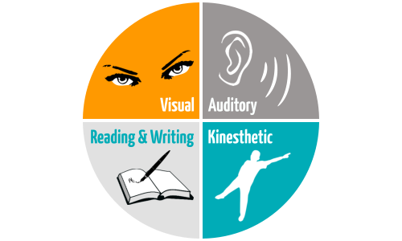
• Kinesthetic: learn by doing. They rely heavily on experiences within the learning environment and with their bodies in particular and they quickly recall from activities or information attached to an encounter or the thoughts of a physical occurrence.

In conclusion after defining and explaining the three learning styles, came to the conclusion that the best learning style to implement and keep under observation for results would be Neil Flaming’s learning style.
As described above in this learning stile we have four sub categories of people with four different ways to learn. Some of them might learn by looking at draw boards, some might learn just by listening what they are required to do inside the organisation, some might perform their day to day requirement by writing everything down and reading articles and the fourth category would be the hands on learners, people that prefer to put their hands on the task to get knowledge and experience.

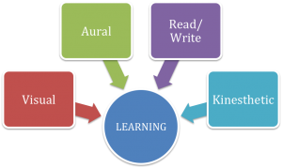
Source: https://www.proctoru.com/industry-news-and-notes/four-different-learning-styles

4. REFLECTION
In this part of the report we have been asked to write a reflection based on our experience before starting this course and after the completing the course.
Before starting this course, I didn’t have too much confidence if not at all to go out in the workplace industry and apply for a better position. I was always under the impression that the job that I had at the time was suitable for me and that was all I will be doing for the rest of my life.
After having a discussion with my family and a university lecturer which I met occasionally I decided to go back to studying. The first step was to join UWTSD Birmingham Learning Centre and follow Skills for The Workplace as program to study.
Passing through all six modules I began to realise that I actually knew what the lecturers where talking about, things that actually made sense and where relevant with my job at the time and what I could improve to get a better position in the workplace or go further to change my career and become a manager someday.
The most interesting part for me was writing a CV. I was under the impression that my cv would be good for every type of job that I was applying for, I was clearly wrong.
Under the guidance of our lecture: Olubukola Adegbite which I would like to say a big Thank You for having the patience and required skills to give us guidance and support in pursuing our future careers, I found out that every job that we tend to apply for requires research, preparation and building up a CV relevant to that specific job.
I also discovered that being a supervisor in to a organisation requires multiple skills such as: consideration for employees, good communication skills, ability to forecast and plan ahead your workload, ability to use office programmes, and many other skills that at the beginning of the course I personally did not had but developed in time during the academic year.
Some of these learned abilities learned I personally put them in practice at my current job and I got a promotion at my workplace. I’m in charge of the Transport And Operations team at the minute but I will not stop at this point, I will definitely pursue my path to become a manager for Amazon UK.
In conclusion I can testify that joining the university and following this course was one of my best decision ever made, this course gave me knowledge, confidence, new abilities and hope for a better future. I would definitely recommend this university to the young upcoming generation and why not for the older people as well.
Like C.S. Lewis used to say “you are never too old to set up a new goal”.
Thank you UWTSD Birmingham Learning Centre and all the staff for the support during the academic year.

REFERENCES:
amazon.jobs. 2020. Fulfilment Centre Management. [online] Available at: <https://www.amazon.jobs/en-gb/teams/fulfillment-center-management> [Accessed 19 November 2020]
amazon.jobs. 2020. Area Manager. [online] Available at: <https://www.amazon.jobs/en-gb/jobs/1353224/area-manager> [Accessed 19 November 2020]
Harrington-Atkinson, T., 2017. Fleming VARK Theory - Paving The Way. [online] Paving the Way. Available at: <https://tracyharringtonatkinson.com/fleming-vark-theory/> [Accessed 20 November 2020]
Martinelli, K. and Martinelli, K., 2020. Writing A Professional Development Plan. [online] The Hub | High Speed Training. Available at: <https://www.highspeedtraining.co.uk/hub/professional-development-plan/> [Accessed 13 November 2020].
McLeod, S., 2017. [online] Simplypsychology.org. Available at: <https://www.simplypsychology.org/learning-kolb.html> [Accessed 20 November 2020].
Sean, L., n.d. Honey And Mumford's Learning Styles – Businessballs.Com. [online] Businessballs.com. Available at: <https://www.businessballs.com/self-awareness/honey-and-mumfords-learning-styles/#:~:text=What%20are%20Honey%20and%20Mumford%27s%20Learning%20Styles%3F%20,%20Observing%20activities%20Feedback%20from%20other%20...%20> [Accessed 20 November 2020]
ProctorU. 2020. The Four Different Learning Styles - Proctoru. [online] Available at: <https://www.proctoru.com/industry-news-and-notes/four-different-learning-styles> [Accessed 14 November 2020]
Medium. 2020. 21 Examples Of Personal Development Goals For A Better You. [online] Available at: <https://medium.com/@iosipratama/21-examples-of-personal-development-goals-for-a-better-you-7dddcbc2f1b1> [Accessed 22 November 2020]
Academy, P., 2020. Advice On Creating An Effective Personal Development Plan (PDP). [online] Professionalacademy.com. Available at: <https://www.professionalacademy.com/blogs-and-advice/-advice-on-creating-an-effective-personal-development-plan--free-template-> [Accessed 23 November 2020]
Goodreads.com. 2020. A Quote By C.S. Lewis. [online] Available at: <https://www.goodreads.com/quotes/812245-you-are-never-too-old-to-set-another-goal-or> [Accessed 26 November 2020].

