Exercises for Functions – 1 (SOLUTIONS)

We will attempt to find the area of the following shape:

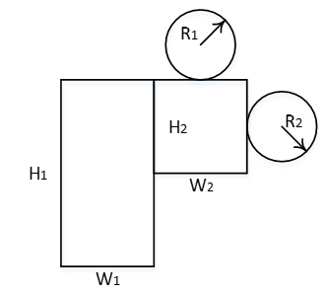

1a Start with the first circle. Write a function, calculatecircle(), to calculate the area of the circle. Call the function, and when it's finished, return the area calculated to the main program (we will need it later).

Sample output:

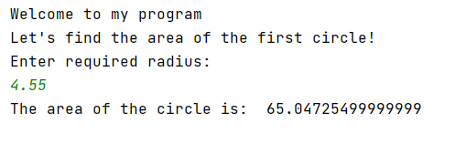
main program

calculatecircle()
(return to main())

Solution:
def calculatecircle():
print("Enter required radius: ")
radius = float(input())
result=radius * radius * 3.142
print("The area of the circle is: ", result)
return result
print("Welcome to my program")
print("Let's find the area of the first circle!")
circle1 = calculatecircle()

1b Calculate the area of a second circle. Re-use the function you already have.

Sample output:

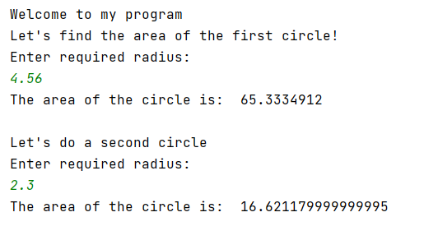

Solution:
def calculatecircle():
print("Enter required radius: ")
radius = float(input())
result=radius * radius * 3.142
print("The area of the circle is: ", result)
return result
print("Welcome to my program")
print("Let's find the area of the first circle!")
circle1 = calculatecircle()
print("\nLet's do a second circle")
circle2 = calculatecircle()

1c. Now write a function to calculate the rectangles and call them from the main program

Sample output:

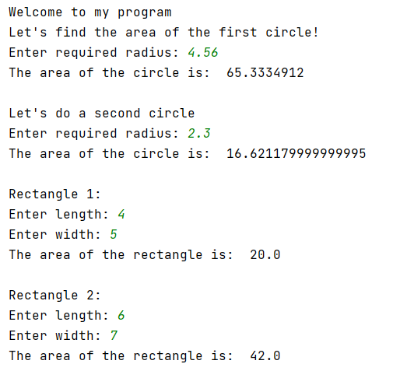

Solution:

def calculatecircle():
radius = float(input("Enter required radius: "))
result=radius * radius * 3.142
print("The area of the circle is: ", result)
return result
def calcrectangle():
length = float(input("Enter length: "))
width = float(input("Enter width: "))
total = length * width
print("The area of the rectangle is: ",total)
return total
print("Welcome to my program")
print("Let's find the area of the first circle!")
circle1 = calculatecircle()
print("\nLet's do a second circle")
circle2 = calculatecircle()
print("\nRectangle 1:")
rect1 = calcrectangle()
print("\nRectangle 2:")
rect2 = calcrectangle()

1d. Providing all the returns back from the functions have been handled correctly, we should have 4 variables in main program holding the areas of the circles and rectangles. (You may need to go back and check you haven't overwritten any!)

It should now be a simple matter to add the areas, and get the final result

Sample output:

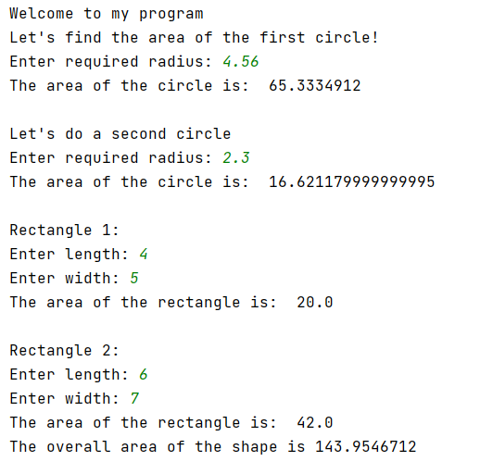

Solution:

def calculatecircle():
radius = float(input("Enter required radius: "))
result=radius * radius * 3.142
print("The area of the circle is: ", result)
return result
def calcrectangle():
length = float(input("Enter length: "))
width = float(input("Enter width: "))
total = length * width
print("The area of the rectangle is: ",total)
return total
print("Welcome to my program")
print("Let's find the area of the first circle!")
circle1 = calculatecircle()
print("\nLet's do a second circle")
circle2 = calculatecircle()
print("\nRectangle 1:")
rect1 = calcrectangle()
print("\nRectangle 2:")
rect2 = calcrectangle()
overallArea = circle1 + circle2 + rect1 + rect2
print("The overall area of the shape is", overallArea)

