Object Orientated programming with C++
Ashleigh Elder P141924
March 21st 2018

Contents

- Introduction

- Terms and Diagrams
  - Terminology
  - Class UML
  - Use Case UML

- The Program

- Bibliography

1 Introduction
For this assignment a “company” required a system to control its electronics manufacturing business. It was required that this system cover all aspects of running a business from ordering parts and producing components to receiving customer orders and storing account information.
2 Terms and Diagrams
2.0 Terminology
Use Case
A “Use Case Diagram” is a diagram that shows the relationship of different “Actors” with a program, the actors can only access specific functions that then use information that is either inherited or extended from the previous function in order to complete an action the actor has initiated.
Class Diagram
A “Class Diagram” is a diagram that provides detailed information about the relationship of each class in the program to each other. This includes any methods or variables initiated by their associated classes (parents and associates).
Object
An object is an instance of a class that operates as part of another function in order to keep similar information in one place kind of like a struct, in the same way an array of structs can exist to keep similar data in the same location an array of objects can also be created.
Inheritance
When a subclass (or “child”) is created using the constructor of its “parent” the child inherits specific methods and variables from its parents. These can be used by an object of the “child” class when called by main. When the “parent” class is deconstructed the children of that class are also deconstructed.
Aggregation
Aggregation is similar to Inheritance in that a main class controls the fate of its subclasses with one main difference, the subclass is created as its own object therefore when one part of an aggregated class “family” is deconstructed, the other classes are not.
Overloading
A function can be overloaded by giving the same function multiple definitions with the constraint of having different types (i.e int float and string). When an overloaded function is called the most appropriate type is chosen by default and used as the function.

Overriding
An overidden class has a base and derived class with the same name and arguments and the member function of the derived class is used instead of the base class which gets ignored.
Singleton Pattern
A class following the “Singleton Pattern” can only ever be created statically one time by its self. This static object can be used by other methods to read data but cannot in and of itself be changed. This can be used when a large number of variables need declaring in order to be used by the rest of the code without needing global variables, as they can be unstable and inefficient.

2.1 Class UML

2.2 Use Case UML
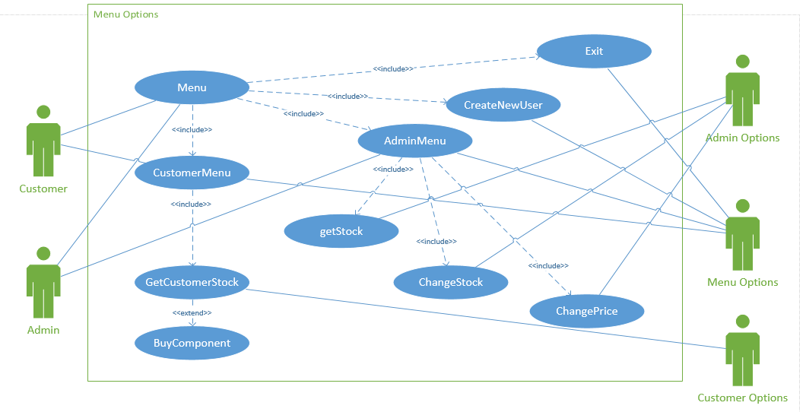

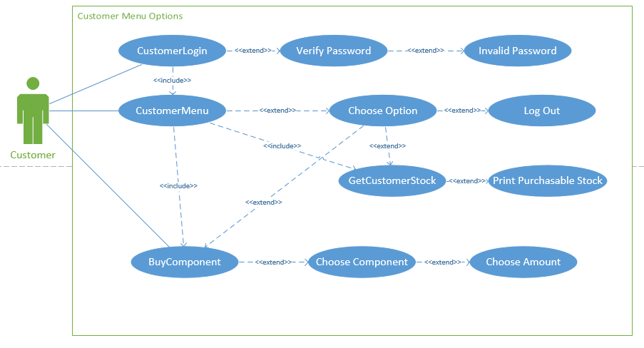

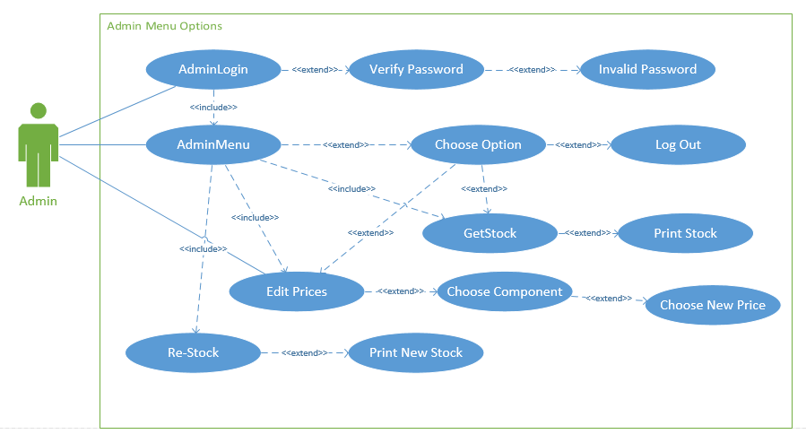

3 The Program
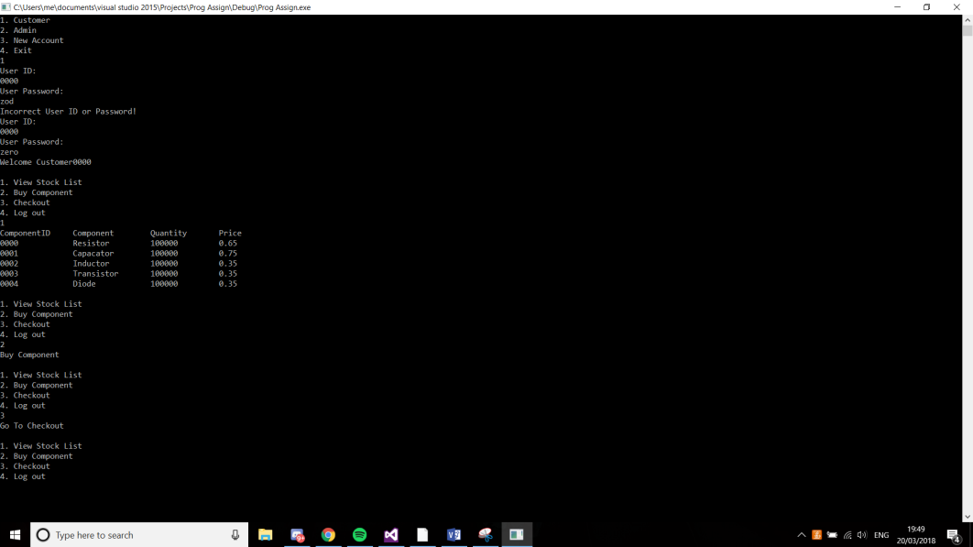
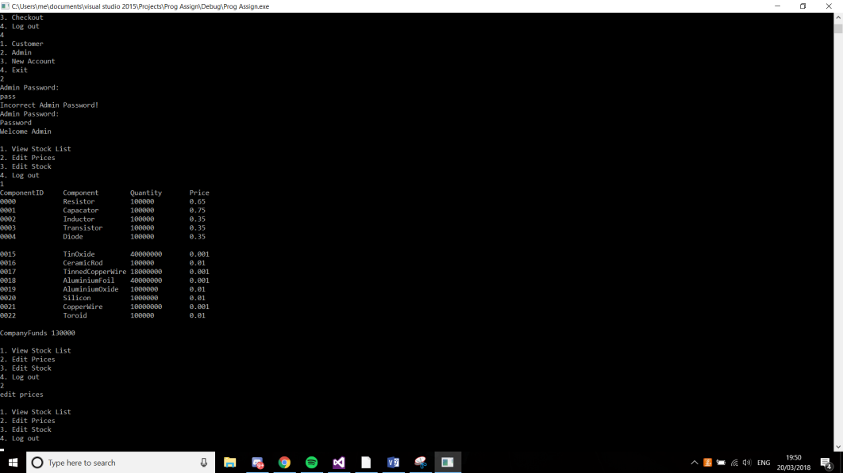

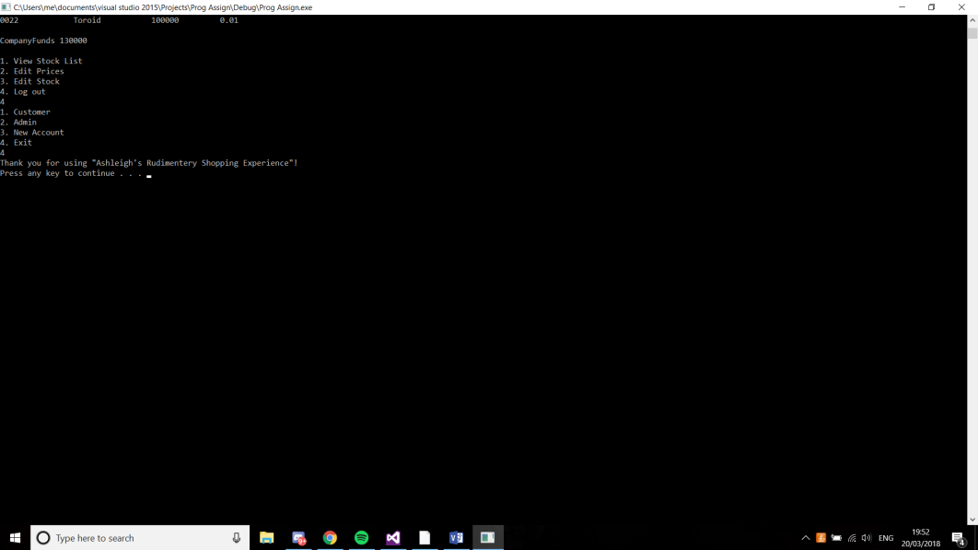
Singleton
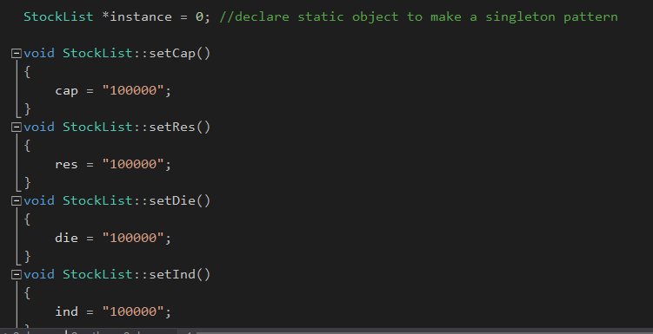
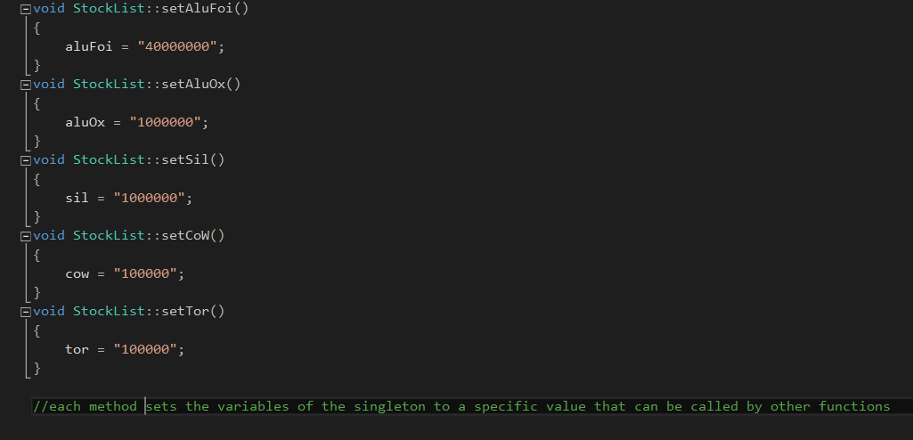
Overloading
Overriding
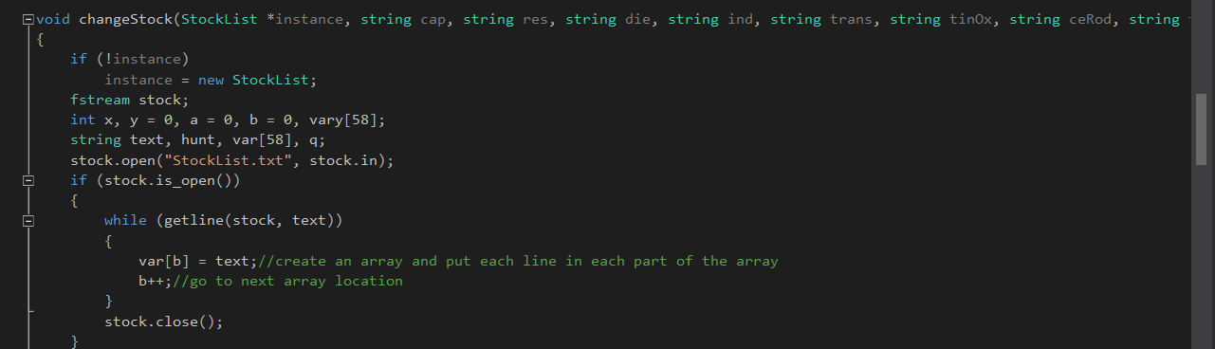
Inheritance
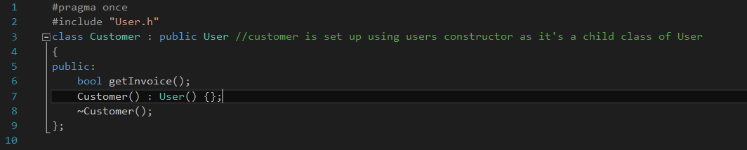

5 Bibliography

