University of Wales Trinity Saint David

Wales Institute of Science & Art

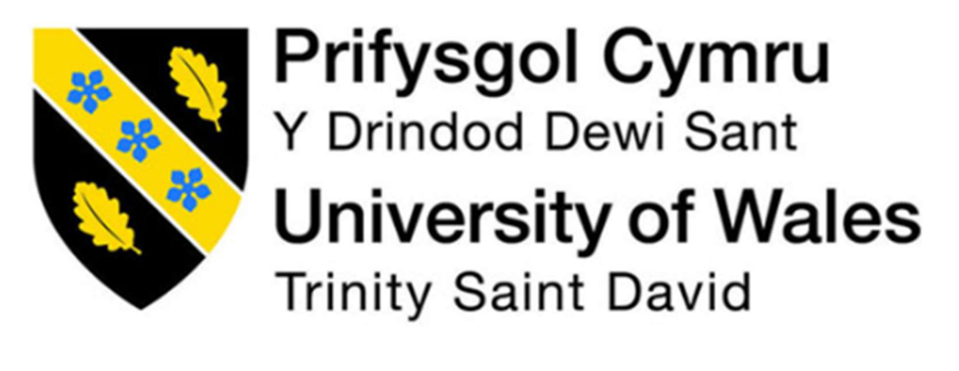

Engineering Materials
Materials and Manufacturing (ACHA4025)

1802 Words
Alexander King
2501127
April 2026
Contents
1 Introduction 2
2 Literature Review 3
2.1 Material Properties 3
2.1.1 Yield Strength 3
2.1.2 Ultimate Tensile Strength 3
2.1.3 Fatigue Resistance 3
2.1.4 Young’s Modulus 3
2.1.5 Ductility 4
2.2 Testing Methodologies 4
2.2.1 Tensile Testing 4
2.2.2 Fractography 4
3 Methodology 5
3.1 Equipment Used 5
3.2 Preparation 5
3.3 Experimental Procedure 5
4 Test Results and Analysis 6
4.1 Quantitative Data 6
4.2 Stress-Strain Graph Analysis 6
5 Conclusion 8
6 References 9

Introduction
This report follows the investigation of 2 failed aluminium driveshafts from a Dakar Rally car. The shafts failed while the car was in operation which meant the team had to retire the car early. The design and manufacturing process has not changed so the team have been asked to direct their attention towards the potential material issue caused by a change in supplier.
The main aim is to investigate and determine the mechanical properties of the aluminium sample in order to understand why the components failed under an operational stress of 90MPa. To do this, the sample will be tensile tested to identify key properties of the material such as yield strength, Ultimate Tensile Strength and Young’s modulus. This will assist in identifying the likely failure mode and allow the team to propose a solution to prevent this from happening again.

Literature Review
In high-level racing such as the Dakar rally, it is crucial that component failures are investigated to understand what potential issues could be prevented such as incorrect materials being used. The following section analyses the mechanical properties of aluminium that are critical to consider when designing driveshafts and the testing methods used for failure analysis.

Material Properties
Drive shafts are rotating members subjected to fluctuating loads of combined bending and torsion, which often result in high stress concentrations (Budynas and Nisbett, 2020). To maintain structural integrity while minimizing unsprung weight, racing teams frequently utilize high-strength 7000-series aluminium alloys (Davis, 2001).

Yield Strength
The Yield Strength is the level of stress at which plastic deformation begins (Callister and Rethwisch, 2018). If a driveshaft has an operational stress level of 90MPa, the yield strength must exceed 90MPa by substantial number in order to maintain an adequate level of safety.

Ultimate Tensile Strength
The Ultimate Tensile Strength of a material is the maximum stress it can withstand before fracture (Askeland and Wright, 2016). The proximity of the yield strength to the Ultimate Tensile Strength determines how reliable a material is under peak torque.

Fatigue Resistance
Fatigue is defined as the progressive structural damage that occurs when a material is subjected to cyclic loading (Suresh, 1998). Due to vibration and torque fluctuations, components often fail due to torsional fatigue in racing environments.

Young’s Modulus
The Young’s Modulus of a material is its resistance to elastic deformation. Aluminium alloys typically exhibit a modulus of approximately 69–71 GPa (Callister and Rethwisch, 2018). For high-performance automotive applications such as the Dakar Rally, a high value for young’s modulus or “E” is favoured as this ensures structural integrity and resistance to vibration under high torque.

Ductility
ductility is the degree of plastic deformation sustained at fracture. High strength often comes at the cost of ductility; therefore, a balance must be struck to ensure the drive shaft can absorb shock loads without catastrophic brittle failure (Campbell, 2008).

Testing Methodologies

Tensile Testing
Standardized tests such as ASTM E8 and ISO 6892-1 are used to determine mechanical properties of a material. The results of these tests define whether the material delivered by different suppliers meets the necessary specifications. Standardized tests also allow for comparison between suppliers to determine the best material and supplier to use depending on the budget of the component.

Fractography
Fractography is the study of fracture surfaces in order to determine the cause of failed components. Visual and microscopic inspection is used to identify the failure mode at fracture surfaces. Brittle fractures usually appear bright and granular, while fatigue failures are characterized by smooth "beach marks" representing the progression of the crack front over time (Vander Voort, 2004). In the context of this investigation, fractography is the main technique used to determine the cause of failure in the driveshaft that is discussed further in the latter sections.

Methodology

Equipment Used
For this experiment, the TecQuipment Tensile Tester Kit ES6 is used along side a dial calliper (to measure the initial dimensions of the test piece which are later used to produce stress and strain calculations) and dial indicator (which is mounted at the base to measure the spring deflection in order to calculate the applied force). The Tester Kit is mounted to a Work Panel to ensure a stable framework for the other components in the test rig.

Preparation
The thickness and width of the aluminium alloy is measured using a dial calliper to calculate the starting cross-sectional area ($A_{0}$). The length is also measured to be used as a baseline for the strain calculations.

Experimental Procedure
The sample is fastened to the tensile test rig, and the dial indicator is set to zero. Tensile load is added to the test piece by rotating the Load Nut clockwise in 0.2mm increments. To ensure an accurate reading is taken each time, the reading is taken 5 seconds after the nut is turned at each interval. The test piece is removed once it fails.

Test Results

Quantitative Data
The Aluminium test piece that was tested had an original cross-sectional area of 2mm² and an original length of 31mm. As seen in Table 1, Aluminium experiences a linear elastic response before transitioning directly into plastic deformation. This transition is a key characteristic of a material in a high-torque component such as the drive shafts on a Dakar Rally car.
(Table 1: Tensile Test Data)
load nut movement | Dial indicator (mm) | Force(N) | Extension(mm) | Stress(N/m^2) | Nominal Strain
0 | 0 | 0 | 0 | 0 | 0
0.2 | 2.15 | 215 | 1.95 | 107.5 | 0.07
0.4 | 4.41 | 441 | 4.01 | 220.5 | 0.14
0.6 | 5.37 | 537 | 4.77 | 268.5 | 0.17
0.8 | 5.56 | 556 | 4.76 | 278 | 0.18

Stress-Strain Graph Analysis

(Graph 1)
Upon analysing Graph 1, it can be seen that aluminium follows a perfectly linear relationship between Stress and Strain until the point of fracture which indicates little significant plastic deformation before failure.

Analysis
The data collected in the previous section is used to perform calculations that define mechanical properties of the material.

Calculations

Young’s Modulus

$E=\frac{∆σ}{∆ϵ}=\frac{107.5MPa}{0.06935}≈1550MPa$
This value is much lower than the standard values for aluminium (70 GPa) which is likely due to the machine compliance or the laboratory test conditions as the test rig used could be significantly improved in order to increase accuracy.

Ultimate Tensile Strength
The Ultimate Tensile Strength is the maximum stress recorded before fracture and s crucial in the application of a driveshaft from a Dakar Rally car as it allows engineers to select a material that is able to withstand the necessary stress before failure while remaining lightweight and not compromising on other properties.
UTS for Sample 1 = 278 MPa
UTS for Sample 2 = 273 MPa
Combined UTS = 275.5 MPa
As the data is consistently linear until the point of failure, the Yield strength is equal to the Ultimate Tensile Strength of 275.5 MPa.

Failure Analysis
It is stated that the maximum measured stress on the part during operation is 90MPa. The material used has a safety factor of 3.06 which means theoretically, the load of 90MPa shouldn’t cause the part to fail as the safety factor is much larger than 1.

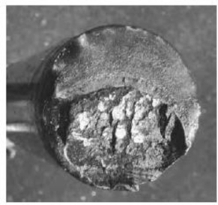
Image 1 displays the surface of the fractured component and presents many characteristics that are common in fatigue failure. The upper area of the surface appears smooth which represents an area of slow crack propagation while the rougher bottom area shows where the material could, finally, no longer support itself under the 90MPa load.

(Image 1 – Shaft Failure)

The Ultimate Tensile Strength for the material is sufficient under a static load however this component is working under harsh and dynamic conditions with prolonged vibration and torsion. Something such as a rock could have caused a crack in the material which then acted as a stress concentrator leading to the cracks propagating until the shaft completely failed. Aluminium is also a very soft material so a small rock could create a deeper crack especially if the rock or vehicle is travelling at high speeds as this would make the impact more likely to be catastrophic, especially when the crack propagates causing a fatigue failure.

Conclusion
During stages 4 and 5 of the Dakar Rally the team experienced 2 drive shaft failures which resulted in both vehicles having to retire early. Upon visual inspection of the failure surface of the component, it is evident that it failed from fatigue. The clear difference in surface textures on the cross-section suggest propagation from a crack formed before the load finally caused the remaining material to catastrophically fail.
The drive shafts were manufactured to the previous design specifications meaning the change in material supplier is the most likely cause of the issues the team is experiencing. The maximum operational stress of 90MPa may have exceeded the fatigue limit or yield strength of the new supplier’s material which suggests that the alloy was not the same grade or temper as the required material.
To mitigate future issues occurring, surface enhancement could be implemented to improve the fatigue resistance of the aluminium alloy drive shafts as the failure appears to have propagated from the outer surface of the shaft. If fatigue has not been an issue before changing material suppliers, a Quality Audit may be necessary to ensure the supplier has a consistent method of manufacturing and heat treating the driver shafts. Once the team have received the shafts from the supplier, they should adopt Non-destructive Testing (such as dye penetrant) as a means of checking the shafts between stages and events to ensure the car is not using shafts displaying early signs of fatigue.

References
Askeland, D.R. and Wright, W.J. (2016). The Science and Engineering of Materials. 7th edn. Boston: Cengage Learning.
Budynas, R.G. and Nisbett, J.K. (2020). Shigley's Mechanical Engineering Design. 11th edn. New York: McGraw-Hill Education.
Callister, W.D. and Rethwisch, D.G. (2018). Materials Science and Engineering: An Introduction. 10th edn. New York: Wiley.
Campbell, F.C. (2008). Elements of Metallurgy and Engineering Alloys. Materials Park: ASM International.
Davis, J.R. (2001). Aluminium and Aluminium Alloys. Materials Park: ASM International.
Suresh, S. (1998). Fatigue of Materials. 2nd edn. Cambridge: Cambridge University Press.
Vander Voort, G.F. (2004). ASM Handbook, Volume 9: Metallography and Microstructures. Materials Park: ASM International.

