Reflection On Research Process
University of Wales Trinity Saint David
Changemakers: Creativity and Value Creation
KElvin Goh (2132035)
2023


University of Wales Trinity Saint David
Business Administration
Year 2 Semester 2

Module Code: IUBA5002
Module Name: Changemakers: Creativity and Value Creation
Assignment Title: Reflection on Research Process

Student Name: Kelvin Goh
Student ID: 2132035
Module Tutor: Mdm. Myfanwy Davies

Table of Contents
1.0 Introduction 3
2.0 Main Body 3
3.0 Conclusion 12
4.0 References 14
5.0 Appendix 17

1.0 Introduction

Theories on reflection and the reflection practice developed from the works of John Dewey, an American psychologist (Akpur, 2020). He emphasised the need to involve reflection in the learning process (Bugg & Dewey, 1934). Our experience shapes us and reflection helps create meaning from our actions which promotes constant personal growth and moral development (Bugg & Dewey, 1934). A reflective essay helps assess one’s knowledge, feelings, beliefs, and values (Yaacob et al., 2021). The goal is to develop critical thinking on a certain topic and foster self-awareness of one’s learning (Akpur, 2020). Reflection motivates a person by highlighting his achievements, assess one’s performance and identify areas to improve, and it allows one to truly learn from his mistakes and avoid it in the future (Yaacob et al., 2021).
The aim of this assignment is to reflect on the research process done in the first assignment and the Gibbs Reflective Cycle is applied to complete this task.

2.0 Main Body

2.1 Gibbs Reflective Cycle

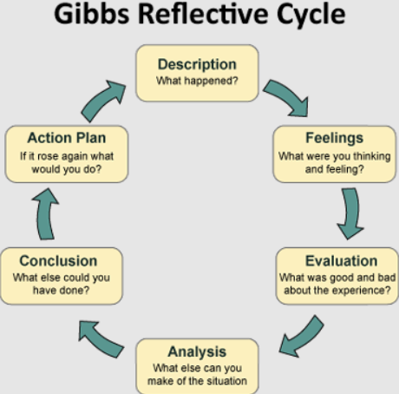
Diagram 1: Gibbs Reflective Cycle. (Source: https://www.crowe-associates.co.uk/coaching-tools/gibbs-reflective-cycle/)

Gibbs Reflective Cycle was developed to help learners continuously improve from a repeated experience but it is also applicable to standalone experience (Gibbs, 1988). It acknowledges the importance of the learner’s feelings in the reflection process as it greatly influences the impact of the reflection on the learner’s growth (Gibbs, 1988). The six stages of the reflective cycle are shown in Diagram 1.
The description stage allows the learner to describe the event without making any judgements or conclusions on it (Gibbs, 1988). The feelings stage focuses on the learner’s emotional response and thoughts about the experience (Gibbs, 1988). Evaluation is where the learner makes a value judgement after considering the experience objectively (Gibbs, 1988).
The analysis stage is where the learner analyses the experience in greater detail by consulting theories and frameworks to understand what happened (Gibbs, 1988). After that, the learner determines what can be concluded from the analysis done on the experience (Gibbs, 1988). What can the learner learn or improve is the highlight of the conclusion stage (Gibbs, 1988). Finally, the learner must create an action plan that lists the things or skills the learner must learn and areas to improve for next time (Gibbs, 1988).

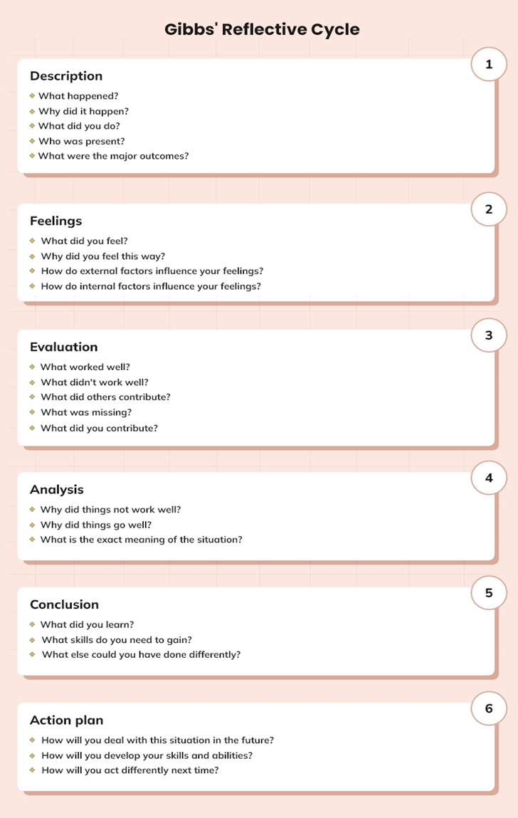
Diagram 2: Questions to Aid the Reflection Process. (Source: Source: https://crowjack.com/blog/strategy/reflection-models/gibbs-reflective-cycle)

Diagram 2 shows the questions that learners can use to formulate their response for all the stages (Gibbs, 1988). The reflective cycle will be used to reflect on 3 specific areas, namely the creation of the research idea, process of developing the idea and individual learning from the experience.

2.2 Reflection on The Creation of Your Idea
2.2.1 Identifying A Problem
We were asked by our module tutor to identify a topic to research. I was excited to look for my next research topic after doing an assignment on current business trends in the previous semester. Selecting a wide topic provides researcher with various avenues to search for a research question (Saunders et al., 2020). Influencer marketing was chosen because I was genuinely interested in it. It is dynamic and it has changed significantly due to the pandemic (Sidhu, 2023). Current news stated that influencer marketing is becoming more crucial for businesses and will continue to grow (Sidhu, 2023).
Next, I conducted a literature review on influencer marketing. Literature review allows a researcher to discover issues currently being discussed by other researchers (Bell et al., 2022). Updated and relevant knowledge on the topic helps narrow down the topic (Bell et al., 2022). However, the scope of the topic widened after the literature review which made it hard to determine the direction of the research. This was evident when conducting the research.
Studies suggests using gap-spotting to narrow down the topic (Fandino, 2019). This method determines the direction of the research on a topic by focusing on the limitations or gaps in the literature (Fandino, 2019). The gaps will become the research question after some fine-tuning (Fandino, 2019). This method is high recommended especially for novice researcher to narrow down a topic and determine potential research questions (Fandino, 2019). Gap-spotting should be implemented in my next research.

2.2.2 Setting A Research Question
After identifying the problem, the next step is turning the problem into a logical research question (Fandino, 2019). Research question is defined as a question that a research project aims to answer through collection, analysis, and interpretation of research data (Fandino, 2019).
I think it is difficult to formulate a good research question. Even though it is important for research question to be structurally sound, there is little support in literature to help craft an innovative research question (Fandino, 2019). I tried to refine my research question with reference to various journals. The research question was approved by my module tutor. However, I later discovered that the research question was still too wide. Research could be conducted but it was impossible to include all research done due to the word limit of the assignment.
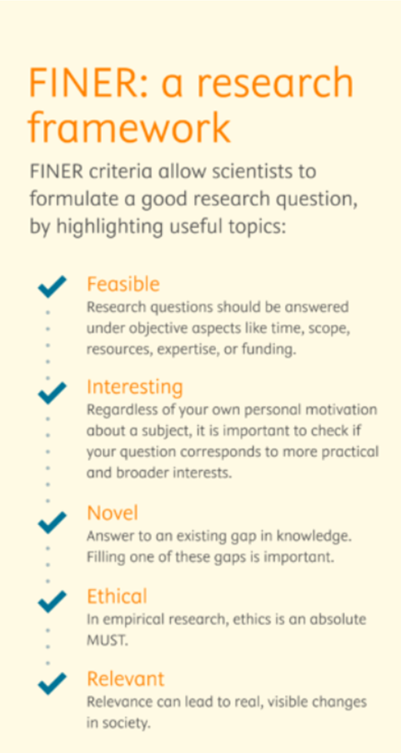
Diagram 3: FINER Framework. (Source: https://scientific-publishing.webshop.elsevier.com/research-process/finer-research-framework/)

The FINER framework can guide researchers to produce a sound research question (Saunders et al., 2020). The FINER criteria are shown in Diagram 3.
A research question is feasible if it is well within a researcher’s ability to investigate it (Saunders et al., 2020). This ensures that the researcher is aware of the scale of the research and that the researcher can complete the research with their limited skills and resources (Saunders et al., 2020). The question must be interesting to the researcher and the community the researcher lives in (Bell et al., 2022). Interest in the question will increase the researcher’s motivation to complete the research (Bell et al., 2022). Furthermore, the question should be unique and developed to bring new insights to the topic chosen. The research should support or expand findings in previous studies (Bell et al., 2022). Research done must be ethical and approved by the relevant authorities and institutions (Bell et al., 2022). Lastly, the research question must be relevant to various stakeholders and create values that would benefit society (Bell et al., 2022). This framework should form the foundation when creating research question in future studies (Saunders et al., 2020).

2.3 Reflecting on The Process of Developing Your Idea
2.3.1 Deciding on the Research Approach
Next is to determine the research approach. Research approach is the systematic ways that researcher use to conduct their research (Hwang et al., 2019). The three research approaches are deductive, inductive, and abductive (Hwang et al., 2019).
Deductive approach is where collection and analysis of data will be used to confirm or reject a theory (Arias Valencia, 2022). Inductive approach begins with collection and analysis of data (Arias Valencia, 2022). After that, the researcher chooses or develops a theory based on the results (Arias Valencia, 2022). Abductive approach is the combination of the two approaches above (Garbuio & Lin, 2021). This approach seeks to explain a phenomenon and refined theory used in the research (Garbuio & Lin, 2021).
The deductive approach was chosen for the research. I felt that this approach is clearly defined which makes the research easy to implement (Wasti et al., 2022). Variables used by the theory allowed for easy comparison with previous studies (Wasti et al., 2022). However, the results of the research can sometimes be hard to explain (Wasti et al., 2022). Deductive approach uses quantitative research which measures variables using numerical data (Arias Valencia, 2022). The data gathered was not able to explain why Malaysians responded the way they did. Subjective interpretation of the data may distort the findings without further studies (Arias Valencia, 2022).
Therefore, the abductive approach is the solution to the problem. Qualitative research should be added to explore the reason behind their choice and perspectives of the people in their natural environment (Żelechowska et al., 2020).

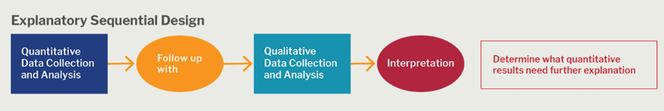
Diagram 4: Mixed Methods Research Design. (Source: https://catalyst.harvard.edu/community-engagement/mmr/)

Using the mixed method research design shown in Diagram 4 will examine influencer marketing in its real-life context and the combination of multiple data sources and methods enhances the validity and reliability of the results (Żelechowska et al., 2020). A better explanation of the results can be obtained through abductive approach and mixed method research (Żelechowska et al., 2020).

2.3.2 Data Collection
Data collection is done based on the research approach chosen. Data collection is the systematic method of gathering and measuring data to answer the research question (Bell et al., 2022). There are two types of data, namely primary and secondary data (Bell et al., 2022). Primary data are data collected for the first time and secondary data are data collected and tested in previous studies (Bell et al., 2022).
Questionnaire (primary data collection) and literature review (secondary data collection) were used for the assignment. Questionnaire is a series of questions used to obtain data on a particular phenomenon or theory (Hitchings & Latham, 2019). The data collection was hectic due to preparation for the final exam and the response was less than expected. The results were able to support or deny findings in previous studies but difficult to convey the feelings or reasons behind the respondents’ choices (Döringer, 2020).
Interviews should be added to collect detailed information on the choices of the respondents (Döringer, 2020). Information collected helps interpret the questionnaire results providing a more comprehensive understanding of the topic (Döringer, 2020).
The number of journals on influencer marketing is massive despite it being a new concept. It was exhausting going through the journals. There was a risk that confirmation bias might affect the information search (McSweeney, 2021). Confirmation bias is the tendency to search information that supports the research and ignore any that contradicts the research (McSweeney, 2021).

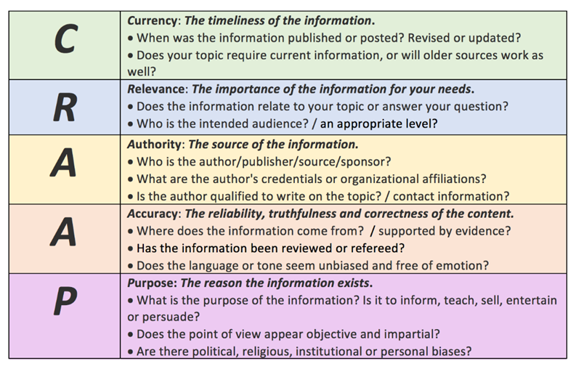
Diagram 5: CRAAP Test. (Source: https://academic-englishuk.com/evaluating-sources/)

It is crucial to be aware of this bias and to be objective during the information search (Suzuki & Yamamoto, 2021). Selecting journals based on the CRAAP test is a good way to avoid confirmation bias and maintains a researcher’s objectivity (Muis et al., 2022). The CRAAP test as shown in Diagram 5 is a checklist that determines the credibility and reliability of any research paper (Muis et al., 2022).

2.3.3 Presenting Your Idea
Research done was presented through an elevator pitch and a research poster. I was nervous when recording the elevator pitch. Feedback given by the module tutor was that I spoke faster because I was nervous and this affected the quality of the presentation.
Presentation anxiety is a common phobia that reduces self-confidence and limits one’s presentation skills (Salem, 2019). This type of anxiety is normal and exists to protect humans from outside judgement or ridicule (Salem, 2019).
There are various techniques to manage this anxiety in order to deliver an effective presentation (Sue et al., 2013). Anxiety causes breathing to become shallow and deep breathing can calm the brain and slows down the speech rate (Sue et al., 2013). Continuous rehearsal before a presentation helps a presenter fine-tune flaws in the presentation which boosts one’s self confidence (Sue et al., 2013).
As for the research poster, I felt this part of the assignment was enjoyable as it allowed me to express my creativity in terms of the poster design. However, it was arduous trying to fit all the necessary data needed.
A researcher must understand a poster is networking tool used to attract people’s attention and not to communicate all the details in the research (Murchie & Diomede, 2020). Visual hierarchy is often use in graphic design to arrange elements in a poster in terms of their importance (Murchie & Diomede, 2020). Presenting information that people can understand easily is one of the main elements of a research poster (Gray et al., 2022). Having less words on a poster helps attract readers and retain their attention (Gray et al., 2022). This ensures the success of the poster delivering the intended message (Gray et al., 2022).

2.3.4 Analysing Data and Formulating Conclusions
The final part of the research involves analysing the data and forming a conclusion based on the analysis. The word count restricts the amount of data that can be presented. I felt that the task of choosing which data to include was onerous due to the IKEA effect. IKEA effect is where a researcher tends to value something more because of the effort invested in producing it (Decision Lab, 2023). Data is seen as equally valuable which complicates the selection process (Brunner et al., 2023). Nonetheless, a researcher must focus on the research question and choose the data that answers it best (Brunner et al., 2023). Forming a habit of asking others for feedback gives the researcher an impartial perspective on the real value of the work done (Saunders et al., 2020).
Developing creativity as a skill helps researcher produce better research results (Ahmad et al., 2020). Creativity can lead to novel ways of presenting data and conclusion (Ahmad et al., 2020). Constraints in the research provide an opportunity for researchers to be creative when presenting their findings (Ahmad et al., 2020). Creativity enhances the researcher’s ability to identify the connections between data collected, merging them to provide new insights while retaining the quality of the data and its meaning (Ahmad et al., 2020). Creativity promotes new ways of presentation and communication of information which is extremely beneficial for students especially in the modern business environment (Ahmad et al., 2020).

2.4 Reflecting on Your Individual Learning
After completion of the assignment, I understood that it was designed to place me outside of my comfort zone so I can learn and grow. I was able to acquire various research skills and understand concepts that would help me conduct high quality research. I also realised that creativity is a skill that can be developed and is applicable in many disciplines. I was able to identified that my presentation skill is weak and requires improvement. I thoroughly enjoyed the entire process and is grateful for the opportunity given.
All the skills I have learned will help me conduct better analysis in my future career leading to better decision making (Bell et al., 2022). Developing my presentation skill and creativity will enrich the way I communicate my ideas creating value for the business (Ahmad et al., 2020).

2.5 Develop an Action Plan
After reflection on the research process, it is necessary to write an action plan to enhance knowledge and skills gained (Adeani et al., 2020). The action plan is attached as Appendix 1. The targets for each process were set (Adeani et al., 2020). The steps needed to achieve the targets were listed (Adeani et al., 2020). Asking for feedback from others on the steps taken can help identify new knowledge and additional steps to improve (Adeani et al., 2020). Lastly, continuous reflection will help identify success criteria to measure your achievements (Adeani et al., 2020).

3.0 Conclusion

The main takeaway is that mistakes made and poor performance do not determine one’s success (Dweck, 2016). It is paramount that one reflects and learn from the experience gained (Dweck, 2016). There is a need to develop a growth mindset when facing any problems or challenges (Yeager et al., 2019). Individuals with a growth mindset believe any abilities can be developed (Yeager et al., 2019). These individuals understands that effort invested will enhance their learning and mistakes are simply opportunities to build new abilities (Yeager et al., 2019). Growth mindset makes an individual feel empowered and committed to take on challenges and learn from them which increases their abilities and achievements (Dweck, 2016). Constant growth is the measure of true success (Dweck, 2016).

(Total Word Count: 2168 Words)

4.0 References
Adeani, I. S., Febriani, R. B., & Syafryadin, S. (2020). Using Gibbs reflective cycle in making reflections of Literary Analysis. Indonesian EFL Journal, 6(2), 139. https://doi.org/10.25134/ieflj.v6i2.3382
Ahmad, K., Nurkhin, A., Muhsin, M., & Pramusinto, H. (2020). Problem-based learning strategy: Its impact on students’ critical and Creative Thinking Skills. European Journal of Educational Research, 9(3), 1141–1150. https://doi.org/10.12973/eu-jer.9.3.1141
Akpur, U. (2020). Critical, reflective, creative thinking and their reflections on academic achievement. Thinking Skills and Creativity, 37, 100683. https://doi.org/10.1016/j.tsc.2020.100683
Arias Valencia, M. M. (2022). Principles, scope, and limitations of the methodological triangulation. Investigación y Educación En Enfermería, 40(2). https://doi.org/10.17533/udea.iee.v40n2e03.
Bell, E., Bryman, A., & Harley, B. (2022). Business research methods. Oxford University Press.
Brunner, F., Gamm, F., & Mill, W. (2023). MyPortfolio: The IKEA effect in financial investment decisions. Journal of Banking &amp; Finance, 154, 106529. https://doi.org/10.1016/j.jbankfin.2022.106529
Bugg, E. G., & Dewey, J. (1934). How we think: A restatement of the relation of reflective thinking to the educative process. The American Journal of Psychology, 46(3), 528. https://doi.org/10.2307/1415632
Decision Lab. (2023). IKEA Effect. The Decision Lab. https://thedecisionlab.com/biases/ikea-effect
Döringer, S. (2020). ‘the problem-centred expert interview’. combining qualitative interviewing approaches for investigating implicit expert knowledge. International Journal of Social Research Methodology, 24(3), 265–278. https://doi.org/10.1080/13645579.2020.1766777
Dweck, C. S. (2016). Mindset The New Psychology of Success. Ballantine Books.
Fandino, W. (2019). Formulating a good research question: Pearls and pitfalls. Indian Journal of Anaesthesia, 63(8), 611. https://doi.org/10.4103/ija.ija_198_19
Garbuio, M., & Lin, N. (2021). Innovative idea generation in problem finding: Abductive reasoning, cognitive impediments, and the promise of Artificial Intelligence. Journal of Product Innovation Management, 38(6), 701–725. https://doi.org/10.1111/jpim.12602
Gibbs, G. (1988) Learning by Doing: A guide to teaching and learning methods. Further Education Unit, Oxford Brookes University, Oxford.
Gray, A. L., Curtis, C. W., Young, M. R., & Bryson, K. K. (2022). Innovative poster designs: A shift toward visual representation of data. American Journal of Health-System Pharmacy, 79(8), 625–628. https://doi.org/10.1093/ajhp/zxac002
Hitchings, R., & Latham, A. (2019). Qualitative methods I: On current conventions in interview research. Progress in Human Geography, 44(2), 389–398. https://doi.org/10.1177/0309132519856412
Hwang, M.-Y., Hong, J.-C., Ye, J.-H., Wu, Y.-F., Tai, K.-H., & Kiu, M.-C. (2019a). Practicing abductive reasoning: The correlations between cognitive factors and learning effects. Computers &amp; Education, 138, 33–45. https://doi.org/10.1016/j.compedu.2019.04.014
McSweeney, B. (2021). Fooling ourselves and others: Confirmation bias and the trustworthiness of qualitative research – part 1 (the threats). Journal of Organizational Change Management, 34(5), 1063–1075. https://doi.org/10.1108/jocm-04-2021-0117
Muis, K. R., Denton, C., & Dubé, A. (2022). Identifying Craap on the internet: A source evaluation intervention. Advances in Social Sciences Research Journal, 9(7), 239–265. https://doi.org/10.14738/assrj.97.12670
Murchie, K. J., & Diomede, D. (2020). Fundamentals of graphic design—essential tools for effective visual science communication. FACETS, 5(1), 409–422. https://doi.org/10.1139/facets-2018-0049
Salem, A. A. (2019). A sage on a stage, to express and impress: TED talks for improving oral presentation skills, vocabulary retention and its impact on reducing speaking anxiety in ESP settings. English Language Teaching, 12(6), 146. https://doi.org/10.5539/elt.v12n6p146
Saunders, M., Lewis, P., &amp; Thornhill, A. (2020). Research methods for business students (8th Edition). Pearson Education.
Sidhu, B. K. (2023, April 24). Influencer marketing gaining strength. The Star. https://www.thestar.com.my/business/business-news/2023/04/24/influencer-marketing-gaining-strength
Sue, A. J., Wilkins, M. M., & Saltus, K. (2013). Own the room: Discover your signature voice to master your leadership presence. Gildan Audio Imprint.
Suzuki, M., & Yamamoto, Y. (2021). Characterizing the influence of confirmation bias on web search behavior. Frontiers in Psychology, 12. https://doi.org/10.3389/fpsyg.2021.771948
Wasti, S. P., Simkhada, P., van Teijlingen, E., Sathian, B., & Banerjee, I. (2022). The growing importance of mixed-methods research in health. Nepal Journal of Epidemiology, 12(1), 1175–1178. https://doi.org/10.3126/nje.v12i1.43633
Yaacob, A., Asraf, R. M., Hussain, R. M., & Ismail, S. N. (2021). Empowering learners’ reflective thinking through collaborative reflective learning. International Journal of Instruction, 14(1), 709–726. https://doi.org/10.29333/iji.2021.14143a
Yeager, D. S., Hanselman, P., Walton, G. M., Murray, J. S., Crosnoe, R., Muller, C., Tipton, E., Schneider, B., Hulleman, C. S., Hinojosa, C. P., Paunesku, D., Romero, C., Flint, K., Roberts, A., Trott, J., Iachan, R., Buontempo, J., Yang, S. M., Carvalho, C. M., … Dweck, C. S. (2019). A national experiment reveals where a growth mindset improves achievement. Nature, 573(7774), 364–369. https://doi.org/10.1038/s41586-019-1466-y
Żelechowska, D., Żyluk, N., & Urbański, M. (2020). Find out a new method to study abductive reasoning in empirical research. International Journal of Qualitative Methods, 19, 160940692090967. https://doi.org/10.1177/1609406920909674

5.0 Appendix

Appendix 1: Action Plan
Research Process | Target | Steps/ Actions | Feedback and Reflection
1.Identifying A Problem | - Develop skill to identify problem. | - Study the research process.  - Identify area of study.  - Conduct literature review on chosen topic.  - Narrow down the topic by using gap spotting.
2.Setting A Research Question | - Develop skill to define research question. | - Study steps to define a research question.  - Apply FINER framework to refine the research question.  - Obtain feedback from peers or colleagues and revise research question.
3.Deciding on the Research Approach | - Develop ability to determine the best research approach. | - Study and understand various research approaches.  - Conduct literature review to identify most used approach for research question.  - Choose the suitable research approach.
4.Data Collection | - Develop efficient data collection method. | Primary Data Collection  - Study various data collection methods.  - Apply suitable data collection method according to research approach.  - Form questions for questionnaire or interviews by referring to the research question.  Secondary Data Collection  - Study confirmation bias and other biases related to data collection.  - Be wary of cognitive biases when conducting data collection.  - Use the CRAAP test to check credibility and reliability of research paper.
5. Presenting Your Idea | - Enhance presentation skill.  - Develop graphic design skills. | Presentation  - Study ways to improve presentation skill and build self-confidence.  - Study breathing exercise to relieve anxiety.  - Do rehearsal and obtain feedback to identify and rectify flaws.  Poster Design  - Study elements of visual hierarchy.  - Design poster according to the elements.  - Practice condensing information for better communication of research findings.
6.Analysing Data and Formulating Conclusions | - Develop good analytical skills.  - Develop creative thinking in related field of study. | - Study cognitive biases that affect data analysis.  - Be wary of IKEA effect when selecting data to include for data presentation.  - Study methods to analyse data.  - Practice analysing data within a certain word count.  - Explore new ways to analyse and present data/ results.

