BMHP5014 – Component 1 Online Portfolio
Student Name: Sofia Rafaqat
Programme: BSc Health and Social Care
Module: Changemakers: Creativity and Value Creation (BMHP5014)
Lecturer: Parese Ahmed
Student Number: 2131225
Submission Date: 25 March 2026

Contents Page

Task 1 – Concept Map (Written Explanation)
Task 2 – Self-Reflection (Gibbs’ Reflective Cycle)
Task 3 – Case Study of a UK Innovation
Task 4 – Research Task: Access to Mental Health Services
Task 5 – Podcast
Task 6 – NHS Leadership Framework Analysis
Task 7 – Self-Reflection Journal (Gibbs’ Reflective Cycle)
Conclusion
Reference List

Task 1 – Concept Map (Written Explanation)
Figure 1: Concept map illustrating the relationship between creativity, innovation and value creation in health and social care.
Health & Social Care Improvement
(Better patient outcomes, quality care,
improved service delivery)
↑

Value Creation ←────── Innovation ──────→ Digital Health Solutions
(Improved efficiency, patient │ • Virtual wards
satisfaction, reduced pressure) │ • Remote monitoring
│ • Telehealth
↓
Creativity
(Generating new ideas)
Concept-map links (Week 1):
Creativity (new & useful ideas) → Innovation (testing/implementing ideas) → Value creation (benefits) → Health & social care improvement (better outcomes, experience, efficiency) → Learning/evaluation → feeds back into creativity.
In health and social care, creativity is the starting point for improvement because practitioners routinely face complex, resource-pressured situations that rarely fit a single ‘standard’ solution. Creative thinking supports reframing problems (e.g., reducing missed appointments, improving communication, or redesigning referral pathways) and generating practical options that can be trailed safely. When creative ideas are implemented and evaluated, they become innovative.
Value creation is the ‘why’ and ‘so what’ of innovation. In this context, value includes clinical outcomes (safety and effectiveness), service user experience (dignity, involvement, accessibility), staff wellbeing, and system performance (reduced waste and smoother pathways). Week 1 learning also emphasises that value must be ethically grounded: improvements should not increase risk, widen inequalities, or undermine safeguarding.
Health and social care improvement occurs when innovations are embedded into everyday practice through leadership support, multidisciplinary collaboration, and continuous evaluation. This relationship is cyclical: creativity generates possibilities, value measures impact, and improvement sustains what works while refining what does not.

Task 2 – Self-Reflection (Gibbs’ Reflective Cycle)

Using Gibbs’ Reflective Cycle (1988), this reflection evaluates my learning from the convergent and divergent paperclip thinking activity. During the session, our group generated alternative uses for a paperclip. Initially, I relied on convergent thinking and focused on obvious uses. As the activity progressed, we were encouraged to adopt divergent thinking and produce more creative ideas.
I initially felt hesitant to share unusual suggestions; however, as the environment became more supportive, my confidence increased. This demonstrated the importance of psychological safety in enabling creativity. The activity showed that creative thinking can be developed through practice rather than being purely innate (Amabile, 1996).
In future health and social care practices, I will aim to remain more open-minded when approaching problems and avoid relying solely on routine solutions. Overall, this activity strengthened my understanding that both convergent and divergent thinking are essential for effective professional problem-solving.

Task 3 – Case Study of a UK Innovation

NHS Virtual Wards are a prominent UK innovation designed to reduce pressure on hospital capacity while maintaining safe, person-centred care. Virtual wards combine remote monitoring technology with multidisciplinary clinical oversight, enabling eligible patients to receive acute-level support at home while key indicators are tracked and acted upon (NHS England, 2022).
Creativity is evident in how the initiative redesigns the place and process of care. Instead of expanding physical bed stock, the NHS re-imagines ‘the ward’ as a coordinated system across home, community and digital infrastructure. This requires adaptive problem-solving in workflow, communication, escalation protocols and patient education—showing that innovation is not only technological, but organisational and relational.
The value created is multi-layered. For service users, home-based care can improve comfort, autonomy and potentially reduce hospital-acquired harms. For the system, virtual wards can support flow and free hospital capacity for patients with more complex needs, aligning with wider service transformation goals (NHS England, 2019).
However, a critical limitation is equity. Digital exclusion, variable home environments, and differing levels of health literacy may reduce access or effectiveness for some groups. Ethical implementation therefore requires inclusive assessment, alternatives for those unable to engage digitally, and ongoing evaluation of outcomes across population groups to ensure that innovation creates value without widening inequalities.
Despite these benefits, successful implementation requires sufficient community workforce capacity, clear clinical escalation pathways, and robust digital infrastructure to ensure patient safety and continuity of care.

Task 4 – Public Health Poster: Tackling Childhood Obesity
Healthy Futures: Tackling Childhood Obesity in Birmingham

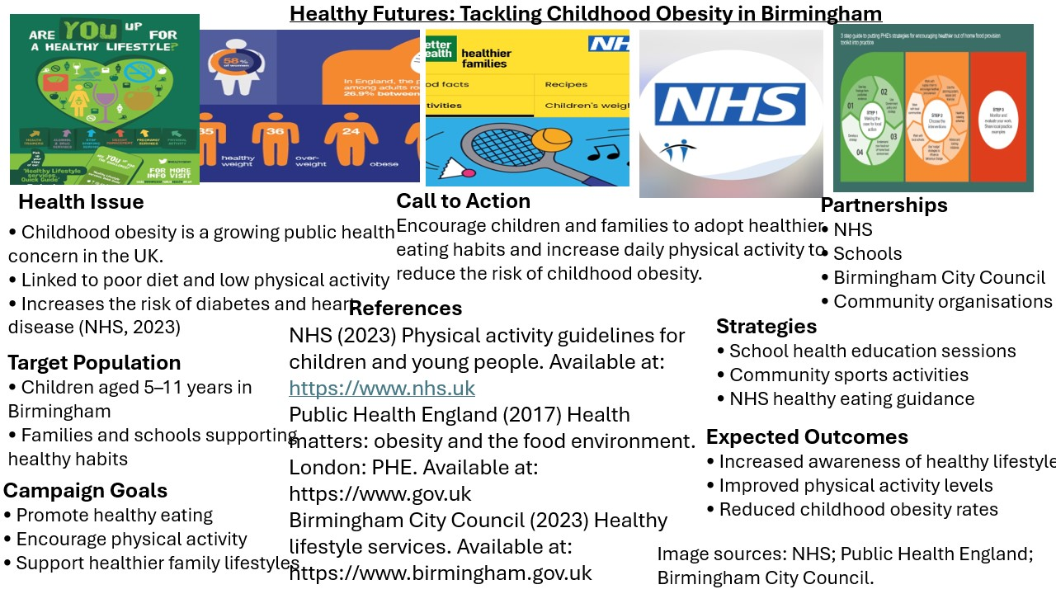
Figure 2: Public health campaign poster promoting childhood obesity prevention through healthy eating, physical activity and community awareness.
Childhood obesity is a growing public health concern in the UK, with significant implications for long-term physical and mental health. According to the NHS, children living with obesity are more likely to develop conditions such as type 2 diabetes, cardiovascular disease and low self-esteem later in life. Public health campaigns therefore play an important role in promoting healthier lifestyles and raising awareness among families and communities.

The “Healthy Futures” poster aims to encourage healthier eating habits and increased physical activity among children and young people in Birmingham. The campaign highlights simple lifestyle changes such as reducing sugary foods, increasing physical activity and supporting families to make healthier choices. By presenting clear visual messages, the poster aims to communicate public health information in an accessible way and support prevention efforts within the community.

Task 5 – Podcast
This two-minute podcast introduces my chosen UK healthcare innovation, NHS at Home (Virtual Wards). The podcast outlines the rationale behind the initiative, explains how it operates using remote monitoring technology, and evaluates its contribution to person-centred care and healthcare sustainability. The discussion reflects key themes from Weeks 4 and 6, including innovation, creativity, and value creation within health and social care systems.

This short podcast communicates key ideas about NHS Virtual Wards in an accessible format for a general audience. It demonstrates how complex healthcare innovation can be translated into clear public health communication.

BMHP5014_Portfolio_Sofia_Rafaqat_2026.docx.m4a

This innovation reflects key theoretical concepts discussed in Weeks 4 and 6 regarding creativity and value creation. Rather than creating something entirely new, Virtual Wards demonstrate adaptive creativity — redesigning existing healthcare delivery models to generate greater value. According to the design thinking framework, innovation often emerges from identifying system pressures and reimagining solutions that improve both user experience and organisational efficiency. NHS at Home creates value at multiple levels: for patients through enhanced dignity and safety, and for the healthcare system through improved sustainability and resource optimisation. This illustrates how creativity in health and social care is not limited to artistic expression but instead involves strategic problem-solving and systemic transformation.

Task 6 – NHS Leadership Framework Analysis
Summary: The NHS Healthcare Leadership Model describes the behaviours expected of leaders across health and care, emphasising that leadership is everyone’s responsibility, not only those with formal authority. It includes dimensions such as inspiring shared purpose, leading with care, evaluating information, engaging the team, holding account, and influencing results (NHS Leadership Academy, 2013). The model aligns leadership with compassionate, inclusive practice, focusing on patient safety, staff wellbeing, and continuous improvement.
Chosen component – Creating the Environment: Leaders encourage creativity by shaping conditions where improvement is possible. ‘Creating the environment’ involves role-modelling openness, enabling learning from feedback, and removing practical barriers (time, resources, unclear processes) that prevent staff from testing ideas. NHS improvement guidance highlights that leaders can strengthen innovation culture by supporting collaboration, making space for experimentation, and reinforcing shared purpose and learning (NHS Institute for Innovation and Improvement, 2010). Used well, this helps leaders balance creativity with accountability—ensuring that new ideas remain evidence-based, equitable and safe.

Task 7 – Self-Reflection Journal (Gibbs’ Reflective Cycle)

Description

This portfolio required the completion of several activities aimed at exploring creativity, innovation, and value creation within health and social care. These tasks included developing a concept map that illustrated the relationship between creativity, innovation, and healthcare improvement, completing a reflective activity using divergent and convergent thinking, analysing an innovative UK healthcare initiative such as NHS Virtual Wards, and producing a podcast focused on a public health issue. The purpose of these activities was to demonstrate how creative thinking can contribute to improving healthcare services and patient outcomes.

Feelings

At the beginning of the portfolio, I felt slightly uncertain about some of the tasks, particularly the podcast and design thinking activity, as they required presenting information in creative and unfamiliar ways. However, as I progressed through the activities, I became more confident in applying creative thinking within a healthcare context. I found the concept map particularly useful because it helped me visually understand how creativity leads to innovation and ultimately creates value in health and social care systems.

Evaluation

Overall, the portfolio tasks were beneficial in enhancing my understanding of how innovation can address challenges within healthcare services. One positive aspect was analysing initiatives such as NHS Virtual Wards, which demonstrated how digital technologies and remote monitoring can improve patient care while reducing pressure on hospitals. However, one challenge I encountered was condensing complex information into concise explanations, particularly when preparing the podcast script and written portfolio tasks.

Analysis

This experience highlighted that creativity plays an essential role in developing innovative solutions in health and social care. Creativity allows professionals to generate new ideas, while innovation focuses on implementing those ideas in practice to improve service delivery and patient outcomes. Through completing the portfolio activities, I strengthened my research, critical thinking, and communication skills. These competencies are important for healthcare professionals who must respond to complex health challenges and continuously seek ways to improve care delivery.

Conclusion

Overall, completing this portfolio improved my understanding of the relationship between creativity, innovation, and value creation in healthcare. It also helped me develop confidence in presenting health information through different formats, including visual tools and audio communication.

Action Plan

In the future, I intend to further develop my ability to apply creative thinking when analysing health challenges and designing potential solutions. I will also continue improving my research and communication skills to ensure that complex healthcare information can be presented clearly and effectively to different audiences.This portfolio experience reinforced the importance of reflective practice in professional development, highlighting that healthcare professionals must continuously evaluate their approaches to improve patient outcomes and service delivery.

Conclusion
This portfolio strengthened my understanding that creativity in health and social care is closely linked to problem-solving, adaptability and service improvement rather than artistic expression alone. Through analysing innovations such as NHS Virtual Wards and engaging with design thinking activities, I developed a greater appreciation of how creative approaches can improve patient experience while supporting organisational sustainability. Overall, the portfolio highlighted the importance of reflective practice, collaborative working and open-minded thinking when addressing complex healthcare challenges. These insights will influence my future professional practice by encouraging proactive, solution-focused approaches to improving health and social care services. As a future health and social care professional, applying creative thinking and evidence-based innovation will be essential for addressing complex health challenges and contributing to sustainable healthcare improvement.

Reference list
- Amabile, T. (1996) Creativity in context. Boulder, CO: Westview Press.
- Lowther-Payne, H.J. (2023) Understanding inequalities in access to adult mental health services.
- Memon, A. et al. (2016) Perceived barriers to accessing mental health services among BME communities.
- NHS England (2019) The NHS Long Term Plan.
- NHS England (2022) Virtual wards: A guide for the NHS.
- NHS Institute for Innovation and Improvement (2010)
- NHS Leadership Academy (2013)
- Public Health England (2017)
- West, M. and Dawson, J. (2012)

