Portfolio and Reflective Piece
Gurpinder Singh

Table of Contents
Three pieces of evidence 3
1 Student Work Placement Logbook 3
2 Tasks completed during the placement 5
3 End of Placement Evaluation 6
Reflective Commentary 7
Introduction 7
Gibbs Reflective Cycle 7
Description 8
Feelings 8
Evaluation 9
Analysis 9
Conclusion 10
Action Plan 10
Reference 12
Appendix 13
Email indicating approval from the module leader to confirm my placent 13
Placement Attendance Form 13
13

Three pieces of evidence

1 Student Work Placement Logbook
Date | March 24, 2024
Tasks Completed | Assisted with Sorting and Pricing Donated Items
Reflection | Knowledge: Working at the animal rescue charity shop was quite eye-opening in terms of the welfare operations, which emphasized the importance of effective management of a huge inventory and the strategies of placing items at an appropriate price. I realized about stock control, window displays and targeted donation campaigns. Finally, I learned through experience about merchandise and market worthwhileiveness. This is where the lie the differences in consumer behaviour in several environments.  Skills Development: The actual process gave me a thorough understanding of the physiology of accounting by helping me to master inventory organization, rationalization and pricing. By correcting the details, I learned responsible use of time assisting the charity with efficient donations handling. The communication and team building skills were strengthened with the collaboration of staff and volunteers, and thus a tidy and appealing shop was manifested.  Self-awareness: Inspired by the situation, in what I can do best: details and organization, I began the work. Nonetheless, I identified some shortcomings while facing the decisions for the appraisal of donated items, especially the market value. Both those encounters highlighted the fact that learning and adaptation are an abiding requirement in a rapidly changing retailing sphere and personal development.
Date | April 7, 2024
Tasks Completed | Supported Customer Inquiries and Transactions at the Shop Counter
Reflection | Knowledge: Exchanging with the customers and using the opportunity to help them not only helped me tell what successful customer service looks like but also see that it is product/service knowledge which makes the difference. The range of merchandise offered by the charity shop, the mission of the group, and all the activities and projects carried out by them, I already have a clearer understanding of. Moreover, through the process, I acquired a clear insight into designing a favourable shopping mission for the clients by rendering them with friendly and supportive services.  Skills Development: A customer’s attention was the capability that most of the skills are thousands of training and retail transactions. I learnt how to use my social skills during my interaction with customers as I willingly answered their enquiries about our products and the charity. Thereupon, besides a computer-based sales system, I acquired a skill in processing transactions correctly and fast. Joining hands with fellow workers made more the partner of teamwork and cooperation, finally, we were able to succeed in providing customers with a good shopping experience.  Self-awareness: Through a deeper understanding of my customer support role which includes query answering and transaction support, I developed new self-awareness about my self-efficacy as far as communication and interpersonal are concerned. I have noticed that interaction with clients is my strong point. I can listen carefully to their concerns, give them expert guidance, and make sure that our customers enjoy our services. Nevertheless, I have auditable strengths and of course weaknesses, too, for example, handling demanding customers and systemizing product information. This attitude develops a better understanding of the importance of empathy, patience and adaptability in customer service positions, making the person grow owing to personal development.
Date | April 21, 2024
Tasks Completed | Participated in Promotional Events to Raise Awareness and Funds.
Reflection | Knowledge: Being allowed to take part in these promotional events proved to be a very helpful thing for me as it gave me a chance to see firsthand what strategies are used to create public awareness and attract funds for charitable causes. The importance of community involvement and coalition building as key components to running effectual fundraising was my learning curve. Further, I discovered very many programs and initiatives that help such as Animal Rescue Charity Shop in the same way to create better animal welfare.  Skills Development: This time, gave me a great opportunity to get both hands-on skills and proficiency in event management, advertisement, and interaction with the community. I got into networking and communication development as I was actively involved in drawing the attention of the people to raise animal welfare issues and the work of the charity shop. Moreover, I have developed the skill of organizing logistics, and activities and I was part of the promotional events operational team, giving a heartbeat to the activities.  Self-awareness: Looking back on this event, I can say that I have developed my power to work with others and become aware of my ability to communicate ideas through words and deeds. I pinpointed the skills I possessed in econ matters, that is, communication, organization as well as teamwork, while the need for improvement touched the areas of public speaking and event coordination. This exposure helped me see how important it is for a person to attend group actions and community events to help the projects even if only with the assistance and make them unforgotten.

2 Tasks completed during the placement
I classed the items according to their type and purpose after looking them over. After classifying the items, I arranged them in specific sections of the store.
Along with feeding the animals fresh food and water based on their schedules and dietary requirements, this was another responsibility of mine. This included preparing food and water bowls, and keeping an eye on the animals' intake to make sure they were getting enough to eat and drink.
While serving customers at the shop, I promoted the charity's mission and garnered support for its cause by giving them attentive, personalised service that catered to their needs and preferences.I've made an effort to establish a warm and inviting atmosphere that might entice clients to come back and support the charity's initiatives.

3 End of Placement Evaluation
By the end of my experience working with the Animal Rescue Charity Shop, I realized some things that were not expected of me and some unforeseen obstacles however they had been a key ingredient of my personal and professional growth. The most unexpected, yet consequently, the most inspiring experience I encountered was the unfailing commitment of staff members and volunteers to the cause of charity, the magnitude of the donations received from different donors. Yet, the rush at the shop and lack of knowledge on how to productively deal with the typical customer queries and transactions during the peak hours were the hurdles to overcome. I realized that I experience many obstacles while working in retail environment makes it even more challenging. Hence, I have a list of skills that I want to develop which is time management, conflict resolution, and a professional attitude in a fast-paced environment.
My placement at the shop has always offered various occasions for problem-solving. Some examples are inventing innovative ways of arranging bought items without damaging them or resolving a conflict with a client in an effective or empathetic manner. Besides that, I employed my expertise to instruct individuals about the charity's goals and programs, and that person was also to some extent involved in the planning and promotion of some charity events to raise money for the animal's wellbeing. My body of work highlighted my aptitude to take on responsibilities autonomously, for instance, doing the shop countering during busy times and learning the store maintenance and tidiness procedure.

Reflective Commentary

Introduction
In this reflective essay, I will take you on a reflective journey where I will be using the 6 Keys of (Gibbs Reflective Cycle) which will help me analyze my learning, the skills I have developed and self-awareness during my voluntary placement. In my attempt to achieve this purpose, I will highlight the growth and the path of the competencies and the preparedness for future development opportunities I gained. Having achieved placement at Farplace Animal Rescue Charity Shop that lasted for few weeks, the experience showed not only an avenue for growth but also a discovery stage. I will demonstrate the beneficial change that can happen to one's personality and work what I call the influential power of this experience. Through the Gibbs reflective structure, I intend to provide a better understanding of this experience and how it enhanced my personal and future professional life.

Gibbs Reflective Cycle
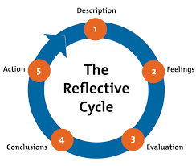
Figure 1 Gibbs Reflective Cycle

The Gibbs Reflective Model is a widely used framework for structured reflection, aiding individuals in analyzing and learning from their experiences (Adeani et al., 2020). It consists of six stages. Firstly, the Description stage prompts individuals to detail the event or experience. In the Feelings stage, emotions and thoughts are explored, allowing for a deeper understanding of personal reactions. Evaluation follows, where the positives and negatives of the experience are assessed. The Analysis stage delves into the underlying factors and significance of the experience. Drawing insights from the analysis, the Conclusion stage allows individuals to identify key learnings and insights gained. Finally, the Action Plan stage involves creating strategies for future actions or improvements based on the reflections. By guiding individuals through this process, the Gibbs Reflective Model promotes critical thinking, self-awareness, and continuous development, enabling individuals to grow personally and professionally (Hashim et al., 2023).

Description
In 2008, Farplace Animal Rescue was officially registered as a charity. Is a kind and devoted nonprofit organisation that works to rescue, heal, and find homes for animals in need. In the UK, Farplace Animal Rescue Charity Shops provide a wealth of used items for a deserving cause. Pre-owned clothing, books, home goods, and other items are tucked away within its hospitable walls and have all been kindly donated to help rescue and rehabilitate animals that are in need. Each purchase helps further the altruistic goal of providing care for animals in addition to finding a new home. (Farplace Animal Rescue, 2023). I've been volunteering at the charity shop for the past few weeks as Working as a volunteer at Farplace Animal Rescue Charity Shop combines compassion, a sense of belonging, and a dedication to animal welfare into a rewarding experience. When volunteers enter this modest but busy facility, they are welcomed with a feeling of purpose and community. I learned all these skills—like critical thinking, problem-solving, and adaptability—during my internship at the charity shop. These are the kinds of skills that are best acquired in real life rather than through classroom instruction.

Feelings
In the first moments of my internship at the store, I was excited, but at the same time unsure of what the future would bring. During the volunteering , I experienced various emotions that were subject to change. I found that being part of a team and meeting diverse people made me resistant, but over time it gave me the opportunity to develop a deeper sense of self-confidence. Moreover, interacting with clients who shared stories about their animals, animal rescue experiences, or personal challenges helped me develop empathy. By actively listening to their narratives, acknowledging their emotions, and offering true understanding and support, I increased my ability to empathize with others. I slowly started to appreciate the opportunities that volunteering gave me, noticing that I was more and more inclined to communicate with people. Even if it meant confronting conflicts, using active listening techniques such as paraphrasing, summarizing and explaining made it easier for me to communicate constructively and find an amicable solution to the problem.

Evaluation
By the end of my experience working with the Animal Rescue Charity Shop, I realized some things that were not expected of me and some unforeseen obstacles however they had been a key ingredient of my personal and professional growth. The most unexpected, yet consequently, the most inspiring experience I encountered was the unfailing commitment of staff members and volunteers to the cause of charity, the magnitude of the donations received from different donors. Yet, the rush at the shop and lack of knowledge on how to productively deal with the typical customer queries and transactions during the peak hours were the hurdles to overcome. I realized that I experience many obstacles while working in retail the busy environment makes it even more challenging. Hence, I have a list of skills that I want to develop which is time management, conflict resolution, and a professional attitude in a fast-paced environment.
My placement at the shop has always offered various occasions for problem-solving. Some examples are inventing innovative ways of arranging bought items without damaging them or resolving a conflict with a client in an effective or empathetic manner. Besides that, I employed my expertise to instruct individuals about the charity's goals and programs, and that person was also to some extent involved in the planning and promotion of some charity events to raise money for the animal's wellbeing. My body of work highlighted my aptitude to take on responsibilities autonomously, for instance, doing the shop countering during busy times and learning the store maintenance and tidiness procedure.

Analysis
Among the takeaways drawn from the volunteering experience, the most important were practical lessons in functioning in a store environment and managing routine tasks and responsibilities. One of the many lessons from this experience is that teamwork and collaboration are fundamental to the successful operation of all organizations. Additionally, volunteering helped me build good communication and positive relationships with clients. Because clear, empathetic communication improves overall interactions, strengthens the organization's impact and contributes to the fulfillment of its mission.

Conclusion
This Reflective essay, through the Gibbs Reflective Cycle lens, presents a total analysis of volunteering I did. It’s been an adventurous way that certainly taught me how to identify my talents, and grow up and learn; as a result, I gained essential concepts related to counselling, self-awareness, and becoming a professional. I have understood that active listening, empathic understanding and effective communication are not just the most essential qualities in the practice of counselling. When facing the challenges I've gone through being on this side, I've learned to cope with them by creating strategies to overcome hurdles and improve my skills. Implementation of joint efforts with my colleagues, successful participation in many procedures, and my involvement in organizational tasks caused my vision of ethical concerns and professional borders to be broader. Overall, I am committed to ongoing learning, self-reflection, and continuous improvement in my journey towards becoming a proficient and compassionate counsellor. This experience has reinforced my passion for counselling and strengthened my resolve to make a positive impact on the lives of others.

Action Plan
Having gone through all the events and insights I have acquired, what could act as the foundation of my future action plan to check on my progress has been made. In terms of recognizing the most imperative aspects that must be improved as far as counselling skills are concerned, these mainly include active listening, empathy, and communication. To do this I will do the following: to get all the courses in advanced counselling, workshops, and seminars that will help me deepen my theory knowledge and practical skills. Moreover, I will particularly engage in seeking ways for practice exposure which may include training in counseling centers or engagement in experiential exercises designed to hone my skills in actual situations. Moreover, I decided to concentrate on understanding the ethical implications of work as well as the relationship between professional and client’ boundaries. I intend to commit myself to self-study, getting myself familiar with articles and research works, and brushing up my skills by dialogue with seasoned professionals as a way of enhancing my expertise in this area. Furthermore, I will endeavour to look for supervisors and mentorship opportunities to get advice and feedback on ethical dilemmas, and maintain the boundaries.
In the pursuit of retaining my emotional well-being and resilience in response to adversity, I will practice implementing self-care measures, particularly regular exercise, mindfulness meditation, and maintaining a good work-life balance. I am well aware of the crucial role of self-awareness and emotional regulation in sustaining my professional practice. I pledge to continue with this by making sure that I am consistent in taking time for introspection and reflection on the self. Fundamentally, this has been a mind-expanding experience for me and it has taught me to cherish the uniqueness and growth of human beings. I plan to make a habit of self-analysis andбой among fellow workers and paying attention to their feedback regularly to keep on enhancing and stepping up my proficiency as a healthcare professional.

Reference
Adeani, I. S., Febriani, R. B., & Syafryadin, S. (2020). Using GIBBS’reflective cycle in making reflections of literary analysis. Indonesian EFL Journal, 6(2), 139-148.
BACP counselling skills competence (2024) ... Available at: https://www.bacp.co.uk/media/8889/bacp-counselling-skills-framework-user-guide-may20.pdf (Accessed: 17 April 2024).
Farplace Animal Rescue. (2023, September 21). Farplace Animal Rescue - Farplace Animal Rescue. https://www.farplace.org.uk/
Gibbs’ reflective cycle (1970) The University of Edinburgh. Available at: https://www.ed.ac.uk/reflection/reflectors-toolkit/reflecting-on-experience/gibbs-reflective-cycle (Accessed: 17 April 2024).
Hashim, S. N. A., Yaacob, A., Suryani, I., Asraf, R. M., Bahador, Z., & Supian, N. (2023). Exploring the Use of Gibbs' Reflective Model in Enhancing In-Service ESL Teachers' Reflective Writing. Arab World English Journal, 14(2).

Appendix

Email indicating approval from the module leader to confirm my placent
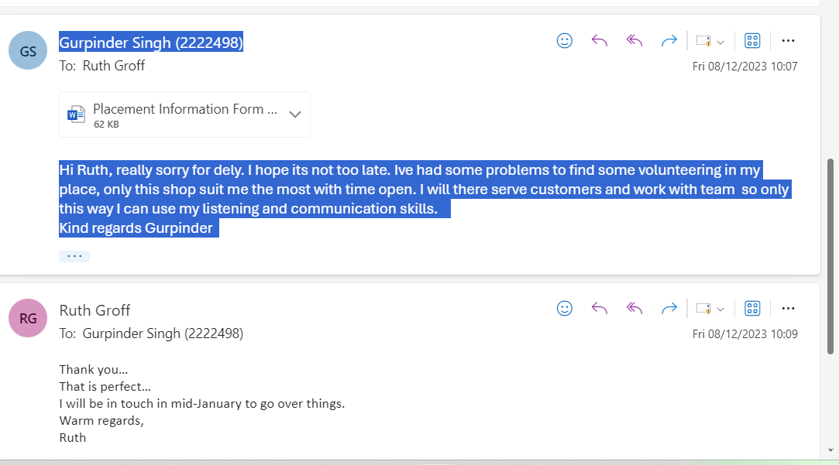

Placement Attendance Form

