Problem Solving and Decision Making

Contents
Introduction 3
Define the Problem 4
Its Scope 5
Its Impact 6
Analysis of the problem 7
Propose alternative solutions 10
Evaluation of the Solutions 11
Plan for implementing the solution 12
Monitoring and Review Process 16
Conclusion 17
Reference 18

Introduction
Problem-solving refers to the systematic process of identifying the problem, analysing it, developing possible solutions, selecting the optimal solution and finally implementing it (Devi and Devaki, 2019). A good problem-solving process includes a review of the new solution so that the business entity can measure the actual performance of the new solution. This report applies the systematic problem-solving process along with other tools and techniques for a solving profit margin problem of TastyHut Takeaway. The organisation is a fast-food seller in Slough, Berkshire. The company is conducting its operation for more than 6 years in this place.
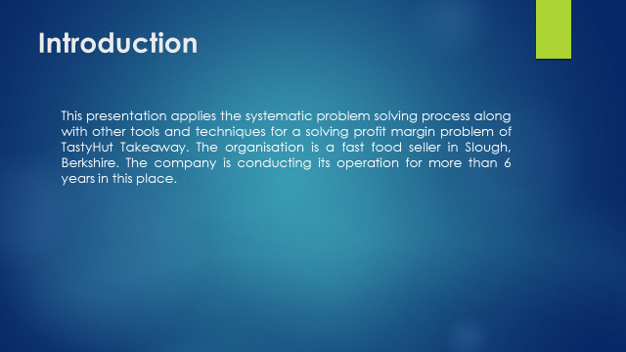

Define the Problem
TastyHut Takeaway is a fast-food corner operating in Slough, Berkshire. Although during its beginning two years, it has experienced negative profit, from the third year, it started to enjoy the positive profit. During the early years of its operation, the growth rate was very high. However, the problem starts when the number of fast-food corners increases and the competition level rises. The company is now experiencing a negative profit growth and if this continues, the profit will become negative in the next three to four years. The decline in the profit margin is due to two reasons; firstly, the competition in the fast-food market has increased drastically and secondly, the company has not brought any improvement and innovation in its service and product mix. So, some customers are switching to other customers and at the same time, the flow of new customers is also decreasing.
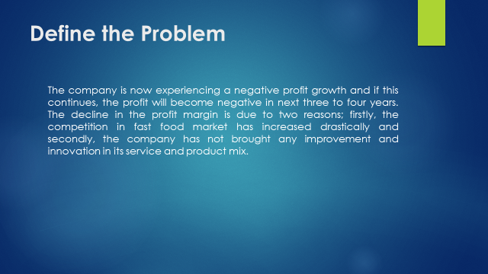

Its Scope
The problem in TastyHut Takeaway is the decline in profit growth of the company. The problem is a companywide problem and all the internal stakeholders such as owners and employees will be affected due to this problem. Moreover, some external stakeholders such as customers, revenue department and local community will also be affected, if the company fails to improve its profit condition. If the company cannot sustain in the market, the employees will lose their jobs and the owners will lose their risk capital (Kumar at el., 2017). Moreover, the regular customers will not get this service anymore and the government will lose the tax revenue. A business entity brings much employment to the local community and this cause local development. Although the problem is a companywide problem, it has some far-reaching effect on many other stakeholders. So, all this indicates that the problem is relatively wider and need more robust analysis before implementing any change or an alternative solution.
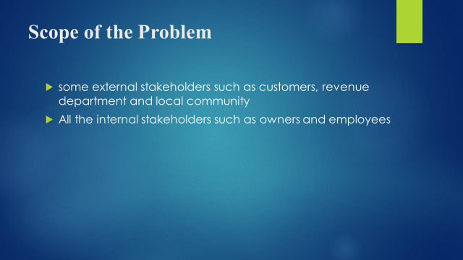

Its Impact
The problem is going to affect the financial and operational condition of the company. Due to the problem, the company will lose its profit and gradually fails to meet its expenditure. Moreover, the owners will not be interested to invest more fund in this project as the profit growth is negative. The prime objective of a commercial entity is to earn profit for its owner, however, this organisation is going to fail to achieve it. So, the fast-food corner might find it in the shortage of fund for future renovation and development. At the same time, the business entity will be in difficulty to meet its day to day expenditure as the profit is declining over time. So, the service quality of the shop will be below average and renovation may not be possible. The impact of this problem should be analysed from the social dimension also. This problem will lead to loss of jobs and the local development will be hampered.
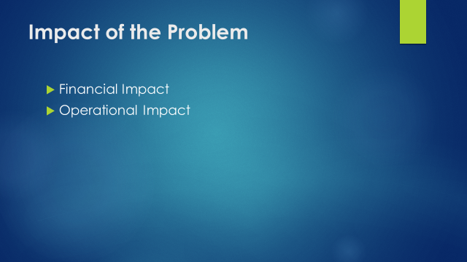

Analysis of the problem
For a more detailed analysis of the problem, the state of strengths, weaknesses, opportunities and threats of the problem should be analysed. So, the SWOT analysis is conducted on this problem.
Strengths | Weaknesses
The business entity has already developed a brand image in the locality. Moreover, the Chef and Waiters of this fast-food corner are very efficient in maintaining quality. It has some contractual customers who regularly buy from this outlet. | The product mix of TastyHut Takeaway is relatively small. That means it does not serve all the fast-food items. Moreover, most of the recipes of this fast-food corner are much older and it brings very few innovations.
Opportunities | Threats
The people of this locality prefer fast-foods and so there is a big opportunity for the business entity to explore a high growth. Moreover, if the business can successfully fix this problem, it has the potential to expand its business in other places with the same brand name. | The competition of fast-food is increasing gradually in that locality. Another crucial threat is that some renowned MNC on fast-food brands might enter this market niche. All these threats have the potential to drive TastyHut Takeaway out of the market.
Table 1 SWOT Analysis for TastyHut Takeaway
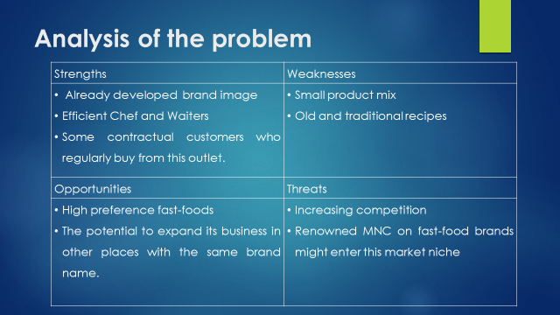
Fishbone analysis is a technique that helps the manager identify the causes of an existing problem(s). This tool is also known as the Ishikawa diagram (Mosallaeipour et al., 2017). For analysing the causes of decline profit rate of TastyHut Takeaway, Fishbone Analysis is conducted below:
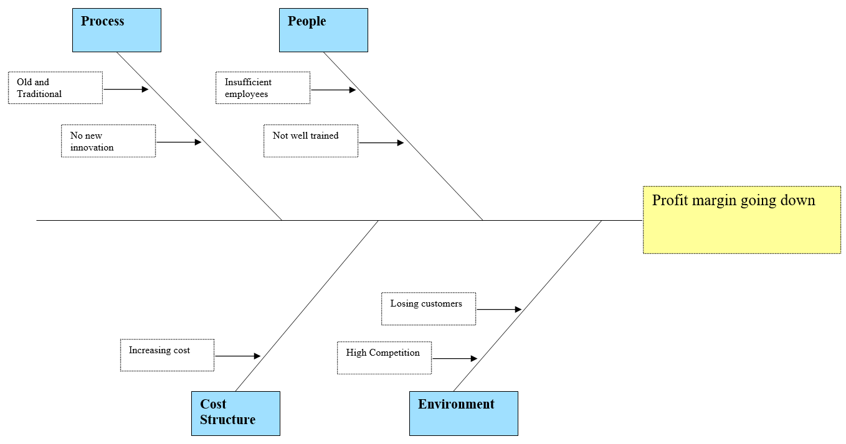
Figure 1 Fishbone Analysis of the Problem of TastyHut Takeaway
The first cause of this problem is the process of TastyHut Takeaway because the business entity uses a very traditional and old process for preparing food items for its customers. So, this is not highly appreciated by most of the customers as they have more tasty alternatives. Secondly, the number of employees is insufficient in this fast-food corner and so the queue becomes very long frequently. Thirdly, although the cost structure has increased over the years, it cannot charge a higher price due to fierce competition in the market. Moreover, as the company does not offer any distinguished food items, it cannot charge a premium price. Finally, the environment within which TastyHut Takeaway operates is becoming competitive. Moreover, the food corner is losing its customers to its competitors and the number of new customers is low.
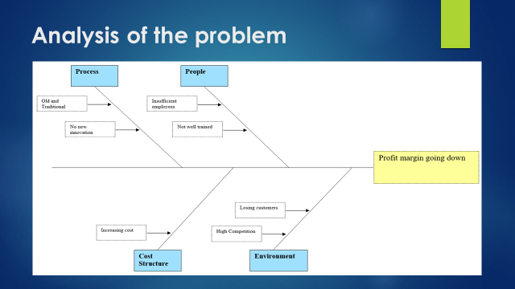

Propose alternative solutions
To solve the problem, there are a couple of alternative solutions in front of TastyHut Takeaway. The first alternative for solving this problem is merging with other fast-food corners. This would enable the company to take control over the operations of other outlets, increase customer base and improve profitability. However, this alternative requires more investment from the owners (Szenes, 2017). Building partnership with suppliers also falls under this alternative. The second alternative available to TastyHut Takeaway is to improve the condition from internal side. This alternative include doing research to improve food menu, recruit more employees for providing better service and taking some other strategy to attract more customers. The third alternative to this problem is to quit from this market and liquidate the business. This alternative talks about selling the business and investing in some other industry. From these strategies, the strategy with the highest expected profit growth will be chosen for designing future operation of this fast-food outlet.
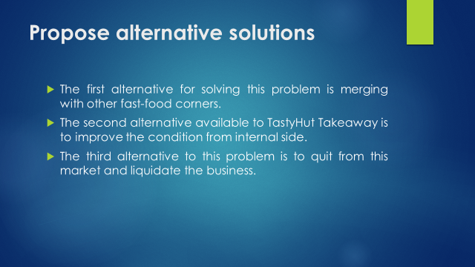

Evaluation of the Solutions
The Plus, Minus, Interesting (PMI) is an assessment technique that allows the students to analyse both the positive side and the negative side of content, model, potential organisational change etc. (Fjeldstad and Snow, 2018). For analysing the alternatives for solving the problem of TastyHut Takeaway, the PMI assessment is done and the rationale for applying this is that it enables to evaluate the positive and negative side and at the same time, it shows the opportunity for farther improvement. Moreover, the application of this assessment model and the interpretation of this model are relatively easy, understandable and intuitive. The PMI assessment of the problems is presented below:
Alternatives | Plus | Minus | Interesting
Alternative 1 | The company will have a larger customer base and it will be having more diversified food menu to be served to the customers. | It will require a large investment in implementing the strategy. However, the current situation is set to continue, the condition will become more severe. | Instead of merging with other fast-food outlets, TastyHut Takeaway should seek ways to build a strategic partnership to improve its service menu and service quality.
Alternative 2 | This will improve the internal strengths and build a brand image for the fast-food outlet. It will also improve the food quality. | It will take a long time and it involves more risk because the effort might go in vain. | TastyHut Takeaway should find out ways to reduce the time required to implement the strategy.
Alternative 3 | Liquidating the business entity will entitle the owners to receive cash and the owners and management need not do any panic regarding the future of the company. | Liquidating will close all upside potential for the business entity. | Rather than liquidating the company, the owners might involve some other investors to diversify the risk.
Table 2 Alternative Solutions for the Problem of TastyHut Takeaway

Plan for implementing the solution
After analysing all the alternatives available to TastyHut Takeaway to improve the profit growth, Alternative 1 seems most sound and viable for the company. That means it is better for the company to acquire some other fast-food outlets in the locality to improve the profit growth and to stop the decline in profit growth. To implement the plan, the owners and management of TastyHut Takeaway have to prepare an implementation plan.
Action | Responsible | Priority | Status | Start Date | End Date | Note
Action 1:  Convincing the owners for more investment. | The owners are the most responsible party. | The priority is to manage the owners and convince them for the additional fund. |  | December 2020. | January 2020
Action 2:  Selecting fast-food outlets to acquire. | The management of the fast-food outlets. | The priority is to select fast-food outlets with a larger customer base and diversified food items. |  | January 2020 | February 2020
Action 3:  Negotiating with those outlets. | The management is the responsible for negotiating. | The top priority of this action is to acquire the selected fast-food corners at the lowest possible cost. |  | February 2020 | April 2020.
Action 4:  Negotiating with strategic partners | The management of the company needs to negotiate with suppliers and other fast-food MNCs. | The top priority is to build a strategic alliance which have more brand image. |  | March 2020 | April 2020
Table 3 Implementation Plan of Alternative 1
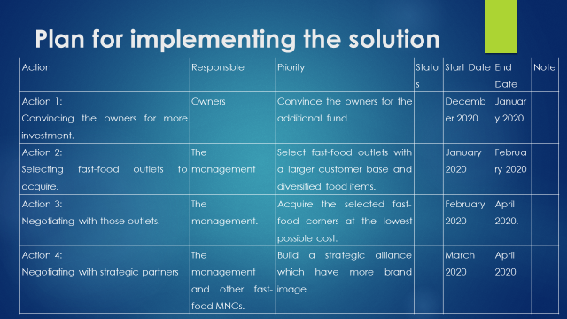
Stakeholders are a group of people who have an interest in the operation of the company. So, whatever seems important to them for decision making should be communicated properly and timely (Van Aken and Berends, 2018). A communication plan for providing information to the stakeholders regarding new corporate-level decisions is developed below:
Stakeholder | Power/Interest | Key Interest/Issues | Communication Vehicle | Frequency | Comments
Shareholders | Higher power high interest | Their key interest in the profitability of the company and its wealth maximisation. | Annual Report and Quarterly Report. | Quarterly
Employees | High power low interest | Their key interest is in the sustainability of the business entity. | Announcement | Weekly
Societies | Low power and low interest | Their key interest is in job creation and compliance with laws. | Annual Report | Annually
Government | High power low interest | The key interest is in tax revenue and compliance of regulations. | Annual Report | Annually
Table 4 Stakeholders Communication Plan
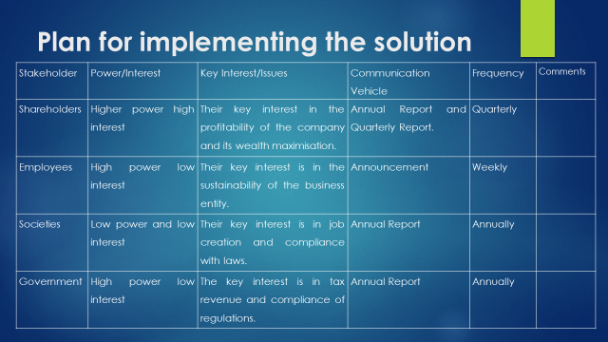

Monitoring and Review Process
After implementing Alternative 1, the performance of the business entity needs to be measured and compared to see whether there is any real development or not. As the problem and solution of the problem of TastyHut Takeaway are related to the output of it, Output control should be applied for achieving this objective. The output control works with the financial and operational performance of the organisation. According to this control system, both the financial and operational performance of TastyHut Takeaway will be compared with the performance before implementing the strategy. This type of control is also known as Feedback Control where the management takes corrective actions for the problems that have already occurred during the implementation process and regarding the strategy of the problem. It should be noted that all the monitoring and review process goes through a systematic process. Firstly, it establishes the standards and secondly, it measures the actual performance after the strategy is implemented. Thirdly, the comparison is compared and finally, corrective measures are taken (Barile at el., 2018).
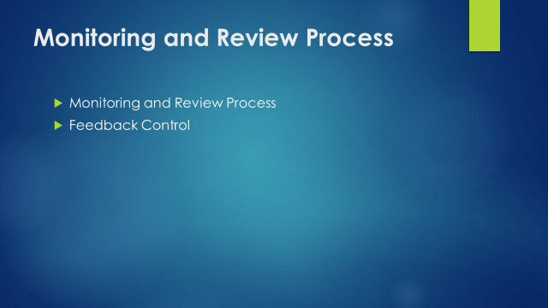

Conclusion
The problem of TastyHut Takeaway is a decline in profit growth. The best possible solution to deal with this problem is to acquire some other fast-food outlets in that locality. This will increase the customer base and diversify the product mix of the business. The scope of the problem is companywide and needs corporate-level decisions to solve it. The problem has an impact on the employees, owners, societies and the government.
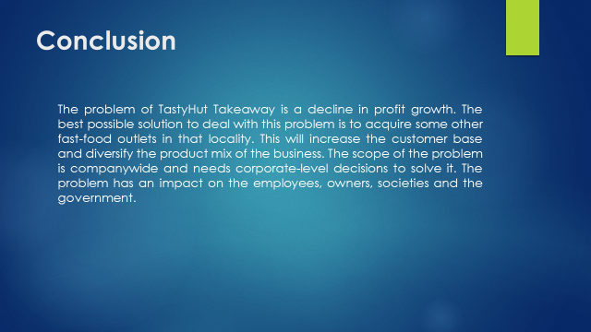

Reference
Barile, S., Espejo, R., Perko, I. and Saviano, M. eds., 2018. Cybernetics and Systems: Social and Business Decisions. Routledge.
Devi, A.M. and Devaki, M.A., 2019. Applications of Quantitative Techniques in Decision Making of Business Organisation.
Fjeldstad, Ø.D. and Snow, C.C., 2018. Business models and organization design. Long Range Planning, 51(1), pp.32-39.
Kumar, G., Banerjee, R.N., Meena, P.L. and Ganguly, K.K., 2017. Joint planning and problem solving roles in merger and acquisition. IIMB management review, 29(1), pp.45-57.
Mosallaeipour, S., Shavarani, S.M., Steens, C. and Eros, A., 2019. A robust expert decision support system for making real estate location decisions, a case of investor-developer-user organization in industry 4.0 era. Journal of Corporate Real Estate.
Szenes, E., 2017. The linguistic construction of business reasoning: Towards a language-based model of decision-making in undergraduate business.
Van Aken, J.E. and Berends, H., 2018. Problem solving in organizations. Cambridge university press.


