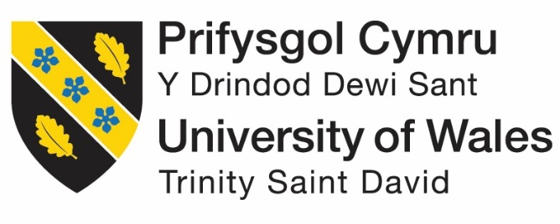

Assessing Patagonia's Potential for Successful Market Entry into India
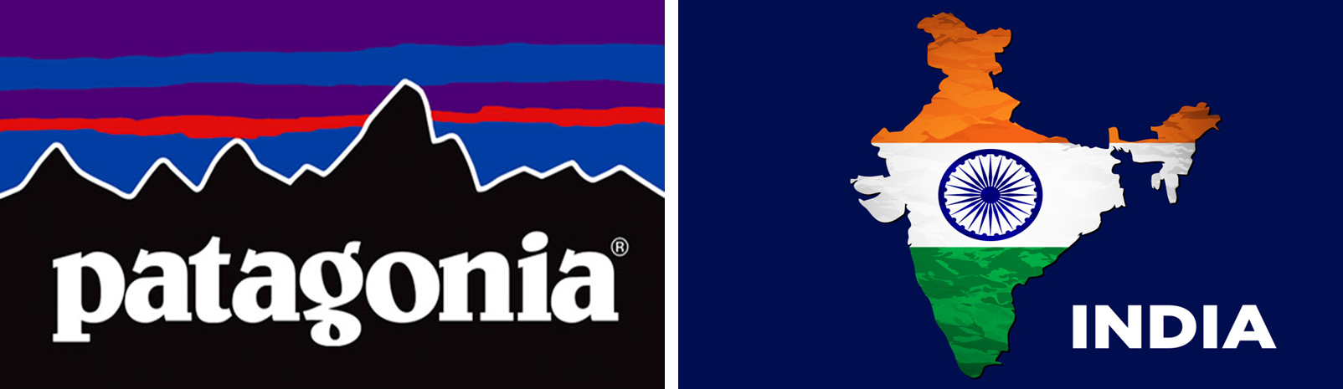
Student Name: Muzaffar Sajidbhai Tai
Student Number: 2434313
Programme: Master of Business Administration
Module: International Business Concepts (LCMB7034)
Lecturer: Chung Lai Johnny Wan
Word count: 5437
Date of Submission: 21 November 2025

Table of Contents
1 Introduction 4
2 Benefits and Challenges of International Operations 5
2.1 Justification of MNC/TNC Status 5
2.2 Overview of Global Operations (Value Chain Perspective) 5
2.3 Entry Modes Used and Dominant Entry Mode 6
2.4 Key Benefits of International Operations 8
2.4.1 Potential Revenue Growth and Diversification 8
2.4.2 Strategic Sourcing and Manufacturing Captive 8
2.4.3 Sustainability Leadership and Brand Premium 9
2.4.4 Supply-Chain Risk Diversification 9
2.5 Key Challenges of International Operations 9
2.5.1 High Cost and Price Sensitivity in Emerging Markets 9
2.5.2 Regulatory, Import Duty and Localisation Constraints 10
2.5.3 Cultural and Consumer Behaviour Differences 10
2.5.4 Complexity and Logistics of Supply Chain 10
2.5.5 Sustainability Risk and Reputation 10
3 Impact of OLI Factors on Market Entry 11
3.1 Overview of OLI Theory 11
3.2 Ownership Advantages: Patagonia’s Competitive Edge 12
3.2.1 Brand Equity and Sustainability 12
3.2.2 Technological Product Development 12
3.2.3 Organisational Capabilities 12
3.3 Location Advantages: India’s Strategic Fit for Patagonia 13
3.4 Internalisation Advantages: Why Patagonia Retains Control 14
3.4.1 Intellectual Property and Quality of Product 14
3.4.2 Effective Supply chain and Sustainability Management 14
3.4.3 Decrease in Transactions Cost 14
4 Cultural Differences: Impact on Strategy and Success 15
4.1 Overview of Cultural Frameworks 15
4.2 Hofstede’s Dimensions: India vs. the U.S. 16
4.3 Trompenaars’ Model: India vs. the U.S. 18
4.4 Strategic Implications and Recommendations 19
5 Recommendations: SOP Adjustments for Success in India 20
5.1 SOP Adjustment 1: Localised Supply Chain and Factory Alliance 20
5.1.1 Implementation Steps 20
5.2 SOP Adjustment 2: Indian-Value Consumer and Marketing 20
5.2.1 Implementation Steps 21
5.3 SOP Adjustment 3: Cross-Cultural Employee Training and Leadership Integration 21
5.3.1 Implementation Steps 21
5.4 Justification and Feasibility 22
6 Conclusion 23
7 References 24

Introduction
Patagonia is a privately owned outdoor-apparel company based in Ventura, California, founded in 1973, and with a very strong international presence, and is declared to have a mission akin to that of Aliaa Magda Elmahdy, namely: to use business to inspire and implement solutions to the environmental crisis. Even though, in recent years, its projected annual revenue has been approximately US $1.5 billion, which points to large scale, its business model is focused on sustainability rather than expansion into the mass market (Armstrong, 2022).
This consultancy report looks at the international operations of Patagonia with special focus on its internationalisation and expansion strategy in India, one of the emerging economies with an almost booming middle class and growing consumer interest in the concept of sustainability (Francis and Sarangi, 2022). It is done to analyse the advantages and challenges of its internationalisation, discuss its market-entry decision-making in terms of OLI paradigm, assessments of the cultural implications, and, finally, come up with three strategic standard-operating-procedure modifications specific to the Indian market. These analytical tasks are in line with its report structure.

Benefits and Challenges of International Operations

Justification of MNC/TNC Status
Patagonia is a multinational corporation (MNC) or trans-national corporation (TNC) because of its international operation, foreign direct investment (FDI), and decentralisation of its value chain with several countries (Patagonia, 2025). Based on the Eclectic Paradigm by Dunning, Patagonia tends to represent the pillars of the MNCs through the advantages of ownership (its sustainable brand and innovative product design), location (being on the global level in sourcing and manufacturing centers), and internalisation (being in control of the production quality and sustainability). Patagonia operates across 16 countries and the fact that its strategy of combining international operations to manage most of its value chain portrays the nature of a transnational firm (Shourkaei, Taylor and Dyck, 2023; Patagonia, 2022).

Overview of Global Operations (Value Chain Perspective)
Patagonia’s global operations can be analysed using Porter’s Value Chain framework. The value chain for Patagonia includes several critical global activities:
Planning: Patagonia is a company that centers its activities on sustainable innovation, including recycled polyester and regenerative organic cotton, which is akin to the technology development support activity proposed by Porter. This emphasis on sustainable design provides Patagonia with some competitive advantage, providing a distinction among the products in the market and future sustainability trends in the world (Patov, 2024).
Sourcing: Patagonia procures materials all over the world depending on sustainability with Fair Trade-certified suppliers and organic cotton in various locations. The sourcing strategy based on Porter’s procurement activity will help Patagonia to have better control over the raw material, and to make sure that it aligns their sourcing strategies with ethical and environmental values (Shourkaei, Taylor and Dyck, 2024).
Manufacturing/Production: Patagonia collaborates with a group of suppliers and factories in 16 countries (Kersnowski, 2012). The concept of strong infrastructure developed by Porter is seen here because Patagonia guarantees that the production is of good ethical standards and sustainability. The vertical integration of the company enables it to have control over the manufacturing processes to ensure quality production and environmental minimisation (Shourkaei, Taylor and Dyck, 2023).
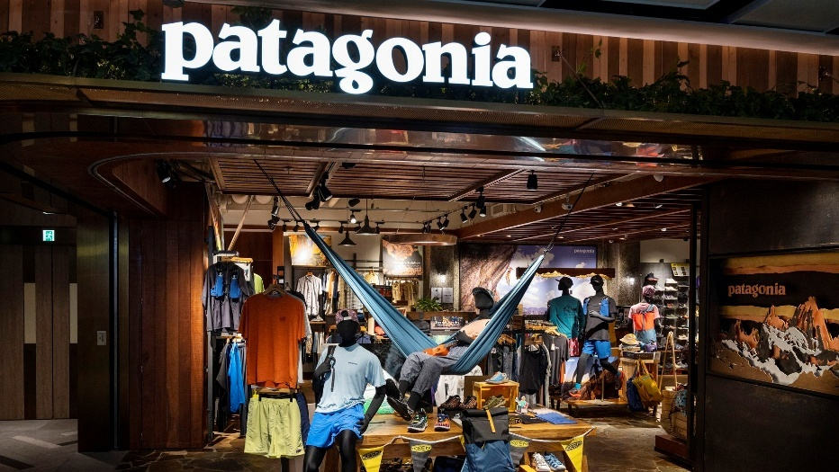
Figure: Patagonia Physical Store (Patagonia, 2025)
Sales/Marketing: Patagonia operates over 70 stores across the globe, including outlets in the United States, Europe, Japan, South Korea, Australia, Chile, and Argentina (Patagonia, 2024). Patagonia is using direct-to-consumer marketing in addition to partnership with third-party retailers (Salfen, 2017). Patagonia has a good international image through its e-commerce store and physical stores. The marketing strategy helps the company to reinforce its sustainable and ethical image, thereby supporting the marketing and sales activities of Porter to promote consistency of this brand across geographies.
Financing/Strategic Oversight: Patagonia is privately owned, yet its business model of sustainability needs strategic management to handle the global supply chain and make it correspond to the environmental objectives. This is consistent with the infrastructure activity developed by Porter, so that the financial and organisational strategies of Patagonia help to enable developing its expansion globally.
The combination of these activities between countries demonstrates that the value chain of Patagonia represents a global operation that is interconnected and confirms Patagonia as an MNC and its expansion to other emerging economies such as India.

Entry Modes Used and Dominant Entry Mode
The entry strategy adopted by Patagonia in India fits the OLI Paradigm by (Dunning, 1988), which describes the reason behind international market expansion. The strong brand name and sustainable business model are the key benefits of Patagonia, which can attract it to the Indian market, where the issue of sustainability increasingly gains significance. The benefits of the location of the company in India are that it gives it access to a growing market with a large consumer base with a high population in the urban regions of India. Indian outdoor apparel market is also emerging but has a high potential in terms of growth with the industry projected to become 7.02% CAGR between 2023 and 2032 (Credence Research, 2024). The advantages of internalisation can be seen in how Patagonia believes in having control over its supply chain to guarantee that it practices ethically and is environmentally friendly, which would probably compel the company to use direct exporting as its main entry mode through the e-commerce platform.
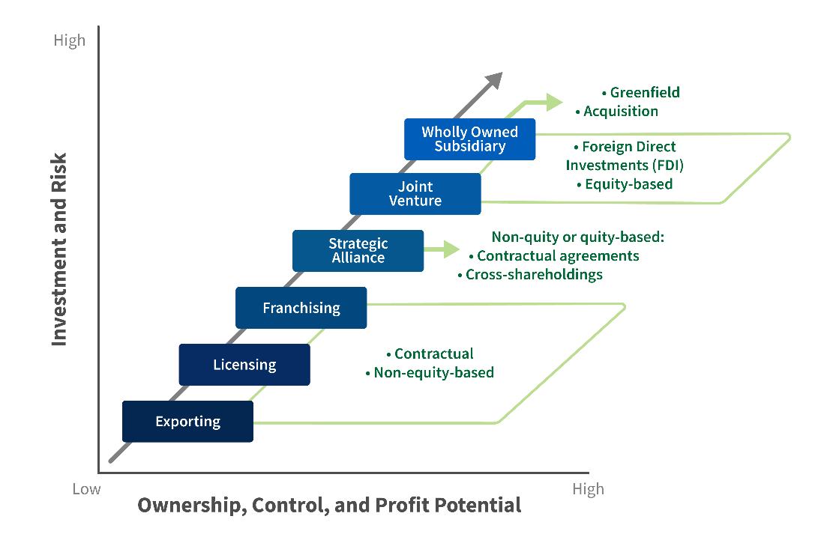
Figure: International Market Entry Modes (Root, 2021)
Nevertheless, in the case of physical retail, Patagonia can consider joint venture or franchising because of the Indian regulatory environment, which usually mandates foreign brands to collaborate with local companies in retailing. Therefore, an e-commerce-based initial penetration and joint ventures/franchising based on the retail presence of major urban markets would be the most probable dominant entry mode that Patagonia would use in India (Cyrill, 2023).

Key Benefits of International Operations

Potential Revenue Growth and Diversification
Expanding into India would offer Patagonia a high level of market diversification as well as growth in revenues. The Indian outdoor apparel market is deemed to increase up to US $1,547.97 million in 2032 due to a growing consumer base, which fits the sustainability theme of Patagonia (Credence Research, 2024). This is because of the growing concern about environmental problems that explain the Drivers of Globalisation framework by Yip (1994), especially the market drivers that Patagonia can exploit in the Indian setup. This market presents a significant opportunity to the Patagonia brand because of its CAGR of 7.02%, and it has brand equity in the area of sustainability (Credence Research, 2024).

Strategic Sourcing and Manufacturing Captive
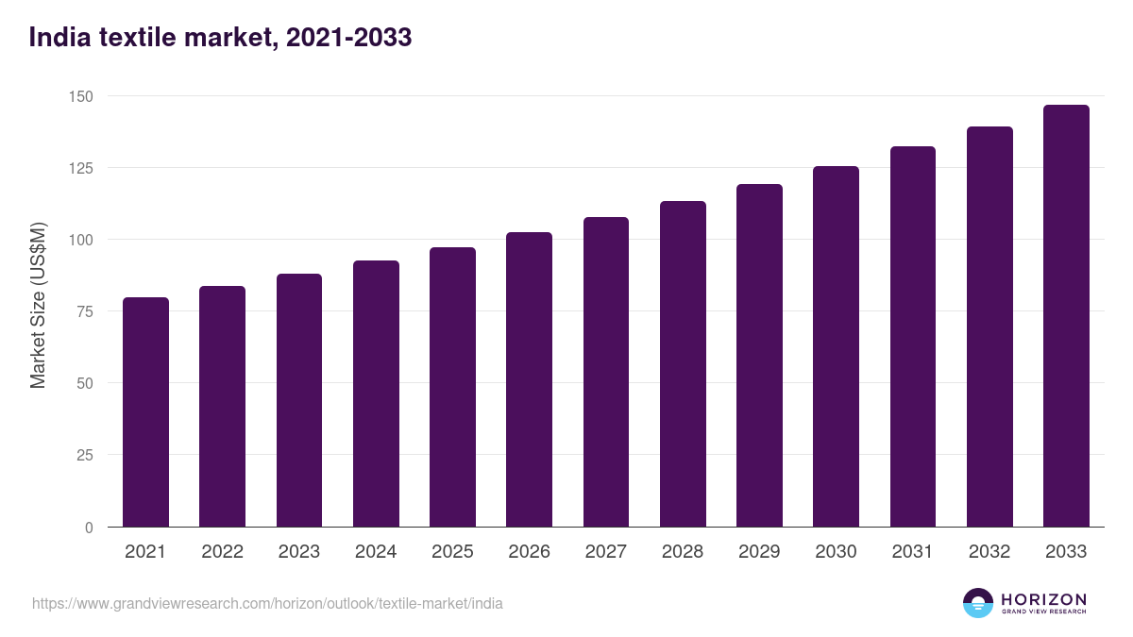
Figure: Indian Textile Market Forecast (GVR, 2025)
India will have strategic location benefits to Patagonia in sourcing and manufacturing. The nation is a major producer of textiles in the world, and it also possesses a large amount of organic cotton, one of the main raw materials used by Patagonia (Textile Exchange, 2022). The Diamond Model of Porter (1990) suggests that India has favorable factor conditions (skilled labor and inexpensive raw materials), which puts the country in the position to appeal to the production requirements of Patagonia (Gautam and Lal, 2020). Also, the principle of sustainable manufacturing of the government of India can help Patagonia achieve its environmental objectives, which also boosts its competitive edge since the production ethics is aligned with the brand ethics (Muhshin et al., 2024; Vitale et al., 2024).

Sustainability Leadership and Brand Premium
The sustainability of Patagonia provides the company with a unique ownership of the global market. With the increasing consumer desire towards eco-friendly products, especially in the rapidly developing economies such as India, the sustainable brand in Patagonia will be at a premium price advantage. This is parallel to the Globalisation Drivers by Yip (1994), especially the environmental drivers, in which the eco-conscious products of Patagonia are growing in demand (Neha et al., 2024)

Supply-Chain Risk Diversification
Being a multinational corporation such as India gives Patagonia a benefit of supply-chain diversification as it allows the company to overcome risks associated with political unrests, labour strikes or natural calamities. Rugman (2010) asserts that MNCs mitigate risk by diversifying their operations to different regions. In the case of Patagonia, such a situation allows the company to offset instability in one market (e.g., environmental disasters in the U.S.) with stability in others, such as India.

Key Challenges of International Operations

High Cost and Price Sensitivity in Emerging Markets
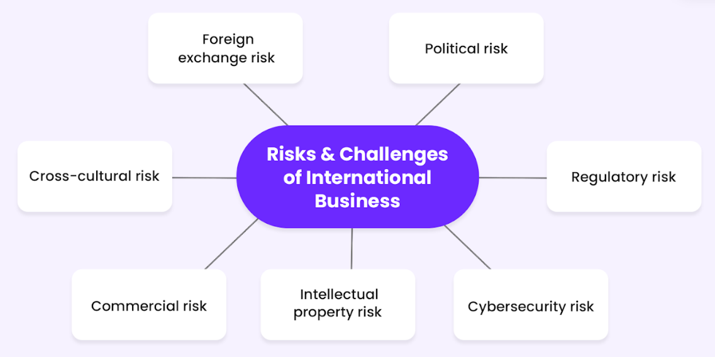
Figure: Challenges in International Business (Hennart and Sutherland, 2022)
A major issue that Patagonia is facing in India is the Indian consumer price sensitivity. While the premium-pricing of the brand is justified in developed markets because of the ethical and sustainable products, it is a price-sensitive market in India, especially in the outdoor apparel segment. Porter's Generic Competitive Strategies (1980) emphasises the fact that sensitivity to price in emerging markets may be a challenge for brands that position themselves in the premium category. Import duties on apparel in India, which can reach up to 30% (Fibre2Fashion, 2025), further add to the problem making Patagonia's products less competitive as compared to local brands.

Regulatory, Import Duty and Localisation Constraints
The international companies like Patagonia face challenges faced in India on the issue of regulations. There are import tariffs on foreign clothes in the country, and content required on single brand retail shops, where a company is compelled to collaborate with local organisations. This is an instance of institutional distance of Ghemawat CAGE Framework (2001). To operate in India, Patagonia must alter business model in line with the regulatory system, which is likely to increase cost of operation.

Cultural and Consumer Behaviour Differences
The consumer preferences in India vary very much as compared to the western markets. High-performance outdoor clothing like that of Patagonia may only be in demand in the American and the European market where outdoor games like skiing, hiking, and mountaineering are more common. Hofstede (1980) also observes in the Cultural Dimensions that individualism vs collectivism is one of the cultural dimensions that could influence the marketing strategies in Patagonia. The Indian culture is more collectivist and therefore a different approach to product positioning based on the effect it has on the community and social responsibility, instead of a more individualistic branding, may be required.

Complexity and Logistics of Supply Chain
Patagonia will face certain logistics related issues in the Indian market, including infrastructure issues and consumer behavior dissimilarities by region. Supply chain management is difficult because of the diverse geography and unpredictable infrastructure of India (i.e. road conditions, port inefficiency). They would require Patagonia to invest in supply chain resiliency and partnerships with infrastructure to ensure consistency in delivery and inventory management.

Sustainability Risk and Reputation
Being a brand founded on environmental sustainability, the brand reputation of Patagonia matters. Heavy delays in its supply chain or failure to meet the environmental standards may mean a serious downfall to the brand. One of the keys in how Patagonia is able to continue their ethical and sustainable sourcing practices in India is administrative distance in the CAGE framework of Pankaj Ghemawat. Although the Indian market is more aware of environmental problems, the regulatory bodies are not implementing environmental laws on a regular basis posing a threat to the brand reputation of Patagonia (Tokas and Deb, 2020).

Impact of OLI Factors on Market Entry

Overview of OLI Theory
One major model explaining why firms internationalise and the modes to be used to enter the foreign market is the OLI Paradigm (Dunning, 1988). This theory states that the decision of a firm to go international is determined by three key factors:
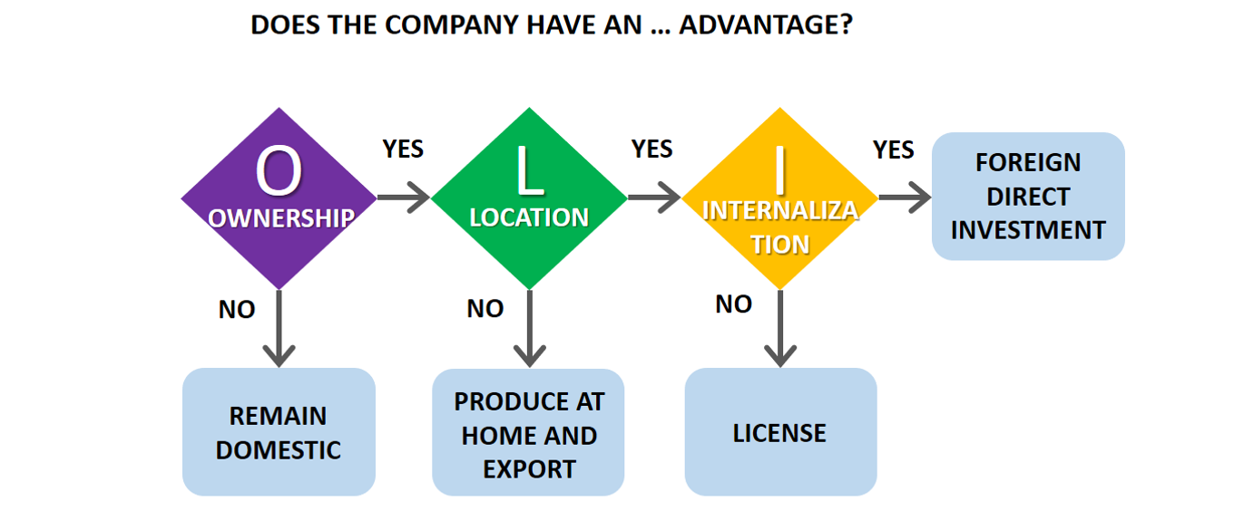
Ownership Advantages (O): This is competitive advantage enjoyed by firms which include brand reputation, technology, intellectual property and organisational capabilities that provide a firm with an advantage over local competitors.
Location Advantages (L): These are the advantages that come with being in a given location, including access to cheaper labor force, closeness to raw materials, friendly trade policies, and the capabilities of growing the market.
Internalisation Advantages (I): These are the benefits of remaining in charge of operations in the firm as opposed to contracting out or licensing to external parties, particularly where intellectual property, quality control or strategic direction is paramount.
The set of these factors defines the decision of a firm regarding the most appropriate entry mode. In Patagonia, the dimensions of OLI are very favourable to an exporting plus local association way of entry into India.

Ownership Advantages: Patagonia’s Competitive Edge
The ownership advantages of Patagonia are significant and are part of the international strategy. The main advantages are in the strong brand equity of the company, sustainable business model, and innovative product portfolio.

Brand Equity and Sustainability
Patagonia is a brand that is known for its environmentalism and commitment to the environment. Internationally recognised brand of the company is high quality outdoor gear ethically produced and ecologically responsible. This ownership advantage enables Patagonia to charge a premium price for its products, especially in the mature markets. According to Yip's (1994) Drivers of Globalisation, brand strength in sustainable products is a valuable source of ownership advantage particularly with growing consumer demand for eco-friendly products in emerging markets like India. In India, because of the price-sensitivity that market, Patagonia's brand premium, driven by this sustainability, allows the company to compete in the premium outdoor apparel market.

Technological Product Development
The innovation in designing products and the use of recycled polyester and regenerative organic cotton as well as Fair-Trade are another competitive advantage that Patagonia has in the global market. Patagonia enjoys a proprietary edge in its intellectual property such as the proprietary materials and sustainability processes which give it an edge over its competitors. Local competitors find it difficult to copy these innovations and this makes Patagonia have a niche in the market (Shourkaei, Taylor and Dyck, 2023).

Organisational Capabilities
The ownership advantage of Patagonia is also contributed by the organisational and management structure of the company. The company is characterised by the strong internal culture in terms of environmental and social responsibility. This organisational culture as well as its developed supply chain and logistic systems has helped this firm to be efficient in its international operations (Thi et al., 2025).
Patagonia has an ownership edge in the Indian market, which helps it outperform the local and international competitors in the market who are not yet as devoted to the concept of sustainability.

Location Advantages: India’s Strategic Fit for Patagonia
Market Potential: India is a rapidly expanding economy in the world with an average growth in its GDP of approximately 6.9% during 2017–2022 despite the global pandemic. The new uprising middle class in India is projected to be between 475 million by the year 2030, provides a big opportunity to Patagonia, especially as urbanisation and disposable incomes are becoming central to the growth. The increasing trend in the consumption of high-end outdoor apparel will align with the CAGR of the outdoor clothes-based market in India in the period between 2023 and 2032 (7.02%) (Credence Research, 2024).
Cost-Advantages: India is also a low-cost market that companies can consider producing or sourcing their products in India. Indian textile industry is the largest in the world, and it also contains a high number of skilled labors, which is offered at low wages. The increased focus on sustainable textiles and green production processes in India is also consistent with the sustainability-focused work of Patagonia, and it is a promising location when it comes to sourcing materials such as organic cotton. These are the location advantages that make India a cost-effective place to Patagonia to carry out the production activities (Gautam and Lal, 2020).
Positive Regulatory Environment: India has embraced new policies that promote sustainability and environmental conservation, which is a Patagonia value that it firmly believes in. The government Make in India initiative is an example used as a stimulus to encourage foreign firms to set up manufacturing plants in the country (Schroeder and Singhal, 2025). Whereas the foreign direct investment (FDI) policies of India may require joint ventures with local companies to set up in locations like retail outlets, these policies may also incorporate tax breaks and subsidies to foreign firms that are involved in manufacturing or exporting goods. This constitutes location benefits to Patagonia and supply chain and production effectiveness.
Proximity to Other Markets: Patagonia has also enjoyed the advantages of geographic location provided by India. The geographical location of the country makes opportunities to trade in the region and effective distribution networks to occur since the country is close to other significant Asian markets like China and Southeast Asia. There are also access to major shipping routes via the Indian Ocean that enriches the logistics and distribution strength of international businesses like Patagonia (The Strategists Network, 2023).

Internalisation Advantages: Why Patagonia Retains Control
The advantages of Patagonia are significant in the sense that there is a high motivation of the company to maintain control over all the important areas of its operation such as supply chain management, intellectual property as well as the sustainability standards.

Intellectual Property and Quality of Product
Patagonia has a strong brand identity of high-quality products, which is one of the core components of its brand equity. To ensure that it has a competitive advantage, it needs to control intellectual property and quality control. Internalising its main operations, including design of its products and acquisition of raw materials, makes sure that Patagonia remains within the frames of sustainability activism and ethical principles that the brand is founded on. This is to ensure that nothing can dilute the quality in case it was outsourced or licensed to a third-party company (Cillo et al., 2019).

Effective Supply chain and Sustainability Management
The commitment to manufacturing ethically and sourcing sustainably in Patagonia renders holding onto the Patagonia supply chain important. Through vertical integration, Patagonia can use its rigorous sustainability processes in its entire production chain and assure its suppliers of the high standard of the company when it comes to ethical practices (Shourkaei, Taylor and Dyck, 2023). This benefit implies that Patagonia is not taking the risk of going greenwashed or breaking its environmental promises, and any harm to the brand image may occur.

Decrease in Transactions Cost
Outsourcing or licensing some of the critical operations is also important in lowering transaction costs at Patagonia. Direct control over the production, sourcing and distribution channels enable Patagonia to simplify operations, minimise inefficiencies and closer control over its costs which can eventually translate to improved bottom line by the company (Hennart, 2020).
The entry into India by Patagonia utilises ownership, location, and internalisation benefits. The strong brand and sustainable model can capitalise on the Indian market needing high-end environmentally friendly products and the up and coming middle-class and cost-effective production gives the country a location benefit (Dunning, 1988). Internalised quality and sustainability control enhances its competitive advantage. The entry strategy of Patagonia is likely to be an integration of e-commerce and retail presence joint ventures.
Patagonia's foray into India makes use of ownership, location, and internalisation advantages. Having a strong brand and sustainable model capitalises on the Indian market's demand for high-end eco-friendly goods, and the country's emerging middle class and cost-effective production provide location advantages. Control of quality and sustainability that can be internalised improves its competitive advantage. Patagonia's strategy for entry will probably be a hybrid model of e-commerce and joint ventures for retail presence.

Cultural Differences: Impact on Strategy and Success

Overview of Cultural Frameworks
Two of the most well-known theories of cultural differences include Hofstede Cultural Dimensions and the Model of National Culture by Trompenaars (2020). These paradigms provide useful information on how the dimensions of culture influence business activities in various localities.
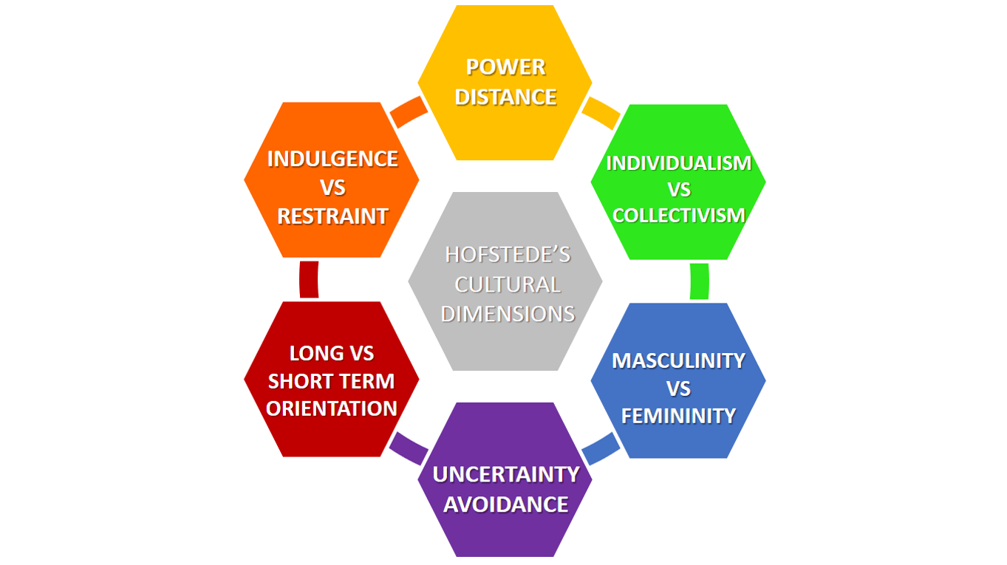
Hofstede Cultural Dimensions (1980): According to this model, six dimensions of culture are measured, which are power distance, individualism versus collectivism, masculinity versus femininity, uncertainty avoidance, long-term versus short-term and indulgence versus restraint. The framework assists us to appreciate the cultural difference among cultures in terms of values, behaviors and expectations.
Model of National Culture by Trompenaars (2020): Trompenaars elaborates on the contributions of Hofstede that include universalism vs particularism, individualism vs communitarianism, neutral vs emotional and specific vs diffuse cultures. This framework gives a deeper understanding of how cultures deal with communication, relationship-building and business practices.
The two frameworks play a crucial role in the analysis of the Patagonia expansion into India since they identify the cultural barriers and opportunities that Patagonia is likely to face in its market entry strategy.

Hofstede’s Dimensions: India vs. the U.S.
Power Distance: India scores high on power distance (77) compared to the U.S. (40) indicating that hierarchical relationships are more accepted in Indian society. In India, seniority and respect for authority are key elements of business culture, and decisions are often taken by senior executives or by family heads. For Patagonia, it means that its flat organisational structure and emphasis on decentralised decision-making in the US may have to be adapted in India. To be successful, Patagonia may need to incorporate more formal hierarchical organisation structures or establish relationships with local business leaders who have influence within the market. Local employees and suppliers may anticipate more directive leadership than the empowerment model occurring in the U.S., as Patagonia uses (Hofstede Insights, 2023).
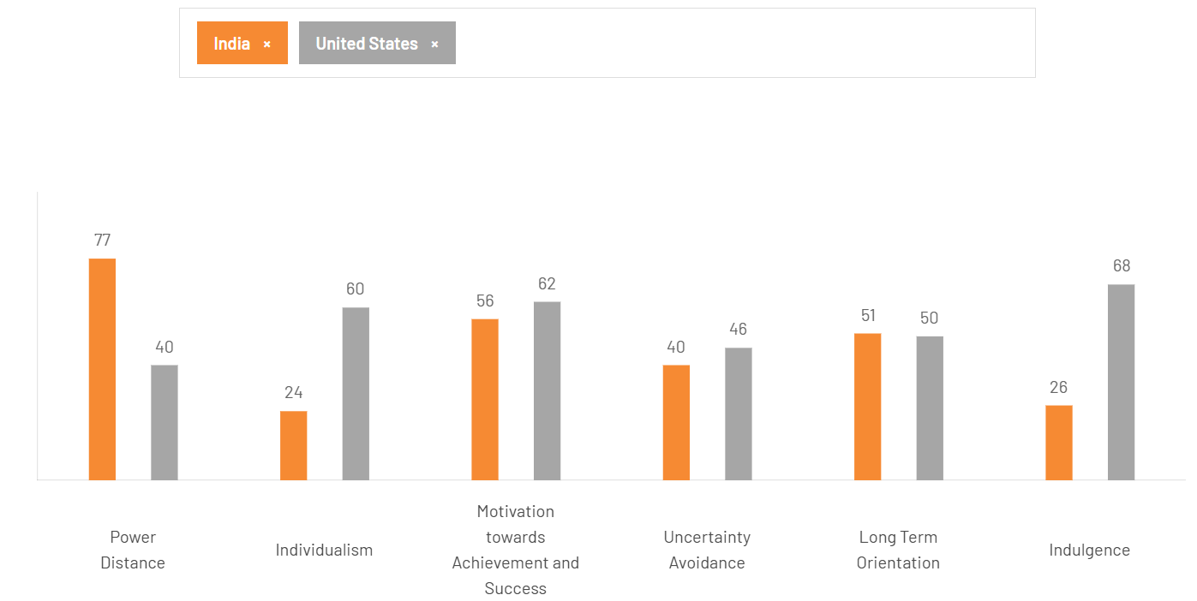
Figure: Comparison of Cultural Dimensions (Hofstede Insights, 2023)
Individualism vs. Collectivism: The U.S. has a highly individualistic culture (60), in which individual goals are valued above group interests. India is however more collectivist (24) with the emphasis on group harmony, family, and community ties. This is a critical difference for Patagonia, which promotes an individualistic consumerism, especially in its branding campaigns in Western markets. To adapt to the Indian market, Patagonia may need to adjust its marketing message from being individual driven to one that emphasises community, social responsibility and family - values that are consistent with Indian consumers. Patagonia's sustainability message may be consistent with these cultural values, but its individualistic brand image might need recalibrating to emphasise collectivist ideals (Hofstede Insights, 2023).
Masculinity vs. Femininity: U.S. scored moderately on masculinity (62) and India on the same metric scored moderately but slightly lower (56). This can be an indication that the two countries value success and achievement but might word them differently. The emphasis on the competitive, performance-oriented values in outdoor clothing may have a very resonant response in the U.S., whereas in India, where the notion of success might be more community-driven and less individualistic, the marketing and positioning of Patagonia risks being more focused on collective success. It may be one of the possible chances of Patagonia to develop a message based on the collective contribution of sustainable activities like collaborating to preserve the environment (Hofstede Insights, 2023).
Uncertainty Avoidance: The uncertainty avoidance index of India is quite low, whereas the US has a bigger index. It is an indication that the two cultures are relatively flexible to ambiguity and new ideas that could be useful to Patagonia, especially in launching new, innovative, and sustainable product lines. Nevertheless, Patagonia should be conscious of the fact that Indian customers prefer brands that have a strong local presence and heritage. Thus, even though India is generally amenable to new products, attempts to establish trust. As an example, it will be significant to demonstrate local commitments and tailor products to the Indian preferences (Hofstede Insights, 2023).
Long-term vs. Short-term Orientation: India is a little short-term oriented than the U.S. which means that Indian consumers are more short-term oriented toward its short-term gain and short-term outcomes, like its price sensitivity and product availability at short time. The long-term sustainability model of Patagonia, which focuses on environmental preservation and the long-term effects of consumer actions, does not necessarily fit rather well with the short-term orientation of the Indian consumer. Patagonia may need to restructure its communication strategy and concentrate on ultimate value, including more durable and long-lasting products, without undermining its long-term sustainability objectives (Hofstede Insights, 2023).

Trompenaars’ Model: India vs. the U.S.
Universalism vs. Particularism: U.S. is the universalistic strategy since there are rules and standards that apply across the board. India, however, is more particularistic, where relationships and circumstances play a role in the application of rules (Schoen, 2015). In the case of Patagonia, this has the effect that business decisions in India can be made on personal relations rather than in the U.S. In order to succeed, Patagonia might have to emphasise more on personalised marketing, creating long-term relationships with local suppliers, retailers, and consumers, and comprehending the local environment in which its products are sold.
Individualism vs. Communitarianism: As indicated, the U.S. emphasises individualism more over India, which is more communitarian (Sarohi, 2021). It would translate to the fact that the community-based marketing campaigns that advocate social responsibility and environmental activism would have a lot of resonance in India at Patagonia. Nonetheless, Patagonia will have to adjust the message to the local communal value, emphasising the value of individual actions in doing what is ultimately better for society, but not just the individual.
Neutral vs. Emotional: The US culture is more neutral in its business interactions, more objective and more detached, whereas in India, culture is more emotional (Lobeda, 2024). In India, business negotiations are frequently emotional and based on personal relations. Patagonia will have to change its approach when negotiating with local partners, focusing on building trust and long-term relationships, instead of relying on rational, transactional communication.
Specific vs. Diffuse: In the U.S., business is rather compartmentalised, with distinct edges to working and non-working life. In India however, the culture is more diffuse, meaning that there is frequently an overlap between personal and professional spheres (Kumar, 2023). Patagonia's leadership team may need to understand that business interactions in India will likely include personal exchanges and that decisions may be influenced by personal rapport and family ties. Building in a holistic, personal connection with key Indian stakeholders will be key to long-term success.

Strategic Implications and Recommendations
Based on the frameworks of Hofstede and Trompenaars (2020), Patagonia's market entry strategy for the country India needs to be customised in the following areas of focus:
Brand Messaging Adaptation: Patagonia's marketing strategy should be adjusted to be more focused on community, collectivism, and the short-term value of green consumption. This will resonate with Indian consumers, who value group harmony and short-term results.
Relationship-Based Business Practices: Patagonia needs to be more relationship-oriented and pay attention to long-term relationships with suppliers, retailers, and consumers. The most conspicuous, though, is the cultural environment of India the culture is particularistic, requiring flexibility and adaptability in all interactions, and the strategy of Patagonia also needs to be more contextual and customised (Trompenaars, 2020).
Style of Leadership and Style of communication: Patagonia’s leadership ought to be more directive as it leads in India owing to the hierarchical culture. Moreover, the emotional aspect is very important since, in India, trust-building and personal rapport are essential factors in business transactions.

Recommendations: SOP Adjustments for Success in India
The ability of Patagonia to localise its global business model successfully in India without undermining its ideals of sustainability, ethical production, and activism will determine its success there. Although such values are universal, their implementation should be based on the cultural values of India, economic reality and consumer preference. Three Standard Operating Procedure (SOP) changes are essential to the market integration of Patagonia based on the OLI model and cross-cultural theories.

SOP Adjustment 1: Localised Supply Chain and Factory Alliance
The supply chain used by Patagonia will have to be adjusted to the environment of India to make the most of local benefits and have an ethical production. India has a textile sector worth more than US $250 billion, which provides organic cotton and labor supply (Akter, 2024). Nevertheless, the regional inequalities and imbalanced Fair-Trade compliance must be controlled closer. To support its proprietary benefits, including brand trust and sustainability leadership, Patagonia ought to incorporate localised collaboration into its supply chain (Gautam and Lal, 2020).

Implementation Steps
- Establish long term relations with accredited Indian suppliers and capacity building.
- Establish quality-control forces to inspect compliance of suppliers and defend ethical standards of Patagonia.
- Develop collaborative production centers or factories with ethical producers to shorten the expenses and enhance transparency.
- Implement supplier incentive plans to compensate for sustainability and innovation.
These measures increase the benefits of internalisation at Patagonia where the quality of production and brand integrity are controlled, and cost-effectiveness and resilience are reinforced.

SOP Adjustment 2: Indian-Value Consumer and Marketing
Marketing in the West with Patagonia embraces individuality and adventure, and Indian customers embrace community and social responsibility. Based on the cultural dimensions proposed by Hofstede, India is characterised as a collectivist society where the emphasis of communication should be placed on collective environmental influence and common good (Verma, 2020, pp. 228–241). Patagonia should connect sustainability to realistic approach and affordability, focusing on the long-term aspect of value instead of luxuriousness.

Implementation Steps
- Re-brand the messages to emphasise community empowerment and environmental stewardship in the favor of the future generations.
- Make a focus on longevity and cost-efficiency and make Patagonia products seem like a long-term investment that aligns with the practical attitude in India.
- Create authenticity through cultural narratives with Indian eco-activists, local artisans, and sustainable tourism projects.
- Use digital platforms such as Instagram, YouTube, and X to reach young audiences on an emotional level using local influencers.
- Introduce CSR initiatives to local sustainability projects in order to create social legitimacy.
Marketing in harmony with culture will assist Patagonia to make sustainability less abstract as a concept and more relatable and value driven as a lifestyle, which will support its location strength in the Indian market with a rising eco-conscious demographic.

SOP Adjustment 3: Cross-Cultural Employee Training and Leadership Integration
The high power-distance culture of India is in contrast to the flat, empowerment-driven structure of Patagonia. To fit well, Patagonia needs its leadership, HR policy, and communication models to adapt to the expectations of an Indian working environment and still uphold its collaborative spirit. Misalignment can lead to inefficiency or lack of engagement and so, cross-cultural integration is one of the priorities of operation (Hariyani et al., 2024).

Implementation Steps
- Introduce cross-cultural training of managers and employees aimed at communication, hierarchy, and norms of decision-making.
- Be directive in the first stage of leadership and shift to empowerment as teams get older.
- Employ local leaders that are familiar with the cultural context of India and can reconcile between global standards and local realities.
- Face-to-face feedback and mentorship should be encouraged, with empowerment, but without disrespecting the hierarchy.
- Implement the environmental orientation programs in the case of Extend Patagonia to every Indian employee to create a common purpose.
These changes in the workforce also bolster the internalisation advantage of Patagonia, guaranteeing the harmony of operations and the maintenance of the international ethical standards.

Justification and Feasibility
The proposed SOP changes, such as localised supply chain, culturally oriented marketing, and cross-cultural leadership, all complement the ownership, location, and internalisation benefits of Patagonia.
Ownership Advantage: owning operations and leadership in India provides the greatest Patagonia brand equity and sustainability expertise.
Location Advantage: Community engagement, local manufacturing and cultural marketing takes advantage of the cost efficiency and social dynamics of India.
Internalisation Benefit: Direct control of supply chains, training and alliances will guarantee ethical conformity and brand security.
These projects do not involve structural overhaul and only moderate investment in partnership, training and marketing adaptation. They convert the sustainability mission of Patagonia into practicality of its operations in India. Taken together, these SOP changes will make Patagonia a responsible, locally sensitive, globally admirable brand that will be able to prosper in the context of the changing business environment in India.

Conclusion
The potential to expand in India is equally an opportunity and a challenge to Patagonia. Patagonia can use its ownership benefits, including good brand and sustainable commitment, to exploit the growing premium, eco-conscious product markets in India. However, in order to succeed, Patagonia will be forced to transform the mode of its operation, by localising its supply chain, marketing and employee training to suit cultural values and business practices in India.
The localised manufacturing relations, localised marketing strategy, and cross-cultural management behavior have to be recommended to make sure that the global values of Patagonia will be welcomed by the Indian consumers and stakeholders. Tweaking the Standard Operating Procedures (SOPs), Patagonia could easily overcome the challenges of the Indian market, attain long term growth without losing the brand image of an ethical company. Through the strategic realignment, Patagonia stands a good chance to thrive in the Indian competitive and dynamic market.

References
Akter, A. (2024) Vision 2030: India is preparing to achieve $100 bn textile and apparel export by 2030, Textile News, Apparel News, RMG News, Fashion Trends. Available at: https://www.textiletoday.com.bd/vision-2030-india-is-preparing-to-achieve-100-bn-textile-and-apparel-export-by-2030.
Armstrong, M. (2022) Infographic: The Size of the Company ‘Given Away’ to Save the Planet, Statista Daily Data. Statista. Available at: https://www.statista.com/chart/28257/patagonia-inc-revenue-company-db/?srsltid=AfmBOopIJ0WFGbO_HjyWKYHEDcGienThP-QhgrSQPj6-kySVcmrNXxGq (Accessed: 18 November 2025).
Cillo, V., Petruzzelli, A.M., Ardito, L. and Del Giudice, M. (2019) ‘Understanding sustainable innovation: A systematic literature review’, Corporate Social Responsibility and Environmental Management, 26(5), pp. 1012–1028. Available at: https://onlinelibrary.wiley.com/doi/abs/10.1002/csr.1783.
Credence Research (2024) India outdoor clothing market size, growth and forecast 2032. Available at: https://www.credenceresearch.com/report/india-outdoor-clothing-market (Accessed: 18 November 2025).
Cyrill, M. (2023) India market entry strategy for international retail brands. India Briefing News. Available at: https://www.india-briefing.com/news/india-market-entry-strategy-for-foreign-brands-international-retailers-29354.html.
Dunning, J.H. (1988) ‘The Eclectic Paradigm of International Production: A Restatement and Some Possible Extensions’, Journal of International Business Studies, 19(1), pp. 1–31. Available at: https://www.jstor.org/stable/154984.
Fibre2Fashion (2025) Indian garments may face up to 30% tariff under US reciprocal regime, Fibre2fashion.com. Fibre2Fashion. Available at: https://www.fibre2fashion.com/news/international-textiles-trade-news/indian-garments-may-face-up-to-30-tariff-under-us-reciprocal-regime-301598-newsdetails.htm.
Francis, A. and Sarangi, G.K. (2022) ‘Sustainable consumer behaviour of Indian millennials: Some evidence’, Current Research in Environmental Sustainability, 4(1), p. 100109. Available at: https://doi.org/10.1016/j.crsust.2021.100109.
Gautam, S. and Lal, M. (2020) ‘Analysing competitiveness and trade performance: Evidence from Indian textile industry and its select competitors’, Transnational Corporations Review, 12(4), pp. 420–438. doi:10.1080/19186444.2020.1768794.
GVR (2025) India Textile Market Size & Outlook, 2033, Grandviewresearch.com. Available at: https://www.grandviewresearch.com/horizon/outlook/textile-market/india.
Hariyani, D. et al. (2024) ‘Causes of organizational failure: A literature review’, Social Sciences & Humanities Open, 10, pp. 101153–101153. Available at: https://doi.org/10.1016/j.ssaho.2024.101153.
Hennart, J.F. (2020) ‘Transaction cost theory and international business’, Journal of World Business, 55(5), 101094. Available at: https://www.sciencedirect.com/science/article/abs/pii/S0022435910000552.
Hennart, J.-F. and Sutherland, D. (2022) ‘International business research: The real challenges are data and theory’, Journal of International Business Studies, 53(9), pp. 2068–2087. Available at: https://doi.org/10.1057/s41267-022-00566-y.
Hofstede Insights (2023) Country comparison: India vs United States. Available at: https://www.theculturefactor.com/country-comparison-tool?countries=india%2Cunited+states (Accessed: 18 November 2025).
Kersnowski, K. (2012) Patagonia Clothing: Made Where? How? Why? - Patagonia Stories, Patagonia Stories. Available at: https://www.patagonia.com/stories/planet/our-footprint/patagonia-clothing-made-where-how-why/story-18467.html.
Kumar, P. (2023) 7 Cultural Differences Between US and India at Work You Need to Know - Global Indian Network, Global Indian Network. Available at: https://globalindiannetwork.com/7-cultural-differences-between-us-and-india-at-work-you-need-to-know/.
Lobeda, B. (2024) Bridging Cultures: The Vital Role of Cultural Awareness and Etiquette in International Business Success, Technorely.com. Available at: https://technorely.com/insights/bridging-cultures-the-vital-role-of-cultural-awareness-and-etiquette-in-international-business-success.
Ly, B. (2021) ‘Competitive advantage and internationalisation: Dunning’s eclectic paradigm revisited’, Cogent Business & Management, 8(1), 1944012. doi:10.1080/23311975.2021.1944012.
Muhshin, M. et al. (2024) ‘Critical barriers to adopt sustainable manufacturing practices in medium-sized ready-made garment manufacturing enterprises and their mitigation strategies’, Heliyon, 10(20), pp. e39195–e39195. Available at: https://doi.org/10.1016/j.heliyon.2024.e39195.
Neha, P.J., Khandai, S. and Srivastava, V. (2024) ‘Sustainable marketing initiatives and consumer perceptions in Asian apparel markets’, Textile & Leather Review, 7, pp. 104–124. Available at: https://www.tlr-journal.com/wp-content/uploads/2024/01/TLR_2023_170_NEHA.pdf.
Patagonia (2022) Corporate and social responsibility history. Available at: https://www.patagonia.com/our-footprint/corporate-social-responsibility-history.html.
Patagonia (2024) Patagonia Store Locator: Find a Patagonia Store Near You, Patagonia.com. Available at: https://www.patagonia.com/store-locator/.
Patagonia (2025) Our Footprint, Patagonia. Available at: https://www.patagonia.com/our-footprint/.
Patov, A. (2024) How Patagonia enhances customer experience (CX) with a commitment to sustainability. Renascence.io. Available at: https://www.renascence.io/journal/how-patagonia-enhances-customer-experience-cx-with-a-commitment-to-sustainability.
Porter, M.E. (1990) The competitive advantage of nations. Macmillan.
Root, F.R. (2021) Entry strategies for international markets. Jossey-Bass.
Salfen, C. (2017) Partnering with the People Who Make Our Clothing, with Fair Trade Practices - Patagonia Stories, Patagonia Stories. Available at: https://www.patagonia.com/stories/planet/our-footprint/partnering-with-the-people-who-make-our-clothing/story-33158.html.
Sarohi, M. (2021) An Individualistic America, ILLUMINATION. Available at: https://medium.com/illumination/an-individualistic-america-583b32901860.
Schoen, R. (2015) Managing International Cooperations: Evaluation of models measuring national cultural differences and their implications for business, Research Gate. Available at: https://doi.org/10.13140/RG.2.2.15434.47044.
Schroeder, R. and Singhal, P. (2025) Make in India: Attainable manufacturing in India. IndiaConnected. Available at: https://www.indiaconnected.co.uk/blog-articles/make-in-india-campaign-attainable-incentives-hubs/.
Shourkaei, M.M., Taylor, K.M. and Dyck, B. (2023) ‘Examining sustainable supply chain management via a social-symbolic work lens: Lessons from Patagonia’, Business Strategy and the Environment, 33(2), pp. 1477–1496. Available at: https://onlinelibrary.wiley.com/doi/full/10.1002/bse.3552.
Textile Exchange (2022) Organic cotton market report 2020/21. Available at: https://textileexchange.org/app/uploads/2022/10/Textile-Exchange_OCMR_2022.pdf (Accessed: 8 November 2025).
The Strategists Network (2023) The Indian Ocean and its access routes. Available at: https://the-strategists-network.com/the-indian-ocean-and-its-access-routes/ (Accessed: 18 November 2025).
Thi, D. et al. (2025) ‘Organisational culture as the antecedent of supply chain collaboration and its relationship with competitive advantage’, The International Journal of Logistics Management, 36(3). Available at: https://doi.org/10.1108/ijlm-02-2024-0089.
Tokas, K. and Deb, A.K. (2020) ‘CAGE distance framework and bilateral trade flows: Case of India’, Management Research Review, 43(10). Available at: https://www.emerald.com/insight/content/doi/10.1108/MRR-09-2019-0386/full/html.
Trompenaars, F. (2020) Riding the waves of culture. McGraw-Hill Education.
Verma, J. (2020) Collectivism in the Cultural Perspective: The Indian Scene, Latest Contributions to Cross-Cultural Psychology, pp. 228–241. Available at: https://doi.org/10.1201/9781003077466-17.
Vitale, G.S., Tripaldi, S. and Palladino, M. (2024) ‘Agronomic strategies for sustainable cotton production: A systematic literature review’, Agriculture, 14(9), 1597. Available at: https://doi.org/10.3390/agriculture14091597.
Yip, G.S. (1994) ‘Industry drivers of global strategy and organization’, The International Executive, 36(5), pp. 529–556. Available at: https://doi.org/10.1002/tie.5060360503.

