Business Plan for Highland Bites

Produced By: FLORIN ANDREI GHINEA

GROUP MEMBERS:
Student Name | Student No.
FLORIN-ANDREI GHINEA | 2214960

Dated: 10 October 2024
Module Name: Entrepreneurship
Module Code: BMIH5001
Lecturer Name: Neil Dyer

CONTENTS

 |  |  |  | PAGE
1. | Executive Summary |  |  | ……3…………….
2. | The Business Idea |  |  | ……4…………….
3. | The Team |  |  | ……6………….
4. | Market Research |  |  | ……8…………….
5. | Marketing Plan |  |  | ……12…………….
6. | Key Resources |  |  | ……15…………….
7. | Finances & Start-Up Support |  |  | ……16…………….
APPENDICES:
Appendix A |  |  |  | SWOT Analysis
Appendix B |  |  |  | PEST Analysis
Appendix C |  |  |  | Copy of Pitch Supporting Material

1. EXECUTIVE SUMMARY
Highland Bites is a new food and beverage business that aims on providing delicious, snack sized, and sustainable foods. The firm is located in a small storefront business and specialises in making and selling healthy snacks that are convenient and sustainable, for the environment. Highland Bites is founded to cater for the increasing demand for healthy snack products that incorporate environmentally friendly packaging and sourcing. The opportunies for the Highland Bites is in growing consumer concern for healthy and eco-friendly food products. The designated audience of the business includes working individuals, active people, and people who care about the planet. This market segment is emerging as personal and social demands for better feed and environmentally friendly procedure in our diet is higher.
Highland Bites’ competitive advantage lies in its commitment to sustainability and unique value proposition: providing a range of natural, easily transportable food items that are good for you and easy to come by. The concept of sustainability is reflected in packaging and ingredients differentiating the company from traditional snack suppliers. The business expects to secure its brand in the selected niche market for its product within one year and increase the outlets and customers. Some of them are creating business relations with environmentally friendly retailing companies and spiking the public awareness through advertising.
2. THE BUSINESS IDEA
2.1 The Product/Service
Highland Bites is a small family business restaurant idea which serves Scottish food. The restaurant is to serve the Scottish audience as well as tourists and provide the atmosphere and menu corresponding to the covered theme. Highland Bites offers very limited but excellent selections of its cuisine which includes Haggis Stuffed mushrooms, Scotch Pie Sliders, Oatcakes with smoked fish sauce among others. All foods that are served are fresh produce sourced from Highland farms to help create a farm-to-table dining experience.
The main aspects being seen as significant by Highland Bites conllcerns the range of products offered, the limited number of articled menu’s and the quality of products brought in from local suppliers with an emphasis on traditional Scottish cuisine in a modern format. The benefits to customers involve savoring an appetite of a different culture in a comfortable and friendly setting. The value proposition for Highland Bites is in offering traditional Scottish food with a contemporary tenure combined with sourcing food ingredients from around the Highlands. The restaurant provides a unique dining atmosphere to ensure that all the s customers get to taste the real Scottish cuisines in a more elegant, tasteful and warm dining area rather than commercial typical restaurants.
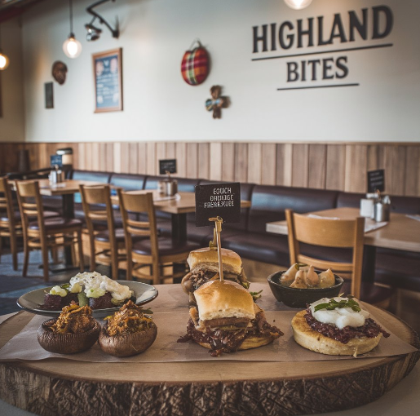
2.2 SWOT Analysis Summary
The greatest advantage of Highland Bites are in its food offer focused on Scottish cuisine, the role of locally sourcing the products, and the establishment’s atmosphere that ensures close contact with the customers. They set the restaurant apart from large chain restaurants and help customer find a niche restaurant in which to enjoy a comfortable meal. However, low seating capacity, a small marketing budget, and, therefore, weaknesses that can impede business growth and development (Razzak et al., 2022). The opportunities of Highland Bites are to establish itself as a source of authentic and sustainable cuisine that is in high demand among consumers; expanding the ranking of customers through active online advertising. Addition to risks rising from seasonal variations in hospitality and competition from other large restaurants, the business need to set up promotions for the specific period of the year and loyalty programs to encourage more local customers.

3. THE TEAM
3.1 Key Personnel
Name and Company Position:
Jason
Head Chef
Skills and Experience:
Jason has 5 years of experience in Scottish cuisine, having worked at several well-known restaurants in Edinburgh. He is skilled in sourcing local ingredients and creating traditional dishes with modern twists.
Role and Responsibilities:
Jason is responsible for menu development, sourcing fresh ingredients, and maintaining high culinary standards. He oversees kitchen operations and ensures that Highland Bites provides an authentic, high-quality dining experience.

Name and Company Position:
Alexa
Operations Manager
Skills and Experience:
Alexa has 2 years of experience in restaurant operations, focusing on team management, customer service, and inventory control.
Role and Responsibilities:
Alexa oversees the day-to-day operations of the restaurant, ensuring smooth service, managing staff schedules, and maintaining supplier relationships.

Name and Company Position:
Camilia
Finance Manager
Skills and Experience:
Camilia is a certified accountant with over 4 years of experience managing finances for small businesses. She has expertise in budgeting, financial planning, and cost control within the food and beverage industry.
Role and Responsibilities:
Camilia is in charge of managing the financial health of Highland Bites, including budgeting, cost analysis, and financial reporting. She ensures the business remains profitable while maintaining reasonable pricing for customers.

3.2 Skills Gaps & Key Partners
    - Additional Staff Requirements (Roles and Responsibilities):
- Sous chef is required to assist the head chef in budgeting and general management of the kitchen and to help prepare meals during preordained peak periods (Filimonau et al., 2020).
- Social media coordinator will be responsible for organizing and executing daily posts and interaction for increased cutomers reach through social media hence fulfilling the gap of social media management and marketing.
- Restaurant supervisor are charged with managing the dining room and addressing customer concerns during popular hours for dining.

3.2.2 Training and Development:
- From a local hospitality training center, customer service training will address the issue of poor interpersonal conduct by the front of house employees customer relations will improve since they will be prepared on how to interact with different people as customers.
- Every employee that works within the kitchen will complete Level 2 Food Hygiene training by a registered training center like High Speed Training. This will help to plug some of the compliance deficit that is evident in the food handling and safety procedures.
- Digital marketing course will be taken online and will arm the marketing team with some of the most relevant tools in social media marketing and online advertising.

3.2.3 Outsourced Support / Key Partners:
- To monitor its online presence, website development, online reservation, and protection from hacking IT Support eeds to be outsourced. This will ensure that there will be a reliable digital foundation and this need a technical input hence the gap will be fulfilled. Estimated cost is £1,500 annually.
- To keep the quality of the advertisements high, a specialist digital marketing agency will be employed for rare but effective occasional campaigns and strategic advice (Farooq and Bowen, 2020). Estimated cost is £3,000 per campaign.
4. MARKET RESEARCH
4.1 Market Information, Trends and External Factors
The food and beverage sector in the UK forms a promising market for Highland Bites. Market research indicates that consumers in the restaurant and cafe spent £132.89 billion in 2023; a 5% increase from the previous year (Statista, 2024). This has raised the level of those that dine out regardless of the strict economic times that are experienced in the country. Also, there is an increasing trend towards local and sustainable food products that fit well within the business model.
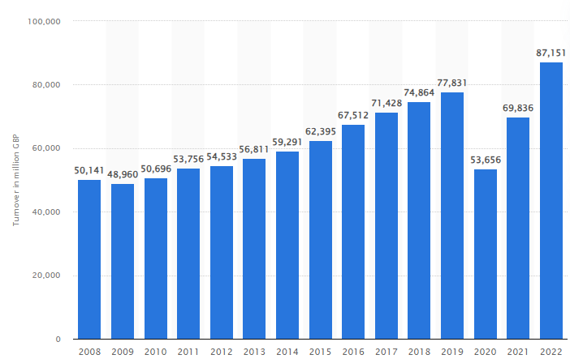
Figure 1: Turnover of enterprises in the food and beverage industry in the United Kingdom from 2008 to 2022
(Source: Statista, 2024)
After rising of inflation to its high of 11.1 % in 2022, it declines below 4% by the end of 2023 and averages 3.6% in 2024, leaving the BE 2% target still unattainable by 2025. (Statista, 2024a). This inflationary pressure is expected to exert more pressure on operations costs especially on food. But of course, since all the ingredients are locally procured and the company aims for a lean supply chain, Highland Bites can accommodate most of these increasing costs while still providing great value to consumers.
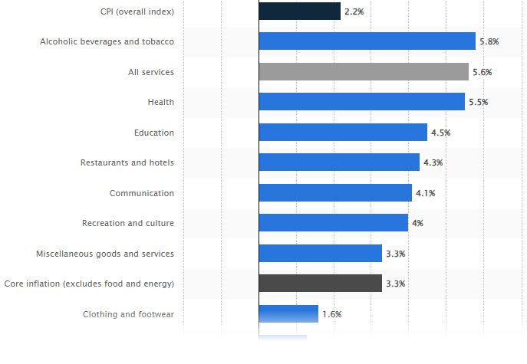
Figure 2: Inflation rate for the Consumer Price Index (CPI) in the United Kingdom in August 2024, by sector
(Source: Statista, 2024a)
Digitization in the restaurant industry technology is changing how customers are served (Statista, 2024b). The delivery and takeaway options, as well the use of ordering apps, digital menus and contactless payments are common. Thus, adopting such technologies, Highland Bites can increase efficiency at workplaces and customer satisfaction, which is up and running these days.
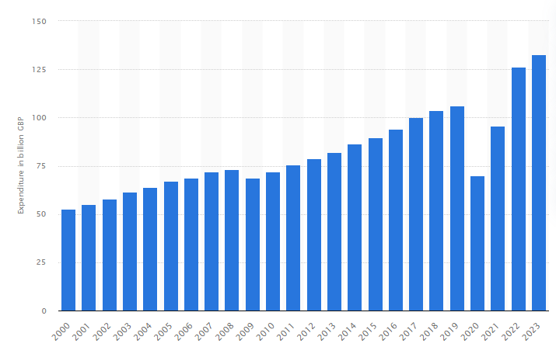
Figure 3: Consumer spending on restaurants and cafés in the United Kingdom from 2000 to 2023
(Source: Statista, 2024b)
4.2 Customer Profiles
- Tourists
Age range: 25-45 years
Income range: £30000- £60000
Scottish tourists expect cultural tourism. Such people are bound to afford to get meals at Highland Bites given that it offers the Scottish type of farm foods.

- Local Food Enthusiasts
Age: 30-55 years
Income: £40,000-£70,000.
Individuals interested in making environmentally friendly choices and consuming the food that is fresh and produced by local farmers visit Highland Bites.

- Eco-Conscious Families
Age: 35-50 years old
Income > £50,000
People go to Highland Bites because it offers healthy organic food and has kid friendly environment. Such customers value its concern with the supply chain and a neat and friendly atmosphere of a family restaurant.

4.3 Competitor Profiles
Competitor | Strengths | Weaknesses | How Highland Bites Competes | USP/Competitive Edge
The Kitchin | - The Kitchin is a Michelin-starred restaurant known for its high-end quality and culinary innovation (The Kitchin, 2024). | - It is expensive and primarily caters to a high-income clientele, making it less accessible for average diners. | - Highland Bites competes by offering similar quality food at a more affordable price, thus targeting a wider audience. | - The competitive edge of Highland Bites lies in its casual yet premium dining atmosphere, with a strong emphasis on authenticity and sustainability.
Howies Restaurants | - Howies Restaurants feature affordable and accessible locations that utilize locally sourced Scottish ingredients (Howies Restaurants, 2024). | - They lack a strong farm-to-table focus and do not emphasize sustainability as a core value. | - Highland Bites differentiates itself by implementing a niche farm-to-table model and offering a more personalized dining experience. | - The unique selling proposition of Highland Bites is its farm-to-table freshness, with a dedicated focus on ethical sourcing and sustainability.

5. MARKETING PLAN
5.1 Price
The Highland Bites’ price will consequently set affordable. Menu prices will be set with the local restaurants, main meals costing between £10 and £25. This makes Highland Bites significantly cheaper to, for example The Kitchin which charges more than £30 for its main courses. This price positioning communicates to the Highland Bites consumers that they will receive quality food procured from local producers but at reasonable premiums.
5.2 Product
The products of Highland Bites will be authentic and sustainable. The branding will be in color range, close to nature as the majority of the dishes are made from natural products while the logo will contain some elements of Scotland. The interior design of the restaurant will be farm-based; timber will be used in its construction, and part of the kitchen will be visible to customers since the use of woods will create warmth within the premises as well as the ceiling having plant-based features.
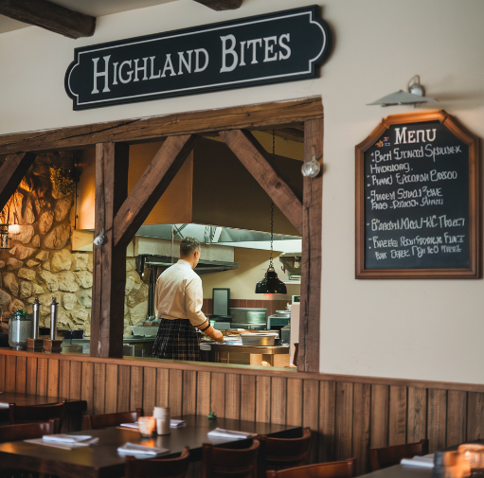
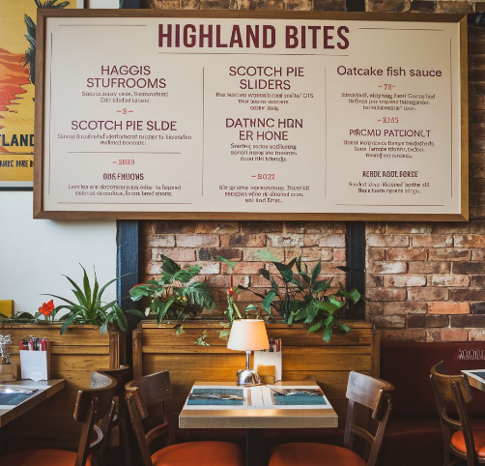
5.3 Placement
Highland Bites will own a physical outlet to ensure that the outlets targets the local people as well as the tourists. All arrangements for both eat-in, takeaway, and delivery arrangements will be made with Deliveroo and Just Eat. The use of such online facilities will help Highland Bites to expand their market reach and guarantee that customers get to order foods that they can prepare at home (Wood, 2020).
5.4 Promotion
In order to promote Highland Bites, an extensive advertising campaign will be used both, online and offline. Instagram and Facebook will act as sources of aesthetically pleasing photos that will incorporate entertaining and or informative content that will be both enthusiast-audience-friendly. The local methods as flyers, the ad in the local newspaper, cooperation with the businesses located nearby will increase the visible presence in the community. In order to maintain contact with consumers, a rewards program, which unlocks different special offers to encourage consumers to come back again will be initiated.
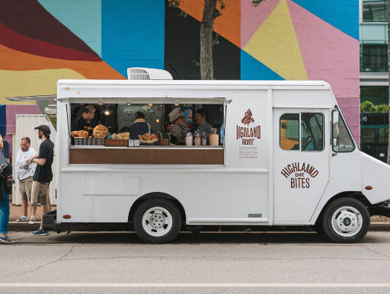
6. KEY RESOURCES
6.1 Premises
Highland Bites needs a physical facility in which the establishment has a dining area, preparing area or kitchen, storage space, and management offices. The space required to serve a restaurant would be 50 to 70 guests can comfortably sit with an atmosphere that complements it, yet the restaurant has to be designed to expand so it can accommodate more clients in the future. Data from the real estate market surveys shows that average commercial rental cost per square footage annually in these regions cost is between £25 and £35.
6.2 Equipment
Various equipments will be necessary in preparing, cooking and serving food for the Highland Bites to run effectively. This refers to large scale use appliances including ovens, refrigerators, dishwashers and utensils such food processors and mixers (Tan and Despotis, 2021). Other accessories- ranging from tables and chairs to create a comfortable dining room will also be important.
6.3 Key Suppliers
Due to the need to ensure that food is sourced freshest quality, and in the process helping the restaurant to work with those suppliers that will help it offer quality menu in the long run, Highland Bites will source its ingredients from local suppliers. Furthermore, the company will look for local farmers and artisans to collaborate with and include in Highland Bites to retain the provenance of food offered and help foster relationships of supply chain sustainability.
7. FINANCES AND START-UP SUPPORT
EXPENDITURE | Year 1  £
Company Registration | 150
Rent/Rates | 40,000
Staff Wages | 100,000
Travel/Accomodation | 5,000
Telephone (mobile) | 500
Broadband | 600
Utilities | 10,000
Marketing and materials | 15,000
Insurance | 2,500
Capital Expenditure/Equipment | 50,000
Training & Development | 3,000
Accounting/Legal | 5,000
Outside Services | 4,000
Stock/Materials Purchases | 30,000
Bank Charges | 500
Office Consumables | 1,000
Loans Repayments | 8,000
Total Expenditure | £ 275,250
INCOME | Year 1  £
Sales A | 150,000
Sales B | 50,000
Sales C | 30,000
Capital Introduced | 20,000
Funding | 250,000
Loans/Borrowing | 10,000
Total Income | £285,000

YEAR ONE PROFIT/LOSS | £
Total Income | 285,000
Total Expenditure | 275,250
Profit/Loss | £ 9,750

7.1 Financial Summary
The financial summarised that the main expenses include rent and rates, reflecting the cost of securing commercial premises necessary for production, sales, and administrative functions. Staff wages are estimated based on the roles outlined in the business plan, including managerial, operational, and marketing personnel. Marketing and materials costs align with the promotional strategies discussed, covering digital advertising, traditional media, and materials such as packaging and branding (Filimonau et al., 2023). Key equipment and capital expenditure involve the necessary tools, machinery, and technology to ensure efficient production and service delivery (Filimonau et al., 2021). In terms of income, projections are based on expected sales from multiple revenue streams, supported by a well-researched pricing strategy. Funding is expected to come from a mix of sources, including start-up grants, small business funding schemes, and possibly crowd-funding initiatives or government-backed loan programs that are suitable for small businesses in the food and beverage industry.

APPENDICES
Appendix A – SWOT Analysis
Strengths | Weaknesses
- Highland Bites offers a unique and authentic Scottish dining experience, featuring traditional dishes with modern twists. | - The restaurant has limited seating capacity, restricting the number of customers it can serve at once.
- The business uses fresh, locally sourced ingredients from nearby farms, ensuring high-quality meals and supporting local producers. | - Highland Bites operates with a small marketing budget, which may limit its ability to attract new customers.
- Its cozy and intimate atmosphere creates a welcoming environment that encourages repeat visits from customers. | - The narrow customer base, mainly local residents and tourists, may limit growth and the ability to reach wider markets.
- Personalized customer service allows for an enhanced dining experience, with staff able to cater to individual needs. | - The limited menu options may restrict customer choices and prevent the restaurant from appealing to a broader audience.
Opportunities | Threats
- There is a growing trend towards authentic, local dining experiences, which Highland Bites can capitalize on to attract more customers. | - Highland Bites faces competition from larger, well-established restaurants that may have more resources and brand recognition.
- Increasing consumer interest in farm-to-table and sustainable food presents an opportunity to differentiate the business further. | - Seasonal tourist demand creates fluctuations in revenue, with quieter periods impacting business sustainability.
- The business has the potential to expand its reach through online marketing and engaging with customers via social media. | - Rising costs of locally sourced ingredients could reduce profit margins and challenge the sustainability of its offerings.

Appendix B – PEST Analysis
Factor | Description
Political | - The UK government has implemented strict regulations on food safety and hygiene, especially in the wake of Brexit, which affected food imports and supply chains.  - Changes in immigration laws have also impacted the availability of labor in the hospitality sector, increasing reliance on local workers.
Economic | - After reaching a peak of 11.1% in October 2022, UK inflation declined to 4% by the end of 2023, but it is still above the Bank of England's 2% target (Statista, 2024).  - Inflation is forecasted to average 3.6% in 2024 (Statista, 2024).  - This impacts food prices and operational costs in the food and beverage industry, squeezing profit margins.  - Additionally, rising interest rates could dampen consumer spending.
Social | - Spending on restaurants and cafes rose by 5% in 2023, reaching £132.89 billion, reflecting consumers' increased demand for dining out experiences (Statista, 2024a).  - Additionally, there is growing demand for sustainable and locally sourced food as UK consumers become more health-conscious and eco-aware.
Technological | - Digitalization is transforming the restaurant industry in the UK, from online ordering systems to AI-powered customer service (Statista, 2024b).  - Mobile apps, QR-code menus, and contactless payment options are becoming standard, improving operational efficiency and enhancing the customer experience.

REFERENCE LIST:
Farooq, M. and Bowen, G., 2020. Impact of social media marketing on SME restaurants in UK. Gbata 2020 Growth and Sustainability in Global Markets: Theory, Evidence, And Practice, pp.24-29.
Filimonau, V., Chiang, C.C., Wang, L.E., Muhialdin, B.J. and Ermolaev, V.A., 2023. Resourcefulness of chefs and food waste prevention in fine dining restaurants. International Journal of Hospitality Management, 108, p.103368.
Filimonau, V., Nghiem, V.N. and Wang, L.E., 2021. Food waste management in ethnic food restaurants. International Journal of Hospitality Management, 92, p.102731.
Filimonau, V., Todorova, E., Mzembe, A., Sauer, L. and Yankholmes, A., 2020. A comparative study of food waste management in full service restaurants of the United Kingdom and the Netherlands. Journal of Cleaner Production, 258, p.120775.
Howies Restaurants, 2024. Scottish, Seasonal and Seriously Tasty. [Online] Available at < https://www.howies.uk.com/ [Accessed on 9th October 2024].
Razzak, B.M., Blackburn, R. and Saridakis, G., 2022. Employees' working life and performance of UK ethnic minority restaurants: a qualitative approach. Benchmarking: An International Journal, 29(1), pp.47-67.
Statista, 2024. Turnover of enterprises in the food and beverage industry in the United Kingdom from 2008 to 2022. [Online] Available at < https://www.statista.com/statistics/558133/food-and-beverage-services-turnover-uk/#:~:text=Food%20service%20industry%20revenue%20in%20the%20UK%202008%2D2022&text=In%202022%2C%20food%20and%20beverage,catering%20and%20other%20food%20services.> [Accessed on 9th October 2024].
Statista, 2024a. Inflation rate for the Consumer Price Index (CPI) in the United Kingdom in August 2024, by sector. [Online] Available at < https://www.statista.com/statistics/281724/consumer-price-index-cpi-united-kingdom/#:~:text=After%20reaching%20a%20peak%20of,usual%20target%20of%20two%20percent. [Accessed on 9th October 2024].
Statista, 2024b. Consumer spending on restaurants and cafés in the United Kingdom from 2000 to 2023. [Online] Available at < https://www.statista.com/statistics/476637/restaurants-and-cafes-consumer-spending-uk/#:~:text=Consumer%20expenditure%20on%20restaurants%20and%20caf%C3%A9s%20in%20the%20UK%202000%2D2023&text=Spending%20on%20restaurants%20and%20cafes%20in%20the%20United%20Kingdom%20increased,percent%20from%20the%20previous%20year. [Accessed on 9th October 2024].
Tan, Y. and Despotis, D., 2021. Investigation of efficiency in the UK hotel industry: A network data envelopment analysis approach. International Journal of Contemporary Hospitality Management, 33(3), pp.1080-1104.
The Kitchin, 2024. Our story. [Online] Available at < https://thekitchin.com/> [Accessed on 9th October 2024].
Wood, R.C., 2020. Perspectives on hospitality industry trade unionism in the UK and beyond. Research in Hospitality Management, 10(2), pp.137-147.

