Emerging Effective Workplace Success
and Relationships in Tesco

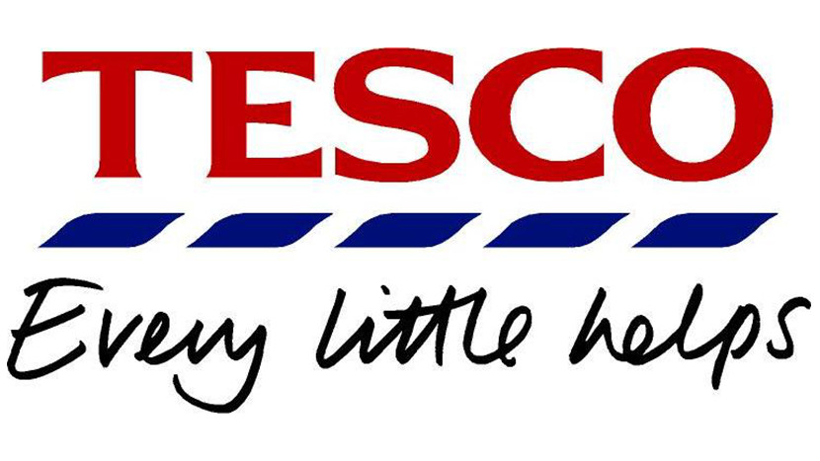

Roxana khanum
Student no: 1712107
Lecturer: Abdullah Al Mamun
Developing relationships and workplace achievement (Bmsk 5002)

Content Page
Introduction……………………….
Vehicle of Motivation; ………………………………………………………………….... Page 4
Taylors theory………………………………………………………… Page 5
Mayo theory……………………………….…………………………. Page 7
Maslow hierarchy needs…………………………………………… Page 8
Herzberg two factor theory…………………………………………. Page 9
360-degree vehicle………………………………………………………………………... Page 10
Leadership and management vehicle…………………………………………………… Page 12
Personal development plan………………………………………………………………. Page 14
Conclusion…………………………………………………………………………………. Page 16
Bibliography………………………………………………………………………………... Page 17

Introduction
Human source management is a tactical, combined as well as a clear method to service, progress as well to the health of the folks at work in the organizations. This as well includes wholly the administration verdicts and deed that would distress the connexion amongst employees and the association. (Beer et al,1984)
HRM includes an established of guidelines that is intended to maximise structural combination, worker pledge, suppleness and the excellence of work. (Guest,1987) this involves of the subsequent plans: the human resource guidelines ought to be combined with the tactical business strategies and be used to reinforce a suitable or a change an unsuitable organizational principles that human resources are valued and modest benefit that may well be selected utmost efficiently by equally constant guiding principle that indorse promise and which substitute an inclination with in staffs to act submissively in the interest of the adaptive organization’s quest of brilliance. (Legge,1989) Human resource management stands a characteristic tactic to service running which search for to accomplish viable benefit over the tactical disposition of extremely dedicated as well as an accomplished staff, via a cohesive range of social, operational and personal methods. (Storey, 1995)

MOTIVATION VEHICLE
In height act is accomplished by moral inspired people who is set to workout mandatory exertion. Although in a straightforward role, (Hunter et al, 1990) initiated that variance in worth has further open routine amongst ‘superior’ and ‘standard’ players was 19 percent and for highly compound job was 48 percent. To able to inspire folks it is obligatory to increase in value how motivation works. Meaning that considerate the inspiration theories as well as how this theory can remain in use.
Also, motivation is to do with durable point and guidelines of actions and those aspects effect folks to act in convinced manners. This period can refer variously to the goals of individuals have and the way in an individual chose their gaols and how they can change their behaviour. People are motivated when they assume that a course of action is likely to lead to the realisation of aims and value prize such that contents their requirements. (Arnold et al, 1991)
  - Tesco’s positive motivation theories applied to workers and organization
Motivation possibly will come from different intrigue, for instance, being careful or as of outside elements, for instance, recognition as well as reward.
Various theories have been suggested to intended for inspiring employees. Salary is seen as a vital inspiration. Additional propelling variables include:
- Valuation for industrious work
- A sensation of achievement
- Duty and firming
- Open door for progress
- Sense of quiz and enjoyment
An inspired workforce will work more earnestly and achieve extra notable yield in a lesser amount of time, this way lessening work costs. Also, this necessitates a lesser amount of supervision and displays pride in its work, having an additional notable result on the consumer.
Tesco thinks about the business that depends on two assemblies of individual consumers and workers. This acknowledges that employees are unique kind and take numerous ways of life outdoor of work. To this end Tesco supports staff with a work/life parity and offers remunerate through:
- Flexible at work
- Unrestricted or diminished amount of medicinal benefits
- Rebate exercise centre contribution
- Focused salary rates
- Employee rebate
- Association share choices.
- Esteeming representatives
Tesco initiate out that it stands imperative to style belief as well as respect. They have also discovered that by appreciating legislatures, giving sensible aims and a fascinating situation for them to work in, it builds representatives" motivation.
At Tesco an inspired discrete on or after staff 'works in association with others to accomplish individual and group destinations'. This implies the person in question spotlights on clients, treats individuals decently and is determined and devoted to receiving censure from others. (studies, 2019)
There are four motivational theories that are applied to Tesco’s, which are:
Taylors Motivational Theory
In the year 1911 engineer Fredrick Taylor issued the unique initial motivational theories. If we do one thing then it will lead to additional thing, therefore folks will be inspired to work if the rewards and punishments are directly related to the way their performance is basis of the makeshift attempts to motivate people by enticements. Every so often this is used as the implied rationale from the performance related pay though this is infrequently an effective motivator. (Taylor,1911)
Also, while advancing his career he did a workroom test to see the optimal presentation levels. One of the experiments he did was the spade design, which would allow workers to shovel for numerous times. The bricklayer design was where he experimented with the numerous gestures that was obligatory and established an effective method to lay bricks, he found that by calculating the time needed for this various element of tasks he possibly will develop the best way to complete a task. These time and motions also led Taylor to conclude that people could work more efficiently than others. Captivating what he has learned from all these workplace experiments, Taylor established four values of methodical running, this is known as ‘Taylorism’. (Team, 2019)
Tesco’s prize agenda partakes some what of similarities toward Taylors theory, this reward correspondences is one and only of the inspiring factors. But there are other factors than money which motivates people in both working lives and personal life. Tesco goes far out there to Taylors and stretches more than a simple pay increase. It cares for diverse lifestyles of all individual employees through an appropriate and targeted benefits.
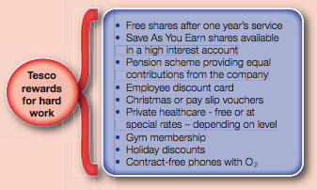 Figure 1.
Several non-financial features can and ensure inspire staffs to able to progress their own outputs. One of the factors possibly will be the wish to help folks, others may well be to progress private skills or get a upgrade. Staffs are motivated extra if they sense the contented in their workplace and this happens frequently once their employer produces a decent atmosphere of workplace and that’s where the employees feel valued. (Studies, 2019)

Elton Mayo Theory
The year 1930s Elton Mayo the theorist advised that motivation at a work stayed endorsed by aspects of consuming great communications, good crew work, certifying that work is interesting and non-repetitive and showing interests to others.
Mayo constructed his assumptions on the investigations that was taken on with the workers at Hawthorne plant of Western Electrical company in Chicago, his work lead to Hawthorne theory. He advised that dullness and repetitiveness tasks directed to condensed motivation also motivation was enhanced through making employees feel significant by giving them a chance of freedom to able to make choices and acknowledging their own social needs.
The actual inspiration behind Elton Mayo’s theory stood questionably of the psychological control over workers, while Taylors theory was being helpful of developments in ‘workers’ pay’ and conditions, Mayo and HRS undertook to eliminate such calls entirely. Mayo’s notion of managers as a natural choice and holding the ability and therefore the right to rule workplaces and the nation particularly difficult. As for (Deetz, 2003) has highlighted that there is nothing about ‘natural’ of the privileged place of capitalist ownership and attendant management authority. Mayo and HRS rendered this managerial choice with superior potential for authoritarianism- ‘corporate repression with a human face’ (Rose,1978, p,121) – than any sorts of Taylorism ideas or measures, a seemingly point that is lost on various critics of SM, past or present. ‘Mayoism’ presented more a delicate and efficient means of exercising this power of mentally via workers emotions.
At Tesco Mayo theory is functioning throughout the company, communication is one the vital factors in motivating employees this could be through 1 to 1 discussion with managers, company intranet or through official structure such as reviews. Line mangers holds a daily team meeting where they update all their staffs on what will be happening for the day and they give out value awards, these awards can be given from any staff to another staff as a way of saying ‘thank you’ and celebrating successes. (Studies, 2019)

Maslow Hierarchy Needs Theory
Abraham Maslow reasoned that humans are motivated by the five essential of needs which are physiological, safety, social, esteem and self-fulfilment. The needs that are at a higher level only arise when a lower need is pleased. This theory focuses on the several needs that will motivate people and the concept that a pleases needs is no longer a motivator. (Maslow, 1954)
The utmost famous classification of needs is the one formed by Maslow (1954). Psychological development takes place as people transfer up the hierarchy of needs, nonetheless this is not certainly an upfront development. The lower needs yet exist even though if temporarily dormant as motivators and individuals continuously return to previous fulfilled of needs. The hierarchy has an instinctual appeal and has been popular. Then again it has not still been confirmed by empirical research such as that conducted by Wahba and Bridwell (1979), also it has been criticized for its apparent inflexibility as different people may well have different responsibilities and its is difficult to accept that needs progress steadily up the hierarchy and for the misleading simplicity of Maslow’s conceptual language, in fact Maslow himself voiced doubts about the validity of a strictly ordered hierarchy.
the real motivation behind Mayo’s theory was, arguably, that of psychological control
over workers. While Taylor was supportive of improvements in workers’ pay and conditions,
Mayo and HRS promised to eliminate such calls entirely. Mayo’s conceptualization of managers
as a natural elite, possessing the ability, and so the right, to rule workplaces and the nation
is especially problematic. For one, and as Deetz (2003) has highlighted, there is nothing ‘natural’
about the privileged place of capitalist ownership and attendant management authority. Rather,
it is produced and reproduced via discursive practices ranging from lexical choice, producing
and distinguishing people and events in specific ways, to telling stories and giving instructions
and orders. Second, Mayo and HRS accorded this managerial elite with vastly greater potential
for authoritarianism — ‘corporate fascism with a human face’ (Rose, 1978, p. 121) — than any
Taylorist ideas or measures, a point seemingly lost on many critics of SM, past and present. While
Taylorism (notwithstanding Taylor’s own exhortations for a great ‘mental revolution’) had pre-
sented managers with the potential to exert power physically over the human body spatially and
temporally, ‘Mayoism’ offered a more a subtle and efficient means of exercising this power
mentally, via workers’ cognition and emotions. It was a new way to control workers to accept less,
while claiming that workers needed psychological counselling about their relations at work that
only management could administer.Maslow and Hertzberg motivational theory

the real motivation behind Mayo’s theory was, arguably, that of psychological control
over workers. While Taylor was supportive of improvements in workers’ pay and conditions,
Mayo and HRS promised to eliminate such calls entirely. Mayo’s conceptualization of managers
as a natural elite, possessing the ability, and so the right, to rule workplaces and the nation
is especially problematic. For one, and as Deetz (2003) has highlighted, there is nothing ‘natural’
about the privileged place of capitalist ownership and attendant management authority. Rather,
it is produced and reproduced via discursive practices ranging from lexical choice, producing
and distinguishing people and events in specific ways, to telling stories and giving instructions
and orders. Second, Mayo and HRS accorded this managerial elite with vastly greater potential
for authoritarianism — ‘corporate fascism with a human face’ (Rose, 1978, p. 121) — than any
Taylorist ideas or measures, a point seemingly lost on many critics of SM, past and present. While
Taylorism (notwithstanding Taylor’s own exhortations for a great ‘mental revolution’) had pre-
sented managers with the potential to exert power physically over the human body spatially and
temporally, ‘Mayoism’ offered a more a subtle and efficient means of exercising this power
mentally, via workers’ cognition and emotions. It was a new way to control workers to accept less,
while claiming that workers needed psychological counselling about their relations at work that
only management could administer.
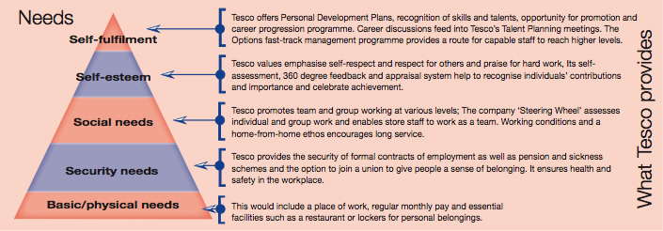
Figure 2.
As you can see that at the lowest part of the pyramid is the basic needs these are that motivates people to work on food and shelter, once these needs are met through pay system the individuals want safety and security through a good job condition. The social needs refer to the necessity to belong and be a part of a group. Self esteem may arise from a raise. At the top is self-fulfilment this is the are for creativeness, challenges and interest. Maslow recommended that accomplishing one level motivates us to accomplish the next. (Studies, 2019)

Herzberg two factor theory
This theory is established by Herzberg (1957) resulting an enquiry into the foundations of job gratification and unhappiness of accountants and engineers. It stood presumed that people have the capability to account precisely the circumstances that completed them fulfilled and displeased by their jobs. Therefore, the subjects were asked to tell their interviewers about their time during which the felt good and not so good about their jobs and how long their feelings continued. The fulfilments of the needs of the second group does nit motivate the individuals to a higher points of job approval and to the additional act on the job. All that can be expected from satisfying the second group of needs is the anticipation of dissatisfaction and poorly job performance.
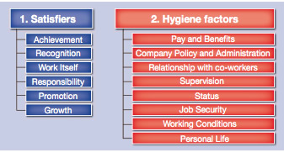 Figure 3.
Tesco’s goal is to inspire their employees both by paying their consideration to the hygiene factors and by aiding satisfiers i.e. it inspires and allows their staffs by suitable as well as appropriate message and giving accountability also getting their staffs involved in choice making. Tesco gives forums every year where this allows staff to be a share of the debates on wage rises, therefore it demonstrates credit of work staffs do and gives reward to them. The staffs at Tesco can also be influenced what food goes onto the restaurant menus, therefore employees become more inspired to make the right selections that can rise their usage of the restaurant. (Studies, 2019)

.

360-DEGREE VECHILE
360-degree feedback allows to recognize complications of organisation as well as the worth of the effort from several bases, therefore the obvious is that managers ought to not be evaluating the deeds that they cannot detect, and management actions of assistants may not well be known to their managers. This feedback system is used for many purposes, Ashridge Management Investigation group (Handy et al, 1996) found that 360-degree feedback forms part of a self-development or an organisation agenda.
Advantages of this method are:
- Individuals get better viewpoint of how they are perceived by others
- Folks more of a round view of how their presentation is
- Improved awareness of and the relevancies of competencies
- Response is professed as well as extra effective and aims, leading to the receiving of marks
The weaknesses:
- Not always folks be frank and give truthful comment.
- Folks may well be put under pressure and strain in giving and getting response.
- Too ample of bureaucracy.
- Lack of act on following feedback.
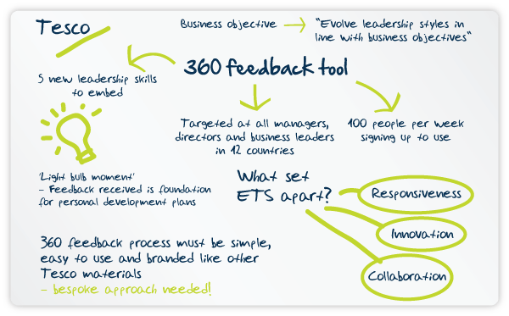Figure 4.
The 360 degree is aimed at every managers, directors and professional leader contemporaries in their stores, circulation centres and crosswise 12 countries offices. Ever since starting this newest system they had average of one hundred colleagues singing up and completing the 360-degree system per week.
Jon Sale, main head of talent at Tesco who has been in personnel for ten years said that he had witnesses the light bulb moments of folks perceive once they get their first response report and that’s when they get areal sense of how they are seen by their colleagues, peers and their line managers. This feedback system has been overwhelming positive, and people have been sharing with them how it became a real foundation for them to able to build a good personal development plan that will help them think of their leadership in the recent business context. (Sale, 2019)

LEADERSHIP AND MANAGEMENT VECHILE
There’s a big difference between management and leadership, management is all about getting tasks done. Managers organise the human and physical resources to able to gain business objectives and goals. Leadership is all about how to influence, motivate and inspire people and is approximately how to coach and develop folks, treating them with respect but then again challenge them. Leaders seek out for creating a strong team with the people who are dedicated to the organisation’ goals.
The method of managing starts with the aims or target that needs to be attained, a boss essential to elect suitable tactic for reaching that certain target. Therefore, the boss wishes to interact this method clearly to his or her team and assign tasks to each one of the crew members. Other factors also will have a big influence on whether the target is accomplished this including the task which is in hand and the skills of the teams and style of leadership.
Leadership styles
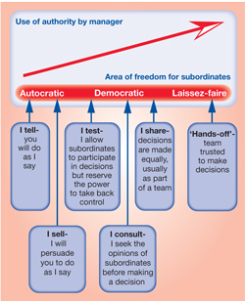 Figure 5.
Business writers Tannenbaum and Schmidt considered dissimilar leadership styles, they recommended that this could be described on a scale ranging from ‘autocratic’ through ‘democratic’ to ‘laissez-faire’. The autocratic style is branded by ‘I tell’ philosophy, this kind of leaders tell their staffs what to do thus this can give a business a clear direction but then again it may lead managers to devalue or overlook inputs from their team. Though an autocratic tactic is appropriate in certain situations this is treasured when the business faces any sorts of crisis or when a vital problem rises that needs an immediate response.
Stephen is the manager of a average sized Tesco store, he nonstop accomplishes a team of 20 departmental managers who are amongst them responsible for almost 300 people. Stephen’s leadership style is to allow his managers to make the utmost decisions but if for example and accident occurred in store then Stephen may take over and ensure a quick and co-ordinated response. In this around is about of leadership tactic that is between autocratic and democratic, this style gives team participations but then again managers have the rights to make the final call.
Only the finest managers will implement management styles suitable to the circumstances, Stephen from Tesco’s prefers leadership style of democratic tactic. He refers as widely as he feels that employees reply better to this tactic, i.e. when arranging for a huge stock reduction programme, he then encourages his mangers to give ideas and plans. Nevertheless, as a store manager he deals with many kinds of situations that may be such as business critical as it is vial he quickly responds to these in most suitable manner.
Martin who is a programme manager for education and skills in Tesco, he possibly will use the democratic tactic when setting training budgets. Managers could give advice on ideas that will make cost saving and together discuss their proposals with Martin, by allowing his managers he will get them to take ownership for the final settled budget.
Laissez-faire is the spectrum of other end of oppressive, bosses who uses this tactic take hands off approach and trusts the team to take the right choice or actions with an extensive agreed restriction i.e. Martin may leave an experienced departmental manager to develop a budget this can be because he trusts the manager has very decent information of requirements of the sector as well as of the business. (studies, 2019)
Folks at each level have responsibility in Tesco such as customer assistant, managers to directors’ face dissimilar types of choices to make apiece derives with its individual errands and schedules. This will stimulus the utmost fitting leadership style for specific piece of work. (studies, 2019)

PERSONAL DEVELOPMENT PLAN
Personal development plan is the method of how to establish aims and goals, it is up to you how you would like to gain or where you would like to go in the short, medium or long term in your life of career. Also, this allows you to identify needs of skills, knowledge and opting for the right development activities that meet the apparent needs.
This does not automatically mean upward movement it somewhat is all about allowing individuals to progress on their own performances and to grasp their full potential at each of the stages of their profession.
Adapting to the PDP it will help individuals to see where they are now and where they would like to go such as by:
- Revive practical skills that date rapidly.
- Building up a transferable skill like self-awareness, capability to learn and flexibility to change and virtuous time management.
- Display and evaluating accomplishments.
The procedure of PDP allows a schedule where you can work to and can lay the foundation such as:
- Non-stop learning.
- Intellect of accomplishments.
- Making sure of the employability and the surviving age somewhere less work that could be guaranteeably to stay same.
- Making the maximum of the chances which might rise. (Institue, 2013)

PDP Example
Objectives | Internal | External | Review date (when)
Sarah in Tesco needs to communicate more better with her colleagues as well as with her customers. | Coaching her as well as seeing what skills she has and how she can better her skills. | Making friends as well as while going out socialising more and being more confident when speaking up. | Every two weeks as this could take time for her to be fully confident.
Lee from Tesco needs to attend more to the workshops and development days provided by the company | By going to this programme, it will allow lee to grow and extend his abilities. | This will allow Lee to know where his weakness is and gain more abilities and improve on them as well. | Every two- three weeks.
Amanda using 360 feedback to see where improvements are needed. | By Amanda using this vehicle she can see which areas of performances she needs to improve and then reviewing her development plans. | Amanda reviewing the performances from the feedback she got, also regularly ensuring that she gets the best from the training and providing feedback. | Every 1 to 2 weeks.

CONCLUSION
I have concluded that in Tesco they use motivation theories and they follow these motivation theories across all their stores that they have. Also 360 feedback is used in Tesco company, this allows their employees to see where they can better their performances as an employee. They too use leadership and management across their Tesco company lastly personal development programme is used this allows them to screen and appraise the goals of the exercise and growth happenings in the workplace.

Bibliography
Institue, C. M., 2013. CMI. [Online]
Available at: https://www.managers.org.uk/~/media/Files/Checklists/CHK-092-Personal_Development_Planning.pdf
[Accessed 31 07 2019].
Sale, j., 2019. ETS. [Online]
Available at: https://www.etsplc.com/insight/tesco-360-degree-feedback/
[Accessed 29 07 2019].
Studies, B. C., 2019. Businees Case Studies. [Online]
Available at: http://businesscasestudies.co.uk/tesco/motivational-theory-in-practice-at-tesco/taylors-motivational-theory.html
[Accessed 28 07 2019].
studies, b. c., 2019. business case studies. [Online]
Available at: http://businesscasestudies.co.uk/tesco/developing-appropriate-leadership-styles/leadership-styles.html
[Accessed 30 07 2019].
studies, b. c., 2019. business case studies. [Online]
Available at: http://businesscasestudies.co.uk/tesco/developing-appropriate-leadership-styles/factors-influencing-leadership-style.html
[Accessed 30 07 2019].
studies, B. c., 2019. Business case studies. [Online]
Available at: http://businesscasestudies.co.uk/tesco/vision-values-and-business-strategies/introduction.html
[Accessed 28 06 2019].
studies, B. c., 2019. Business case studies. [Online]
Available at: http://businesscasestudies.co.uk/tesco/motivational-theory-in-practice-at-tesco/what-is-motivation.html
[Accessed 28 06 2019].
Studies, B. C., 2019. Business Case Studies. [Online]
Available at: http://businesscasestudies.co.uk/tesco/motivational-theory-in-practice-at-tesco/the-mayo-effect.html
[Accessed 28 07 2019].
Studies, B. C., 2019. Business Case Studies. [Online]
Available at: http://businesscasestudies.co.uk/tesco/motivational-theory-in-practice-at-tesco/maslow-and-herzberg.html
[Accessed 29 07 2019].
Studies, B. C., 2019. Business Case Studies. [Online]
Available at: http://businesscasestudies.co.uk/tesco/motivational-theory-in-practice-at-tesco/maslow-and-herzberg.html
[Accessed 29 07 2019].
team, M. c., 2019. MindTools. [Online]
Available at: https://www.mindtools.com/pages/article/good-relationships.htm
[Accessed 12 06 2019].
Team, M. T., 2019. Mind Tools. [Online]
Available at: https://www.mindtools.com/pages/article/newTMM_Taylor.htm
[Accessed 29 07 2019].
Legge, K (1989) Human resource management: a critical analysis, in (ed) J Storey, New Perspectives in Human Resource Management, Routledge, London
Storey, J (ed) (1995) Human Resource Management: A critical text, Routledge, London
Taylor, F W (1911) Principles of Scientific Management, Harper, New York
Hunter, J E, Schmidt, F L and Judiesch, M K (1990) Individual differences in output variability as a function of job complexity, Journal of Applied Psychology, 75 (1), pp 28–42
Arnold, J, Robertson, I T and Cooper, C L (1991) Work Psychology, Pitman, London
Deetz, Stanley (2003). Disciplinary power, conflict suppression and HRM. In M. Alvesson & H. Willmott (Eds), Studying management critically. London: Sage
Rose, Michael (1978). Industrial behaviour: Theoretical developments since Taylor. Harmondsworth: Penguin.
Maslow, A (1954) Motivation and Personality, Harper & Row, New York
Wahba, M A and Bridwell, L G (1979) Maslow reconsidered: a review of research on the need hierarchy theory, in (eds) R M Sters and L W Porter, Motivation and Work Behaviour, McGraw Hill, New York
Herzberg, F W, Mausner, B and Snyderman, B (1957) The Motivation to Work, Wiley, New York
e-reward (2005) Survey of Performance Management, e-reward.co.uk, Stockport Handy, L, Devine, M and Heath, L (1996) 360-Degree Feedback: Unguided missile or powerful weapon? Ashridge Management Group, Berkhamstead

Deetz, Stanley (2003). Disciplinary power, conflict suppression and HRM. In M. Alvesson & H. Willmott
(Eds), Studying management critically. London: Sage.

