The Global Business Environment
Module code: LCBB4005

Assignment Title: Assessment 1
Environmental Analysis of Automobile Industry

Student ID:2114394

Table of Contents
Introduction 1
External Environment Analysis 1
Internal Environment Analysis 3
Porter’s Five Force Strategy 4
Porter’s Generic Strategy 4
Porter’s Value Chain Analysis 5
The Rational for Engaging International Business of BMW 6
Summary and Conclusion 7
Reference 8

Table of Figures
Figure 1. The Revenue of BMW in the Industry. 2
Figure 2. Porter's Generic Strategy. 4
Figure 3. Porter’s Value Chain Analysis. 5

Introduction
The report aims to study and analyse an international brand for understanding the business environment of that brand and strategies for operating the business in the business environment. BMW is one of the most popular internationally recognised brands that has established its business more than 105 years ago.in the study, the internal and external environment of the brand will be focused on along with the Porter five force analysis. Also, Porter’s generic strategy and Porter’s value chain analysis will be focused on in the study for understanding the organisation and its activities.

External Environment Analysis
According to Jiang (2018), the external environment is the business environment where the organisation is going to develop its market and products. An organisation tries to develop and analyse its external environment so that it’s become able to understand the need of its internal strength on that market. PESTLE analysis is the activity that helps the organisation to understand the external environment as this analysis figure out the political, economic, social, technological, legal and ecological environment of a business (Su at al., 2018). All the factors show the current situation of the market area for the organisation. So, for understanding the external environment of the business of BMW, PESTLE analysis will be helpful.
Political: BMW has the demand worldwide but currently has some issues regarding Brexit in the European Union. The organisation has to pay a high tax for imports and export. Though the organisation has some facilities regarding trade tax for the business deal among USA and China. But business outside the UK the organisation has to pay a high tax for exporting cars. Though because of the demand of BMW, the government of different countries are helping the brand to enter the market directly.
Economic: COVID-19 has created a negative impact on the economy over the world and so people around the world even if are demanding the cars of BMW, have to think twice before buying cars. Fila et al. (2020) mentioned that BMW is struggling with the factors of investment after COVID-19 as the return on the investment of the organisation has decreased after 2019. But the brand has taken the strategies so that it increases. So, in 2020, the return of investment has become 6.27% from 5.70%.
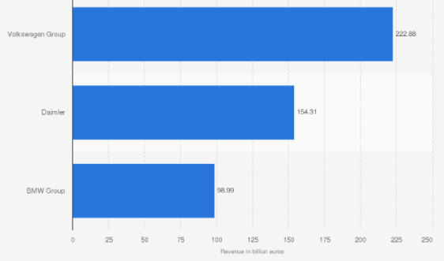
Figure 1. The Revenue of BMW in the Industry.
Source: Kukkamalla et al. (2020).
Social: BMW is operating the business in more than 140 countries around the world and among all the markets the business is popular for its automotive cars. So, the business satisfies its customers with its cars but along with the vehicles, the business is offering customers the brand value that is also the factor that motivates customers to get the car from BMW (Kozlovskyi et al., 2018). The customers who are the customers of the brand are loyal to the brand because of the brand value of BMW.
Technological: One of the main influencers of this business is the development of technologies regarding cars. BMW adopted all the technologies even is developing the technologies for the development of its products. Along with the vehicles, the brand is also offering customers different batteries and other parts and products for vehicles that are attracting customers.
Legal: The organisation BMW has aced many of the legal issues in the year 2017, 2018 for the engines failure of the cars, as a result, the customers of different areas around the world have made complain. So, the brand has become more careful so that no engine failure can occur again. The brand has created that a part of their promotion that BMW in the new version and become successful to attract the customers to the brand (Mosteanu et al., 2019).
Ecological: For being sustainable in the industry BMW is contributing a lot to the development of the ecological environment over the world. The brand has introduced electronic cars in the market that has a big role in decreasing carbon emission. It has decreased 42% of carbon emission by cars in the EU and other countries. That has developed the image of the brand to the customers as well.

Internal Environment Analysis
Fabian and Jan (2019) explained that the internal environment reflects the capacity of an organisation in the market environment. The organisations usually contain some of the strengths and weaknesses. Also, the external environment of an organisation creates opportunities and threats for the brand that can be used or overcome with the strength and weaknesses of the organisation. Internal environment analysis helps the organisation to understand all the factors regarding the organisation. SWOT analysis is an internal environment analysis that helps the brand to be more certain about its strength, weakness, opportunity and threat.
Strength: BMW has a high brand value in the industry of automobile cars. The brand is very valuable to the customers who like the special products to use. The brand is a worldwide popular brand and so this brand has business in more than 140 countries over the world. The brand is competent in the term of hybrid and electronic are industry as well (Schaermann and Hanke, 2019). The partnership with China has also increased the brand value of BMW. The brand is continuously developing its strategies for meeting all the future challenges and also overcoming the current challenges.
Weakness: The brand has failed many times while trying to develop electronic terms. A so the investment in the brand is raising but the return is not too high. The organisation has some debt that should not also. And that fact is affecting the investment and profit of BMW. The organisation needs to focus on the profit because it has not reached the target of its profit rate till now.
Opportunities: Köhl et al. (2018) mentioned that the organisation has the opportunity to lounge new models of cars in the market as everyone always expects new cars from the brand. As the demand for cars is very high so BMW has the opportunity to develop cars in the budge of the middle-income class customers so that the segmented customer's group can be raised.
Threat: The competitors of BMW are a threat to the brand as some brands also contain a brand value like BMW and offer customers customised cars as well. The always-changing trends are also a threat to the brand as to cope with all the trends the brand has to invest very high.

Porter’s Five Force Strategy
Bargaining Power of Buyers: The bargaining power of the customers of BMW is not too high. As the brand value of BMW is very high and all the new trends regarding cars start with BMW (Hoppenburg, 2021).
Bargaining Power of Suppliers: All the raw materials of the brand have to be best and so the supplier’s bargaining power is very high with BMW. The organisation and so is trying to become independent in terms of raw materials.
Threat of New Entrance: The threat of new entrance is very low as after entering the market to reaching the brand value like BMW will be very hard and there are not many car companies who can suddenly enter the industry.
Threat of Substitute: The threat here is moderate because many of the middle-income class people rather getting a car prefers to have a motorcycle (Brunk and Hamandi 2020). So, the brand needs to think to increase the segmented customers for BMW.
Industry Rivalry: There are many rivalry organisations who are competing with the brand such as Audi, Porsche, Lexus etc. so competition among rivalry of BMW is very high.

Porter’s Generic Strategy
According to Kahlert (2020), Porter’s generic strategy focuses on the competitive advantage of an organisation and its strategy to satisfy the customers. The organisation can focus on the cost leadership factor for developing strategy or the differentiation for developing the organisational strategy.
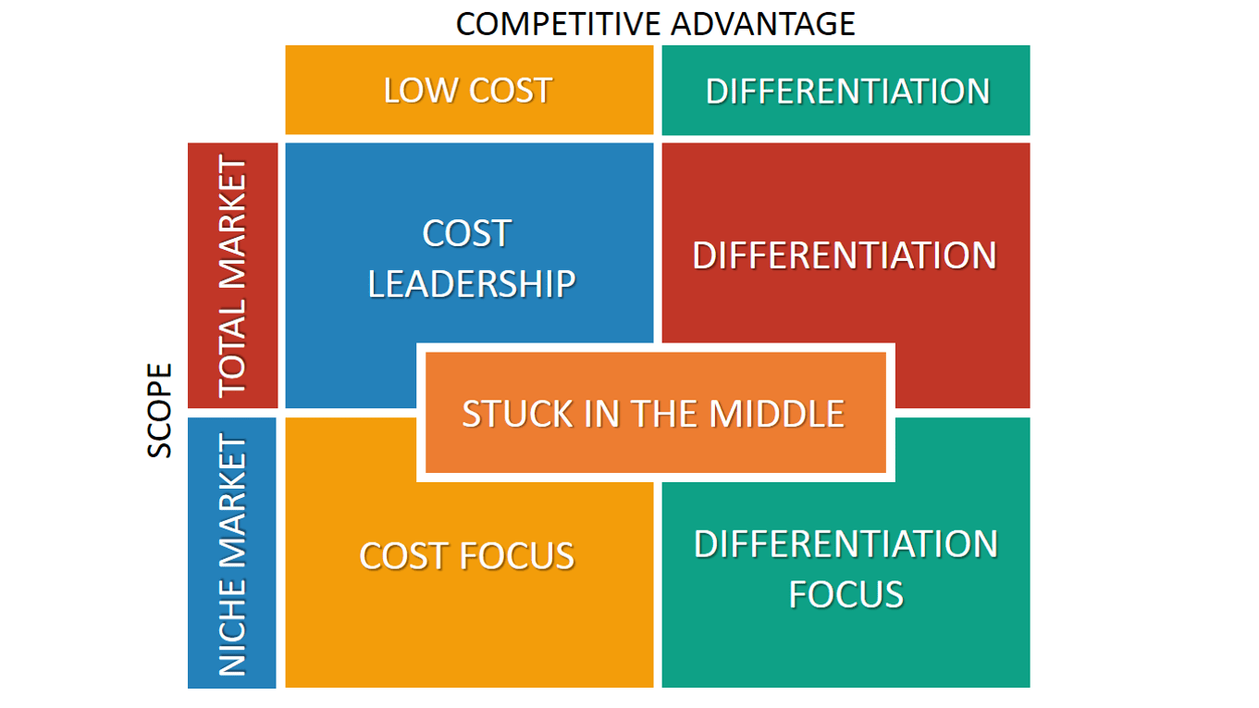
Figure 2. Porter's Generic Strategy.
Source: Kahlert (2020).
BMW has focused on the differentiation strategy as the brand develops products with high technologies and has continued innovation strategy is the competitive advantage of BMW. BMW has created the products in a way that the brand creates trends with its innovations and developments. According to Helmold and Terry (2021), all the other brands are also developed products for the customers with high technologies but the brand value that BMW contains. The brand has made many sports cars also those are very high in price as those cars contain many features that other cars do not have. BMW has invested high in the development of products and innovation that has made the brand produce cars at high costs. So, focusing on the differentiation strategy it is hard for BMW to focus on cost leadership. As the cost of production of the brad is very high.

Porter’s Value Chain Analysis
Porter’s value chain analysis is the activity to the analysis of the activities of the brand to collaborate the primary activity of the brand with the support activities. These activities are the term that makes the organisation successful to operate the business and help to understand the value chain of the brand.
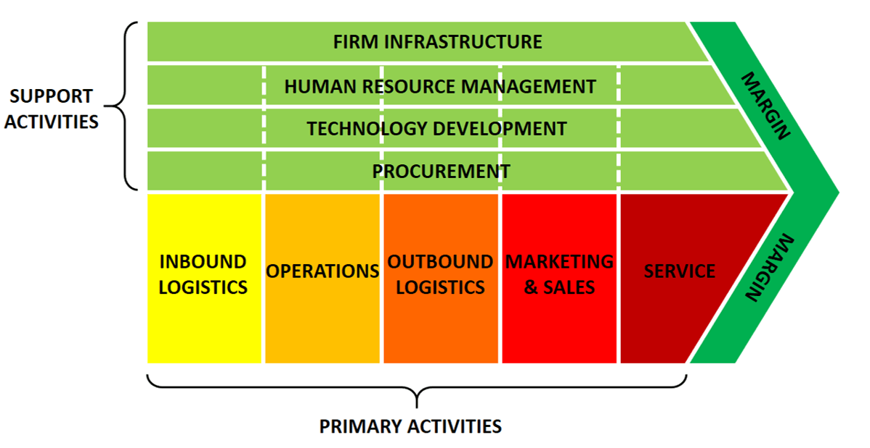
Figure 3. Porter’s Value Chain Analysis.
Source: Kaiser et al. (2019).
BMW has more than 13000 suppliers over the world that add value to its inbound logistics and create the opportunity to operate the production operation (Xu, 2019). Outbound logistics are the activities that help the organisation to sell products and let the organisation manage all the activities regarding its marketing and sales. After the sales of the brand BMW, it focuses on those produces for the after services or customers feedback as well. So that with that feedback the brand become able to develop its products more. The supportive activities are also important for the brad for firm infrastructure, selecting the human resource management. One of the most important support activities of the brand is technology as the brand without technology cannot develop its products very well. The procurement term is also a part of the value chain of the brand BMW.

The Rational for Engaging International Business of BMW
Janoskova and Kliestikova (2018) mentioned that a brand that is internationally recognised has a high market value and the demand for that brand become very high. BMW has that recognition and after starting the business the brand has focused on that term very well. And so that brand has created all the strategies to be an internally recognised brand. And now the brand has business more than 140 counters over the world. Even if the brand has not reached the targeted profit rate the brand has a high revenue among its competitors now. One of the reasons behind its high revenue is being an international business. The organisation has the target to reach all over the world and every person over the world will know about the brand.

Summary and Conclusion
In the report, the brand BMW has been analysed so that the internal and external environment of the brand can be understood very well. For understanding the environment both the PESTLE analysis and SWOT analysis has been focused on. The organisation has a positive external environment not only in the UK but also over the world. Also, there are many strategies and opportunities of the brand that will help the brand to be more successful in the market. Porter’s five force has been also focused to understand the threats and opportunities of the brand that is also a part of the business environment of BMW. Porter’s generic model has been developed for understanding the organisation strategy. The porter value chain analysis helped to understand the organisation value chain. And lastly, the rationale of being an international organisation has been analysed.
The brand should develop vehicles for not only the high-income class people but also the middle-income class customers so that the brand can increase its target customer range. The brand should develop and promote more car accessories for the brand as well so that the organisation become able to increase its product line more. Cost reduction can help the brand to increase the profit rate as well.

Reference
Brunk, H. and Hamandi, L., 2020. The Relationship between R&D Investment, Strategic Evolution and Firm Performance in the Automotive Industry.
Fabian, B. and Jan, T., 2019. The Italian Mafia, Swedish Ikea, German BMW, and Korean Samsung-Understanding Family Business Management.
Fila, M., Levicky, M., Mura, L., Maros, M. and Korenkova, M., 2020. Innovations for business management: Motivation and barriers.
Helmold, M. and Terry, B., 2021. Introduction: The Value Chain. In Operations and Supply Management 4.0 (pp. 1-19). Springer, Cham.
Hoppenburg, T.T., 2021. The business portfolio synergy analyzer: a model for evaluating synergies between business models and its application to BMW (Doctoral dissertation).
Janoskova, K. and Kliestikova, J., 2018. Analysis of the impact of selected determinants on brand value. Journal of International Studies, 11(1).
Jiang, X., 2018. Improving the Cross-Cultural Marketing Strategy of Chinese Automobile Industry: Case Company: BMW.
Kahlert, A., 2020. An explorative Analysis of how Autonomous Driving Technology impacts the Business Model of the Automotive Premium Segment: A Case Study of the BMW Group (Doctoral dissertation, Griffith College.).
Kaiser, C., Festl, A., Pucher, G., Fellmann, M. and Stocker, A., 2019, September. The Vehicle Data Value Chain as a Lightweight Model to Describe Digital Vehicle Services. In WEBIST (pp. 68-79).
Köhl, W., Siedelhofer, C., Siegmund, G., Schuster, C., Mayer, S. and Bloemer, A., 2018. Flexible production systems as an answer to a volatile environment. In 18. Internationales Stuttgarter Symposium (pp. 189-202). Springer Vieweg, Wiesbaden.
Kozlovskyi, S., Shaulska, L., Butyrskyi, A., Burkina, N. and Popovskyi, Y., 2018. The marketing strategy for making optimal managerial decisions by means of smart analytics. Innovative Marketing, 14(4), pp.1-18.
Kukkamalla, P.K., Bikfalvi, A. and Arbussa, A., 2020. The new BMW: business model innovation transforms an automotive leader. Journal of Business Strategy.
Mosteanu, N.R., Facia, A., Torrebruno, G. and Torrebruno, F., 2019. Fractals–A Smart Financial Tool to Assess Business Management Decisions. Journal of Information Systems & Operations Management, pp.45-56.
Schaermann, A. and Hanke, T., 2019. BMW Group: Generation and Validation of Sensor Models for Automated Driving Systems Using VIRES VTD. Engineering Reality Magazine, 9.
Su, P.J., Lu, H.P. and Lin, P.H., 2018. How the microfilm marketing strategy stimulates consumers' purchase intention. Social Behavior and Personality: an international journal, 46(6), pp.953-968.
Xu, X., 2019. Value creation for intelligent connected vehicles: an industry value-chain perspective. In Digital Business Models (pp. 57-79). Palgrave Macmillan, Cham.

