The Global Business Environment

Assessment 2

Maya Boteva
|ID 2112590

Executive summary
The business environments across the globe are ever-changing. The present report has provided a comprehensive description of the potential implications of a pandemic on the automotive industry of the UK. The study has shown the impact of Covid-19 on the industry, concerning skill shortage, alongside vehicle manufacturing disruption. Alongside, the study provided an overview of the megatrends, which are derived out of the automobile industry, to restore their economic resilience within the business sector. Lastly, the study has shown the potential success and survival factors that enable the automobile industry to locate its key dispositions in business.

Table of Contents
Introduction 4
Industry overview 4
Impact of the pandemic on the automobile industry 5
Survival and success factors for the automobile industry 6
Megatrends of the industry 8
Conclusion 9
Reference List 10

Introduction
There are varied factors that further add to the development of business propositions. The year 2020 saw the advent of the coronavirus pandemic, which shook the very foundation of business processes to a great extent. This eventually led to a change in the current business landscape, which eventually led to the development of varied business sectors and the automobile industry is no exception. Considering this viewpoint, the present study will talk about the potential impact of the pandemic on the automobile industry. This will involve an identification of the definite survival and success factors in terms of locating the megatrends relative to the situation.

Industry overview
Within the premises of the UK economy, the automotive industry of the country likely contributes to greater economic development. At present, the UK automotive industry accounts for a turnover of over £78.9 billion, from which £15.3 billion of value is added to the national economy (automotive council, 2021). The Society of Motor Manufacturers and Traders (SMMT) is considered to be the major trade association operating in the UK, which includes a variety of activities. It further helps in supporting the representation of ideas within the industry.

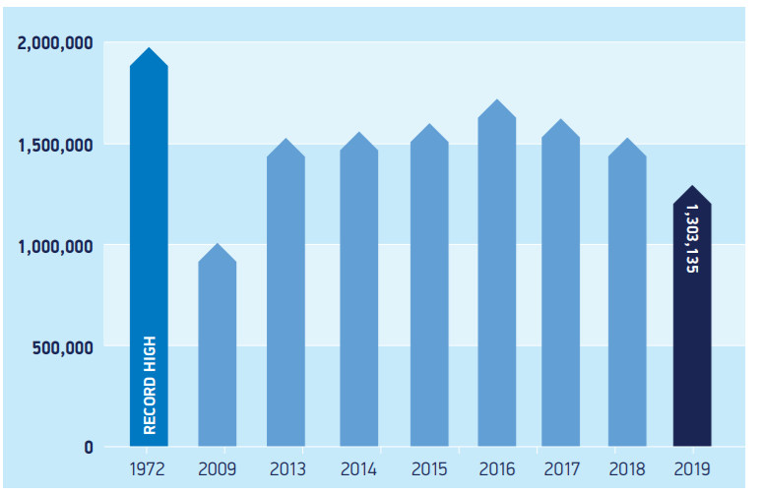
Figure 1: UK car manufacturing statistics
(Source: smmt, 2020)
Apart from this, it is evident to point out that the UK is considered to be the largest manufacturer of passenger vehicles as of 2020. However, due to the advent of the pandemic, the sales of cars dropped by 1.6 billion. In 2020, Ford was awarded the best-selling car brand in the UK (Wagner, 2021). From a global point of view, the business development of the automotive industry is likely considered crucial for economic development. The advent of Covid-19 created a halt in the supposed business development of most of the automotive industry as a whole. The association of restrictions related to the pandemic has disrupted the operations of most automobile companies to a great extent (Hensley et al., 2021).

Impact of the pandemic on the automobile industry
The automobile industry in the UK plays an important role in contributing to the economy. The implication of the Coronavirus pandemic is found to bring drastic changes to the industry insights, which is rapid and severe at the same time. The original equipment makers or the OEMs were compelled to close the production site of their distribution networks. On the other hand, many dealers had to let go of their business as vehicles became inoperative since 2020 for over six months (Wu et al., 2021). The government’s impending decision to call in a lockdown eventually reduced the number of vehicles that disrupted the operational activities of the companies to a great extent. The SMMT is of opinion that there has been over 45% of the decline in vehicle registration, which has resulted in easing of the supply chain processes largely. The chips shortage within the premises of the automobile industry is likely to continue as a result of high-end globalization, owing to the advent of Covid-19. It cannot be denied that the industry chain has been highly sensitive to improved efficiency and cost, but chips shortage is known to worsen the situation. It is because of the Covid-19 pandemic that the manufacturing and the delivery of chips for cars have been disrupted, which has largely hampered the car manufacturing process to a great extent.
It cannot be denied that the automobile industry of the UK is globally integrated and the disruption in the Chinese exports eventually restricted the acquiring of supplies for car manufacturing. This resulted in large scale interruptions in car manufacturing across Europe. A major implication, which is equally found to be disrupted is the fact that automobile companies might be forced to divert capital, which would require the continuation of operations (PWC, 2021). This would require R&D funding, which would help in acquiring insight into advanced technologies. However, due to lack of workforce and the acceleration of lowering output will eventually result in distraction of the business process due to lack of economic backup. However, there had been a shift in consumer preference, which acted as both an opportunity and threat for the automobile companies. Since the current pandemic requires following physical distancing protocols, the facilitation of personal vehicles became an imperative element for consumers. This shift in consumer preference is considered to be a potential business opportunity. But, due to lack of labour and lack of raw materials, the companies were unable to carry out their production process to a great extent (smart, 2021)

Survival and success factors for the automobile industry
Survival factors
The onset of Covid-19 is likely to reimagine the future of the automobile industry in the UK. Despite the disruption caused due to the pandemic condition, certain definite survival factors need to be taken into account. These factors potentially act as a manifestation of the operational activities, which needs to be improved to acquire effective business development. Within this operational level, the automobile industry of the UK is likely to gain an advantage by reshaping its organizational structure and operations. Therefore, the following survival factors can be considered imminent towards the development of the automobile industry of the UK and are as follows:
- Radical focus towards online sales is the foremost survival factor that the automobile industry needs to take into account. At present, most automobile companies are essentially using online sales channels, which helps them to engage with business effectively. There has been a 13% increase in the use of digital channels. The 2019 Digital Quotient analysis evaluated the dire need for digitisation of the industry, which would mitigate the issue of a below-average score of companies with only B2B players in the market. Furthermore, most automobile companies have understood the need to locate the models of remote selling, which would facilitate the need for consumer demand. The development of a digital strategy would eventually help in paving the way for recovering from the business aftermath of Covid-19 (Hofstätter et al., 2020).
- In addition, a survival factor for the development of the automobile industry of the UK is that of acquiring a paradigm shift to recurring revenue streams. The stock indexes of this industry witnessed a drop of over 40%, which affected the business processes of the industry to a great extent. But by shifting to the recurring revenue stream will help in gaining access to products or services (Ortiz-Villajos and Sotoca, 2018). This is in exchange for a recurring fee that is charged within scheduled intervals. Such a proposition would deliver a foundation for subscription businesses, which will somewhat recover the economy to a great extent.
- The rise of on-demand mobility is another major survival factor, which the automobile industry might witness ahead in them. This refers to the cat that, the pandemic crisis eventually managed to reinforce trends regarding the provision of greater flexibility. It is because post-pandemic, customers are found to be hesitant about carrying out large-scale investments and car purchasing is one of them (He and Harris, 2020). The role of mobility players within this premise is to reposition their offerings. It will further offer customers the flexibility to be able to purchase cars and this will help the companies to increase their recurring revenues.
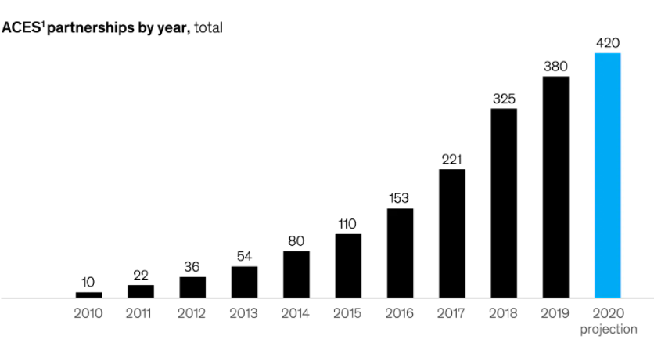
Figure 2: Investment opportunities in automation technologies and further projection
(Source: Hofstätter et al., 2020)
- Due to the advent of the Covid-19 pandemic, it so happened that, companies are looking for the development of their economic propositions, which would further require financial efforts. However, with proper investment in automated technologies and shared mobility, the automobile industry will be able to deliver its financial solutions effectively. To achieve this, the automobile industry needs to acquire an optimization of asset deployment with the help of strategic partnerships. It cannot be denied that the original equipment manufacturers and their economic outlook has undergone drastic change owing to the pandemic situation (Belhadi et al., 2021). Hence, the survival factor for the automobile industry is to be able to acquire a future-oriented business. For the achievement of this proposition, it is important to collaborate with former competitors and tech players.
Success factors
The automobile industry perceives the advantage of increased quality of life, which is based on increased mobility and safety. The advent of the Covid-19 pandemic has resulted in potential disruption of supposed business processes starting from lack of workforce to unavailability of raw materials. This eventually made the automobile companies think of alternative solutions, which will help them in reaching their business restoration. Such a scenario makes the necessity of identifying potential success factors that will enable profound business development within the automobile industry (Yadav and Singh, 2020). The preliminary factor that is undoubtedly a significant element is that of digital development. The increasing popularity of online channels is likely to provide certain alternatives, which are considered to be significant touchpoints for the purchasing process. This digital transformation needs to be a top priority for the companies, which would result in aggressive business development. It will also expedite effective revenue growth alongside profitability.
The presence of a robust and resilient supply chain is perhaps a major intrinsic element, which automobile companies consider to be a significant priority. The coronavirus dilemma further complicated the situation of the supply chain due to the presence of prolonged lockdown and unavailability of the workforce. Therefore, automobile companies need to rethink sustainable alternatives, which will help them to restore their supply chain processes (Hastig and Sodhi, 2020). This will eventually require the implementation of a proper digital infrastructure that will help in the management of the alignment of suppliers. The use of digital and automatic tools will further facilitate the simplification of quality control to a great extent. The association of a distribution network is an element, which is primarily driven by certain franchised dealerships. The post-Covid-19 scenario in the automobile industry requires knowledge and understanding about the key trends, which will facilitate business development. On the other hand, the ability and commitment of companies into strengthening customer awareness needs to be acquired, based on which the distribution network is to be developed (Bai et al., 2020).

Megatrends of the industry
The megatrends within a specific industry essentially portray an impact on a global scale. Some of the notable megatrends at a global level is found to be similar to that of global threats. Connected cars IoT is the foremost megatrend in the automobile industry. It refers to the application of IoT devices, which are capable of interacting with potential smart devices present on similar networks. With this IoT application, the automated vehicle is found to be equipped with automated technology. This helps in driving the vehicle without any physical labour, the car drives automatically with this technology. The first-ever company to have launched such cars in the market is that of Tesla (Kalaitzi et al., 2021). The company has been implementing standard connectivity on all their cars, which provides effective options to connect cars to the internet and communicate with the same. The company’s primary aim is to be able to effectively accelerate the transition of sustainable energy.
Due to the Covid-19 pandemic, people are more inclined to emphasise physical distancing. The presence of connected cars will be able to fulfil this aspect and the vehicle will also show real-time traffic information. In addition, the revenue pool of the automobile industry is likely to increase, which will result in diversifying the characteristically data-driven mobility services. Shared mobility provisions are likely to provide effective solutions with shorter lifecycles. This is likely to become a common factor as consumers are hesitant towards making large investments (Miglani, 2019). The use of shared mobility will eventually enable the companies to facilitate their upgrading demands in private cars as well. The availability of fully automated vehicles is likely to pave the way for further business development. This would include the provision of advanced systems for driver assistance that is likely to play a significant role in providing the best possible services within the industry.

Conclusion
In light of the above assessment and analytic association, it is important to conclude with certain remarks. It is to be noted that, the arrival of the pandemic has disrupted the automobile industry at large. However, owing to the current business scenario, and its digital dependence, the automobile industry is likely to gain successful imposition of business processes effectively. Therefore, the current study has managed to identify the implications of the pandemic on the automobile industry. The study has also shown the extent to which the survival and the SuccessFactors will facilitate a steady economic recovery of the industry.

Reference List
automotive council, 2021. UK Automotive Sector: overview [online] Available at: https://www.automotivecouncil.co.uk/uk-automotive-sector/ [Accessed 06 December 2021]
Bai, C., Dallasega, P., Orzes, G. and Sarkis, J., 2020. Industry 4.0 technologies assessment: A sustainability perspective. International journal of production economics, 229, p.107776.
Belhadi, A., Kamble, S., Jabbour, C.J.C., Gunasekaran, A., Ndubisi, N.O. and Venkatesh, M., 2021. Manufacturing and service supply chain resilience to the COVID-19 outbreak: Lessons learned from the automobile and airline industries. Technological Forecasting and Social Change, 163, p.120447.
Hastig, G.M. and Sodhi, M.S., 2020. Blockchain for supply chain traceability: Business requirements and critical success factors. Production and Operations Management, 29(4), pp.935-954.
He, H. and Harris, L., 2020. The impact of Covid-19 pandemic on corporate social responsibility and marketing philosophy. Journal of business research, 116, pp.176-182.
Hensley, R., Maurer, I., and Padhi, A., 2021. How the automotive industry is accelerating out of the turn [online] Available at: https://www.mckinsey.com/industries/automotive-and-assembly/our-insights/how-the-automotive-industry-is-accelerating-out-of-the-turn [Accessed 06 December 2021]
Hofstätter, T., Krawina, M., Mühlreiter, B., Pöhler, S., and Tschiesner, A., 2020. Reimagining the auto industry’s future: It’s now or never [online] Available at: https://www.mckinsey.com/industries/automotive-and-assembly/our-insights/reimagining-the-auto-industrys-future-its-now-or-never [Accessed 06 December 2021]
Kalaitzi, D., Matopoulos, A., Fornasiero, R., Sardesai, S., Barros, A.C., Balech, S. and Muerza, V., 2021. Megatrends and trends shaping supply chain innovation. In Next generation supply chains (pp. 3-34). Springer, Cham.
Miglani, S., 2019. The growth of the Indian automobile industry: Analysis of the roles of government policy and other enabling factors. In Innovation, economic development, and intellectual property in India and China (pp. 439-463). Springer, Singapore.
Ortiz-Villajos, J.M. and Sotoca, S., 2018. Innovation and business survival: A long-term approach. Research policy, 47(8), pp.1418-1436.
pwc, 2021. UK automotive demand in the wake of COVID-19 [online] Available at: https://www.pwc.co.uk/industries/automotive/insights/uk-automotive-demand-in-the-wake-of-covid-19.html [Accessed 06 December 2021]
smmt, 2020. SMMT MOTOR INDUSTRY FACTS 2020 [online] Available at: https://www.smmt.co.uk/wp-content/uploads/sites/2/SMMT-Motor-Industry-Facts-JUNE-2020-FINAL.pdf [Accessed 06 December 2021]
smmt, 2021. UK car production down -29.3% as coronavirus slams brakes on sector [online] Available at: https://www.smmt.co.uk/2021/01/uk-car-production-down-29-3-as-coronavirus-slams-brakes-on-sector/ [Accessed 06 December 2021]
Wagner, I., 2021. The automotive industry in the United Kingdom - statistics & facts [online] Available at: https://www.statista.com/topics/1982/the-uk-automotive-industry/#topicHeader__wrapper [Accessed 06 December 2021]
Wu, X., Zhang, C. and Du, W., 2021, July. An analysis on the crisis of “chips shortage” in automobile industry——Based on the double influence of COVID-19 and trade friction. In Journal of Physics: Conference Series (Vol. 1971, No. 1, p. 012100). IOP Publishing.
Yadav, S. and Singh, S.P., 2020. Blockchain critical success factors for sustainable supply chain. Resources, Conservation and Recycling, 152, p.104505.

