Assignment 1: - Report

Student Name: Sonia Davie Bijmohun

Student Number: 1905918

Lecturer Name: Christopher Mafuva

Module Name: Effective Team Working and Communication

Module Code: BMSW4002

Table of Contents | Page
- Introduction---------------------------------------------------------------------------------  - Relevant Theories of Communication-------------------------------------------------  - Shannon Weaver Model  - Berlo’s Model  - Schramm’s Model  - How communication can be made effective in a business organization-----  - The Importance of Effective Communication at Barclays------------------------  - Methods of Communication------------------------------------------------------------  - Verbal  - Non-Verbal  - Written  - The purpose of communication between management and employees-----  - Conclusion-----------------------------------------------------------------------------------  - Appendix-------------------------------------------------------------------------------------  - References----------------------------------------------------------------------------------- | 3  3  5  6  6  7  7  8,9,10,11,12  13, 14

- Introduction
The purpose of this report is to analyse different types of communication and the relevance of communication within a team. Communication Is demonstrated through interaction between two individuals or more, which is sent to each other using a communication medium such as oral, written, electronic or non-Verbal to create a mutual understanding. (Maund, 2015)
The reason why communication is so important in business is to work together to drive each other toward the main purpose of a company, which is the growth and where business lies amongst competitors and to show profitable figures.
A team is defined as a group of people who are created to perform relevant tasks. They share specific common goals and interact with each other in the process to achieve the same result in the end. (Maund, 2015)
Teamwork is essential for the success and competition of a business as people bring together their own set of talents and skills. (Middleton, 2015)
I will elaborate and detail the different types of communication and methods, theories of communication, why communication is essential in a business environment and how communication plays a bit part in teamwork.

- Relevant theories of Communication

  - Shannon-Weaver Model of Communication: -
Figure 1.

The relevance of the Shannon-Weaver Model of communication is huge as it was designed especially for the development of effective communication between the sender and receiver, but in the recent years it is used across the whole communication industry. Factors such as “Noise” were found which had an impact on the communication process. The main reason it was made was for technical issues written through an article in “Bell System Technical Journal” called “A Mathematical Theory of Communication”.

The sender chooses which message they wish to send, the messages is encoded through equipment which is used to turn messages into signals. The decoder’s role is to convert data received into an understandable message; this is the reverse process of the encoder.
The concept consists of different dilemmas between the sender and receive, which includes signals such as binary data or waves small enough to be transmitted through satellites and cables then based on the message received, the receiver then rephrases to give their feedback. Throughout, the model focuses on external noises such as a car horn or rain and thunder which affects the channel and interprets messages or signals wrongly (Communication Theory, 2017).

There was once a scientist called Warren Weaver and a mathematician called Claude Shannon in 1940 who both had a job at the bell telephone company invented the theory to help engineers to perform better at work. Later down the line, because they became the most popular model of communication, they were known to be the mother of all models and was given the nickname “The Shannon-Weaver Model” (Hendricks, 2003-2019).
In the workplace this theory can be applied to communication by using an office where possible to avoid any noise interruptions.

  - Berlo’s Model of Communication
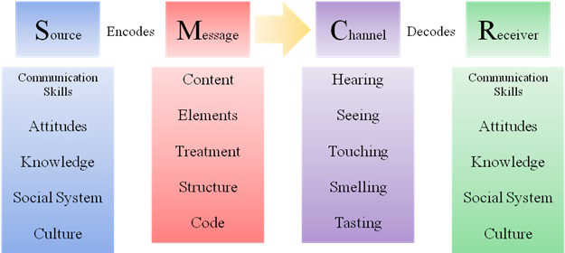
Figure 2. (Rathinaswamy, 2017)

The most convenient communication takes places when both the sender and the receiver (as shown in figure 2) have communication skills which are mutual like attitude, knowledge, social system and culture, these important factors make decoding and encoding easier as people are connected.
A pattern called the SMCR, S is the source, which is also the sender of the original idea, encodes which is affected by the communication skills possessed, M is the message in which different elements are conveyed like tone of voice or the information in a PowerPoint slide. C is the channel through which the message is sent in relation to the five human senses. R is the receiver, who then decodes using their communication skills (Khalimzoda, 2016, p. 426).

This theory is important in our society as Britain is multicultural and the people have diverse understandings, therefore in the workplace we need to be able to take out time and break down the message and think closely about how other people may want to be treated before approaching a colleague or client.

  - Schramm’s Model of Communication

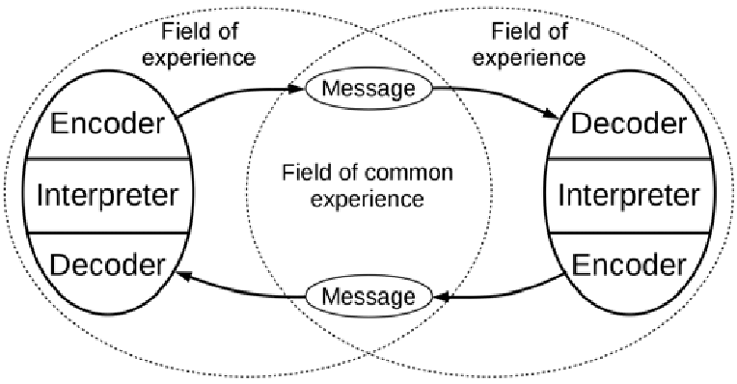
Figure 3. (Al-Darraji, 2015)

The idea behind the straightforward Wilbert Schramm’s suggestion of communication is that two people should take turns in the two-way process to send and receive messages. As shown in figure 3, there are different components of the theory. Schramm’s impression is dynamic as it is always developing. It comes from the middle part of a circular cycle as sender and receiver share common experiences as per relationships, backgrounds and the type of information and how it is shared. People in common can give appropriate feedback and share metaphors, meaning the style of language they communicate (Santiago, 2018).

Use of the Schramm’s concept in the workplace may be unsuitable towards some colleagues or customers. As you familiarise yourself with people there could easily be clashes or misinterpretation even though your intentions are good, this can affect your overall performance.

- How communication can be made effective in a business organisation
Through empathetic communication, employees must be confident in the information given to them by members of the organisation as they are the face of the company and are trusted by members of the public who value the information which is being received.
With great communication, employees are capable with negative issues and respond fast and turn it into a positive, giving themselves a good representation in the business. Employees should also know well about the company’s background as well as its products and services in order to deal with these situations without the need for apprehensiveness. Communication in a team can be effective by making people feel comfortable when dealing with conflict and resolving issues. Communication is more effective when the company is organisational and employees from all levels of the company come together to build strong teamworking skills so they can provide each other with knowledge, structure and a positive work environment to achieve the company’s goals.
The more product knowledge an employee has can influence the way they can do their job better in terms of other business connections and their approach to the community, their family and friends.
Communication with customers can create new and innovative ideas as information can be used to achieve better results in product and service delivery. Employees need to understand that seeing opportunities for transformation of the company’s success is their chance to be seen and to receive feedback and have the company’s implications.
In order to achieve positive feedback, expectations for employees as well as customers need to be established with the help of effective communication. Clear expectations will influence an employee’s performance to better the business and will indicate their duties to achieve positive feedback. Clear communication will help to manage customer expectations on the ideal way to approach the business and how they can deal with service issues.
There are some key factors such as trust and loyalty in work relationships which are powered by communication which has a focus to meet each person’s needs. Good and constructive feedback is essential when important information is being passed on. When good relationships are built with people from their own networks, communication about products, services and company values can help the organisation to expand (Richards, 2019).

- The importance of communication at Barclays Bank
It is highly required at Barclays to have high standards of communication as they are a reputable company around the world and they have set levels for different employees to be able to deliver only specific information as misinformation can lead to complaints which is taken very seriously in the banking industry. For customers, communication approach with the bank is the key to find out which products and services available is most suitable them and their family. When customers have received the correct information about products and services efficiently, it allows them to realise how much Barclays can offer them and that it isn’t necessary to do deal with multiple third party companies and that they can do everything in once place, such as open an ISA account for savings, take out a life insurance policy to protect their family, or even a policy to protect their home and personal belongings.

For employee’s communication vital for the company’s reputation, and day to day running of the business as Barclays is a reputable company and employees are the face of the company. You need to promote healthy business by having a professional approach in the way you approach customers as they are trusting you with the most important thing; their money. You need to be able to build relationship with regular customers and be able to judge how they may be feeling and not force customers into paying for services but to identify the customers need and find the right attitude and convince them why the service may be beneficial to them. Offers and promotions are a good way to bring out your communication skills for the engagement of customers with the business.

Most of all, communication plays a big part in teamworking, coming up with creative and innovative ways and sharing those ideas, bringing them together promotes business and provides culture to the organisation. As staff members, teams should communicate frequently, technology has made it easy where you can talk to colleagues in different departments by walkie-talkie, phone or email. At the beginning of the business day, all staff have the same motives and their goals are to reach target figures by continuous engagement with customers and share responsibility.

- Methods of communication
  - Verbal
This type of communication involves creating meaningful messages through types of languages and the information is accurately broken down and interpreted. Within the shared language surrounds verbal fillers such as ‘um’ or ‘like’. Professional people make the most effective use of their language skills, continuously developing gives you the ability to interpret more complicated messages. Although good speakers are always transmitting their point across, the listener may fail to understand the speakers meaning due to different factors (Maund. M. Schreik. M &Tinkler. K, 2017). Time is taken to think carefully about the meaning of the words are chosen before constructing a sentence, people are judgemental so how someone may react to your message must be considered.

  - Non-Verbal
This type of communication simply means the way to communicate without words. A more technical definition is “communication other than written or spoken language creates meaning for someone” (Ivy & Wahl, 2014, p.5).
Communicating without speech or writing is considered a tool for conveying thoughts, attitudes, perceptions and meaning. It has been proven through research that 55% of interpersonal messages are demonstrated through non-verbal communication (Lavan, 2012).

Emotion is shown through people behaviour, for example, you see someone looks sad and you ask them what’s wrong and they respond “nothing” but then through things like tears, body posture and facial expressions you understand something different to what the person is perceiving. In a professional environment, when communication you can distinguish a person who seems disinterested by their behaviour, they may have bad eye contact, folded arms or fidgeting or a slouching position.

  - Written Communication
This type of communication is used to send information to different places such as business organisations, this could be an email, handwritten or typed letter which in most cases will be formal. Informal messages could be through social media to a colleague to organise for a Christmas event.

- The purpose of communication between management and employees
Management should be concise to avoid confusion and misunderstanding, technical jargon and avoid inputting too much information in writing should be avoided, messages have to be consistent with all employees, so nobody feels left out, sometimes messages need to be delivered multiple times to ensure understanding. CEO’s need to ensure that management are leading an example to show there is a relationship between achieving goals of the organisation and the having communication strategies with employees, this encourages trust in the organisation. Management should be able to understand employee needs and make sure they’re receiving the information they need so they can work efficiently, it is of high importance for time to be given to employees for training often. Measure the effectiveness of objectives and ask for feedback from employees about day to day activities. Prioritisation should be given to employees first and they should be notified of anything serious before hearing it elsewhere (Primepay, 2019).

- Conclusion
In summary, I have learnt that various techniques are used to facilitate communication. Theories written in the pass have contributed to the structure of communication which is still being used to create more advance communication processed. I have understood that to make communication effective in an organisation everyone needs to contribute and have positive attitude, at Barclays bank correct information must be provided for people to put their trust in our institution to protect their money. I have also understood that different methods of communication to are used to express oneself in personal and work-related conversations. Lastly, valuable communication skills are transferred between management and employees for success in all areas of the business.
The never-ending process of communication will to be used evermore in groups and teams.

- Appendix
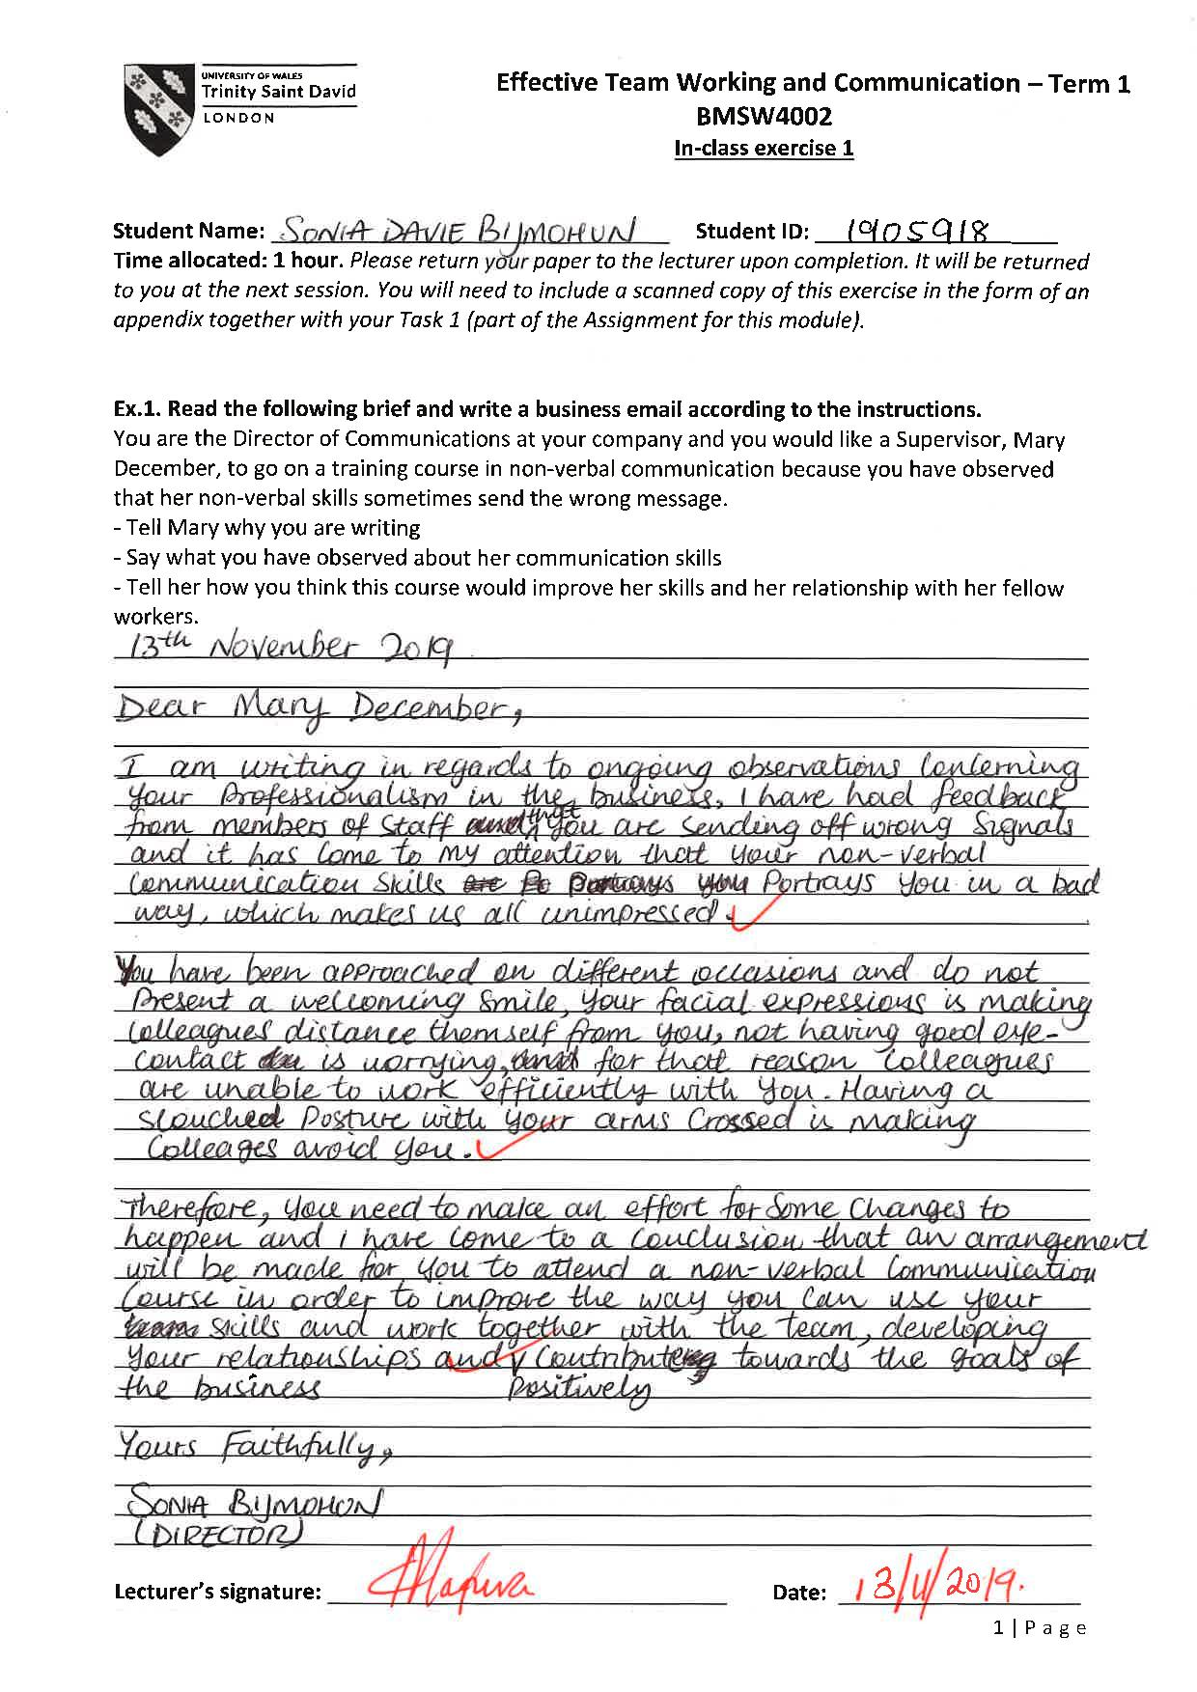

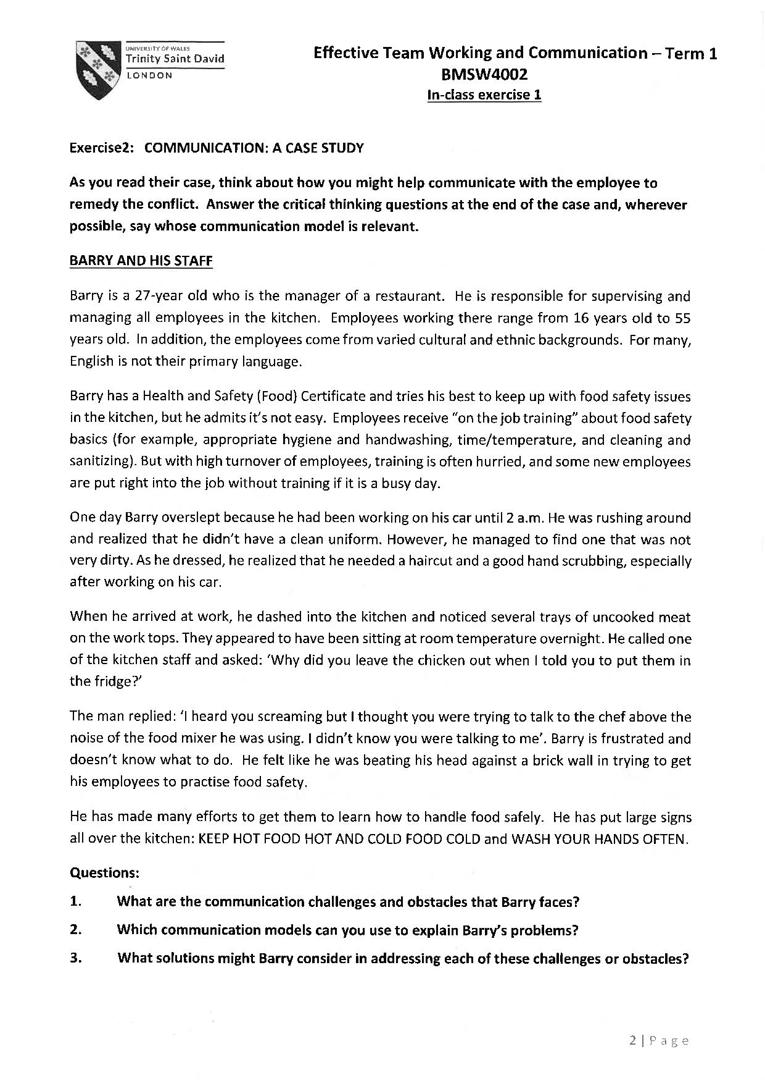

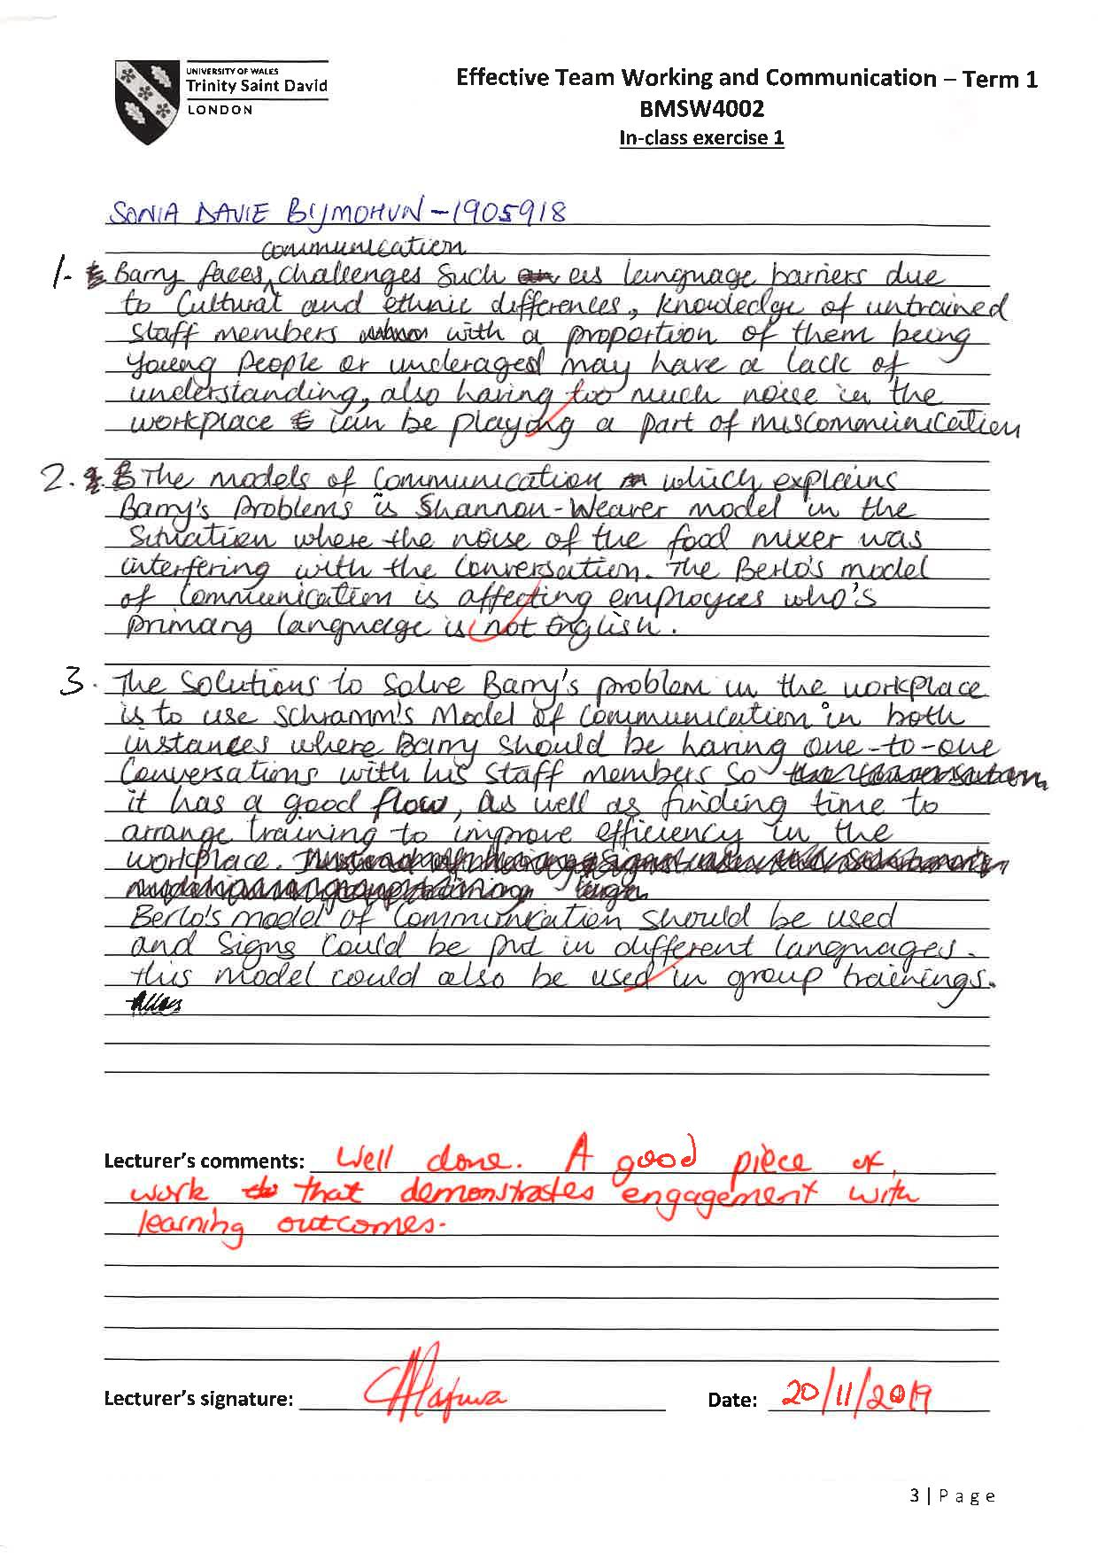

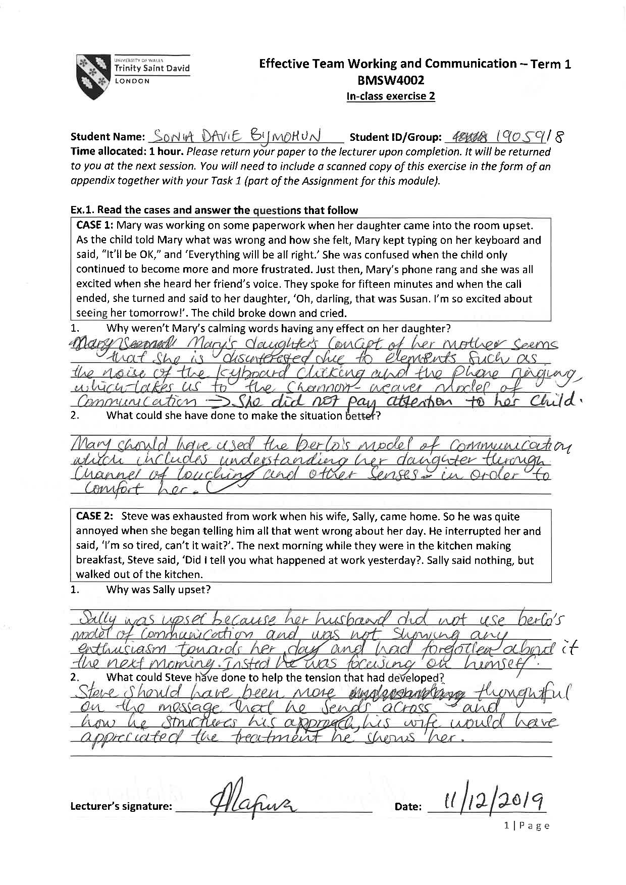

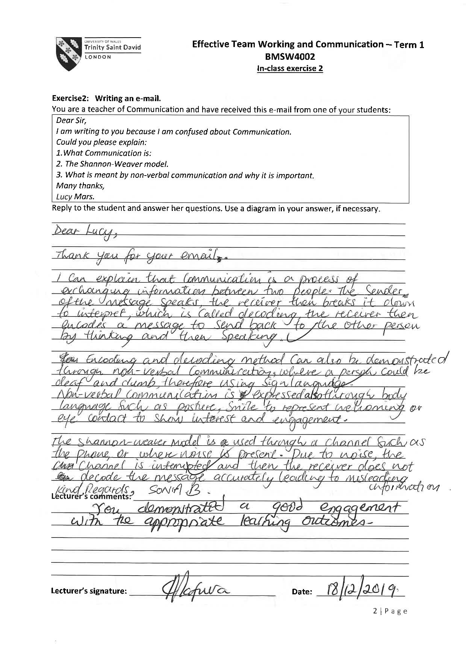

References

Communication Theory (2019) Shannon and Weaver model of communication [Online]. Available at: https://www.communicationtheory.org/shannon-and-weaver-model-of-communication/ (Accessed: 25 December 2019).

Hendricks. B (2019) Shannon-Weaver Model of Communication: History, Features & Application [Online]. Available at: https://study.com/academy/lesson/shannon-weaver-model-of-communication-history-features-application.html (Accessed: 25 December 2019).

Maund. A, Schreik. M & Tinkler. K. P (2015) Certificate in higher education: skills for the workplace student yearbook. London: SAGE, p. 47.

Kozlowski and Bell (2003) ‘What is a team?’ cited in Maund. A, Schreik. M & Tinkler K. P (2015) Certificate in higher education: skills for the workplace student yearbook. London: SAGE, pp. 4-5.

John. J. J (2011) ‘Pulling together: 10 rules for high-performance teamwork’ cited in Middleton. T (2019) The importance of teamwork (as proven by science) [Online]. Available at: https://www.atlassian.com/blog/teamwork/the-importance-of-teamwork (Accessed: 26 December 2019).

Kalimzoda. I (2016) ‘Communication models and common basis for multicultural communication in Latvia’, From the Proceedings of the International Scientific Conference, Turiba University, Latvia, 27-28 May 2016, 4, pp. 423-433, [Online]. Available at: https://www.researchgate.net/publication/303556858_COMMUNICATION_MODELS_AND_COMMON_BASIS_FOR_MULTICULTURAL_COMMUNICATION_IN_LATVIA (Accessed: 28 December 2019).

Rathinaswamy. J (2017). Picture of the SMCR model of communication [Online}. Available at: http://jayaseelansr.blogspot.com/2017/07/david-berlos-model-of-communication.html (Accessed: 28 December 2019).

Al-Darraji. S (2015). Picture of the interactive model of communication presented by Schramm [Online}. Available at: https://www.researchgate.net/figure/The-interactive-model-of-communication-presented-by-Schramm-14_fig1_311739283 (Accessed: 30 December 2019).

Santiago. B (2018). Schramm’s model of communication: YouTube Video [Online]. Available at: https://www.youtube.com/watch?v=2lC_GDVYm64 (Accessed: 30 December 2019).

Richards. L (2019). How effective communication will help an organisation [Online]. Available at: (https://smallbusiness.chron.com/effective-communication-organization-1400.html (Accessed: 31 December 2019).

Maund. A, Schreik. M & Tinkler, K. P (2017) Certificate in higher education: skills for the workplace student yearbook. London: SAGE, p. 67.

Ivy & Wahl (2014) cited in Maund. A, Schreik. M & Tinkler. K. P (2017) Certificate in higher education: skills for the workplace student yearbook. London: SAGE, p. 69.

Lavan (2012) cited in Maund. A. Schreik. M & Tinkler. K. P (2017) Certificate in higher education: skills for the workplace student yearbook. London: SAGE, p. 69.
Primepay (2019). 11 tips for effective employee communication [Online]. Available at: https://primepay.com/blog/11-tips-effective-employee-communication (Accessed: 5 December 2020).

