Student name Mohammed Amir Hussain Chaudhary Student registration Number 1711710 Module code B M S w – 6102 Group number One Lecturer’s name Dr Nazmul Hasan Module name developing innovation and creativity for . business advantage

Task1

Overview of the innovative service.
The innovative service that I intend propose to create will be in the form of an app called coronavirus health and safety app (CHASA). This app will be designed and built for the sole purpose of guiding the general public on how to protect themselves from the coronavirus pandemic and if they are suffering from coronavirus symptoms or they are infected, then this app will guide them through each and every necessary step of their journey to recovering themselves, whilst. their privacy and identity is protected. After scanning the environment, this innovative app will be created because there is the pull factor in the market for this app.

This app is an improved version (radical business innovation) of the governments track and trace app (GTATA). According to Cavanagh (2007). Individuals infected with the coronavirus will have mild to moderate breathing illness at a primary stage. Once this app has been installed on a smart device (mobile phone, iPod, laptop, computer etc.). It will notify the individual immediately if it detects that the individual has been in close contact with other who have tested positive for coronavirus. The user of this app will benefit from many other additional features which will be explained at a later stage.

This app will be launched on a digital platform. Bearing in mind the present scenario of the coronavirus, sales of products or services on online platforms have increased, due to the government put restriction none essential shops to close. According to Srinivasan and Venkatraman (2018). There are many benefits to launching an app on a digital platform such as providing more value to your customers, connect better with customers and boost profits.

The intended customers for this app are the general public (working class individuals) from youngsters to middle aged and senior citizens, as the app is affordable for everyone. This app will be very appealing to health-conscious individuals and will target the local market (west midlands region).

This app has only one other app which is similar to this app and that is the app which is GTATA the GTATA has only been launched about six months ago and currently it is very popular, the method needed to obtain the GTATA is it can be downloaded for free. The overall cost for the entire project of setting up the app on a digital platform is estimated at £1,000 pounds only. This app can be downloaded for just £2.00 only, which is less than the price you pay for a cup of coffee and will give the satisfaction of knowing what steps are required when faced with coronavirus.
Compared to the competitor.
This app will assist individuals to gain the necessary information required to avoid passing the virus onto others by helping them to isolating themselves. The modification between the GTATA and the CHASA are clarified below.

The GTATA advises individuals to wash their hands with soaps for 20 second. The CHASA also advises the same, at the same time this app will also advise you on which is the best soaps to use in this pandemic and the reason for choosing this soap.

The GTATA advises on wearing face masks when you go out, The CHASA will tell you exactly the same advice, also advice you on which type of masks are better and safer to use in this pandemic and explain the reasons for this choice. According to (Eikenberry et. al. 2020). Face masks helps stop the user from conveying the coronavirus to other individuals and may provide some defence to the user.

The GTATA advises on isolating yourself for 14 days, when you have coronavirus symptoms. The CHASA will tell you exactly the same and will also explain on how to keep your family safe, distance you should maintain from family members and what steps to take when you require help.

If you are infected with coronavirus, the GTATA advises to book a coronavirus test. The CHASA will provide you with the same advice, it will also provide you with the information on where the nearest test centre is, what are the availability at that test centre, how long your expected to wait for your test and when will you receive your test results.

Additional benefit of CHASA compared to the GTATA is this app is a dual app, when you open the app you will notice two click buttons, if you click the wright button it will guide you about healthy foods, which food contains how many calories, how many calories should an individual consume on a daily basis to sustain a healthy diet. If you click the left button it will take you to the coronavirus section.

Process of sustaining the new and innovative app
For the sustainability of this business app idea, there is a needs to establish a strong sense of direction for the app. Recognising the business requirement to back the app, to sustain the idea there is the needs to meet the customer’s requirements and at the same time be attentive of a business, another approach that can be applied to sustain the new app is employ proper technicians to make sure the app is updated when required, changes one of the main form of innovation, the app will be updated frequently, when it comes to customer service, there will be no compromising. According to De Brentani (2001). To increase a business, it involves the right knowledgeable principals, wisely designated strategic partnerships, and products and/or services with strong requirement at the marketplace.

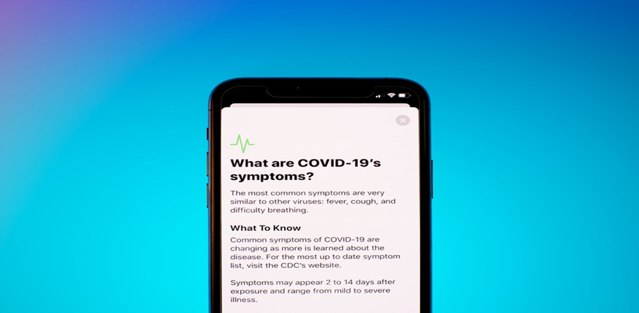
Figure 1: Images coronavirus health and safety app

Task 2

Developing the app.
This app was developed using Monday.com website. Monday.com is a website that creates apps by using swing2app software tool to develop them. The main motive for using the Monday.com website to develop this App was, it was the most competitive App developing website, in comparison to other websites like dynamic web applications, portal web app and animated web applications. The Monday.com offered a package that suited our budget that have been allocated for the CHASA. According to (Castledine et. al. 2011). It is very vital to use a professional website to develop an app as they are trained and efficient in that sector. Another facility that Monday.com offer for free is they register your app for copyright purposes, so your app can’t be copied.


Figure 2: Images of Monday.com.

Proposed to set up an online digital platform for the app.
This app is going to be launched on google apps store a digital platform for launching a service app. Google app store can be easily accessed by any digital device that can be linked to the internet. These authors claim (McIlroy et. al. 2016) It offers access to content on the Google app store, containing apps, magazines, books, movies, music and TV programs etc. Before finalising the idea of launching this app on Google app store extensive researches have been conducted on other online platforms such as SaaS and Shopify, blog.hubspot.com and after analysing all the data of the above mentioned, it is clear that google app store can be easily linked with other online platforms. It is easy to download apps from google app store. their payment protection system is very secure and also, the budget for launching the CHASA had some influence on launching the app on google app store.

Figure 3: google app store

PayPal payment method.
Google app store use PayPal method to receive payments from their customers. According to Top ten money transfers UK (2020). Top money transfer services are EX, Currencies direct, Currencyfair and PayPal. After analysing the above, it was concluded that PayPal offered the best rates, which is 3% of every transaction made, this offer is only for new business (which is way better than the rate their competitors offered). PayPal’s payment protection system is very secure and customers will feel safe using PayPal as it is a recognisable brand.

Figure 4: Image of PayPal

Creating the content.
The focus will be to create a very good quality app, this is vital because people appreciate good quality over quantity, this will play a key role in establishing the app within the marketplace. There is the need to focus on making the app appealable to customers by using short, creative and catchy sentences which customers can understand and empathise with. This is a closed innovation as it was created by an individual in a self-contained environment. According to Handley and Chapman (2010). When you create a content, one should keep in mind that content fulfils the market goal. Researches should be carried out to understand your customers.

Gaining knowledge on PCI - DSS and their impacts.
In today’s global world, every business is accepting card payment methods to operate their business successfully. According to Forsythe and Shi (2016). Over 75% of the population in UK are purchasing products online or at a retail store using card payment methods. Payment Card Industry (PCI) Data Security Standard (DSS) are required for organizations that operate or utilise a card-processing devise in their businesses, every entrepreneur should make sure that business process of keeping and conveying data associated to credit card are preserve in a secure environment.

According to Shaw (2009). If a business does not apply with PCI requirements for compliance with security measures, it could result in forfeiting of the device and legal action can be taken against the entrepreneur, he further goes on to explain about the legislation.gov.uk, 2020 the “Copyrights act, Designs and Patents Act 1988 (c.48)” propose the right method for monitoring upon ways in which data would be utilised. The entire purpose of the PCI-DSS is to protect card data from thieves and hackers. Via ensuring the standard are upheld, you can keep your data secure, evading costly data breaches and safeguarding your employees and your clients.

It is very vital for the customer of CHASA to feel secure when they are making the payment to purchase the app. For purchasing the services of PCI-DSS, CHASA will be charged annually £100 pounds.


Figure 5: Image of PCI and DSS

Task 3

Marketing
Marketing is a strategy that an organization applies to promote their product or service. Marketing comprises selling, advertising and delivering products to customers and other establishments. According to Bratnicka-Myśliwiec (2015) Marketing can be split into different areas such as increase brand awareness, to grow and preserve through leadership, to increase customer value. Marketing is significant because it helps you sell your products or service and creates a better relationship amongst the customer and the supplier.

The main objective for any business is to make money and marketing is a crucial network to reach that target. Marketing is the backbone for CHASA. As a new business, proper marketing approaches are essential to launch the app, without marketing strategies this app will find it very difficult to exist in the market and reach its ultimate goal. According to (Hooley et. al. 2008). Marketing has a significant role in boosting the sales of a business.

Launching the app.
The approach that will be applied to launch the CHASA, is the product lifecycle. It will be utilized like a check list for each and every stages before the final launch of the product, so that each and every possibility are analysed in an appropriate method and nothing is missed out. According to Day (1981). Product lifecycle is extensively used in the marketing world as a development tool.

Product has a lifecycle which comprises of numerous phases which it goes through, at every phase, there are diverse challenges the marketers have to deal with to make sure the product gets through to the following phase. According to Tidd and Bessant (2018). Managing innovation is crucial, as this can create a pathway to launch a product or a service successfully.

Utilising social media platforms for marketing.
In the era where technology is dominating our lives, utilising social media platforms such as Facebook, Twitter and Instagram to influence the intended customers, this will be a beneficial strategy for the CHASA as these platforms are effective and a cost efficient process. By using these social media platforms information and images of the app can be shared.

As entrepreneur I am able to upload videos and chats in regards to the app. Furthermore, these social media platforms are useful in collecting feedbacks. Another approach that will be applied is putting leaflets on billboards at the local corner shops, the reason for taking this approach is the senior citizens who are not connected to the digital platforms, this app is very vital for them to, it is also in line with the budget of the project as putting leaflets on billboards are free. Below are the statics for businesses using social media platforms to promote their business in UK 2019 (Matt 2020). In the reference there is the link to the Apps webpage and in appendix there is the image of the Apps webpage.

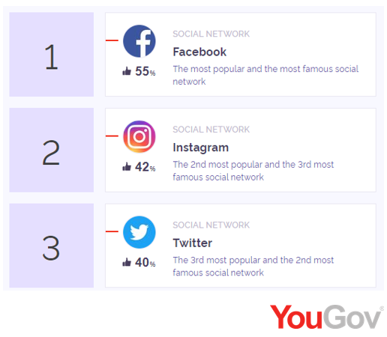
Figure 6: Static for social media platforms (2020)

Using paid search engine optimization (SEO).
When you search for a certain product or a business on google search engine, there are many similar businesses that show up, most of the time customers look at the top few and decide on utilising one of them. If your business advert is not in the top few then there is a very good chance that customers will not notice your company. If your business is subscribed with SEO then your business will appear above your competitors. According to Buss and Strauss (2009). The benefit for businesses who use SEO for their business are SEO Leads to Improving users experience and approves effective cost management. CHASA is a new app, it is vital that SEO should applied to this app, so when customers search for similar apps, this app will appear in the top few and will have a better chance for this app to be successful.


Figure 7: Diagram of search engine optimization

Understanding the customer and their journey.
For business it is essential that they understand the value of their customers. In order to understand the necessity of the customers it is vital that businesses understand the customer experience in the entire journey. These authors claim (Lilien, et. al. 2002). Using idea generation and idea screening from the project lifecycle will assist businesses to gather feedbacks and ideas on their product.

As the proprietor of CHASA, the attention will be on analysing the customer journey and experience that customers went through when they were interacting with CHASA. Not just observing at part of an experience (like reading the app or downloading it) but the customers full experience of the journey of using the app. for example, after downloading the app did they follow all the procedure’s, how did they find the app was it helpful or not, was it beneficial for them if so, in what way, any recommendations for future improvements.
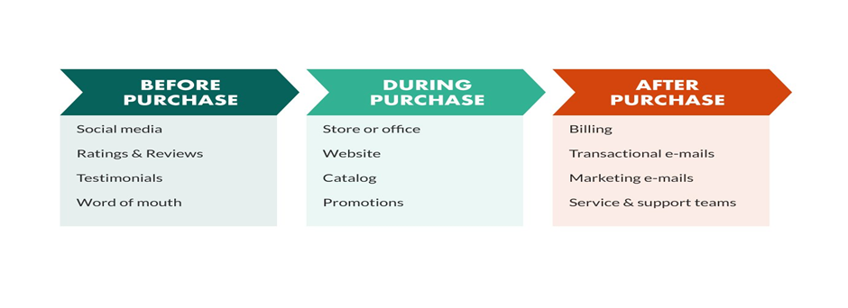
Figure 8: Image of customer’s journey.

Email is a vital strategy that will be applied to share the message about CHASA to potential present and future customers, as every smart devise has the ability to receive and send emails and almost every businesses and individuals (adults) in the UK are in interaction with a smart devise, but everyone can’t be emailed, due to data protection, so only friends, family, relatives and people that socialize on Facebook, Twitter, Instagram, WhatsApp will be contacted through email only after obtaining their consent to this. According to Sterne and Priore (2000). Email marketing is the action of sending a commercial message, naturally to a group of individuals, using email. In its comprehensive sense, every email sent to a potential or current customer could be regarded as email marketing.


Figure 9: benefits of using professional business Email

Reference.
- Bratnicka-Myśliwiec, K., 2015. Relationship between leadership styles and organizational creativity. Management and Business Administration. Central Europe, (1), pp.69-78.
- Buriy, A. (2015) image of app store (online) Available at:
https://www.behance.net/gallery/30575717/Free-icons-AppStore-and-Google-Play-(2015). Accessed on 5-10-2015.
- Buss, A. and Strauss, N., 2009. Online community handbook: Building your business and brand on the Web. New Riders.
- Castledine, E., Eftos, M. and Wheeler, M., 2011. Build mobile websites and apps for smart devices. SitePoint.
- Cavanagh, D., 2007. Coronavirus avian infectious bronchitis virus. Veterinary research, 38(2), pp.281-297.
- Chaudhary, M., A., H., 2020. Image of Coronavirus Health and Safety App.
(online) Available at https://app-for-coronavirus-healthy-and-safty.myshopify.com/admin/products/6066050564281 Accessed on 5-10-2020.
- Day, G.S., 1981. The product life cycle: analysis and applications issues. Journal of marketing, 45(4), pp.60-67.
- De Brentani, U., 2001. Innovative versus incremental new business services: Different keys for achieving success. Journal of Product Innovation Management: An International Publication of the Product Development & Management Association, 18(3), pp.169-187.
- Edinburgh Napier university (2018) images PCI and DSS (online). Available at:
https://staff.napier.ac.uk/services/finance/Pages/PCIDSS.aspx. Accessed on 2-10-2020.
- Eikenberry, S.E., Mancuso, M., Iboi, E., Phan, T., Eikenberry, K., Kuang, Y., Kostelich, E. and Gumel, A.B., 2020. To mask or not to mask: Modeling the potential for face mask use by the general public to curtail the COVID-19 pandemic. Infectious Disease Modelling.
- Forsythe, S.M. and Shi, B., 2016. Consumer patronage and risk perceptions in Internet shopping. Journal of Business research, 56(11), pp.867-875.
- Gurmanll (2017) images of SEO (online). Available at:
https://www.fiverr.com/gurmanii/write-seo-shopify-product-description. Accessed on 6-10-2020.
- Handley, A. and Chapman, C.C., 2010. Content rules: How to create killer blogs, podcasts, videos, ebooks, webinars (and more) that engage customers and ignite your business (Vol. 5). John Wiley & Sons.
- Holland, A. (2019) images of Monday.com (online) Available at: https://monday.com/ Accessed on 5.10.2020.
- Hooley, G.J., Piercy, N. and Nicoulaud, B., 2008. Marketing strategy and competitive positioning. Pearson Education.
- Lilien, G.L., Morrison, P.D., Searls, K., Sonnack, M. and Hippel, E.V., 2002. Performance assessment of the lead user idea-generation process for new product development. Management science, 48(8), pp.1042-1059.
- MacDonald, S. (2020) image of customer journey (online). Available at:
https://www.superoffice.com/blog/customer-journey/. Accessed on 27-10-2020.
- Matt. (2020) Social media statistics in the UK. (online) Available at: https://www.talkwalker.com/blog/social-media-statistics-in-the-uk. Accessed on 4-10-2020.
- McIlroy, S., Ali, N. and Hassan, A.E., 2016. Fresh apps: an empirical study of frequently-updated mobile apps in the Google play store. Empirical Software Engineering, 21(3), pp.1346-1370.
- McGowan, B. (2020) image Coronavirus healthy and safety app (online) Available at: https://unsplash.com/s/photos/images-coronavirus-app. Accessed on 4.10.2020.
- Pavan (2015) Image of Email (online). Available at:
https://www.znetlive.com/blog/5-benefits-of-a-professional-e-mail-address-for-your-business/. Accessed on 8-10-2020.
- Shaw, A., 2009. Data breach: from notification to prevention using PCI DSS. Colum. JL & Soc. Probs., 43, p.517.
- Srinivasan, A. and Venkatraman, N., 2018. Entrepreneurship in digital platforms: A network‐centric view. Strategic Entrepreneurship Journal, 12(1), pp.54-71.
- Sterne, J. and Priore, A., 2000. Email marketing: using email to reach your target audience and build customer relationships. John Wiley & Sons, Inc.
- Tidd, J. and Bessant, J.R., 2018. Managing innovation: integrating technological, market and organizational change. John Wiley & Sons.
- Top ten money transfer .com (2020) (online) Available at: https://www.top10moneytransfer.com/send-money-online-uk. Accessed on 4-10-2020.

Appendix.
Image of Coronavirus Health and Safety App.



