Module name: International Business Communications

Assignment 1

Module Code: LCBB6001

Name: Valentina Pituscanu
Student ID: 2124861

Table of Contents
About Aviva 3
A Proposal of EU Country that Aviva Should Consider for Expansion 4
ECONOMIC STABILITY 5
TECHNOLOGICAL INFRASTRUCTURE 5
Hofstede cultural dimensions: Spain vs Netherlands 9
Recommendation 11
Cross-Cultural Training 11
Language Support 11
Adapt Communication Style 12
Cultural Sensitivity 12

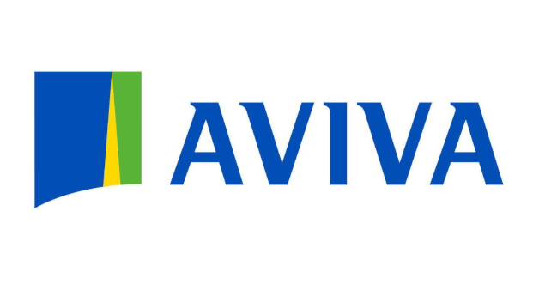

About Aviva

The multinational and universal insurance company is registered in London, UK; Aviva plc is the largest insurer in the world. It has offices in Europe, Asia, and North America that serve as its markets. Aviva offers diverse types of coverage such as life insurance, general insurance, savings and assets management.
Key Information on Aviva:
In 1696 Hand-in-Hand Fire & Life Insurance Society was established in London where it finally grew to become what is now known as Aviva over the years through different fusions, acquisitions and rebranding efforts.
Worldwide presence characterizes a company such as Aviva that operates from multiple markets including significant ones like the United Kingdom (UK), Ireland, France Canada and other Asian nations. It also has operations outside of its home country thus regarded as one of the top global insurers.
The firm has a wide array of policy types meant for individuals or corporations with offerings from life assurance to health policies to property-casualty covers to solutions for retirements and investments.
In addition to insurance, Aviva also offers financial services such as asset management, wealth management and retirement planning solutions. This is to ensure that customers’ financial objectives are met and they secure a future through an all-inclusive range of financial products and services.
Aviva has made sustainability in business practice and corporate responsibility its core priority. The company considers the environment, social issues, and governance in its operations and investment decisions. Various CSR projects that reduce the carbon footprint of the company, endorse diversity & inclusion and support communities have been set by Aviva.
Innovation is given prime attention at Aviva to remain competitive amidst rapidly changing insurance market trends. At present, this insurer is investing in digital advancements along with technology to improve the experiences of clients, coming up with fresh customized policies to adapt to ever-changing client requirements while cutting costs.
Maintaining transparency, accountability as well as integrity within business operations requires having high standards of corporate governance which Aviva maintains too. Ethical behaviour in business practices and adherence to relevant regulations are regularly appraised by the company through various initiatives since it’s guided by some moral compasses among other regulatory demands.

Aviva, in all, is a major player in the global insurance industry for strong financial performance and its comprehensive product offerings as well as sustainability and corporate responsibility. Aviva has remained a reliable partner for individuals and enterprises seeking to deal with risks in their lives through insurance products and financial services due to its extensive presence across the globe.
A Proposal of EU Country that Aviva Should Consider for Expansion
Expansion of business operations into new territories represents a landmark decision by any organization that wants growth and sheer survival amid today’s globalization. This applies also to the multinational insurance company Aviva. As an insurer at the forefront, Aviva is always after opening up new markets for it. Consequently, this essay will discuss what factors the company should consider while making recommendations on where next to expand in Europe from within the European Union.
ECONOMIC STABILITY
The first thing that Aviva must focus on when recommending a potential EU-based country for expansion is economic stability without any doubt. For instance, it provides predictability that helps reduce risks associated with market volatility. Related to the strong GDP advancement, low inflation and political stability in the country is a good environment for business expansion. This is apparent with the likes of Germany, France and the Netherlands which have great economies and stable business climates within the European Union(EU).
Regulatory Environment
Aviva needs to look at insurance industry regulatory frameworks in prospective EU-based countries. The appropriate regulations ensure competition as well as consumer protection and financial stability. Besides, sticking to EU laws and standards facilitates understanding of more general market practices thus leading to easier integration into the European marketplace.
MARKET POTENTIAL
The targeted country should be probed about its market potential by doing comprehensive market research on insurance products or services demand (Aviva). For this reason, indicators such as population demography, income levels and existing insurance penetration rates do play a significant role in estimating market potentials. It has been found that those countries experiencing demographic shifts such as an ageing population or growing middle-class segment offer attractive opportunities for insurance companies. Additionally, studying the competitive scenario along with identifying untapped niche segments may provide Aviva with a competitive advantage in the chosen country

TECHNOLOGICAL INFRASTRUCTURE
In today's digital era, technology infrastructure is essential for any business venture. Aviva should consider the technological capability of prospective EU-based countries including their internet penetration rates, literacy in digital skills and the availability of advanced IT infrastructures. Technological advancement facilitates the delivery of innovative insurance products, enhances customer engagement through digital channels and streamlines operational efficiency.
CULTURAL AND LINGUISTIC CONSIDERATIONS
Cultural nuance and language preference are major determinants of success for business operations in a foreign market. Aviva must look into cultural diversity and linguistic choice as propelling factors to ascertain whether it will be possible to communicate effectively with consumers in that region or not. Trust is built through effective communication reflecting local sensibilities and languages which make the customers feel understood. Furthermore, by understanding cultural norms, Aviva can tailor its product offerings and promotional strategies to appeal to its target audience.
Cultural Differences Between Spain and the Netherlands
To evaluate Spain and the Netherlands based on the criteria provided, let’s now look at each consideration:

Aspects | Spain | Netherlands
Country Facts | Situated in southwestern Europe, Spain has rich historical background, multiculturalism and a Mediterranean climate. It has over 47 million people as residents who speak Spanish as their official language. In high-context cultures like that of Spain, non-verbal cues and contextual factors play very significant role in communication. | Located in northwestern Europe, it is known for being flat with windmills and tulip fields. It has more than 17 million inhabitants who speak Dutch as their official language. Generally direct communication is common among the Dutch culture which embraces low-context approach.
Social Environment and Profiles | Family and personal relations are very important in Spain. The Spanish also value work-life balance hence have long lunch breaks and are not strict on time keeping. They may have hierarchical structures at workplaces which make decision making process slow as they always try to build consensus. | In the Netherlands, equality and individualism are highly upheld. Work-life balance is also significant thus employees work for fewer hours compared to other countries. Decision making in Dutch companies is a collective responsibility because communication channels are open so anyone can give their opinion.
Language | Spanish is the official language spoken by majority of Spaniards which makes it a must learn if you want to communicate well either socially or professionally. | Dutch is their national language but English proficiency levels among Dutch citizens especially those engaged in business transactions are quite remarkable thus attracting more global investors who do not have linguistic barriers with this country.
Possible Risks | High rates of unemployment among young people challenge Spain’s economy greatly while political unrest like that witnessed in Catalonia poses risks for firms operating within its territories; besides these factors bureaucracy coupled with red tapes could also slow down business activities there. | Stable economy and business-friendly environment are among the features of the Netherlands. In some sectors, however, there may be problems with rising housing prices and lack of skilled workers. Businesses connected with UK can also be affected by the uncertainties related to Brexit.
Labour Outlooks and Diversity | Spain has a diverse workforce, with people from different cultural backgrounds. Nevertheless, gender equality has not yet been achieved because many women face barriers to career progression. There is an ongoing effort to create workplaces that are more inclusive and diverse. | A large number of expatriates work in the Netherlands which therefore boasts highly diversified labour market. The country values diversity at work places while promoting inclusivity too. Women participate actively in employment thereby making gender equality relatively high as compared to most nations.
Spain and the Netherlands present different opportunities as well as challenges for businesses looking forward towards expansion abroad. Spain boasts a rich cultural heritage alongside a laid-back lifestyle but suffers from economic instability coupled with political uncertainties. On another hand, the Netherlands offers a favourable business environment characterized by stability supported by a highly skilled labour force though may face housing cost inflation in other sectors due to limited supply chain capacities caused by a labour shortage.Businesses therefore need to be aware of these facts before establishing themselves abroad in unfamiliar territories.

Hofstede cultural dimensions: Spain vs Netherlands

According to Hofstede (1980), cultures can be categorized into six dimensions. These dimensions are power distance, uncertainty avoidance, individualism versus collectivism, masculinity versus femininity, long-term orientation versus short-term orientation, and indulgence versus restraint. The differences between countries can be compared by a score. The score goes from 0 to 100. According to Hofstede’s insights (n.d.), there are some sharp differences between the Dutch and the Spanish cultures.

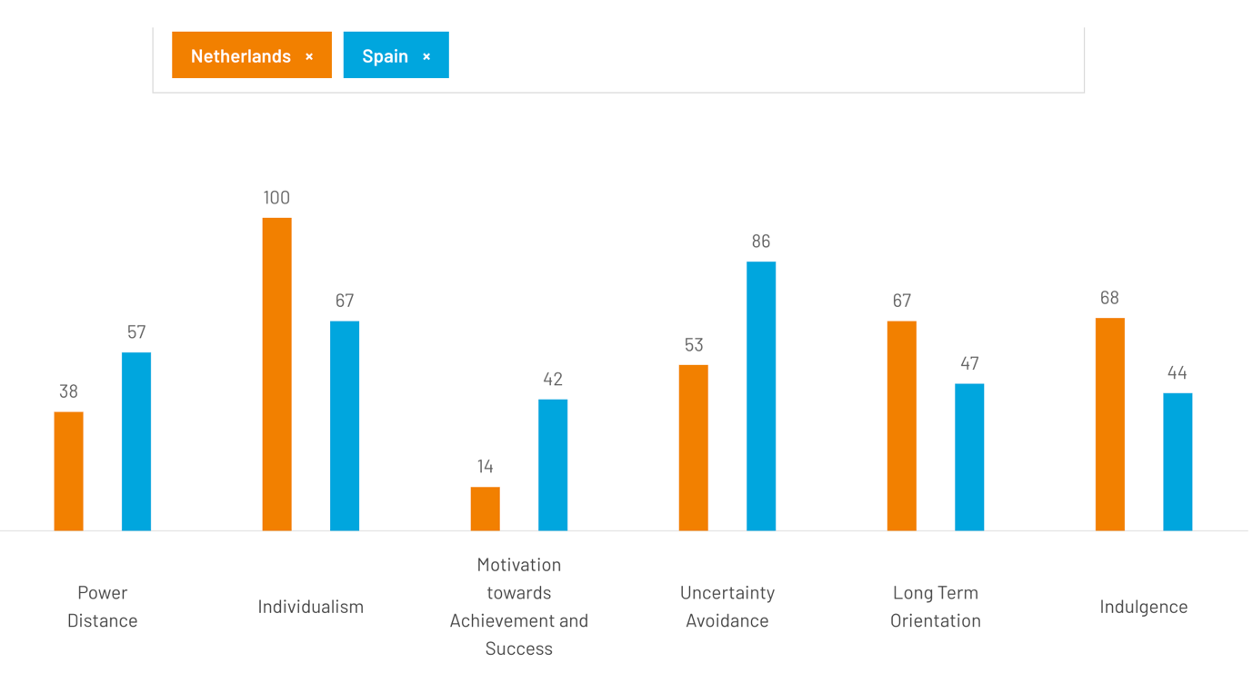
The text describes six cultural dimensions, as defined by Hofstede (2011).

The first dimension is individualism versus collectivism. In collectivist cultures, people are born into extended families or clans that protect them in exchange for loyalty. Harmony must always be maintained in such cultures. On the other hand, in individualistic cultures, speaking one’s mind is considered healthy.

The second dimension is femininity versus masculinity. Hofstede (2011) describes a feminine culture as one with minimum emotional and social role differentiation between the genders. In such cultures, it is important to maintain a healthy work-life balance. Masculinity, on the other hand, is described as the exact opposite, with maximum emotional and social role differentiation between the genders. According to the scores, it is more normal in Spain for a woman to not have a job.

The third dimension is uncertainty avoidance. In strong uncertainty avoidance cultures like Spain, the uncertainty inherent in life is felt like a continuous threat that must be fought. Staying in jobs, even if disliked, is normal, and everything different is automatically classified as dangerous. In weak uncertainty avoidance cultures like the Netherlands, the uncertainty inherent in life is accepted, and each day is taken as it comes. Changing jobs is not a problem, and everything different is classified as curious.

The fourth dimension is long-term versus short-term orientation. In short-term oriented countries like Spain, personal steadiness and stability are important. A good person is always the same, one is supposed to be proud of one’s country, and students attribute success and failure to luck. In long-term oriented countries like the Netherlands, people think that a good person adapts to the circumstances. One should be trying to learn from other countries, and students attribute success and failure to the amount of effort put in.

Lastly, the fifth dimension is indulgence versus restraint. It is related to the gratification versus control of basic human desires related to enjoying life. The Netherlands has a more indulgent culture, while Spain has a more restrained culture. In an indulgent culture, a higher percentage of people declare themselves very happy, freedom of speech is seen as important, and they have a perception of personal life control. In a restrained culture, there are fewer very happy people, a perception of helplessness, and freedom of speech is not a primary concern.

Recommendation
Based on this assessment, it appears that the Netherlands provides a better environment for British firms due to a stable business setting, highly qualified workforce coupled with good command of English language among Dutch nationals. Moreover, directness in Dutch culture is more in line with typical British business interactions.
- Cross-Cultural Training
Offer extensive cross-cultural training programs for British staff who will be stationed or require frequent contact with people from Holland to enable them to appreciate various cultural communication styles including etiquette norms common within Dutch society while at the same time gaining the necessary knowledge needed when dealing with such counterparts effectively.

Language Support
Even though the Netherlands has a good command of English, it can be useful to provide language support such as translation services or language courses because this will help in easy communication, especially where difficult terms or phrases are involved which require explanation.

Adapt Communication Style
When doing business with Dutch people, British companies should adjust their communication style so that it becomes more direct and explicit as preferred by them. One should strive to make their messages concise, transparent and clear for better understanding among the parties concerned.
- Build Relationships
Relationship building is important in any given society but more so in Spain than anywhere else (so) although there is less hierarchy observed between ranks within an organization structure here compared to other parts of Europe like Britain; therefore it would not hurt if Brits took time to know each other better. They need to spend some hours together networking among themselves as well as engaging locals who can serve as valuable contacts during their stay there while at work.
- Cultural Sensitivity
People involved in any kind of business are urged to be culturally sensitive towards others they deal with and this applies even when venturing into foreign territories like Holland where customs might differ greatly from one's own country. It calls for open-mindedness on both sides lest either party may view certain actions negatively due lack of knowledge or understanding about each other ’s traditions thus causing unnecessary conflicts or misunderstandings.
- Utilize Technology
It is appropriate that technological advancements are made use of so that no matter how far apart different teams responsible for the same project may be situated geographically speaking. This means( thus ) making good use of video conferencing software like Zoom; project management tools such as Trello could also come in handy here since they allow sharing files among team members who may not be physically present at the same location.
- Seek Local Expertise
For successful communication between two parties involved in international trade, either side should seek help from professionals who have deep knowledge about their counterpart’s customs, business practices and legal framework. Thus if British businesses would like to know more about these aspects related to the Dutch market , then they should consider hiring local staff or consultants with relevant experience .By so doing, much time will be saved which could have been spent trying to figure out things by oneself thus giving room to other important duties during stay there while at work .

Conclusion
All these methods can be applied by UK companies to solve communication problems experienced when operating abroad such as in Spain and the Netherlands. Good communication skills, understanding of different cultures (cultural sensitivity) as well as networking among staff members are very vital elements that can contribute towards successful business relationship creation with partners within foreign markets like the Dutch one.

Economic stability, regulatory environment, cultural nuances and communication dynamics are among the factors that need to be considered by British businesses when making decisions about their expansion strategy. For instance, this can involve selecting Spain which has a rich cultural heritage and values personal relationships or the Netherlands characterized by a stable business environment and direct communication style; however, in either case, they need to adapt their approach based on local context.
To add on, there is a need for proactive steps like cross-cultural training, language support system establishment, adapting communication styles and fostering strong relationships with locals if they are to overcome communication barriers. Appreciating diversity; respecting cultural differences as well as incorporating technology into communication processes are also key components of creating an inclusive environment where all people can thrive.
In conclusion, what determines whether or not a British company succeeds in entering EU markets lies with how well it handles communication challenges while being sensitive towards them but at the same time flexible enough to learn from various points of view. In addition, by embracing inclusivity coupled with promoting a collaborative culture among employees; British firms could maximize their growth potential during European Union expansions thus ensuring sustainable development for all parties concerned.

